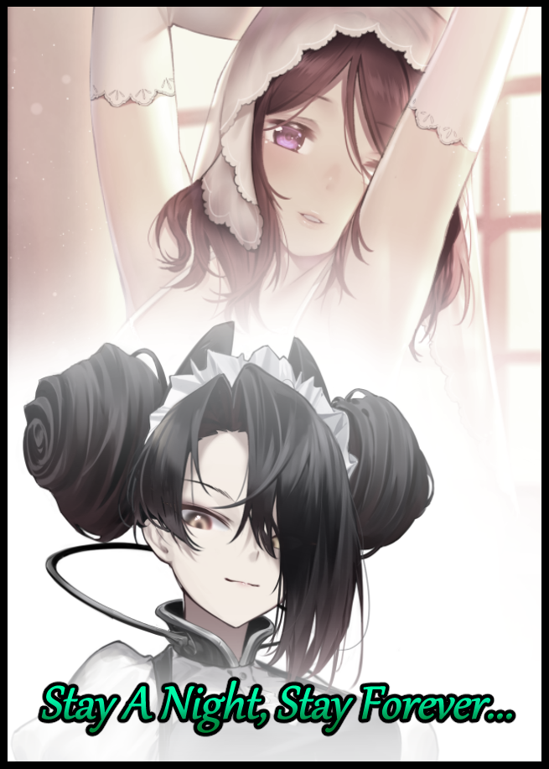

**"Dude, are we seriously going along with this? This place is supposed to be…y'know? Empty! No one said anything about some random MILF calling the shots way out here, and now you wanna take her up on her offer for a sleepover?! We should be going home!"**

**"C'mon man, you're overreacting…the place being intact should be a good thing right? What were you expecting, getting tetanus in some dusty old ruin?**

**"YES!"**

Doing a poor job of masking their argument while trailing a short distance behind the subject of their heated discussion leading them down a winding corridor fashioned out of sturdy wood lined with intricate carvings and decor, the two men would continue to bicker amongst themselves, clueless to the danger presented by the seemingly innocuous woman dressed in dulled scarlet robes that looked just as ancient as the surroundings were, strolling soundlessly ahead, serene eyes scouring the dust covered furniture and mold infest nooks.

Despite the calm expression she wore, her mind was heavy with disappointment, displeased by an apparent weakening of the hold she possessed over her home. One that wouldn't look so unkempt and weathered if she was in her prime, a time that could only be glimpsed in memory now, letting out another quiet huff at the fact that not even someone like herself had been able to escape the ravages of time.

But as her ears prick once more at the mention of the faux name she had thought up in the spur of the moment drifting in from behind, she wasn't totally lost on the idea of recruiting a little help for affairs related to cleanup and maintenance…but that could be handled by a single individual with the sufficient skill set…so that left her with one spare soul and the container that housed it, silently pondering the matter in her mind while her unsuspecting exterior shows the men their accommodations, presenting the homely little room with an outstretched hand and a warm smile on her face.

**"Feel free to use these quarters however you wish…that is, if you two intend to stay the night…it gets dreadfully lonely out here without company…"**

**"Oh no ma'am, the pleasure is ours. Thanks spot for the room!"**

**"Speak for yourself idiot…"**

**"My, there's no need to bicker…if you want, I could find another room to your liking?"**

**"That's not…*\*hah\**...I'm good…thanks…"**

And just like that, any discourse between them was settled as she watches the more lax of the two chastise his companion for making a lady bend the knee to his 'whining'. But already, she had an excellent idea as to what she wanted out of them after this brief yet informative glimpse into their personalities.

One was a cautious mind who wasn't quick to accept anything at face value. Thinking of the possibilities behind what he could see rather than straight up accepting it for what it was without complaint. But with a will that couldn't overcome a little bit of feminine persuasion, rendering them submissive to the right kind of 'authority'...

And the other, a lech who leaped face first into attempting to please members of the opposite sex. Taking every opportunity to rub up closer and closer however they could to the target of their less than honest eyes, through which an egregiously perverted soul peers out at the world with…

Two different personalities, two distinct fates that awaited them. And as she bows low to bid them farewell with a final suggestion to look for the master bedroom where they had come across her earlier, the scheming mistress would set her plan in motion with a knowing smile on her face, leaving the two men to their own devices as she retreats to her quarters, knowing full well that she wouldn't see a lick of them ever again…at least, not as they currently were.

When her millenia long rest had been prematurely disturbed by the sudden arrival of her latest guests on the mansion grounds, she almost couldn't believe how much time had passed since she last closed her eyes, forced to sleep when unfavorable conditions had ousted her from a world of wild, superstitious folk. Only to awaken in an age that was more or less…'open' to such topics now, desensitized through entertainment media and general common sense now that science was a proven concept instead of the label of 'devil magic' folk of old were quick to use.

But without the full scope of her abilities, the world at large remained shrouded in mystery, something she hoped to overcome with a little bit of help from her soon-to-be servants once her domain's influence crept into their minds and twisted their bodies to her liking. A process that had started ever since she'd become aware of their presence on grounds she had full control over, it was how she'd been able to learn of the outside world through the gradual increase in memory she could peruse as her hold over the two continued to grow stronger the longer they remained. Inciting change that would gradually overwhelm their current selves…a process that would no doubt take some time thanks to her waning strength.

In the meantime, she would prepare herself for the thrilling evening to come with what little time she had left before then while her 'guests' busy themselves within the room they were given, continuing their discussion in assumed privacy.

**"Seriously, you need to chillax. Some banging lady offers us a free night at her place and you're more interested in crawling through a wreck?"**

**"And you need to use your brain more. This place was *supposed* to be a wreck. And now it's suddenly spruced up looking like it just needs a little more remodeling to fix? I'm telling you, something's not right here…"**

**"And *I'm* telling *you* to stop worrying…you probably didn't get a good look last week…what with your hair being long and all, probably mistook that fringe for some broken wood!"**

**"The stairs in the lobby were caved in, there weren't any torches in the halls and there definitely wasn't anyone living here when I came by, I checked!"**

**"Alright, alright, chill…I'll go look around the place…you keep groaning..."**

**"Whatever…"**

Slamming the door behind him before tromping footsteps fade into the distance, the distrustful man remaining inside the room sighs before flopping over onto the bed, staring up at the ceiling with a bitter frown on his face. He would've told his friend to be careful out there, but what did he care? The dolt was too fixated on women to care. They were supposed to be trekking through a derelict ruin as per their usual thrill seeking activities on the weekends, but here they were, relaxing in an admittedly posh mansion from a time period he wasn't privy to. He was a college student studying for a degree in engineering after all, not a bookworm historian. Was he getting too tense? Or was his friend losing touch with his adventurous side? He couldn't tell.

**"Damn hair…really should get it cut soon…could've sworn it wasn't so long this morning though…"**

Running a hand through his scalp before pinching at an exceptionally long tuft of hair that was oddly smooth to the touch with little resistance to be found as he rubs them down, the agitated man continues to grumble, unaware of the loss of hair follicles occurring right under his nose as his skin cleanses itself of all other blemishes, including the tan he had worked to gain over the years as a pale beige coloration slowly takes its place. And with his eyes focused on the cobwebs tucked away in the ceiling while strange new thoughts begin to trickle into his mind, the changes would remain unnoticed as his static position on the bed shifts, accommodating for an increase in rear mass gained from a wave of fat inserting itself into his rump, leaving with him a subtle curve below and an even leaner back that arches inward, causing a slight strain in his lungs before he exhales, causing an immediate collapse and expansion in his torso as ribs shift slightly while a gaunt figure bends to the whim of an invisible sculptor, shaping waves and dips until an hourglass figure was hidden away behind clothes that had become ill fitting to wear, teased by the protrusion of broad hips and a tight waistline appearing every so often as the man continues to toss and turn atop the posh bed, trying to ease his mind to no avail.

**"Shit this is really starting to piss me off…gotta be a cutter around here or something…"**

Rising up with a notable increase in hair that droops low enough to hang down over small, rounded shoulders and gentle bumps that were still in the process of blooming atop a compact chest, the irate man trudges over toward the nearby table and wardrobe, hoping to find a cutting implement to trim his fringe despite the abundant overflow of darkening hair trickling down the exposed nape of a dainty neck that squeezes in beneath a softening visage that loses its stubble in exchange for an alluring dab of rosy red in squeezable cheeks taking their place beneath elongating eyes, shifting from narrow slits into slant, serpentine sockets granting a permanent semi sultry gaze as dull gray stones dilate before taking on a brilliant amber gold coloration to complete the look of someone with cunning and intellect. All while brunette cocoa fades under a sleek wave of brooding obsidian seeping forth from the roots, adding a tinge of mystique to a side swept fringe that collapses over the left eye of a now effeminate man, still oblivious to the many changes he had suffered by mysterious energies that were wise enough to split the work between body and mind equally, fiddling with his mind as easily as they did his flesh. Tweaking personality, discarding memories, altering biases…and so much more that couldn't be mentioned, having a noticeable effect on his progress once slender arms begin to slow in their pace while a hunched over position vanishes in favor of prim poise; back straightened, neck upright, legs kept close together…

**"Seriously, where does one even keep their scissors in such a place? It should be almost impossible to misplace it…perhaps in another room? No matter…a haircut isn't what I need right now is it? There's something else I don't quite remember…something…important for…what?"**

Muttering quietly under his breath in a higher pitch, the man squats down to manage his height instead of slouching in search of an object that hadn't quite materialized in his tingling mind, long hair reaches down to a pert ass while fattened thighs protest inadequate pants, pushing against the straining fabric that hadn't been tested until now, squishing against solid calves tapering off into waifish feet that were far too small for men’s sized boots, tipped with dyed nails painted to match the ones adorning the slender hands rifling through old cupboards and dried books whose contents were too ravaged by age to decipher…save for a name written in ink on the leather binding, the sight of which causes a soft gasp to escape out of bloated lips that didn't need lipstick to boost their already impressive natural pink hue and glossy texture, eyes widening ever so slightly as a switch flips in the back of his mind.

Rising to full height before kicking off the cumbersome footwear that made walking a trifle, the mesmerized man makes his way barefoot over towards the large wardrobe that remained unchecked near the back with a confident sway in his step accompanied by a bounce and a jiggle from the unmistakable pillows jutting out the front and tenting the top in such a way that an unintentional curtain opens to reveal a slightly less muscular but attractively toned navel and an even more tantalizing view offered by woefully loose pants that were about to fall away. A problem that would soon be fixed by new directives guiding the hand, opening the left side door before reaching in without hesitation to pull out a simple if elegant outfit composed of an underlying vanilla top with frilly shoulder length sleeves and a gunmetal gray dress with pale highlights sporting a frilled hem of white, setting the combo down with a smile at the sight of such a perfect thing for a woman like herself to wear…causing a nanosecond's worth of doubt to pass her by before fading entirely against the ongoing wave of new memories overwriting the old, informing the vanishing man of new loyalties while an entirely different lifestyle eradicates prior thoughts and behavioral patterns, showing no hesitation and shame as the changeling slips out of her baggy clothes, letting her top fall to the floor in a crumpled mess to expose heft breasts that rose and fell with each breath, tipped with swollen nipples like targets atop the creamy white mounds they sat upon, taking a moment to let her sensitive skin relish in the cool air of the mistress' mansion before reaching into the wardrobe again, extracting a sizeable black bra with salacious patterns sewn into its make, pursing the cups around her teats with practiced movement that suggested years of repetition before reaching around to secure the clasp around her smooth back with dainty fingers nudging against the subtle indents of shoulder bones. Displaying the gorgeous heft of her bosom as the twin melons jiggle to her movement before moving on to her pants, letting it slide off without resistance as they crumple around the lithe legs of a certified goddess…

…Between which a startling sight plays out where the vestiges of a sizable pecker do their utmost to resist the force of internal muscles pulling it into a slit formed by thick labia and moist folds of pink flesh; the entrance to what was clearly a female's reproductive system. Already, repurposed testicles had been neutered, forced to accept their role as egg producing ovaries flanking the fully functional chamber of a mother's womb, throbbing with heat and virility while female hormones and feel good chemicals saturate the curvy woman's body, making her blush as she raises a leg to insert her feet through the holes of the sinfully delightful black thong that had caught her eyes out of the assortment of underwear within the once empty wardrobe, purposefully letting it's smooth length rub against porcelain smooth skin along the way up her legs, biting her lower lip with a throaty groan, a purring moan, uncaring of the tiny penis twitching in defiance of the purpose robbed of it, replaced by a tiny hole that widens just beneath it, wasting no time in testing it's functionality with a singular driblet of women's nectar oozing out of it before the warm embrace of underwear arrives to soak it up. A process that delights the newborn woman as she lets her thumbs slip free after ensuring the thong was nice and tight; biting into her vagina, stimulating her clit while riding up between the slappable cheeks of a bountiful ass…

With her mind and body subdued, the rest of the silent process was a quick affair, rifling through the wardrobes between the equipping of every major set that composed her uniform. Buttoning up nice and tight, ensuring her gloves were firmly on, checking if the polish of her high heeled boots remained unblemished by dust and wear. Some minor accessories for flair. And most importantly; combing her hair before doing it up in the usual style she had it in ever since she had the fortune of being picked up off the street to work at her gracious charge's home; twin buns atop her head, a gracious side swept fringe and just a little bit left hanging on the side to bring equal emphasis to a foxy right eye of a woman who was self taught, self made and tempered to ensure she cater to her mistress' every need…a thought that had her innards tightening in excitement, masked by the noble, exterior expected of a maiden with the position of head maid.

A bearable life in college, the many experiences to be had in forgotten locales brimming with adventure and danger, a horndog doofus, a distant family and even a name were discarded without hesitation…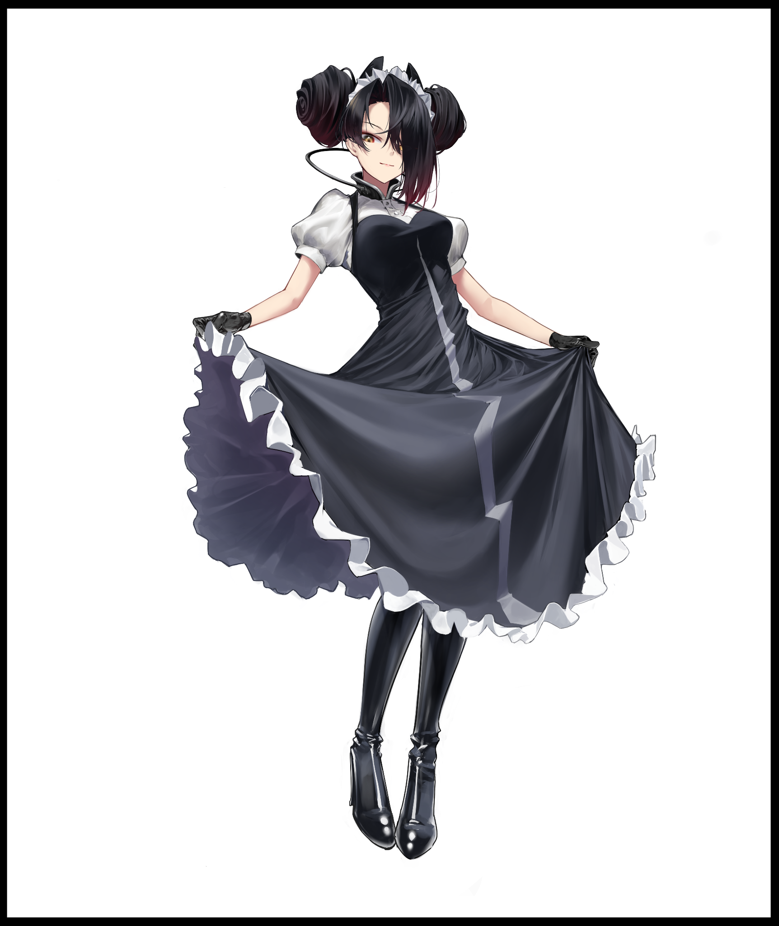

**"What was I thinking of…trying to sleep when the day isn't even over yet…there's still dinner to prepare, and the mansion is sorely lacking in maintenance…"**

Fluffing her dress with a longing sigh, the maid bends her knees, squatting down to pick up the dirty clothes and shoes littering the floor, gazing with a lax eye over the men's wear she intended to throw out seeing as they served no purpose in a home populated by women, but as she exits the guest room to ferry the stinking pile outside, a nagging thought eats away at the back of her mind.

*'Wasn't there someone else here? I could've sworn I was conversing with them not too long ago…'*

To her knowledge, the only people in the mansion as of now were the mistress, herself and…someone she despised with all her heart, more so out of jealousy than anything else.

While she worked hard to ensure their home remained in perfect condition while procuring supplies from the isolated world outside with pain staking walking trips to and fro. The *Pet* maintained her constant, slovenly lifestyle. Being rewarded almost every day and night by the mistress for almost no charge at all in comparison to her weekly meetings in the bed…the things she would do and relinquish at the prospect of being granted the privilege of allowing herself to be ravished at every hour of every day by the lady of the mansion herself…but alas, she was only one person. And the home needed tidying up. If anything, it was something she could take pride in.

*'Much more than that contemptible woman…'*

While the head maid continues on her task, her former companion would fare no better than she had against the irresistible taint of the lady's power. Looking dramatically different since the last time he'd been seen leaving the room on an ill-advised trek through the maze-like interior of the large woodland mansion.

Instead of a slow, logical transformation. The process currently setting in on the unwary man ran rampant, going so far as to alter the clothes on his body. Thinning touch fabric and exposing skin in plentiful amounts while the flesh beneath warps and ripples with each step, granting a bountiful amount of baby fat and supple flesh that, in comparison with maid's toned physique, left him looking like a gravure model, exercising not to remain for but rather, maintain the gorgeous figure that had steadily supplanting the gaunt, skeletal frame of the mischievous man whose true intentions were less than noble.

True, they were born of curiosity, but it didn't change the fact that the reason behind this little escapade of his was perverse and seeded in lechery. Intent on finding the lady's quarters in an effort to sneak a glimpse of her after spending agonizing minutes walking behind her, tempted by the flesh beneath that enchanting robe of hers. None the wiser to how his wish would soon be granted in a way he never would have thought possible, muttering under his breath every step of the way…

**"If I remember right…should take a turn down this side of the crossroad…and…yeah, just a little more…"**

By the time he had cleared the length of a corridor, most of the muscle that made up his sturdy figure gleaned from an active lifestyle had faded away, eating away at yet another piece of his identity in tandem with the other changes, taking each step with much more noticeable 'movement' now as a silken head of hair bobs to the momentum while pert flesh abundant in the ass and chest jiggles to the rhythm of heavy footfalls that seemed to be speeding up, losing the element of surprise needed if he wanted to sneak up to the lady's room unnoticed.

Except he couldn't fathom the idea of 'sneaking' up to his lady's room. Not when the urge to be there right now had suddenly engulfed his mind, spurring slow steps into a hurried waddle carried by long pretty legs that no longer had the capability for a prolonged run, pumping up with heavenly layers with each passing second until an ovoid thigh gap was carved into shape between alluring legs sporting thick thighs that rubbed together with every step, parting only when they came to a stop or for other, more salacious purposes, removing the thumping of calloused soles once clean, petite feet began to tap against the floor in place of heavy pads sporting stubby toes.

Turning the corner with a simple twist of childbearing hips and a flutter of dark red hair in the wind teasing onlookers with glimpses of a perfectly proportioned back clad in a transparent nightdress hugging impossibly tight around a voluptuous figure with the notable sight of panty strings wrapped around a heart shaped ass that stuck out high and proud, the pervert's mind was a mess, breaking into an all out sprint now that his libido was reaching high into the sky, feeling an intense heat in his groin and a numbing ache in his mind that he knew could not be quenched through the simple pursuit of temporary release alone, a fact told and cemented to him through the sweet whispers uttered in a familiar voice leaking in from the shadowy recesses of his mind. Following sweet words and promises of great rewards of ultimate pleasure without question, even when his erect manhood, crushed tight by flower panties derived from repurposed boxers, begins to recede, excited by the soft fabric that hugged deflating balls while impossibly smooth thighs brushed against its length as wrinkled sacs smoothened out, organs pushed and warped, new muscles manifest…until a sopping slit was all that remained beneath damp women's wear, forming a pudgy cameltoe perfect for someone to pinch between their fingers…eliciting joyous moans and wet spurts of pleasure from the redheaded babe that had taken shape from the simplistic man who sought to glimpse a woman of equal stature, ending up becoming such a specimen instead beneath her own notice.

Although it wasn't as if there was much left of her former identity in the bodacious girl hurriedly making her way towards the mistress of the mansion with an unabashedly feminine gait, both mentally and physically, moving with slender arms crooked at the elbows, fingers pursed. Legs perpetually bent inward at the knees in such a way that each step would inadvertently thrust her ass and hips out, swaying like an attractive pendulum while a mane of wavy red hair frames the delightfully innocent face of a subservient woman whose only purpose in life was to serve as bedmate for whoever fancied her presence…or struck an everlasting relationship with. The thought of which causes another wave of electric pleasure to shoot up her spine, biting back a moan as her hypersensitive form yearns for that person’s touch, struggling against the feeling of erect nipples swelling to life behind a cushioned bra supporting her perfect C cups, smaller than she would’ve liked, but as long as the Mistress saw no issue with it, there wasn’t any reason for her to yearn for more.

**“Just a tiny bit more now, and I’ll be with Mistress again!”**

Coming to a stop before the double doors she remembered walking out of this morning before engaging in a longer than expected chat that felt more like a drilling by the head maid, the Mistress' pet bunny raps her knuckles against the solid oak before making her way inside without a word, drifting quietly across the spacious interior towards the bed nestled right up against the wall where an unshielded window allowed for natural light to come pouring in, an excellent spotlight of warm afternoon rays the redhead basks under for a moment before reaching towards the nightstand, opening the first compartment that she knew held the remaining parts of her outfit, slowly dressing petite hands in skin tight gloves, taking in the piercing gaze of the eyes she could feel scouring her voluptuous body up and down, raising a pure white wedding cowl over her head to complete the look of a beautiful young lady giving her life partner a good show as her arms remain raised and tucked behind her head, arching her back with loving eyes locked with those of the lady of the mansion, watching her rise from where she sits on the couch, distracting her to the wave of scarlet wiping azure from her eyes, sighing under her breath as the last piece of a thoroughly addled mind finally clicks into place…

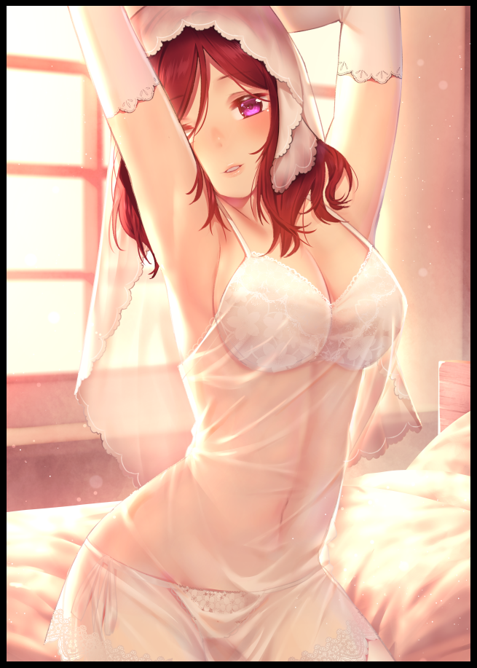

**"Does this please you m'lady? I apologize for the lengthy wait…the head maid had quite a bit to say…"**

**"Very much so…and It's alright my dear…you're here now aren't you? Though I do wonder what my precious helper had to say that kept you for so long?"**

**"Mostly venting her frustrations m'lady, nothing more…I think an additional maid or two would work nicely in lightening her workload…but I am simply your pet m'lady, my words matter little in the face of your own…m’lady? Ah!"**

Gasping sharply as the larger woman falls down around her like a predator descending on prey, the mistress' bunny struggles to keep her moans silent as her lover's arms begin to coil and stroke her needy form, pinching a nipple as fingers slip under her bra while the other busies itself above, cradling her cheek while dexterous middle and index fingers piston in and out of her mouth, playing with a spasming tongue…

**"To degrade yourself before me…pet or otherwise, you *are* one of my girls…don't fret about voicing your own opinion more my dear, it might be difficult to…*scout* for potential helpers but I trust the head maid's ability to whip them into shape…now come, we've little time before dinner…and I would like to enjoy your body before then…"**

**"*Mnahh~* A-As you wish m'lady…"**

Falling over onto the sheets like a puppy yearning for a belly rub, the joyous lady doesn't hesitate as she begins to work the body of an almost perfect incarnation of her former lover, given shape through new flesh. Her face looked a bit too young and naive. And her body, while amazing to touch and look at, hadn't yet bloomed to full maturity. Something she couldn't wait to see after the passage of a few more years over the use of more magic, preferring to see how this cute, little seedling would flower on her own…would she become a gentle lily? Or perhaps a thorny rose…just like the other new tenant of the mansion currently huffing away in the kitchen.

*'No doubt the new head maid must be furious if she's as perfect a replica as my dear rabbit…no matter, people will come looking…and her desire for companionship outside of my company will be satiated somewhat…I should reward her tonight…'*

Setting aside her thoughts, the newly awakened witch of the steadily reviving woodland mansion would set herself to work on the mewling redhead beneath her, and come later that evening after a hearty dinner of stew and soup, the brooding maid with a far more adulterous experience thanks to her seasoned tenure in the art of making love between women.

Both the bunny and the maid were eternally blissful in their indulgence of the mistress, savoring every moment under her employ as trusted companions, ignorant to the desecration of their former selves and the lives they had been plucked from…

THE END

*Image Sources*

Image 1 by Kimi : <https://www.pixiv.net/en/users/62177439>

Image 2 by Nagareboshi : <https://www.pixiv.net/en/users/8391>