LIZARD LOVIN’
COMMISSION STORY
BY CHALDEACHANGE
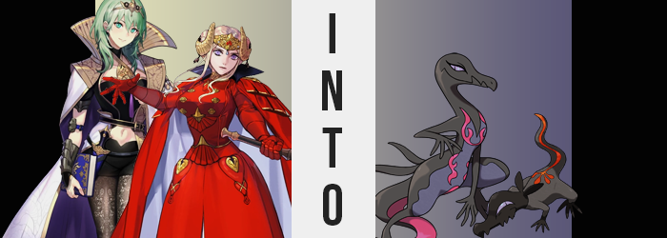

DRIP, DRIP, DRIP…

Edelgard von Hresvelg was alone with her thoughts in a rather unusual location – one she had directed her strike team to occupy to set up camp for the night. The woman represented the will of the Adrestian Empire and had guided it into a war against the Church of Favonius and all of its allies some years ago. It was a decision that she hadn’t made lightly. How could she? Because of that choice she had made enemies of old friends and, for a time, she had even lost the professor that she had loved because of it.

The latter loss had affected the Adrestian emperor deeply. So it was only natural that when Byleth returned that Edelgard had managed to pull herself out of the hole of despair she had fallen into. She simply wished that the woman she loved, well, would realize her feelings. “Well, it’s not as wishing for a miracle like that will make it come true.” The words that she mumbled to herself echoed through the cave tunnel she was navigating.

Why a cave system? On the way to their next battlefield, Edelgard had seen the entranceway and had decided it might be a safe place to camp for the night. She and Byleth were scouting nearby caverns while the rest of the Black Eagle Strike Force set up camp closer to the entrance. Edelgard’s logic had been that it was best to keep them out of sight of their enemies and Byleth agreed. She didn’t mind navigating in the dim light as she was now.

“No signs that any monsters have lived here, but…” She and Edelgard were simply supposed to be searching for signs of animals or monsters that might have been a danger to them. Wolves and bears were the most common cave-dwelling threats, and Byleth hadn’t seen anything like that. But there were signs of something else having once occupied the cave. Scratch marks that seemed very old and a subtle but pungent scent that hung in the air of the cave she had found at the back of one tunnel. “Is that a nest? Or was a nest, I guess.”

It had been hard to make out with the little light the ball of magic light she produced provided, but there was a makeshift nest made out of leaves and straw that must have been gathered from outside the cavern. But there were also old, broken egg shells. Something had lived in the cave but they were long gone now. “The smell is stronger here though. It's a little putrid but…” Oddly… nice? It was even odder that, after stepping away from the nest, she found the scent was getting stronger still.

Unaware that her own skin was producing it.

But it didn’t exactly take her long to clue into the fact that something was wrong. Not necessarily with her surroundings but with herself. “Mm?” Byleth wasn’t often one to voice her deepest thoughts aloud, but she made a noise as she craned her neck a little. There was an uncanny feeling building at the base of her spine. A pressure? The best she could describe it was like ‘something wanted out’ but from where? Her shorts? Her body? With the white cloak she was wearing in this class it was almost impossible to see anything behind her anyways, and the big, golden collar didn’t help things in the least.

“H-Hey…?” The obscurity she faced made her all the more anxious when the pressure released and it felt like something had slid out from above her shorts. She could feel something flopping around behind her, reaching out more and more to tickle the cape. But why could she feel whatever was sticking out touching her cape as if it were a part of her body? Seeing no other option, she reached back to take hold of whatever it was. But she also wasn’t exactly ready for what her fingers grasped.

The professor immediately shuddered as fingers came into contact with a surface that was long, smooth, and scaly. She was quick to liken it to touching a snake or a lizard. The issue was that, if she was correct and this was a reptilian tail – why was it attached to her body? The base felt thicker and it gradually thinned out as her fingers traveled along its length. Once she was able to surmise how long it was she gingerly grabbed it and pulled the length around her hip to look at it.

And she hadn’t been wrong. “A tail…” Her assessment had been correct then. Black on top and hot pink on its underside, it didn’t have the coloring of any scaled creature she was aware of. Making matters more confusing? The sensation of two black tendrils right above it touching the cape behind her added to her sensory woes. It was a strange feeling to just suddenly have body parts that hadn’t existed prior. “What is happening to lazzle?”

To what? Byleth shook her head as if to clear whatever had inspired her to make that sound, hardly noticing that as she blinked? Each blink happened twice. A transparent, second set of eyelids had formed beneath her regular pair. They closed vertically instead of horizontally, and gradually? The colors of the green eyes beneath them began to dull to a pale purple. Not just her irises but her sclera as well. Leaving only black pupils with their usual colors but not their usual shapes, for they had shifted into slits.

The woman finally dropped her new tail but not because she had lost interest in it. Rather, she had been taken off-guard by the sight of the hands that had been playing with it. “These scalazzles…” She turned both hands over in awe. On the back of her hands and fingers? Black scales like those on top of her tail had begun to spread, whereas on their undersides? The same hot pink as well. It also looked as if her fingers were thinning and lengthening? And what had become of her fingernails!? Even her palms thinned at the sides until her hands were more a hub for her fingers than anything.

Byleth wobbled. “Salazzle!?” Which prompted her to cry out yet another unfamiliar noise unintentionally. She was having problems standing and, in fact, her heeled boots just weren’t comfortable. If you could examine their interiors it certainly would have made sense why that was. Her feet had suffered changes similar to her hands, but significantly longer toes wanted to spread out within boots that were too restrictive. Black scales crept up towards her knees and lifted the backs of those feet too. The woman’s ankles and lower legs thinned, and before long her posture was tilting forward passively.

There was a very clear theme of distorting the woman’s humanity present, and as the seconds ticked on and the toxic scent grew stronger – created through the scales that were spreading across her body – Byleth’s shape departed farther and farther from that of a warm-blooded human. In fact she was feeling quite cool, no doubt because scales were replacing her human skin all over. Her back was almost entirely painted black, whereas the front of her torso and above her knees was treated to a slightly darker purple than her eyes now sported instead.

“Help lazzle!” And as her stature began to crumble and her clothes swallowed her? The professor was left grappling with a realization. It was getting harder to think and understand. Complicated concepts that she as a human had known were slipping between her fingers and what she could think about felt both simplified and oddly instinctual. But she still felt horny. Which almost seemed to coincide with the fact that while she was becoming less human, there was still a feminine charm to the shape she was gaining in its place.

Take Byleth’s thighs for example. While her legs were shorter and pencil thin beneath her knees, her thighs kept a plump and ovular shape almost like a mature woman’s thighs might. This meant that while her ass was painted over with scales too, her rump still had a shapeliness beneath her tail. Even her chest maintained the subtle curvature of a pair of breasts. Despite losing their individual shapes and nipples, and being painted over with hot pink flame patterns.

Her height had slipped down to about two thirds of what she had usually been, and the individual that was more creature than human found her clothes stifling as a result. She struggled to squirm free while hair fell from her head – brows, eyelashes, and all – and her mouth was pulled out into a hooked snout. She couldn’t stop her tongue from flickering out here and there, showing off how thin and forked it was. And eventually?

The creature craned her long neck and heaved. “Laaaaazle!” It had been an act guided purely by instinct. She summoned a sticky, acidic substance from the depths of her stomach and douse the human clothes she was wearing in it. The clothes melted away but did absolutely nothing to Byleth’s skin, leaving her naked as if to show off how scaled she had become from head to toe. But why did her elongated eyes have such a beckoning look to them? It was almost as if she was passively trying to seduce anyone that looked at her.

Despite being a lizard.

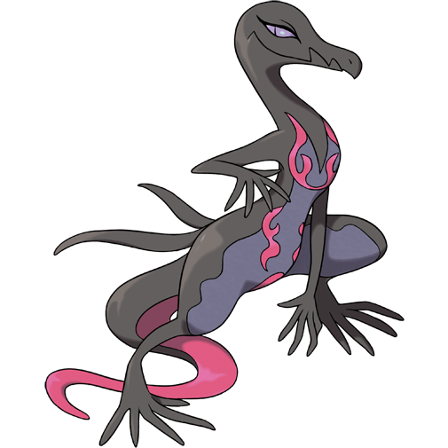
“Sal! Salazzle!” The almost four foot tall lizard’s reptilian head twisted from side to side as she stood on her hind legs. The darkness of the cavern was of little consequence to the wild Salazzle, whose purple eyes were designed to see in habitats like these. She puffed out her chest instinctively as she stood, her long tongue occasionally flickering out to taste the air to better absorb the scents. Of course the strongest scent was being produced by her own body. A potent pheromone of her that would attract males. Not that there were any males in the cavern to attract. Yet.

She dropped make down onto all fours, sticky fingers helping her crawl onto the cavern wall as her maw clicked open and closed. There wasn’t a single trace of ‘Byleth’ left within the Pokémon. At least not one that bore any humanity. Her thoughts were much simpler now. Need to make nest. Need to find food. Need to mate. “Salazzle!” She cooed to herself at these thoughts. She could smell the traces of Pokémon like her in the cave. It had been used as a nest in the past before. She would just need to recreate it.

But first? She needed help. Why do it all herself when she could make something else make most of the effort?

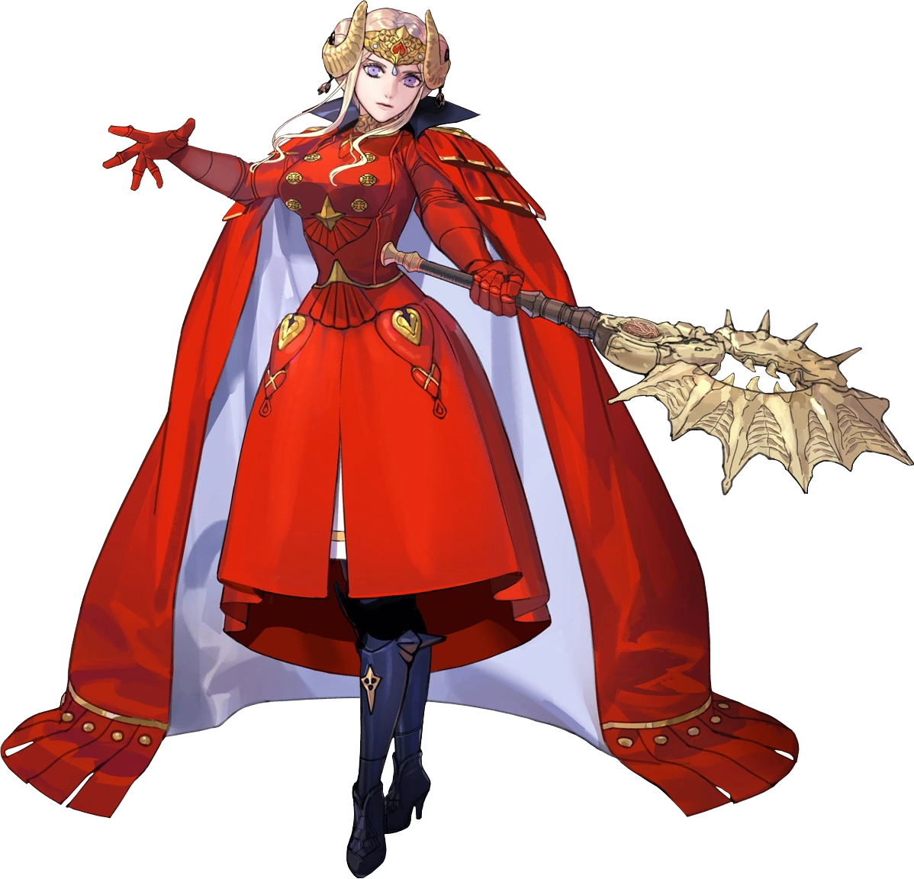
“Hm? Was that the professor?” For a brief moment Edelgard felt like she had heard Byleth’s voice. It had been a little muffled. So muffled that she couldn’t really make out if she was saying something or making a noise. “If she was close enough for me to hear then perhaps I should make sure she’s alright.” She altered the course of her path towards the sound of the voice, but noticed something odd as she began that trek.

There was a strange scent in the air. It felt a little pungent and overpowering at first, but as the emperor moved closer to the cavern she found herself almost enjoying it. It was enticing and was making her heart race. “I hope the professor is okay… I really love the professor… Her beautiful face and luscious lips… She’s so hot… She— ERM!?” It took a few lines for Edelgard to finally snap herself out of it. But what was it? She found Byleth to be attractive, but she’d never thought to express those feelings the way she was just babbling on like someone who was blindingly horny.

But she felt that way. Horny. And there was a great deal of warmth pooling between her legs.

And yet despite feeling warm down there, her body had actually begun to feel cooler everywhere else. Compared to Byleth, Edelgard would suffer from ignorance early on because of the dress and armor she wore. Her face was really the only skin of her body that was exposed and so if, say, dark grey scales had begun to spread across the woman’s torso? How could she have possibly realized as much?

It went without saying that this was legitimately what was happening. Beginning with and erasing her navel, these scales moved up, down, and around her torso to cover it in its entirely. “I’d do anything for Byleth…” Was it related to how she couldn’t stop herself from simping for her professor? Absolutely. But said simping had stronger implications than one might have expected initially.

For as the grey scales wrapped themselves around Edelgard’s breasts? Her nipples did fade, for reptiles did not breast feed. But it was more than that. This skin tightened and flattened until naught remained in terms of bust. And in a similar fashion? Her ass and thighs went the same way. Beneath her lavish, armored outfit? The emperor’s body had been robbed of any apparent femininity, leaving her figure to be extremely androgynous.

Edelgard swayed to and fro, her walk slowing as the armor she was wearing became increasingly heavy and her mind began to wander more and more. She dropped her axe so that a hand could massage the front of her gown. Why was she so overwhelmingly aroused? It didn’t even occur to her that the gesture she was making with that hand was as if she were trying to grab something, all the while her pussy feeling oddly full.

“E-EH! Is that an alandit!?” Cheeks burning crimson already, realization struck her once something pushed up against her panties from within. Or, perhaps, it was better to say it pushed up against his panties. It was small, but a hardened cock had protruded from her pussy before the hole closed in around it entirely. “I have a dick…!?” Why did he have a dick!? Although the more he thought about it? It would be easier to service his queen this way, right? “Sala… for Byleth…?”

Little by little it seemed his height was diminishing by the time his sex had changed. Armored gauntlets fell from his hands, revealing pitch black scales had crept around shrunken hands that resembled stubbier versions of the Salazzle’s – each hand lacking a thumb. Arms and legs shrunk and narrowed and, with a shrill “SALANDIT!?” he eventually tripped over his own outfit and slid right out of the neck of it. His body was already shorter than three feet and far too narrow. It was probably for the best.

But as he flopped about, free from those coils, it was clear just how much more lizard Edelgard was than human now. Knees and elbows were bent to the sides to give him the posture of a creature that would skitter across the floor, and a tail finally seemed to be emerging from the end of his body. Its scales were largely grey, but an orange-red strip ran down its top towards its tip, with a four-pronged pattern at the base of his back.

Help! Help! Need! Want! Feed! Mate! Problem? No! The critter’s thoughts were nowhere near as complicated as a human’s, owed solely to the smaller brain within a balding, black head that stretched forward into a reptilian snout with a hooked end. He almost resembled a little bandit once eyes turned purple and squinted wryly passively, two tendrils sticking out his head’s back almost like the ties of a mask. A tongue, long and forked, flickered out over and over as he attempted to acclimate to his environment.

But all he could taste were the pheromones of the woman he wanted to mate with, riling him up further.

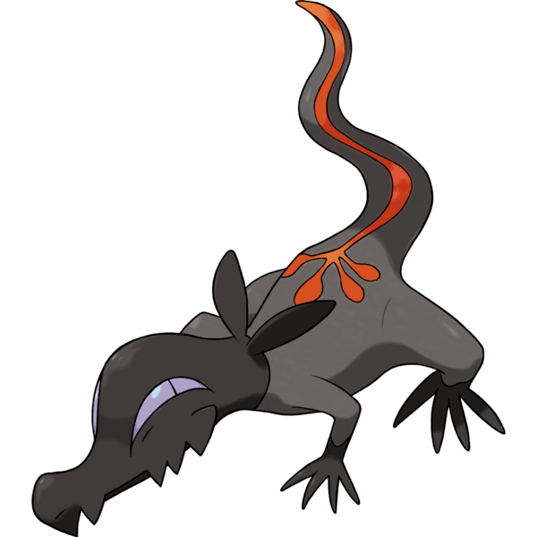
Only about half the length of the Salazzle that Byleth had become and essentially bound to all fours, the Salandit that Edelgard had become could no longer contain himself. He scurried across the cavern floor and walls towards the scent of the pheromones that its tiny nostrils found irresistible. “Dit! Dit! Sal-an-dit!” Every so often its tongue tasted the poisonous scent, its reptilian mind now even simpler than the Salazzle’s – likely because he was the pre-evolution of the line. But male Salandit couldn’t evolve anyways.

They were destined to love and provide for a Salazzle as part of her reverse harem.

Mate! Mate! Mate! Mate! Mate! Only one thought ran around in his tiny little head, his reptilian member still erect between his legs. He was getting closer, closer, closer! Until finally? He found himself in an open cavern with the Salazzle in question preparing a nest. “Salandit!” He leaped at her, no recognition between the two creatures of their past self. But before he could show his ‘queen’ just how much he ‘loved’ her?

“SALAZZLE!” She hissed at him. He froze up and his body shuddered. She was giving him commands. He would always serve his queen no matter what she wanted of him. And she wanted him to help her build her nest. Mating would come later, yes. All for mating. All for mating. And so the two took off for the cavern entrance – but only one of them would end up doing any work.

Chaos struck the temporarily camp of the Black Eagle Strike Force not long after. The Salazzle that had once been their professor had passed buy, her pheromones lingering in the air and transforming the rest of her students into additional Salandit. The women turned into males just like Edelgard did, immediately joining their professor’s reverse harem. While the men? They became female lizards, destined to one day evolve into Salazzles to begin reptilian harems of their own.

Needless to say? The end of the war was sudden. Adrestia’s Emperor and her most fervent followers had up and disappeared, never to be found. And while the cavern they had camped in was eventually located? Anyone who went to investigate disappeared in kind.

Cursed to become part of the lizard harem themselves.

