LEAH'S MESSY MORNING
SUBSCRIBESTAR SPECIAL

Lately, I have been producing a lot of intense content and I hope you have all been enjoying it. It does take a toll on my body though, being a toilet day in and out for different women! Yesterday night I was planning on taking an evening off from all my other jobs to focus on writing. I made a coffee, smoked some weed, sat down at my computer, and just as I put my fingers to the keyboard, I was interrupted by a text message notification.

I picked up my phone and checked the message, it made my stomach tighten. It was from Leah!

“I just had a huge dish of butter chicken and my stomach is on fire! I’ll be over in twenty! And I’m staying the night!” she did not ask, she did not even check if I was free, she just let me know she would be over to use my mouth and to be ready. You probably have a boner just reading that, but try to imagine in real life, you are about to do work, try to get something done, only for someone to interrupt you to let you know you’ll be inhaling their feces! It’s quite jarring, I felt like an object like I truly had no say in any of this. If I told her no, would she even listen?

It was 11 pm and I could hear her downstairs in my house! Leah has become friends with Mistress Corinne, and she often gets let in without me even knowing she has arrived! It’s terrifying not knowing when punishments and meals are coming! Leah used her foot to kick open my door as she came in, she had her purse in one hand and a beer in the other!

“Hey, toilet! How’s your night been!” she asked casually and seriously while jumping onto my bed and taking a sip of her drink. Lately, that has been her nickname for me, Toilet.

“I was about to do some work!” I smiled but there was a hint of annoyance in my voice, she picked up on it.

“Keyword, ABOUT TO. Now come massage my feet! Where is the controller, I wanna watch Netflix!” she demanded as she started to drink her beer!

I sat there on the floor, her big sweaty feet in my face! She continuously rubbed her toes over my nose, grabbing at it while I glanced at my laptop to my left, the word document was blank! I wanted to push her feet off of me and start my work but I need to keep my scat stars happy!

I spent thirty minutes massaging her sweaty feet, letting her abuse my face with her soles, pinching my nose, pushing her foot down my throat, etc, before she instructed me to remove them! I peeled the socks off of her feet, ahs must have been wearing them all day! Her feet, top, and bottom were covered in bits of damp lint!

“Mmm that feels refreshing!” she giggled as she spread her toes wide and wiggled them over my face!

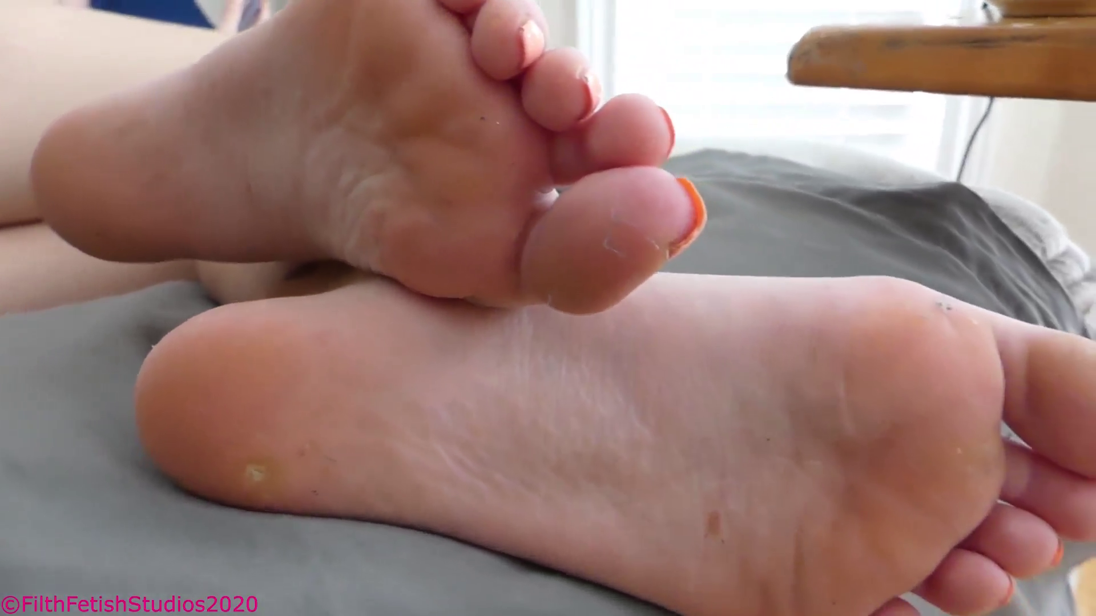

Leah has VERY smelly feet! She was a dancer and went to an art school for college where she performed in all sorts of shows! Her feet are long, slender, but they always stink badly! She knows it too and takes pleasure in making me suffer under them! Her soles were rubbing up and down my face as she smiled down at me.

“I wore my ugg boots all day today because I knew I wanted to come to use you!” she smiled, I didn’t respond and continued massaging.

“HEY, what do you say??? Where are your manners?” she asked with a fake insulted look on her face.

“Thank you, Princess…” I answered and continued to massage.

“FOR?”

“Thank you Princess for getting your feet nice and fragrant for me! You are too kind to me!” I replied.

“That’s better!” she smiled and pushed both feet into my face!

“OH! I have a fart coming!” Leah practically shouted as she jumped onto all fours sticking her ass out into my face! I grabbed the sides of her leggings and pulled them down, she had no panties on! Grabbing each cheek I spread softly and pressed my nose to her asshole, I could feel it was sticky with the tip of my nose, and instantly I could smell the terrible earthy unwashed odor!

BBBBFRTTTTTTT

The stink was terrible but I have begun to get used to Leah’s gas. It’s always very potent, sour, and cheesy, it smells like she has always been eating too much swiss! The worst part is how badly it burns and makes my eyes water! I sniffed deep, inhaling and huffing against her sticky pulsing asshole as she moaned.

“Mmmmmm how did that smell?” she asked, I was still processing her gas and couldn’t respond though. I was moving away from her ass just when she called out again…

“There’s 1 more!” she said excitedly, pushing her butt out towards my face!

I grabbed her cheeks and began spreading them, I hadn’t even moved my face inward between her cheeks yet when it exploded out! I saw her sticky pink asshole ripple and slap open then closed as the blast of cheesy gas hit me point-blank in the face! I could feel the warmth on my eyes and it burned!

Leah watched Netflix for another thirty minutes or so and was out cold by midnight! I picked her up and moved her to the top of the bed, tucking her in and then taking my place at the bottom by her feet. She likes having me lay with my face behind her ass so I promptly got into position. As soon as I was laying down, she began shuffling around and slid her clothes off, her bare ass now right before me!



She has such thick plump cheeks, it’s impossible not to be drawn in by her ass! It took only minutes for her to fall asleep as the heat began building under the heavy bedsheets! I could feel it and was starting to sweat, I never get any sleep on the nights she is here! As the heat rose, the odor from her ass got worse and worse, eventually with me able to smell it from a few inches away with her cheeks not spread!

Leah was breathing deeply, sleeping soundly as I baked under the sheets! Watched her adjust as she lifted her hips, pushing her butt back towards me, her ass cheeks spread ever so slightly before…

Spppprrrttttt bbfrpppppppshiiiiisssssssssssssssssssssssssss

The fart that leaked out from her dirty asshole was like poison! It started splattering, wet, making a mess between her cheeks before dying out into a very subtle hissing, like a gas line that had begun leaking! I took one sniff and then huffed in while choking, it was fucking terrible! I could feel my throat pulsing as I tried to stop my gag reflex but the odor was so strong! I could see the blankets moving when suddenly I felt her hand on the back of my head, gripping my hair. She used all her sleepy strength to push me forward while jutting her ass back! My nose rammed between her sweaty cheeks, I could hear her purr and moan as my nose rubbed against the bitter wet shit. It’s safe to say I did not get much sleep that night!


(Pic from the morning, she was on her phone and farting up a storm!)

When the morning came I had not got a single second of sleep! My nose was coated with dried shit and my face was covered in sweaty swampy ass juice! Leah rolled over onto her back and sat up while yawning.

“Good Morning Toilet! Ready for your breakfast!?” she asked, I truly was not!

I had a sickly empty feeling in my stomach and was not ready for one of her shits! Leah’s feces are always messy, wet, sour and cheesy, almost impossible to get down! I could feel my gag reflex already triggering as I crawled into the toilet box. I waited and waited as she packed a bowl and smoked. As soon as she set the lighter down, I could hear her rushing to the bathroom.



Leah wasted no time at all pulling open the lid and throwing her plump ass onto the seat. I barely got a moment to ready myself as she released a hot fart followed by some very mushy sickly feces! I held back trying not to gag (she hates that) as her feces filled my mouth and poured down my face!

“I want you to eat it ALL!” she demanded as I started to cry, there was no way

Her anus bubbled and let a series of wet farts out followed by more juicy blobs of wet shit. I prayed for it to end and someone high up there was clearly listening. Leah began wiping and got up, the lid slamming above me! I was covered in her shit but happy that it was over, it could have been much much worse.

“Stay right here slave! I’ll be back!” Leah demanded as she left for the bedroom…

Her shit was leaking down my face, turning to mush in my mouth! I wanted to clean up so badly but she told me to wait, I couldn’t disobey her!

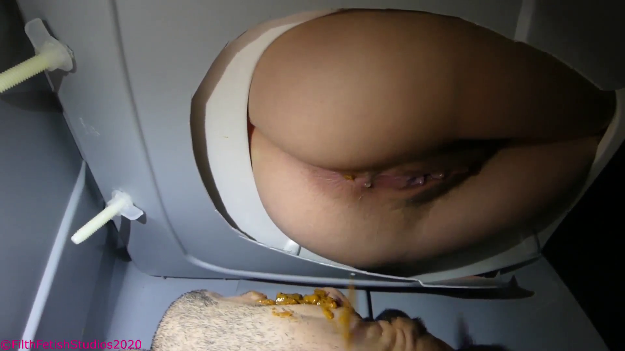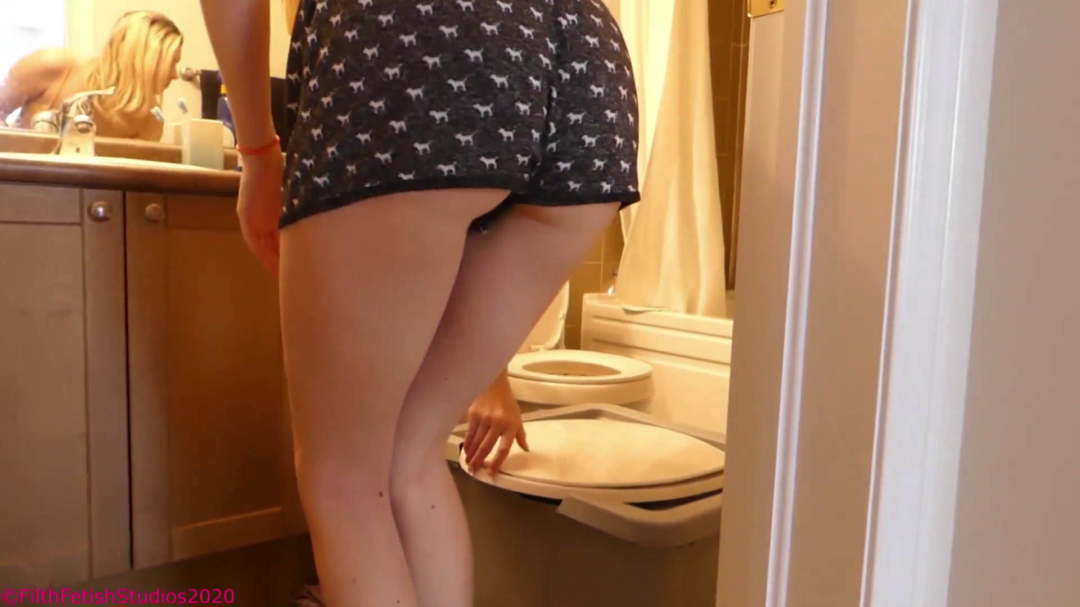

It was less than a minute later that she came RUNNING BACK. Leah slammed her ass down above me and told me to open my mouth wide, which I stupidly did. I was not expecting it, could never have seen it coming! Her anus ripped open and unleashed a watery bulk of feces from the depths of hell! It filled my mouth and poured down my face as she moaned in relief, finally getting rid of the filth sitting in her intestines for the whole night

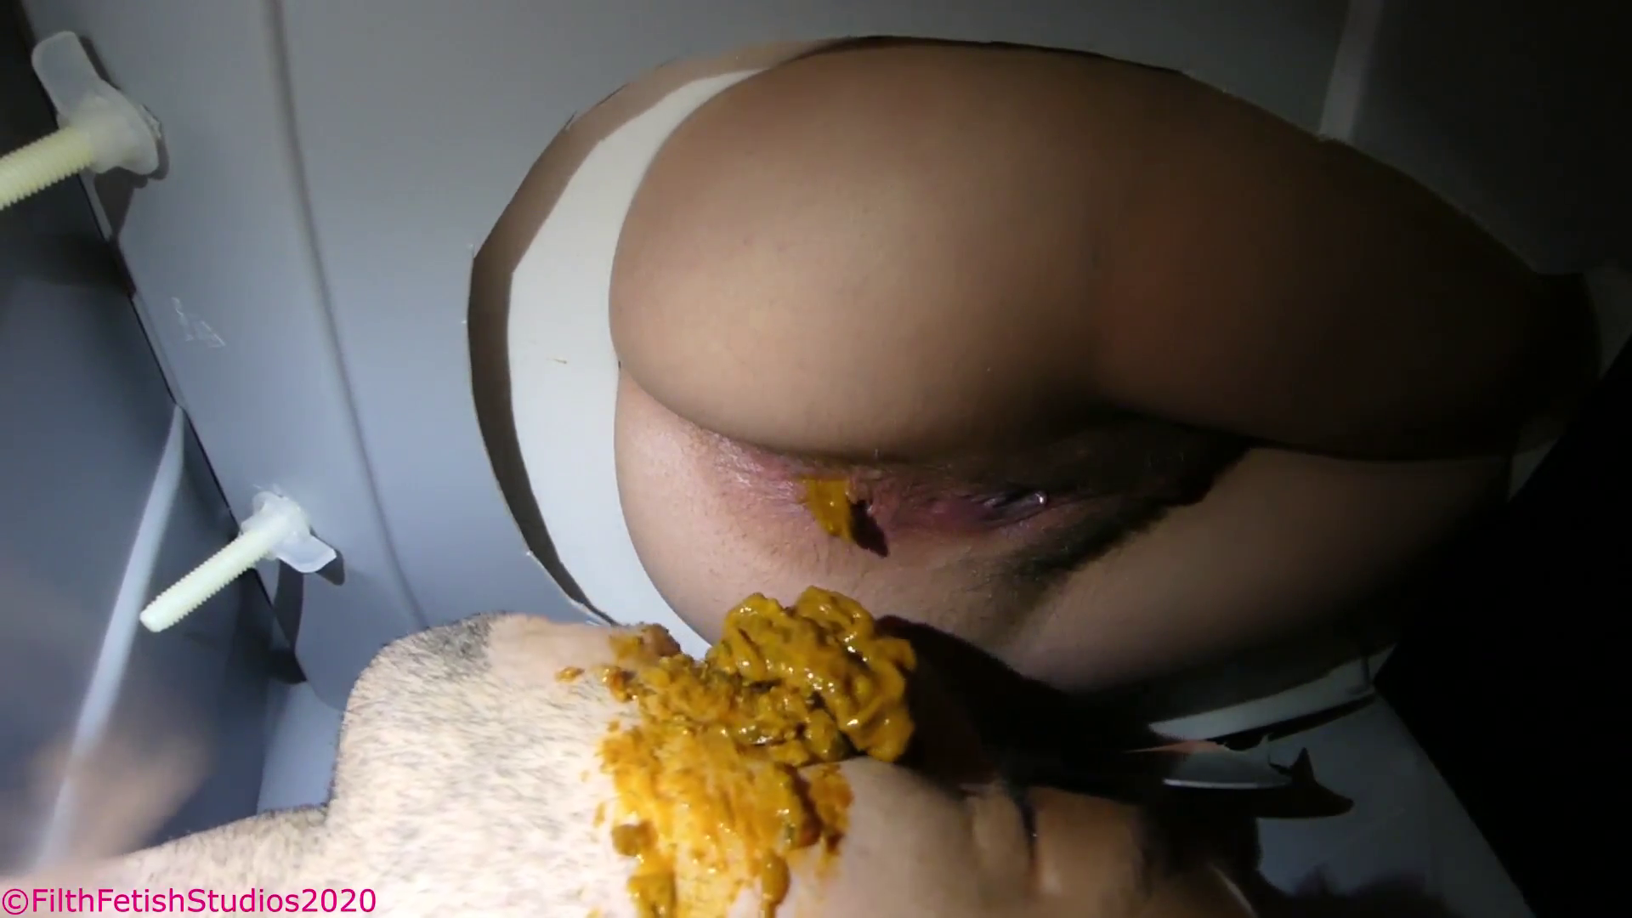

“And there’s the butter chicken!” Leah began laughing above me as her feces ran down my face, there was so much and it was literally steaming above me! I could feel it burning my face, running into my eyes, leaking to the back of my throat! Leah let out a giggle as she got up and wiped again.

“You better finish ALL OF THAT, people emailed me, they want you to consume! And I want money, so get to it Toilet, don’t let me down!” Leah closed the bathroom door, and I began to cry!

This story took place THIS MORNING. I am going to have A LOT MORE TRUE stories and content coming. This was a small teaser of what the $10 tier and higher get to experience!

