TIDDY OF TIME III.
FEBRUARY 2022 REQUEST STORY
BY CHALDEACHANGE
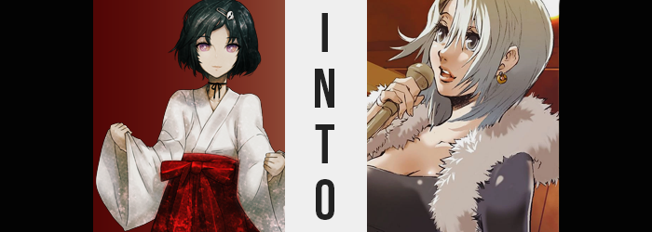

Luka Urushibara didn’t really know what was going on here.

The last he knew, he had been invited over to the Secret Gadget Laboratory with the others in order to have a little party, just women. Admittedly it had all made him a little anxious, if only because, well… He was a dude. He looked every part the girl he sounded like, to the point that he was much more comfortable being seen as a woman rather than being addressed with his biological sex.

Perhaps that was why that despite his anxiety it had also made him feel a little happy? It was nice to be treated the way you wanted to deep down. But he definitely didn’t have the courage to reinforce that idea to his family and friends. He had a very traditional background family wise, and he could only imagine the troubles that embracing such a life might bring. The thought had crossed Luka’s mind plenty of times though. That he’d be better off had he been born a girl.

This tangent aside, whether or not he’d been born a man or woman likely wouldn’t have changed just how confused he was. He’d been in the laboratory’s kitchenette area when a strange sound had emanated from the building’s rooftop, and Luka had been swallowed up by a very strange light. The next he knew, he wasn’t in the lab anymore. He wasn’t even sure if he was in Japan anymore.

“Um… is this a dressing room?” That was the impression that he got based on the mirror, chair, and star on the door – but he certainly could not fathom how he had ended up in one. It wasn’t lit by electric lightbulbs, either. Candles? Rather, the whole room had a rather Western antique energy to it in the design of the mahogany furniture and the wooden walls.

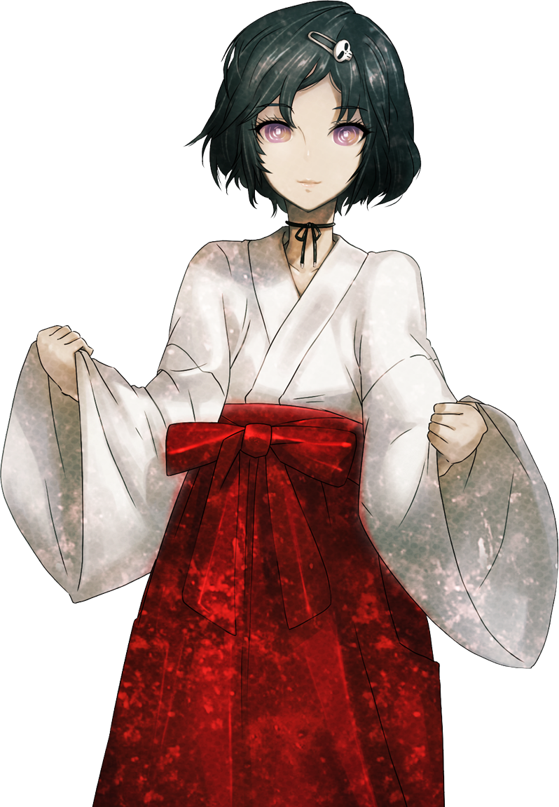
There was also the matter of the thick smog that filled the air. Cigarette smoke? But it didn’t quite smell like the traditional cigarettes he was used to. There was an ash tray in front of the mirror, and a bottle of what looked to be wine right beside it. All things that were of no use to him, and made him think that this room might have belonged to someone rather important and imposing. “…English?”

Saving his words for the things he found most startling, it was the text on the few pieces of parchment in the room that caught his eye. And ‘parchment’ was certainly the word, for the quality wasn’t like the printer paper or notebooks he was used to. The paper was yellowed, less pressed, and scrawled upon it? English. There wasn’t a spot of kanji in the entire room. Nor were there windows for him to check outside.

Lingering a little longer than he was comfortable, he glanced at the name on the door’s inside, just above the star. It was a nameplate, and using the English he had been taught in high school, Luka did his best to read. “Shiruvi… Rumieru?” Of course, since Japanese was his first language, he didn’t say it entirely properly. But that sounded like a woman’s name, which certainly made sense considering the small closet in the room’s back appeared to be stuffed with various dresses.

Again, like with everything… They didn’t seem to be all that modern?

But as had been the case with the girls in the Secret Gadget Laboratory, Luka had been caught up in an explosion of energy caused by the time machine. He had been launched not only into the past, but into a different country. This wasn’t modern Japan. It was Europe, and in the early 1700s to boot. That certainly explained the lack of electricity, as well as how old-timey things looked to be.

This was something that Luka would realize, but doing so would come with a cost. Like his peers who had ended up in different times before him, he would slowly become assimilated into this time period as an individual of said time period. But rather than realize, technically? It was more like the reality of his situation would be ‘this is the 1700s’ while he completely forgot about the future. In fact, the assimilative process had already begun to pay dividends.

Luka was just completely ignorant to most of them.

For example? Ever so strangely enough, beneath his shrine maiden-like attire, his nipples looked all so slightly more engorged than they normally did. Rather, they were expanding so that they ultimately looked like little rosebuds, and from that point on his chest pushed forward with new mass. Not substantially so – not by a long shot – but it was most certainly enough to shape them into something blatant. An attribute that wasn’t typically associated with the bodies of young men, for they belonged to the fairer sex. Luka had grown a pair of A-cup breasts, unknowingly pushing him closer to his desire of being a girl.

“Mm? Is something… wrong?” He couldn’t exactly place what it was, even though the case was the feeling of his engorged nipples rubbing up against the underside of his outfit. Like a woman’s, they were naturally much more sensitive than a boy’s, and he was feeling this in a way that left him initially befuddled.

What’s more, discomfort was continuously amplified as far as his outfit was concerned, which was alarming in the sense that it was an outfit he wore each and every day. It had gotten a little tighter around the waist. Not overly so, but there was definitely more tension around his hips. Because said hips had widened just a little bit. As had the rump housed between them, becoming slightly perkier with the excess seeing Luka’s thighs soften as well.

Now, if this sounded like it was all contributing to an already perceived femininity? That was because it most certainly was. Even looking at his hands and feet. Fingers shortened and became even more slender than they normally were, with nails just a little longer. Luka’s tootsies underwent a very similar metamorphosis, with heels smoothing and toes shrinking ever so subtly. It wasn’t a significant change regardless of hand or foot, but it did enough to suggest what was clearly obvious at this point.

That Luka was becoming a girl.

“Ah!?” While these transformations seemingly made a point to keep the subjects oblivious to what was transpiring, the boy couldn’t help but let out a gasp, responding to a sharp tugging between his legs that forced slenderer fingers to grasp the front of his costume. “I’m… a girl!?” She indeed was. Her dick was gone, a girl’s counterpart replacing it just as quickly. It was shocking, but there was something else in her voice. Joy? Elation? She had always wanted this! She had always… Had she not always been a girl?

Believe it or not, flipping the switch on Luka’s biological sex was only one step in a several step plan. Now that he had become a she, step 2 came into play. One that saw her personal background repurposed so that she fit better into this city and country. To that end, streaks of blonde had begun to pop up amongst the locks of her hair. Platinum in sheen, while it almost looked like these streaks were dyed, the fact that the color seeped into her scalp indicated that they were, in fact, the product of an all-natural color.

The length of this new blonde came to tickle the base of her neck in the back, the hairclip that pinned her bangs sliding undone as the hair in the front fell down like curtains that dangled on the sides of her eyes. It gave her a more mature look, one that was heightened by thinner brows of blonde and fur above her pussy that was shaved into a strip.

“Sylvie…?” For some reason, her attention had been drawn back to the name by the star on the door. Not only did her voice sound a little deeper, but she was now reading the English flawless and without the accent of a girl that spoke it as a second language. In fact, she could read the many posters scattered about the room. Detailing shows and singers, while in her head? Her thoughts were being processed in the same language.

As this language transition transpired, a culture change of similar intensity affected her face. Her lips became fuller, for one, but her eyes similarly grew. Bigger, rounder, notably without the pinched corners so typical of East Asian races. She was left to resemble someone of Caucasian descent – European considering the town she was in. While the colors of those eyes turned to a grey. Grey, with very long lashes. With broader cheeks, there was something about the look that almost made Luka appear older. Not like a girl in her mid-teens, but like a woman in her twenties.

And her body’s figure, gradually, would come to agree with that assessment.

Luka herself had become rather far-gone when it came to her identity. The history that her memories spoke of were not of a Japanese boy with gender identity issues like they should have, but instead she remembered being born and raised in a different part of the world altogether. She had suffered, lost, and from the ashes had been gifted eternity… or something to that effect. Truthfully, the girl herself did not notice the difference. “Do I need to get ready… for something?”

The fit of her shrine maiden outfit was rapidly imperiled on several fronts simultaneously. Among them was her height, which was elaborated upon vertically thanks to growing limbs and a lengthening torso. Before long, the crimson of her garb has been pulled down to her hips, leaving loose white to just barely hide her navel. But even then it was ultimately hoisted high enough to show off that bellybutton.

Hoisted because the small breasts she had developed only minutes before had swollen with no shortage of significance. It was such a quick process that yielded such ample results that you could almost say they ballooned, really. For pushing and unfolding the front of her robe, cleavage spilled out, revealing a pair of perky, D-cup tits that better suited the natural, more mature beauty that her face and height suggested. And really? Looking down at them, she didn’t find them shocking. She just thought her clothes looked a little… strange? Her new assets actually gave her a huge confidence boost.

One that grew even greater as her figure, well, grew even greater. Hips swung wide, loosening crimson so that the skirt fell from her hips to reveal the boys’ boxers she’d been wearing underneath. Except they didn’t really look to fit properly with the more mature sway of her gait, nor with how the legs of the shorts suffocated thighs that swelled to an overabundance of thick, soft, meatiness. It was naturally enticing, and its weight pushed her hips even wider – so that legs could rest more comfortably with her knees tilting inward as a result.

And so too was her rear end blessed with ample abundance, cheeks swelling within boxers that had been afforded no choice but to tear at the sides thanks to the expansion within on all front. Pale, fatty tissue poked up and over the cusp of her boxers’ waistband, and by the time her figure had fully formed? Well, she looked like an adult woman who had put on an outfit that was six sizes too small for her.

“What am I…? What country is this outfit from?” A discerning eye (thanks to her new personality and background), could tell that those clothes were not of European make, and yet? She was left wondering what she had been talking about not even a moment later. For her ill-fit costume? It had been replaced by a black cocktail dress with open cleavage, complete with matching heels, a mink scarf, and golden earrings. It was an outfit that was considered high-fashion for the era she lived in, and most women couldn’t expect to own such luxury items without a steady flow of sizable income.

When all was said and done, Sylvie Lumiere gently smacked the ear on one side of her head to give her noggin a little shake. It was a crude gesture, but one she thought was necessary to help alleviate the off feeling that she had been subjected to so suddenly. “Now, now. Tonight of all nights isn’t the night to feeling unwell. Not if I’m going to make a name for myself.” Looking to steel what she interpreted to be nerves, she reached for the open bottle of wine by the mirror and took a hearty chug.

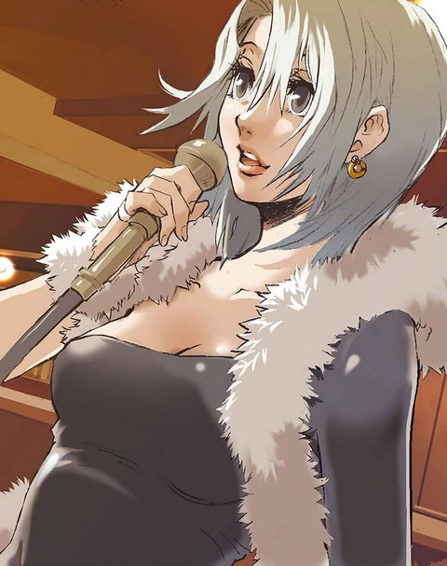
Tonight was important because of a member in the audience. She was a singer, or at the very least she had recently become a singer. This and that happened, and she had opted down this career path while she laid low for a while. After all, she had literally all of the time in the world thanks to her status as an Immortal. It had been a few months since she had started out, and she was just now beginning to gather a crowd at the bar she had started singing in.

And tonight? Well, a big-wig from the local singer’s guild was in attendance, undoubtedly having heard rumors of her from the other patrons. If she could impress him, well? Her career would definitely take off. Sylvia had it all, really. A beautiful voice, a beautiful face, and a smoking hot body. Every day as of late, she thanked the heavens that she had been born a woman.

All of the suffering she had endured as a result notwithstanding.

“That’s better. I’m not sure why I got so rattled.” Sylvie had been doing it for so long now that she didn’t normally get so worked up, but in truth? She had only felt that way because Luka’s anxious personality traits had lingered a little longer than they had been welcome. Piecing herself back together now, she took reassurance in the sight of the black cocktail dress she was wearing. It showed off a generous showing of cleavage, and her fur scarf drew attention to those girls of hers. “I’m giving them more of a show than they deserve, honestly.”

“SYLVIE? ALMOST TIME!”

A voice called from beyond her door. The bar’s owner. He’d been such a sweetie to her while she had gotten her career off the ground. She was beyond thankful. But this was all rather bittersweet in the end, too. Because she was immortal she would one day have to move on from this place. Eventually people would start asking questions, and then perhaps she would have to start her life all over again. But she had other goals in the pipeline too. Plans she now had an eternity to see to fruition. Plans of revenge.

Revenge on the one who had killed her boyfriend some five years ago.

