COMBAT ENHANCED
COMMISSION STORY
BY CHALDEACHANGE
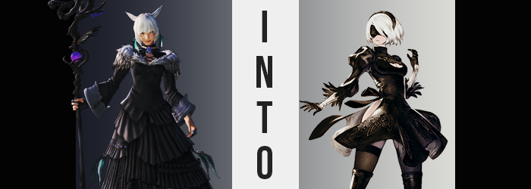

The lull following the defeat of the Endsinger and the end of the Final Days was a welcome one for most of those who lived upon the planet of Hydaelyn, known to those who knew the truth as ‘Etheirys’. For most of those alive in the current era they had been born into the looming threat of the end, with the Garlean Empire as an ever persistent threat that tore nations apart in pursuit of conquest, and terrible monsters like the Primals sundering the little peace that remained.

But now the Empire was no longer a threat to anyone and the Final Days could no longer take place. Humanity had wiggled itself free of the maws of a fate that had been predetermined since the days of the Ancients thanks to the efforts of the Scions of the Seventh Dawn and the Warrior of Light who had been counted among their ranks. Many things had been sacrificed and plenty of lives had been lost to reach this point, but ultimately there had been no other way.

Heroes had risen in the midst of it all but had then disappeared soon after. The Scions themselves were a good example of this. While the members still operated individually, the organization itself had been snuffed out now that their purpose had been fulfilled. Each body that had operated under its banner had their own wants and goals, and for the first time in a long time they were finally able to pursue those things.

Y’shtola Rhul’s goals were a product of her journey as a Scion though. “Very well. I’ll remain here to continue my research for the time being, let me know the next time you’re in Sharlayan.” She gave the Warrior of Light a nod as the exited the small research space that the Miqo’te scholar had been using in the nation of scholars. It was a room filled with books she had reserved for her research – research on how to traverse between the Source and its reflections on a whim.

The Warrior of Light had been in town on business and had sought the woman out. They were old friends and allies after all so there was nothing strange about them meeting to catch up on their experiences. They fully supported Y’shtola’s efforts, knowing full well that the woman wanted to reunite with Ryne, Lunar, and all of the other friends they had made on the First during their stay.

But their meeting had been a short one and they had recently left, leaving the Miqo’te alone to her own devices in her small and cluttered space. It was a room she had rented from the library, allowing her to keep all of the materials she needed in the same space. But it was just a small room that was lined with shelves with a table in the center; there wasn’t really all that much space to move around.

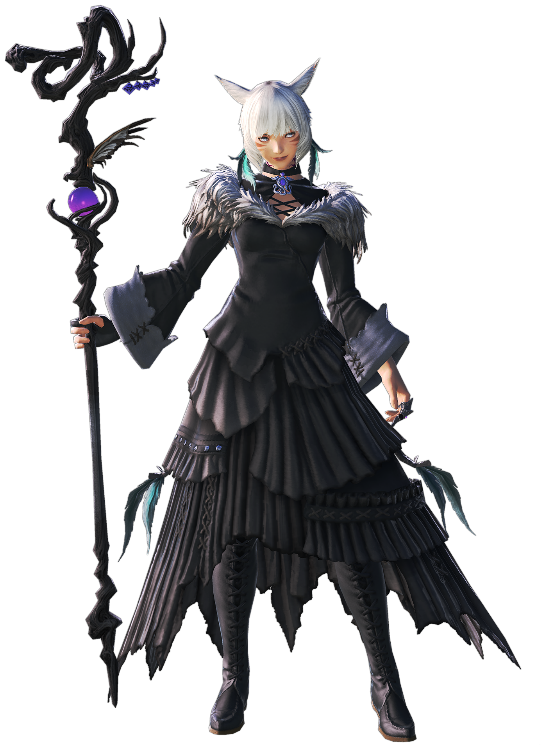
Even though it was cramped and seemingly chaotic at a glance with books and papers scattered about, Y’shtola knew exactly where everything she needed was. That was why that, even in the corner of her eye, she could tell that something was out of place after the Warrior of Light had left. “Hm?” She strut over to the opposite side of the table where they had been sitting, noticing something on the floor. “They left something behind? It must have fallen out of their bag.”

Was it Allagan technology? It was a small, square box with a number of buttons on it. It didn’t match anything she could think of, but they had seen futuristic devices like it in Allagan locales. If it was a remote then it was likely made to control something and required a signal to do that. The chances of anything like that being nearby was next to impossible and so in all likelihood it was probably something that her friend had just been holding onto.

Because of this she didn’t exercise very much caution when she reached down to pick it up. “I will just return it to them the next time they—” Her thumb pushed into the biggest button on the remote, and the very moment she had? Well, something unbelievable had happened; there was a reason she hadn’t managed to finish her sentence.

Y’shtola had disappeared.

It was strange. The sensation that had followed was reminiscent of when she had been brought to the First by the Crystal Exarch; like a pull between worlds themselves. Emerging on the other side provoked recollections of that experience in other ways as well. Being surrounded by an unfamiliar locale. Being naked. Evidently much like her experience on the First, whatever had brought her to this place had not replicated her clothing upon arrival.

“Well this is curious.” She was surrounded by tall buildings not unlike those they had seen in Emet-Selch’s recreation of Amaurot although these ones were old and worn down. Many were cracked and grown over with vegetation while others had collapsed entirely. Even the streets themselves had been grown over. “Was it the device, or did someone bring me here? I suppose I need to…” Y’shtola trailed off a moment before finishing her comment.

“…Contact the Bunker.”

Shock was evident across Y’shtola’s facial features as she paused, fearful of saying anything else initially because she was fearful of that trend continuing. The trend of her saying something she hadn’t intended on saying. The only expected thing to say when being suddenly thrust into unknown circumstances like these were to try and figure out where she was and how to return. But contact the bunker? She didn’t even know what that meant. Was it a place? An individual? Where or who was it?

Though things were a touch more dire than she had initially realized. Something was wrong with her mind, and of course an intellectual scholar like this Miqo’te would take a great deal of issue with that. But she also needed to worry about her physical body if the coloration of her skin served as any indicator. While not exceptionally so, she typically had enough melanin to her skin to present her complexion with a light tan. But that was fading, making way for a pinkish pale from head to toe.

While the whisker-like markings upon her checks were sacrificed all the same.

Even if the woman had noticed this change in pigmentation early on however, she wouldn’t have realized a second truth about it. While her skin was still in a very technical sense, well, skin… It wasn’t biological but instead an artificial mockup of skin. If you shot her with a bullet or sliced at her with a regular blade now, her skin would not so easily be pierced nor slice. It also lacked the potential to bruise or blemish.

Mind you, this wasn’t the only aspect of her physical form that had changed both in color and durability. Already a silvery color itself, Y’shtola’s hair lightened just like her skin had. And much like her skin, its qualities changed in order to become more synthetic. Hair that wouldn’t easily burn or cut, but also hair that would never grow naturally. It did grow briefly in that moment however in order to present the woman with a fluffy bob that stopped just above her neckline. But it was still hardly a change from her usual hairstyle, maybe aside from bangs being thicker with a leftward sweep.

“My situation… I need to ascertain… but my data…?” By the time the scholar finally managed to find her voice once more, the words that spilled out had become erratic to say the least. She couldn’t seem to quite grasp what she wanted to say, a side effect of what was happening to her mentally. Her brain felt jumbled? Like thoughts and memories were being compartmentalized and filed away. Which sounded like a strange way to describe the thoughts and memories passing through someone’s brain.

But what if what was in her skull wasn’t technically a brain? Or at the very least that brain was being converted into something else. Brain matter had been hardening inside her skull, wires and chips taking shape to compose a small computer where a biological brain had once been. This rewired the surrounding area, and you could definitely see it in her eyes. Not only did their worn silvers begin to glow a bright blue, but they glazed over in a way that made it seem more like she was gazing through a pair of camera lenses that just so happened to resemble eyes.

Which was exactly what she was doing.

Her facial structure had begun to differ visually, with narrowed eyes and a rounder jaw shape. But there was a curious thing about her skull and, well, all of her bones. The more the transformation wore on, the less they actually were bones. They had been hardening into a steel of great integrity, making it difficult to break much less dent this new frame of hers. Of course it wasn’t this steel frame that ultimately made her lips so thick, glossy, and enticing. Considering her body was becoming more and more like a weapon one had to wonder just why a side effect of this transformation had bestowed a greater beauty upon her face, actually.

A great warmth was spreading throughout her body that initially didn’t feel all that dissimilar to arousal, but the longer it permeated throughout her ‘flesh’ the less it actually felt that way. “I… I am… My mission…?” The digitization of the woman’s brain stole away any hope of her thinking critically about her situation, preventing her from taking note of things like how her voice sounded deeper and oddly alluring.

The warmth that had spread was just communicating her transformation to other regions of her body, through blood that wasn’t necessarily blood any longer. It had changed in nature into a similar fluid that was meant to replicate a human’s blood, even passing through a beating pump where Y’shtola’s heart had once been. But this liquid did not keep her alive so much as it did keep her cool. It was a coolant meant to prevent her body from overheating and in a way the immediate changes were a way to alleviate any heat her body did create.

You could dispel hot temperatures easier through a greater surface area, right? Perhaps that was why her thighs and ass grew in their abundance? It wasn’t even a little bit of abundance, either. The woman’s thighs ballooned in width, artificial skin pulled tightly around upper legs that jiggled to essentially twice the width of her waist each. Rather than press up against each other between her legs though, her hips were forced wide by the girth of a bubbled, heart-shaped ass that would certainly clap with each step.

The heat her body was creating was easily exhausted through these areas and yet they weren’t even the only placed that had grown to suit the purpose of heat exhaustion. While not quite on the same scale as her ass and legs, Y’shtola’s bosom swelled a little as well. A singular cup size stretched while it became warmer and cooler again, clearly helping regulate a body that was much hotter than it should have been. If it had been a human body anyways.

As her ears flattened against her head and detached to become a black headband (while a suitable pair of replacement, human ears appeared on the sides of her head) there were plenty of questions to be posed about the scholar’s current form. She clearly wasn’t human internally, so why did she look like one? There must have been an easier way to design a weapon than by giving it a form nearly indistinguishable from that of a person. That said, with her metal frame she was a lot heavier than she looked. 350lbs, in fact.

The hangups she’d been experiencing with her changing brain were becoming less frequent now that her body was almost completely transformed. Clarity was returning, but it wasn’t the same clarity that she had possessed before. Had she been her old self she might have questioned the feeling of her cat tail detaching from her back, much less the sight of it lengthening and hardening into a katana that floated behind her with rings of light keeping it in place.

And she might have questioned the sudden appearance of a new outfit. Yes, she was no longer naked, but what she was wearing was… interesting. A white leotard beneath a decorative, black dress with a cleavage cutout and exposed hips and thighs (to ventilate, of course). Thigh high stockings and black heeled boots of leather found her legs, once again highlighting just how girthy she was down there while elegant gloves covered what else was exposed of her arms. Finally? She became blindfolded by a black visor that ran past both blue eyes. Yet she could see through it?

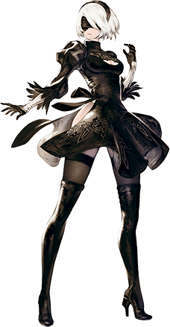
“Running a systems diagnostic. Searching for vulnerabilities.” Despite having a body that for all intents and purposes appeared normal, the woman’s words revealed the truth about what she really was. An android created as part of the YoRHa series to look exceptionally close to a human. Even though she looked the part, however? Yorha No. 2 Type-B or 2B for short was not a human. Her insides were all artificial, designs made to her body to make her stronger, tougher, and faster than any human could have ever dreamed of becoming.

Did androids have dreams of their own? That question wasn’t one that 2B was at liberty of answering herself. But she felt like she might have had something like a dream rather recently… That was because while she couldn’t exactly recall it, thoughts of her past life did linger in the back of her mind. Y’shtola had possessed dreams but she couldn’t remember what they were in this new form of hers.

“Strange. There is memory data I don’t recall having recorded before.” After scanning herself the android woman had found those lingering memories, in fact. Yet according to YoRHa protocol data stored in an android’s memory needed to be approved. Whatever was recorded there? It wasn’t supposed to be there. “Memory data deleted.” And now she would never know what had been recorded there, meaning not a single trace of her past life could have been found.

But it didn’t bother 2B. Whatever data had been planted there? In her mind it must have been done so to distract her. It could have been a Logic Virus or something from the Machine Lifeforms that it was her job to hunt. It was better in her mind that it had been deleted, not knowing just how important it should have been to her.

She looked around the City Ruins through her visor. “Are Pod and 9S back at the Resistance Camp? I suppose I should make contact with them before we head to our next destination.” A location south of the Resistance Camp where Machine Lifeform activity had apparently been on the rise. It felt odd to not have her Pod at her side. Why had she left it behind? Memories of her purpose and past were clear as day while memories of the past few hours felt unusually groggy.

“I guess it doesn’t matter. Let’s just get to work.”

