BOTW: WITHOUT BLESSINGS
CHAPTER 2: FREE AND FEATHERY
BY CHALDEACHANGE
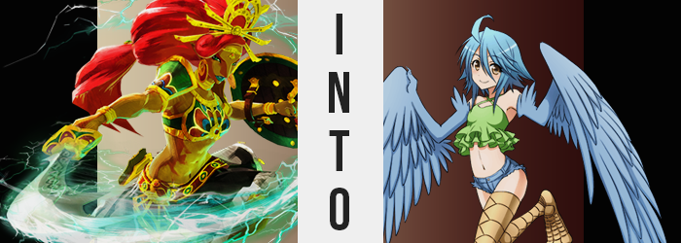

It was only natural that Urbosa would feel panic after the situation she had been thrust into. Calamity Ganon had returned, sooner than expected, and before any of the Champions could get back to their Divine Beasts, an unforeseen enchantment had spirited them away from one another – although none of them knew where the others had been sent in the first place.

For the leader of the Gerudo, she at least recognized the location she found herself at, although it was not one typically illuminated by a sky of crimson above. “Birida Lookout?” The highest point of the lookout, in fact. It was a location that looked over the entire Gerudo Desert as well as the village that she had been born and raised in, however perhaps thanks to Calamity Ganon’s influence, a terrible sandstorm had been whipped up below.

In Urbosa’s mind, it could have been much worse. It was something of a hike down, but she hadn’t been sent all that far from her Divine Beast. She could make progress much more quickly than if she had been sent to the other side of Hyrule, but she hoped that the continent’s people could hold out until the Champions were able to reach their weapons in time.

More than that though, she worried about the little princess. As a friend of Zelda’s mother, she had taken it upon herself to watch over that child through the thick and thin. She must have felt so bad after not awakening her powers at the mountain, and now that they were separated? She could only hope that the maiden was still at Link’s side so that he could protect her. Which she wasn’t, but Urbosa couldn’t have known that.

“The sky… There is something strange about it.” Perhaps it seemed as if the Gerudo was just stating the obvious, but there was more reason to this comment than there might have seemed like at first. It wasn’t merely the color that she was referring to, and in fact there was something else it was giving off. An aura? An energy? She did not have the exact word needed to describe it, but whatever it was, it was bringing the hairs on her body to stand on end.

Urbosa’s skin was tingling fantastically under its light, and as a result she paused as opposed to making her way down the cliffside immediately like she had originally planned. If there was a risk present, she would be doing herself a disservice by not addressing it – a disservice that would apply to Hyrule if she fell before she could activate the beast. But run or remain, the outcome would have been the same for the Gerudo woman.

“Hm?” For a member of the Gerudo tribe, their overwhelming size was one of their key assets. Any who knew of their people knew of their overwhelming stature, and that was what made it all the more obvious that Urbosa’s height – a height well over six feet – had begun to diminish as if to steal away some of her greatest pride.

There wasn’t exactly anything discreet about it in the first place, but Urbosa’s mind? To nullify much of the shock, the mental changes bled in like a comforting fog, lifting her worries even if the woman did take notice of her point of view fading downward atop the cliff. Whether it was her arms, her legs, or even her rippling torso, it all shortened with purpose, and that shortness ultimately brought a number of issues when it came to her outfit.

Because for her regressing height to not appear too strange, that meant that her horizontal size would naturally shrink as well. Shoulders narrowed, as did her hips. And all of the mass on her body? Well, it was left little choice but to lessen as well, with bulging biceps and thick thighs retaining their proportional mass, but still thinning some to suit her new frame even as her body continued to drop well beneath the 5’5” mark.

“Something… is not…?” Urbosa struggled to grapple with the situation as the sound of jewelry clanging against sand and rock below filled the air. With limbs thinner, golden bangles and pauldrons rattled onto the floor, and even the mighty headpiece she wore slid off her head – because her head was smaller as well. The chest armor she adorned around her bosom even looked to empty, and its hefty gradually became more and more inconvenient, while what robed her lower half ultimately hung on to her hips with very little to bind it in place.

Now shorter than 5’, another five inches were lost from that point on so that she was a meager 4’7” – a far cry from the statuesque design she sported typically. Her appearance beget that of a child, and truthfully? That seemed more and more like it was the case in the end. Her face, you see, had been slowly rounding as she had shrunk. Urbosa had also adopted a fairer jaw, and lips painted blue that were always so abundant upon her features had subsided so that they were pronounced, but not with the excessiveness they had been before.

That really appeared to be the overall trend, that less was somehow more. Because as her towering Gerudo figure had become meager, so too did her build. The muscles, the other key aspect of her race traditionally, thinned until her body appeared incredibly fragile. The only real trace of any strength left was in a tummy that still sported some tone, but it was nowhere near the rippling state that it had been before.

And just as she had softened, so too did her curves thin. Breasts that were once proud and perky, DDs upon a pronounced frame, slowly deflated until they were little more than lackluster A-cups. By this juncture her chest armor looked poised to slide off her shoulder, for the only part still bound to her body was the golden straps that sat loosely on her shoulder. What was draped over the girl’s hips wasn’t so lucky though, and cloth fell to expose her bare butt.

“Urbosa feels… Mm?” The Gerudo’s voice sounded much higher now, and the decision to refer to herself in the third-person spoke to the effect that the phenomenon was having on her mind. The thick fog that had rendered her oblivious was twisting her personality as well, with her keen intellect and maturity dwindling away with each passing moment. It was getting hard to think critically, and so her shortness hadn’t even really struck her. From Urbosa’s point of view wasn’t she supposed to be this small? And feathery?

…Feathery?

That sounded like a strange adjective to use, and yet it wasn’t inaccurate either. Blue plumage began to erupt up and down her arms, quickly coating them with soft and downy feathers, while her fingers? Aside from her feather-covered thumbs, they all merged into a single extension that ultimate hooked into what was clearly a wingspan. Urbosa’s posture was forced slightly forward as a result, and long, blue feathers soon stretched from her appendages to grant her a pair of wings for arms. Wing that had cute, little, clawed thumbs. You know, for grabbing things somehow!

What she couldn’t grab with those ‘hands’ would have to be grabbed with her feet though, and to those ends there were changes in her feet – and the attached legs – as well. Starting from the base of her tanned thighs and down to her tippy toes, her skin hardened and lightened into a light golden color. Utterly dry in appearance, an indented pattern of darker bronze demonstrated what was expected: that these were in fact the legs of a bird.

“Whoa~!” Her changing balance provoked an air-headed exclamation of surprise, and it sounded more than a little ditzy. But it was for a good reason. As her feet took on traits similar to her legs, toes fused together so that she had three per foot, and their tips sharpened into razor-sharp talons. But the Gerudo’s heels also rose so that she balanced on toes alone, feet essentially becoming tarsometatarsus bones that were typical of avian species. Since birds walked on their toes, this portion of the leg was always raised to make things easier.

No longer able to bear the weight of her armored chest piece, the bird girl leaned forward in an attempt to shake it off over her head, only to realize it was getting caught on her wings. “Why won’t it get off Urbosa!? Get off, stupid!” It inevitably spiraled into chaotic flailing as she tried to free herself, panicked gestures just as childish as her words. “Off! Off! Oooooff!” Through a stroke of luck she bumped into a large boulder behind her, and it knocked the clasp in the back so that it fell off and revealed her bare chest. “Much better!”

When had she put that on? She couldn’t really remember. But with her body bare, it was easier to see that a change of color had come for her tanned, Gerudo skin. A white so pale that for a time she almost appeared to be speckled, yet those spots swelled and merged so that they inevitable created an even coating of color across anything that wasn’t feathered or otherwise bird-aligned.

A blue that was more vibrant than her feathers also found the red of Urbosa’s hair, painting it with a color that was much more complimentary to her overall aesthetic now. It even colored the hair above her crotch, and her eyebrows! But that wasn’t all that happened with her hair. For as if a pair of magical scissors had suddenly lopped it off, every strand of hair that was longer than her shoulders was chopped right off, with the severed portions carried by the wind. What remained? It was styled messily, with a thick tuft of it pointed upward in a silly way above bangs that were fluffed to the sides.

The bird let out a little sneeze. “ACHOO!” Not because the sand being thrown about midst the burning sky was bothering her, but because her long, sharp Gerudo nose had narrowed and flattened, becoming one much more in line with the Hylian race. It was cute and petite, and made the rest of her youthened face seem brighter. That said, eyes that widened and took on a golden glow certainly helped things in that department too.

“Huh? What was Papi doing?” Tilting her head, ‘birdbrained’ wouldn’t even be a potent enough term to use to describe just had dumb the once proud, strong, intelligent, warrior woman had become. Her flesh and blood now that of a cute and youthful harpy, Papi was more interested in how pretty the red sky looked than anything. She just couldn’t keep her eyes off of it!

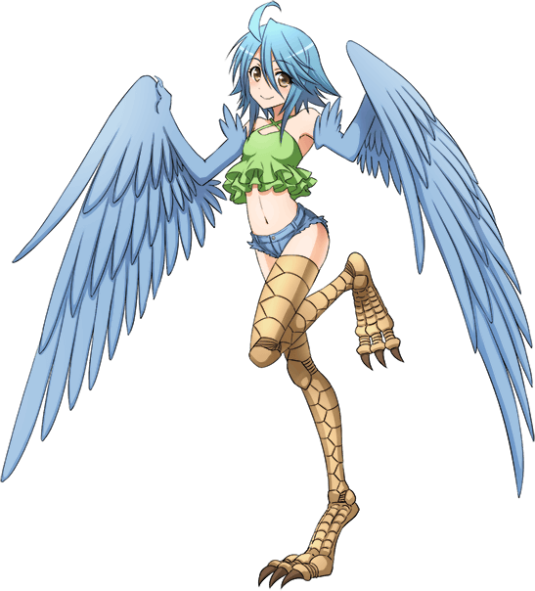
Nothing really seemed to bother the feathery fiend. Not the ominous color of the sky, the temperature of the lookout, or even the fact that she had been rendered naked. It didn’t make any sense for a monster to wear clothes, right? And she was very much a monster! …Well, if she could find some rags to put on later, she probably would. No one wanted sand stuck in places where the sun didn’t shine, after all.

Unlike the Nereid on the east coast, Papi was not stirred into a frenzy by the crimson light above. That was meant to make the monsters unpredictable and wild, but this harpy? She was so stupid inherently that she already had these traits baked into her psyche. Sure, she might not attack anyone for the sake of killing them, but she would undoubtedly make some poor soldier miserable by bothering the hell out of them.

