DRAGON FORCED
BIWEEKLY STORY #94
BY CHALDEACHANGE
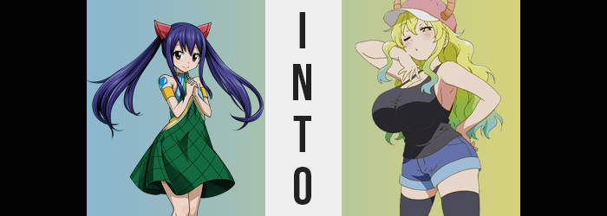

There was no shortage of adventure for Wendy Marvell since she had joined the mage guild, Fairy Tail. And honestly? She couldn’t have been happier with the new life that she led. Surely it was a life that had possessed its downs, and on more than one occasion she had most certainly believed that she might have died – or been unable to prevent someone else from dying. But in the end? The good very much outweighed the bad.

You see, Fiore was a continent populated by magic users. Those with the talent to do so could take up a specific type of magic and dedicate their lives to perfecting it. Typically, magic users gathered under the banners of guilds in order to complete jobs and quests that could take them all over the world. It could be as simple as rescuing a cat from a tree, or as dangerous as fighting terrifying monsters.

Wendy was young, only around the age of twelve or thirteen, but she was a treasured member of this system, nonetheless. Her magic, that of the Sky Dragon that had taught her, was powerful. It specialized in buffing and healing, but Sky Dragon Slayer magic had a number of useful combative spells as well. She was young but extraordinarily talented.

While she could wield the magic of a dragon though, she wasn’t actually a dragon. There had been the threat of such a thing happening at one point, but with the defeat of Acnologia and that particular story closed, it seemed that the threat of such a thing ever happening had been ended forever.

…Or had it?

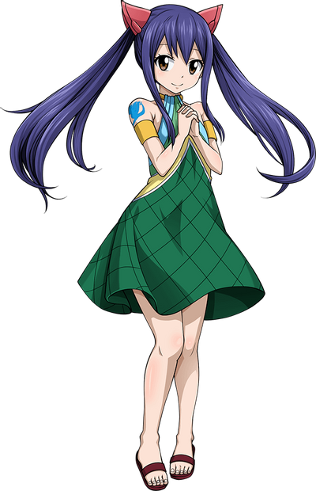
“Hmm… Lucy said she’d heard there might be treasure around here, didn’t she?” Another day, another quest. And in this case, it was only the girls of Team Natsu that had opted to embark on it. Promises of treasure and a substantial paycheck had led them to some newly discovered ruins not all that far from their hometown of Magnolia. How they had gone undiscovered all this time was a mystery. But the promise of treasure appeared to have been founded on truth.

The three of them – consisting of Wendy, Erza, and Lucy – had all split up to explore various corners of the ruins. The monsters that populated them had been low-leveled, and any of the women were more than capable of taking care of themselves in this case. If they were to get separated, Wendy’s superior senses would have no trouble reuniting them as well.

Much to the young teen’s surprise, there really was a treasure down the path she had chosen! Hoisted on a pedestal was a strange, bejeweled egg that almost reminded her of a dragon’s egg. It had a gradient of color, starting with a bright green on the top and gradually sweeping down to a greenish blue on the bottom. “There don’t seem to be any traps…” She was judging this based on a spell she had cast to scan for potential problems.

Was it really unguarded? Why? It appeared to be valuable!

Wendy was still skeptical, but she climbed up onto the podium to grab the egg, n0netheless. The moment her hands wrapped around the bejeweled egg’s exterior, though? It gave off a bright light, and an uncanny warmth jumped from it and into her hands. “Huh!?” She stumbled back down the steps she had climbed, forced to look away from the light. But by the time it had waned? Her attention was drawn more in towards herself. She felt… odd.

Warm? Was that all she felt? She couldn’t really place a finger on it exactly. But she also felt stunned, utterly incapable of casting a spell that might dissuade the power affecting her, much less run off to get help. “I can’t really… move?” Either of those options would have been more useful than standing there doing nothing, but she was incapable of doing either. She could really only move her head, after all, and this wasn’t sufficient enough to do anything but talk or observe.

While she was frozen in a standing position however, she still suddenly found her posture to be a little shaky. “Huh!? What’s going on!?” She felt unbalanced, and yet while she couldn’t put her hands out to the side to keep it maintained, there still didn’t seem to be much of a risk of falling over thanks to the force that kept her paralyzed. It took her a moment, but Wendy did eventually understand why she felt this way. “Wait… Am I getting taller!?” Little by little, she seemed to be looking down further at the steps that led to the crystal egg.

She was growing taller, and that in itself explained some of the strange feelings that had washed over it. Like the fact that her body itself felt tight, with skin and flesh feeling like it was being pulled. Also the fact that a cool breeze now tickled her upper thighs, which were usually covered by her skirt. But with her body taller, that skirt had been hoisted so that even her white panties were exposed.

Wendy’s height, ultimately, peaked at around 5’8”. This was essentially an extra foot of height, and while the girl had always dreamed about being taller, she hadn’t expected it to happen like this. Only able to look down, she could tell just how much bigger she’d gotten. But to prevent herself from looking like a piece of lanky tree, she had also gotten wide as well. Both shoulders and hips had been parted, with her waistline looking rather thin comparatively beneath where her dress was sitting upon her tummy.

“No, I didn’t just get taller, did I…?” Observing her chest a moment, didn’t it look bigger? Had she been able to examine her rear, she also would have gotten the same impression. Or if she had even had a mirror to see her face. But she was most certainly older, now resembling a young adult rather than a girl that almost seemed like she’d never grow out of her childhood. But if this was true… “Do I really only grow this much!?” If she really was an adult now, then the disappointing showing of her chest was even more depressing!

But why had the egg made her older? Wendy didn’t really understand, and she was growing increasingly concerned that someone would find her paralyzed like this. After all, because her butt and hips were bigger, her small panties were struggling to not get sucked up by her butt crack. And her breasts? While they were only a little bigger, with her dress so small compared to the rest of her body, those boobs were poking out from the sides. “I hope no one finds me like this…”

She actually had more important things to worry about, the (now) young woman just didn’t realize it yet. Her Fairy Tail marking on her right shoulder had disappeared, and this was most certainly part of it, but… Something was very wrong with her eyes. They appeared more mature now that she was older, but it was actually their colors that were alarming. The right one had turned to a foresty green, which in itself was already odd. But the left one? Not only was it now glowing a golden color in the iris, but the irises around this gold had darkened to black. She was also having a hard time keeping those eyes open and was finding preference in squinting – without thinking much as to why.

There was also the matter of Wendy’s hair. Her blue locks were not only lightening but growing amply. They fluttered down her lengthened back, growing wavier and wavier as they did so. In the process, the color of that hair became layered. Blonde near the top, green in the middle, and almost a turquoise near the tips. It was a hair color that Wendy would normally have freaked out if she had seen.

Yet she was beginning to feel somewhat satisfied.

“Actually, this feels kind of nice, doesn’t it?” Through swollen lips comparable to those of a porn star she had uttered these words, oblivious to how her face was no longer recognizable in general with its egregiously forced, natural beauty despite still being quite soft. Even her voice bore a sensual deepness that hadn’t been there before. What had once been shocking had become something that she was beginning to desire. And that included the emergence of a pair of horns from atop her head that finally knocked her hairclips out of place. Brownish-pink and flat topped, they curved upwards to indicate that this Dragon Slayer was now more dragon than human.

Caught up in the sauce, a purr practically cooed from the back of the woman’s throat as her once lackluster body began to develop into what she had desired – no, what she deserved. Her hips were pulled to double their original girth, snapping the waistband of her panties which then fell to the ground, exposing a bush of blonde hair above her pussy. From this point on, the surrounding area bloated with glee.

Her thighs amassed a great deal of, well, a mass. Plump and sensual, they became so ample that they passively touched each other in the middle even with her significantly wider gait, with knees tucked in towards one another. On Wendy’s backside, the same girthy aesthetic was applied to her cheeks, which bloated and bounced, and seemed to look pleasingly slappable. While Wendy might have normally been ashamed to have a body so lewd, much less to be so revealed, she found herself feeling more and more into it as things continued.

“Yes, make them big! I don’t mind showing them off!” With a declaration that felt one part her old self, and one part the bold, provocative individual she was becoming, she squinted down with anticipation at her bosom. A bosom that readily met her expectations, with B-cup tits bloating so quickly that they tore right through the front of her dress. The woman herself began to tear the excess cloth away, it not even occurring to her that her ability to move had been returned to her.

Bigger and bigger those tits became, almost ridiculously so if you considered how they appeared relative to even her taller height. A 145cm bust was what she ended up with, and this meant that either tit had surpassed her head in size, with full and perky nipples that rivaled her eyes in size, poking up and to the sides. Wendy herself had found her hands kneading these massive mammaries, their keen sensitivity feeding an arousal of the likes she had never felt before.

Or, well, her new self had most certainly felt it before.

Despite all that had just happened to her, despite the fact that she had been transformed into a tall, buxom woman who just happened to be a dragon at the same time, a pleasant smile played upon her lips. “My, I feel great! Who knew you could feel so good?” She felt confident. She felt attractive. She felt powerful. All things that Wendy seldom, if ever felt. But then again? She was hardly Wendy any longer, short of some vague recollections that reminded her of the life she had once had.

Instead, lingering in her birthday suit, Quetzalcoatl or Lucoa as she more commonly went by, was left reveling in the life of the one she had become. Hands stroked her significantly ample tits with need, no longer the young girl who aspired to grow bigger one day in that department. Nay, she was now a woman who not only had all that she had ever desired, but she was also a woman who had no qualms about using these features to get her way – whether that was to scratch a carnal itch or exploit others into doing things for her. There was very little shame left in her mind, which was why she didn’t even bother to attempt to cover herself up.

Stopping short of masturbating in her temple, the dragon goddess recalled something from Wendy’s memories. That there were two other women in the temple at the time. “Oh! I suppose I could fashion myself some new friends, couldn’t I? Then we could really have some fun!”

