KEEPING TRENDY
COMMISSION STORY
BY CHALDEACHANGE
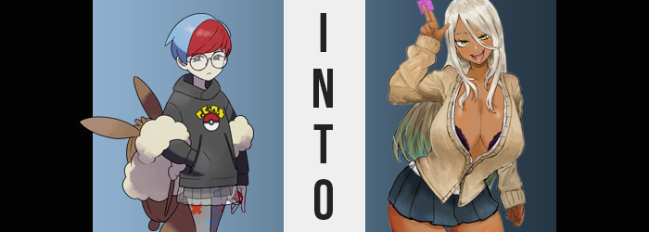

“Alright, talk to you later, sis.”

Hitting the button to end the call, Penny leaned as far back as humanly possible in her computer chair without falling backwards. “That… was stressful.” Dealing with her family was always stressful from her perspective. That was why she had moved to Paldea in the first place. She loved them but she needed to be away from them for her own sanity. Her father was just way too clingy and way too much! But it wasn’t like she had decided to go to school in Paldea for that reason alone. She wasn’t that cruel.

There just weren’t any schools as good as the one as she was attending back where she was born and raised. The Galar region had plenty of things going for it, but its traditional Pokémon League wasn’t at all integrated with its educational system. The same could hardly be said of Paldea. The League and the schools were completely intertwined and that was a desirable thing to Penny.

It had certainly made it easy for her to hack things in the past, but she had retired that particular aspect of herself. For her own safety.

So she had been in Paldea for a while now, living in the school dorms. She was as far removed from her mother, father, and older sister as she possibly could be and yet that didn’t prevent them from reaching out to her. Hearing from her mom? No big deal. Her dad? He could be a lot and often got on her nerves. Her sister, Peonia? Penny’s relationship with her was somewhere in the middle. She didn’t find her as annoying as her dad, but the two siblings didn’t have much in common. Penny took more after her mom than her dad after all.
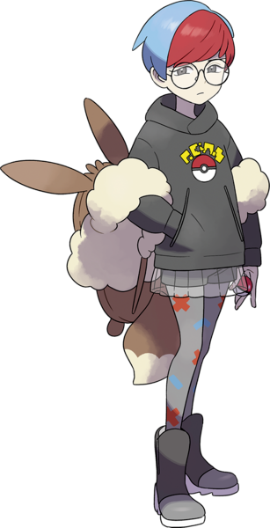
That didn’t stop Peonia from doting on her though, not even from a different region entirely. Her big sister was always worrying about her health and her fashion. Even in the phone call she had just finished Peonia was suggesting things the younger sister could do to ‘look cuter’ or ‘find a boyfriend’. These were things she just wasn’t interested in. She’d rather be comfortable than fashionable and there was nothing more comfortable to wear in her wardrobe than her usual hoodie, skirt, and leggings combo.

“Gyaru? I know that’s the fashion she’s into, but it wouldn’t look very good on me. After all, she’s the one who inherited dad’s skin tone.” Penny wasn’t even really all that familiar with it. She knew a little from things she had seen online, but from her experience it had a tendency to be associated with very unsavory things. It was fetishized pretty heavily, wasn’t it? But Peonia also wasn’t that sort of girl. Thinking about it a moment, she pushed forward on her chair again to run a simple internet search.

And unsurprisingly? A lot of the results had been blocked by the school’s NSFW content filter. “Yeah, it’s pretty lewd, right?” The girl felt validated in her assumptions. While the images that weren’t filtered out weren’t lewd in any capacity, there was a running similarity between most of them that she had already touched on. Tanned skin. Her dad and sister had melanin-rich skin but Penny herself had taken off her completely white mother.

Getting a fake tan was an option, but wouldn’t that be tacky? Plus most of these girls had clearly bleached their hair until it was a platinum blonde. Penny obviously dyed her own hair because there was no way to get an even mix of red and blue, but she had no experience with bleaching. Even if she could do it she’d look ridiculous with blonde hair. She didn’t need to see it with her own two eyes to know that much.

Not thinking too much about it because she was lost in thought, she continued to scroll down the list of pictures. Occasionally she enlarged one and then closed it. These were all still fashion ideas that didn’t interest her at all. Some of them wore colored contacts, a lot of them had their tits out as much as they could without getting caught by the censor. “I can’t believe Peonia dresses this way. People might assume she’s a slut.” Which was kind of a rude thing to even imply about her own sister, wasn’t it?

Well, a stray Rotom that had occupied the school’s internet agreed that this was a little rude. Rude enough to warrant karmic justice of a sort, and so it accessed some of the hidden images on the network as reference material. References that were then turned into data and carried through the Pokémon’s own electric shock. A shock that was delivered to Penny through the mouse she had been using, giving her quite a surprise. “Youch!?”

She practically leapt onto her feet. “Was that a static shock? What the hell!?” The girl was shaking her arm wildly to try and loosen up the numbness the shock had delivered. And that was part of why she seemed so upset about it. Static shocks shouldn’t have been that strong. You usually only felt them at the point of contact, right? It should have gone away as quickly as she had felt it.

And yet the feeling not only lingered but she felt it vaguely reverberating throughout her entire body.

“That… was weird? Is there a problem with my wiring?” If it really had been an electrical issue then she could sadly think of a few ways it might have happened. Her room was always full of loose fur for one, seeing as she was a staunch lover of Eeveelutions and kept hers out of their balls all of the time when she was in her dorm. It was possible that some of her Jolteon’s fur specifically had slipped past the fan and filter and was causing issues. “I feel really heavy though. I wonder if I should seek medical assistance…?” How would she explain this to Nurse Miriam though?

While contemplating her next steps, a number of discreet changes unfolded just out of her view. These changes would have been obvious had she gone looking for them, but since she was distracted by how she felt the teen didn’t necessarily observe these areas just quite yet. One of the most discreet was actually one she wouldn’t have been able to see without a reflective surface anyways. That being a change in the color of her irises to a golden yellow. The same eye color as her mom, incidentally.

But when it came to changing colors? Her eyes weren’t alone nor were they the most telling about what was happening to her. For someone who had just been thinking about how bad her hair would look if it was blonde, it was surely a bad sign that the red and blue hair atop her head was being dyed to a platinum shade of that very color. It was close to her sister’s hair color and, unlike the red and blue she’d had, was not a dye whatsoever. It was her new natural hair color.

Penny rubbed at her arm through the cloth of her hoodie, not paying attention to the hand doing the rubbing. Her skin felt a little tingly which she assumed was a side effect of the shock. And while this wasn’t untrue it was also far more than that. Even the visible fingers showed as much, although in terms of exposed skin her face was a more obvious canvas of note. It was happening to Penny’s entire body though: a darkening of her skin that eventually settled into a copper tan. Like her new, blonde hair coloration that was her natural color now, not at all a fake tan. And while not as dark as her dad’s skin it was still a little darker than her sisters.

“Huh?” An itching at the back of the teen’s neck had eventually guided one of these tanned hands past her shoulder. For a split second she had thought her fingers had looked a little odd as they’d passed her face, but she’d been too desperate to pull away the piece of fur or whatever was touching her skin behind her head. Only for her to get struck by an unusual feeling when she tugged it. “Ow!?” Why had tugging it hurt? Why could her fingers wrap around a lot of loose… fur? No, the fur of her Eeveelutions wasn’t this long?

It wasn’t until she pulled some of it in front of her that she was hit with a quadruple whammy. “What in the like, world!?” One and two: what she had pulled was lengthened hair (long enough to reach her ass now, likely) and it was platinum blonde. Three and four: her skin had a rich tan, and she had pink, stick-on nails all of a sudden!? “What’s going on here? I totally look like one of those gyaru gals!” Why… did that fill her with a happy feeling though? Was this pride?

She shook her head, disheveling long, loose blonde hair so that her bangs swung between her eyes. “Is this because of the zappy thingy? Wh-Why am I talking like some dumb, slutty bimbo bitch!?” As hard as Penny tried she couldn’t even stop herself! Complicated words just weren’t coming to her, and trashier dialogue was spewing out like uncontrolled filth. Was she getting stupider!?

“Woah!” Her body still felt weird, but this was the first time she’d almost fallen over without any warning. She hadn’t even taken a step! But reaching down to her desk to stabilize herself she was quick to realize. She didn’t normally need to reach down at all. Golden eyes blinked. She didn’t vocalize her awe but she definitely felt it. She was getting taller! It was only four inches or so, but it was more than enough to pull down her tights – which in turn yanked her shorts and panties down to her thighs, showing off most of her pelvis. Whereas her tummy was exposed as higher shoulders hoisted her sweater and undershirt.

This was weird? It was totally weird, right!? Makes it way easier to mount bigger dudes, though. What in the world was she even thinking!? Things that weren’t even all that out of place considering her memories. Penny looked older in the face. All of those features were accentuated and puffy. Memories were added and changed with her age. Memories of skipping classes to get laid, of the techniques she’d developed with her huge tits and plump thighs to get men to cum. “Mmn… This is totes making me horny. Er— What… am I fucking saying!?” And in such a husky voice to boot.

Her awareness of what she was saying didn’t change how accurate it was though. Her loins were stirring, but they’d widened from use without any real visual cue – her bush of pubes thickening above. Though in terms of thickening it wasn’t just that unkempt bush that was affected. Penny’s shorts were still caught around her thighs, but they felt tighter and so she reached down to scooch them off. “The fuck’s happening now? My thighs are looking real, damn plush! Wait… aren’t they always though? Just like my huge ass!”

Seemingly the corruption of her mind was coming along swimmingly. She wasn’t questioning her situation any longer, and so the sight of her tanned thighs tripling in girth didn’t phase her. She could remember wrapping them around the heads and dicks of men with that kind of kink. Just like all of those times she’d taken it in her now swollen, heart-shaped ass. It had all bloated to perfection, pushing her hips five inches wider as it had swelled.

Two scents wafted from her body now. One was an overabundance of perfume that seemed to appear just as thick mascara and eyeliner dotted her eyes, while lips become sticky and shiny. The other scent? It was clearly the scent of sex. Like she had fucked recently or at least masturbated. The perfume could only cover up so much, and that would at least explain why her skin looked oddly shiny with sweat all of a sudden.

“Better get this fucking thing off me too! Hup!” Faux fingernails slid under the bottom of her hoodie. Penny seemed to realized it wouldn’t fit on a subconscious level and so it needed to go. By the time she’d lifted it along with her top over her breasts, the breasts in question were already double their original size with nipples that were thick and puffy. Tossing the clothing aside, the slightest movement of her body saw those swelling, naked tits bounce. It became easier for them to swing about and jiggle as the seconds ticked on because they were growing bigger in size.

Nails dug into her tits and she twerked her only enormous nipples playfully. “Like, I really wanna give someone a big old titty fuck right now!” It would have been really easy to do seeing as the titties in question were K-cups, each mound far larger than her head to the point that they naturally drooped under their own weight. “Oopsie~!”

Penny’s hands slid off her lewd and trashy body just in term to be re-robed. The Rotom’s power wasn’t only replicating the lewdest gyaru visual and mental tropes it could find onto the woman’s body, but their fashion as well. A leopard print thong and loose, lace bra with low socks made up the undermost layer. But an open cardigan and dress shirt showed off her tits almost in full along with easy access for that titty fuck she had been talking about. A pleated, blue skirt that was so short that you could see the base of her panties even when standing properly made up the rest.

The absence of her glasses went unnoticed, but her eyes were still just as bad. She was wearing contacts now – she wouldn’t be caught dead wearing nerdy shit like spectacles!

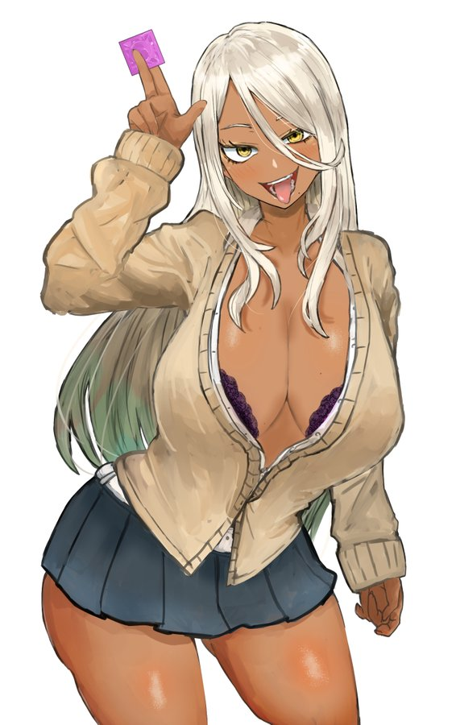
“O-M-G I am looking sooooo hawt right now!” Penny could no longer stifle the intrusive thoughts that had been bubbling up from her depths. They had grown stronger and stronger the more her body had changed, and now? The thoughts of her ‘old’ personality might have been the intrusive ones. For as much as, very deep down, she knew she wasn’t a vapid gyaru slut, the woman could not help what she had become.

She was older, now in her early twenties. Much too old to be attending the academy under normal circumstance, and yet the Rotom that had changed her had gotten up to additional nonsense in the background. It couldn’t change reality but it had changed her student identifications and records to match the new identity it had given her. According to the school she was now a twenty-one year old who had been attending for a very long time. Because she kept getting held back for failing.

To be fair, the school had other cases like this, and adults were welcome to enroll regardless of how old or young they were. “Oh, didn’t I like have a test tomorrow? Shouldn’t I study or something?” That would probably have been a good idea. She needed to graduate sooner or later, right? But in the end Penny simply shrugged. If she passed then she’d have to return home to her family, and her little sister Peonia couldn’t handle just how much better of a gyaru she was! Of course, Peonia’s memories were still the same. Everyone’s were. So she probably would have question who the strange woman was.

Which probably would have been an issue that would turn up in a phone call sooner or later.

“Yeah, like, why study when I could totes go for a good fucking right now. Just gotta find some smokin’ hot daddy to take me in for the night!” Seemingly the strained relationship she’d had with her father had manifested in a different way, and as a gyaru slut her favorite type had become older men as a side effect of her daddy issues. The very thought made her loins ache. She was horny! One could say it was a side effect of her body growing more sensual as she’d changed, but truth be told this new life of hers was of a woman who was typically horny.

And so she hit the streets of the town on the prowl. But not before bumping into some old friends on the way.

