Helluva Stream

Commission for Asibow

By

Desmond Fallout

The following contains: Goat to Pokémon-wolf hybrid TF, hyper penis, macro growth.

Read at your own discretion.



It was nice to see the chat already active by the time the stream turned on. That got things even more lively with messages of greetings and compliments flying by with an occasional emote spam.

On screen, after an annoying four minutes of twitch ads, was a young goat monster happily standing in a humble living room setting. Her snow-white fur blanketed a corpulent figure dressed only in her underwear. A thick stomach hung forward with such a pouch it almost obscured the front of their panties. Granted most comments were directed at the fluffy breasts packed into a giant blue bra like two snowballs.

"I can't believe I'm doing this." Asibow either didn't notice or didn't care the tripod was running when expressing outright embarrassment for her open display. She also flipped the mood like a light switch a moment later, staring directly into the camera with her snout curled into a grin. "Good evening, everyone! Welcome to our first stream for October. If you've been keeping up with my Twitter you know we have a different kind of event tonight."

The pleasant charade cracked slightly when Asibow began biting her lower lip. After a second of tense hesitation, she took a deep breath and seemed to give into the unseen gaze of her many watchers. The goat turned and bent over to shift through a pile of items on her coffee table. An act that fully presented her massive backside to the camera.

Soft pings sounded off in rapid succession. The default chat sound for when receiving support like followers and donations. Asibow was hardly surprised when she turned back to find the chat had gone wild for just three seconds of massive goat butt. Despite her cheeks blushing scarlet, she made sure to thank and comment on all the proceeds to her livelihood like a professional before continuing.

“For those of you just joining us, welcome! Tonight's show is thanks to a very generous fan of mine, which is why you get to see me live and more natural than I’d usually care to be for the public.” She held up a book in one meaty hand making sure its cover crafted to resemble a skull faced the camera. “Someone paid me a lot, and I do mean a LOT, of money to dress like this and read from this spell book. Make sure you thank them for the fanservice, if anything else. I have absolutely no idea what these spells are supposed to do, but we’re already in this deep.”

Asibow flipped to the bookmarked page her mysterious fan had indicated and began to read. The words were in some other language so the big goat had no idea if she was even pronouncing anything right. Nothing sure seemed to be happening while she glanced around her home. No weird noises, spooky wailing, or even a spark of magic. Hell, the lights didn’t even flicker.

It wouldn’t be until rewatching the recording later that she’d realize everyone opposite the camera got to witness something entirely different. While Asibow recited the incantation, red light had taken form around their pawed feet twisting to shape a pentagram. When she reached the crescendo this marker burned with a thin misty vapor that swirled around the goat monster's thick form eventually piercing the thin fur and vanishing inside her.

“And that is that!” Asibow slammed the book closed, dispersing the effects from the live feed before she’d glanced over to check it. Eyebrows wrinkled, unable to make sense of the snippets of chat she could catch. “What the heck has you guys all excited. It’s not like something was goin-NNNNGGGHHH!!”

The book slipped from Asibow’s grip so she could grab at her crotch with both hands. Her pained moans broke many a listener’s eardrums while she hobbled around with chubby thighs smashed together. It was like her insides had received a blow from a massive boot. One so hard that sensitive organs were sent plummeting downward despite her best efforts to keep everything squeezed in.

“W-what isss ha-haaa aah aaah!?”

Asibow’s hands rocked back like her groin was scolding hot. Legs were forced to spread in an unwittingly perfect panty shot for the camera. It lasted about three seconds before the fine cotton’s flat surface began to push out from some unexpected growths. The large bulge inflated with the speed of a balloon on an air hose. A fresh sack of white fur was soon spilling out through the underwear’s legs, pushing the front further and further down with the mass of two large grapefruits. Before Asibow could even think to reach down and attempt to cover them, a mighty phallus broke over the top and flopped forward to great the goat’s audience.

“You gotta be kidding me!” The goat belated in sheer embarrassment, especially with her new manhood already getting firm as it bounced on the waistband of her panties. No amount of fiddling was going to get that ten-inch stick back under the thin cloth. “Of all the things to make happen to me with magic…well, there goes my general audience rating. Least now we know why I had to do this half naked.”

Huge payout or no, having a pair of balls equally gigantic was too much spectacle for one stream. Asibow was opening her mouth to excuse herself to put on some pants when the odd sensation reversed direction in a flood across her backside. Tingles pricked at her tail, causing it to thrash about wildly on its perch atop her titanic rump.

“Wait, it’s not over!?” Asibow’s eyes went wide. She twisted around just in time to watch the tiny nub of fluff pop and unfurl in a growth that left it over four feet long. The impressive tail thickened out with massive amounts of silky hairs that brought a new weight to the goat’s spine. The fur on top had even darkened to a grey color, which began spreading across her ass and back all the way to her head. “What does that spell d-awoo?”

Asibow coughed and snorted, magic welling up in her throat that soon infected all of her face. The goat's eyes squeezed shut in a snarl, but it didn’t stop her muzzle from thinning considerably. Her nostrils pulled closer together before being shoved out into a separate black button of a nose. Once floppy ears shot up as if gripped by invisible hands, moving towards the top of her skull as they became acutely pointed at the tip. She tried to shake the harsh alterations off, only to cause her tuft of white hair to tint grey before pouring down her back into a very rich mane.

“Argh! Gah! And that was insanely unpleasant!” She shouted when the magic had finally left her sinuses. One look at the recording feedback and the ex-goat gave off a very canine bark of surprise. “A wolf too? Really? I can’t… huh? I look like Loona?”

Asibow read off some of the chat lines now endlessly scrolling past her screen. Viewers had jumped into the triple digits, and the dings of new subscriptions weren’t slowing down either. She couldn’t help but scoff after getting a better look at herself. She did look exactly like the white and gray hellhound from everyone’s favorite YouTube series. That is if she weighed six hundred pounds and had an oak log for a dick.

“Okay. I guess there’s worse things to be publicly turned into.” Asibow stepped forward, hating the close up of her privates that gave in order to reach the stream controls. “But seriously guys, I need to go…oh, no way!”

Tension flooded all five of the new wolf's limbs leaving her hand hovering inches from the keyboard. Asibow growled, unable to understand why her hands refused her commands until they began to snap and recede. She reeled back howling in alarm, holding up her hands to watch her pinkies completely melt away. The remaining fingers were soon crushed under the mounting size of her claws, which grew bigger than hunting knives as they bleached a pure white.

“Graaauuud?!” Asibow rumbled as she staggered forward onto the table of computer equipment. The audience was robbed of the chance to witness her heels cracking into a very high arch that sent her balance out of whack. The toes on her paws soon met the same fate as her hands, becoming devoured by a drastic growth in claws until three mighty talons made up the majority of her feet.

“What’s this…graa…groudon?” Asibow’s speech turned into a very odd animal bark hinting of the hybrid form taking her over. A fact better exemplified when spikes began growing out the sides of her neck and thickening tail. “This was totally n-not worth the mo..hurp!”

Considering the only thing filling up the stream was Asibow’s face and ample breasts, the former suddenly snapping out of their tight bra and spilling over the table was confusing for many viewers. Her butt and incredibly dense tail arched behind her as if she’d gotten on a step ladder without moving, allowing a few observant watchers to rightfully deduce she’d just grown drastically in overall size.

“Oh no. I forgot Groudon is huge,” Asibow said in a horrified whisper. She pushed off the table in an attempt to get some distance from anything valuable. It did little good. The camera had just enough time to catch her much larger hybrid Pokémon-wolf form compared against the living room furniture before another growth surge sent her filling out in all directions.

Sounds of wood crashing and Asibow cursing filled the speakers as her head broke through the ceiling. Moments later, her penis had smashed directly into the camera, abruptly putting an end to the stream.

Copyright © Desmond Fallout

All rights reserved.

Afterward

Hello, you beautiful person! I hope you enjoyed this story as much as I loved making it. If you’d like to read more, feel free to check out several of my other platforms where I post content for free and special exclusives.

<https://www.patreon.com/Vault72>

<https://www.furaffinity.net/user/desmondfallout/>

<https://www.deviantart.com/desmondfallout>

<https://ko-fi.com/A54251GK>

<https://twitter.com/DesmondFallout>

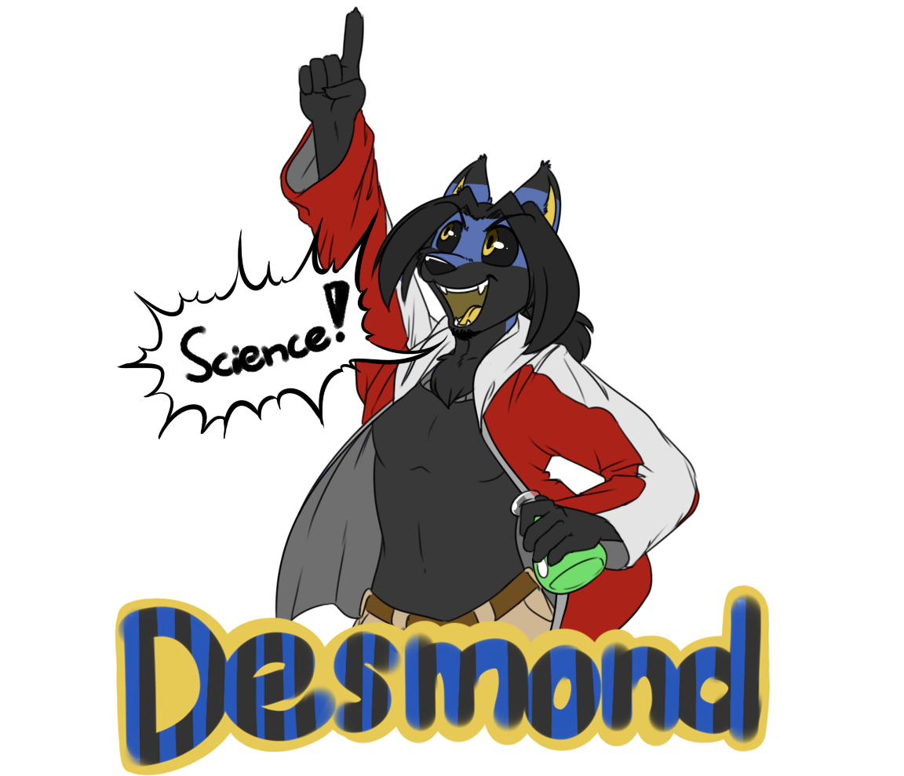

SPECIAL THANKS!

All my work is made possible through the amazingly awesome support of my fans and friends. Thank you everyone for helping me entertain you!

A special shout out to my top supporters on Patreon and DeviantArt:

BouncyKnight

Gearhead46

Axel Stephan

Aneru

Nathaniel Windcaster

Meepes

Redbow

Forvet

Xilimyth Senuva

Scott Collier

Max O-Zuma