PAPER PANIC
COMMISSION STORY
BY CHALDEACHANGE
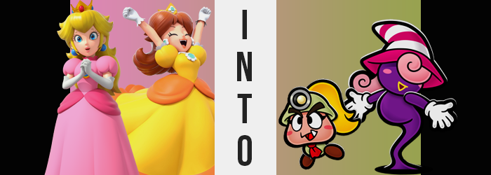

“It’s such an exciting day today!”

“Really? I don’t see what’s so exciting about being in such a stuffy place…”

The reactions of the two princesses that entered the library doors couldn’t have been any more different, and that was reflected in their body language. The pink-gowned, blonde haired Princess Peach of the Mushroom Kingdom was looking around enthusiastically, whereas the yellow-gowned, brown haired Princess Daisy of Sarasaland had crossed her arms with disinterest beneath her chest. Being the sportier of the two women, the brunette wasn’t the type to find much joy exploring libraries – or reading at all for that matter.

Yet Peach had pulled her along while she had been visiting, much to her dismay. The two had been about to go out to play tennis, an activity that she would have found far more amusing, when a Toad had come in to inform his princess that a new batch of books had been delivered to the castle’s library from town. “Oh, don’t be like that, Daisy! There’s so much fun and whimsy in a good book! You should really give them a chance!” The blonde wasn’t dissuaded by her friend’s complaints as she picked a novel up off the pile of new deliveries.

Daisy just shrugged as she moved to the other side of the table. At the very least there were a number of picture books there. The pretty colors were nice to look at, and they could amuse her simpler preferences, if anything. When she looked at the one on top, though? “Mario and the Thousand Year Door? They’re making books about him for children now?” Not that she had anything against Mario. She was just surprised. And she went to open it to get a closer look.

Which was something that would lead to the end of the reign of both royals.

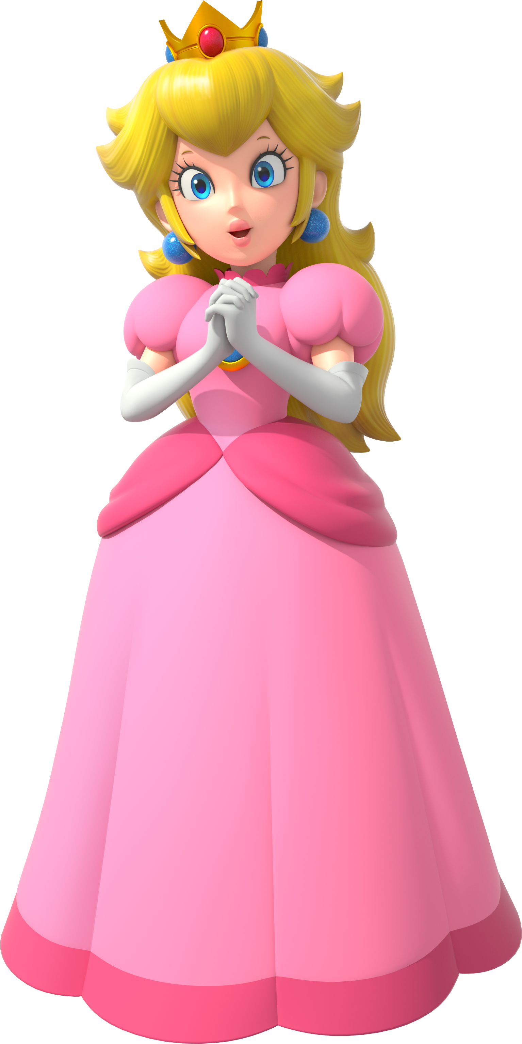
“Oh dear! Where am I?” Princess Peach could remember being in the library of her castle, but now? She was standing in what looked to be in the empty square of a small harbor town. It felt vaguely familiar somehow, but what was more striking to her was how flat her surroundings were. Things didn’t really seem to pop like she knew them to. “It’s almost as if I’m in a storybook… Oh!” This realization jogged her memory.

She remembered the moments prior to her appearance in this place. Daisy had been commenting on one of the story books, but Peach had been looking at the novel she had been holding rather than in her friend’s direction. She just recalled seeing a glow in the corner of her eye. “And then there was a flash of light, and now I’m here?” If the woman seemed calm, it was because she was unfortunately accustomed to such strange things happening to her.

“But this port town… Why does it feel so familiar? I’m certain I’ve never been here before…”

Peach couldn’t really piece together her situation with the limited clues she had. If she was really in a book, then how was that possible? As she’d soon learn firsthand, however? What was or wasn’t possible within this realm was far different than the world that she knew. And that was really saying something when you considered just how crazy the Mushroom Kingdom and its surrounding nations could be at times.

“But still… Daisy likes picture books. I guess I’ll need to write that down!” The princess paused after making that comment. “Hm? Write it down? Why would I do that?” She supposed that it was an interesting fact about Sarasaland’s own princess, but the compulsion to jot it down in a book was unnecessary and quite random from her perspective. But wouldn’t it be useful to have notes on what everyone else likes? Or their SECRETS?

Something deep, deep down apparently had an issue with her rejection of that note keeping desire and spoke against it, leaving the woman confused. So confused that she was only looking inward at her own thoughts rather than paying any mind to her body. Had she been doing the latter? Well, she might have noticed that some strange things were transpiring. Possibly. The shade of her blonde hair had darkened a little bit for one, and slowly but surely it was being pulled back – bangs and all – until it was simply all a ponytail in the back.

“Secrets… for keeping? Or for tattling! Th-That would be rude!” Princess Peach shook her head from side to side, saying ‘no’ even with her own body language. But in the meantime? Something was off about her skin. Its pleasant pale-pink color was darkening, and ironically darkening so that it was peachier? The pink was far more reminiscent of the fruit, and yet? It wasn’t evenly spread. It covered her torso, face, and legs. But her arms remained untouched for some reason.

A related issue was the first aspect of her physical shift that the woman noticed. Because her arms just fell to her sides suddenly. “Oh!?” It was almost like they had fallen asleep or something. There was no feeling to them, nor could she move them. “What’s wrong with my— AH!?” She could see her skin between her long gloves and the puffy pink sleeves of her dress. Or, well, that was exactly what had alarmed her. She could see it at first. But over a matter of a few seconds?

She became unable to see it.

“Wh-What!?” Peach would have raised her hands to her lips as she gasped out with surprise, but she was fundamentally unable to as her gloves fell to the ground and her sleeves deflated to hang loosely at the sides of her torso. Before her very eyes? Her arms had disappeared, leaving a smooth surface curving in from her shoulders to her torso. “M-My arms!?” If this happened to someone else, it might be worth jotting down! …Was this really the time to be having thoughts like that!?

The sensation of not having arms was certainly distracting, but another strange feeling hit her fast and hard. “What now…?” Her feet felt bloated? The princess leaned forward the best that she could to see without her arms to balance herself, but soon remembered her dress was so long that she couldn’t see what was happening within her heels. It was odd, though. She felt a little too comfortable moving without arms.

But what if her feet were different, too? She couldn’t see what fate had befallen them, but they had been growing within her pink heels. Flesh became thick and soft, while toes merged together within the footwear. It didn’t take long for them to push themselves out of the heels, and Princess Peach stumbled for a moment until her oval, round feet managed to find their balance on the cobblestone path – each one twice their original size.

Once again? She adjusted quickly. But it was actually more than that. She had already forgotten that her arms had disappeared and recognized that loss as ‘normal’, and it wouldn’t take very long at all for her to wonder why she had been so concerned about her feet in the first place. “I…? Is something wrong with m-m-m-me?” The Mushroom Kingdom’s princess’ voice sounded high and squeaky, and that stutter? It only sounded as she began to speak in an odd dialect. It wasn’t a normal spoken tongue.

But it was the chirpy tongue spoken within this book.

Fittingly, this seemed to occur in tandem with some rather profound changes to her face and head. Princess Peach’s lips thinned, which made it easier for one sharp, triangular tooth to grow up from the left side of her mouth. That fang was the kind of design trait that might have been used to make an otherwise simple character standout. Just like the oval blush stickers that appeared on her cheeks. A permanent blush left upon her face.

A face that was rapidly shifting so that it was short and wide? Her cheeks pulled out with a playful jiggle until they stretched several inches beyond the breadth of a narrowed forehead. It almost made her head look like the top of a mushroom? The colors of her eyes also faded to a solid black though, and those eyes became rounder with much sharper eyebrows in the corners. They looked a little more cartoonish. Just like how thick and black her eyebrows grew. They were almost comically large.

And made up for how her nose and ears had seemingly disappeared in the process.

“Oof!?” The princess chirped at a sudden weight landing upon her head. She didn’t even have the impulse to reach up and touch it with her hands anymore because the thought that she might have ever had hands was silly to her changing mind. “Oh, it must be my mining cap, right?” Her favorite hat! …Wasn’t it? Didn’t she wear a crown? But that had long since disappeared.

She shook her mushroom-shaped head for a moment. “Why do I feel kind of weird? Everything’s really small, isn’t it?” Somehow, she felt like she was used to looking up at things and not down at them? Reality was prompt when it came to aligning with those memories though. Her point of view began to dip dramatically, but not because her body was shrinking as a whole. Her head remained the same bigger size, but her torso? It was compressing.

Her womanly breasts disappeared into her chest, but that chest also disappeared into her stomach as it all became a single entity; merely a vessel for the necessary stomach every living body needed. This stomach protruded a little bit, and even her back rounded in the back. Her torso was essentially just a ball attached to oval feet in the end, and that was highlight once her dress disappeared and was replaced with a pale green shirt, a red tie, and a pair of boots. All fitting her Goomba body perfectly.

THWOMP!

Once her transformation had completed? The world around her suddenly closed in on her. Things went dark for a single second, but then it opened up to her again. Yet she was… different. She was… two dimensional. In the real world, the force that changed her had slammed the book shut and, in doing so, had made her a 2D paper fixture within it. Just like everything else in her surroundings.

Through feats that could not be explained, Goombella removed a book paper from the pocket of her shirt and began to flip through the pages. “Hm… Did I learn anything interesting about the people of Rogueport to jot down today?” The book was full of pages lined with ‘fun facts’ about the people of Mushroom Kingdom. A book of the Goomba’s own making, which once again raised questions about how an armless and handless creature could write in a book in the first place. But this world of paper she was in? It was one where it was best to suspend your disbelief.

The young woman merely waddled along with the book open in front of her. Her life had been a little bit boring as of late and she was hoping that something interesting would come along! As an archaeology student from the University of Goom, she was just itching for adventure! While walking past the harbor, though? Goombella paused. She saw a mustachioed man with a red hat on. “Wait, could that be…?”

“Hehehe! Maybe things will get more interesting, after all!”

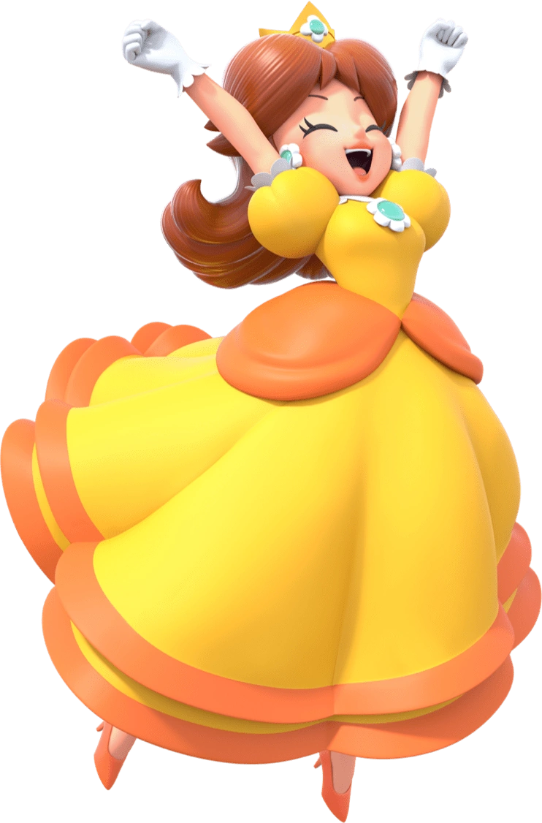
“Wh—!? What’s with this worn down place!? It’s creepy!” The flash of light had displaced Princess Daisy just like it had Peach, but onto an entirely different page of the book that the two had been trapped within. This one was much closer to the book’s center and focused on an entirely difficult locale. A run down village with eerie crows in the trees above, a dark purple sky casting limited, foreboding lighting across the scene. She was standing away from the decrepit homes near a small stretch of tall grass.

It was all so flat, like the book she had opened in the first place. The princess wasn’t so simple that she couldn’t put two and two together; she must have been in the book. But why? “And why do I have the strangest feeling that I’m supposed to be looking for something? Is that why I’m by this tall grass?” She felt like she was really going to be in trouble if she didn’t find what she was looking for, too.

Not that she had any idea from who. Yet.

What Princess Daisy did know was that she was feeling a little bloated. “Um… Does getting teleported into a strange 2D world give you gas?” She was definitely tomboyish enough to say something so uncouth, and normally she wouldn’t have even given it a second thought, but… “I-I mean, why would I say something so indecent?” She seemed to care all of a sudden but didn’t acknowledge how out of character it was for her to do so.

“E-Eh!?” To be fair to her? She had immediately realized that this bloated feeling wasn’t from gas. Not unless she was being inflated. Because her attention had been fixed downward at the sight of the torso of her dress pushing forward. “A-Am I getting fat!?” What’s wrong with being a little round? I can look pretty and cute, nonetheless! And yet, these weren’t even really things she normally cared about.

Those thoughts didn’t do very much to dissuade her panic in the moment, though. The round shape of her tummy pushing against her dress inch by inch was very unsettling. It almost felt like she was going to explode, and it became even stranger once she realized her breasts weren’t only just doing the same thing but were gradually merging with this big belly in the process. But just when it looked like it was going to explode through her garment? Something even more uncanny happened.

The tightening cloth slacked and returned to its original position… while a big, dark purple stomach phased through it. “M-My belly!?” Both of her hands reached down to grope at a gut that had to have extended about four inches past her chin at its peak, rounding into where her chest should have been and then into her neck. She could touch this stomach, so how was it the clothing had phased through it almost like a… ghost?

This concern was reinforced as her gloves slid through her hands and the stomach she was grabbing and fell to the ground, revealing hands that were just as purple – with larger fingers to boot. Whatever was happening to her… it was spreading. Panicked, she lifted her gut and watched it jiggle. “I guess it’s a little cute… Wh-What am I saying!?” She was sporty! A tomboy! But all of that healthiness had left her body. A big belly wasn’t traditionally ‘cute’. …To a human. But what if beauty standards varied between species?

Well, naturally they did. And her own were shifting to reflect that.

Purple spread across Daisy’s skin quickly. It consumed her torso and hands first, and as it gradually moved up her arms her sleeves began to phase through her. In the end? Those arms had been the only thing holding her dress up, and it completely phased through her body to pool around her feet. The princess was left completely naked, but that also didn’t seem to be a problem? Her breasts, nipples and all, had already become one with the rounded mass of her torso, and purple had swept over her loins to remove any traces of sex in the first place.

“Th-Th-This is pretty normal for a shade, right? So why do I…?” Her voice did the exact same thing that Peach’s had during her own transformation, glitching several times as it became high, squeaky, and almost incoherent – shifting into the language spoken within the storybook. But the skin of her face darkened towards the same purple as the rest of her body as it did so. Shades were akin to Boos or ghosts in nature, which was why despite being rounder, Daisy’s body had actually become significantly lighter. It could already phase through things as her clothes falling off revealed, but it could also hide in the shadows.

Was that why she felt its pull at her feet? “Eh?” She had to lean forward to see past her tummy, not even able to recognize how much her face was even changing in the meantime. Its shape pulled out so that it was entirely circular – like a big ball – and her nose faded away as pink blush circles appeared on her cheeks. Her lips? They thinned until they looked more like two dimensional, yellow lines that sat upon her face and while her eyes took on that same color between two absent ears…?

How those eyes looked didn’t matter, ultimately. You weren’t able to see them, largely because of the woman’s hair. It thickened and curled in general, but her bangs suffered from this more so than the back. It almost swirled like ice cream, obscuring her gaze from an outside perspective as the whole of it lightened to a cotton candy pink color. Despite not being able to see her eyes, though? She could still see clearly through them. “My… feet? W-Wait! I don’t…?”

Everything that had happened above her now (non-existent) neck was of little consequence to the woman, who had still been staring at where her feet should have been. But there weren’t any feet. Her legs had been coated with the same purple and fused together into a long, thin wisp that stuck into a pool of shadows on the ground. That pool must have been the pull she had felt before, but it was also part of her body, oddly enough.

She didn’t really see it as much of a problem now. The young woman couldn’t even remember what had been bothering her. And the weight of a white and pink striped witch’s hat atop her head, or thick white gloves over her big, ghostly hands didn’t change that. As she saw it? Those were the things that she always wore. But she still jumped with a “WAH!?” when the book slammed shut and reopened with a loud…

THWOMP!

Rendering her in a 2D paper form just like Goombella.

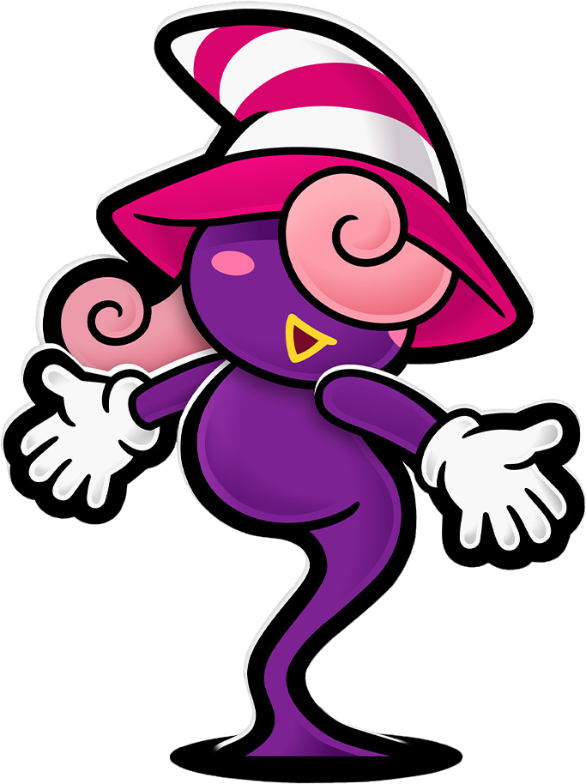
Vivian felt panic wash over herself much more strongly now that her transformation had been completed, but it wasn’t like any awareness of that transformation was the cause. “Oh no… I really need to find that Superbombomb before it’s too late. But where could it be?” She didn’t want her sisters to yell at her unnecessarily again! She was tired of being in trouble for things that weren’t her fault at all. Why did they have to be so mean to her? Was it just because she identified as a woman?

“Why does it even matter though?” She gave a downcast sigh. She had a point. It wasn’t like her purple and shadowy body had any sexual characteristics. She could be whatever she wanted to be! Beldam was just being mean because she couldn’t accept something different! Vivian’s mind was honestly more or less made up by this point. The Shadow Siren yearned to break free from her sister and be who she wanted to be. But there was an issue… her self-confidence wasn’t very good. She needed a little push.

But sometimes the pushes you needed could come from the uncanniest of places. Take the strange man that was approaching the shade. Or, well… He was a man, right? He was flat and purple and didn’t really have much in the way of identifying features. It was almost like those features had been stripped away from them. Vivian didn’t really know what to make of him.

But she didn’t know how much he would change her life, either.

The Mushroom Kingdom castle library had gone still and quiet ever since the two princesses had disappeared. It was fortunate that no one else had been in the library at the time of the flashing light else they might have been sucked in as well. But since the damage was now done already? It was absolutely safe. The picture book was just sitting on the table, open, exactly where Princess Daisy had left it.

“Princess Peach?” The room’s peace was eventually disturbed by a toad who stuck his little head in through the door. Once he realized no one was inside, he shuffled the rest of the way into the library with his confusion plain upon his face. “I could have sworn she and Princess Daisy came in here. Maybe they left? But I should clean up, I guess!” A task that began with him closing the open picture book on the table. And once it was closed, he moved it onto the nearby shelf.

Who knew the next time that book would be opened?

