DARK // LIGHT
JANUARY 2022 REQUEST STORY
BY CHALDEACHANGE
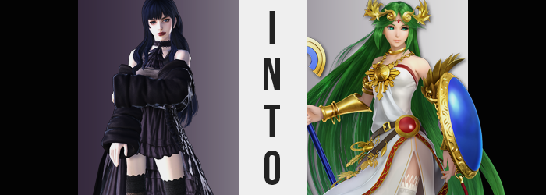

It had been a few hours since it had happened. A fight between Gaia and Ryne that had seen them heading their separate ways for the rest of the day. While they were girlfriends and they treasured one another more than anything, it was all part of a healthy relationship to disagree now and again. The goth-styled Gaia knew this, but it didn’t make weathering the fight in question any easier. She would rather not be fighting with Ryne at all so that she didn’t feel this way.

Had she confided in anyone about these insecurities she feared that they might label her as sensitive or weak, and Gaia would have loathed to be seen as such. The front of a strong, independent young woman that she put on was important to her. So much so that she only showed the ‘weaker’ part of herself to Ryne, whom she couldn’t rely on for this reason alone.

“Augh! Why are feelings so complicated!?” Like you might expect of any teen girl, she was having a great deal of difficulty figuring out what to do. Should she apologize? Was that even really a question? She definitely had to apologize! But how should she go about it? When? Was it too early?

Ultimately, it had all brought her back to Ryne’s room. She was hoping to apologize before bed, and even though it was dark out she could see that the lamp in her bedroom was still on from outside. But there had been no answer when she’d knocked, and upon sticking her head in? Ryne was nowhere to be seen. But there was… something.

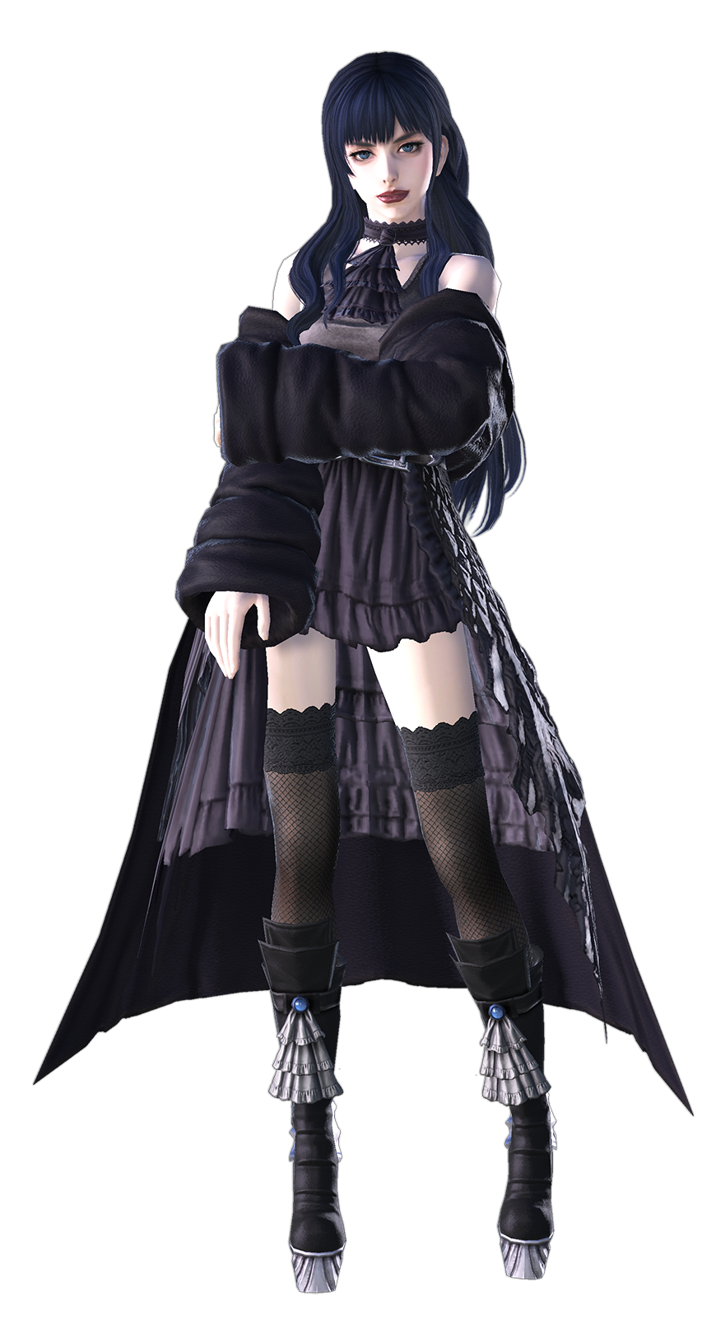
“This energy is strange. Did something happen in here?” It was as if the atmosphere was somehow stifling, reminding her somewhat of how it felt within Eden Prime. It felt like that, briefly, there had been a surplus of darkness within. But now? The energy was overflowing with light. Gaia, of course, had no means of knowing that early Ryne had an expressed a desire that had transformed her into the goddess of another realm, and now? She was being directly exposed to an energy that remained.

An energy that had trailed the darkness from another world, for it was the light to that darkness. The yin to that yang. One could not exist without the other, and to those ends? The energy required a suitable host. Despite what Medusa had assumed previously, her other half had yet to manifest. She had merely sensed her presence within the First. But now?

A suitable vessel had finally appeared.

“Something did happen, and I hope Ryne—” With her investigation Gaia had reached out towards the chair at her girlfriend’s desk with hopes of doing a little bit of investigation work, only to immediately pause when she caught sight of her own sleeve. While dressed in a fashion similar to Ryne’s, Gaia always dressed in clothing that was a little frillier and, most importantly, blacker. Yet her detached sleeve? What she saw now was material of a golden color. “What!?”

Upon further examination, it wasn’t just her sleeves. Her choker and the lace decoration that dangled from it had both also turned gold, but her dress and tights? They were a pure white now, with boots browned. Colors aside though, their styles and textures all remained consistent with what she remembered. “Just what is… Is whatever happened here affecting me as well!?” It was indeed, and there were signs of that upon her face. After all, the color of Gaia’s lips pinkened, for all of her dark-colored makeup had been utterly obliterated.

The girl could feel it. That energy she had felt upon entering the room? It was converging upon her. Flowing into her. And it was so, so sickeningly radiant that she felt like she might spew at any given moment. Fortunately it didn’t come to that, but it also didn’t amount to nothing either. For the changed color of her clothing was only a minor altercation compared to what would follow.

Such as, for example, the physical manifestation of that power’s presence within the girl’s eyes. Gray optics began to shine after enough of the energy had been drawn into her body, and from that light their colors irreversibly changed to a shimmering emerald. What’s more, those eyes widened ever so slightly and her lashed grew longer. That wasn’t even the end for Gaia’s face, for age saw her maturity and perceived wisdom swell at the cost of downsizing her rather profoundly sized lips.

“I… I’m… What is this!? It’s… invading…!?” She wouldn’t liken it to the harshness of when she had been spirited away be her ‘fairy’, but the invasive nature certain elicited shades of that experience. The powerlessness of it all was what she loathed the most, made worse by the fact that she was not unaware that her body was twisting.

Emerald had found her raven locks now, and with that color they spilled much, much longer than she would have ever sanely grown it out. It cascaded down to her ankles, and in the process straightened out so that there was not a single natural curl to its name. While at the front? Bangs parted in the center, swept to both sides to overlap the cuts that framed down to her shoulders at her head’s sides. What was most miraculous of all was that this hair was programmed to ‘hang to ankles’, so even if something affected, say, her height, then it would still stretch to that length.

Which, incidentally… “H-Hey!? Wait, my voice is…?” Gaia was assaulted by two simultaneous realizations. The first was that she was growing taller, and the next was that her voice was not only deeper, but she was speaking with an unfamiliar accent. Of the two the former was probably of greater interest, though.

A greater interest in a greater height, for the girl sprung up into the shape of a 5’9” woman. This naturally left her outfit somewhat ill-fitting, with the skirt of the dress lifted to reveal her now white underwear. But this was only a fleeting inconvenience, for the dress soon lengthened to roughly where it had sat before while her thigh highs did the same. It seemed that whatever undertaking her figure took, her clothes would ultimately change to fit.

Which greatly worked to her benefit in the coming moments.

“Ongh!?” A sharp pinch at the sides of her stomach, while not painful, was clearly felt as their width narrowed – and perhaps because of it, her hips swung several inches wider. From them, mass then accumulated with the intention of presenting her with the figure that both her face and height suggested would be the norm for her perceived age. As a direct result of this, before lengthening again the skirt of her dress was lifted some by the cheeks of her rear, which had amassed an impressive heft in their pursuit of pronounced maturity to the point that she could feel undergarments digging in ever so briefly. As did her thighs, which passively rubbed together between two thicker legs.

Gaia loathed to admit it, but it all felt very nice. With each passing moment came an influx of strength within, but that strength was accompanied by a growing presence as well. Through pleasure she was weakened, and this new persona gradually overcame her own. Wearing dark makeup? Holing herself up alone in a dark room? She couldn’t fathom doing anything like that as she was now. No, for a goddess— “But I’m not a goddess! …Am I?”

Some might argue that in terms of figure she was. Her lower half was already desirable in appearance, and the front of her dress was beginning to prove that her chest was inheriting the same qualities. Nipples erect from the warmth that provoked their growth, her tits swelled up into the DD-scape – which didn’t even look that huge considering her height. “This body isn’t… It isn’t…”

“Oh!?” The woman was forced to hold that thought as a flash of light saw her entire outfit rearranged. Not in color, for that groundwork had already been laid. But in terms of design? Everything that had turned gold turned into either armor or jewelry, such as the armguards she now possessed and the hefty neckpiece that now dangled from a golden chain across her bosom. While anything white? Well, it remained a dress, but one that resembled a layered toga more by design, with red trim and golden decals.

Her thigh highs remained, well, one of them did. Her right leg was bare aside from brown heels and a golden ankle bracelet, but her left was still clad in a white satin that looked just as expensive as her dress did. There were also other accessories, such as the golden tiara with a red gemstone in its center, and the two belts draped across her waist. There was also the rod of gold and blue, as well as the matching shield that she appeared to conjure with no shortage of ease. Speaking to newly bestowed powers and knowledge. Because how else would she know to beckon those two objects in particular?

Truthfully, she could not really be called Gaia anymore. She did not look like the girl, nor would she act like the girl. Her memories weren’t even the same, and spoke to a life led in a distant realm, overseeing all manner of realms herself. But that was why she, at least, appeared to properly grasp her present circumstances in a better capacity than most might.

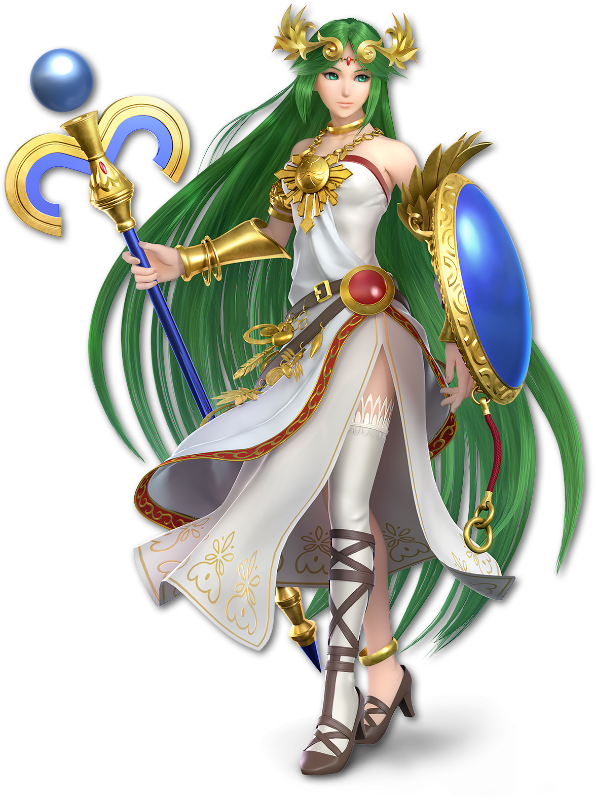
“Oh Medusa, just what have you done?” The sigh of a woman disappointed in her sibling gasped the moment the last of the puzzle pieces clicked. She had once been Gaia, but now she was the goddess Palutena. A divinity from another world altogether. A part of who she had once been lingered within – this body was only possible because of her – and through it she could now surmise the identity of the one Medusa had possessed. “To take a body of such importance to this one… How fitting of you.”

If Medusa was here then that meant she had tragically little time to dwell upon her best plan of action. In all likelihood she could share this form with the girl she was possessing, granting her access to her abilities. In fact that might be for the best, lazy as Palutena was. But not until they’d had a chance to negotiate.

What this would ultimately set up would be a battle between good and evil, between two girlfriends possessed by goddesses from another realm, doing battle so that they could be reunited and regain the simple life of love they had once possessed. It sounded absolutely legendary!

“And yet…” Palutena winked. “We don’t have the budget to write a script for that entire saga! Sorry about that, dear reader!”

