PARTY TIME
BIWEEKLY STORY #99
BY CHALDEACHANGE
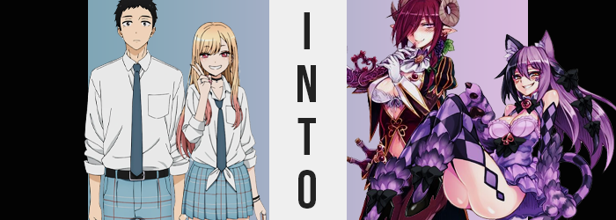

Wakana Gojo had plenty of reasons to be nervous. This was technically his first proper Halloween party appearance. The first in his entire teen life, because he had always been so socially distant from his peers that he couldn’t have fathomed being accepted at a gathering like that. At least not once they learned of his love for Hina Dolls.

But this was a year filled with firsts for him. After connecting with one of the most popular girls in his class, Marin Kitagawa, and helping her with her cosplays? The two of them had become unlikely friends and feelings had begun to be harbored between the two. Marin was a lot more comfortable in general social situations than Gojo, and because of that and the fact that she was so pretty she was naturally invited to all of the big parties.

And in the end he had been invited by extension. “Pick a matching costume she said, but aren’t these all for girl characters?” Of course in the end Marin had wanted to go to the party in matching costumes, but technically they weren’t of characters. Monsters? Creatures? They were something of the sort from a lewd encyclopedia of some manner that Marin was interested in on the internet. He didn’t really understand the details, but he was thankful she was fine with store bought costumes over having to make some this time.

“I guess this one’s for a man. Looks kind of like a butler?” Marin had already run off to buy her costume, wanting to keep them a surprise. So she wasn’t there to correct him on the fact that while the costume did look it belonged on a man…

It didn’t.

“That… was a lot harder than I thought it would be. Maybe this costume wasn’t for a man after all…?” A few weeks later it was finally Halloween, and Gojo had struggled to put on his costume while Marin had been doing the same with her own in his bathroom. He wasn’t sure why she had insisted on getting changed at his place instead of going back to her own apartment in the first place, especially when the party’s venue was closer to where she lived. Yet here she was as she often was these days.

He had managed to get the costume on, but it was tight around his broad shoulders, and he didn’t like how he showed off his navel. Just the way it fit in general felt much better suited to an alternative frame. The frame of a woman. “Maybe Kitagawa will help me adjust it…?” She had mentioned that she might need help with adjusting her own, whatever it was, so she could help him in return?

It was strange, though. “Did I have something to drink?” He’d only been intoxicated once or twice in his life, drinks shared with his dad at home considering his age. But as if out of nowhere he had suddenly begun to feel… similar. Like, just a bit, his head was swimming, and his balance felt a touch uncertain. Maybe that wasn’t all that unusual since the costume had come with fake looking hooves made of plastic. He could hardly stand on them in the first place.

It was his fault for choosing that costume in the first place, though? Maybe he could just trade them in for shoes before his newfound dizziness had him spill over? An idea worth enacting, he raised his leg and bent his knee so he could access the fake hoof and pull it off, but…

For some reason Gojo couldn’t seem to tug it free.

“Huh? What’s it stuck on? It barely fit before…” The boy raised an eyebrow as he tugged, feeling the pull as if he was pulling on his own body… which was impossible. But had the plastic hooves always been this heavy? Or felt this hard? What about the fact fur that wrapped around his ankle? Using it as a grip, it felt like he was pulling on his own leg hair? “What the—!?”

The feeling prompted him to let go of the foot, and when it hit the ground? A loud CLOP filled the otherwise silence, and his imbalance was gone. He took a step forward, and another back with the other foot – completely in awe. “Wait is that actually my foot? Is it part of my body!?” Gojo hadn’t wanted to say it because it had sounded crazy, and yet as he tapped the goat-like hooves against each other, they made a very realistic clacking sound.

“Wh—!?” And if he wasn’t having enough issues, that balance that he eventually reclaimed almost spun into a forward tumble – at least before he caught him self on the nearby table. He managed to pick himself back up, but it was awkward, like his legs were bending in an unnatural way. And by the time he managed to look down at himself, well… It was pretty plain as to why that was.

His legs, in the velvet pants that came with the costume, looked broken. Knees were still where they were, but halfway between them and his new hooves there was a second set of joints that pulled backwards. “What’s wrong with – HIC – my legs!?” Gojo could do little more than gawk at them, not noticing the hiccups that had begun to erupt with the taste of alcohol on his breath.

Even as he stared at those legs, however, their situation worsened past the disjointed shapes. The velvet pants felt unusually tight all of a sudden, and there were two reasons for this. Well, one of those reasons was exclusive to around Gojo’s thighs, because they were bloating strangely. Excessively, even, so that their shapes were plump and voluptuous, even widening his hips. But the true was also same of his ass, for it swelled into a pleasant peach shape.

With his thighs and rear exceeding the fit of his pants though, you would probably expect them to rip and tear. But the tension was a product of them tightening as well… sort of. It was more like the velvet was binding to his skin, coating his legs, rear, hips, and even his crotch. And once it was bound? The fibers loosened and fluffed up, pulling away from the boy’s body as a soft coat of fur complete with a tail that had once been a decoration, now fused with and part of her body.

But was Gojo truly still a boy?

“HIC!?” While the fur has sprouted around their crotch, it was completely flat. When the pants had flattened they’d pushed the cock and balls into her loins, with a moist pussy hidden beneath the fur. “I’m really not feeling sho good…” Slightly slurring her words now, it seemed her goatlike bottom half and new sex were no longer registering with the same panic they had previously. Almost like she was adjusting to it mentally, accepting things as they were.

And with her sex changed towards the feminine the rest of her body soon turned to reflect it. Her stature, for example, dropped several inches – albeit she was still tall enough to dwarf Marin. But it was more evident in her face, where features softened and rounded. The chiseled look of Gojo’s jaw eroded and his eyes narrowed. Plump lips brought together a face that was pretty and feminine, but it was also simultaneously handsome in a beautiful way. A beautiful, mature way. She was certainly older now, definitely a young adult at least.

Her eyes had begun to glow pink, and streaks of maroon that matched her pants began to slip into the hair of her head. These strands lengthened and as it spread to encompass her mane overall, it flattened and fell to her shoulders while bangs were brushed across her right eye. “Pfft! Pfft!” Trying to blow her hair away from her eye, a feminine giggle escaped her lips soon after. It sounded like the giggling of a drunk woman more than anything.

Which might as well have been the reality of the situation since she could no longer think straight whatsoever. If she could, she likely would have noticed that the weight of the prop horns she was wearing had becoming infinitely heftier, or that the fake ear extensions that had been put on to give her pointy ears were now literally her ears. Her humanity could very easily be called into question by this juncture.

For a newly transformed woman though, she was still lacking a little something and its absence was highlighted by the open coat and perceived vest covering her chest. Gojo had originally thought it was oddly shaped for a vest, but in truth? It was a pale purple bra – or was meant to be. It just didn’t become obvious until her chest had begun to swell.
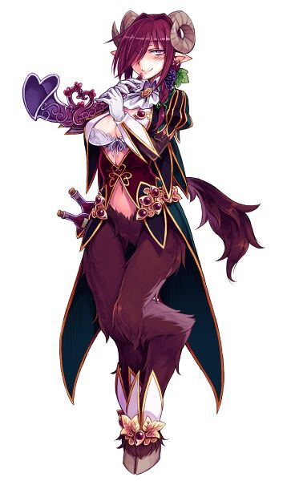
With nipples erect, the mass below them began to swell to demonstrate that the sides of the vest were actually cups, and the fatty tissue quickly made work of filling the DD cups. As they grew mightier in size though, the sides of her tummy pinched in to demonstrate how her proportions had been shaped into an hourglass figure. Her mighty bust ached and burned now, arousal building steadily within as it became difficult to avoid holding them with shrunken fingers.

The monster woman’s hooves clacked against the floorboards of her bedroom as she finally managed to find her inner balance, although the lingering intoxication and taste of booze on her lips left her tipsy for an entirely different reason. “Hic! I feel so gooood, and waaaarm!” Truthfully this Satyros was still Gojo deep down, but she was quite literally drunk on her new nature as a monster.

She was thirsty for booze, but also thirsty in general. Able to recognize her beginnings, the fact that she had once been a human male, her drunken stupor was beset with a careless curiosity regarding her new body. But it wouldn’t be any fun to explore all by herself, now would it? “I wonder if Kitagawa-chan is ready yet? Hic!”

Surely they could have some fun together?

Meanwhile, Marin had been having a bit of difficulty with her own costume. Not that it was so ill fit that it would cause problems, but as it turned out she had picked up a costume that was just a touch too big for her. “This totally sucks! This isn’t the size the label said!” While the teen was content with her own figure and didn’t actually desire to be all that more abundant, it was quickly clear that her costume was made for a slightly thicker figure than herself, which was odd…

“Did I lose weight or something?” She had tried it on the night she had bought it and it had fit fine, and yet the material now seemed like it struggled to cling to her chest and legs? And she had been hoping to woo Gojo with her perfectly fitted Cheshire Cat costume, too! “I guess I can just get him to help refit it, but the impact won’t be the same!” But while she was distraught, it finally struck Marin as a little odd.

Why couldn’t she stop smiling? She was really distressed here!

But if it wasn’t distressing enough that she couldn’t wipe the smile off her face, she noticed something else in the mirror – and felt it – that sent a chill down her spine. The cat ears that were on her head via headband, one dark purple and the other a touch lighter, were twitching. “Uh… This thing didn’t come with batteries, did it?” In fact she was pretty darn sure it had just been a pair of fake ears upon a prop, yet they looked much more authentic now, and the twitching suddenly helped that.

Mind you there was also a similar but related problem. The fake tail that was attached to the back of her costume’s purple skirt, striped with dark and light purples itself, had begun to swish back and forth. “Nya!? Stop it!” Panicked by all this she swatted at her tail with one hand, and her ears with the other… but it proved difficult to grasp anything.

How could she? She was wearing thick and oversized, furry gloves meant to resemble the paws of a cat. With three fingers per glove and with how dense they were there wasn’t exactly much room for flexibility, and so Marin abandoned the idea to try and pull them off. The issue? They wouldn’t, no matter how much she pulled one hand with the next. It felt more like she was yanking her own flesh and blood.

“H-Huh? What the heck? This totally isn’t cool, nya!?” There it was again. She’d thought that she had heard it before – a catlike noise escaping her lips, but this time she had definitely heard it. All while she panicked about her gloves… or her paws? She could feel their warmth now. She could feel through them. Their touch was her touch. Which meant that the costume had become real, absorbing her human hands into them. Did that mean her ears and tail were as well?

To be fair, if she had managed to brush away the hair from the sides of her head she would’ve realized that her human ears were already gone. And on the subject of her hair? Marin’s beautiful blonde locks had been gradually changing themselves. They didn’t lengthen, but the slight waviness they normally held did subside some so that they were straighter. But more than that the color purple bled into them, matching the color of the fur of their ears on either side. That meant the hair on her left side was the lighter purple, while in the front on the right the darker purple was more apparent.

Only the lighter purple persisted in her pubes though.

“Nyaha! I can’t believe this!” Despite how shocking this all was, the girl was still all smiles and even giggled a cat-like laugh as shock gave way to humor. Was she finding this funny? A little, but only because she was feeling stronger and sexier. In a way she, too, was getting drunk. But only drunk on the high of her transformation. Her voice was softer and floatier now, and the lips that it was spoken through were fuller and turned into a cat-like smirk. Faux tattoos she had plastered on her cheeks as part of her costume? They became legitimate tattoos that could not be etched away. Not to mention the purple sheen her irises took, but other than that her face didn’t really change all that much.

Maybe she looked a touch older? Like around the age of twenty or so.

Rather than express distress any longer, curiosity was palpable upon the monster woman’s expression. She hadn’t realized, or perhaps she had but didn’t care, but he body had begun to lift off the ground. She was just floating there, and in doing so the fact that her costume was a bit too big for her body was once again utterly obvious, for it looked like it was going to fall from her body in places.

It didn’t, of course, but not without a bit of help. Now that monsterhood had been bestowed upon the woman it had become time to round her out to fill the role a little more effectively. Like the cups of the purple leotard beneath her top, which left her cleavage exposed in all of its inadequacy? Well, their size wasn’t a concern for much longer. Not as a surge of weight saw them jiggle to attention, filling the D-cup cups and enticing one of her paws to play with them.

The same was true of her thighs where her checkerboard thigh highs were a touch loose. Weight saw her upper legs bloat with delight, and even then the excess ran off into her ass which swelled all the same. It certainly gave her a wedgie, what with the leotard being compounded in between two excellently swollen cheeks that more or less entirely exposed as she floated there. Why even bother wearing a skirt, then?

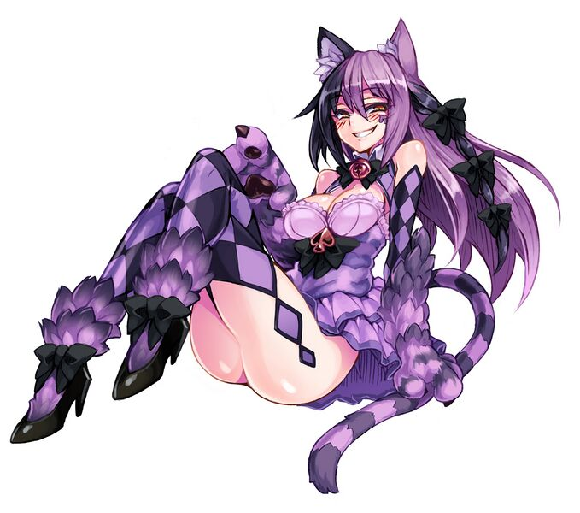
Not once had the woman’s smile left her over the course of her transformation, and it persisted even as she floated there now perfectly fit into the costume she had chosen. Or, well… Was it really a costume at this point? Her feline ears twitched, and her cat tail swished all while she hummed joyously to herself. “Nyahaha! I like this! I feel so strong and sexy~!”

Perhaps she didn’t look all that strong, but it wasn’t the physical strength she was talking about. The Cheshire Cat was a talented mischief making-type monster girl that was confident in her sexiness and was not shy to use it to her advantage. Marin was figuratively drunk on these feelings, and so when the sound of heavy footsteps could be heard approaching the bathroom door?
She disappeared, reappearing behind the Satyros that was approaching. Considering her own circumstances wasn’t it likely that this was Gojo? And so she grabbed the other monster girl’s ass playfully. “Gojo-chan? Hey, do you wanna fuck?”

Well that was one way to speed run their relationship.

