Q-BUNNY
COMMISSION STORY
BY CHALDEACHANGE
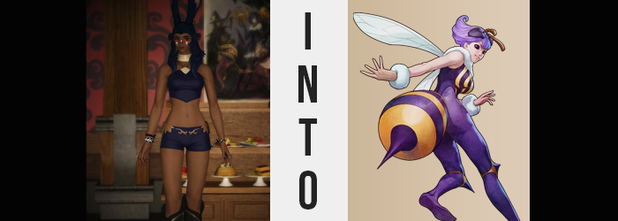

Iona really hadn’t liked anything about this job, and she had taken on plenty of them over the course of her life. Whether it was helping clear out weaker monsters from a field, helping repair a device she had never seen before, or even something as inconsequential as shoveling out a stable – she didn’t really complain about much. Which made sense, since she was pretty careful about screening these jobs before she took them. If something sounded like a job she couldn’t handle, or if there was an element she wasn’t comfortable with she just wouldn’t accept it.

That was just how the Viera operated. It was what worked. But in this instance, even in the beginning she had been a little offput. “There are a lot of bees… Why are there so many bees?” She had been tasked with helping a local researcher move their supplies from one research post to the next, and she had been told that they had been researching local wildlife. But upon setting foot in the current research post she had been greeted with glass case after glass case full of buzzing bees.

The walls were lined with them.

“I guess the notes did say I didn’t need to move anything biological, but still…” Their buzzing was loud and Iona was made understandably uncomfortable by it, but so long as they were in their cases then that was fine, right? She just had to be very careful not to knock anything over while transporting boxes and furniture into the carriage outside. Her client was paying her well after all, she couldn’t really afford to bail at the literal last second.

Honestly, this all sounded like the setup for something to go horribly wrong. Would the woman trip and crash through a case? Perhaps something was propping one up and she’d move it, forcing it to fall down and then release the hundreds of stinger wielding insects that called the case its home? Perhaps an earthquake, unlikely as it was in these parts, would rumble and break one of the enclosures open? It almost seemed like a million things could have spelled the worst case scenario for her.
But surprisingly? “Phew… done.” Hour after hour had passed without incident until everything except the bees was put away on the carriage outside. It was now early evening, with the inside of the research facility lit only with torches as the sun was on the verge of setting. Nothing had broken, no bees had escaped, and the researcher would be coming to pick them up in the morning to transport them properly. All was well.

“I suppose all that’s left is to leave the receipt inside…” Being a businesswoman that commonly did business with all sorts of people, Iona naturally had a system by this point in her life. She collected the payment first when the client would not be present during the job itself, which was what had happened with this particular task. The receipt was just remedial paperwork so that there was a record of the transaction. Some people threw them away of course, but Iona saw them as useful tools.

So after writing it up on her carriage with the intent of moving the carriage in question to the drop off location on the other side of town before ending her day, Iona brought it inside. One table had been left there as per request, and it was beside one of the bee enclosures. Seeing as the Viera hadn’t had any actual issues with it over the course of the day, her guard was done. And so when she put the receipt down on the table…

Yeah, nothing happened.

It really appeared that, for all of her worries, nothing all that bad was going to happen to Iona. She was on her way out now, without a single enclosure between herself and the door. But truth be told? Nothing had needed to break for things to go wrong. After all, the researcher had recently released some of their test subjects. And they had been doing more than simple research. There had been some genetic modifications made.

And so a bit of bad luck buzzed past the woman’s past as she was about to leave. A single bee that had returned to what it perceived as its ‘home’ after being released the day before. One that looked like a normal bee, but much of its fuzz was a dark purple instead of the usual black. And it was a little more aggressive than your average bee, too, because…

“Ow!?” With her guard down after a long day of not being attacked by any bees, she couldn’t hide the shock and pain of being suddenly stung in her right arm before the insect in question flew off into the back of the room. She had it in her right mind to chase it down and swat it after what it had done to her, but that risked actually releasing the others and making her one swollen sting wound turn into tens of them.

But on that note… “Wait, I thought it stung me?” The spot that had hurt and throbbed after being penetrated by the bug’s stinger? It had only been a moment, but that still should have been enough for the spot to turn red and raise. Yet it wasn’t raised at all. There wasn’t even a puncture wound? “Was I just imagining it?” But she could vividly recall the pain?

Not thinking much about why, Iona smacked her tongue against her lips expectantly, as if she was hoping to acquire a taste of something. Something that she was now craving even though she was distracted by the unperceivable bee sting. But the sting, in a sense, provided the perfect distraction to keep her from thinking too hard about it. After all, Iona wasn’t all that into eating sweets nor tasting sweet things. But the flavor she hoped to savor in the moment? It was undoubtedly something extremely sweet.

Her tongue stretched out to her lips again, but this time? It reached farther than it had the last time. In fact it reached farther than any mortal’s tongue should have reached. Almost to her chin in fact, at least until it withdrew back into her mouth once more so that she could speak. “Odd…!” The Viera’s fingers had run across where the sting had been, and she referred to her findings with an odd amount of childish energy.

All the while? The woman’s appearance was becoming what could only be described as increasingly monstrous. Since her purple top revealed much of her back anyways, there was no hiding that a pair of protrusions had begun to push out from the bases of her shoulder blades. It looked uncomfortable to say the least, particularly when those lumps seemed to open and translucent chitiThn began to force itself out, but Iona didn’t even twitch at the feeling. The obsession with something sweet was becoming less subconscious and more conscious.

She couldn’t stop thinking about sugar.

The desire had become all-encompassing, and her mind was racing as she tried to think about where she might find something sweet. Had she brought any snacks? No. Was there food in the facility? No. It was on the outskirts of town, too, so she couldn’t make a quick trip to buy something. The stronger the feeling became, the darker her eyes turned in color. And not just her irises. Although they were part of it, her white sclera took on the same color – a very dark purple. And this was ignoring how the chitin was still sliding out of her back, forming a pair of wings that undeniably looked as if they belonged to an insect.

“I’m really, really craving something sweet!” Something was off about the way the Viera was speaking aside from the swell of energy. At times her words sounded distorted and inhuman, just as her purple eyes, wings, and her long tongue appeared to physically suggest. And they weren’t even the only areas that were suggestive that her mortality was becoming compromised. For her ability to hear momentarily dulled as those ears shrank in size and thinned in thickness, yet the tilted forward atop her head.

Once they had? Her nose felt practically useless. Because her new antennae could detect odors much more keenly than her nostrils. “Sweet?” She could sense something sweet outside with them, but her legs didn’t immediately carry her there. In fact, her body felt a little too cumbersome to move? At the very least her hearing had returned, but only because a pair of Hyur-like ears had emerged from her head’s sides.

Iona swayed back and forth, her desire to snack still too potent for any critical thinking to shine through. Had she been able too, there was no doubt she would have noticed how tender the skin overtop of her tailbone felt. Nor that something had begun to expand from that tenderness. Just a touch at first, pressing up against her underwear and shorts, pressure built along with the expanding flesh until, finally?

RIIIIIIIIP!

The back of her shorts blew out, tatters of purple cloth and black underwear falling onto the floor behind her. For a moment it might have appeared as if the woman’s ass had been expanding, and yet upon closer examination? That wasn’t really it at all. Tanned flesh was growing out from above her ass, with a thin band of it extending from her tailbone with the intention of connecting her body to the lump that was dangling from it.

And that lump? It was growing exceptionally large, and at a quick pace at that. It became gratuitously bulbous, smaller at the base and thicker near its ‘tip’, and her tanned skin didn’t even retain its color as this growth swelled larger than her torso. Dark purple, yellow, dark purple, yellow. Starting at the base, stripes of these colors emerged in rotating stripes of fuzz, all culminating in purple at the tip where a sharp point began to emerge. A stinger. It all resembled the abdomen and pointy bits of a bee, and Iona subconsciously noted how full this abdomen felt. Full with venom.

Realistically this all should have been very alarming, and yet! “Mm… Want! Sweet!” She chirped childishly in a higher pitched, distorted voice for the sugar she craved. She didn’t even react to a moment of blindness that was followed by two bulbous, dark purple eyes that emerged from the sides of her head. Her vision was suddenly split into a plethora of tiny lenses at various angles – for she was seeing not through the eyes on the front of her fact, but those new insect eyes that had found her scalp.

“WAH!?” For how hyper focused she was on the idea of consuming a sugary treat, even Iona couldn’t help but notice a sharp and dramatic loss of height. Being a Viera woman she was supposed to be roughly six feet tall, but she’d dropped so dramatically down to just above four feet that it had felt as if she was falling. What was left of her clothes slid off in the process, but surprisingly? She wasn’t exactly naked underneath.

A fuzz similar to that upon her insect abdomen had begun to sprout out across most of her skin. Purple shrouded her back, her ass, and legs, and these regions seemed to proportionally change once wrapped up in its warmth. Her ass swelled into a much fuller shape for example, protruding to the point where it touched her abdomen from behind even with the thinner section holding it away from the rest of her body. While her thighs became thicker as well, taking advantage of her shorter height to give her a curvier aesthetic.

This purple likewise enraptured her tummy and pussy, just barely hiding the impression of her loins. But when it came to her breasts? Almost like there were a pair of smaller abdomens, the exact same yellow and purple pattern swirled around them. Though thankfully her nipples didn’t become stingers, their presence ultimately shrouded by the yellow fuzz on the front. But the size of those breasts? They were fuller, perkier. A little too perfect, admittedly. These E-cups looked like they had been specially crafted to seduce, or to at least bait in prey. Everything about her small body gave off that impression.

But every hunter in the animal kingdom had more than a few tricks up their sleeves, right? Even though she had nothing on her arms aside from some puffy wrist wraps.

And when it came to any remaining exposed skin? Her face, neck, and arms being the only examples? The melanin in that skin seemingly drained away, rendering her tan obsolete in favor of a skin tone that was a palish pink instead. While she had essentially become a bee woman, it was evident that there wouldn’t even be any remaining resemblance to her previous self at transformation’s end.

It could be seen in a face that looked more youthful, yet still like that of an adult. Her rounder features didn’t look an iota like the original Iona, and even the flatter shape of her Viera nose was now button shaped. This extended into her hair, too, as the purple lightened and the length was reduced, curling upwards in the back just above her shoulders.

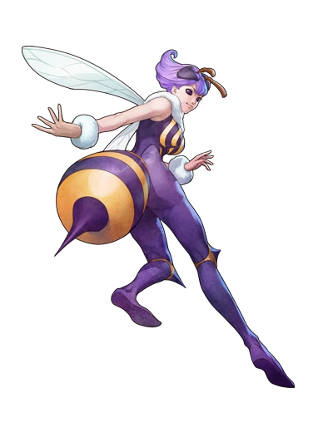
While she was only an inch taller than four feet now, there was no denying that the bee’s body was that of an adult woman with her figure as it was. “Yummy, yummy, yummy! I can smell some nectar!” Despite how she appeared though, the way she spoke was more akin to that of a child than anything. She was experiencing a sensory overload thanks to her new form, and could practically taste the nectar in the flowers outside. So she buzzed out the door and began to look midst the setting sun.

It might have felt uncanny to her at first, but Q-Bee now felt completely adjusted to that fact that her eyes were that of an insect. It felt completely normal to float along with those thin wings of hers too, which might have elicited thoughts of the opening paragraph of the Bee Movie script. The bee woman’s head was largely empty now. She still had independent though, but it was largely guided by instinct.

“Tasty, tasty!” Food was clearly in the forefront of her mind as a long tongue slurped up the contents of a tiny flower she hovered over. All she wanted to do was eat and grow her hive. And how would she do the latter, you ask? Well, her stinger, much like the bee that had stung her, had a special type of venom. A single sting would be enough to turn any moral into a Soul Bee just like her. They would be completely obedient to her too, regardless of how hard they fought her influence. She just had to be careful not to get killed first.

“Time to find my first underlings!”

