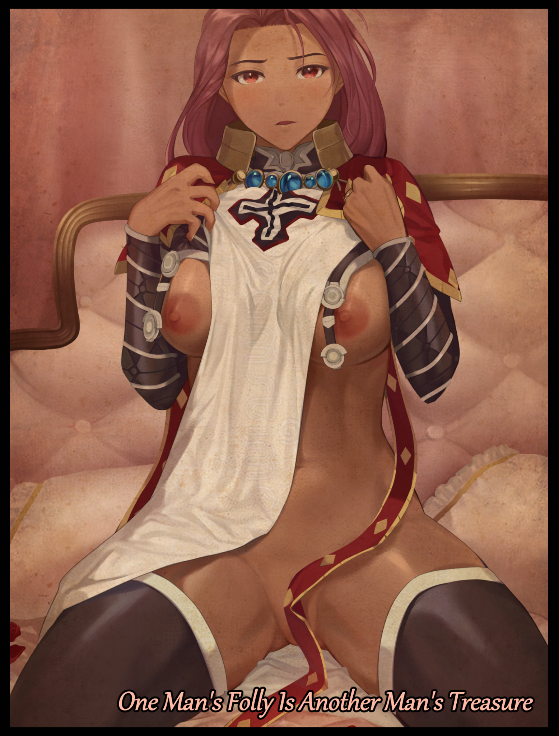
The people of Narakus were a proud civilization of forward thinking men and women. Always pushing to innovate in everything they did, from developing new agricultural methods to inventing contraptions of steam and iron. The Narakusians lived isolated lives beneath the notice of their far more primitive neighbors in an effort to maintain peace amidst concerns that their discovery would lead to the arrival of greedy interlopers looking to take their knowledge for their own gain. No matter how long they maintained an isolationist policy, explorers from the lands beyond would eventually come across them. It was a matter of when, not if.

And with some of the most dangerous inventions known to man present within the vast underground vaults that lay beneath the impenetrable walls of the castle that served as the capital of Narakus, a decree by the current King was made to commission a device that blended the marvelous prowess of modern technology with the limitless potential of ancient magic in an effort to mask the entire kingdom from the rest of the world . An undertaking the kingdom's people understood as a necessity if they and the world at large were to remain safe and secure.

It was a project that, at first, seemed impossible to achieve as the smartest Narakusian minds tossed ideas left right and center, unsure of what path to even pursue. Did they just simply attempt to build a wall? An array of cloaking devices working in tandem to render their settlements invisible? All of them were unfeasible proposals that would take way too much time and resources to accomplish.And even if they somehow got it done, an invisible kingdom would still be discovered if someone were to simply cross the threshold and poke around.

But the researchers and scribes wouldn't have to bang their heads together for much longer when an old crone with a formerly small title to her name had come forth with her own idea and the custom made spell to make it all work; the culmination of all her life's work into alternate planes of existence, bubble universes and even personally designed spaces that could be snuck away between the fabric of reality where the weave that separated whole worlds would be their haven, teleporting Narakus' citizenry, infrastructure and emplacements into a bubble that perfectly replicated the rolling hills and verdant greenery of the original, free to continue with their lives without fear.

It was an ingenious plan that sounded too good to be true. All the necessary components were already assembled including a functional prototype in the form of a curious tablet containing the witch's home. Now all that remained was to bring it up to a scale capable of containing an entire kingdom and utter the incantations written neatly on weathered parchment. A commitment that saw all Narakus come together to see its completion.

All except one individual who saw things differently. A man with grand plans for his people whether they liked it or not.

The Minister, one of the King's closest advisors and a dear friend. The man saw the commission as an act of cowardice. In his eyes, the superiority of Narakus should've been used to spread, conquer and assimilate. Not hide from the world. It was a clash of philosophy between the Minister and his King, but out of respect, the man had acquiesced many times to his friend's refusal to bend the knee to his aggressive expansionist policy. But once he'd heard of the great retreat, he knew he had to act before it was too late.

Attempting a coup was out of the question, assassination was impossible considering how tightly guarded the King was despite his refusal to put others at risk. Then that left only one possible tactic that didn't require his physically being there, an underhanded one the Minister wasn't too proud to admit his family had heavy involvement in seeing to its creation.

Originally meant to oust future Kings and Queens who proved inadequate in tending to the kingdom and its people, the Minister's family heirloom was the result of decades perhaps millenias worth of research and planning; a scroll capable of transmogrifying any thing imaginable into something else entirely while also realigning the weave to ensure reality was kept in check.

The usual punishment for weak, pitiful rulers was an eternity spent as nothing more than gilded statues that would prove more beneficial displayed out at the front hall. An unjust fate for one so wise as the current King, but to the Minister, his ideals bore more weight in his heart than personal relationships and morality, spurring his tongue onward, uttering the ancient words of power while kneeling within the crystalline hoop, the family relic that served as the hand, the deliverer of 'divine judgment', in supplication, hands pressed together.

Unbeknownst to the power hungry Minister however, his family history wasn't as black hearted as he thought it was. For who in their right mind would simply leave such a powerful artifact for anyone to use and potentially abuse?

Such a mechanic was purposefully left out from the scripture passed down in the Minister's family when the time came for one to assume the duties of the King's aide, a test to see if temptations of power and greed could lure the chosen Minister into using the artifact for his or her own purposes.

So when the last word leaves the Minister's lips, a blinding white light blossoms forth from within the hoop before the man can do anything else, consuming everything within it including the kneeling figure of the man at the center of it all. Wiping away that moment in time as the world seems to go rewind as the events that preceded the Minister's attempted betrayal are reset along with the time of day.

The last thing the Minister could remember was finishing the incantation before his vision went white and all feeling in his body faded away. It left him floating through an empty void as a weightless entity, unaware of what was going on around him, a wayward soul left to the mercy of the otherworldly forces that governed the weave. And what they saw in the mortal before them would make them scowl in disgust if they had faces to visualize their emotions with.

'For a man to betray his calling for personal gain proves they are no man at all. To betray a man…no, a friend as just as the King…your fate will be one just and fitting.'

With the thundering raucous booming their final verdict, the Minister's robes unwind themselves into nothingness, leaving the Narakusian man naked and afraid in a half conscious state to bear the brunt of his punishment wrought on by miasma that engulfs his form, coursing over skin in a violent wave while pouring into whatever orifice was available. Slowly but surely reshaping the portly man into something more pleasing to the eyes as unhealthy layers of fat vanish in favor of toned musculature lined with supple flesh, accentuating long slender arms that end off in firm hands tipped with dainty digits connected to a rapidly shrunken down torso bestowed with plentiful curves and cute round shoulders while powerful legs sporting thick thighs and curved calves tapering off into waifish feet lure the eyes up their curvaceous length, attached to freshly widened hips, a pillowy ass with bountiful cheeks and a toned belly sporting heated abs, beneath which laid a hot steaming womb prepared with an egg, ready for the lucky man who would inevitably end up piercing the tight folds of a virgin pussy now present between the former Minister's attractive legs as plump labia and folds of pink spasm in excitement at the instinctual thought of a mans pecker filling its aching void all the way through, nevermind the fact that said void used to be a fat sausage reduced to the cute nub of tingling nerves that would leave most women trembling if touched.

By the time long auburn locks begin to pool down and around an arched back thrusting out a hefty pair of milk filled tits topped with erect, darkened nipples, the Minister's former self had vanished under all the changes, replaced by a muscular yet buxom woman a few years younger. Her ochre tinted hide was smooth to the touch and delightfully radiant with a visible oily sheen to it. And unlike her forebearer, the muscle she bore was enough to shame most Narakusian men. Especially dominant in her arms and legs considering the new duties she would be tending to very soon once she awoke.

And her face was nothing to scoff at. In place of the brooding, bearded Minister's, the female warrior he had become bore the visage of a goddess. Complete with firm, thin brows atop alluring almond shaped slits that hid amber tinted irises from view, flanking a sleek nose line that led further down to pert lips that could whisper sweet words just as easily as they could bellow war cries and rousing speeches in a sonorous yet baritone voice befitting a true knight of the kingdom.

With the Minister's rebirth complete, her nubile young body twitches in response to the crawling lines of energy beginning to appear all around her, tracing new, sturdier clothes and heavy pieces of armor made from the finest Narakusian smiths and forged out of the nation's own alloy. Draped in luxurious yet protective silks meant to denote her new position as Captain of the Guard and personal bodyguard to the King himself, responsible for watching over him at all hours of the day. But politics and math would do little against assassins and well armed assailants, so those pesky memories of old would have to go.
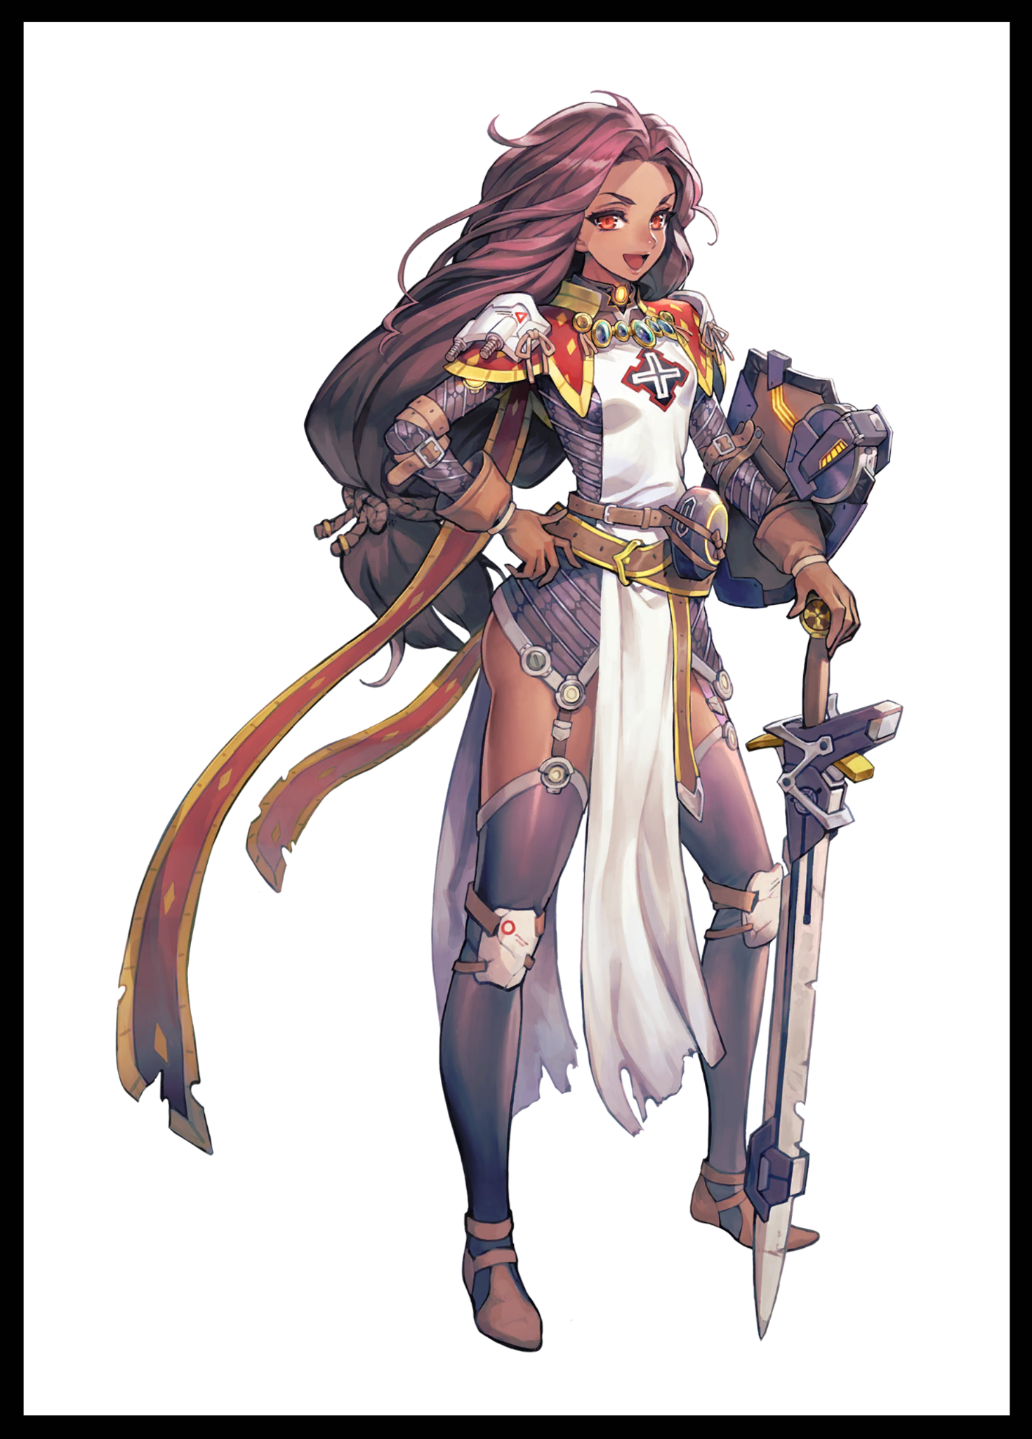
In place of his scheming, she only knew the way of the sword and shield, gaining an innate mastery over the weapons she now held dear to heart. Instead of keeping the other political figures and their interests in mind, she now remembered the squads under her command and the entire city's layout from the secret escape tunnels to the guard patrols in charge of maintaining them. All of the Minister's memories were slowly but surely being replaced bit by bit as invisible hands poked and prodded away at her mind, bestowing the Captain with necessary memories while robbing her of her old ones. Ensuring the foul soul she once was would be rendered clean and pure for the rest of her life.

More importantly however, were the views she held on the King. A bodyguard couldn't hold animosity or a rivalry, they needed reverence and understanding…though in her case, the fickle minds of the weave implant one tiny little suggestion to go just as a bundle of rope finishes tying her wild flowing mane at its tip, sending her out of the dream and back into an altered reality that was to be her new home just as the first rays of the morning sun peer over the horizon, blasting the Captain's right in the face as her serene eyes flutter open.

Roused from her slumber, the dutiful woman washes up in the barracks before donning her usual attire of chainmail weave, heavy armor and protective clothing. Strapping in her buckler shield and ensuring her sword sheath was tied properly without a sound to give her men some more time to sleep before heading outside, crossing the familiar dirt path towards the castle proper while greeting the gardener's and guards on duty with a smile. Making sure they were alright before heading in.

Today seemed different for the Captain as she strode through the empty halls of the castle, she had woken up on time, snuck in a small breakfast on the side and washed up…so why did she feel as if there was something she forgot to do? A very important task that was on the cusp of remembrance but still too far out of reach.

Until her eyes widen at the sight of her sister…no, the Minister, walking by her, presumably off to tend to the ongoing project to isolate their nation. She could barely return the kindly woman's wave without wincing in uncertainty. Excusing herself down a corridor to the side of the main hallway in an effort to get her wits together as a hand rises to clench at her beating heart through her bosom…

…Before bumping into someone unexpected in her hurried rush to get some privacy; the King himself! But what was he doing all the way out here this early in the morning? He should've been in his quarters just waking up from a good night's rest. This was unacceptable! What if he got in trouble while she wasn't around and she didn't know he'd gone wandering off early without an armed escort? In a brief moment, the Captain's motherly temperament gets the better of her, chastising the apologetic man for his actions before huffing as an awkward moment of silence passes now that her scolding was done, leaving her flustered over what to do next as her mind suddenly blanks out. Just what was going on today? Never before had she been so confused on what to do next now that she was with her liege.

Seeing the confusion on her face however, the curious King invites her to join him on a walk much to her surprise, taking the flustered Captain on a quiet stroll through the castle, occasionally exchanging words as the kindly King questions her on her well being and other such personal matters while the confused Captain quips about the man having too much time on his hands to be wandering around without purpose, to which he responds to the negative. Raising a brow while responding to his queries, explaining how she felt a little strange today and the fact she had mistakenly called the Minister her sister.

"Hm…that definitely doesn't sound good…never thought I'd see the day the gallant Captain of the Knights waver in her duty…worry not, I think I've got just the thing…go on, relieve yourself of your equipment."

Pushing open the doors to his quarters, the Captain acquiesces to her King's command with a smidge of uncertainty in mind, wondering just what he meant by having 'just the thing' to cure her of her mental plague, remaining oblivious to her pert ass sticking up exposed in the air alongside her vulnerable snatch as she bends over to lean her sword against the wall in an easily reachable location should the need arise for it.

Before she could right herself, eager fingers slip past her folds, pushing into her uncovered vagina and probing hard against her erogenous zones with practiced finesse, eliciting a squeal of surprise cut short by a guttural moan as her eyes roll back up into her skull from the sudden wave of orgasmic pleasure rolling over her as another hand unfastens the clasps holding her pauldrons together, letting the heavy metal drop to the floor while keeping the gallant Captain under control through expert thrusts of a middle finger against the entrance to her womb while a thumb strokes her sputtering clitoris, eliciting startled cries, shameful moans and spastic jerking as her opportunistic King continues to disprove her, shedding her chainmail to give her unsuspectingly huge breasts some much needed breathing room and undoing her hairtie before finally leading her over to his bed with a trail of pussy juice leading back to it, laying the tuckered out woman over the sheets gently before extracting his fingers from her gushing snatch. Allowing the flustered woman some time and distance to wonder just what the hell her liege was thinking, until another burst of memory enlightens her to a more intimate relationship going on between the two of them during moments of brevity where they had the world all to themselves.

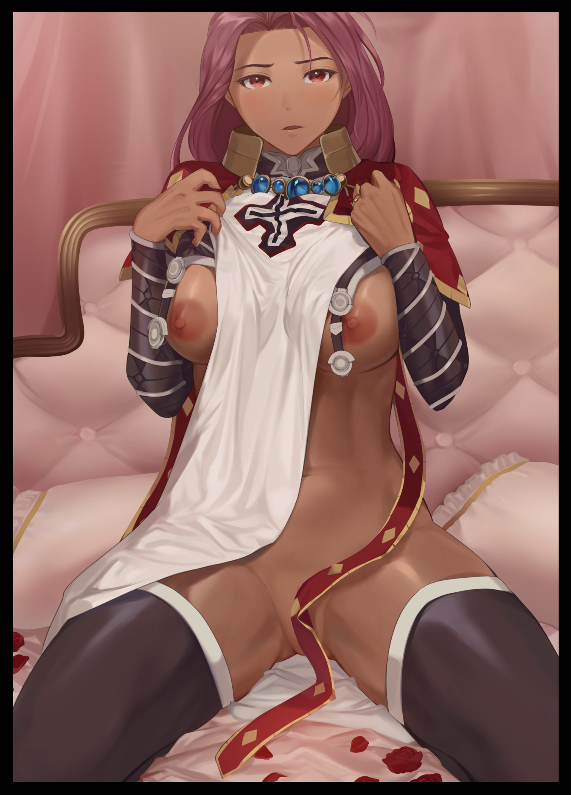
And now, during the final phases of the project where things were winding down, the King was free to roam his home without much concern now that the bulk of the logistics and planning was over. He now had more time on his hands than he was used to…time he took to nurturing his relationship with the gallant Captain, not as her King but as her lover. And with that final recollection shot through her tingling brain, the Captain's anger and hesitation fades, replaced by a lustful ire for more as she rights herself on the bed. Spreading her legs for her man as he joins her on the sheets, disrobed and ready to fulfill her wishes. Until now, the two had abstained from sexual intercourse over fears about possible public outcry from the nobles and political parties stemming from their vastly different standings in life. But after the Minister had quietly spoken to the King the night before, he knew now was as good a time as any to finally grant the Captain her wish to be his one and only as she turns her head back in pain, grunting in labor as the girth of her King pushes past her hymen, teasing her innards before finally kissing the entrance to her baby maker, lodged deep inside her as she cries out in relief and joy. Immediately reciprocating the King's advances with her own…

By the time the two laid spent and sweating bed with thick spunk oozing from the lower lips of the giggly Captain, the former Minister's punishment would be served for his attempt on the King's life; bearing the responsibility to birth and rear his children into respected folk while her former, much more capable sister took over the mantle of Minister, uttering prayers of thanks to the person in question as she rubs her belly, loving the sensation of her future husband's essence rolling around in her uterus while imagining a happy future with her children filling the halls of the castle with their laughter.

While she did have her doubts about the Narakus exodus upon its initial inception, her fears had been assuaged over the time she spent with her King ever since being given the honor of becoming his bodyguard for life. As long as she had him and her close ones by her side, it didn't matter where they went, as long as they were together, her happiness would be everlasting, excited at the prospect of eternal peace and solitude with the memories of old left to fade away in the annals of a history king detached from the one she lived…

THE END

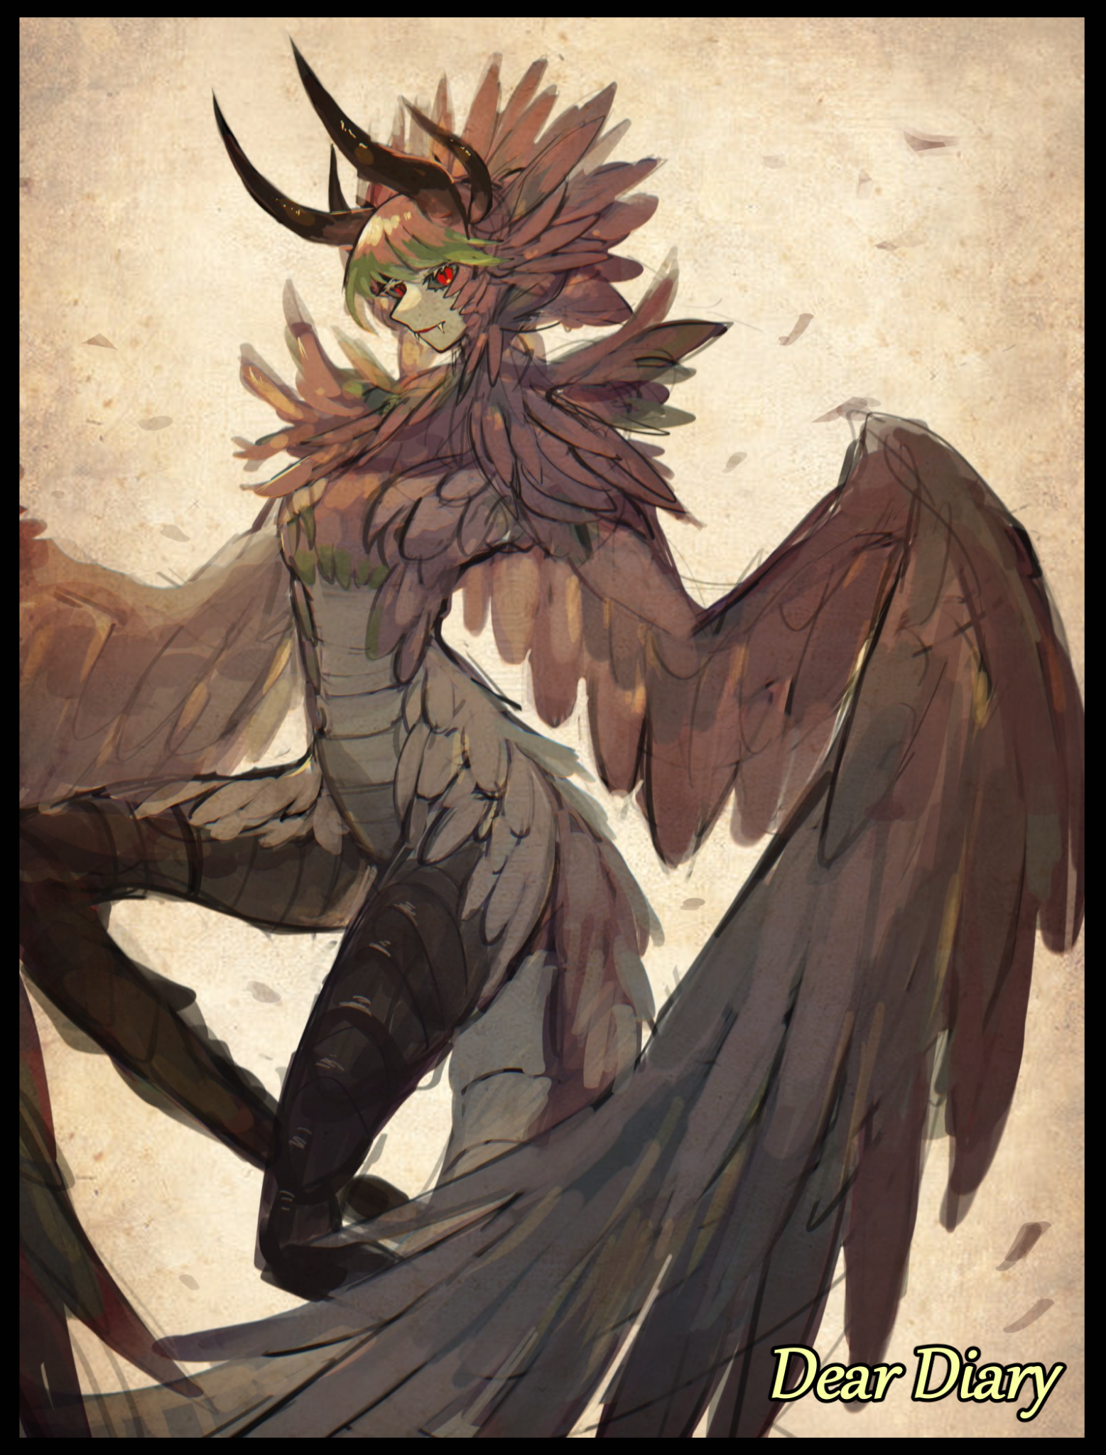
Far out north in a ruined metropolis overrun by thick vines and towering trees, a hooded figure wrapped in a ramshackle coat moves slowly through the gutted corridors of what was once an apartment building. Picking through rotted remnants of cupboard shelves and rusted containers for something besides rotted scraps and the dust of ages. Treading carefully in fear of falling straight down towards the bog down below the rotted flooring.

With how old the building was, any door that might've been locked was easily accessible with a simple application of force to the hinges of the dessicated wood. But from the careful demeanor the stranger practiced as they crept from room to room, it was clear they preferred not to go loud if there were other, more stealthier methods available to them while they continued to look for whatever it was they had come all the way out here for.

Because in this new world where the glory days of mankind were long gone and buried, what little pockets of civilization were left across the planet knew there was little to be found where places known as cities once stood. And even if there were supplies to be found in abundance, people avoided visiting the former population centers of old humanity in fear of the humanoid monsters that seemed to favor places like the aforementioned cities or towns. Collectively called Monstergirls for their appearance; blending the qualities of the fairer sex with the brutal efficiency of mother nature's vast creations.

In essence, where you could find the relics of old, so too could you find these creatures that almost always bore the features of women ranging from bodacious minxes to innocent fawns. Only a handful of people in the modern day knew of their origins but the majority only knew two things; that they were to be avoided, and contact with their bodily fluids could trigger a slow, but irreversible metamorphosis in the unfortunate soul that would warp both body and mind till nothing of their former self remained. Whether they were male or female, the infected would inevitably end up becoming yet another biologically female monster roaming the wild with no memory of their past to bog them down. Once a member of the community was marked, they had to be ferried far away from whatever village they belonged to in an effort to ensure the resulting creature didn't wreak any further havoc.

Thus far no distinct males amongst the myriad monster species have ever been sighted, but there existed hermaphroditic specimens that, while physically indifferent from their other kin, had the ability to manifest a phallic member alongside their original privates, presumably for mating purposes, acting like the animals they took heavily after with a degree of higher intellect in whatever they did. Mating rituals, territorial disputes, hunting.

While cases of direct confrontation between humans and monsters were rare, there were those who went out of their way to get closer, risking their lives or more worryingly, their humanity to study these fascinating creatures. While people knew about the virus that birthed more of their kind, the source point behind it all; the virus, the end of old humanity and the subsequent events that followed were a mystery. That was what scholars like the hooded figure were here to discover as they unfurl the animal fur hood of their rugged jacket to gaze out over the strangely beautiful scene of toppled buildings and shattered streets all covered in the greens and browns of mother nature while the wind whips at his face, sending his fuzzy head of blonde flapping wildly as he stands on the edge of a broken apartment where half of it had fallen off and crumbled away.

But as he turns his attention back to what little remains of the room, his eyes go wide at the sight of an intact book lying closed on the floor amongst other withered scraps like the broken head of a pencil and a decayed eraser. Scrambling over in excitement, the man plants his rear down on the floor, scooping up the innocuous leather thing gently in his hands as if he was treating a newborn baby. His cheeks were pale, his hands trembling, body deadly still. This was the first intact book he'd seen in a long time that had miraculously survived exposure to the elements. Even now as he held the rough leather wrapped book in his hand, he could see the name of its previous owner still written in that ink old humanity used in abundance.

With bated breath, the excited scholar carefully pries open the cover before flipping through yellowed page after yellow page chock full of scribbles that left him disappointed at first, but the more he flipped, the sooner he realized that this book had probably belonged to an artist, seeing a gradual improvement in skill, from details to shading, it was an impressive collection on its own even if it offered nothing literary wise.

Until the drawings ceased about midway through the book before words appeared a few pages forward as if the owner, Ty, had opened it either in a panic or simply didn't care about continuity. From there, the scholar's knowledge starved brain would sharpen, peering into the personal account of someone who existed hundreds of years ago. Hoping to glean important revelations from Ty's experiences as he begins to read off of the diary;

Everything's gone to hell. I don't know why I'm writing this but Mark…Mark was always going on about making a diary or something to make a mark of themselves or something. To let the people in the future know about what we used to do. So I guess in writing this to pass the time…TV's playing nothing but static and the Wi-fi's out. Ben's been trying to get the radio 'working' again but I don't think it's gonna help…he's still telling himself that it's broken, that there's interference blocking out the broadcast.

I don't have it in me to tell him to stop…

We were supposed to head out to the countryside. Got everything packed and ready to go and all three of us were out the door by 9. Thing is, when the world's in the middle of a crazy viral outbreak, traffic's bound to be bad, and unsurprisingly, we got caught up in it.

When word of this thing got loose, It's like no one really cared much, no one lifted a finger, life just…went on like nothing was wrong. Until it..whatever this thing was, started cropping up all over the place without warning. It's like some kind of timer hit zero and all of a sudden we've got high fevers and comas popping in the millions. That's what got us going in the first place, we wanted to get the hell away from any places where people gathered a bunch, figured that was what caused the sudden spike.

The more I think about it now though…that couldn't have been it…cases occurring simultaneously all over the world? This wasn't a natural disease or virus…

Since everyone had the same idea or were hurrying off elsewhere, the roads were jammed, and we didn't have the time or space to go back, so we were stuck out there in a line of honking cars and screaming folk, everyone was just…yelling, screaming, getting into fights asking the front to hurry up and move. We just stayed in the car, didn't wanna risk it by going out there.

If I hadn't turned to look out the window to our right at that point in time, I wonder if I would've ended up in Mark's place…

I moved back just in time to avoid getting hit cuz something huge just came down from the sky, smashed our car hard and pulled Mark out the window since he was the closest. The crowd just fell silent, heads all looking sky high at the thing that hit our car, we could all see Mark struggling in its arms…or legs I guess…it was way too fast and unnatural for anyone to even say anything until that bug lady landed on a lamppost with Mark wrapped up like some mummy in a cocoon beneath it, staring at people with red eyes and twitchy feelers.

I think everyone wanted to believe it was a dream, that a grown man hadn't just been bagged up like a sack of meat, but the moment it screamed…it was like a wake-up call.

Me and Ben just ran, we took our bags and ran. We didn't want to leave Mark but there was a car sized bug monster right on top of him…and we didn't have cutters or anything long enough to pull him down from a highway lamppost.

By the time we crossed the asphalt and onto an emergency stairwell leading back to the streets, we had some time to look back and…there were just so many cocoons we couldn't see the one Mark was in, not when so many others were scattered all over the place with new ones being dumped onto the ground with every passing second. The bug lady just kept making passes, and everytime she did, there'd be a new cocoon in her grip by the time she was back in the air…

It was hectic as hell, but we managed to make it back to the apartment in one piece. Tired as heck, but we made it.

Pausing for a moment to review what he'd learned so far, the scholar muses about the documented ferocity of what he could only suspect was a monster related to the insect genus, considering the description of multiple limbs and the ability to cocoon people at an astonishing speed. A Mothgirl from the sounds of it. And if it was indeed the same, then the author was right to have left his friend behind. Unlike infection through normal means, being cocooned induced the changes faster after a swift jab of the viral payload in its abdomen, within minutes Mark would've simply been another Mothgirl subservient to the one who had turned her, like a drone would to a queen.

But if what was written here was true, then that meant the disease manifested slowly before appearing all over the world in its final form as it was known even to this day, as if some sort of critical mass had been reached. He had suspected it to be a creation of what was known as a government, an organization people now regarded with disdain…but maybe their ire had been misplaced all this time with this sudden revelation of old data from a time long forgotten…

Continuing on past monotonous entries and illegible pages that had been smeared and stained, the scholar comes across a turning point in the author's life since the start of the incident. His friend; Ben, falling victim to the infection.

I don’t wanna say its the sickness but…I think Ben’s ill with whatever’s been spreading and making more of those monsters…asshole, I told him not to go out without telling me…I guess he must've thought it was safe after the commotion outside died down abit yesterday because the idiot went outside…

It happened last night, I was sleeping on the couch as usual, windows were barricaded, doors were locked. But I swore then I heard the front door lock twist open. I took a peek, and there wasn't anyone there so I went back to bed thinking we'd live for another day…but what I didn't check was Ben's room.

So when I woke up the next morning to find Ben refusing to leave his room, I knew that sound last night wasn't someone entering…it was him sneaking outside. I went inside anyway, and sure enough, the idiot was running a fever, and it didn't take me long to find the cause…a cut on his left calf he must've got when he said he barely got away from another one of those monsters on the floor below us.

'Was just looking for supplies y'know?' yeah, right, dickhead was probably looking to make a break for it and leave me. Over the past week he's been losing it. Going stir crazy. Was only a matter of time before he tried something stupid like going outside when theres monsters all over the place.

And now he's gonna end up turning into one of them…fucking A.

Thanks to his efforts to 'fix' the radio since we lost Mark, we heard from the military broadcasts that these monsters were actually infected people, and that the virus or whatever the hell makes them spreads through saliva or other such bodily fluids. The incubation period was said to vary from person to person but at most, it takes about two weeks…and at the least? Minutes.

Thankfully Ben wasn't looking like the hulk yet so we guessed he still had some time till he changed. The sick thing is? The virus didn't just change the body, it did things to the brain, makes you think stuff you wouldn't have, makes you wanna do things you'd never do before. It sounds terrible but…by the time the fever goes away…Ben won't be himself anymore.

It's been a few hours since I tucked him in, he's completely bedridden, says he feels like shit and got no energy to move. But the cut in his leg…it's got stuff growing around it. I took a closer look a second ago when he was asleep and it's…I think it's fur. Magenta pink fur. I didn't dare touch him so I just left the room then, locked it up too, just in case.

A part of me was thinking he deserved it, but another side didn't want to see him go through this. Losing your body and mind till you can't tell you were even changed? That's not something you wish on anyone.

But the important takeaway from all this is…I guess I'm a nanny now. Ben can't move so I'm gonna have to feed him his food and…help him go to the toilet…great. And no news other than that looping broadcast telling people to stay indoors with that info drop on the virus so, Happy Apocalypse I guess…might not be able to keep this thing updated but we’ll see. Ty, signing off.

Just as the author said, there was a notable gap spanning a handful of pages filled with nothing but scribbles and sketches made by idle hands whose mind sought freedom in the comfort of drawing. And it was in these collection of drawings that the scholar could pick out details of Monstergirls thrown in here and there. A Mothgirl fast asleep on her perch. A Dragoness mid-flight being chased by a four winged vehicle of human design. He must've had photogenic memory to be able to sketch all these scenes without constant references to work with.

Eventually, the scenic sketches give way to words once more as the scholar slowly flips the page, only to be surprised by a sudden slip of exceptionally weathered paper falling loose from the book, picking it up off the floor to view the barely discernible image of a Cheshire Cat with her arms tied behind her back, eyeing the viewer with wide, curious eyes. An innocent gaze meant to lure in the unsuspecting, thinking she was as harmless as a babe…until rending claws were extended to tear apart the foolish soul who dared approach. It had the man tingling with excitement to see what would become of Ty if he was indeed the one who drew this perfect sketch of a captive Cheshire…whose signature magenta coloration hinted at Ben’s ultimate fate…
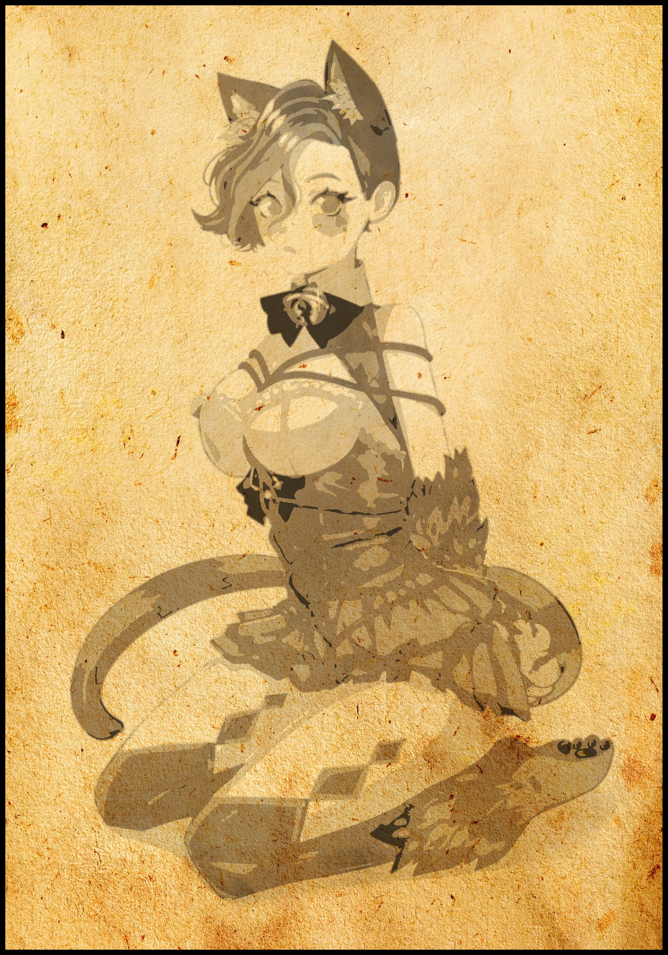
I did something strange last night…wasn't sure what got over me but I wanted to test something with Ben…well, with what was left of her at least.

She's gone now, free to do whatever she likes outside with her new pals…and I'm still here, alone now…

Over the past few days since he got infected, I've been tending to him with food and cleaning up after him whenever he needed to…well, go if you catch my meaning. After the second day he just didn't wake up anymore. He was still breathing but the fever must've knocked him out, that and the freaky things that's been going on with his body. I didn't believe the news but seeing it happen up front…it's something else altogether, especially when I set up a camera to record the process as it goes on over time. Seeing flesh move like water, creeps me out even now.

On the fourth day, his entire body had shrunk and feminized with his legs and arms growing that pink fur I saw in his wounds. On the fifth, he was starting to grow breasts and his face…don't wanna sound gay but…he was looking good. Even started to have his hair go all soft and long like a girl. And on the sixth? Her old clothes had been replaced by a frilly dress complete with the appropriate undergarments…don't ask me how the hell that happened. And she didn't go to the toilet standing anymore…I knew she wasn't human, not anymore with a long ass tail rising up off her ass and soft cat ears poking up through her suave hair. But keeping my eyes on a nude cat girl with her hands tied behind her back squatting on the potty with her vag showing was hard…

She was surprisingly domestic actually, she didn't respond anymore when I called her by her old name. I guess she forgot at some point after waking up from her brief coma. But whenever the time came to eat, she didn't struggle or fight when I came to feed her. Nor did she resist when I had to wash her. Over time I forgot she was even supposed be that retarded friend who tried to run and ditch me. She couldn't speak but I think she more or less understood what I wanted her to do. She'd spend the day sleeping or looking out the window at what was going on outside, snarling occasionally whenever the rare helicopter passed us by. But other than that, she was as tame as an actual house cat. Even let me draw her when I asked her, staying perfectly still with a cute little mew.

I'm writing this about a few months into our, or I guess now it's just me, staying here in this dingy apartment. Supplies enough to last through next year…pity I won't be there to see it all through.

The broadcast loop died a few weeks back and the helicopter patrols have been growing less and less. Back when this all went down, you could hear people screaming, explosions in the distance and inhuman screeching. But now as I write this…it's all gone. There's nothing to hear. Did everyone get infected? Was there an evacuation and I missed it while taking care of Ben? Like I said, it doesn't matter.

Yesterday was different for Ben. She started getting all fidgety when I woke up, tail stuck straight in the air while beads of sweat ran down all over her sensual body. At first I thought it was a fever, that she'd caught sick from being cooped up for so long. She was groaning, yelling in pain, but when I looked at her face, her eyes didn't look like they were-

Slapping the book with a tiny fistbump, the scholar could already envision the following scene just from the brief description of Ben’s state that morning. Pain, a heated look, tail raised up high, all signs that pointed to a feline in heat…it was rare for a Monstergirl to seek release from a human male. But the scholar was beginning to wonder if this transformed Ben truly saw Ty as her friend. Cheshire Cats were masters of deception, able to take in everything about their surroundings before putting them to use in manipulating their targets. And when combined with their incredible patience and willingness to play the long game, maybe this was the turning point in her scheme to finally infect her gracious human host…or maybe she truly did want him to be her mate? No matter, there was still a story to read.

-suffering. They looked…hot…her tongue was out, drooling all over the place. And beneath her clothes, her nipples were rock hard. Driving her mad when each movement probably had the fabric rubbing them all over. I tried to help her but she almost got me for the first time, lunged forward with her mouth wide open before she seemed to restrain her instincts, hissing before letting out a guttural scream I'd never heard her make while bounding across the living room in a pink blue before slamming the door to her room shut. Leaving behind a bundle of torn rope lying on the floor.

For the rest of the day, I was left alone to think. Plan my next steps. I had a vague idea of what was going on but there were only two solutions to solve it.

One, I let her go free, release her to maybe, hopefully find another one of her monster friends to relieve her of her pain…if she even wanted to of course.

Or two, I give myself to her, see how it plays out. Because from what I remember, cats in heat don't ever stop feeling it until they were knocked up or a few weeks have passed. And in this state of Estrus, they were basically ripe for impregnation…which meant that in Ben's tummy…she had eggs ready to be fertilized. And her body was telling her to do so despite her hesitation to infect me…it was what made me so conflicted about the whole thing. The reports said all infected lost themselves by the end, but Ben still seemed to be herself if a bit lost…I knew then I had to try. And really, what did I have left? For all I knew, civilization was gone and I might be the last uninfected person left in town.

So when night fell and I finished my dinner alone, I opened the door to Ben's room dressed in nothing but my boxers…and she looked wasted.

Her clothes were drenched, her body was curled into a ball and her skin was so pale it looked like she wasn't going to make it. From the looks of it, she'd fallen asleep in an effort to block out the physical and emotional stress. But the moment I got closer, her eyes instantly snapped open and she jumped away into the corner of the room like those vids of cats being spooked by pickles. It brought a chuckle out of me and a hiss from her as I ignored her warnings. Shutting the door behind me and locking it before I laid myself out on the floor before her.

It took a long time for her to come around, but eventually, she took the bait. Approaching me with cautious steps on all fours until her legs flanked my sides and her paws were close enough to brush against my shoulders. She must've gotten the hint of what my presence meant because she had stripped at some point, going a step further as she squats there in the nude, red eyes glazed over yet still waiting, unwilling to follow up with the next step as if she wanted me to do it. To take the lead.

I still remember the lardass Ben was, I remember how mad I was at being forced to take care of him like he was some senile old man. But now that same lardass was here, naked and willing as I grabbed her hips and forced her down over my erection. In any other zombie movie, the sacrificial moment usually arrived in the form of an unavoidable bite, leading to a tear jerking moment where the main character or some other important figure has to then die for the greater good of the survivors…only in this case, I'd given myself over to the zombie…and her other mouth held a heavenly bite…Jesus that was cringe to write. Well, I guess it's not cringe if it-
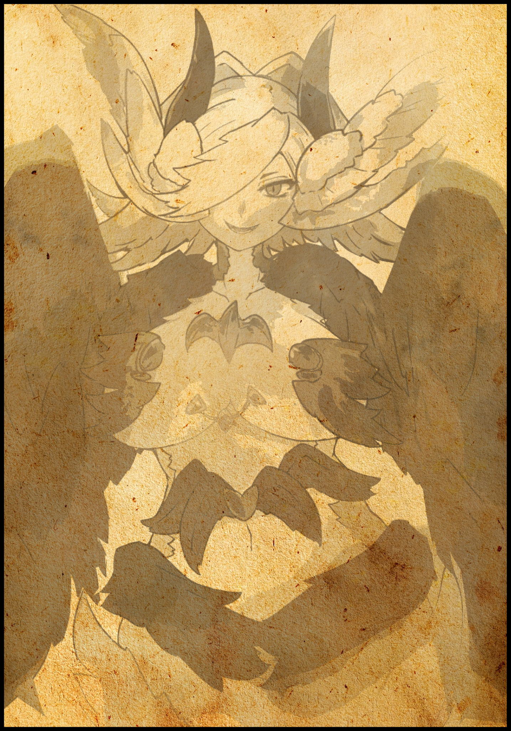
From there, the pages blur once more, covered in indecipherable words that were washed away, forcing an involuntary click of the tongue from the scholar at having the climax be ruined and cut short.

Before his body tenses up upon hearing a subtle flap carry across the air of the dead city. Forcing himself to stay still and hold his breath until he was sure it had been a trick of the wind. After a few tense seconds of waiting with a nervous eye cast at the gaping hole in the wall, the man relaxes before continuing to flip through the book, coming across the next entry and a really badly drawn still of what he could only guess was a Harpy, cementing the fear of what he heard earlier in the back of his mind before willing his eyes away from the life like sketch and onto the next page where the words seemed scratchy and stiff, as if written by hands that were on the verge of losing control of themselves.

Must’ve accidentally wiped a few days worth of entries, hands are almost gone now, I can’t draw either and my mind…it's been slipping ever since I slept with her, I don't remember her name but my body definitely does…not for long though…every night I go to sleep, I wake up feeling…looking different.

But to go over the stuff I erased in accident…I've been living alone ever since I had sex with the girl, trying to hope, convince myself somehow, that maybe I was some special wunderkind who was immune to the gift. That hope was misplaced when I realized the scab on my thigh was actually a scut…s-scale…I think they were called? It started off small, but eventually both my legs became wrapped up in them…A

It was at this point when a massive blot of ink stains the paper, as if Ty had forgotten the nib of his pen remained stuck to the page, seeping its midnight fluid into the paper that remained marked to this day, an obscuring splotch. Flipping the page, the scholar continues reading when the author finally snaps out of the strange spell he had been trapped in for who knew how long.

She came by again…sang her song right outside the window before leaving. It wasn't the girl I slept with, she had claws and fur…this one was…like me, like the others who came before her. Vibrant feathers, bright scutes on her gorgeous legs…but that isn't me though…at least, not yet. Every time my pen slips, and my eyes run over what I've written and drawn, I'm reminded of who I am. A human, a man…but everytime my kindred come by to sing for me, remember less and less….I can't even tell what's changed with my body anymore.

Have my muscles faded? Did I always have such sensitive skin? Pretty soon I'm sure I'll stop writing entirely. I was sure someone else got me to do this but once I wake up next time…will I still feel that same drive to carry on with the next page?

I don't want to forget…but I'm so tired of trying…

So the infected were indeed aware of their plight. But unlike the other cases he'd witnessed, this man, Ty, didn't seem to fall ill with fever, nor did he enter into a coma for the duration of his sickness. Instead he spent his waking hours fretting over the memories lost to the inevitable scourge. But one word remained on the scholar's mind as he pondered Ty's fate and the Harpy's song.

Gift, he had used that word in reference to the virus. Whether it was because his mind was slipping or it implied a deeper meaning and origin behind the transmogrifying virus. He just wasn't sure. This was the first case ever documented of a conscious subject. And considering all Monstergirls lacked the ability to speak the myriad tongues of humanity's still thriving remnants, this was probably the closest he would ever get to deciphering the words of one such specimen who had yet to embrace her new identity.

But as he flips the page after that emotional cliffhanger from Ty who was clearly on the verge of succumbing to the virus. The words Don't Forget are written continuously with the same splotches from earlier interrupting the mantra on occasion until inevitably, they cease altogether, allowing for the spelling of Don't Forget to continue without interference.

It was when the man knew that Ty had ceased to be after the final splotch. The moment the pen rose from the page, her purpose, her old life had been rendered forfeit. Judging from her description of the changes and the strange behavior displayed by the visiting Harpys, she was now one of them…and if his estimates were correct. Ty had lasted close to a year before she fell. That meant the Harpy she had become was probably long dead by now. A solemn moment for the scholar to frown on as he stared at the repeating words spelt out over and over across the pages before noticing something strange.

The words were growing clearer, darker and more defined, as if the entries were being made earlier and earlier, fast forwarding through time until the man came upon the last page where the ink was still wet and the words were neatly scribed with fine hand. The wing flap from earlier, it couldn't be how could it?

Turning his head in paranoid fear at the opening, nothing. The door he’d snuck through, nothing.

Before a snort puffs through his nostrils, followed up by a loud baritone laugh that echoes down the corridor outside. Hundreds of years had passed since the last entry was made and its author was now a carefree Harpy none the wiser to her problems of old. That was that, short and simple. But as he gently lowers the book back onto the floor, his eyes narrow in regret. There was so much he wanted to learn more about, but even he knew when not to overstep his boundaries and when to fall back when the stakes were simply too high to deal with. Besides, he had learned plenty today. That had to be worth something right?
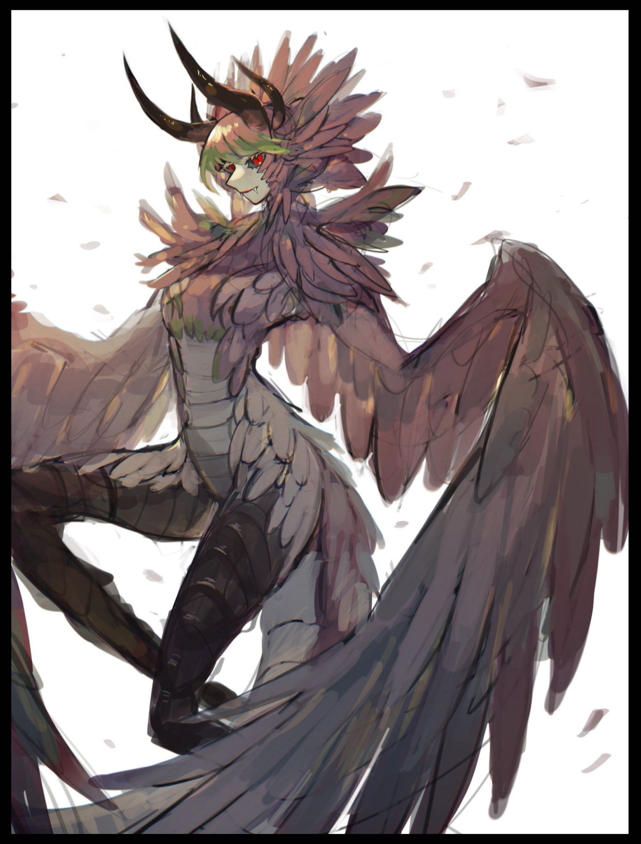
Standing up and dusting off his pants, the man dons his hood once more before giving the apartment one final glance as he turns to make his way back down the corridor, departing as his footsteps begin to fade until nothing can be heard except the gentle hum of the wind.

Before a shadow falls over the building as a towering figure floats silently to the apartment floor, kicking up dust with each beat from massive wings connected to the curvaceous torso of a woman and a thick leathery tail extending from between the pert cheeks of a streamlined derriere. All coated in fine feathers colored a mesmerizing shade of bronze with a pale platinum tint to it stemming from the armored belly of radiant scutes that adorned the Royal Harpy’s toned navel and firm mammaries.

Wicked talons click as triple jointed feet move forward, carrying the tall imposing Monstergirl as she hunches over toward the spot where the scholar was sitting, reaching a wing out to grasp at the book before another flips open the cover, slowly perusing each page with attentive red eyes. Scanning over cute scribbles, impressive drawings and then the brief tale of a human and his comrades who didn't last a year into the spread of their gift throughout the world. In truth, the words were alien to her. But the meaning behind them wasn't. She understood their loss of Mark, the brief conflict between the author and Ben. Followed by the brief moment of fear and indecision a now lonely Ty would have to go through until…she came, smiling whimsically as she rolled a pen between her feathers before slotting them back inside her wings with practiced finesse.

Collapsing the pages, a gentle wing places the diary back down to where she had always left it since her initial awakening before her sisters, the Royal Harpy turns tail before dropping off the edge of the building, carrying herself on the wind back towards her nest far off in the distance. She would return again next year to make her annual mark on the pages out of an instinctual need to do so, an obligation to fulfill until the last page was filled while refreshing herself on the story within. It was the least she could do for the lonely human who had no idea what to do in the face of something as awe inspiring as the gift was.

Meanwhile, the scholar would glance upward just in time to glimpse the distant shadow cast by the grand silhouette of the Harpy matriarch flying off into the sun. There was still much to learn about the infamous creatures and their ways, but given enough time, he was certain they'd be able to coexist as equals. That was a Royal Harpy, a legend few got to witness with their lives, and he had a feeling it was none other than Ty. A few hundred years older now with a more benevolent nature to her judging by the fact he was still standing.

Despite the dangers, a scholar's life was one of never ending thrills. They learned new things, archived them and taught them to their respective communes. While he wouldn't learn much in the scientific field today, the tale of Ty would be one he was sure to remember for a long time to come…

THE END

