PATOOIE, FATUI
COMMISSION STORY
BY CHALDEACHANGE
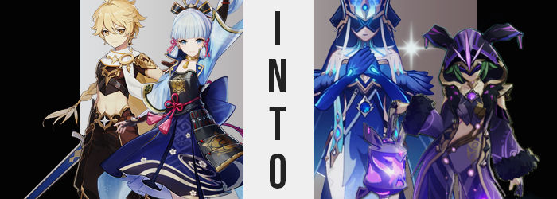

The Vision Hunt Decree felt like an issue that had plagued Inazuma so long ago now by this point. Put in place by the ruler of the island nation, the Raiden Shogun, it had sought to wrestle away the Visions held by its people. Something that no one agreed with, but it was something that those working under her had no choice but to enforce. In the end it had been little more than a bad decision fueled by misinformation… and a leader that was not quite what she seemed.

It had been reversed in the end in no small part thanks to the efforts of the Traveler, Aether, a young man from beyond the stars of this world that constantly found himself pushed into its struggles while pursuing his missing twin sister. He had wanted nothing to do with Inazuma’s problems when he had first arrived, already tired after being sucked up into the drama of both Mondstadt and Liyue. But after getting to know the people of the nation, after befriending some of them and seeing their suffering, he had eventually decided to help them.

That was why even after most of the nation’s more obvious issues had been dealt with, and they were finally in the recovery stages, he was still helping them out. He was in no rush to travel to Sumeru just yet, and in this case? He was out and about on a personal favor requested of him by one of the first allies he’d made when he’d first arrived in Inazuma.

“Traveler? Do you think we should split up temporarily? There shouldn’t be any threats present.” That ally suddenly spoke up, stirring the blonde-haired young man from a moment of thought. It was Ayaka Kamisato, a fairly prolific individual in Inazuma. Around the same age, the two had certainly hit it off back when he had first arrived. But they weren’t here, out at this remote and abandoned camp, for the sake of reminiscing.

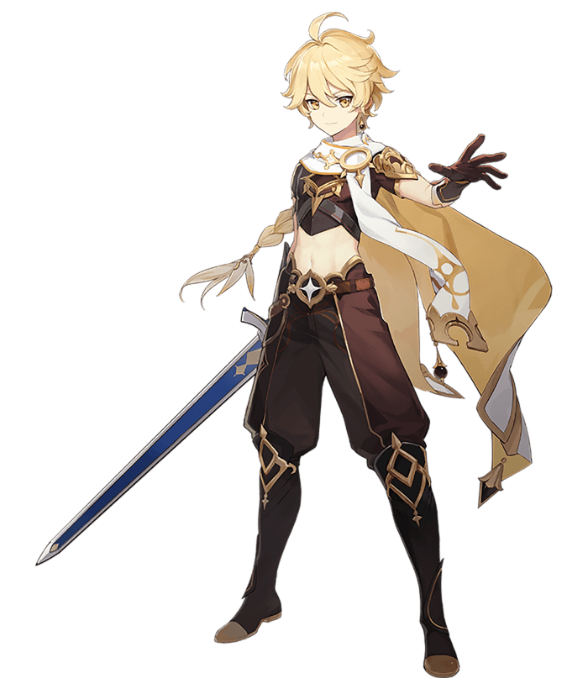
In fact, they were helping with a little cleanup. Fatui agents had used this outdoor camp as one of their bases of operation while the Vision Hunt Decree was underway. As always they were up to no good, but in this case their plans had been extra nefarious. Seeing the civil war take place with Inazuma thanks to the decree, they had started circulation Delusions in secret – fake Visions that gave regular humans the ability to wield elemental powers at a cost. And that cost turned out to be their own life force. Many had died as a result of these plans.

“Sure.” With a nod, the boy pointed off towards one corner of the camp. The direction he’d take off in, and so the two teens split up. After La Signora was defeated, the Fatui in Inazuma had scattered – and had left the remaining Delusions scattered about these many camps they had been using. It was dangerous to leave them there; they needed to be destroyed. And that was what had brought the two of them there that day.

Aether lamented that Paimon wasn’t at his side that day, but back in Inazuma City she had been swayed into staying by promise of Thoma’s home cooking. Sure, she could be annoying at times. But that little fairy of a person was still his closest friend.

“Hm… This must be part of the stash. The crates look like the others.” While exploring one of the bigger tents on his side of the camp, he eventually came across some boxes that bore familiar emblems. He had seen them enough in other camps to know that he was right, but he still reached into the crate and picked up one of its contents just to make sure. “Yup.”

With his palm turned to his face, he could easily seen that he was correct. It was a faux Vision, one bearing the emblem of the Hydro element. That meant that their information was correct, and they’d have to get someone out here to collect and destroy what remained. Just as he was about to put the Delusion back in the box, however? It began to glow.

“Huh? That’s weird…” Considering his constitution, which was considered ‘unique’ by the people of this world, there shouldn’t have been a reaction between himself and the Delusion strong enough to force it to activate, but he didn’t quite feel alarmed by it. But he probably should have.

In fact, he couldn’t seem to dop the Delusion regardless of how much he wanted to. And the light it glowed with? It not only became increasingly brighter, but so too do his yellow eyes begin to glow with the very same blue. Even stranger? So did his lips? Well, it wasn’t like Aether’s lips began to physically glow. It was a blue lipstick that was applied to them. One that had them appearing fuller, and debatably more feminine.

Had that only been isolated to his lips, then maybe it wouldn’t have been that odd? But it bled into the rest of the Traveler’s facial features as well. Glowing eyes not only grew rounder, but the lashes that they blinked with extended almost a full inch – and there was very clearly mascara forcing them to look that way. His facial structure as a whole became longer and fuller, more unlike the people from Snezhaya that he had met throughout his travels.

Or, well, the women.

“I need to get rid of this thing… But why would I discard my own Delusion?” Conflicting thoughts arose and were ultimately spoken, one in a voice that sounded much more maidenly than the boy’s typical sound. Any desire to discard the item that was changing him had all but waned, even though the transformation itself was growing much more severe.

Take Aether’s hair, for example? Already light in color, its blonde began to fade into something even paler. A soft white that better suited his new eye color, but looked almost a little sickly… when you also factored in how his skin was paling as well. Not only was that skin getting paler, mind you, but it appeared to be getting softer as well. Both to the touch, and in the sense that all the muscles that firmed his arms, legs, and exposed tummy had melted away into something squishier and physically weaker.

And mentally? All of his sword training disappeared with it. He soon found himself better versed in the ways of wielding Hydro through a catalyst.

“Ugh! Oh my, what was that?” A sudden feeling had forced him to lurch forward… except something about that statement was now false. That something was the implication that he was still male, which she most certainly wasn’t. Her cock and balls had been yoinked inside of her pelvis, which had been sudden enough to prompt her outcry. Just as quickly as it happened, and as prominent as it was though? She just as quickly dismissed it as nothing. Another sign that her mentalscape was being reshaped just as her body was.

With her sex changed, the rest of her body began to fall in line as well. A plumpness beset her thighs, seeing them burgeon and swell past a point that would have been comfortable in her pants. In fact, they swelled with such an abundance that tears began to form in their sides, hips afforded no choice but to push impossibly wide in the process. Of course, her ass followed suit. And boy did it bloat. As if to match hips and thighs that looked too out of place on a woman of her shorted stature, her cheeks ballooned and bounced, cleavage poking out above pants that could hardly cling on any longer before they were eventually yanked down to reveal much of her pale, bare ass.

Farther north? What was once a bare, featureless chest soon fattened up and pushed forward. It took but a single glance to identify what was obvious – that a pair of breasts were budding and swelling with glee. Initially starting as slight mounds that just pushed Aether’s top forward with slightness, they eventually swelled bigger and bigger, lifting the top until her pale underboob was entirely exposed and bare to the world. By the time they had reached peak fullness, they were around E or F-cups.

Sizes that, once again, appeared rather out of place on a body that was so short.

In the meantime, Aether’s head felt like it was in a daze. Where was she? What was she doing? What was she supposed to be doing? These were all questions that should have had clear answers, and yet her memories felt like they were all swirling in a vortex of uncertainty. Which worked out fine for the force that was transforming her in the first place, because it kept her plenty distracted from the changes that came to her body.

Though the final one had finally begun to take place. It was true that her figure just didn’t look right upon such a short and young body, and that was ultimately fixed as her height began to increase. Slowly but surely she reached towards a height of six feet, her pants pulled down off her ass and crotch to reveal her pussy and a bush of white hair all the meanwhile. Lengthened fingers saw her gloved fit uncomfortably, and a longer torso showed off even more of her tummy.

That said? Did she still seem fuller? All of the skin on her body ultimately appeared looser. And judging by her face, it was fairly clear why. Not only was the woman getting taller, but she had been getting older as well. What was once a boy in his teens had quickly become a woman in her thirties, complete with the signs of aging in her body’s physique.

And then, with a blast of water from the Delusion that didn’t even make her bat an eyelash? Her clothing was transformed into an elegant, blue dress over white tights – accommodated by matching blue gloves and black boots. A headpiece of blue (complete with a veil) was fashioned to a mask that covered her eyes, yet she could still see. It was an outfit that covered everything except her shoulders and lower face, yet shapely as her body was? The tight fit of these clothes still made her very attractive.

With the mask now covering her icy blue eyes, it was difficult to perceive the expression that the new Fatui Mirror Maiden was wearing. Tall and curvy, she was an older woman who would bear a suggestive sway regardless of how she moved. She was also clearly a woman of Snezhayan descent, which Aether most certainly was not. But it didn’t really matter that she had once been a man from another world. No.
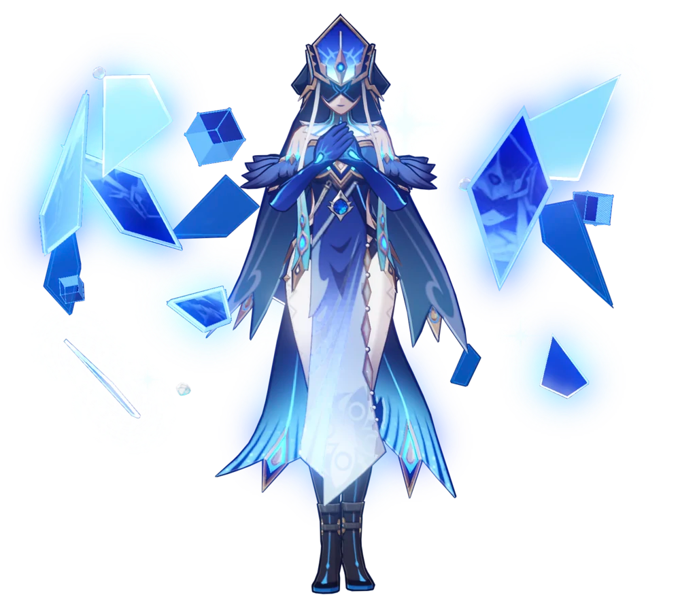
Angelina believed that she had been born and raised in Snezhaya, that she had taken up the cause of the Fatui because it was best for her great nation. That their great Tsaritsa would never lead them astray. Searching for a lost sibling? Such a thought never even crossed her mind. She just wanted to bring prosperity to her homeland, to be able to help provide for her family. Nothing else mattered – most certainly not the needs of other kingdoms.

“Strange, though… Did something happen to the camp? I suppose I will wait a little longer and see if anyone else arrives…” It almost seemed like the camp had been abandoned. But why? How? When? She had question after question, but absolutely no answers. And so, like a mature and reasonable woman, she would wait.

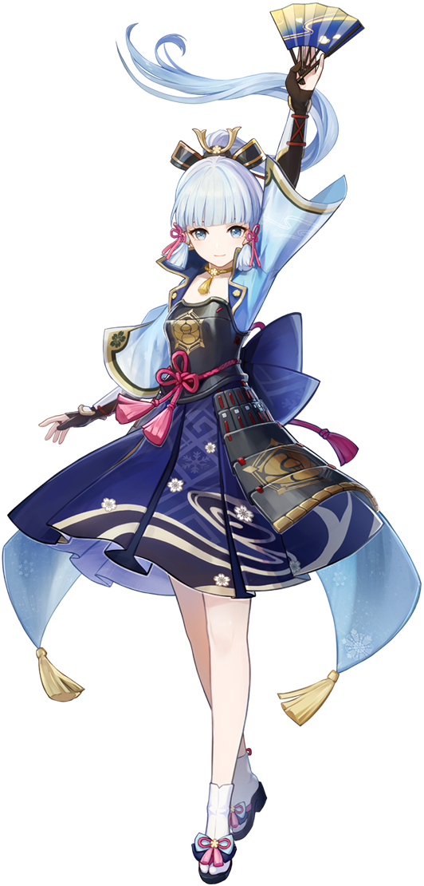
“Oh! This looks like the other crates we’ve seen!” Around the same time that Aether had found a crate, so too did Ayaka Kamisato find one as well in the opposing corner of the camp. A young woman with no shortage of elegance, each of her movements was deliberate and careful as she pushed the lid off the crate enough to pick up the first item she saw inside. Holding a Vision herself, there was no reason for her to fear a Delusion. Two could not exist in tandem with one another.

Admittedly, she had never actually held one in her own hands. It appeared to bear the symbol of the Electro element, while Ayaka herself was a wielder of the icy Cryo. It was scary just how much it resembled a Vision – scary because she knew that it was through that similarity that the Fatui had managed to trick innocent people into wielding one and hurting themselves as a result. As she lamented this, though? She suddenly found her eyes widening.

Because the Delusion began to glow in her hand.

“What’s… going on here? Why do I feel so… Hehehe!?” The light was bright and tingly, and while Ayaka didn’t quite notice it, it completely destroyed the Cryo Vision that was hanging behind her neck. What startled her more than the light, however, was the giggle that had escaped her lips. Not only was it out of character, but it was completely unwarranted. What had provoked her to make such a sound!?

She could only assume that the cause was the Delusion glowing in her hand, but as much as she wanted to discard it? She couldn’t. Not because it was physically impossible, but because she subconsciously prevented herself from doing so. “I need to throw my Delusion away! Ahaha! Why would I do that, though? Because it’s causing something strange!” Why was she even arguing with herself!? It was as if there were two voices wrestling for control, all while her eyes began to glow the same deep purple as the Delusion.

All of the fine hairs on her body began to stand up as if they were reaction to the Electro element that was born from the light of the Delusion. But these hairs weren’t the only things standing up. Somehow her body found this all to be arousing, and her nipples were standing erect beneath the armor that covered her chest. Not only did they grow erect, mind you, but they grew in size as well. A precursor to the advent of size that also came from her chest. Breasts swelled, although only a pair of cup sizes in the end. While the growth wasn’t that excessive, it was still enough for soft breast meat to push over the cusp of the armor plate, wanting so desperately to escape.

“Ooooh! I feel so tingly! Wh-What am I saying…?” Ayaka’s bizarre comments almost bore as much whimsy as those of a child, even though her body was increasingly becoming more and more like an adult. Her hips had swung wider beneath her skirt, and from them? Her thighs and ass alike both grew fuller. Legs took on much shapelier forms while her ass swelled into a peach shape – both stretching the white spandex she wore beneath her skirt. In the end, she bore a figure that was much more adult.

And that showed in her face, as well. While perhaps only in her twenties, the age that was applied to her still escalated what had originally been her perceived age as a teenager. Not only did her facial features grow older though, but they also appeared to differentiate themselves from those of a woman of Inazuman birth. The narrower shapes of her eyes widened, for one, and her face appeared slightly longer overall. While she kept the mole beneath her eye, otherwise? She looked like a Snezhayan.

And her memories were beginning to reflect that.

“I’m… Heeheehee! I feel great!” Ayaka could still tell that something was wrong, but she cared less and less about it. A forest green not only teased the white of her hair, but overall saw the length of it shorten to boot. Before long it rested only at her shoulders, the locks courses and spreading out to the sides. She idly began pulling at her clothes, trying to paw at the overflowing tits beneath them, not even caring about how it might have looked had she been caught.

Fortunately for her, her unhinged actions had an easier time pawing at her breasts once a jolt of electricity ran across her body. It saw her outfit to be dyed in purple, armor peeling off and becoming repurposed into a bodysuit of Snezhayan make. It highlighted her curves nicely, with a hood that hid her face – or at least the parts that weren’t already hidden by her new mask. She really loved how big and fluffy her sleeves were!

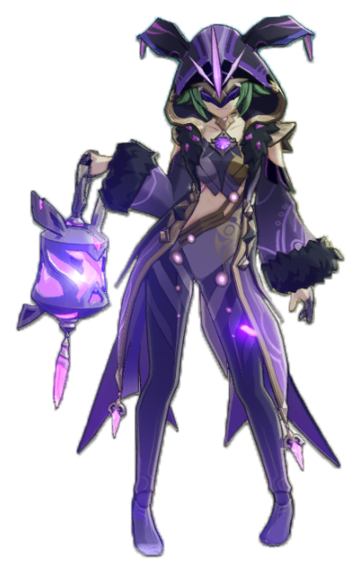
“Hehehe! What was I doing? I feel so freeeee all of a sudden!” While Ayaka was elegant and deliberate, none of that was present in how she conducted herself now. Her movements were erratic, the woman practically dancing about while idle. And her voice? She was just blurting out whatever she wanted to in the most uncouth of ways. That made her the perfect Electro Fatui Cicin Mage, for they were all childish and free-spirited despite being fully grown adults. Perhaps that was the sort of price they had paid for the Delusion at their sides?

Nonetheless, Annika saw herself as nothing but a Fatui Mage. As had been the case with Angelina, there was no doubt in her mind when it came to her origins. That she was born in and had been raised in Snezhaya, and that she had chosen this path. Wasn’t it so fun to live this life, anyways? She could cause so much chaos with no repercussions! It was great!

“Buuut what the hell happened here!? Why was our camp trashed!? ANGELINAAAAAA!?” The Mirror Maiden was something of the camp mom, so of course Annika would be drawn to her, childish as she was. That said, there was something else to their relationship as well. But the two would have to endure the unfortunate truth. That the Fatui had failed in Inazuma, and that they would have to return home.

But hey! Perhaps they could make their betrothal official before they were reassigned?

