CLASS ADVANCEMENT
COMMISSION STORY
BY CHALDEACHANGE
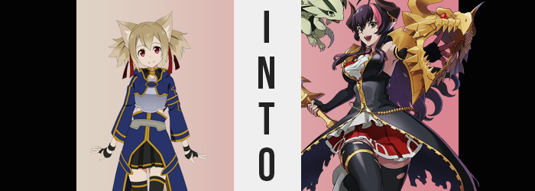

ALfheim Online, otherwise known as ALO, was a wonderful game.

An immersive virtual reality massive multiplayer online game, it rose in the coattails of the disastrous failure of Sword Art Online’s tragic conclusion, where everyone was trapped within the game world and many, many players died in real life as a result. The equipment that was used for ALfheim Online was provenly safe and had been for years by this point in time. There was no risk of a Sword Art Online situation ever happening again.

The theme of ALO was a fairly simple one. It was a world of fairies, and so fantasy elements were abound in plenty. Each player got to choose a fairy subtype for their race and had a number of jobs to choose from, and since the game was the kind of immersive VR where you could upload your mind and experience the game like it was some manner of pseudo reality? You could really simulate the feeling of flying with your wings, something that had prompted it to rise in popularity.

It was such a good game that many of the Sword Art Online survivors had ultimately chosen it as their game of choice. After all of the trauma they had lived through it was a good recovery tool, and since it was fun and popular? Plenty of kids their age were into it anyways.

For Keiko Ayano, a player of ALO who went by the username ‘Silica’, it was part therapeutic and part fun. She was a survivor of the Sword Art Online incident, but her friends from her time trapped in that game also frequented ALO. In fact, thanks to Kirito and Asuna, one could say that they had garnered quite a reputation within the game’s community. And while she normally played exclusively with her friends…

On that day, Silica was playing alone. Well maybe it was incorrect to say that she was playing alone, but she wasn’t playing with anyone she was exactly familiar with. The rest of her friends were busy with this and that, too busy to play games that evening. But Silica? Her schedule was open, and ALO actually had a pretty interesting event going on! One that she didn’t want to admit, but there was a small caveat.

It was a large scale raid event that introduced a brand new dungeon into the game. It was only active one day of the week every week, which meant if you missed the day it was on, you wouldn’t have the same progress as everyone else who was able to do it. But you also needed to go into the dungeon with a raid party. A group of five or more. You didn’t need to return to it with the same group to pick up with your current progress, so the Cait Sith girl intended on getting a head start so she could bring the others up to where she had gotten to the next week!

“Um… Did I get separated from the others?” Being trailed by her feather dragon familiar, Pina, Silica could not help but notice that everyone else in the party she had entered the dungeon with was nowhere to be found. They had made it quite a ways in together, and she had been thinking the next checkpoint would be a good place to save her progress and log off. But had she taken a wrong turn? They were completely alone!

The hallway she was walking down was dimly lit. Maybe it wasn’t all that surprising that she had lost track of them. Should she turn around or move forward? The teen moved around anxiously, unsure of which route to take to reunite with the others or at least find the next rest spot. But in the end it didn’t really matter.

CRASH!

“AAAAAAAAAAAAH!”

Because the floor suddenly gave way beneath the Beast Tamer, sending her falling several floors down into the dungeon. It wasn’t until she was inches away from hitting the floor, but she managed to remember to activate her wings to cushion the fall. Her feet were just inches from the ground, a close save that likely would have sent her back to respawn from the fall damage had she not deployed those wings in time. “…Phew.” But Pina, it seemed, was still a ways up. She’d probably fly down sooner or later.

It was surprisingly well lit wherever she had fallen. “Is this a treasure room? Maybe this was lucky?” There was a lot of gold scattered about. Had that broken floor been a trap meant to test anyone that fell into it? To reward them with the treasure? It really looked like up was the only way out. Among the treasures though? There was a curved, golden blade with sharp barbs along its edge resting on a pedestal. It looked rare. If she was going to take back anything, that would be it, right?

And so Silica picked it up with the intention of stashing it in her inventory. Maybe Kirito or Asuna could make some use of it? Swords weren’t really her forte. Before she could put it away though? A message appeared on her HUD. It took her by surprise, and she dropped the blade as a result. “Class changed to Dragon Knight? Um… Wh-What?” There weren’t items that could just change your class without permission, were there!? It would have gone against the very spirit of the game if there had been!

That was assuming that this blade belonged in the game though. It was an oversight that the developers hadn’t caught onto. No one was supposed to find the room that Silica had fallen into, and certainly no one was supposed to interact with that curved, golden blade. The code it contained was unusual, so much so that it had been deemed a danger to the player base. Yet at the same time they had been wholly unable to remove it, so at best they could only cover it up with a secret room.

It seemed someone on the development team had left a path open intentionally though, with similar items appearing elsewhere in the confines of the dungeon.

On her HUD, a number of different screens flickered past in quick succession. “I can’t read all of this that quickly!” From what sense she could make of it, it seemed to be outlining all of her new abilities and attacks. Lethal Punto? Biting Dragon? Dragon Wings? These were all attack names she could just barely catch sight of as they flickered past her vision, display windows closing just as quickly as they popped up. But her character’s stats were rising too, giving her numbers that were… Well, could the number values for a character in ALfheim Online even go as high as hers now were? “Maybe I should log out!?”

That would have been the most rational decision, but she couldn’t. She had yet to save her progress in the new dungeon, and doing a forced logout would prompt her into restarting the entire thing! It would have been a waste of her entire night, and as things stood? She didn’t think she was in any danger. At worst she figured she would need to send a support ticket to the admins of the game later to have any damage undone. Yet even if she had actually tried to log out at this point? It wouldn’t have worked.

Eventually all of the popups concluded and her HUD returned to normal, prompting a “Phew…” to escape the Cait Sith’s lips. But her moment of relief was a fleeting one, for now that the things had been taken care of on the statistic end of the game, adjustments had to be made to her model. An ALO player’s character model was ultimately an extension of their own body, however. It felt like a real body to them, just with pain inhibitors to prevent unpleasant feelings from being communicated. So if something were to change in this avatar body of hers?

Silica would definitely feel it. Which she did.

“Um…? Is something wrong with my model? Why do the treasure piles seem farther away?” It took her a moment to initially realize that something was awry. Sure, her clothing felt a little tight in the vertical sense all of a sudden, but it was her surroundings that tipped her off. She looked down at her own armor, noticing the top had been pulled up to show her tummy, and the base of her skirt was sitting higher on her thigh. “W-Wait, am I getting taller?”

The girl had always wondered what it was like to be taller. She was still growing, but was she ever going to hit a growth spurt at this point? It certainly hadn’t felt like it, yet her avatar was clearly undergoing one at that very moment. She had grown taller, bones and flesh alike changing to accommodate an added four inches of height. This didn’t sound like a lot, but the fairy’s body was rendered quite lanky.

“Is this part of the class’ kit? But no other classes change your model, do they!?” There had been a voice crack at the edge of her sentence, making her voice come across as deeper and, oddly enough, more energetic when contrasted by Silica’s regular personality. But the surprise she had spoken with hadn’t been unprompted. After all, her hips had suddenly popped and her knees had buckled as hips settled into a widened gait, almost knocking her forward. “Wah!?”

By the time she managed to correct her posture, there was a little more to her body than there had been prior to her almost falling over. As she rose back up into a straight standing position, the weight of her thighs bloated and thickened, making good use of the thigh gap that had been afforded to her by her now widened gait. They were thick with soft tissue, but there was also a newfound mass of muscle to them as well. The same could be said of her ass, which pushed out behind her – stretching her panties until they naturally wedgied her ass crack in the back, but likewise ground against her crotch in the front.

“Eep!? Why can I feel that!?” ALO models had a safety mechanism on them so that nothing sexual could be seen or felt, yet evidently that safety had been overwritten for the sake of Silica’s transformation. The muscles of her tummy tightened into hard abs above her widened hips, yet that sexual feeling issue came into play again once change began to affect her chest.

Her bosom felt warm. Tingly, even. She knew what it felt like when she was aroused, and it did feel a little like that. And with the metal plating of the armored chest piece surrounding her tunic pushing forward, she could tell why this was the case. “Woah! Is my chest getting bigger!?” She was utterly shocked, so why was she saying it with such enthusiasm? That voice crack from before was persistent now too, giving her a permanent voice change.

The steel armor dug into her back, for the heft of her bosom was pushing the section in the front forward. It was metal, there was no way that growing breasts would break it regardless of how big they became – and all signs pointed to them reaching D-cups at least. With all of that weight pooling within, desperate for a place to escape as enlarged nipples pressed against cool metal, she soon found it difficult to breathe. She was gasping for air!

Fortunately for her, the armor she had equipped was swapped out without her needing to do anything. Her figure was clad suddenly in black, flowing overcoat with torn tails over a ruffled, white blouse and crimson skirt hemmed with white decals. Black thigh highs reached up to the center of her thighs, and cloth boots wrapped her tootsies. Fingerless, black gloves reached up to her shoulders, but the fashion of it all didn’t matter. Silica’s bosom heaved as she took a deep breath, her breasts no longer crushing her lungs with their mighty weight.

“Did that really just happen? I must look way more mature…!”, she managed to say between gasped breaths. She didn’t know just how right she was, because even her face reflected a change in age that better suited her new body. Plump lips were pulled into a smile beneath a sharper nose. Her eyes were bigger and sported longer lashes, though her irises had been changed to green from red. With a narrower shape overall, she didn’t look anything like her previous self.

And the final touches settled in entirely when things came to her head. Furred, tan ears were robbed of their fluff, shapes thinning as those ears settled down on the sides of her head to better resemble a pair of pointed ears that were more common among the other fairy races in the game. Her similarly colored hair thinned and lengthened, color darkening to a dark purple aside from a streak of pink that ran across the left side of her bangs. And while not uncomfortable, a pair of curved horns then curled forward from the back of her skull, completing her transformation.

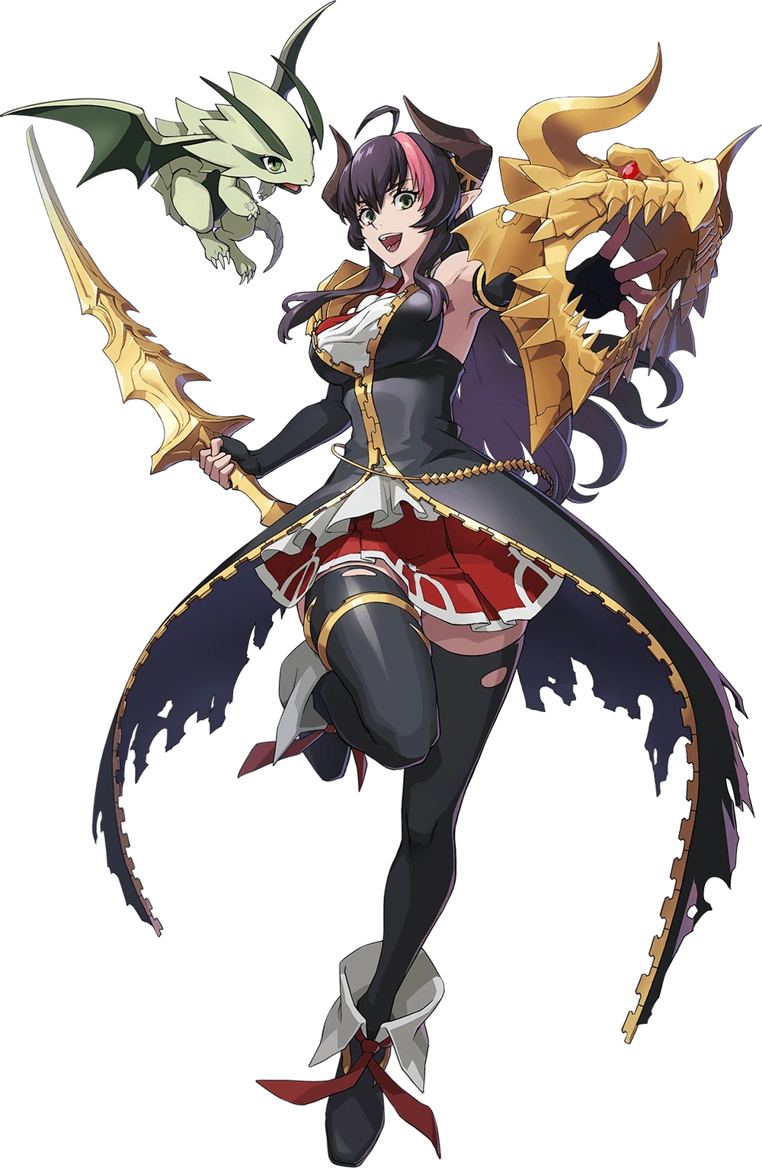
“Heeeeeey! Astra!? Where are you, Astra!?” The woman at the bottom of the pit called up to the darkness above her, and no sooner than she had, a small, green, scaly dragon flew down at a high speed, eventually floating just over her shoulder. “There you are! I was wondering where you got off to!” This dragon, Astra, was actually no different than the woman herself. It was the product of Silica’s class change. Astra had been Pina.

It seemed that Silica herself realized. “Wait, why am I calling you Astra? Isn’t your name… Uh… What was it again? But I guess Astra still works!” The dragon chirped in reply. At least the woman still recognized herself as herself, but her personality was much bouncier and extroverted, wasn’t it? The old Silica wouldn’t speak with that much energy. But on the bright side? She felt closer to her dragon companion than she ever had!

As expected of the one that carried the title of Dragon Knight!

“Hmm… This body feels a lot stronger, and it’s definitely way more mature! My stats have gone way up too! I bet there’s some baddies in this dungeon that we could use to test our new strength, right?” The Dragon Knight had the right attitude, but why was she so unphased by it? Shouldn’t she have rightfully been shocked? But it all felt right. While Silica herself didn’t see it this way, maybe a little too right. She almost didn’t want to go back to the way she was before!

But if she was going to find some monsters to fight, the woman and dragon had to get out of the treasure room, didn’t they? Fortunately? That wasn’t really a problem! Because out of nowhere? A pair of big, green dragon wings expanded from her back, and she bounded back to the floor she had been on with a single flap of those strong wings. Astra followed after, of course. The moment she landed further down the hallway, those wings retracted and disappeared again.

Starting down the way, a thought did cross her mind. “I probably should log off soon though, right? I need to get ready for bed… But why would I log off when I’m having so much fun? In fact, I could stay here forever!” It was a thought that would come to be realized regardless of her intentions. Because the Dragon Knight was not an ALO class.

And because of this, she could not log out.

