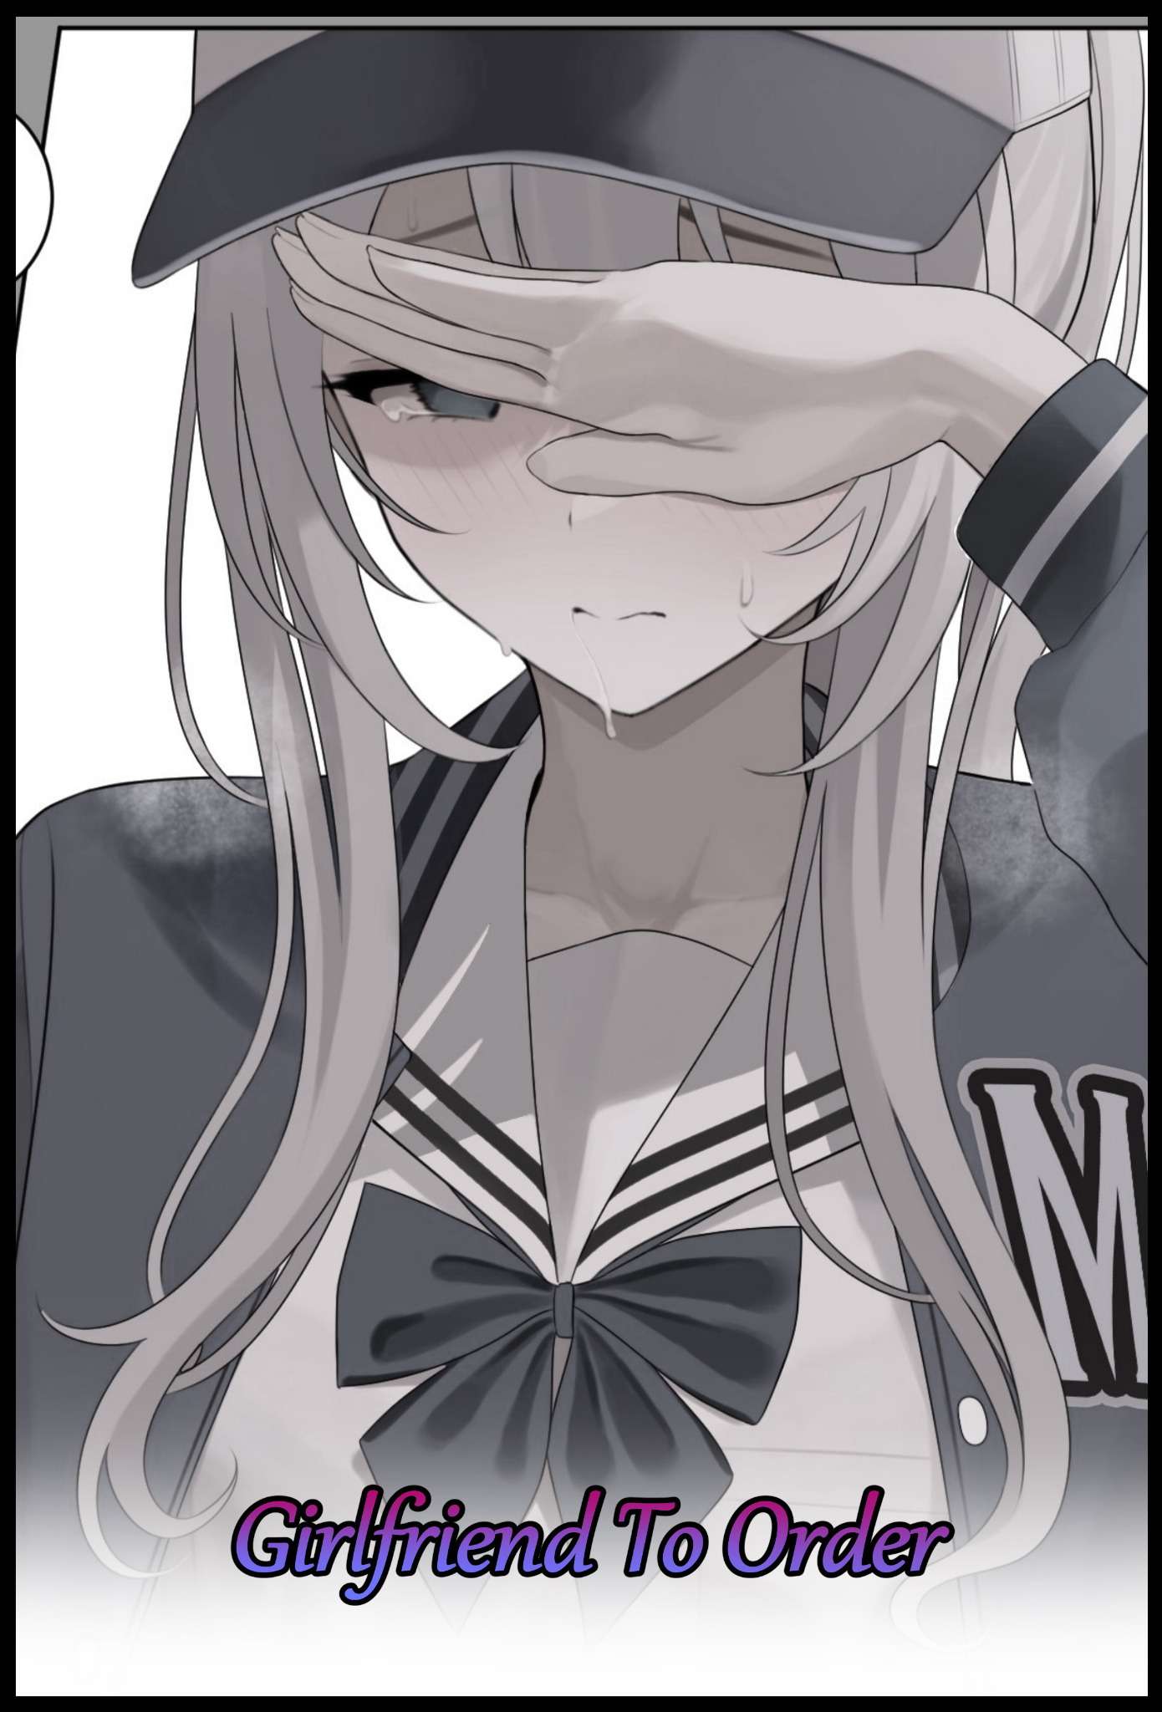

Rolling around the floor of his bedroom, a young man going by the name of Nick seemed to be overcome with joy from whatever he was looking at on the phone he held onto with sweaty hands, eyes so wide they looked like they could pop from their sockets at any moment while he continued to carve a visible path into the carpet beneath him with his rotating body before coming to a sudden stop on his back, arms raised high into the air with a faint bead of sweat rolling down his forehead from the exertion of it all.

**"I can't believe I was lucky enough to get selected for this test! Finally…a girlfriend to call my own! Now we'll see who's the loner when I'm done with this baby!"**

Rewinding to a time in the not so distant past a few weeks ago, Nick had been with his best friend Fred when he would receive an advertisement message from a well known pharmaceutical company based in the local region looking for willing participants to help test an augmented reality application that could supposedly grant its user the ability to create their dream girlfriend with a female oriented version of the app being used to develop it, co-opting advances and tech with the old app to vastly improve this one with wild promises like granting the user the chance to be with the girl of their wishes in the flesh…

As wild and crazy as it sounded, Nick, ever the gullible youngster, had been quick to buy into the whole shebang, earning himself a mocking response from Fred once he'd excitedly told him about the message.

**"Seriously man? 'Dream Girlfriend'? You're better off lookin' for a real one than trustin' in that sort of stuff! How much did they get off of you huh? Better check to see if that's some sort of scam you got yourself into before they make off with your piggy bank!"**

**"Hey screw you man! It's no scam! And it's from Biofirmica! How can it not be real? They made all that super high tech medicine stuff didn't they?"**

Thinking back on it now only made Nick grimace in a mix of embarrassment and ignorant righteousness. Sure, his outburst had been unwarranted but his pride would not allow him to back down and see his mistakes as they were. He had heard plenty of the firm's achievements in the field of medicinal science. But he had also neglected their juicy history of unfair corporate practices involving the assimilation of smaller medical brands and the targeted assault of its bigger rivals aiming to cripple and rob them of their secrets. All rumors of course, but none so crazy as to be unbelievable, unlike the ad that had been sent to Nick.

**"Nick buddy…I think you might need to chill out for a sec…didn't mean any offense when I said what I said…just spittin' the facts before you get yourself in trouble…Biofirmica ain't all rosy as you might wanna think it is…"**

Unfaithful, he'd called his friend. Refusing to see him ever since their first major argument in the few years they'd been together since middle school. Believing himself to be on the side of angels until the fateful day when he would receive an alert message from the contact he had saved on his phone, telling him the app was ready to be downloaded and tested alongside an incredibly brief letter that basically told him what he could and couldn't do with the highly secretive software. Typical company NDA agreement stuff when it came to unreleased products being tested by the faithful few like Nick had fashioned himself out to be, wholly believing in Biofirmica as he installs the application to his phone on the way home, not even taking the time to bathe and freshen up before he had ended up where he was now; rolling around, unable to do anything in a state of delirium, eyeing up the newly installed app he'd booted up after touching down in his bedroom, ignoring the message sent by Fred asking where he'd like to go for his upcoming birthday in his bid to get right into the thick of it.

At first glance, Nick could tell how 'fragile' this high quality creation was from the moment his mind had settled enough to figure out what he was looking at. A minimalist user interface that gave off high quality vibes while looking…well…simplistic. But at the same time there were many placeholder assets floating here and there that made the beta test part ring even louder in his mind, proud to see his concerns were right and that Fred had been stupid to look down on Biofirmica as a trustworthy company. The same one his dad worked in. The same groundbreaking medicine makers that had saved his mom from a near fatal disease…he was as proud to help them as he was excited at the prospect of 'generating' his dream girlfriend like they promised, a process he couldn't seem to understand as he scrolls through the simple main menu, above which sits the proposed title of the application; Build-A-Mate…on the nose but straightforward…

**"Now, let's see what this thing can…do…holy, are these just the base options? There's so goddamn many!"**

Body shape, eye patterns, brow configuration, ethnicity, skin tone, hair length and color, the length of her nails. There were so many options, many of which extended past physical traits and into realm of impossibility, making Nick's excitement skyrocket as the mind of a hormonal teenager with one foot in childish naivete and the other in adulthood begins to flood with the endless possibilities he could create with this extremely detailed list of preferences he would like to see in a girl tailor made for himself.

Despite being a final year highschool student, Nick's knowledge base was…to put it kindly, above average. Meaning that *some* of the options would be confusing to make out for the horny youngster as his fingers set to work building up an undyingly loyal girl. Caring less about parameters like 'Set Point To' while devoting more brain power towards stuff like writing up a perverse preference for a sporty gal who would act completely serious and refined in front of everyone else…

*'Except when she's alone with her lover~ Where she'll be all over him in no time, willing to do whatever he wants her to do~'*

Crafting the perfect body of an athlete balanced with that of a gravure model with the provided 3D sculpting feature was more than enough to blind Nick to all the dangerous blanks he was living in the creator as he continued towards the end, focused more on stuff like kinks, libido levels, behavioral tics and speech patterns instead of the missing links as to who and what he would've liked to add those triggers to, living many things up in the air for debate by the forces that governed the unsuspectingly powerful tool in the hands of a clueless young man, grinning from ear to ear as he inspects his finalized creation with a thumb hovering dangerously close over the bright red FINISH button with some very nondescript warning text beneath far too small for anyone to pick up on until it was too late.

Platinum hair done up into a ponytail as natural as the pronounced curves that showed subtly through the girl's school uniform and accompanying open football jacket that kept her sheltered from the elements, topping the ensemble off with a cute cap nestled atop her head. The perfect cover for the closet pervert he intended to bring to life after his hovering thumb finally depresses the switch, causing the application to freeze momentarily before a loading screen appears, leaving Nick in anticipation as he wonders what medical miracle the company he had unabated faith in would conjure up to make his fantasy a reality. Cloning? Generating an entirely new flesh and blood body based on his preferences? He had a feeling all would be answered once the request had been processed and the next page loaded up.

Except what he didn't know was that the spaces he'd left empty were directions for the application to differentiate between who the Boyfriend (Master) was and the Girlfriend (Recipient) was. Thinking of them as nothing more than debug notes to ignore in the long run, none the wiser to the insidious way the application worked as it begins its work, reaching out for the closest material to work with…and thanks to Nick's failure to register himself as the creation's Master and with no clear Recipient designated, the intangible hands of Biofirmica's latest creation reaches out for the oblivious man still lying on his back, creeping into his skin, resonating with flesh and bone as genetic material begins to change in accordance with the selections he had made himself.

As remarkable as Biofirmica was, not even they could generate an entire human being from out of nowhere with a smartphone, at least not yet. So the next best thing they could think of gleaned from the aforementioned girls dating app was to convert pre existing biomass, reshaping it like putty into the desired format inputted by the user. And as Nick would soon find out, the process seemed to have far reaching effects that extended beyond the physical and mental realms as it's influence immediately makes itself known through an increasingly growing sense of nausea that makes Nick lose focus on the app once his vision begins to turn blurry, overlaid with afterimages that made it hard to keep track of what was going on.

**"W-Woah…head’s feeling…strange…what's happening to me…ugh!"**

A sudden stiffness in the joints causes Nick to let go of the phone, bonking himself over the head with the meaty device covered in a thick, protective casing. But that was a mild discomfort compared to the searing fire spreading itself all over his body as muscles began to flare up while the bones beneath felt like they were begin broken into by minuscule drills, triggering every nerve in Nick's body, unable to even cry for help as his jaws seemed to lock into a grimace, only able to choke out a long, guttural groan of discomfort as he tries to right himself into a seated position, barely able to do much but fall onto his side just as the first in a series of changes Nick had brought upon himself begins to wrack his poor body…made even more noticeable considering how he wasn't the sporty type himself, leaving plenty of room for the hands of Biofirmica to make their mark as solid skin begins to ripple like water…

Beginning with the skeletal arms that held onto the phone, mass would begin to pump itself into wiry forearms, bulking them up alongside an added layer of supple flesh and warm fat that aids in constraining the resulting limb to a slender build that remained strong despite its petit look, ending off in fingers that were trimmed off bulk and fat until they matched up nicely with the hands they were attached to, tipped with nails cleansing themselves of dirt and malnutrition on their way to becoming pristine shells of calcified skin fit for a princess. Leaving Nick with the arms of a young girl his age that had seen much more use than the simplistic jerking of a shaft judging by the subtle musculature hidden beneath the creamy smooth hide that adorns their length, spreading slowly beneath clothes that were becoming increasingly baggy as the young man's overall height begins to dwindle, shrinking away on the spot as if his overall mass was being readjusted to fit with his remodeled arms as comically large shoulders pop and snap into small, rounded slopes leading in to a compact torso gradually losing ugly creases and overlapping folds until a feminine silhouette begins to take shape in the form of an arching spine accompanied by a pained groan and a lean belly signaled by a hearty growl from the organs within as new ones begin to bubble and grow while old ones shift and fade, all while poor Nick struggles to get a grip on reality in the throes of intense pain.

**"S-Someone…need…help!"**

No one would come to Nick's aid as he continues to succumb to the strange metamorphosis overwriting his old form, already small enough to leave his trousers limp and baggy as they slowly slip off of his legs, revealing the oddly entrancing sight of the boney things being pumped with an equal amount of soft, jiggly fat and hardened muscle connected to a rear that had likewise been amped up into globular cheeks ever since the affliction had spread over to the rest of his body, resulting in a subtle S curve to Nick's profile resulting from the way his new bubble butt stuck out from the back while his chest remained sticking out proudly in the front.

A chest that likewise, could not hold against the application's inevitable touch as nerves flare, inactive glands sizzle to life while sensitivity spikes engulf the entirety of Nick's pectorals. Resulting in a brief interruption in the form of subtle arousal as his chest starts to bloat and surge with activity, growing with each panicked breath that slips out a just a tiny pitch higher than the last in tune with the slimming of the Adam's Apple in his throat, leading to a womanly alto notably distinct from Nick's nasally voice.

In the span of a few minutes, Nick's body had gone from that of an unexercised whelp into the blooming form of a young maiden well versed in sports, burning away waste fat and unhealthy toxins as a saggy belly becomes toned and tight with an undulating wave composed of hard muscle and soft flesh intertwined with each other to form a perfect core. Radiating outward into the beginnings of an hourglass figure once crunching bone and liquefying flesh reconfigures to set parameters. Shaping Nick's ideal girlfriend out of his own flesh as a pained visage begins to warp and shift just like the rest of his body, tickled by a growth of silken hair that slowly creeps down over a sweat slick brow with an excess tumbling down the nape of a delicate neck, creeping past rounded ears before spilling over the carpet in waves of pale brown as a new color seeps forth from the root, permanently dyeing individual threads in shimmering silver just in time for Nick's brand new D cups to finish their growth, coming to a stop with a nice jiggle and painfully swollen nipples tipping their immense heft, colored pale pink in contrast with the dull brown of their formerly inert state.

In their riled up condition however, sitting up was now an impossibility for Nick's untrained mind as the feminizing man collapses back onto his elbows with a girlish cry mixed with equal levels of wincing pain and sonorous pleasure from the increasing levels of arousal overpowering the pain that once kept him pinned…although the manly term of address didn't seem to apply to Nick for much longer when the final steps began toward the removal of his shriveled manhood, starting with a gurgled cry out of soft spoken lips in response to a powerful tug in his stomach as his body trashes to and fro, causing more chain reactions once blubbery breasts slap against each other while rubbing against the floor, managing to launch himself into a slumped over position on the bed out of sheer adrenaline once the mind-blowing pleasure in his groin reaches a level he'd never thought possible, oblivious to how he'd lost his lower wear awhile ago, leaving the excruciating process down under exposed for the world to see as a low hanging pecker begins to jiggle and shift, retreating back inside a warm slit being formed from appropriated skin now that his testicles had been sucked inside of the salivating gash between plump thighs, assimilated into the new sexual organ nestled beneath a heated tummy, signalling an irrevocable reversal to *her* expected role in matters of copulation, unable to resist the forced rewrite as her spine tingles with electric pleasure before it all shoots back down to a freshly formed, virgin vagina, whiting out her mind as strength immediately leaves her body, sending the newborn girl sliding off the bed and onto her pert ass, splashing down with a vapid look on her face complete with dull blue eyes rolled up into the back of her skull, barely registering the stream of slick fluids being squirted out of her urethra just beneath the twitching remnants of a penis, forever reduced into an inflamed clitoris perfect for a man to pinch between his thumb and index finger…just like what she had specified in the app…reaching out with shaky hands for the phone she could barely see in the foreground of her darkening vision, glimpsing the blurred image of it being warped before her eyes into a glimmering thing covered in obnoxiously girly decor.

She knew the application had to be the culprit, but after feeling as if she'd just been put through a wringer from the strain of the physical alterations and experiencing a woman's orgasm for the first time before she even got to jerk one off as a man much less lose that virginity, she was in no state to crawl the short distance between herself and her similarly bewitched phone. Darkness leaving her blind to the way her own room was beginning to fall victim to the application's power, being reformatted to fit the existence she had written out for herself in a fit of lust, ignorant of the consequences when she would inevitably mess up badly…mind racing for who to ask for help now that she'd gotten herself into this mess as her eyelids finally grow too heavy to keep open any longer, succumbing to exhaustion as her half naked body goes limp in the middle of a changing room as the decor warps to suit an inhabitant who loved sport as much as she did the normal things a girl her age would take interest in; boy band posters, childish plushies arrayed on a fluffy, well kept bed…and on the edge of her table, where there once used to be video game paraphernalia from another life, lies a bevy of collectibles ranging in age from a few years ago till recently, including a photo frame that contained a shot of the girl in question alongside someone else…

But the changes weren't done, not on a mental level at least, and as soon as Nick falls asleep, the last of the application's 'magic' runs its course before a notification appears with a distracting ringtone that hadn't been set before, notifying the user of the success of the beta test and the proceeding self deletion of the app and everything related to it, including the original message that had advertised the test to a clueless Nick, wiping her phone clean of any traceable evidence she could use to besmirch Biofirmica's name as they continued their work…although with the current edits made to reality itself, the company's efforts for secrecy at this point seemed to be overkill. A painful realization that Nick would soon come to know the next time she awoke.

*'I can't believe that dummy was actually right…'*

The past few days had been a mess ever since Nick had made the mistake of accepting the advert to participate in a beta test for an application with Biofirmica's name all over it. He'd thought it a simple in and out routine, having placed great faith in the company while blocking out the detractors, all in the hopes that they'd grant his juvenile dreams with a simple press of a button…and even though it had, and a part of him still disliked being forced to do as he was told…another part was growing to love this new life he'd been forced into.

The medicinal firm's application would do as promised, but not in the way the ignorant young man had been hoping for thanks to an error of his own making, and now he had to pay the price with his own body being overwritten by that of the dream girl she'd meticulously focused on for all the wrong reasons…but then again, maybe it was for the best she didn't know about the functions she had failed to fill in that landed her here in the first place. Left to flounder on her own while blaming the big bad company for her own mistake, a first considering how real the firm's ruthless nature was behind the hushed rumors.

Upon awakening from her traumatic rebirth, Nick would immediately be faced with a drawback in the form of mental 'filters' that would prevent her from ever speaking of the truth regarding her circumstances. Although that would be a hard story to sell considering how the entire world seemed to have forgotten the person behind the name of ***Nick Caldwell*** altogether, remembering her for the artificial existence she had written for herself instead.

When her nubile, young form had drifted into the realm of sleep on that fateful day, memories would begin to insert themselves inside of her vulnerable brain alongside new habits and kinks that weren't there before, aligning themselves neatly alongside the original in such a way that overlaid the edits over the old, forming a cage of sorts that made up the aforementioned filter; forcibly warping whatever signals came out of there into the desired format…in other words, Nick would remain conscious, having her every word and action utterly feminized and reprogrammed into those of ***Nisha Caldwell***; her custom made female alter ego.

While her age and status as a final year highschool student hadn't changed. The fine little details that made up her life certainly had. Instead of a lax boy with average grades and no social life outside of his dealings with a certain someone, Nisha wasn't the type to shy away from conversation and merry making, having an air of charismatic confidence about her that seemed to draw the eyes. And with a three year long record in the school's volleyball team including multiple wins scored for the team, Nisha's spot on the student body's most wanted girls to date was high for a reason, including some of her other fellow girls who wouldn't say no to someone with a face that mixed dashing handsomeness with steely eyed beauty, framed by a gorgeous head of platinum silver none of them could believe was actually natural despite the records to prove it.

But none would be in denial greater than Nisha herself even if she remained calm and collected on the outside. For she knew better than everyone else that everything about her was a lie, a lie made real because of her slip up as she spent every waking moment trying to be Nick, only for the application's hold over her to turn her words into those of Nisha's alongside a whole host of other behavioral checks. Like trying to walk without swaying her hips becoming an impossibility. Or how kicking up her legs like she usually did was now a taboo when newly installed lessons of femininity told her it was indecent for a girl to expose herself, sitting all prim and proper with her legs tightly pressed together, skirt folded over warm thighs. It was so severe to the point where she couldn't even act on her former likes anymore once the new rigorous lifestyle of Nisha began to eat away at her old one. Becoming a prisoner inside her own body, screaming to be let out in a voice no one seemed to be able to hear…save for a certain someone whose relationship with her had evolved greatly thanks to the ongoing tampering of Biofirmica's technology…

**"Nisha! Hey! Do you hear me?! Wait up!"**

Everytime Nisha looked in the mirror, she felt alienated, robbed of a chance for something greater. She wanted to be *with* the girl looking back at her in the glass to show off to everyone with that juvenile sense of hers, not stuck inside of her feeling everything she did while unable to act upon her own desires. That was how she felt during the first few days…but after almost a week had passed? That cold, bitter numbness was beginning to pass for warm acceptance, easing into the life of Nisha Caldwell, gradually detaching from her old one as the days flew by, marching steadily on to a significant day and an encounter with a man that had been strangely absent from the moment of her awakening till now, something vague memories served to inform her of when she had left volleyball practice on Friday, exchanging stares with the blonde haired jock standing by the school gates as if he knew her schedule inside and out…

**"H-Hey! Are you still mad about last week? I told you; it was just…it's my fault alright?"**

Strangely enough, the applications control over her words seemed to be at its weakest whenever she was near Fred, no doubt thanks to the previously mentioned bit she had decided to include in the form of a kinky reaction her body would begin to undergo whenever she was in the presence of her significant other hoping to use her in obscene fashion, and since she hadn't designated a target in her time as Nick, Fred had been the next best choice considering how closely associated he was with him, causing the resultant Nisha to enter into an elevated state of estrus whenever she came into the presence of Fred, acting completely different to her usual self.

Although Nick had 'programmed' it to have always been a thing with his dream girlfriend in writing, the actual reality change seemed to have triggered the perverse habit in the new girl's psyche only recently, meaning this moment was…*new* and not entirely within what the app could control…allowing Nisha to be herself by a small margin, fighting through a haze of arousal and an intense need to elevate their status as boyfriend and girlfriend into something more, hence the incident that had taken place a week ago, rewriting the fight the two men had over a sketchy advert into a scuffle that had almost ended with Nisha losing her virginity after her attempts to play coy with Fred had led him to do something he seemed to severely regret. Enough for him to avoid his girlfriend for over a week until now…seeing as how it was her birthday today…

*'And he even bought presents…how sweet…'*

What little remained of Nick could *feel* Nisha's unabashed lust for her friend struggling to break free of her control. Holding it in as best she could while continuing to lead Fred onward, keeping distance with him while giving signs for him to follow in the form of short stops along the way with playful looks of faux confusion or a suggestive crook of the finger. All while her brain was on fire with perverted imagery involving herself and Fred, including one that linked back to the incident awhile back; where she had willingly flashed Fred with an eyeful of the sexy black string panties she had ordered after discovering her *urges* once she was sure they were alone in the locker rooms, posing just like a porn actress she'd caught him watching an AV of in secret, the trigger to this whole mess.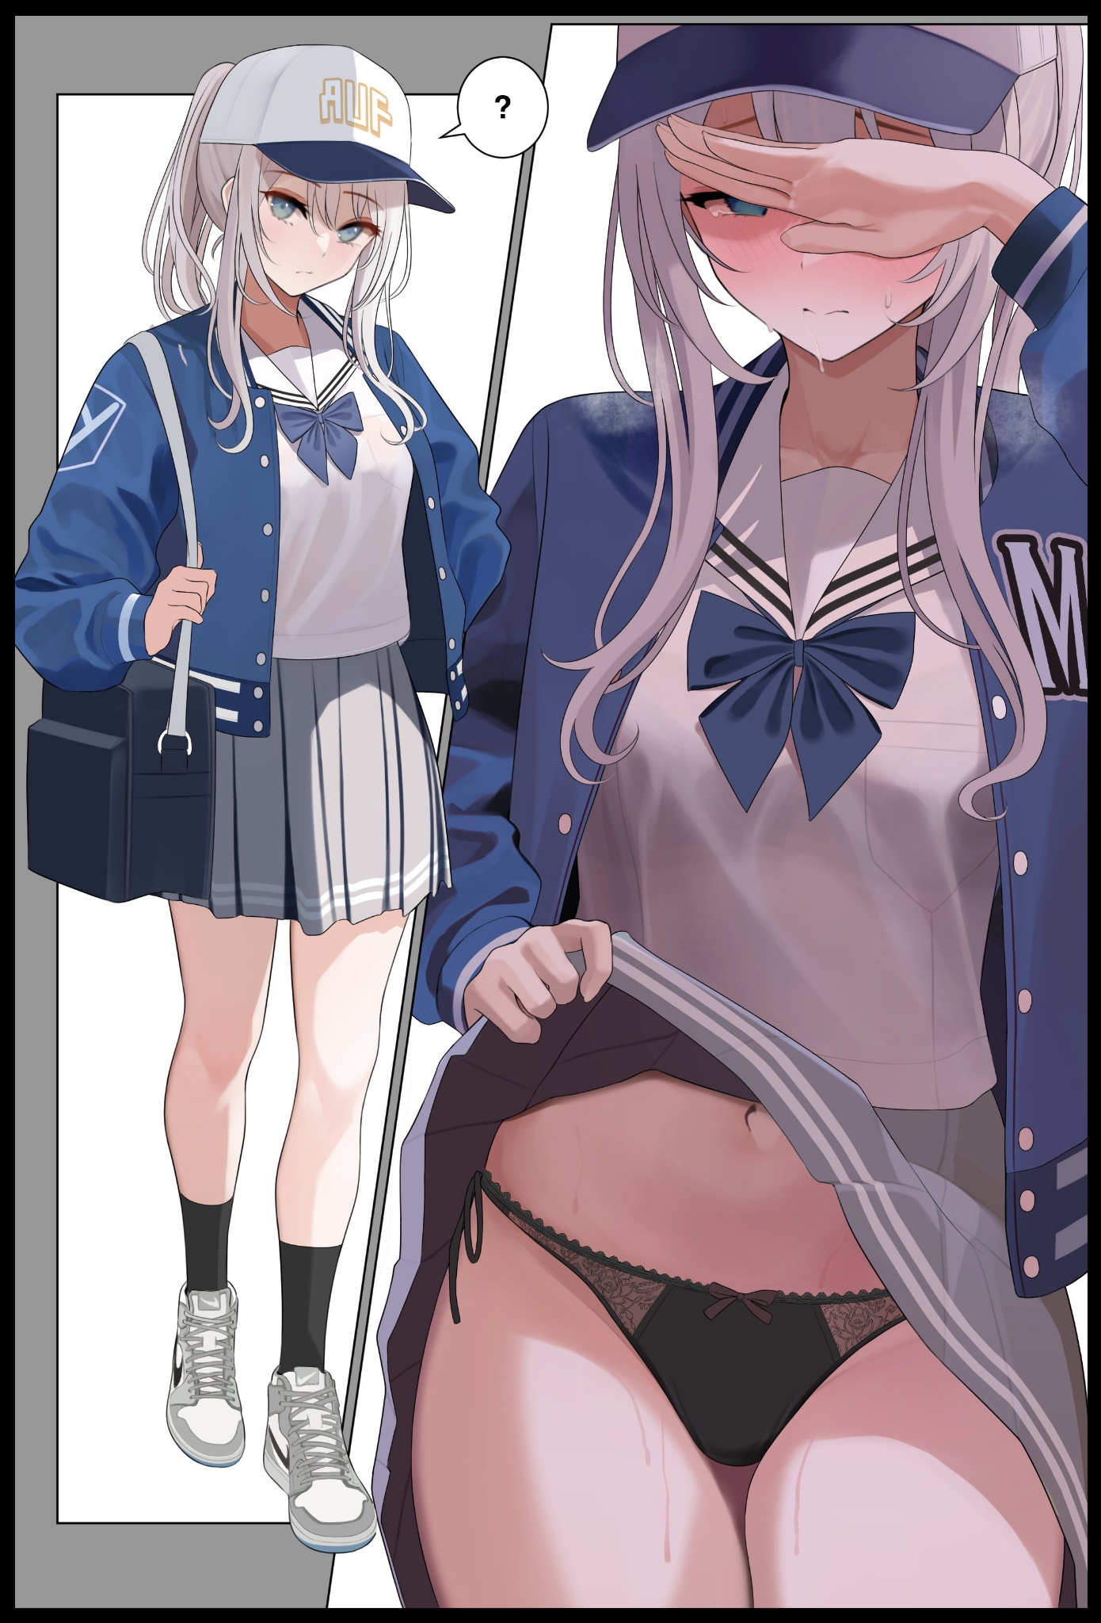

And as the vision progresses, Nisha's resolve would be severely tested as her sky blue eyes begin to dull, panting involuntarily under her breath as phantom fingers trace the throbbing regions of her navel before lifting away, returning shortly afterwards to torment the sensitive regions of her inner thighs along the same path Fred had touched on that day after losing control. After all, how could he not? His own girlfriend, inviting him to cop a feel, raising her skirt all on her own. Her salaciously seductive face maddened with arousal behind a mask of embarrassment as she feels her loved one run his hands all over her sweaty belly before retreating, almost as if he was getting second thoughts…

**"Just...Do it…"**

Nisha chokes the words out under her breath as she struggles to keep her gait focused and consistent, shaking her head in defiance even when the very real memory proceeds onward to the climax, making the last few flights of steps up to her apartment as she turns around to make sure Fred was still following, betraying her cold demeanor with one pleading look before hurrying up the steps, desperate to plunge her fingers down between her legs when each movement only served to squeeze the wanton folds of her loins, reminding her of the ridiculously *amazing* time she felt when Fred's hesitant hands finally reached her privates, peeling apart the silken threads to reveal her sopping wet flower, untouched and preserved just for him. Nisha's was the first he'd seen in real life, but even in porn, Fred had never seen vaginal folds flexing and waning in need as much as his girlfriend's were in that very moment. She remembered how his thumb had brushed aside a thick glob of precum leaking out of her urethra only for another to immediately drip out of it. She loved the way his pinky slid into her inner walls before sliding around the length of it, coming out with a wet pop and his finger all coated in her nectar…

By the time she had collapsed onto her couch thanking the heavens for her parents coming home late tonight, Nisha was a sopping mess, panting in exhaustion, her hands cupped over her beet red face in embarrassment and confusion, sweaty clothes outlining her slender body just in time for the doors to open slowly once more as her guest steps inside, looking around carefully before zoning in on the silver haired maiden slumped over on the couch, clearly in duress as he turns to lock the door before moving over to join his girlfriend on the couch, reaching out to rub her shoulders gently, helping her take off the suffocatingly warm jacket and cap that had contained so much body heat they radiated off of Nisha's trembling body in distorting spouts of exhaust.

But with the covers off, Fred could easily tell what had gotten over her; sighting the unmistakable tents formed by erect nipples protruding out of the cups of a loosened bra while the area of the couch she sat on was beginning to turn dark and damp…

**"F-Fred?"**

**"W-Wuh?! Oh…w-what's on your mind?"**

Nisha had no idea what she was doing as her arms fall away from her face, staring up into the bigger man sitting with an uncertain frown on his face with hazy blue eyes before leaning against him, sucking in a breath before exhaling, calming herself down with the knowledge that Fred's physical presence in her living room wasn't just a lucid dream. She felt ashamed that he was here to witness her in such a sorry state, but at the same time, she felt at peace, happy just to have him by her side to lean on whenever she wanted to. And that left her confused. About her gender, her identity…it was a mess of a two weeks she desperately wanted clearance right now.

And without that annoying buzz of Biofirmica's technology to hinder her and a more or less stable mind, Nisha decides to gander one question on the man that had tried to talk her out of this in a second life she knew she could no longer return to, the man who still took the effort to ask her out for her birthday party when she was still a naive, selfish man…

**"If…let's say…if there was a man out there…a real egotistical prick of a man who could be good friends with you. And he got an…advertisement by a shady company to test something for them…"**

**"Like Biofirmica?"**

**"Like Biofirmica…what would you tell him to do?"**

Falling silent for a moment, Nisha could sense an air of disbelief from Fred, swallowing his doubts as he puts his mind toward answering the sudden question imposed upon him, coming up with an answer that made Nisha's slow beating heart thump with an added beat.

**"Well…I'd tell him to back out of it…but…if he decides to go ahead with it…then I can't really say no right?"**

**"Hmm…but this friend might take…offense…to your statement and ignore you…do you cut ties if it gets to that point?"**

**"Not necessarily…I'd warm him further, keep constant checks…but if he's really too far gone or if the advert test turns out to affect him badly…then there ain't much I can do…Nisha, what's with the sudden-"**

Cutting her boyfriend off with a harsh push that ends with Nisha straddling a bewildered Fred, the hesitant girl undoes her ponytail before unbuttoning her clothes, leaving only her loosely done bra and skirt to conceal her naked body as she sits atop Fred in in a highly insinuating position, breathing heavily out of her nostrils.

**"But what if this friend happens to turn into a girl…a certain silver haired girl who's been programmed to play the girlfriend of the man who tried to warn her all this time as punishment by Biofirmica? Would you still willingly take her on if you knew she was a man before?"**

**"Nisha! This isn't like you to ask this sort of stuff! And what's this whole thing about 'being a man' before?"**

**"Just answer it…please?"**

**"Hahh…alright alright…turned into a girl…that looks like you…living a fake life…well…if she's still a girl…and the same friend I know…then it ain't gay right?"**

**"You mean?"**

**"I'd make her 'lie' a reality, if Biofirmica thinks they can make her miserable then they've got another thin' comin' for em…plus…I don't think I'd have ever got a girlfriend of my own if I never met you Nisha…huh…answerin' that makes me feel a lil strange…"**

Easily slipping off of Fred's waist as he rises to take initiative, Nisha allows her man to undress her, peeling off her crumpled bra with a clumsy hand that ends with her biting back a moan after a calloused thumb brushes by a swollen nipple. Followed up right after by the clasp of her skirt coming loose, falling off the side of the couch to leave the silver flower shivering in excitement, hands frozen just short of reaching the hem of her rubbery panties, narrowed eyes of determined ebony matched with Nisha's calming blue.

**"Are you…sure about this? I mean…I didn't think-"**

**"Just do it…I want this…and..mmmhm…I think you want it too~"**

Reaching up with a playful finger, Nisha traces the bulge in Fred's pants, mirroring the way he had fingered her last week and delighting in the way the big man shivered against her touch, prodding the tip of it with a manicured finger before letting things settle down, swapping a laugh or two with her former friend turned lover before their faces swoop down low, matching lips into a heated kiss, locking serpentine tongues together in a mutual exchange of fluids accompanied by steady grunts vocalized by the overbearing blonde and arousing moans leaking out of the pert lips of his comparatively smaller partner, erect penis slipping free of its prison after Nisha's previous tampering, flopping out onto her throbbing tummy, immediately causing her loins to let loose another load that drips all over the couch and onto the floor as they part ways, staring into each others eyes with equal desire burning in black and blue.

There was no doubt left in the girl's mind, she truly did love Fred and he was as perfect a lover as he was a good friend…funny how it only took the loss of her manhood and a little mental tampering to get her to see the error of her ways but…here she was.

And if she was going to get screwed as a girl…she couldn't think of anyone better to do it with.

**"Right…almost forgot…happy birthday Nisha…"**

**"And I love you too…darling~"**

Biofirmica's application would lose its control over Nisha shortly after the temporary disconnect, unable to silence her inner voice from speaking out against them. But at that point, neither side had anything to worry about, because Nisha loved her life as it was, especially after experiencing how tender and precious the first moment of coital union between two lovers could be, savoring Fred's being inside of her with lucid passion alongside the up close and personal view of his handsome face pressed up close to hers while he enjoyed every part of her with the same level of devotion, nibbling on her breasts, caressing her cheeks and oftentimes getting a bit rough with a slap on her ass or an exceptional thrust that always had her cooing in that sonorous voice of hers…it was a liberating experience she wished could have gone on forever…but with her parents coming home soon with her birthday cake in tow, Nisha and her future husband knew they had to get dressed and cleaned up before they got caught.

In his bid to get himself a faux girlfriend, Nick would inadvertently become the very embodiment of his dream girl. But in so doing, would discover the blessings of a true romance in what should've been, for all accounts, a bad end…

As for Biofirmica and the future of Build-A-Mate…that was a story for another time…

THE END