To the unsuspecting eye, *Kasumi Chiba* was an ordinary highschool student making the most out of every second afforded to her in the prime of her adolescent youth. Ensuring her studies were on point with a straight laced mind while a warm and bubbly persona of a klutz made Kasumi an easy individual to strike up a conversation with. Earning many associates who would find it hard to forget about the quiet flower who could never stay still despite her mousy outward demeanor, vanishing before anyone could notice only to return at a random period afterwards as if nothing had happened. Dismissing her absences with a variety of miscellaneous excuses that got her off the hook with only a small handful left to wonder about what was really going on with the mysterious second year.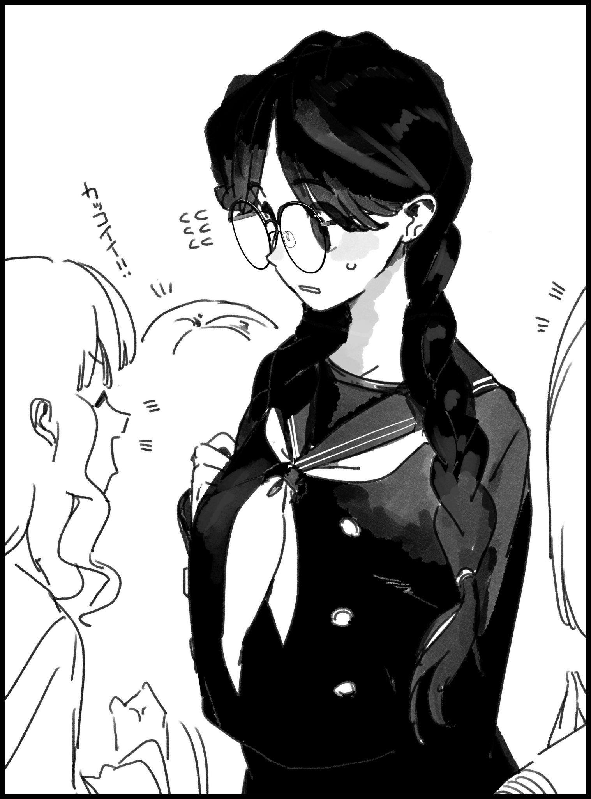

And while it wasn't anything extreme like the seditious pastime some had begun to suspect Kasumi of partaking in, the truth would've been just as unbelievable if they would ever come to know of it. For not a single one could ever link the bookish Kasumi they knew to the crime fighting heroine that had begun to appear in sporadic locales across Japan. Not when they looked and behaved so dissimilarly to one another; with Kasumi being renowned for her kindly mannerisms and soothing voice while the woman in red and gilded gold, while silent, had always been seen with an indignant look on her face whenever she made an appearance to put a stop to crime wherever it occurred. A logical assumption that had served as a useful mask to fool all but one inquisitive mind…

Although that didn't mean she was always there to stamp out evildoers, the mere knowledge of the unnamed heroine's existence and inhumanly swift response had done wonders in cutting down on crime rates all the same. For how were they to steal if, at any moment, they could be run down and apprehended in less than a second? Couple that with an apparent resistance to blunt force trauma and bladed weapons, and few if any were left willing to change things out with Kasumi's 'other self' after she had awoken to unique abilities one day after collapsing in middle school due to the onset of a sudden high fever that had almost claimed her life. Cared for by her parents and friends while she slept in a sickness induced coma, dreaming of strange experiences she could only assume were related to a distant ancestor of sorts. For when she next awoke, her physical strength had been multiplied a hundredfold despite the lack of corresponding musculature. Affording the stunned highschooler the ability to achieve superhuman feats no one else could perform. And while she had been disappointed to find out she could not fly like the foreign man in her feverish dreams could, the fact that she could now move faster than a speedy fly was something she could not rightfully scoff at. Just like the implications of what this all meant after doing a little reading into the subject matter, deciding to adopt the vision's crime fighting career as her own alongside a similarly designed outfit she had weaved together for her own use while doing so thanks to the masterful skills of an artisan her mother had passed down to her back in middle school.



But in her short career as a crime fighting heroine, Kasumi could not help but think of the one truly responsible for it all. For without him to concoct the idea of crime control through deterrence, the highschooler’s immaculate grades and social life would’ve been immensely hard to juggle if she had stuck to her original plan of attending to every criminal in Japan. Dissuaded from walking that path once a curious classmate and longtime friend of hers had come forth with the startling admission that he knew of her secret. Citing the news report in which she had made her debut as his means of figuring out it was her, for it was none other than his father who had taught the two of them that style of close quarters fighting back when they were naive kids in a far more simpler time. Finding themselves drifting back together once a perceptive *Bruce Wayne* had caught on to his childhood friend’s sudden ambitions, leading him to aid her with the resources he had access to thanks to being the sole heir and son to a multimillion dollar company with worldwide connections that ran deep enough to grant them access to the police bulletin…and all the major hotspots Kasumi would need to strike fear in to cripple crime across the country in one fell swoop once news of the *Supergirl* would inevitably begin to spread.

And now that it had? Kasumi would find herself pondering important matters pertaining to her ordinary life rather than the fantastical one she lived in the shadows. Matters of a sort that any fickle minded lady like herself would inevitably grow to be concerned of. Especially if the outcome would determine who she spent her future with going forward, sighing in romantic fashion with half-lidded eyes hidden behind thick rimmed glasses as her mind continues to fluster over the idea of confiding in her friends about confessing her feelings to Bruce. Was it too soon? Was she being too hasty? What if he didn’t…no…what if he also harbored feelings for her? And if so, she’d have to think about their future!

Shaking her head at all these intrusive thoughts before they could cloud her judgment, Kasumi’s keen vision would just so happen to chance upon a strange oddity in the skies above her school. Gazing at the empty spot where she could’ve sworn she had laid eyes on what looked like a diminutive man with otherworldly proportions standing on thin-air looking directly at her before vanishing…had she just been imagining things? Most likely, because despite her enhanced senses, not even Kasumi could stave off the debilitating effects of a tiring day at school. Setting her mind back on track but not before a small smile paints itself over her beautiful face at the idea of taking Bruce as her one and only, unable to help herself as the giddy mind of a highschool girl deviates once again to romantic dates, a heartfelt confession, the ultimate wedding to mark their union and how happy her parents would be once they knew they were getting a son-in-law…before the blush on her innocent visage deepens at the encroaching thought of doing ‘it’ with her childhood friend. Coming to a standstill in the corner of the humid classroom as seedy thoughts begin to flourish, envisioning a well lit bedroom in a humble home fit for a small family. Seeing a hypothetical version of herself in a few years from now sprawled over the sheets with warm yearning clear for a similarly aged Bruce to relish in as he crawls over her smaller frame…

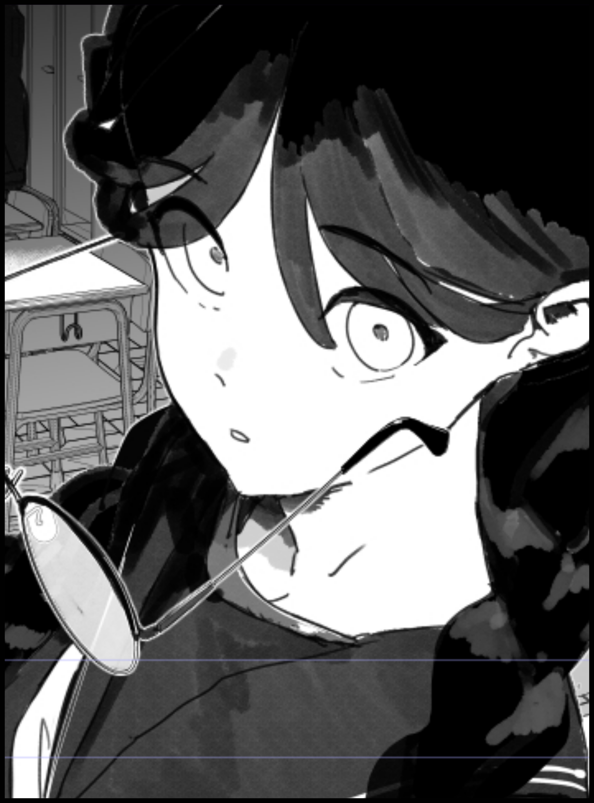

A light slap on the cheek would snap Kasumi out of the soon-to-be raunchy daydream, clearly affected in more ways than one by that abrupt thought as she slips the last of her belongings into her bag before turning to walk out of the humid room. Intent on hitting the hay much earlier than usual for today before she did something she would regret for the rest of her life. For as innocent as she might appear to be, Kasumi was no stranger to the sexual side of life, especially after hitting puberty and the realization of her growing femininity whenever she was out there fighting crime in her vigilante suit.

Unbeknownst to Kasumi however, the anomaly from earlier was no mere trick of the light but rather the one and only glimpse of an old enemy she no longer remembered. Not after she had fallen victim to awe-inspiring powers that allowed him to bend and twist the fabric of reality as he saw fit. Ensnaring not just her but the young man she was infatuated with…and as a result, none could ever recall the likes of the Man of Steel or his ‘other side’; the Caped Crusader.

Instead, there was Kasumi and Bruce. A young couple-to-be living each day to the best of their abilities with differing plans for what the other wanted to see in an uncertain future made complicated by the former’s ‘unique’ abilities and the lofty expectations placed upon the latter by parents who would most likely deny their son’s wishes if it meant he would marry a ‘peasant’ foreigner. An exciting event the dwarf of a man could not wait to see play out in the near future as a gloved hand shuts the monochrome manga he had contained his favorite superhero in for the fun of it. Gaining a heavy dose inspiration after coincidentally happening upon the Kryptonian and Lois who just so happened to be mirroring the Bat on the other end of the city with his own romantic interest…and so, with a simple snap and a quick realignment of existence itself, had begun a romance of his own making between two hapless souls who were none the wiser to the pocket reality they had been thrust into and the identities that had been stripped from them. With ***Clark Kent*** in particular left so drastically changed to a point where scant little of his indomitable will had carried over to the whimsical Kasumi Chiba, who had unconsciously come to accept her rather mundane role in this new Earth as a toned down variation of her former superpowered self. Favoring Bruce, the man she hesitated to confess her love to instead of some American news reporter whose face and name she could no longer remember…and from how fast the couple were beginning to latch on to one another, the Fifth Dimensional imp that was ***Mister Myxzptlk*** wouldn’t be surprised if the adorable Kasumi and her dashing boyfriend would end up a happily wedded couple by the time the first inkling of there ever being something wrong would set in…feeling just as excited as the lucky girl was at the thought as he turns over to take a nap while Kasumi would head on home to a warm dinner and loving parents, smiling all the way…

A free-spirited entity in control of this much power was meant to use it, and what better way was there than to fiddle around with one of the greatest beings yet to populate the expansive playground that was reality itself?

THE END

Images by Sunoco : <https://twitter.com/sunoco600>