HONKAI STAR RAIL: TROPE CITY
CH5: SMOKES AND DRINKS
BY CHALDEACHANGE
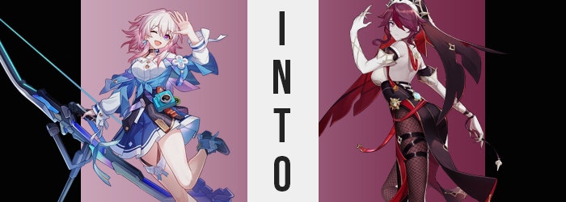

“Brr…! Thank goodness I’m finally inside!”

March 7th rubbed her hands together to produce heart as she ran up the stairs of the grand Goethe Hotel in the capital city of Jarilo-VI, Belobog. The young woman was very quick to duck into one of the nearby hallways, not at all interested in lingering in the lobby without Stelle or Himeko at her side. Unfortunately for her, after dealing with Topaz her two fellow Nameless had gone up to meet with the leader of the planet, Bronya Rand.

The archer could have gone too, but she’d been so hungry! And so instead of going along with them she had hit up a snack vendor on the street, stuffed her face, and then decided to return to the room she was sharing with Stelle ahead of time. March knew that they wouldn’t be too long. “Miss Himeko said she’d take us out for dinner tonight too, didn’t she? Hehe, I’m gonna make her regret that invitation!” By stuffing her face until Himeko’s wallet cried!

“…Wait, don’t we all share funds?” There went that plan! Any money spent would probably just be coming from the Astral Express’ coffers, which meant it was money they had all be contributing! “Maybe I’ll just stick to the salad then…” She would definitely order more than that, but it was the thought that counted! Probably!

This entire solo conversation had been transpired as March had walked down the hall to her room, fumbled with the key a moment, and then eventually let herself in. Honestly? Crashing on her (unmade) made in the hotel room had sounded like a really good idea. It wasn’t often she got a chance to nap with how often the crew was thrown into chaos, and so maybe it wouldn’t hurt to crash for a bit? She hummed to herself as she flopped onto that bed of hers and closed her eyes.

Ignorant to a flash of light that had shone from the phone in her pocket.

“Ouch! What the heck am I laying on, rocks!?” Rather, from March 7th’s perspective it felt like the soft and comfortable bed that she had laying on had just been replaced by something cold and hard. It wasn’t until her eyes shot open to find herself looking up at a starry night sky that she realized she was not in her hotel room. “H-Huh!? What in the world just happened to me!? Did I get teleported or something!? Is this a dream!?”

She had plenty of ground to think that, but the warm breeze on her cheeks felt real. As did the cobblestone beneath her ass. Upon rolling over and pushing herself up onto her feet, she quickly identified where she was. Not specifically where she was, but she could tell what kind of place it was. On the horizon there were a number of rustic buildings and windmills, and the place where she was standing? It seemed to be an outdoor dining area on the roof of a restaurant or bar. She could smell food and booze – which didn’t improve her vast, endless appetite.

“I mean, I guess I could go for a drink…”

Wait, like an alcoholic drink?

Not to say that she wasn’t of legal drinking age. March 7th had been operating on the idea that she was at least in her twenties even though she didn’t really have any memories of her past. Himeko and Welt both said she appeared too old to be a teenager, so that had to be the case, right? Her complexion wasn’t overtly youthful, but it didn’t lean into anything all that tired or fatigued either – so she couldn’t be much older than her early twenties.

Yet that, for some reason, came into question as she racked her brain about what she had meant by those words. She didn’t drink alcohol very often and she hadn’t really been craving booze or anything. Unbeknownst to the young woman in the meantime? That ‘youthful’ complexion of hers had began to appear a touch more… worn down. Pink and springy skin lost much of its color, fading to a pasty grey whereas her face looked increasingly tired. Dark bangs formed under her eyes, and they stood out even more with her skin color changed.

“YAAAAAWN!” Was it really odd to her that she was yawning? Nope! She had been thinking of taking a nap before all of this had occurred, after all. Although as she yawned, an exposed mouth revealed some additional peculiarities. The lips that this yawn was bellowed through had thickened to nearly twice their original thickness, their glossy color a little darker than before. But with her mouth open? You could also make out canines that seemed a touch… sharper.

This was all part of a series of changes that continued to wrack her face, stealing away all of her ‘cuteness’ and replacing it with a tired maturity. Her multicolored, pink and blue eyes had been narrowing beyond their tired bags, lashes lengthening and those colors mixing into a purplish red with regular, black pupils. With her facial shape narrowing and with all of the other changes compounding, March didn’t really look much like March. She looked like a different woman. One that was, perhaps, pushing thirty.

She sighed, her voice notably deeper. “What is this feeling?” Could it have been that she was somehow noticing the changes she was undergoing? Not quite. She was noting a restlessness within. It was making her agitated and she couldn’t place it. It wasn’t like she was annoyed about anything or anyone in particular. It was much more like she wanted something? Her body was developing a craving.

Perhaps it had something to do with the subtle taste of cigarette smoke that was clinging to her tongue now?

While this craving intensified, her appearance continued to depart farther and farther from what March 7th should have looked like. Bubblegum pink locks were the next victims, with each individual strand darkening to a purplish red that was very similar to the color of her eyes. It didn’t grow much longer, but it was rippled now like it was typically styled into a tight bun in the back. Whereas in the front? Her center bangs became darker than the rest, and thicker strands were swept leftward.

“This is really starting to piss me off…” The woman’s one foot had begun to tap impatiently. She had been sent to, uh…? And then she, uh…? What had pissed her off again? Probably nothing. She was used to feeling like this when she had gone a while without a smoke, right? Where had all of the pep to her voice gone? She sounded just as tired as she looked. And she looked a little intimidating, too. Her visual style had taken a stern departure from bubblegum pastel colors to something more gothic, at least when it came to her body.

Not that her body’s transformation had stopped there. March’s skirt could clearly be seen lifting higher and higher, inevitably revealing the woman’s pink underwear without the skirt reaching down to cover it. The cause could likewise be seen in her arms jutting out a few inches farther from her sleeves, and said cause? She had grown. About four inches or so overall, making her around 5’8”. That was a fairly sizable jump, making her around the same height as Himeko. Maybe even a little taller.

Her skirt was lifted high enough, in fact, that now her entire legs and hips were exposed, as was her ass. All regions of her body that could be observed now packing on the pounds, but not in a manner that was in any way unattractive. Her thighs thickened like pale grey sponges, skin pulled taut and a beauty mark emerging on her innermost right thigh. This weight was applied in equal measure to the cake of her rear, cheeks burgeoning with a sensual jiggle into an arousing heart shape. Once again with another beauty mark, this time on her right cheek – only visible because her panties had been gnawed into the crevice of her deepened crack.

All pushing her hips dubiously wider.

“Ugh, these clothes aren’t helping either. …These clothes?” Was there something wrong with her outfit? Leering down at her dress, she had very mixed and confusing feelings. Were those colors she would wear? They didn’t really go with her overall appearance, did they? Not to mention that they didn’t fit. But she still recognized them as hers. Thus the confusion formed – prompted by the fact that her mind was adjusting to her new life.

And it seemed that in this new life was one with not only a big ass and thighs, but likewise a larger chest. Perhaps they didn’t reach the same heights as her fuller rump, but March’s bosom definitely swelled. The added weight pressed into her button-up blouse, so much so that the two yellow buttons that held it in place eventually popped off so that her E-cup tits had room to breathe, a sea of pale-grey cleavage completely visible.

The woman shook her head to clear her mind about her clothing woes. And it worked? But not in the way one might expect. Because what she was wearing shifted, reforming into a different outfit entirely. She was dressed up in a form-fitting nun habit that sported white spikes and a dark purple coif. Her back was fully exposed, with white cloth hugging her breasts down below to match long, clawed gloves. A slit, black skirt still revealed the full shape of her ass, while legs were obscured by dark fishnet stockings and a plethora of belts that higher her right thigh keenly. Black heels with golden decals warmed her feet, that gold matching the lining of her skirt and an ornament on the side of her skirt. She definitely didn’t look like a regular woman; certainly not dressed like that.

The tall and suspicious looking woman reached into the pouch that had appeared on her hip and pulled out both a cigarette and a lighter. She motioned with an experienced familiarity, sticking it in her mouth and lighting the tip like it was the most natural thing in the world to her. Rosaria inhaled deeply and eventually removed the cigarette so that she could exhale a plethora of smoke. It certainly wasn’t a good look for a woman dressed up like she was in the service of the Church. Even though she was.
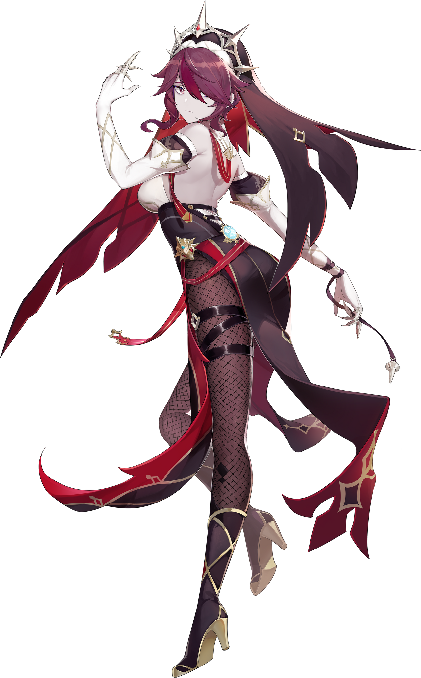
“That’s better.” With the nicotine getting to work, the craving that had been making her bad mood even worse finally subsided. She flicked some ash from the tip of the lit stick and began to pace about, evidently not versed at all with the idea that she had just been a pure and silly young woman. Rosaria was anything but. She was mature and mysterious, with gothic fashion sensibilities and with a personality that saw no qualms with doing bad things for the greater good.

Like stalking or killing, for example.

But the ‘sister’ wasn’t on duty at present. She found herself visiting her usual spot for drinks and food, and she knew that there was a tall glass of blood red wine waiting for her at the bar downstairs. “I really needed this damned smoke though. When did I have my last one? Not even ten minutes ago? Whatever.” Before lighting up that smoke, she’d had the worst craving of her life. Like she’d gone her whole life without smoking. But that was dumb, because if that had been the case then she wouldn’t have had cravings in the first place!

“Hm. Wonder if any women would come back with me after…”

Again: those were not things a sister of the church should have been thinking!

