INAZUMAN ADVERTS
APRIL 2022 BIG STORY
BY CHALDEACHANGE
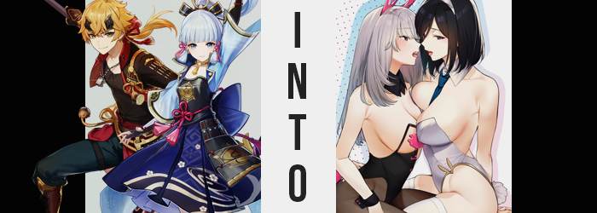

Thoma wasn’t quite sure how it had come to this. Well, he was sure, technically, but it was a tale he was hesitant to retell from sheer embarrassment. After all, the day had been meant to be one of merriment, with a local festival being held in Inazuma’s capital for the day following in the wake of their most recent festival, which had focused on light novels.

This festival wasn’t one so mundane. It was to honor the great beasts and creatures that populated their island nation, from the smallest of fish to the greatest of predators. All life deserved to be celebrated after all, and so for thousands of years the Grand Narukami Shrine had worked in conjunction with the capital for the sake of paying proper reverence.

…Which, over the years, had taken a much different form. What was once a small festival had evolved into one as bombastic as the others thanks to the whims of the shrine’s Guuji Yae. Yae Miko held a reverence of her own – and that was to big parties, good food, and useful advertising opportunities. After all, she ran her own publishing company which produced some of the most riveting light novels in all of Teyvat.

In fact, their most recent publication, A Tale of Two Bunny Girls, had practically been flying off the shelves. A tale about two young women that are enlisted to work as bunny girls at a local café, the pair fall in love as their relationship quickly blossoms into something more carnal. A tale so lustful could only have been penned by Miko herself, who seemed to have no shortage of pent-up sexual frustrations for some reason. There were theories that she had a secret lover that she could only see once in a while, but who knew if that were true?

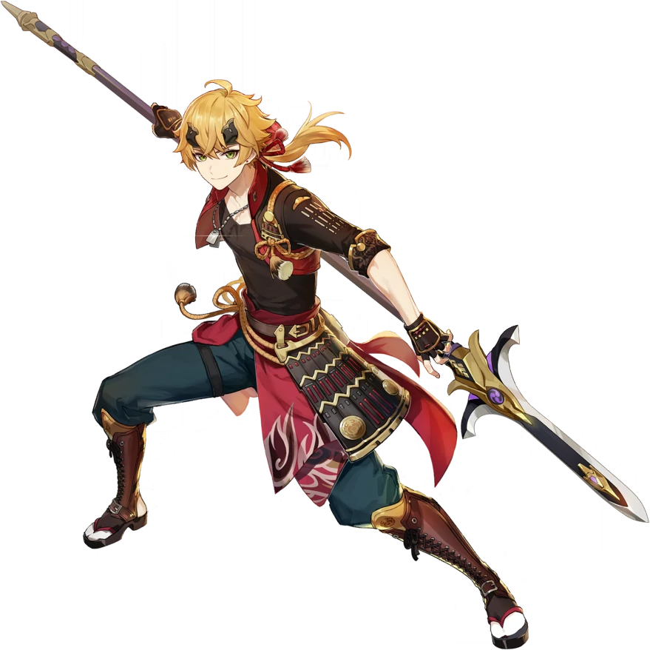
And such was where Thoma’s day had taken a strange turn. Being the Servant of the Kamisato clan, he had been escorting the young lady of the clan, Ayaka Kamisato through the festival as they had planned when the had suddenly been stopped by one of the staff of the Yae Publishing House with a request. To neither of their surprise, it seemed like Yae Miko planned on using the festival to push even more copies of A Tale of Two Bunny Girls, but they were missing a key piece of their advertising strategy.

A pair of women to dress up as the two main heroines, Shizuka and Akemi. Yet they hadn’t communicated to Thoma just who the characters were, much less the fact that they were women. He nor Ayaka ever had much of an opportunity to engage in reading light novels to know the plot of the publishing house’s latest release, and he assumed that Ayaka’s older brother would not like her reading texts with such themes.

“Um… None of these clothes are for men, though?” Ultimately, the servant was uncomfortable because the woman who had approached them had asked both him and Ayaka to try modeling an outfit to wear for just an hour to help promote their new release. Ayaka, being good-natured, had agreed on the grounds that it was nothing too embarrassing, and thus he had been roped in as well.

So after being shuffled off to a changing room, imagine his surprise to find that the outfit that had been set aside for him was both not designed for a man, but hardly an outfit at all. Dangling on the back of the door was a skimpy bunny girl costume with pink pasties where he assumed the nipples would go, along with heels, leggings, and the necessary bunny ears. “There’s no way I’m going to wear this, much less fit in it…”

Or, at least, that was what he originally believed. Yet the changing room he had stepped into had been enchanted by the Guuji Yae herself with magic. A magic that would alter whoever stepped foot into it to suit any outfit hung from the back of the door, and not even solely in the physical sense. Their very nature would be transformed as well.

In Thoma’s case, it had already begun to some extent or another. Having already stripped off his armor so that he was adorned in only his pants and his brown tee, there were some very telltale signs that something was amiss just by simply looking at his arms – although the consequences of what could be seen there extended across his entire body.

The muscle that had accumulated across his body all began to melt away. Slowly but surely, firm strength softened, leaving limbs thin and his chest and belly rather lacking. Thoma himself did not even clue into the fact that it was even happening initially, and instead just felt very exhausted all of a sudden. Which made sense, really, because once you were used to being able to perform a certain way physically, it would be a night and day difference were that ability suddenly taken from you.

“Whoa, that’s strange!” The young man placed his hand on the inside of the changing room to keep himself steady once the fatigue ultimately hit him, although because he didn’t look at that hand he also missed another warning sign that something was going very, very awry. The hand he’d placed there gradually appeared smaller, with fingertips resting lower on the wood than they had before as nails grew out slightly longer. They appeared downright maidenly, which was a feature soon shared by the feet in his socks, for they had likewise shrunken in a similar manner.

Although, on the subject of shrinking? “Whoa!? Wait a second, something’s not right here!” All it took was the brief sensation of his point of view dropping before the ginger-haired man began to question things. He had dropped sharply down to about 5’2” over the course of twenty seconds or so, and both his shirt and pants both threatened to fall off his body. “Did I just… shrink?” Using common sense, he reached for the door to the changing room to get help. Except the door wouldn’t open. Had the woman attending to him locked it shut? “…It appears I’ve fallen into some sort of trap.”

What kind of trap shrunk the person inside of it to a slightly shorter size, though? A fair question, but only because he’d yet to comprehend the scope of what was happening to him. His Vision, hidden beneath his armor nearby, had even changed from Pyro to Cryo – the type of Vision that the main charact of A Tale of Two Bunny Girls possessed. More and more, he was beginning to look just like her. But his mind was also becoming wired so that his personality was similar, with his reactions growing calmer and cooler. Just like Shizuka.

Strands of silver began to pop up midst his already long hair, but even then the length of Thoma’s locks could be seen growing longer still while the ponytail was forced to unravel in the meantime. It ultimately fell straight down the halfway point of his back, while the silver took root entirely from roots to the tips until it almost looked like a wig – yet it was wholly authentic.

“I need to… My voice as well…?” The way he was speaking sounded too calm for what was happening to him, but it also came across much more like a woman’s voice now. Communicated through lips that appeared fuller and rosier, his entire face was in the process of being reconstructed, however. Features collapsed, growing smaller overall which soon highlighted that his eyes were growing bigger.

Yet it was strange, for while they grew in size? The corners pinched inward until they looked more like those of an Inazuman native rather than a man who had been Mondstadt-born like he had been. Fairer and fairer his complexion became, with a smaller nose and gentler slopes, until he sported the face of a pretty, young woman. Even his teeth shrunk and rearranged to better fit a smaller mouth with a smaller tongue.

Slender, feminine fingers brushed away silver bangs that had grown to brush against the tops of his eyes. “I… Am I becoming a woman?” From his voice to his hands and hair, not to mention his loss of mass, this was certainly the conclusion to draw. The costume, the booth, this had all been some kind of elaborate scheme on the Guuji Yae’s part, evidently.

And so he couldn’t even bring himself to feign surprise as he, well, became a she. Unsurprisingly, the act of one’s dick becoming a pussy felt one part strange and one part arousing, and the front of his boxers grew flatter and flatter beneath pants that were hardly able to rest on her hips. Not that this was a problem for all that long, ultimately, because with her new sex finally applied to her, the rest of a woman’s figure began to blossom.

This meant that his hips soon widened, pulling the loose waistband tight once more. Boxers grew tighter and tighter, but because her ass soon burgeoned with additional mass – bum growing plump and perky, but not excessively so while any excess saw her thighs flourish in a very similar manner.

She blinked down at her shirt wordlessly as nipples appeared to press up against the dark brown fabric from beneath. They had grown in size, jumping more than a few coin sizes overall, but their swell paled in comparison to the flesh that amassed beneath them. It didn’t take long for the base of her shirt, which had hung over her pants with her previous loss of height, to pull up so that her belly was revealed – all because breasts had grown to a perky D-cups that the cloth could not accommodate without lifting. They felt sensitive and achey, likely because she was aroused from the entire process.

But she didn’t address that feeling yet because something in her mind alarmed her.

“My name is… Shizuka?” What had it been before? None of her other memories had changed (that she had noticed, at least), so why just her name? How was she supposed to explain to someone what had happened to her if she couldn’t even remember her old name? It didn’t quite click with her that this was the point. It would be problematic if it got out that the Yae Publishing House was transforming people for the sake of promotional events!

She couldn’t quite figure out why she was doing it, but Shizuka peeled away the shirt that now hung loosely off of her to expose her ample, bare tits to the confines of the changing room. Was she embarrassed, having just changed into a woman? A little, seeing as her memories were still Thoma’s. But her personality had been altered to make her somewhat cooler in nature, and there was a tinge of acceptance in response to what had happened that halted any further overreactions.

“I suppose… I should put this on.” The bunny girl outfit was ridiculous in that it would show off so much of her skin, but other than being a little coy about it, Shizuka didn’t seem to have many reservations. Which made sense, because in the novels Shizuka was a cool beauty who cared little about showing herself off. She did what she had to in order to support her family. Of course, this Shizuka didn’t know that, because she was operating on Thoma’s memories… for the most part.

She quickly found that some memories had been adjusted for her own sake. She now knew how to take care of her new body and how to dress herself, and so putting on the costume didn’t take very long at all. Before long her tight little body was done up in the revealing garment, little pink bunny tail and all. “I guess I should see if Akemi is done…”

She hadn’t meant to say ‘Akemi’ though. She had meant to say ‘Ayaka’.

Ayaka Kamisato hadn’t had the same reservations about wearing a costume for an hour as Thoma had. As long as her conditions were met, she could take a little time out of her day to help a local business! Considering her post, it was more or less expected of her (and Miko had been counting on her maintaining that mentality).


“Erm… They told me this would be a modest ensemble, but isn’t this… Isn’t this going to show off far too much skin?” Having already stripped down to her bra and panties, the Kamisato daughter raised a brow after the attendant had taken her clothes and left the costume dangling from the door of the changing room that she occupied.

It was a silver leotard with a bunny tail on the end, with white thigh highs, bunny ears, and heels. It looked like it was made for a much taller woman than she was – not to mention much bustier – but that wasn’t even the main issue. She had been told the outfit would be modest, yet that would expose her thighs, shoulders, back, and even most of her breasts! “I cannot wear this! Excuse me?” She’d hoped to catch the attendant to get her clothing back but heard no response.

After all, the enchantment had already begun to do its work.

Ayaka’s hair had always been a silvery white that bordered a pale blue in color. It was the same color that her brother’s hair was, and the pair of them had inherited it from their long passed mother. That was why the fact that a raven black color had begun to replace its original color with haste was so alarming. Not only was her hair darkening, but it was unraveling shorter – which was obvious since she had untied her hair when she had stripped down into her undergarments in the first place.

In a way, it happened so fast that it almost looked like her hair was a tape measure suddenly being withdrawn all at once. It pulled up to the base of her neck where it inevitably stopped shortening, but the bob that the young lady was left with was a far cry from what it had once been. Even her bangs had been rearranged, no longer soft and fluffy but thin and swept across her right eye. “Um…?” Which she naturally noticed.

“My hair!? Oh my! Why is it this color? Why is it so… short?” Feeling around her hairline with her hands, the fingers that were doing do grew slightly longer in the process – while her feet below grew an extra size of their own around the same time. Ayaka did not have the same firsthand experience with Guuji Yae as she had, because the kitsune was always formal and proper around the Kamisato daughter. She wasn’t aware that the pink-haired woman was capable of such feats, let alone aware enough to assume that she had now fallen victim to such a ploy.

Blinking, there was no mirror in the changing room for her to note how her eyes had changed to a dull purple in color, nor how their shapes had narrowed in slight to give off the impression that she was physically a little older than the late teens she was meant to be. This was soon supported by an overall change in her face, taking away the features that made her identifiable as Ayaka Kamisato and left her resembling a woman that would have been unfamiliar to anyone who hadn’t read A Tale of Two Bunny Girls.

But from the mature aesthetic of her bloated, upturned lips to a nose that reached a sharp point between two very thin brows, she strongly resembled Akemi from the novel. She was the main character’s love interest, a tall and attractive woman that Shizuka meets working at the maid café. She was the more experienced of the two, and the more forward of the pair. While Ayaka certainly appeared identical from the neck up, work had to be done so that she could fit into that bunny girl outfit still.

And to those ends, she soon sprung up. “Whoa!?” Her balance was threatened thanks to her arms, legs, and torso alike all lengthening, her body quickly jumping up to 5’8” while the white undergarments she’d been wearing managed to hang on despite how dramatic the change was. “I’m… taller? And mm, my voice?” She certainly sounded older, with that uncharacteristic mm bearing a sensual sound. Well, it was uncharacteristic for Ayaka perhaps.

But not for Akemi.

For some reason, Ayaka was becoming more and more curious about her transformation. Had her skin gotten more sensitive? She’d began to touch her body – nowhere indecent, but here and there. It was suggestive of how more comfortable she’d become with herself the more of Akemi’s personality she inherited, and this even applied to the moment that she felt her bra beginning to tighten. “I’m even getting bigger there? Oh~!”

She wasn’t even batting an eyelash anymore. Not as the flesh of her breasts swelled until her cups were pouring over, fabric digging into the flesh of her tits that was pooling over the sides of their containers. It didn’t take long for the band that bound them to snap, although a moment later and the woman would have removed it herself, and E-cup tits spilled out with a distracting yet pleasant bounce. Indentations from where the bra had been digging into them lingered a moment but would fade with time. And Ayaka? She began to touch her tits, not noting a beauty mark that had appeared under the left one. So this is what it feels like to have ‘em so big? Feels nice.

Of course, her breasts weren’t the only part of her body to grow fuller. The cheeks of her rear end blossomed as well, stretching her plain white panties to their limits. At least until those limits were broken by the expansion of her hips, and the cloth peeled off to reveal a bush of black pubic hair above her pussy as well.

She paid the loss of her underwear no notice, instead still fondling her bosom. Nonetheless, even with her ass swollen to a pleasant peach shape that was larger than Shizuka’s, her body continued to swell down there. Thighs engorged brilliantly, fatty tissue that brought them softness pulling her pink skin taut around them. They rubbed passively against each other between her legs, conveying just how horny she was becoming. She was even a little wet, honestly.

Her thighs ultimately grew bigger still, but because stronger muscle formed beneath the fat that had padded them before. Akemi was an athlete as well, and so her body took on a pleasant tone from her arms to her legs. Of course, this left her with a sexy looking six-pack for a tummy as well. She had a very sexy, alluring body – and a daring personality to match.
“My name is… Akemi?” Few things had been changed in the woman’s memories, but her name was one of the few that had. The tall, busty, black-haired babe that had once been the small and fair Ayaka traced her body’s lines with some degree of skill, goosebumps forming under her own touch. Akemi was so strong, so confident, but she was also incredibly comfortable in her own skin. The transformation had been arousing on all fronts, and with Akemi’s personality implanted in her, she was weighing the pros and cons and masturbating seeing as she was alone.

…Eventually she opted against it, putting on her bunny girl costume. She didn’t bat an eye at her reflection in the end. Tall and sexy, she was the kind of woman that anyone would be happy to have. Yet why did her mind keep wandering to Shizuka? That was another thing that had changed in her memories. She couldn’t picture Shizuka as Thoma anymore. Probably so that the pair of them couldn’t tell anyone who they had once been. But Akemi could visualize her as if she’d just seen her and thinking of how hot Shizuka was just made her arousal build again. But she had work to— “Shizuka-chan?”

Akemi had opened the door to her changing room to find the slightly younger woman in question standing on the other side. Cheeks a bright pink. Evidently, she’d been having similar feelings. Transformed into a pair of women that were in love with each other in the novel, they too now found themselves in love. And extremely frisky after having their bodies and minds reconfigured. “Akemi-senpai, do you want to – MMPH!?”

She didn’t even get to finish posing her question before the taller woman grabbed the silver haired one and pulled her into the changing room, shutting the door behind her while locking her lips so that her tongue could immediately get to work. Passions ran wild, hands went exploring, and bunny girl costumes were quickly peeled away.

And they would definitely be late for their promotion event.

