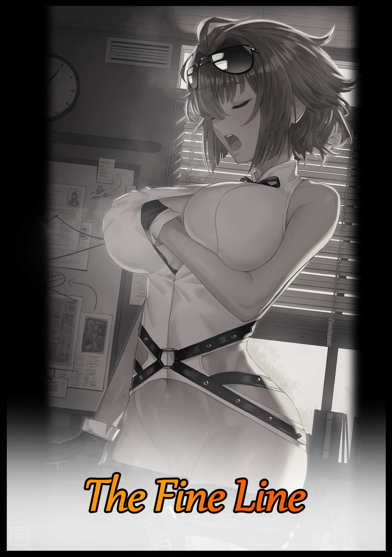

“Hey! Did you hear? Apparently, word around the base is; Marianne’s got a boyfriend!”

“You don’t mean our Marianne do you? Sheesh…how’s she even got the time to go out lookin’ for one anyway? We barely even get to enjoy ourselves when those bozos keep showin’ up…”

With the muffled sound of two women in heated discussion leaking through the not-so soundproof walls that kept the sole occupant of a locked up office bathed in the fiery orange of a setting sun hidden, a young woman struggles to keep her insinuating vocalizations from leaking out of wanton lips, a near impossible task when both of her hands were occupied. With one being used to prop herself up against the table her trembling figure bucked against while the other ravished her right breast, groping the well developed tit with practiced motion performed by a shaky hand clad in rubberised gloves that only served to stimulate angry looking nubs of pink tenting the fabric of her skintight top

Occasionally letting loose arousing moans she could no longer contain within a parched throat accompanied by a myriad of tantalizing expressions her boyish visage contorts into with every firm squeeze of her hypersensitive bosom, the buxom brunette cranes her neck downward in shame as her ears prick up once more, listening in to the shameless gossip going on in the next room over, all while broad hips continue to gyrate, squishing the plump folds of her throbbing vagina against the corner of the table, grunting every time the polished mahogany edge presses into her aching clitoris, shooting bolts of electric pleasure up through her spine while a fertile womb kicks with desire just beneath a sweaty, toned navel after being reminded of last night's events as the girls continued their conversation.

"How'd they even find out though?"

"Oh, that's the good part…you know the gala last night? The one with all the bigwigs? Apparently, our little newbie's been spotted there…and you won’t believe who she was with! Alex Farron! Y’know, young prodigy and all that? To get all chummy with the likes of him, rubbing shoulders, walking around hand in hand even? That’s no coincidence!”

“You’re kiddin’ me…you sure she wasn’t on some security detail or somethin’? Undercover bodyguard business?”

“A rookie guarding a high profile target? No way…The Bull spotted her! And she was leading guard detail for the gala, Marianne wasn't there for official stuff!"

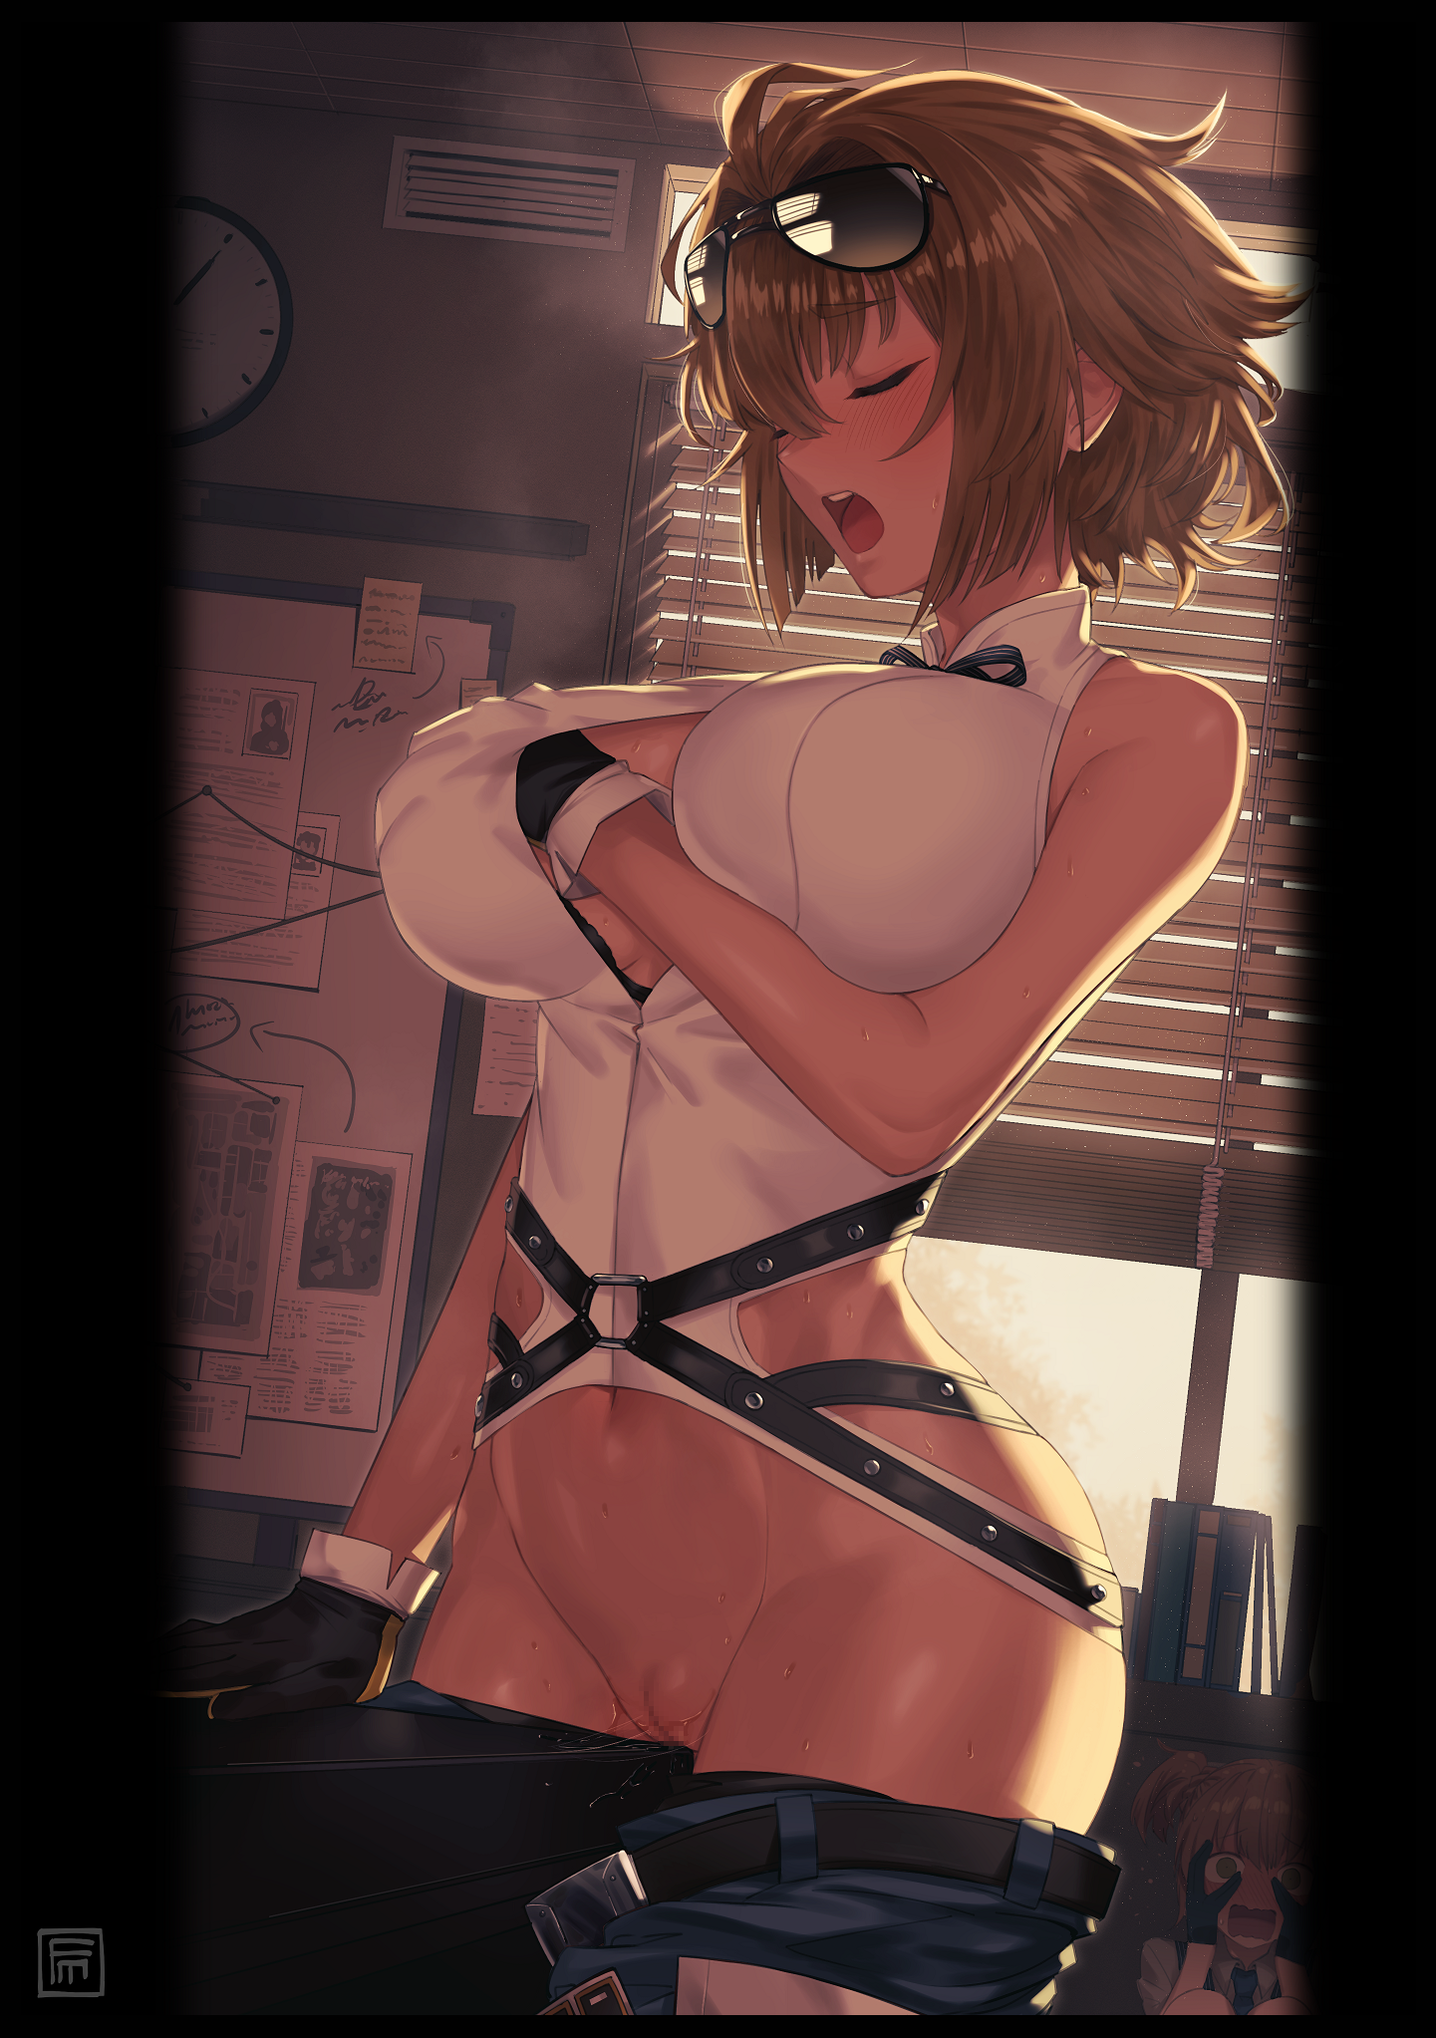
Hearing that accursed name only made it harder for Marianne to hold her ground against the sudden spike in her already intense libido, letting loose a drawn out cry that was all she could do to dilute the loud moan that would have slipped free otherwise, accompanied by the subtle pitter patter of transparent driblets splashing onto the floor, melding with the ever growing puddle already present between her trembling legs, sustained by her drooling body as it continues it’s mindless masturbatory loop after the temporary halt caused by a mind-blowing orgasm that unfortunately, didn't match up to her first…a frustrating fact that left the short haired brunette in even more dire straits, unable to do anything but mutter under her breath in between cute yelps and high pitched whining…all while hidden eyes, wide with a mix of horror and embarrassment, watch silently from beneath the shadow of a nearby table, feeling awkward and unsure of what to do next.

"Kgh! C-Can't…f-focus…hard…need hard? N-No-ogh?!"

In truth, the situation was far more complicated than it seemed. For the fellow magical girl trainee masturbating so shamelessly before her very eyes wasn't doing so for the fun of it, in fact, 'Marianne' wanted dearly to get out before anyone else came in, already aware of the peeping tom in the room after her ears had caught a panicked gasp from somewhere behind her alongside the recognizable thump of a head knocking against wood. But picking up on that was a mistake as much as it was a warning, for it only seemed to spur the fires of desire within her instead of encouraging it to flicker and fade. Add to that the weighty cloud occupying her head, and she was trapped in an endless cycle of estrus wrought by multiple factors, most severe of them being the one that had landed the not-so ordinary magical girl in her…or rather, his current predicament.

Rewinding to a recent point in history when there had been one more criminal mastermind on the loose, there existed a mad scientist going by the simple name of Dr Matthias, a crooked man with a penchant for villainous deeds, responsible for developing dastardly weapons, plotting against a society he had perceived to be against him since his youth and the brilliant mind behind the creation of what he would simply dub; the Inversitron. A device capable of flipping specific traits in the subject and his trump card against the so-called herpes responsible for his downfall many times over.

In a world where science had developed to a point where impossibilities were now a reality, the world needed fitting defenders to match the increased threat posed by criminals like Matthias. And none irritated him more than the pesky women from Magicrad, an organization, fashioning themselves after 'magical girls' seeing as how each member had the ability to enter into an empowered state where they had access to powers more akin to high fantasy magic than the logic of science. Something the prodigal mind could not accept, and so he had sought to harness their power for his own purposes, leading to the development of the Inversitron, through which he planned to flip his simplistic existence as an ordinary human, becoming something more, strong enough to rid him and his villainous allies of the magical girls once and for all…alongside a handful of notorious rivals he wouldn't mind casting aside…

Except Matthias hadn't quite calibrated the device properly, nor had he bothered to test its effects on proper subjects in his haste to taste victory. And in so doing, had sealed his fate the moment the automatic locks snapped shut around his limbs before the emergency alarms in the secret laboratory began to blare, barely giving him enough time to react with a startled yell before an all consuming glow of white hot energy engulfs his vision, releasing him from the cold bite of metal restraints as all worldly sensations left Matthias' body with the departure of his soul from this earthly realm…

But as he would soon find out the next time he awoke, life wasn't quite done with Matthias as his weary eyes slowly open, greeted by the sight of a plain old apartment flat and a heavy weight on his chest, made worse by an eerie void between legs plump with fat around the thighs yet were retained a sturdy build with firm musculature embedded evenly across the smooth pillars just like the toned layers present in a rosy navel, far divorced from the old spindly ones he was used to moving around on the beginnings of a beer belly he was beginning to sport after crossing the threshold of his fifties.

Matthias was initially ecstatic, thinking the project to be a success and the sudden displacement from the lab to…wherever this was to be a minor side effect of the alterations done to the spatial weave of reality through a technique far too complicated to explain. But after the aforementioned weight on his chest seemed to bounce and sway without restraint while heightened sensitivity in soft skin tingles from brushing up against the comfortable sheets of a bunk bed, the scientist knew his magnum opus had backfired on him once her eyes grace the reflection of a young woman staring back at her in the mirror, the sight of which, causes her mind to cloud and dull over as if an invisible hand had wrapped itself firmly around the soft tissues of her brain, filling her in on a life that, much to her dismay, seemed set in stone.

Regressed in age both physically and mentally alongside a complete reversal in gender, the newly dubbed Marianne would find herself stuck in a place she had never expected to see with her own two eyes; the dorms that served as room and board for the next generation of Magicrad's magical abominations…and in this new reality broken and mended together by the Inversitron…she was now one of them…but a lifestyle change from big time villain to wannabe heroine wasn't all the feminized scientist would have to deal with.

The Inversitron had been thorough…maybe too thorough…for Marriane, after managing to leave Magicrad thanks to that day being a weekend, would discover everything that could've been credited to her former self had been undone or deleted from the face of the Earth. The bombing of the downtown plaza that should've still been under repair didn't look a day old, the entrance to her secret laboratory replaced by a thick slab of concrete where a warehouse should've been and in turn; the complete destruction of the only device capable of undoing this mistake; having shot itself in the metaphorical some after causing an inadvertent time paradox.

Because if Dr Matthias never existed…and Marriane having an IQ equivalent to a middle schooler despite her virile age of twenty three…the Inversitron could never have existed in the first place along with everything else she had accomplished, effectively game ending her career as a villain to the point where said career had been deleted by the world, forgotten by its people, her efforts to fight the system…undone by her own hands, like a pancake being flipped out of the frying pan and into the fire after the chef had been overcome by cocky confidence…

"Mmm…I'm still not buyin' that whole girlfriend stick…I've heard stuff about this Farron guy…bad stuff…Marianne might be great in a fight and all but…y'know she ain't too bright in the head right? What if she's gotten herself in trouble?"

"Y'mean that stuff about Alex being in cahoots with crime circles and villain groups? I dunno…should we really check up on her? Like, follow her around? From what the Bull said, she seemed pretty happy with him last night, even came decked out in her outfit!"

"*Cough* she what?!"

Finding a moment of reprieve back in the present, a sweat soaked Marianne basks in the heat given off by her estrus-gripped body, thinking back to the events of last night in what should've been a begrudging attempt to approach one of her most despised rivals for help, hoping to appeal to a connection that no longer existed through the use of her old memories, including a detailed list of all he had done, his contacts, his supply chain in the criminal underworld and most importantly; his genius level intellect that bordered her own, or rather, her forgotten self. If she could convince him that she had been a fellow crime lord now stuck as a goody two shoes magical girl, then maybe she could get him to recreate the Inversitron and bring Matthias back into the fold. And so the idea to infiltrate the gala had come to mind, set to take place in the very same plaza that should've been a crater.

Unfortunately for Marianne however, a massive IQ deduction and a remarkable aptitude for channeling mana through her spritely body were only surface symptoms in comparison to what she couldn't detect unless put under certain conditions, for everything would only continue to go downhill from the very moment her shifty eyes finally came to rest upon her former rival after slipping in using her credentials as a Magicrad 'heroine' followed up by minutes of squeezing through a bustling party of stuffy men and stiff women. Causing the hidden changes that had gone unnoticed until now to surface, inadvertently entering into her magical girl persona known to her fellow trainees as Halcyon for the predominant gold coloration and the startling change from the tomboy she usually was to a relatively peppy girl adorned in a gorgeous dress, beneath which were her weapons of choice; handguns…except she had no use for them tonight despite her righteous senses tingling with the need to enact justice upon the recognition of Alex as a crime boss…stifled only by another emotion that had been completely foreign to Marianne till now.

The man she once was had been an isolationist, preferring the company of machines over people, carrying out his evil machinations from the comforts of his many underground lakes, with the only human interaction being drawn out arguments with 'allies' and an exchange of taunts and insults with the heroes that inevitably came to bring him in, where he would always escape a short time after, beginning the cycle once more. Just a crooked old man doing his best to inflict as much harm as possible upon the world.

Under the Inversitron's effects however, Marianne was everything Matthias wasn't. Outgoing, pretty yet handsome, an overwhelming adoration for law and order, and most importantly; a heightened awareness of the female form…alongside a new yearning for a partner of the opposite sex, a lust for a man where there was none before, kept hidden in the heart of a soon-to-be heroine of justice who had sworn to keep everyone, from her loving family to wastrels on the street safe and sound.

And with that desire for a romantic partner melding fiercely with her warrior's code, Marianne would soon find herself approaching Alex, not to bring up her part, but rather, entice him into an intimate spot, and lucky for her, the crime boss had been thoroughly wasted by alcohol prior to their unexpected meeting.

Senses dulled by inebriation, the young man would be easily swept up into the arms of this stunning girl in an extravagant dress that easily caught the eye amongst the crowd. And on the other side of the fence, the minxy gal, overcome by an alien heat burning strong in her head, down between itching loins and a burgeoning bosom, did all she could to keep her target wrapped up in her fingers, choosing her words carefully, leading him on to believe that this special girl before him had more to her than meets the eye…she knew his background…yet hers wasn't known to him, and despite his caution with possible spies of the feminine sort, something about the daring brunette seemed to reassure Alex…whether it was because she checked every box when it came to what he looked for in women or something else about her demeanor, he didn't know, nor did he care.

And judging from how red the blush on her face was alongside the not-so subtle nubs of swollen nipples pressing up against the luxurious fabric of her top, she didn't either…

The events of the rest of the evening were a blur from there. Marianne could only vaguely recall chatting up her former rival about a great many things while they took time to stroll around the gala to enjoy what little it offered besides the performances and occasional speeches, never once mentioning her former self besides hinting at her knowledge of his secrets, spurring him on with a crooked finger as he in turn, tried to figure out who she was and how someone like her could know so much about him…yet did nothing at all to apprehend him, something she was initially considering but an idea she dropped soon after reaching another conclusion only her vapid brain could think of. One where she would use love and gradual rehabilitation to steer Alex onto the path of righteousness.

While the latter was an uncertainty, the former was a surefire guarantee. For not long after the two had gotten familiar with one another, Alex had been quick to scurry back to his manor on the other side of the city with Marianne in tow, where she would have the privilege of her first time being taken by her former rival, awakening something inside Marianne upon the stinging pain of her hymen breaking before utterly mind melting pleasure floods her entire being…receiving just as much as she gave with her body, whimpering under a combined assault of praise from Alex for her body, gently cradling her in his enlarged figure now that she was a waifish young lady at a fitting age to be his newly wed in comparison to her former identity being old enough to be his father…
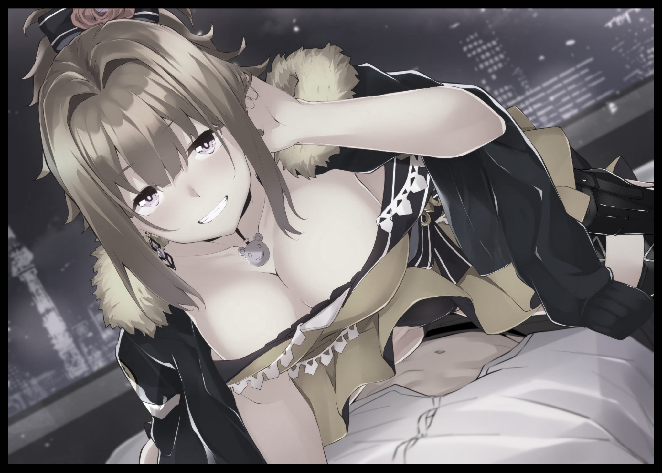
Making a quick escape the following morning after enough sense had returned for Marianne to realize what she had done, the embarrassed magical girl would return to Magicrad just in time to cleanup and prepare for morning practice, integrating quite nicely into her class of fellow trainees, most of whom looked up to her as a big sister figure of sorts thanks to this new reality establishing her as the ace of the class, something that made the seniors and regulars a tad bit jealous, hence the intense back talk and gossip going on in the background like the two unseen faces continuing to discuss the mystery behind this new rookie of theirs, unaware of her scandalous presence right next door, still unable to stop her needy body from resuming it's embarrassing display with a choked cry of dismay once her aching hips start to thrust once more, giving her pudgy pussy a good rubbing as yet another load of precum splashes against the floor, squirting out of a puckered urethra she was ashamed to remember Alex's skillful fingers prodding against near the tail end of their intimate meeting. She hadn't even gotten to participate in any form of raunchy activity for over fifty years in her time as a man…and not even two days after being turned into a woman, she had already lost her virginity to the one man she had least expected to find interest in, blissfully ignorant to the machinations of her lost invention and the role it had to play in it while tussling with the mind boggling concept of love and the reciprocation of it…for if everything else about her had been flipped on its head…who was to say her rivalry hadn't been as well in addition to everything else that hadn't yet found significance to cross her mind?

And in that sequestered manor near the Magicrad training facility, its head was already busy formulating plans to try and get in touch with the mysterious witch that had enthralled him so last night, unable to forget the feel of her porcelain skin, the husky quality of her boyish yet oh so sweet voice, the silken bob of brunette…striking purple eyes…the natural aroma shradiated...and the tightness of her beautiful body...Marriane was seared into his mind, and the crime lord wanted to see her once more, to get to know her just as well as she seemed to know him.

But before either one could meet once more, there still remained the issue of the unwitting witness to her senior's shameless behavior in the privacy of their study room, still unsure of what to do next as she watches Halcyon orgasm for what must've been the fifth time, blushing even more furiously upon the sight of another shimmering waterfall dripping down between her slender legs accompanied by the sonorous wisp of her voice in the air, evidently trying to keep herself quiet, her spasming body…looking more and more tempting to reach a hand out before grasping ahold of those fleshy assets of hers as a tingle of lust shoots through the body of Marianne's roommate, urging her to her feet as she steadily begins to approach the panting woman whose relief at finally feeling her libido die away would soon be broken once eager hands find their way beneath her clothes, repeating the cycle once more as Marianne's neck twists backward, tongue lolling in the air as her mouth opens to let out a scream of pleasure…

"W-What the hell? Did you hear that?"

"Yeah…kinda sounded like…y'know what…maybe it's just our imagination…"

As terrible as the original intent behind the creation of the Inversitron was, its backfiring had unintentionally warped that evil…as for what laid ahead in this new world for a villain and the madly aroused heroine coming to grips with her newfound womanhood and the feelings associated with it he now sought dearly…only time would tell…

THE END

Image Sources

Image 1 by Fumato : https://www.pixiv.net/en/users/9284013

Image 2 by Flugel : https://www.pixiv.net/en/users/14016789

