***Repurposed Assets***

***Azur Lane Akagi & Kaga TG/TF Story***

Ashton was a natural wiz when it came to computers and engineering, being able to take apart a laptop at the early age of ten and putting it back together without a single hitch after going up the scales from analog clocks to smartphones.

And it didn't take long for young Ashton to develop a further interest in machines, moving on to coding and other digital mumbo jumbo no kid his age should've been able to process and understand.

But he was no ordinary kid, born to two of the greatest minds of the century responsible for developing some of the government's most vital infrastructure and operating software. Ashton's parents wasted no time in teaching their child all they knew in the hopes that he would one day surpass them.

"You've got the potential to right so many wrongs in this world son, and we're gonna teach you how to do it!"

That was what he remembered his father telling him all those years ago when he was nothing more than a naive young boy in the basement of his parents' workshop. But that didn’t mean his entire childhood had been grueling lessons in coding and disassembling complex machinery. Because like any other boy his age, Ashton had a fondness for games and animated shows, with his earlier exposure giving him plenty of time to get familiar with the big hitters like the Fate series.

Unfortunately for the boy, not many shared his interest in technology and science, shunning him as the eccentric nerd of the class on his first day in high school after he'd gone off a tangent during icebreaker on day one. The usual buzzing reception and wide eyed interest from his middle school days absent in the lazy eyes of his classmates as some broke into mocking jeers and laughter.

And when he tried to stand up for his family after some no-faced bullies had gone so far as to insult his parents when he brought up their profession during lunch break, a one-sided beating had broken out, with the frail body of Ashton standing no chance against the more athletic kids as they laid into him.

He learned two things after that day. That the outside world wasn't as kind as he thought it would be and that words wouldn't be enough to win fights. He needed insurance, something that would make sure everyone knew not to mess with him and that he meant business. The words of his father rang in his mind as he laid still in bed with his aching face bandaged up, diabolical plans and insidious ideas roiling in his mind.

Balancing studies and revenge had been a simple thing to do for the young genius, keeping to himself all day and only ever speaking to his parents when he came back home from school, ensuring them that he was doing fine and keeping his project a secret before rushing upstairs to continue his work on a tool that he had gathered some inspiration from after recently coming across an interesting thing many people seemed interested in these days on mobile app stores.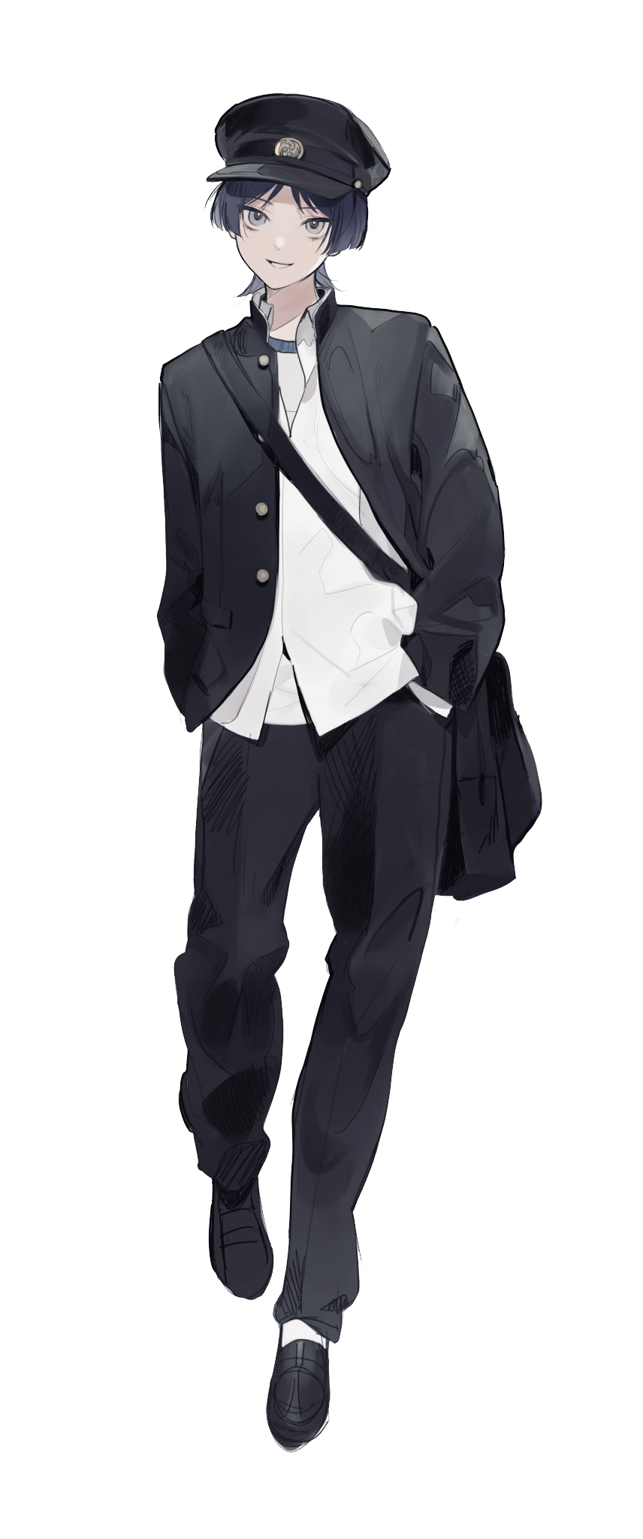

It was taking a long time, with Ashton having to endure the abuse meted out by the thuggish students who had formed into a tight knit gang of sorts led by one of his classmates with a typically crude name of Jack Spencer, making him a primary target for daily shakedowns of his lunch money, due in part to his claims of his parents working for the government. Probably stemming from less than pleasant run-ins with the law.

"C’mon rich kid! You've gotta have more than this right? Didn't you say mummy and daddy rake in the dough all day working for the suits at the military or some shit?"

It had made him eager to exact his revenge on more than one occasion, but he wasn't willing to test out prototype tech that would most likely end up killing the douchebag. He didn't want to be a murderer, he wanted to see his bully suffer for all he had done to him and the others he targeted, but he needed to remain alive for that to happen at all.

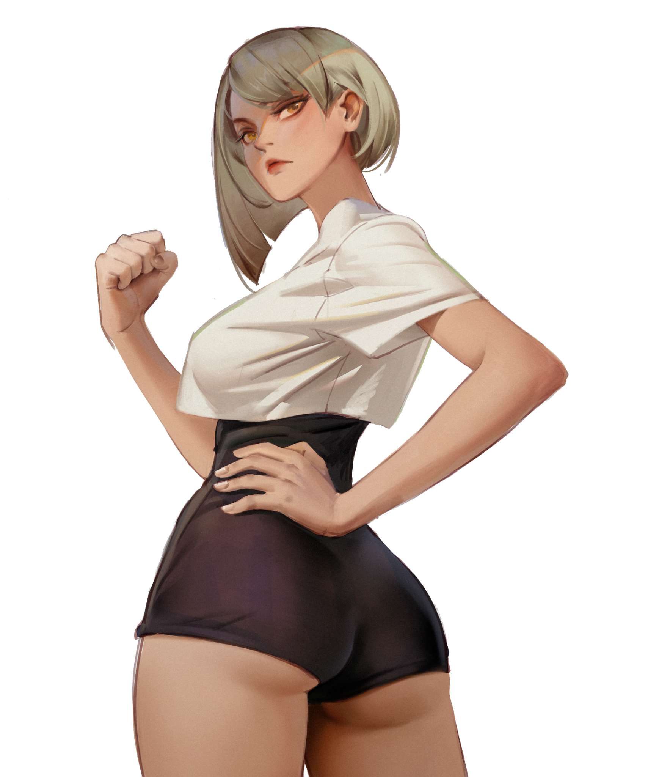

And to make matters worse, the smug dolt had gotten himself a girlfriend from a grade above and the queen bee most of the delinquent girls flocked around; Nadia Einsworth. Apparently the shame of her family who were haughty socialites, Nadia had taken to venting her stress by bullying other girls whom she saw as being too high and mighty, which basically meant everyone else, while following along with her newfound boyfriend’s every whim, including going out of her way to add herself onto Ashton's hitlist. Alongside her long list of other offences including ignoring the school dress code and other such violations.

While many seemed to mindlessly drool after her good looks and *‘shining’* personality, Ashton had to hold back his disgust whenever the arrogant bitch had him backed up into a corner, that annoying whiny voice of hers raking against his ears. Forced to walk away from the many times he had seen her picking on other girls with her entourage of mindless drones.

For someone in the cheerleading squad, it seemed the vapid smile he’d seen from her past performances was just for show with the way she scowled down at him from her lofty position.

"So sorry hun, but baby Jack tells me you're not being cooperative with him, nothin’ personal alright?”

Eventually, weeks would turn into months, and before he knew it, a year had already come and gone, with his secret project seemingly missing one final piece before it could truly function without incident. But Ashton was still just an ordinary young man, without access to more advanced technology and knowledge, it seemed as if he was stuck at a dead end. Fumbling with loose ends he could never clip all throughout the winter break with one week left till the next school year began.

Until his father had entered his room without warning, giving him no chance to hide the handheld device lying disassembled beneath a lamp. But he wasn't here to rat him out, instead, the man had simply sat down comfortably beside his son, inspecting what was for all intents and purposes; his first creation.

Ashton knew his dad was appraising his work from the focused look in his eyes, prying apart components and figuring out their mechanics and purpose all with a simple glance. Waiting with bated breath before his idol puts down the device with an approving nod.

"Nice work…but you've got yourself a dangerous tool here son. It's missing one last piece to make it work…don't give me that look now, wouldn't be much of a father if I didn't know my boy was being bullied in school!"

As embarrassing as it was to realize all the actions he'd taken to ensure the secrecy of his work, Ashton had been relieved to finally be able to talk to someone else about it who wouldn’t protest the idea he had in mind to pay back the people that had tormented him and many others.

It came as a slight shock to learn that both his parents were agreeable to the idea, with his mother joining over video call since she wasn’t home that evening. Apparently to get to where they were now in the government, there were many things they had to commit themselves to do, treading the thin gray line between good and evil as they worked for the safety of the country.

But by the end of that night, and with the combined intellect of his parents, Ashton’s device was ready to go after a serious moment of swearing an oath never to use it on those who didn’t deserve it, going to bed with a feeling of joy he hadn’t felt in a long time. But considering the extra oomph his father had added to the device and what it would do to Jack and Nadia, it was a strange thing to derive joy from.

*Then again, who wouldn’t be happy with getting some payback?*

"Get the fuck in here nerd!"

Ashton certainly hadn’t expected his tormentor to grow bold enough to have him tossed into the gym locker rooms so early before homeroom. Before, all he did was tug on his sleeves and pull him around, landing maybe a slight kick or two, but over the winter break, the bully had grown in more than just muscle mass, with a brooding violence he could feel just from making eye contact with him.

Even Nadia seemed a bit disgruntled with the way her boyfriend was acting, a slight hint of uncertainty in those snarky eyes of hers as she stood by his side, blocking the way out.

If Ashton had come to school the same way he always had in the past, then he might've been too afraid to move a muscle with his eyes locked on the heavy steel bat in his Jack's arms, which Ashton had a feeling that Jack wasn't holding onto just for show. Whatever had happened to his classmate had left him unhinged and violent. Even more so than he was last year.

But things were different now, fiddling with the hardcase device in his back pocket as he withdraws it, Ashton feels a sense of exhilaration run through him with the cold touch of the matte smooth device in his hands, pointing it squarely at the duo before pressing his thumb down on the screen.

"You're handing us your shit now pussy?"

"That looks like it could sell for a ton babe! I’ll do the honors and…wait…why can’t I move?!”

Upon hearing Nadia’s panicked cries the moment she realizes her entire body has been frozen stiff, Ashton walks toward his immobilized prey, returning the young woman’s furious gaze with an unfeeling stare.

Jack, of course, didn’t catch on immediately to what was going on, clicking his tongue in frustration as he stood there watching his girlfriend do nothing, even with Ashton walking up to them. "What’re you playing at Nadi?! Just grab it already!"

"I-I can’t! The freak did something to me! I..I can’t move!”

“Are you fucking with me? The hell do you mean *‘you can’t move’*?! The nerd’s right in front of you!”

Adjusting the trajectory so the red LED was now facing Jack, Ashton sighs as he hits the screen once more, smiling in a mixed expression of awe and satisfaction as the room falls silent. It was like watching a mute man throw a temper tantrum as he watches the raging bully swing his bat, shouting unheard expletives before his strike bounces off a barrier made of air, recoiling in surprise with shock visible on his face before reaming his mad swings once more.

“I’m not gonna waste time explaining how this works to you dickwad, so just sit back and watch…”

It had been awhile since he’d heard himself speak in a voice louder than a mumble around these two so hearing that brave remark leave his own mouth only served to fuel that adrenaline running through Ashton’s body as he dials through the device, looking at all the custom additions his father had made after he pitched his idea about turning the bullies into gacha character data to fill in the ranks of the missing roster in his favourite mobile game; Azur Lane. To which his father had offered another more tantalizing idea.

*'Why not go one step further Ash? Instead of turning them into 2D digital assets…ever wonder what they'd look…feel like in 3D? Living, breathing people wholly devoted to you…sounds great right?'*

He had been assured many times by the eager middle aged man that It was tried and tested technology much safer than the digital compression tech Ashton had been planning to use. Though he couldn't tell if it was because he genuinely wanted to see the people who bullied his son pay or because he seemed to pop a boxer after spying the twin fox girls he had sheepishly shown to him after agreeing to the plan.

Focusing his thoughts back onto the present, Ashton redirects the remote back over to Nadia, her angry eyes wavering for a moment once she spots the dreaded red LED pointed straight at her head. The screen of the device displays a full scan of her body like a game avatar as he scrolls over to the **MANUAL UPDATE** tab, selecting Diana as the subject before dragging the sprite of a silver haired Japanese girl over to the results section, agreeing to the overwrite warning.

"W-What're you gonna d-do to me you freak? What? Just cuz we messed with you a lil you want revenge or some shit?! Don't make me laugh!"

That made Ashton's brow furrow in anger, clenching his teeth as his mind raced with the names and faces of the various other people that suffered under her rampant bullying and physical assaults, with some of them no longer even going to school at all.

But with her angered shouts that seemed to point to everything else besides her as the root cause, it seemed like the self righteous fool had never once reflected on her actions. Pure denial and unhinged venom spewing from her soft lips with anger and confusion in her rabid eyes. An unsightly face showing the true colors of the monster that hid beneath the shell of a girl that many called *‘beautiful’*.

It made what was coming to Nadia all the more sweeter as Ashton flicks his finger over the screen, double tapping the confirmation button before an audible beep rings out, just as the self justified ramblings of the delinquent cuts off sharply with a startled choke, her pale orange pupils widening in shock before she falls over onto the floor with control returned to her body.

"Let the show begin…"

With a startled Jack watching silently in the background still trapped inside his invisible cage, Nadia falls over onto the floor of the locker room, convulsing as her slender body begins to warp and change, tanned skin rippling like water as the artificial layer of cocoa fades away under a creamy vanilla tone with a faint yellowish hue reminiscent of a person from Asian descent.

The loud sounds of fabric shredding apart signifies the next step of the transformation as her growing body tears through the already tight fitting clothes, exposing the peculiar sight of Nadia’s breasts squirming and trembling in a grotesque fashion, jumping up a cup size or two as they begin to sag down her creamy smooth chest beneath which sits a well trained core leading down to a neatly trimmed runway of silver pubes. While her tits wobbled precariously on the D-cup range, they remained firm and perky, tipped with a pair of hardened pink nipples swaying gently with each shallow breath from Nadia’s vibrant lips now free of thick gaudy lipstick.

With the subject material sporting a more or less identical build to the character Ashton had chosen, the only thing left remaining of the former American teen was her lifeless face frozen into an emotionless stare with drool running down her cheeks. But even that wouldn’t last for long as the new yellowish hue of her skin creeps up her chin, aging her up a few years as the corners of her eyes begin to slant, dull orange pupils filling over with a deep blue coloration with the rest of her face turning into one of oriental beauty, the dirty blonde strands of her treated hair losing all coloration as a snow white locks of silk begin to rise around her subtly twitching body, rearranging into a well maintained bob cut complete with a neatly trimmed fringe to complement her striking eyes as life begins to fill her faded eyes.

Rising off the floor without making a sound, the two young men watch as Nadia flexes her arms, dexterous branches tipped with sharpened nails tracing the air while manifesting supernatural spouts of eerie blue flames that washes over her naked body, materializing a pale white kimono decorated with cyan blue streaks as it flops over her shoulders, lying undone and hanging over her breasts as a flurry of fox tails erupts just above her hearty rear, forcing an erotic moan out of her with a mature airy wisp Nadia could never hope to match, her brows furrowing in need before glancing over towards Ashton, not a sign of hostility left in those brilliant blue eyes of hers.

And with the appearance of a pair of fluffy ears coated in tufts of soft white fur atop her cranium, Nadia the highschool delinquent, leader of a sorority and girlfriend of the scumbag; Jack Spencer, no longer existed. In her place stood a stoic Japanese woman in the prime of her youth, a voluptuous figure clad in an undone yukata that did little to cover her up with an array of bushy fox tails swaying serenely behind her, sighing in satisfaction as she wipes away the sweat of exertion trickling down her forehead, staring down at Ashton with a smile on her face as she nods subtly in greeting, another beep from the device in his hands displaying a completed status bar with the words; **ASSET RELOADED** displayed in bold beneath.

“I am Kaga, Aircraft Carrier of the 1st Carrier Division…I assume you are my Commander? A pleasure to meet you! I sense a great many things we can achieve together on the path to righteousness.”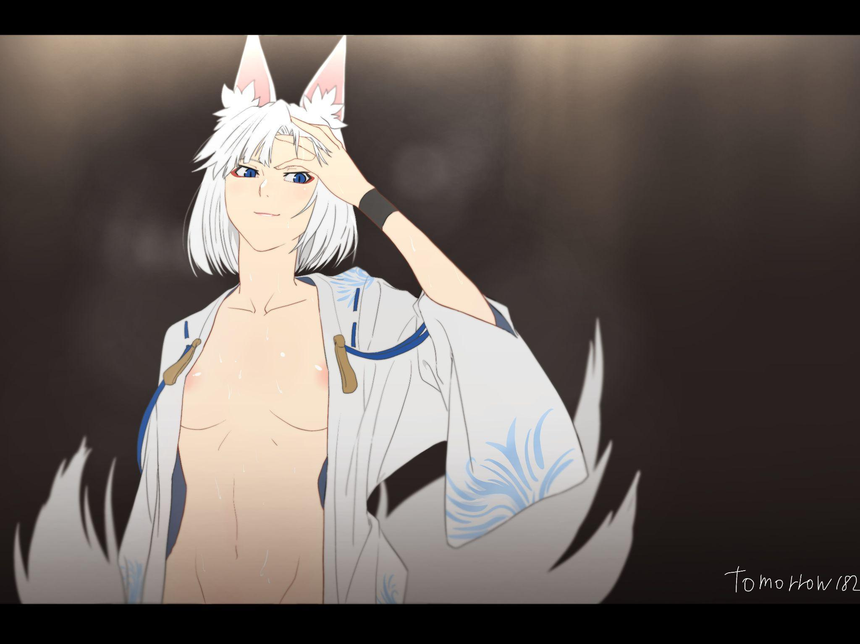

Ashton could hardly believe his eyes as he stood there for a moment in stunned silence, his eyes scanning the perfectly replicated physique of the character he had only ever seen in game now standing before him in all her nude glory.

But before he could get too greedy, Ashton clears his throat before extending a hand before the tall foxy lady. "Y-Yeah! Same here…I'm Ashton by the way, no need to call me Commander…it feels weird!"

"Nonsense! As my Commander you have every right to order me around as you see fit…as long as it's necessary…speaking of, who is this worm? He's been glaring at us like a mangy pup for a while now, should I deal with him?" It was his first time holding another girl's arms in his own so the supple feel of Kaga's palms had come as a surprise to him.

But her less than subtle threat was an alarming thing to hear as Ashton tugs her arms adamantly before the blue wisps of ethereal fire she had summoned could do harm, drawing the attention of Kaga as she retracts her stern gaze away from the squirming figure of Jack, who had held up his arms as if they could save him from the searing blue orbs of Kaga's wrath.

"No violence! I hate this man as much as you feel the need to wipe him off the face of the Earth, but I've got a better solution!"

Before Kaga can question him further, Ashton lets go of her hands before stepping towards the cowering figure of Jack, the formerly fearsome bully now shivering in a ball, the bat clenched tightly around his trembling hands. Left at a disadvantage and backed into a corner, Ashton couldn’t feel a lick of pity for the wreck of a man responsible for ruining the lives of so many others as he keys in the last set of commands, scanning in Jack’s form before selecting the silhouette next to Kaga for the final result. Only to be met by an error code.

*‘Ah right…he’s still muted…and locked in a box.’*

Undoing his previous command and freeing Jack from his prison and muted voice, Ashton forgets the considerably sparse distance now separating the two, realizing too late the moment Jack’s whimper turns into a ferocious war cry as he leaps off the floor, fueled by adrenaline with bat raised toward Ashton’s head.

"YOU’RE GONNA PAY FOR THIS YOU LITTLE SH-GURGH!?"

“You dare raise your hand against the Commander…in that case…”

Before he feels a gentle grip pry him out of harm's way before a pale blur rushes by him, turning around to catch Kaga flying forward at breakneck speed, gripping Jack’s neck in one clawed hand with a murderous fire in her eyes.

“Nadi…you…”

Not wasting a second, Ashton points the remote toward Kaga and Jack, hitting the screen right before the enraged shipgirl could snap the poor man’s neck against the door as time seems to freeze for the pair, leaving Ashston struggling to catch his balance in from how far Kaga had pushed him back earlier. The furious strangled shouts of Jack and the rising growl of Kaga’s blue fire fading into silence.

Watching with bated breath, the young man breathes a sigh of relief as the visual changes that had afflicted Nadia earlier begins to take hold of Jack, his coarse, weathered skin rippling like water as a creamy wave similar in appearance to Kaga’s skin tone washes over him, albeit sporting a slightly darker hue with his toughened arms cracking and reshaping into feminine branches ending off in dainty hands, dirt crusted nails lengthening into polished shells shining in the light. All while his lifeless purple eyes begin to flare a brilliant red; memories of a horrid life with drug addicts for parents and two years of abusing fellow students razed to ash as a new personality takes root within Jack’s now emptied out mind.

Kaga remained still before the transfiguring figure of Jack, the arm wrapped around his slimming throat lightening their grip as her furious look gives way to an uncertain frown. As if she had realized something after gazing at the feminine body beneath the baggy clothes with a pert set of breasts blooming forth into a bosom that soon rivalled hers in size, with familiar strands of dark brown hair beginning to slide down Jack's barely recognizable body.

“Sister Akagi…what are you thinking? Taking on that horrendous shape…I could’ve killed you!”

“Ara~ I’ve been found! As expected of my dearest Sister!”

Ashton couldn’t help but shiver as he heard that seductive whisper come leaking out of the bully’s mouth, moving back warily as Kaga gently drops him, or rather her to the floor with the ill fitting jeans struggling to hold on to Jack’s now slimmer waistline sliding down to the floor, revealing a shapely pair of hairless legs beneath before striding towards him, gaining a gradual sway to her hips as they snap into wide set handlebars, flanking a seductive navel with clear muscle indentation around her soft tender belly, leading down an incline to a hairless slit where the dwindling remnants of a dick can be seen slithering up through her moist innards, dripping it’s sweet sticky load all over the floor of the locker room as she approaches Ashton

By now, Jack was a fading memory in the face of the gravure model strutting down the middle of the room like it was a runway as an array of tails begins to emerge from atop her shapely rear just as it did with Kaga before her, sporting extravagant midnight black fur tapering off into chestnut brown streaks as a pair of fox ears pierces through the top of her skull, flapping to attention as they grow to full height.

But his eyes werent focused on the crimson spouts of flame beginning to erupt all over the newborn woman’s body or the fluffy blossom of tails swaying gently in the air behind her. Instead, Ashton had his eyes locked on the creepy face contorted into an expression that looked more at home on a woman than a man. Because for some odd reason, she still sported Jack’s face, a stain upon her otherwise knockout body,

“My, my, you’re looking rather pale Commander~ What’s wrong? Don’t you remember the face of your dearest Akagi?”

Pretty soon, she had her breasts pressed up against a shivering Ashton with his back against the wall, vehemently refusing to look up at the nightmarish fusion of a bodacious babe and the person he hated most standing before him. Until something sharp pinches at his chin before forcefully raising it face up to eye level as the last bits of a black kimono finishes forming over her body, marked with golden accents and crimson thread in stark contrast to her sister’s cool color palette.

“Come, Let us mark our reunion with a kiss commander~”

Ashton wanted nothing more than to push away from her and run, but with the supernatural strength of the shipgirl now fully in control of her new body, the young man was powerless to resist as he felt his lips make contact with Jack’s, surprised to feel soft pillowy lips wrap around his own, opening his eyes just in time to witness a thin wave of phantom fire wash over what remained of Jack's face, erasing the last remaining fragment of the former bully as Akagi's familiar visage peers through from beneath; foxy eyelids narrowed in lust as her tongue slaps noisily in Ashton’s mouth, eager to taste his saliva with giddy moans and happy giggles leaking through.

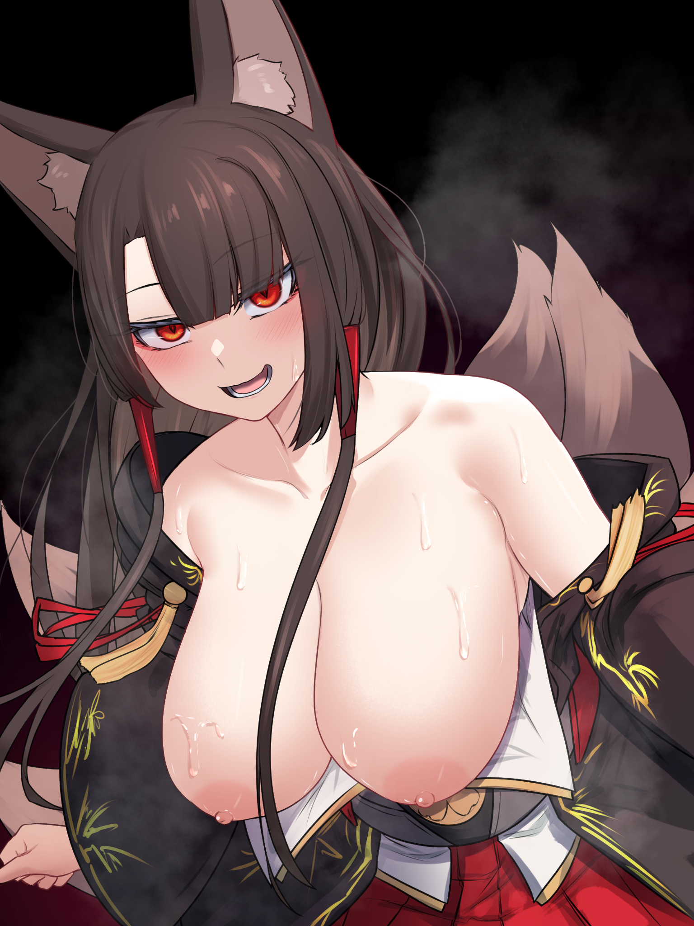

By the time they part from their heated kiss, the flimsy cups of Akagi’s top come undone, leaving her pillowy tits to flop and jiggle without restraint. A lustful look on her face demanded more with her eyes locking on Ashton's in a heated standoff, curved shoulders only serving to rile Ashton’s newfound libido up a notch as the seductive vixen begins to strip, giggling as she crawls forward while hiking up her skirt…

***\*Cough\****

Before Kaga clears her throat loudly, interrupting before the situation could escalate further while standing by the door with a miffed expression on her face over the pair's moment of intimacy.

“Aww~ Feeling lonely? I guess I can make an exception if it's you Sister...”

“Sister Akagi, please take this seriously…we’re still deep in enemy territory, this is no time to play around.”

Hearing that snaps Ashton back into focus as he pushes past Akagi toward Kaga, who had taken on a tense posture with her shoulders squared and the fur on her tails on end, his raging erection all but forgotten. "W-What did I just say earlier Kaga? No violence! And this isn’t *‘enemy territory’* , it's a school! *My* school!"

It was a surreal experience for Ashton who had been surrounded and locked in not too long ago by the bullies that had made his life at school a living hell for the past year, sitting between two very much older Japanese women on a single bench as he struggled to explain the situation with a pair of meaty boobs pressing up against his shoulders from an attention starved Akagi to his right who was barely listening to the lecture, while the silver haired lady sitting upright with her eyes closed to his left had her arms folded over her lap, with a fully formed kimono now adorning her lithe slender figure. Tense ears sticking up and listening attentively.

But after a few minutes of endless talk, Ashton had finally gone through the entire story; from the creation of the remote, the bullies that they once were and the circumstances they were in. Although the girls seemed to take the news that they weren’t in their old world and were instead given form from two corrupt individuals just fine, with Ashton spying a wicked grin on Akagi’s face at the motion that she was once some thug with a narcissistic streak.

“Ara~ To think my vessel had the audacity to strike out at those without the strength to stand against them…Rest assured Commander, I will make doubly sure this body repents for all it has done!”

But the fire of pure lust burning in her eyes with a flushed look on her face as she said those words had Ashton wondering if she was referring to something else entirely when she used those words with his eyes trying not to wander down to her bucking hips and trembling thighs.

Then again, the idea of doing it with a woman that had once been a condescending prick did seem like a tempting punishment, but that bridge could be crossed in the future with more pressing matters to attend to.

"A-And that’s about it basically…you might find some unpleasant people here Kaga but please…try not to lash out…”

“I will try my best Commander…but from what you’ve told me…I have an idea in mind involving that device of yours…if you would grant me permission?”

Hearing that had Ashton raising a brow in intrigue, glancing down at the device still held tightly in his hands with the status report on-screen announcing Akagi’s complete assimilation of Jack’s existence, glancing back up at the two fox women in a mixed expression of excitement and disbelief. If the device had worked as intended, then no one outside would ever remember there being a Jack Spencer or Nadia Einsworth. But how much of them even remained in their new bodies, were they trapped as passengers? Waiting for the right chance to strike back? That thought was troubling to think about.

But that still left the question on what to do about the newly created sisters flanking him, his gaze softening at the warm look Kaga seemed to give him as if she could sense his hesitance to trust her. Unlike his parents who had probably grown insensitive to their work, Ashton was beginning to feel a nagging sense that ordering these two girls around with a programmed sense of loyalty in their minds, no matter how warped their previous selves were, wasn’t such an occasion to write home about. Jumping a bit as he feels Kaga’s warm hands grip firmly around his own.

“I assure you Commander…no, Ashton…that whoever I was before no longer remains within me. I am simply Kaga, your loyal aide. Not the ‘Nadia’ scamp who once tormented you. If you do not want to entrust the device to my hands then I understand…I only wish for you to hear me out on what I have to offer regarding our future together…as I am sure Sister Akagi would like to agree?”

“HmMmm! Well said dear~ In fact, you were rather wise to bestow the divine elegance of your dearest Akagi upon the worm I have quite thoroughly pruned away…Only I alone exist to serve you now so feel free to make use of me to your heart's content~”

“What she means to say is; you don't have to go at it alone. We’re here for you to confide in Commander. I know we’ve only just met, but if chance permits, maybe this really can bloom into a more sensible relationship you can feel prideful of!”

As strange as it was to feel comforted by two not-so-fictional characters from a video game, Ashton could feel the heavy weight of indecision and responsibility leave his shoulders as he returns Kaga’s affectionate stare, glancing back over to find Akagi’s lustful demeanour having toned down a notch to show how serious she was taking this matter.

He’d finally done it; wiping the school’s biggest bullies off the face of reality while replacing them with two fine girls he hoped to build a good relationship with.

"Alright then…thanks for that you two…now what did you have in mind for things moving forward?”

**Epilogue**

A few weeks would pass since the incident in the locker rooms with life at Ashton’s highschool taking an interesting turn for the better with the loss of the school’s most notorious bullies that no one would ever realize. Since in this altered reality; Jack Spencer and Nadia Einsworth never existed in the first place, replaced instead by the two hottest teachers in school. The levelheaded and analytical Ms Kaga and the salacious vixen Ms Akagi, dressing in complementary blue and red outfits respectively, seeing as how they were barely ever apart from one another unless they had to tend to different classes and lessons that clashed with their timetable.

But for the most part, the sibling teachers were inseparable; eating lunch together, doing their paperwork together and if permitted; teaching lessons together much to the joy of the lucky class that got to have the two women in charge of them.

It wasn’t just their looks that got the school riled up, with the sisters being deceptively capable individuals that belied their looks. For instance, Kaga wasn’t just in charge of Math and History lessons but also dabbled in taking charge of the Archery club, lending her time that could be spent marking tests or sorting papers for next week's lesson towards bettering the skills of the students in the club, displaying her excellent proficiency with the bow. As an added bonus, her sister Akagi would tag along from time to time, showcasing her own aptitude with some lessons basically devolving into a competition between who could score the most bullseyes within the hour.

But there were also rumours running wild in the school that didn’t sound much like the women most of the student body had seen and spoken with; salacious tales of an unused classroom in the building being used as they solicited favours of the sexual kind from a student. Of course, it was just rumour, and with no substantial evidence besides word of mouth, the incriminating talk soon begins to fade, dismissed as the words of some jealous individual.

All except one second year student who knew the rumours were more than just seditious lies, being familiar with the two sisters in more ways than one.

"A-Akagi…C-Can we focus on the lesson please? I’ve got a History test coming up next week so…I promise I’ll make it up to you tonight!”

“Ughh, you’re no fun today Ash~”

“The Commander is right Sister…you were lucky we managed to catch the interloper last week before he could run…you should reign in your impulses!”

“Oh hoh? I seem to recall you fervently cradling our lovely Commander’s potent member in that lovely mouth of yours~ In fact, while I was busy apprehending the rat, you were busy trying to free yourself from his tantalizing girth!! Mmm~ I don’t blame you though…”

As the two sisters continued bickering, Ashton couldn’t help a smile as he thinks back to the events of the past few weeks since Akagi and Kaga had gone around the entire place with the remote in hand, rewiring reality to accommodate them as they settled quickly into the role of teachers at Ashton’s highschool, with the two really helping

And then there was the tense moment where he had to reintroduce the two to his parents, who had forgotten about Jack and Nadia entirely with the vague memory remaining of what they had helped their son create on that fateful night before second year began.

“How pre-emptive of you Commander! A pleasure to make your acquaintance Father, Mother! Your son *giggle* is in very good hands~”

“Sister Akagi!”

While his father was more than eager to return the handshake from a bubbly Akagi, Ashton would have a much harder time convincing her that she was good company and not at all one to be suspicious of.

That had all taken place a long time ago, and now here he was in an unused classroom taking supplementary lessons in History from his two newfound guardians and friends, while he was a genius when it came to science and math, wordy subjects like History and Social Studies had him stumped. But it did have the added bonus of giving the trio time to grow closer,, with Kaga still remaining on the fence about dropping all her formalities and calling Ashton by name. It seemed that one time name drop after her *‘birth’* really had been a genuine moment from the heart.

Until it came to a head just a few weeks back when he had entered to find the duo suspiciously silent, unaware of the plan they had discussed to finally take his virginity that humid afternoon. Leading to the unfortunate scenario where Ashton had to whisper an apology before wiping the memory of one of the students that had witnessed their passionate love making, with the only reason there wasn’t a bigger fuss being Akagi’s sharp senses picking up on the intruder peering in through the unlocked doors. With Kaga stuck in a position that only made his libio perk up again, it was up to Akagi to prevent his escape.

But ever since then, the remote had gone back to dormancy, never to be used again with the problems plaguing Ashton settled and gone, hopefully if they were more careful in the future, he wouldn’t have to resort to it ever again. Looking warmly at the sight of the two women arguing with their vulpine traits beginning to show through their lustrous hair, surrounded by red and blue spouts of flame that took on a life of their own as old world planes.

In his eyes, they weren’t simple video game characters brought to life anymore, but living breathing people with their own quirky attributes. Compared to the two careless brutes that had been used to give them shape and life, this was an amazing outcome.

"Umm, How about a picture?”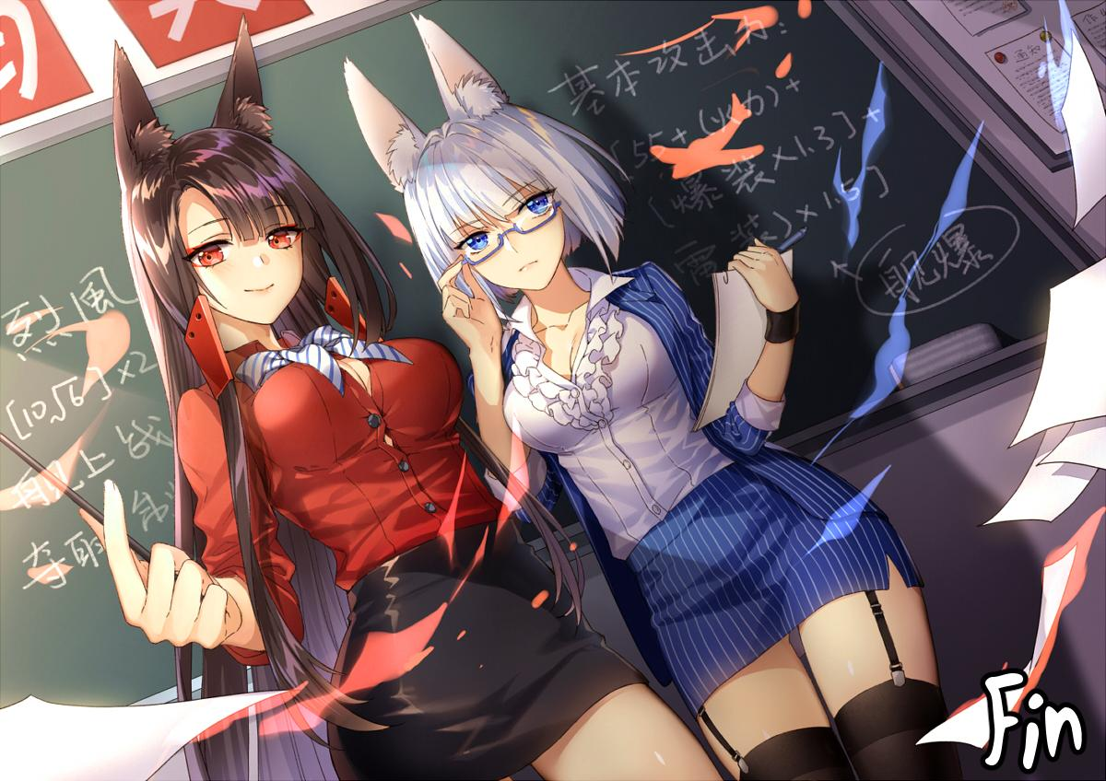

“Do you need to ask? Snap away Ash~”

“Of course Commander, make sure to capture my elegance and dignity!”

With the two women striking a pose as Ashton holds up his camera, the young man takes the shot, hoping this moment and every one after with the two women would last far into the future.

***THE END***