LOYALTY WITH AGE II.
COMMISSION STORY
BY CHALDEACHANGE
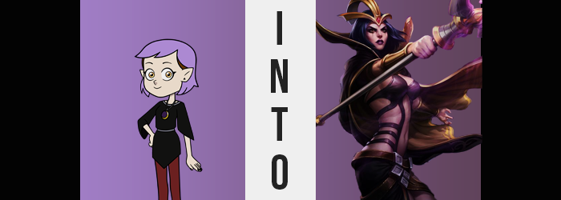

Giddy with excitement, Amity Blight picked a spare strand of dyed, purple hair and tucked it behind one of her pointed ears – typically shaped for a resident of The Boiling Isles. For a very long time the fourteen year old had felt trapped. Her controlling mother had sent her down the path that she had seen as ‘optimal’ for her children, and because of that Amity had developed a terrible attitude of supremacy that had affected her relationships with others negatively.

Amity didn’t blame her mother for all of that, though. If she had gathered to resolve to change herself sooner, then it could have all been avoided. But the reason that the young witch was so happy these days was because she had met the one person that had been able to help her realize how terrible she had been so that she could become a better person. And she had helped Amity find the strength to finally oppose her mother’s control.

And it was a human of all people.

She knew well enough that her mother hated the relationship she had forged with Luz, and she absolutely despised the fact that they were dating. Amity was on a secret rendezvous that evening for that very reason, in fact. Luz had planned with her the day before to have a date at that time and place, and she was patiently awaiting Luz’s arrival. But in the end? Luz didn’t show up! Well… someone did.

“Wait, wait, wait. You’re saying you’re Luz, and you received a strange package with a curse?” A much older woman had ultimately appeared before the teenager in the end. Parts of her body were made of steel, and her age… Amity had a hard time guessing for sure. It seemed like whatever modifications had been made to her body had affected her aging somehow? That was Amity’s best guess, anyways. Regardless, it was a hard pill for Amity to swallow in general. “Do you have any proof? Luz is… You look way different from her!” An entirely different age, an entirely different personality, and even a different race.

The woman who had introduced herself as ‘Camille’ seemed to think pensively for a moment before opening her mouth to speak. She perfectly described the experience that Luz and Amity had together during Grom. They were recounted in a tone that was much firmer than the girl would ever have expected from Luz, but she spoke of aspects of that night that only Luz could have known. “I hope you can believe me. I have nowhere else to turn if you don’t.”

Camille seemed to be sincere with her words. And while she was different? “I… think I can tell. That you’re Luz, I mean.” How could she describe it? Girlfriend’s intuition? Something like that. But this was still a lot to absorb, especially when she considered the implications to their relationship. Camille didn’t behave like Luz, and if she was stuck that way? Their relationship wouldn’t be able to go forward considering the huge gap in their ages if Luz was an adult and she wasn’t. “Could I have a few moments to myself? I just need to think, I think.”

“That’s fine. Take whatever time you need.”

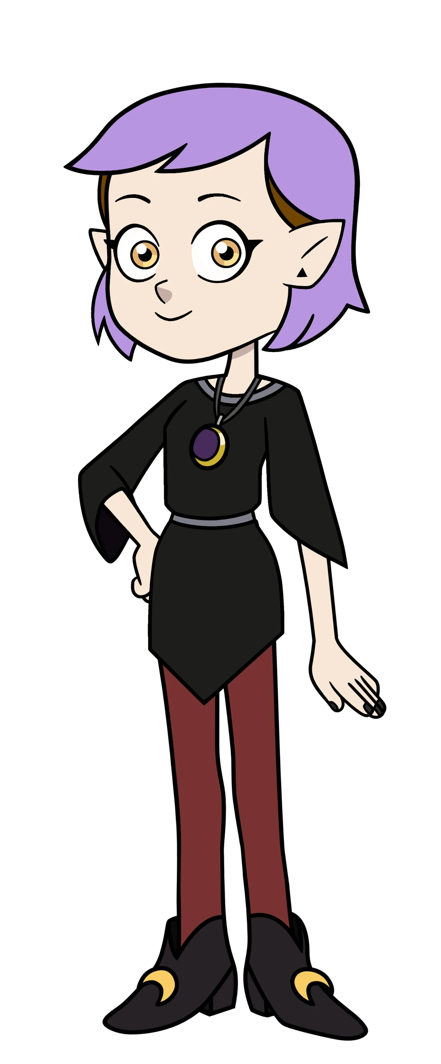
Because the two had met on the forested outskirts of the town, Amity just moved a little deeper into the woods so that she could think. “Why did I act like that? It isn’t like I don’t know what my answer is…” That she would do whatever she could to help Camille look for a way to reverse her transformation, of course. Amity loved Luz and there was no way that she would ever give up on her over something like that. The Luz that was still buried deep within Camille had probably been hoping to hear that.

And so, she felt a little bad that she hadn’t been able to provide that reassurance immediately. Once she returned, she would be certain to say that clearly and apologize! “Should I head back now?” There wasn’t much else that she really had to mull over. She’d left mostly from the shock of everything despite what she had said. “I guess there’s no point in making her wait any longer…” They would have to figure out what to tell the others before they could figure out how to reverse it. There was a lot to discuss.

Amity was ignorant to the magic that lingered in the air, though. It had clung to her immediate area after spending time with Camille – the spell that had affected the one now having moved to the other. Was that unfortunate? Yes, but it didn’t really change anything. If she had returned home after the date, a box addressed to her would have been waiting in her room containing the exact same curse. This unplanned meeting on Odelia’s part would simply move things along a little more quickly. “Hm?”

The fourteen year old paused only a few steps into her walk back. “Something’s… odd.” The hairs on her body were all standing on end. There was something in the air. No, it wasn’t persistent. If she moved away quickly, she escaped it for a moment, but it would catch up. Like a swarm of bees chasing a target. But it wasn’t bees. There were spells that moved like that, however. “Shoot!” What was going on? Had someone cast a spell on her similar to what had been cast on Luz, or…?

Was the spell transferred to me when we came into close contact? The young witch froze up at the thought. If it hypothetically did, then what was about to become of her? Was she also going to change into a copy of Camille? While they knew the outcome that had awaited Luz, the actual nature of the spell that had changed her in the first place remained unknown. The two didn’t really understand that it was drawing on the essence from people of other worlds to reconstruct the people of this one into their image according to a set of guidelines. But not even Odelia understood its true nature, to be fair.

She had simply seen it as a means to turn Luz into an older woman so that she would become like-minded. So, if that spell had transferred to Amity…

The girl frantically looked over her body for any signs of immediate change. There didn’t really appear to be, at least as far as she could perceive. But what about what she couldn’t perceive? A vague tingling sensation upon her lips allowed Amity to identify a point of concern. “My face! Crud!” It only took a single hand to poke and prod her own facial features, and through touch alone she could more or less identify most of what was transpiring.

Her lips had a much fuller shape even despite her younger age, and her nose felt like it was a little more pronounced? Her nostrils were certainly wider. Structurally? Did her face not feel as large? Like her head had actually shrunk? Did that explain why her eyes had almost felt like they were bulging out of her head? In a way, although that was more a product of those eyes shrinking and narrowing. Ultimately, she didn’t look a lick like she was supposed to facially.

And it was worse than she could even note with fingers alone. Thick makeup had made its way onto her skin, seeing her lips painted with dark purple and, as eyeshadow surrounded her gaze, smudged lines ran down vertically from them. “My face cha— Not just my face. My voice? It sounds so… deep.” Because she was so aware of the fact that she was changing, she was quickly able to identify the happenings as they occurred.

Amity was calm. Maybe a little too calm. She found herself curious about what was happening to her body instead of carrying that panic she had felt at first. And thinking about the possibilities of those who might have done this to Luz and herself? She couldn’t help but feel overly spiteful. More spiteful than the small girl had ever felt before. Mind you, how much longer could she even be considered ‘small’ (despite being a completely average size for a fourteen year old).

“Oh. This is interesting.” The girl seemed to realize what was happening before it even happened. Her clothing felt a touch tighter than normal, and considering it was an outfit designed to fit her body perfectly? There could only be one reason for that aside from the clothing itself shrinking. Which, when she considered all angles, was not the likely explanation. “I’m growing.”

Once this particularly vertical change kicked into full force it became blatant. Limbs lengthened, and as a result of that the tights that wrapped around her hips were yanked down her legs until they rested at her knees. The skirt of her black dress was hoisted to not only show the undergarments she had on underneath, but even her tummy while arms shot out of the sleeves. But with hips flaring horizontally and her shoulders extending too, one additional aspect of this shift became clear enough.

Amity wasn’t just growing. Like Luz had during her transformation into Camille, she was growing up. There had already been an air of maturity to her face during its initial shift, but by the time her height had been elevated to 5’5” from a mere 4’11”, there was little point in trying to claim that the woman was still a child. She physically looked to be somewhere in her thirties, perhaps even in her forties. But it was hard to say for sure. “Hmm…”

Recognizing that the teen-sized clothing she was wearing would definitely tear if she moved too suddenly, the witch cut out of the middleman and tore off her sleeves with lengthened, clawed fingertips and then used those same hands to remove shoes that were too small for her bigger feet – even pulling the tights off the rest of the way. By the time she had finished? She found herself admiring her skin. Its usual pale had shifted. Not dramatically, but there was a more violet hue to it that felt eerie somehow.

But as she was, Amity didn’t really see that as a negative. The more she changed, the more powerful she felt. And that power, unfortunately, felt good. But it felt good for other reasons too. “I am older, am I not?” Old enough to at least not be mistaken for a child under any circumstance. Which meant she was old enough to pursue a relationship with another adult. She mused on this further internally, though at the expense of not realizing the purple in her hair was darkening. Her bands were pulled away from her forehead and it all lengthened to her shoulder.

“If I’m an older woman, however, then why…?” So much of her body was revealed since she was only dressed in her panties and a now sleeveless dress that fit her more like a t-shirt, and that made it easy to see that there wasn’t much of her? Her hips and shoulders had widened, sure, but her chest and rump hadn’t grown at all to suit her age. This seemed to bother her for some reason. But her distaste for her absence of curves wasn’t what triggered those final changes. Changes that brought her the weight where she desired it.

This growth began in her chest. “Ah!” Her exclamation of surprise suggested delight and it was delightful to watch her A-cup chest rise like cookie dough in the oven. Nipples hardened and swelled; their shapes visible against the underside of the dress’ remained. Flesh pooled beneath them not long after, and violet-colored skin stretched around the D-cup orbs that built steadily with a jiggle. “But this won’t do…” Amity slid her index finger into her neckline and gave a sharp tug that tore the front of the dress down the middle. Her newly enhanced tits jiggled free now, their perkiness respectable for a woman of her perceived age.

Although in truth she was much, much older than she looked.

The witch didn’t even need to try to remove her underwear in the end. The waistband of the black garment snapped all on its own, courtesy of a plushness forming to her cheeks and thighs in kind. Her pussy was promptly exposed between two pleasantly plump legs, a bush of dark purple pubes having formed atop it at some point, whereas her ass jutted out in a peach shape, utterly bare, behind her.

Amity could feel a power within that bolstered her confidence even more. She knew exactly what to do and, with a clap of her hands, seemingly wielded magic to reclothe herself in an entirely different ensemble. A dark purple leather bikini top that had bands of leather run down and across her largely bare body all of the way down to the matching bikini bottom. It looked more like bondage gear than anything, though.

A series of brown belts were affixed around wide hips, holding in place cloth around her right hip. A proper, purple cape hung from her shoulders, and it had golden trim that matched the golden tiara – with a red gemstone in the center – that concealed her otherwise bare forehead. She also had a single, purple legging on her left leg, with both feet possessing golden heels.

And then there was the long staff that appeared in her right hand, sporting a violet gemstone floating in its center.


“That was an unusual experience, but I suppose it worked out in the end.” There was a refinement to how the older woman looked, but there was also something sinister hiding within her tone. Such was the way of Leblanc, but while that was the name that this sorceress went by? Aside from having her demeanor distorted by her new form, Amity was still very much in control. Like Luz had after her transformation into Camille, she still fully recalled the life she had lived before. The only memories she’d gained aided her with being more comfortable in her new body.

Even though what she had just experienced had been so shocking, the woman wore a smirk upon her lips. “At the very least this makes thing easier.” She was referring to her relationship with Camille specifically. That age gap was now essentially a nonissue now that she was older herself, and her plans didn’t really need to change, did they? Because they could look for a cure together. So that Luz never needed to feel like she was alone in all of this.

Leblanc couldn’t deny that she was having some intrusive thoughts that ran contrary to that line of thinking, though. The most prominent of which being a questioning voice deep down that wondered if it was even worth it to try reversing things? Weren’t things better like this? She was a powerful sorceress that even Belos would probably be incapable of defeating. And with Camille at her side? They would essentially be unstoppable.

“Well, I suppose it wouldn’t hurt to consult Camille on these things now.” She couldn’t be sure how her girlfriend would react to her own transformation. If she also saw no issues with remaining this way so long as they were together, then perhaps they could make a change of plans? That said, there was still one point of business she wanted to take care of regardless of what they chose to do now. “Odelia…” She knew that the magic that had transformed them had her mother’s handiwork written all over it.

And so, some revenge might have been in order.

“Now what form would be the most embarrassing for her?”

