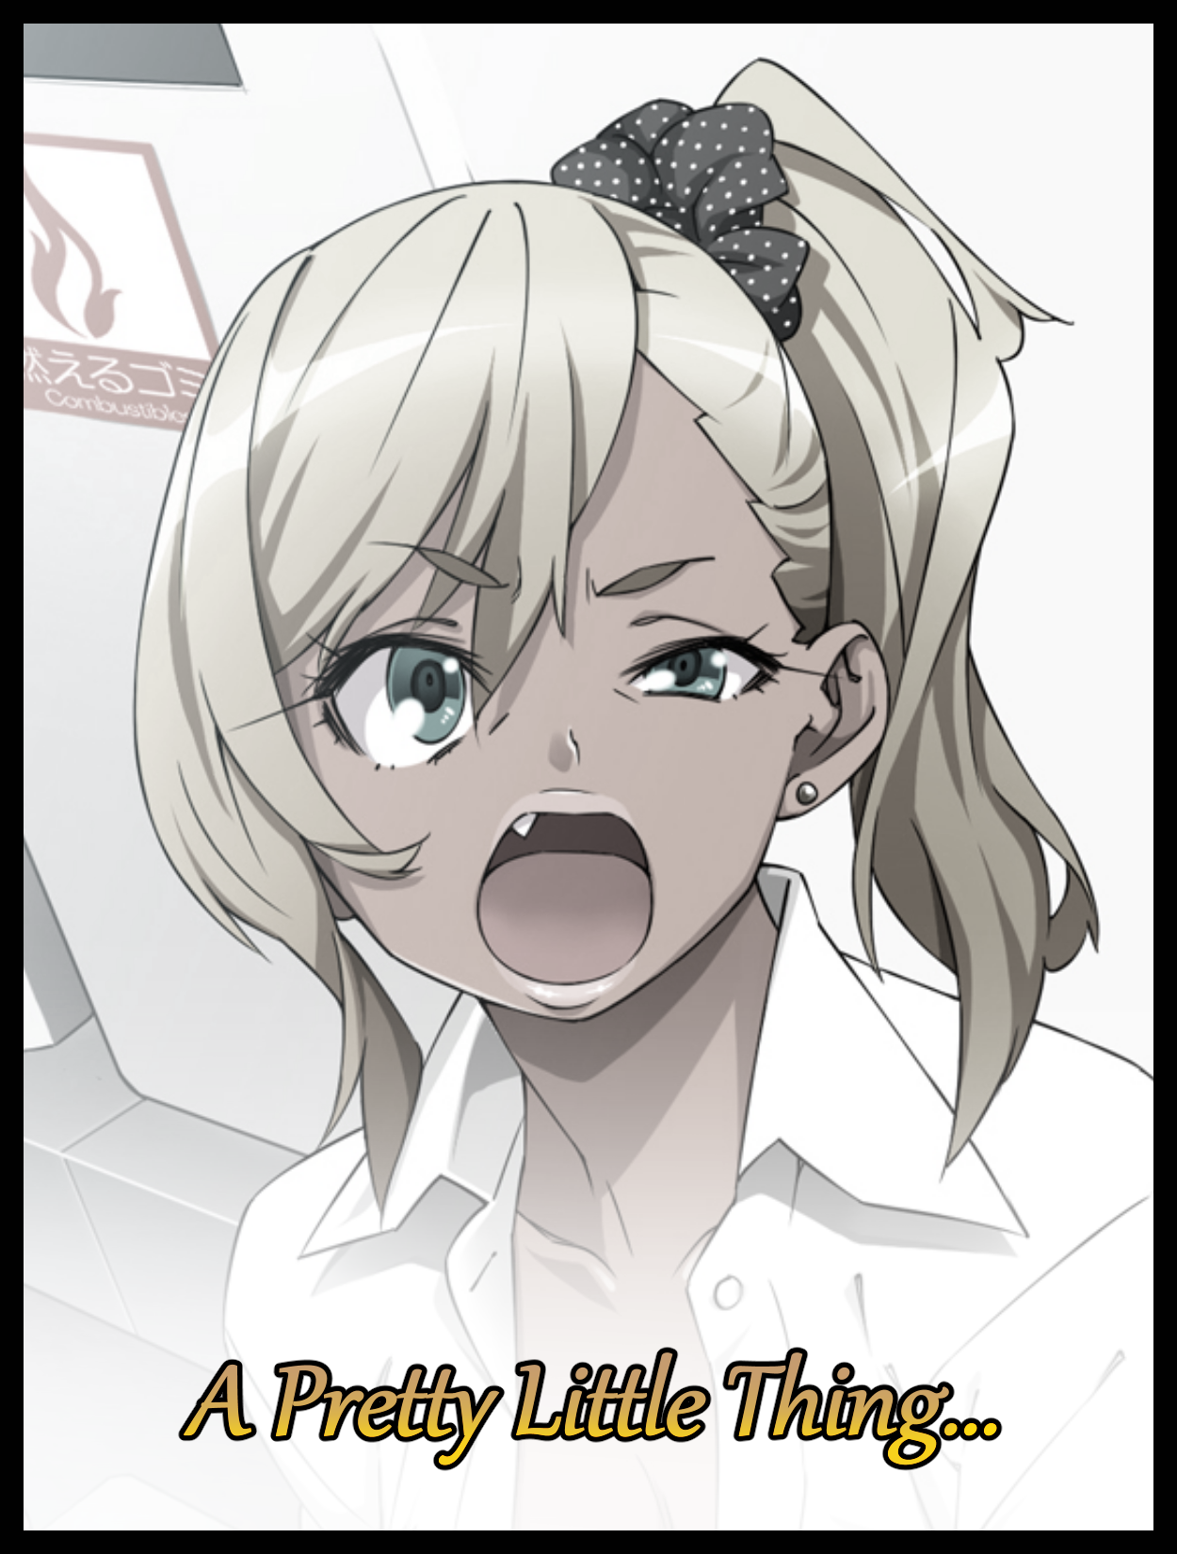

***"Just don't overthink things and do your job…you're a police officer aren't you? This is our chance to knock down the city's big time goons for good…so don't muck it up…"***

*A simple job*, that was all ***James Maroy*** had been able to take away after attending a one on one meeting with the superintendent of the police force, his boss…and she was as non negotiable as she always was; taking the slightest hint of hesitation as a sign of weakness and refusal of her orders like someone had insulted her parents. The steely eyed woman of the force in charge of everyone and everything to do in regards to the men and women in blue operating in Metropolis…and James, despite his pedigree, was simply another pawn in her eyes.

He knew that, many others did too. But he hadn't expected her to assign him such a…*derogatory* assignment. It was such a terrible yet brilliant idea that would only take the most willing of souls to accomplish, someone with a *specific* set of skills he didn't have. And yet, she had chosen him for the job despite his protests…he knew a superior needed to be hard on their underlings at times, but there was a difference between foolishness and 'tough love', and something told James that there has to be something more behind the superintendent's choice. After all, the toughest decisions were often made by the most capable of individuals, so maybe his being handed this impossible task had good reason behind it.

Unfortunately for James, being a paragon for justice, had been *too* trusting toward those on 'his' side of the fence. Seeing the world through eyes that lacked the critical filter that was the acceptance of a moral gray, rendering him blind to the foundations of a betrayal that had been delivered in the form of a very light slap to the cheek. One that would serve to cement the Metropolitan raised police officer’s downfall over the course of an agonizingly slow downfall…one he could no longer act to prevent after long having since lost the ability to do so once his mind had eventually succumbed to the corruptive influence of the spell the superintendent and her peers had cast over him.

The mission brief in the office had taken place over a year ago, the sting op meant to take place at the tail end of it; less than half that amount of time. And since its conclusion, James Maroy had become a thing of the past, with most officers mourning his loss in the wake of the biggest crime crackdown in Metropolis’ history. One with stunning results that left crime rates at an all time low and jails across the city filled to the brink with inmates all awaiting their respective sentences, most of which would be a lifetime behind bars at a supermax penitentiary beyond the city limits where the light of day was a commodity for it’s many loathsome inhabitants.

All thanks to the sacrifice of Metropolitan Police Department’s best officer, who had allegedly sacrificed himself to give away critical information related to the various crime groups that were vital in dismantling the scumbags operations…*allegedly*…

Because only one man seemed to know more than others did. The very same one who had stood behind James Maroy in the superintendent’s office as the stuffy, middle aged lady basically chewed him out for no good reason before enlisting him in an op that, in truth, was actually the testbed for a highly confidential government black op technology. One that could in essence, allow for someone to live forever through genetic tampering and morphological mutations…in essence; an immortality through rebirth…and James had been chosen as the candidate for their first, live human trial under the guise of cleaning out Metropolis’ seedy underbelly.

As advisor and the personal bodyguard to the superintendent, ***Dillan McCoy*** knew the operation was important and very much real despite the dagger hidden behind its squeaky clean exterior. If it was a success, then in one fell swoop…with minimal casualties…they could rid themselves of some of the worst individuals mankind had ever seen, ones who had committed plenty of atrocities, doing so with a smile on their faces. Men and women who deserve life sentences…or even better; *Death…*

But Dillan knew the fate his boss had planned for James was unjust, disgusting…but he couldn’t lift a finger or utter a word of it to his longtime idol and the latest of MPD’s martyrs. Not when the people he was contending with were capable of ending the lives of those closest to him at the snap of a finger. It wasn’t the superintendent he feared, no. It was the suits backing the entire operation…the ones who had created the technology responsible for erasing James from the face of the Earth…a grave sin that he too, had been a part of because of his unwillingness to come forward despite knowing that if he had just whispered a word or two, then maybe James wouldn’t have ‘vanished’ from the face of Metropolis…

A black stain on Dillan’s soul the man was intent on fixing as he glances down at the vial in his hands, an auto syringe filled to the brim with medication and futuristic nanites primed for genetic modification, coded to the original genetic information of James Maroy before he had stepped into the clinic that day for the ‘surgery’ he had undergone for the operation, wiping away rainwater as it trickles down over the edge of his umbrella, making a mighty big splash everytime his boots hit the ground in front of him as he navigates a tight, dirty walkway down the side of a neon lit street in the middle of ***Kabukichō***, ***Japan***. The exact location listed in the MPD database on the many criminals and other such ‘undesirable’ entities that had either been imprisoned…*or deported on the basis of being illegal immigrants.*

And as his venture through a rather quiet evening in one of Asia’s largest adult entertainment districts comes to a peak, the blinker built into the syringe begins to flash, alerting Dillan to the closing distance between himself and the registered recipient, turning corners, narrowly avoiding drunk locals and trying not to trip on the wet floor as he turns corners and navigates empty alleyways in an effort to close in on the source, and with the green light in his hand strobing to maximum speed, a final turn leaves the policeman frozen, stunned to complete silence as he gazes down the sheltered darkness toward the very end of the alley, wide eyes picking out velvety magenta fabrics refracting the light of a nearby vending machine while brilliant streaks of blonde that tapers off into pink tips of silken hair flutter wildly in the air, jostled by the rigorous movements of the woman they belonged to as her voluptuous form, barely clothed by the salacious garments that do little to conceal her perverse form as it’s well endowed assets jiggle and sway to the momentum of her heated movements. Supple arms braced against the brick wall, curvy legs rooted firmly into the ground, buoyant tits flopping like balloons beneath her shapely torso while the fleshy cheeks of a killer ass claps together with every mind blowing thrust delivered by the drunken man behind her using broad, handlebar hips for support as he rams his lower half into her sopping wet loins, clearly enjoying the rough treatment as a jet of liquid shoots out with each insertion, mixing into a soapy mess beneath the shameless couple before being washed away by the ongoing rain, the sounds of jingling bangles and clinky jewelry, throaty moans of both man and woman spewing Japanese slurs and professing empty words of faux love, all masked by the incessant rattle of metal being hammered on by a thousand droplets…



Dilan’s retreat had been swift as he slams his back against the wall just out of sight. His mind left reeling by the brief glimpse of the raunchy happenings playing out in the back alleys of Kabukichō. He didn’t want to see it, but the faint glow of the pulsing syringe only served to cement the fact that this was not a coincidence. It really was him…but at the same time, Dillan couldn’t believe it. The James he knew wouldn’t have let himself get screwed like that…the police officer he believed in wouldn’t have looked that happy at taking a dick inside of him…the idol he looked up to…

*‘No! This ends tonight…not one second longer!’*

The secretary had never once taken such an ‘active’ role in the field before. Being a constable before then, Dillan didn’t have much experience being a blooded cop in action, so understandably, his heart and mind were a complete mess as he turns the corner, barely avoiding crashing into the same man he’d seen earlier as he vanishes back down the way Dillan had come from. Leaving the foreign man alone to stare down the short distance between himself and the scantily clad prostitute cleaning herself off as best she could from her recent round of ‘fun’...doing so in mocking parallels as she reaches down between sweat slick thighs to extract the wrinkled rubber hanging out of her soiled flower, pulling it free with a subtle, wet pop and a moan of delight from her vulgar lips as she brings the sour balloon up to face height before downing the contents without hesitation, taking the time to tip the filled condom over until the last of the bitter spunk inside drips out and down over her eager tongue, lolling for more before retracting back in between fattened lips as she tosses the thing aside with a quick flick of dainty fingers tipped with nails painted over in glossy glamor, bending down to adjust the straps of a crotchless garter belt before ensuring her pillowy breasts, upon which a beauty mark laid nestled over the right tit, were nice and snug behind the woefully inadequate lengths of a V-string one piece swimsuit that left very little to the imagination as swollen nipples tent to hardened erection behind the rubbery material, showing off strawberry pink areola and the creamy smooth skin surrounding it, blending lines of pale beige with khaki hued skin blessed by the sun across the majority of her curvaceous form, turning to meet Dillan’s focused visage with a foxy smile on her face upon noticing his presence midway through fluffing out her eye catching mane, leering eyes of azure and a small lick of her lips signalling her misconception of what she thought the foreign man in front of her was here for as he approaches with uncertain steps, holding what looked to be drugs in his hand. An appealing form of payment she would've loved to indulge him in were it not for the quota she needed to hit by dawn…

**“*Gomen*~ Can’t take tonight! Cash only~"**

Sighing in exasperation as he comes within arm's length of the prostitute, Dillan would find himself stunned to silence at the sight (and smell) of what had become of James Moray over the span of a single year. Reminding himself of the officer and what he stood for in comparison to the tanned Japanese woman standing before him with her tits hanging free and a leaking vagina exposed so openly beneath the hem of a miniskirt that might as well not be there at all, mistakenly assuming him for a customer and not the secretary of the woman that had doomed her to this life…he had expected her to hold out somewhat against the biological programming forced into her mind. Fighting back just like she had for so many years now back at Metropolis…

So to look at those vapid, wanton eyes of hers in tandem with the fresh memory of what he had just witnessed earlier in spite of his conviction that he could right it all was almost nauseatingly mind rending to Dillan as he chokes out a few words before the confused gal who had no idea what he was looking all shaken for judging by the dismissive frown her lustful visage had contorted into after realizing he wasn’t going to be an easy customer.

**"How could they…you can't seriously be gone in there, right sir? S-Say something…"**

**"Eh? I…hahh…今、こんなことしていいのか？”**

*(Eh? I…hahh…do I seriously have to deal with this right now?)*

Missing her disdainful words as his mind drifts momentarily back to the past, Dillan recalls the time when James, still the same burly cop he remembered him as, had taken the very same green batch of genetic altering fluid currently held tight in his arms. Except the organic code sloshing around inside the mix back then had been the product of an unfeeling machine set to work on a gene mold aimed at recreating 'the most tantalizing piece of ass that would have the entire criminal underworld turning their heads' if the words of the head scientist were to be believed. A highly potent mix guaranteed to transform those injected with it into the walking wet dream of almost every single gangbanger in Metropolis…sexual deviancy made flesh so to speak.

He had been there when they locked James up inside a cylindrical vat, within which they had administered the mix through airborne means; flooding the airtight interior with a gaseous green cloud that immediately begins to show it’s effects across the extremities of the police officer’s body, darkening skin with an artificial tan while hair follicles shrivel up alongside the miraculous healing of scars and other such blemishes left by knives and low caliber rounds. Leaving smooth hide behind while the burly masses beneath are undone as bundles of muscle tighten momentarily before vanishing in a heartbeat. Melted away as overclocked nanites worked to devour the unnecessary biomass hindering the formation of smooth slender arms lined with fat and left with only the bare minimum for movement and tone.

In seconds, gnarled fingers roughed up by years of experience in the field were left thin and waifish. Tipped with newly grown nails of polished pink, wrapped up in porcelain smooth skin sporting a gaudy tan completely overwriting sun kissed Caucasian paleness as the renewed skin tone converges across his chest after consuming small, rounded shoulders that snap inward upon the tightening of his skeletal structure, leaving James with a slender, petite frame in exchange for his broad intimidating one. And when taken in tandem with a dramatic loss in height resulting from an apparent regression in age from a forty something year old grizzled crime fighting veteran to what looked like a young femboy dressed in overalls far too large for his size, even Dillan had to admit that what he was witnessing could very well be considered a modern day scientific marvel; to mold the human body so swiftly and accurately without harm to the subject…that was what he had thought close to a year ago…but now? After seeing what it had done to the man he still respected, he knew better.

It only took the passage of a few minutes to strip James of his trained physique, leaving him frail and helpless as he falls to his knees with a noticeable jiggle across his fattening, portly frame once bourgeois layers begin to sag forth from a warm, tender tummy. A cushioned core formed from devoured abdominal muscles, an alluring baseline from which twin pairs of porky thighs extended, leading to curved calves and dainty feet that were just as well cared for as his new arms were. And a little ways above where the new skin coloration had earlier converged, chiseled pecs were softened by the hands of the flesh sculpting machines proliferating in the gas, softening James’ body before layering weak muscle and pliable flesh, revitalizing dormant glands and nerves, cleansing skin. All to further the growth and perfect formation of a healthy set of breasts as the two burgeoning masses ballooned outward in a strenuous process that strains the officer’s body in more ways than one as an overflow of sweat caused by the inevitable generation of heat from such so much mass being ‘reorganized’ among other factors applies a glistening coat to his womanly exterior, taking on a much more feminine posture once the mental restrictions begin to kick in, forcing James to sit with his slender legs bent inward at the knees, squishing thighs together in an act that causes his back to arch inward from the surprising stimulation of crushing his withering pecker as it begins to recede, fading from existence as wrinkled skin irons out to form smooth exteriors fit to harbor the spongey, damp innards of a woman’s snatch as it blossoms at the forefront of an inflating rear, giving the imperiled man some much needed comfort as a gaunt ass becomes a slappable derriere that would give most other women a run for their money as it shears through the all-size underwear James had been wearing, giving the audience a good show of his twitching penis putting on it’s final airs of resistance in the form of a forced expulsion of semen that splashes onto the floor of the chamber. A milky release that begins to grow more and more ‘watery’ and clear with each passing second just as the timer hits the second minute.

By then, James had all but vanished. If it weren’t for his clothes, no one would ever guess that the young Japanese woman lying in a puddle of her own juices with a haggard look of hesitant pleasure on her face could ever have been the MPD’s top dog. Not when impressive double D tits tipped with creamy pink nipples jiggled to the tune of each steamy breath exhaled through greatly fattened lips cleansed of its former mottled quality alongside the stubble that once lined them. Leaving the shapely chin of a young lady’s face untouched as saliva trickles down the side of her mouth upon the evidently orgasmic feeling of having a womb be grown in real time alongside the respective nerves flaring to life, connecting to her nervous system in a manner that made James realize just how drastic the changes were as dull eyes of amber widen before a new shade of cyan blue shimmers to the forefront alongside a vixenly slant that bestows *her* with an alluring gaze...and when coupled with the sight of her tits flopping freely in the air alongside the unadulterated image of a wanton vagina shooting a translucent jet of precum out of a hole that had once been a girthy rod to wash away the white cloud between her shivering legs…safe to say that most of the men in the room that day were more attentive than ever before as they watched the last vestiges of James Maroy fade away as a crew cut head of brunette hair softens before exploding into a curly blossom of blonde tendrils, snaking down past a fragile neck, tickling pert cheeks of baby fat, framing beautiful eyes of oriental origin, curling down to poke at a massive cleavage while the rest tumbles down a tantalizingly arched spine that was just begging for a man to run his fingers across…

That was the moment when James Maroy as he once was in the flesh had ceased to be, giving way for ***Junko Mari***. A peppy Japanese gal whose seedy background was just as fake as her appearance made her out to be. Because that was the point of such a drastic (and degrading) makeover, with just the perfect baby doll disguise to sneak in undetected, ‘James’, operating under her new alias of Junko, could easily forward intel on VIPs, hidden caches and other such things the MPD would need to bring down the shady shadow looming over the city they were in charge of protecting. But even Dillan knew a man-turned-girl wouldn’t be enough to blend in so seamlessly. Forget mannerisms, Junko wouldn’t even know the first thing about being a girl! She had been born a red blooded Metropolitan man, not the blonde haired overseas bimbo she now looked like…and the mind of a man in the body of a girl sent to spy on some of the most cutthroat scoundrels in the world sounded like a disaster in the making.

Although once Junko had recovered enough to exit the pod on her own as a sweaty, shivering mess. The first words out of her mouth were more than enough for Dillan to realize that more changes than just the physical had afflicted the former policeman as she turns toward him with a blush over her cheeks and a terribly furious frown on her face before delivering a searing insult that sounded nothing like what her fatherly old self would’ve said in her place…worded in a highly sensual voice dripping with sexual flair and the not so subtle hint of an accent behind it…

***“The fuck ya lookin’ at?! Disgustin’ law lovin’ asshole!”***

Apparently not trusting in James’ ability to adapt to his new body and a purposefully excluded detail from the briefing the superintendent had given him, Junko’s new body had been packaged with a whole array of mental locks and restrictions placed to ensure she would play the role of being the perfect sex pet lusted after by the criminal body in Metropolis. Everything, from speech patterns, mannerisms all the way down to personal likes and dislikes had been tuned to those of the ideal girl a thug would look for.

One who hated the police as much as she hated the law. A purpose bred whore whose body was made to excel in all things related to rutting. An uncaring wench whose only interests were men, money and glitz. A totally corrupt individual whose morals were just as twisted as the folk who called upon her bodily services…a complete inversion of James Moray’s character, that was who Junko Mari was, and like it or not, she would be stuck that way until the operation’s end, a timer that had begun the very moment she had unwillingly traded her manhood for a throbbing snatch working hand in hand with a tampered brain to feed her perverse impulses and deep seated, irrational hatred for the police as she fought to free herself from the hands of the suits she had walked inside here willingly with.

According to the doctor, it was like a mix of forced filter and an organic form of autopilot that would take over whenever it was needed. And in Junko’s life, that meant almost every single second of her days going forward. The policeman inside her would still be able to do her job in a manner of speaking, but it would all be ‘translated’ to appear as the unsuspecting actions of a ditzy groupie…ensuring no accidental slips of the tongue, no moment where she would be caught breaking character

***“Just a pretty little thing…”***

Or so the superintendent had said as she watched Junko be ferried out of the clinic like a raving madwoman, no doubt struggling to break free of her mental restraints in an effort to confront her boss about her ‘accidental’ slip of the tongue in omitting that critical piece of information from her. Because if James knew he would essentially be surrendering his free will to step inside the shoes of some foreign bimbo, he never would’ve agreed to such a thing. But as she was forcibly put through the last bits of the procedure that would leave her the perfect trojan horse to deliver straight into enemy hands, it was far too late to do anything once they threw her out the back door rather harshly to put up the act that she wasn’t some goody two shoes cop lover.

Everything related to James Maroy’s life would come to a screeching halt for the duration of his stay in the world as Junko, beginning the impossible task of infiltrating the higher echelons of the local underworld that very night after catching the eyes of a rough looking thug loitering outside the edges of one of the many bars frequented by seedy folk like him. In another time, the cop in his midst would’ve gladly put him down without another word before bringing him in for questioning. But as things stood, Junko was physically incapable of doing such a thing, and thanks to her newly instilled impulses, the unwilling soul locked away inside of her could only shiver as she pressed her body up against his. Dressed in a skimpy schoolgirl’s uniform that looked a size too small for her, leaving her swollen, pressed up mammaries to crease a massive tent into the semi-transparent thing while a raging hard on below ruffles her pleated skirt, exposing the lack of underwear to conceal her equally fiery libido as loosened lips spilled their load right then and there, a sensation the man-turned-woman would soon grow *very* used to over the course of the evening as a the role of an escort soon escalates once the pair enters the bar, passed around like a slab of meat to be fondled and groped, all while James could do little but bear with the torment as the undetectable nanites lingering in her body worked to keep up the appearance of a juicy new babe fresh off the import train to sell herself in Metropolis…and as the peppy, side hung ponytail blondie swung her hips and shimmied around the booming halls with her ass on full display, it wouldn’t be long till one of the big players himself showed to see what all the fuss was about, only to be completely enthralled by the excitable young enchantress dancing atop the stage…putting on a masterful show unsuspectingly powerful thighs kept her glued to the cold metal pole upon which she would spin and throw herself off of…right into his arms.

That had been only one of a few recorded instances Dillan had seen for himself, live feeds fed from the machines in Junko’s body that provided the monitoring team back at the MPD with a complete, real time status update. From what their wanton ‘little slut’ was up to all the way to new juicy intel she would pick up on...it was then, while ignoring the display of Junko being taken bareback in the crime boss’ quarters, would he gain an inkling of insight as to the superintendent’s real purpose behind the forceful recruitment of James to serve as the experiment’s subject…it was the perfect position to shift the blame of the aftermath over to the criminals they would round up in the masses if anything was to go wrong…like say; if Metropolis’ most famous police officer were to be announced as KIA the following day after the end of the city wide crime bust about two months or so after Junko Mari’s had made her way into the city as an illegal immigrant working the sex trade…the unassuming form of the MPD’s best currently sitting outside one of the nearby Japanese themed convenience stores while the flames of one-sided warfare burned alongside distant booms and gunshots flaring in the distance.

Dillan had still been hopefully naive as he shut the car door, exiting alongside the superintendent, thinking they were there to retrieve their hardworking agent and return her to her old form. A wish that would soon be shattered once the not so formal appearance of the very same suits that had ushered them into the clinic a handful of months ago rounded the back of the store, ensuring Junko would have no way of escape left to her as her former boss pulls out an old MPD recruitment flier, one that had her old self plastered as the cover boy in stunning detail, almost as if to mock the slutty gyaru sitting on the curb in the middle of texting one of her many boy toys before they were silenced by the crackdown.

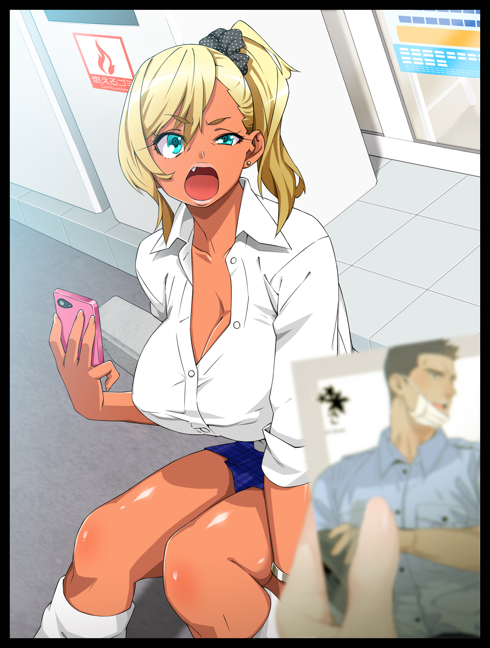

***“The fuck is this?! I haven’t done anythin’ wrong so screw off ya old hag!”***

***“Oh, but I’m afraid you have ‘Junko’...after all, illegal citizens like you don’t belong in the streets of such a shining moral beacon like Metropolis…but from that stupid look on your face, you don’t understand a word of what I’m saying, do you? Boys, she's all yours~”***

The secretary had tried to protest, knowing full well that beneath the surface, James must’ve been trying to convince them to help her, to change her back to normal, finally freeing her from two months of being forced to act like a deviant. Her words and behavior twisted by the ever present mental programming hogging her mind…but it wouldn’t matter, nothing he could say or do would ever be enough to help James as he was forced to watch the shady men haul Junko away screaming bloody murder, held back by the superintendent herself, grinning madly all the way through with victorious glee written in her wicked eyes.

As it turned out, the superintendent didn’t quite like the idea of some young upstart being far more popular than she was. In her eyes, she had worked the hardest out of anyone else in the MPD to get where she was now. And that pursuit to pretty up her career had turned her into a ruthless narcissist, cold blooded enough to sentence a legitimate police officer, one of the force’s most brilliant, upstanding members to a hellish life as some rabid, anarchistic skank to be deported back to whatever destination had been listed in her forged documents just because she had received the appropriate level of praise and adoration expected of such an upstanding (former) man of the law far exceeding that of the superintendent, the head honcho of the MPD…she wanted it all, and with the sudden proposal of the operation by the shady black ops team from the government to serve as a test for their newest toy, she had the means to rid herself of the troublesome little thorn in her side that was James Maroy forevermore, ensuring none would ever hear from or heap praise after endless praise upon him ever again. Trapped in a feminized body hardwired to loathe the things she once loved, the side she once stood for…as well as an unwitting lab rat to see what would happen if one were to be left in such a state for prolonged periods of time, unbeknownst to Dillan as his mind snaps back to focus in the dimly lit enclosure that was a sheltered alleyway somewhere in the heart of Kabukichō, the place he had finally tracked Junko down to after filing his resignation from the MPD, no longer able to sit still with the guilt of his inability eating away at him for months, utilizing stolen data and traffic records to pin his target down alongside the ‘cure’ to her condition, procured from the superintendent’s office after she had proposed a different idea to extend the experiment to her benefactors the night before James was supposed to return…a fix that, as Dillan would soon discover, was far too late to be delivered on time as his hazy vision snaps back to focus before the ‘matured’ version of the vulgar prostitute he had seen not too long ago in Metropolis as she decides to act on her own accord after the silence hanging between them goes on for far too long, impatiently pressing her lovely body up against his as she squeezes her bosom in a lewd gesture, all while her sweaty, nubile body comes close enough for the former policeman to reel at the smell of sex and decadence wafting off of her luxurious head of blonde hair. Distracting him enough to the point where he puts up no resistance against her advances as a salacious hand drifts down to caress his erect member, massaging the thing through Dillan’s jeans as she coos down his ear in a frighteningly seductive voice far removed from that of the whiny brat she used to be despite a far more retarded vocabulary…almost as if she had lost almost all her former knowledge of the English language in the time since then…

**“*Come~* Junko know you have money…so? Want me or not? Can promise you very good time if say yes~”**

Junko’s breasts, after so much use, had grown far larger with a notable sag to them. Her face, while retaining a modicum of her former youth, now looked very much like that of a sultry, mature babe. Losing most of the pomp in her lips in exchange for a sleeker set that gave her a far more appealing look while the rest of her body had undergone an overall aging effect, no doubt thanks to a mix of surgery and whatever else she had subjected herself to after being ‘returned’ to the seediest location in Japan…and this was Dillan’s chance to finally save her from it…

**“なんだ？あっち行けよカス！クソ外国人...やっぱり何かおかしいぞ...。”**

*(What the? Get away from me you fucking scumbag! shitty foreigners...knew something was wrong with you…)*

The raised hand that had been about to jab the syringe down the side of her neck was slapped away hard the moment Junko’s keen eyes catch sight of the MPD badge pinned to his wallet sticking out of his breast pocket, triggering a violent reaction from the thoroughly brainwashed street walker as she backs away from her attempted seduction of the ex-cop, uncaring of his despairing look at the sight of the broken thing he had tried to inject her with being washed away and diluted in the raging downpour going on in the background as she rushes into the arms of her boyfriend as he exits from the nearby doors to check out what had made his Junko scream the way she did.

The emotional distress roiling in Dillan’s head like the crashing waves of a stormy sea battering the shoreline would render him blind and deaf to the sounds of the complaining prostitute as she gleefully sics her man on the foreigner, eyes glued to the spilled genetic material that would’ve only had a chance at righting the damage left by the superintendent’s manipulation after their monitoring of Junko’s status had ceased about a week ago after deeming her a success when the nanites, in tandem with the ‘loving’ locals of the scandalous district had helped her ‘flower’ into her current self as one of the adult entertainment district’s finest whores, moving on to the next steps in their plans. Leaving Dillan in the dark as he tumbles to the wet ground after receiving a swift, strong punch that leaves him sprawled in one go, soaking up the filth of Kabukichō, numbed to the insult hurled his way by the burlesque brute of a man as he turns his back on him, tromping over toward Junko who would waste no time in reciprocating his efforts with a sloppy kiss, cooing like a horny animal as an unwavering hand slips low, brushing by the hem of her skirt to caress her aching cunt…the last thing he would ever see of Junko as the two vanish into the darkness of the open door before it slams shut, casting one final lecherous look at the fallen man as she vanishes with a lasting glimmer of blonde and pink left by wispy trails of hair…

Before the sweet embrace of unconscious darkness arrives to claim the physically and emotionally exhausted man, his ambitions crushed…his hopes for righting past wrongs, ruined forevermore…

THE END

*Image Sources*

Image 1 by Ishii Takamori : <https://www.pixiv.net/en/users/503837>

Image 2 by 23 : <https://www.pixiv.net/en/users/38543>

Image 3 by BitYan (Yaoi Warning) : <https://twitter.com/88ya8ya>

Misc assets from Heaven Burns Red