UN ÉTÉ FRANÇAIS
BONUS STORY
BY CHALDEACHANGE
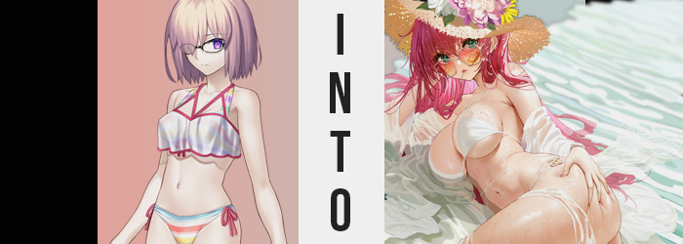

“I’m not sure what I was expecting, but I guess a beach is a beach no matter what part of the world we’re in…”

As the Chaldea Security Organization did every summer, they had arranged a visit to a beachside Singularity so that all of the staff and Servants could relax together. This summer, they had decided to visit the beached of France on recommendation from the esteemed Marie Antoinette.

They had settled on Pampelonne Beach in the Saint-Tropez region, known for its blue water, sandy beach, and gentle breeze. But before they could deem a location safe for travel, they first needed to send an investigation team. Just a small group of Servants, two or three at most. And in this case? Mashu Kyrielight, Marie Antoinette, and Jeanne d’Arc had all been sent without Ritsuka.

Jeanne had already moved a little inland to make sure things were secure there, while Marie Antoinette and Mashu were left to wander the beach. They had ten hours, which meant there was a little time for relaxation, and the Rider was already throwing down towels and unpacking a basket of goodies – including lotions and snacks – for the three to enjoy once the area was secured.

Mashu thought she was getting a little ahead of herself, though. “Marie-san? We haven’t even made sure the beach is safe yet…” It was like she was trying to eat her dessert before dinner, but Marie always had been a little unconventional when it came to things like these.

“Non!” The Rider’s retort, in French, came both quickly and with a bright smile. “These beaches are safe! The beauty of France wouldn’t be sullied by fiends, don’t you think? Besides, Mademoiselle Mashu! Don’t you think you could benefit for a little R&R? Allow me to pamper you like a real French woman!”

Marie giggled and ran over to take Mashu’s hand, before leading her to the towels she’d set down. “M-Marie-san!?” The queen’s gentle fingers brought Shielder, clad in her swimsuit, down onto the towel before pushing her back so that she was laying down. If Jeanne had come back in that moment, it certainly would have looked indecent with Marie practically laying on top of her. But she eventually let up and pointed indecisively at the lotions. “What are you doing?”

“I just want to help you relax! You’re always so tense because of our missions, even though you’re so pretty. I thought some peace and quiet at the French beachside would do you some good!” Ah, so that was why? Mashu hadn’t originally planned on coming, but Marie Antoinette has specifically requested she come. At least it seemed to be from a place of good intentions!

Though, the pair of them were missing a vital piece of information. That there was a Grail at work in this Singularity, one that had taken Marie’s earlier comment very literally. Rider was already caught up in the illusion, unaware that anything was wrong and that she was acting according to the Grail’s power. But Mashu? Given time, she’d notice. After all, she was the target.

Marie sat atop Mashu’s tummy now, mounting her so that she couldn’t get up. The Shielder was, of course, blushing. Even if there were no romantic connotations to this situation, such physical intimacy was just simply she wasn’t familiar with. Still, Marie Antoinette’s carefree attitude was infectious. “Maybe you’re right…” It wouldn’t hurt to take the edge of now and again, right?

“Bien sûr que j'ai raison!” Of course she was right! Marie knew fatigue well whenever she saw it, and to help alleviate that fatigue she had squirted some tanning oil from a bottle into her hands, which she then rubbed together. “Now hold still, Mashu! This may tickle a little!”

Her hands, covered in cold oil, both gripped Mashu’s right arm. Not only was it ticklish, but the coolness of the oil itself made her squirm a little as the Rider kneaded fingers into the knight Servant’s skin. “Using the finest oils at the beach is a key part of the enjoyment, oui?” Was that true? Mashu couldn’t fathom how.

But being massaged like this did feel a little nice. The arm Marie was rubbing had become so relaxed that she could just feel the tenseness leaving her muscles. Though, unfortunately? That was an ample mischaracterization of what was happening.

Because under Marie’s touch, the firmness of Mashu’s rigorous muscles, built from tireless training for the sake of protecting her senpai, was dwindling. The sheen of the oil reflected off of her skin, but what was contained within that skin was deflating, softening, being robbed of all the muscle that made the girl strong. The feeling of weakness wasn’t because Mashu was relaxed; it was because she was legitimately becoming frailer.

The girl that was mounted twitched briefly, and so Marie’s lips turned into a smirk as she laced oily fingers with Mashu’s own. “Does it feel pleasant?” Yet while her intentions were good, the fingers of the violet-haired maiden changed while interlocked with the queen’s own. Scars and callouses evaporated, and nails both grew long and took on all of the qualities of a proper manicure – now painted with bright pink gloss.

Marie eventually leaned over to the other side of Mashu’s body after taking fresh oil in her hands, and the same phenomenon ran on repeat. It was strange that not even Rider herself noticed what was happening, but at this point in time she was simply akin to a fiddle being played by the forces guiding her companion’s transformation in the first place.

“Oui, it feels nice…” At first, Mashu had been reluctant to admit that the oily massage was pleasant, if only to avoid encouraging Marie to go farther. But deep down? A small part of her wanted more. She wanted it so badly that the fact that she had first responded in French had entirely escaped her notice. Mashu didn’t even know French!

After finishing the second arm, the queen giggled and lifted herself off Mashu enough so that she could shimmy back onto her thighs, leaving her companions bare tummy exposed. After applying more tanning gunk to her hands, she wriggled her fingers in the air a moment for bringing them down on the other’s abs, making sure to be extra ticklish as she lathered that belly up. “AHAHAHA! MARIE-SAN! STOP IT!”

But Marie simply smiled brightly and continued, ignorant to the fact that the muscles her cool fingers were digging into were softening as she tickled. Their firmness melted away, stealing away her abs and leaving that belly decorated by only the slightest presence of tone that was otherwise smothered by an attractive softness – one that made the depths of her bellybutton appear all the vaster.

While rubbing the sides of Mashu’s tummy, her waistline pulled inward even though there was no squeezing nor pressing on her part, giving her figure the potential to became even more hourglass-like than it already was. Although, at the same time? The length of her belly appeared to pull upwards, more indicative that her spine had lengthened slightly. She was a little taller, and that came to be reflected in her arms as well.

Mashu had been tossing and turning from the tickling all the while, but she eventually subsided when it stopped. “That was mean, Marie-san!” She was pouting so cutely that the queen couldn’t help but beam at her with a giggle.

“And now, onto your jambes!” Or her legs, as they were referred to in English. Marie lifted herself again, but this time stood so she could turn around and rest gently on Mashu’s belly once more. With the legs in front of her, it made it a lot easier for Marie to stretch forward and rub the girl’s ankles with two oily hands in tandem, running them up towards her thighs given time.

It was again, very cold from Mashu’s point of view, but at least it wasn’t ticklish. The feeling of relaxation slowly worked its way up her legs via the touch of Marie’s massage – because just as with her arms, the muscles were weakening. Around the point of her knees though, hands lingered a moment both below and above the kneecaps. Not because she was intentionally lingering in these places, but because the legs grew slightly longer just as her spine and arms had. All in all, she had earned an additional two inches of height.

Things only became that much more bizarre once Marie’s fingers teased Mashu’s thighs. “Mon Dieu!?” Shielder exclaimed with surprise in French as she felt the girl cop the underside and inside of her thighs, these areas a little more intimate than their peaks. But it was necessary as Marie’s hands were being guided automatically around mass that was swelling.

Mashu’s thighs were thickening, and that wasn’t a process to scoff at considering her thighs had always been quite abundant on their own. Her muscles had mostly melted, of course, and that softness attribute to some of their bulge, but much of it was brand new, like fat was seeping in with the intention of full closing the gap between her thighs. Before long, Marie’s hands were meeting in the middle, caught between their hefts. How strange, was Mashu always this squishy? The thought nagged at Rider a moment, but it eventually came to pass.

“Okay, now roll onto you tummy, mademoiselle!” Oil flew through the air as she clapped her hands together and got up. Mashu did what was asked of her without protest, largely because she was beginning to enjoy this skinship session more and more the longer it wore on. “Merci!”

Now forward facing again, Marie rested her butt atop Mashu’s and began to rub oil against a back that was just littered with muscle. Muscle that evaporated just as quickly as the rest of it, leaving her back just as soft and slender as everything else on her body. But, feeling mischievous, she oiled her hands once more and dropped her chest down upon her partner’s oiled flesh, hands reaching around and under Mashu’s bikini top, groping the breasts with oily digits. “Don’t leave any place unoiled!”

“M-M-M-MADEMOISELLE MARIE!? WHAT ON EARTH ARE YOU DOING!?” Again, there was gratuitous French mixed in with Mashu’s exclamation as she wriggled under Marie’s weight, feeling fingers dig into her breasts and toy with her nipples.

As they did, Mashu’s chin was unintentionally lifted higher from the floor as the breasts she was resting against the towel on began to firm and swell. Her nipples were rock hard thanks to the cold digits of the queen, though in their hardness they’d also jumped up an entire coin size. Her tits jumped up to what could easily be described as a set of E-cups, and Marie was gayly playing with them to her hearts content. “But you have such a nice bosom! Much softer than mine!”

“What if Mademoiselle Jeanne returns!? What will she think!?” Mashu’s observation was sensical, even if the fact that her voice was now much squeakier wasn’t. Still, just as neither of them had noted the softness, the growth, or the French, they didn’t take notice of a change in pitch.

“I suppose you have a point!” Marie finally withdrew her hands, only to set her sights on another pile of cushiony flesh. To take Mashu by surprise, she didn’t even get up to turn around, though she did shimmy forward a bit, so she had easier access to her chosen spot. Leaning back a bit, her hands dipped behind her under Mashu’s bikini bottom, oiling up her rear – from the outskirts, into the crack.

Mashu squeaked and whined again, but it did feel good. In fact, all of this had felt good. Why was she fighting a massage from her queen at the beach? It really didn’t make a lot of sense, not when she found her queen to be so kind and beautiful. An ideal partner of sorts. Still, through her touch, the cheeks of her body grew as plentiful as the thighs beneath them. The fit of her bikini bottom looked ready to burst beneath their peach shape, but with oil soaking into the bikini as well, slack eventually was given while the bikini bottom turned pure white – and skimpier – just as the brassiere section did around her larger breasts.

“And now for the piece de resistance!” Marie jumped onto her feet again and stepped aside, before instructing the other woman to roll over on the towel again. Once she was upright once more, the Rider laid against her subject with all of her body’s weight, breasts docking ever so intimate while she drew oily fingers to the well-endowed woman’s face. “You need to make sure your face doesn’t burn, non?”

As pale fingers traced Mashu’s(?) cheeks, they became thinner. As they tickled her lips, they became fuller. As they passed her eyes, they not only became wider and more European, but their purples brightened to blueish green. Her beauty had become far more Western, and her hair soon tumbled down her shoulders in a pinkish red that pooled on the towel behind her. If standing, her hair would have reached her ample rear for sure.

She stood stunned a moment. Something was wrong, was it not? She felt incredibly good, but something also felt different. Almost like she was looking at the world through vastly different eyes. She recognized herself as a proud French woman, and that struck her as the oddest. Since when had she had any nationality to speak of? Yet, the more she looked at her queen’s beautiful eyes, the less concerned she grew.

“Hm? Mademoiselle Marie? What was I thinking just now? Mon Dieu!” The French submarine woman, Surcouf, stood stunned to find the queen laying atop her seductive form, grinning mischievously down at her. She felt as if she’d just awoken from a long dream where she was someone else entirely, not of French descent. Which struck her as bizarre, since she had been a proud citizen of France for as long as she could remember! “Are you comfy, ma reine? ♪”

What complaints could she have about shared skinship with the great Marie Antoinette. She was as pretty as she was adorable, and Surcouf’s tastes weren’t for men alone. Both girls giggled together a moment, both ignorant to the fact that this scene had come about as a result of Mashu’s transformation, and eventually rolled the two onto their side before letting Marie fall onto her back on the towel. “Comfy as can be! After all, we’re both on the beach of our homeland!”

It was now Surcouf laying atop Rider, their breasts docked as the submarine’s eyes danced to the very same bottle of oil that Marie had applied to her. “Well, you applied oil to me, so I guess it’s only fair that I apply it to you now, non?” The two, blushing like a pair of brides, broke out into further giggles.

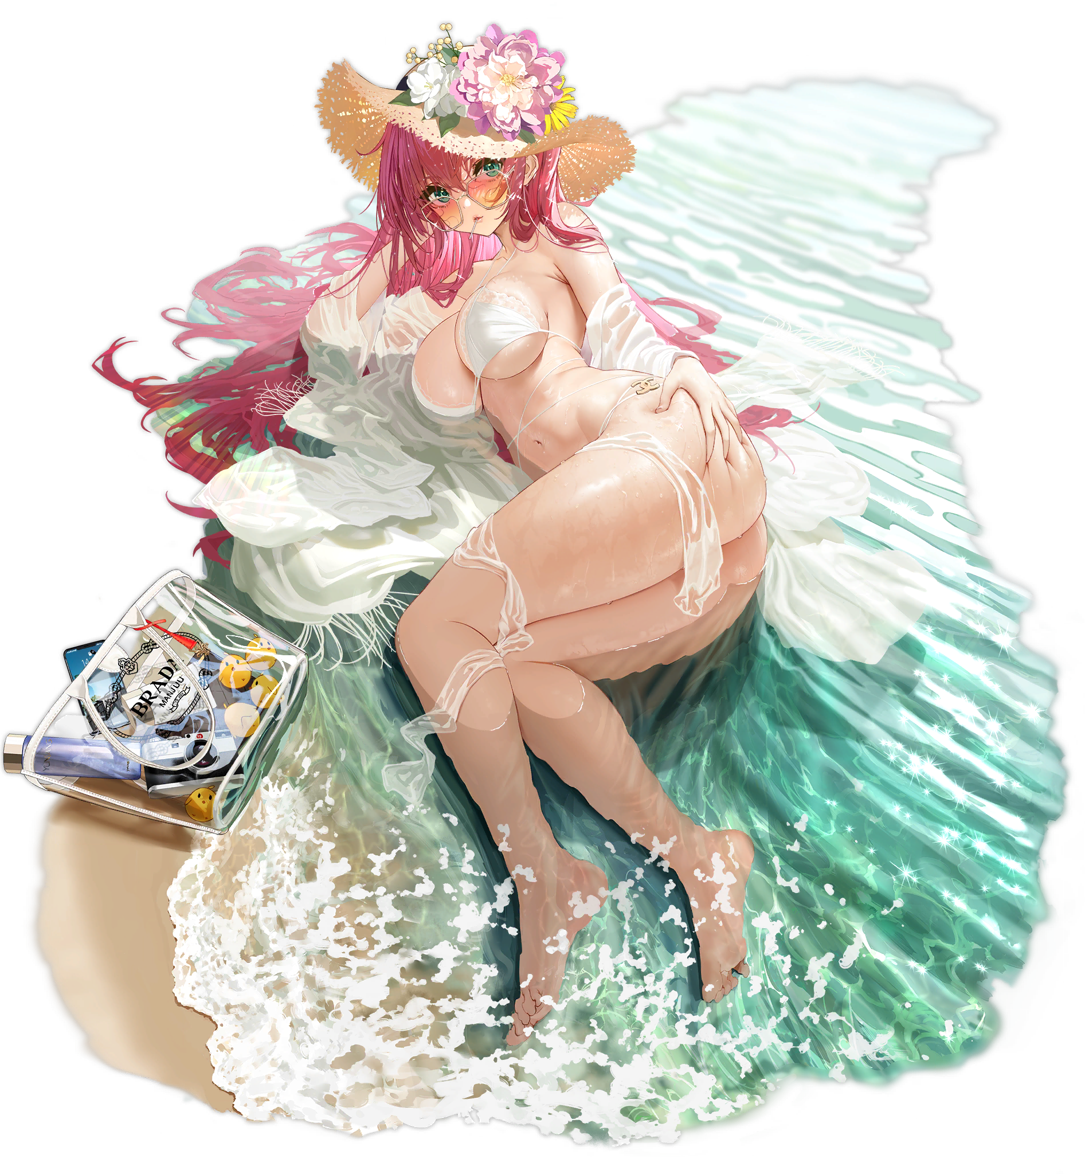
Jeanne was certainly in for an unusual sight when she returned.

