STARTING LIFE IN ANOTHER ISEKAI
CH3: ANTANGONIST?
BY CHALDEACHANGE
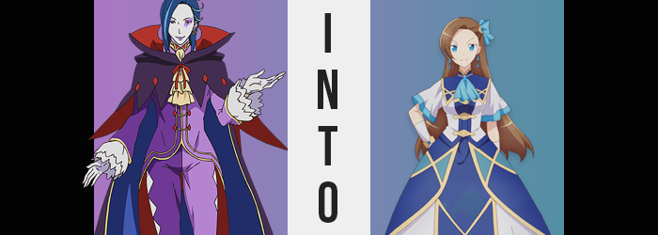

“Hmmmm~? Did someone touch something they shouldn’t have?”

While Rem nor Ram hadn’t had the foggiest idea about what had been happening, the same certainly wasn’t true about Roswaal L. Mathers. He was the Court Mage of Lugnica and the one whose collection that Subaru had disturbed in the first place. It went without saying that if there’d been an accident, he was essentially the only person that would have been guaranteed to understand.

But even then, his knowledge about that item had been fairly limited in the first place. He could tell that it was not of his world and that it carried a power that shouldn’t be tampered with – yet he couldn’t ascertain that power’s effects without tampering in the first place. In the end, Roswaal had simply left it alone and forgotten about it. At least until its power had sucked him in along with presumably everyone else nearby.

Now he was standing in what looked to be the dorm room of a school of some sort. Considering the truth behind his own existence, Roswaal had visited and studied at plenty of schools across the world over the course of his awfully long life, and yet he’d never been to one with an aesthetic quite like this.

“Hm. This clearly isn’t Lugnica. Could it be…?” The item that had brought him here had been from another world, so was this another world itself? That might explain the inconsistences and the unusual feeling he had. It was almost as if his powers had been sealed away? But he couldn’t imagine a force powerful enough to do that. Of course, only something on the scale of the world’s authority itself might- “Oh, is that how it is?”

If his hunch was right, then his odds weren’t particularly high at that moment.

He could already feel the influence of a greater power than even himself at work, and Roswaal gingerly raised a hand to observe its influences. The greyish tone of his skin, something that few questioned despite its unusualness regularly, was already being put through the wringer. What surfaced in its place was a pinkish tone that seemed far more normal and much healthier. It wasn’t merely his hands that received this boon though, and color found its way into the man’s body from head to toe – even erasing the ridiculous purple marking across his left eye and bringing a pink to his lips and nipples.

“I seeeee~! Well, I suppose there’s no point in trying to fight it?” Traveled and wise as he wise, the man could identify a fruitless endeavor when he saw, or was subjected to, one. This power was greater than his own, there wasn’t any real merit in trying to make a spectacle of resistance or shock. Not that he could resist. Already, his vast knowledge of magic had been forfeited. At best? Well, he seemed to know how to summon a lump of dirt from the ground?

Hey! It can be useful for knocking people off balance!

Or so said a voice in the back of his head.

And who was he to argue? His jester-like ensemble appeared to be growing all around him now. No, perhaps it was fairer to say that his frame was diminishing instead? Quite statuesque in visage, what was shaved from his frame was of fairly substantial merit that found hands consumed by sleeves, and pants baggy at his feet while held on only by the waistband at his – Oops! Never mind, there they go. Fortunately, his height loss had been substantial enough that his purple top hung a little past his groin, obscuring all but his legs.

On the other hand? One might not assume them to be, but Roswaal’s legs were quite hairy. Or had been, up until the moment those hairs were essentially eviscerated by an unknown force, leaving a freshly shaved look and feeling in their absence. A similar trend saw to his arms as well, not that one could even see anything with how far the sleeves dangled now.

Likewise obscured was his hands themselves. Fingers once long, fingernails even longer, both points had regressed in length just as his palms had become small. Actually, his fingernails were so short by the end of it all that they looked like they might have been chewed, and speckles of dirt caught between them and his fingertips suggested he might have been rooting around in soil of all things. Back at the manor, that was a job for his maids!

But gardening is fun! It’s a great distraction!

…Apparently.

The more Roswaal’s transformation wore on, the more restless he became. Not in a negative way, but more like having a boundless energy one wasn’t used to accommodating that was just banging on the walls in hopes that it might be expressed. He could likewise tell that his keen intellect was, well, dulling. “But nothing I can do about that!” Not even his eccentric manner of speech had been retained, and in fact his voice had become quite girlish after shrinking down to this height.

Fundamentally, his facial features had always appeared quite androgynous. Yet, femininity became rather evident as a tingling ran through those features. His complexion became fair, his eyes soft and wide, his nose petite, and his lips rather pudgy with a pinkish sheen. Until he looked like a young woman, perhaps around her mid-teens.

Not that his figure truly conveyed that at first, but he could feel that correction coming. “Oop!?” A maidenly squeak accompanied the first step, which resulted in a bubbling upon his chest. It didn’t feel particularly sensual, but he could certainly feel hardened nipples rubbing up against the underside of his shirt, along with budding breasts plumping up beneath them into a set of Bs distinguishable enough that their shapes could be made out from the outside.

Frankly? Roswaal had been a woman once before, so he didn’t find this all that shocking. If you want context for this, please watch Re:zero season 2! Certainly, the feeling of losing one’s cock and balls was unusual to be felt, but he – she was still largely indifferent to it. You could blame the fact that she’d been a woman once before of course, but what was just as much to blame was her twisting perception of reality in the first place.

An unfamiliar dorm room began to look more like home. The weight of her shrunken body began to feel more natural. Her memories were in the process of adjusting so that she fit right in with this world, and as her ass bulged into a tender peach shape that flipped up the back of her top, and thighs bulged with maturing delight, little remained of who she’d once been anyways. “What was I doing? I guess it felt kind of important…” The way she spoke sounded about as scatterbrained as she felt, honestly.

The blue of the bright sky finally found itself awash among her eyes, and the girl’s eccentrically dark blue mane? It found mundanity as a brunette coloration bled into her roots and swept up to her tips, growing and fluffifying (yes, this is now a word) her hair so that it gently fell down her back. But hey, at least the curl of her bangs that were swept rightward was fully retained!

All that was left now was her outfit, and a tear in fabric’s reality sudden jarred the girl’s surroundings – she herself not aware of what had actually changed, leaving her wondering what had happened for a second. In truth, she was now clad in an ornate dress of white, blue, and gold. Completely accessorized with white gloves, a blue bow, and matching gem earrings, her visage gave off an aura of refinement.

Too bad nothing about her personality did the same!

“Wow, the time really got away from me! I won’t have time to tend to the garden before class at this rate!” Katarina Claes wiped the sweat from her brow before skipping over to her desk to pack her bag for the day. She felt as if she’d just been sidetracked by something silly, but wasn’t that fairly standard for her? She was something of a ditz and was very well aware of it. As were her dear friends, as they often reminded her!

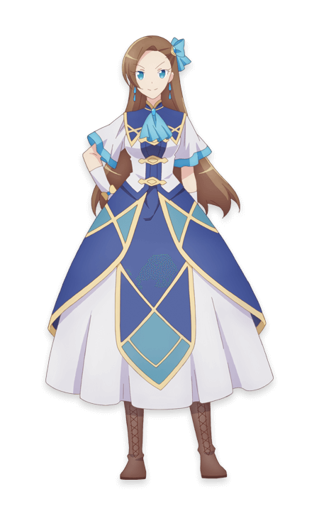
Of all the things she’d forgotten from the past ten or so minutes, the only consistency between her memory now and before was the understanding that she was from another world. Because Katarina Claes simply was. After passing on, she’d been reincarnated into the world of the game Fortune Lover, and as the primary villainess at that!

Wait. “Is that the kind of situation I’m in? Didn’t I come from somewhere more magical?” She tilted her head to the side before shrugging it off and throwing her bag containing her books and farming clothes over her shoulder. “Nah! That doesn’t make sense. I struggle so much with magic even now. Japan didn’t have any magic at all.” And with that she closed the book on these ponderings, before launching herself out the door of her dorm room to get on with her day.

“I can’t afford to waste anymore ti— OW!?”

She’d tripped over nothing and bonked her head on a wall.

