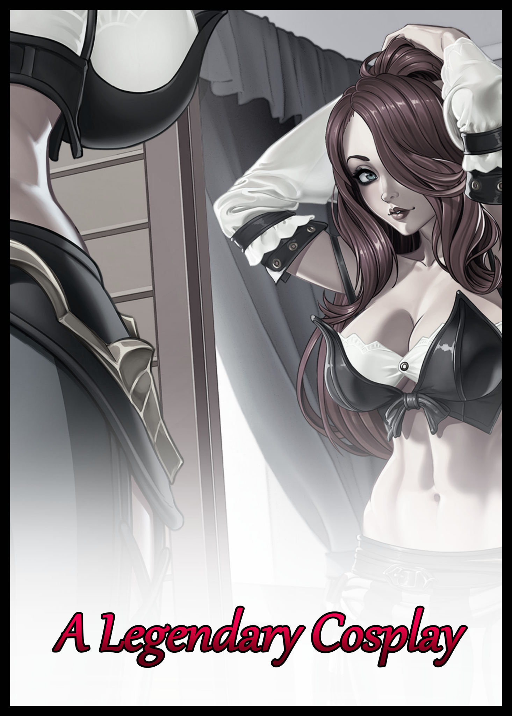

"For the last time Em; no means no. I'm not gonna…spend days locked up in some stuffy suit again! You know how hot those things can get! I'll be lucky if I walk away with just a heat stroke this time…" The thump of a stopper taking the impact of a plastic rimmed door sliding open after a forceful shove from a blonde haired woman stomping her way into the homely bedroom. Dressed in nothing more than a soaked towel that did little to hide her shapely figure from view. Urging the man lying on the king-sized bed to avert his gaze if her irate expression wasn’t already enough of an indicator.

"But I haven't even said a word? C'mon, it's not like that at all!" Despite her appearance however, self control tempers her rage. Unballing the fist her hand had shifted into upon hearing the man’s assumption and the accusatory tone it had been laced with. Displaying a measure of affection for him in a way few ever could without simply lashing out or at least making their dissatisfaction known, taking on a more casual tone in a successful effort to shift the conversation back to the easygoing flow it had started off with. “Look…just hear me out alright? I promise you; it’s not what you think it is. If I wanted you stuffed in a mascot again…you know I wouldn’t skirt around the topic and just shove you in myself right?”

“Hah! Yeah…yeah you’re right…still got the ache in my back from that…” Hushed voices free of strife return to join in the relatively calm atmosphere of a bedroom shrouded in evening blues. Illuminated by the warm glow of a small lamp sitting patiently on a nightstand by the side of the bed closest to the huffing man who seemed to catch on fast to his significant other’s intent on keeping their discussion a civil one. Pleasing her to an extent while annoying her as an adorable pout crosses her visage for a fraction of a second at the sight of him returning to scroll through the social media feeds on his phone as if nothing had happened before she turns her back on him, scooting over toward the wardrobe to pull off a waiting set of clothing hanging on the handle. Wasting no time in picking up the conversation where she left off after enough time had passed in silence.

“It’s not a not a birthday bash for kids, alright? It’s a convention. No mascots, no costumes…well, sort of…" Scoffing at what she had said, the man sets his phone down before turning over to face the blonde just as a baggy shirt tumbles over her lean torso. "Sort of? So what, you want me to just…tag along with you to a convention free of charge? Why now?"

Without a single response to his wit, the woman jumps straight to business. Masterfully putting on her clothes in a way that would never reveal a hint of skin to the person behind her if he was even intent on sneaking a peek as the non-existent drive to spy on her leads him to slump back into the bed, eyes locked on the pale ceiling above while a lazy hand fumbles for a misplaced phone. "Yep, it's not just any boring old con mind you…there'll be plenty of stuff to see, lot’s to do, cosplay to treat the eyes with and a lot of nice folk to chat with. A real nice vacation plan I had in mind to spend some time with my boyfriend…that is of course, unless he doesn’t want to?”

Freezing up with a pensive look on his face, the man's initial disinterest turns to curiosity as he ponders the idea of accompanying his girlfriend to a convention, something he had never really been to before. Wondering if there really were no other strings attached before weighing the benefits if he were to contest her claims of him being unwilling to attend. Juggling the thought of seeing Emily all dolled up in a lovely outfit with the nagging idea that something was amiss.

Because for as long as he knew her, Charlie had never once received an invitation from his girlfriend to partake in her beloved hobby before. He was more than aware of Emily's status as a professional cosplayer. And when it came to that particular field, he knew he had no place by her side in that regard. Not when cosplayers were often favored more for their looks, and not the underlying 'meat' that were their hearts and minds. The prettier the better, and Charlie knew when to call it quits when his overweight stature would never turn heads, assuming it’d be better for Emily if no one knew she had a ‘deadbeat’ for a boyfriend…until now that is…

"But…won't I, y’know, stand out? And not for good reason mind you…” Turning over to look Emily in the eyes, he knew then that she had instantly caught on to the sensitive topic he had been skirting around. Shooting him a confused look that steadily turns into a disappointed glare in the span of a second.

“Not for good…oh…you aren’t getting all self-conscious on me now, are you?"

“I’m sorry Em…I just...didn’t think it was worth bringing up at all. I don’t exactly look the type to be caught playing dress up next to the likes of someone like you right?”

“Playing dress up hmm? Is that what you think cosplay’s all about? All right, that’s it. You’re coming along with me tomorrow and that’s final! No but's, what's or whatever the heck else excuse you've got!”

Before Charlie could say a word in protest to such a last minute notice, Emily, now dressed and ready for bed, throws herself onto the sheets, landing smack dab on the vacant portion of the sturdy mattress beside her boyfriend’s bulk. Laughing as she does so in her usual carefree tone, disarming him of anything he might've had to say in opposition to this declaration of hers in the fear of ruining the moment as the pair fall silent for a few seconds. Lying still next to each other with their eyes locked to the ceiling until Emily's hand comes to rest on Charlie's own, clenched tightly in a gentle show of affirmation for her feelings toward him and their relationship despite the disparity between their appearances. A foul assumption the fortunate man couldn't help but feel bad about for thinking so hard about. Reciprocating it with a firm grip that grows lax as the full strain of the day's events registers itself in weary limbs and tingling joints now that the mildly tense atmosphere in the room had been significantly toned down enough for the soft, enticing embrace of sleep to coax the couple to a good night's rest. "So…tomorrow huh? That's…sudden…"

"I take it you're all in then? Yep, eight o'clock sharp in the morning. I've got a little surprise in store for you before we hit the main floor~"

"Any luck I get a hint or two before then? I'd like to know what I'm getting my feet into before I jump in."

"Not a chance, I said it was a surprise didn't I? Now hurry up and get some rest. Then you can see for yourself~"

Landing a swift peck on the cheek, Emily turns back toward her side without giving him the chance to reciprocate. Leaving him in the metaphorical dust to turn off the lights and get to bed in preparation for tomorrow. Turning herself off like a machine by the time his hand had depressed the lamp's power switch. Dousing the room in darkness with only the spots in Charlie's vision to pick out the vague silhouettes of his surroundings. Looking toward the golden mop of slightly damp hair belonging to Emily lying by his side before following suit and tucking himself in for the night. "G'nite Em…"

Although he never considered himself to be a freeloader. A part of Charlie couldn't help but feel blessed and equally thankful for Emily's insistence to remain by his side throughout the three or so years since they had come together after an initial, chance encounter in university had led to their joining as boyfriend and girlfriend despite the aforementioned disparity between their appearances. A gap he had desperately wanted to close on his part by working out and eating less as much as he could to lose that pudge. But a commitment like that would need time to see the payoff through, a lengthy period that didn't go too well with self deprecating thoughts and a hesitation to follow through with the plan due to the lack of immediate results. And yet, Emily hadn't said a word about his size ever since moving in to live with him. Working a well paying job modeling gig while he did his best every day as an ordinary wage earner. Hardly what one would call a match made in heaven…but it was a match nonetheless, one Charlie would resolve to uphold and strengthen right then and there before heavy eyelids slid shut. Putting festering doubts to rest in anticipation for the convention and Emily’s ‘surprise’, the thought of which brings Charlie back to a not so distant past shared with his magically charged kid sister and the many tangles they shared before moving out to live with Emily. Realizing he’d need to tell her about his unique little sister at some point or risk facing her wrath. ‘Heh…Marly’s not gonna like it if she hears I haven’t even told Emily about her whenever she drops by…if she does for that matter…wonder how she’s doing out there on her own…’

Sighing to alleviate his troubled mind of all the intrusive thoughts preventing him from getting some much needed rest, a final heavy sigh would escape Charlie before his mind follows suit with his unmoving body; drifting into a realm of cozy sleep from which he would not wake from till the morrow came.

And when it did, those last minute thoughts about Marly would return once more in force after a fateful meeting within the makeshift changing rooms for the big name cosplayers in attendance at the convention center. Snapping Charlie out of the lethargic haze induced by a light breakfast and the bumpy cab ride on the way to the con as he backs away from his girlfriend and the mysterious woman she stood next to with a look of unabashed glee on her face seconds after entering a secluded room with barely any time to make a proper introduction.

“W-Wait a sec Em…you want me to do what?!” A foot slides back toward the door behind him out of nervous reflex. And not without good reason, for it was his dealings with Marly that taught him the truth that laid in the existence of the unnatural. Demihumans living amongst the ordinary masses, and while he had the benefit of Marly being his sister, this stranger was exactly that, and although Emily seemed to know her, who could say she hadn’t already swayed her over to her side using some sort of mind control? Luring him into a false sense of safety so he wouldn’t make a scene before doing whatever it is she had in mind.

But before things could escalate, it would be the stranger’s interference to defuse Charlie’s skepticism. Remaining rooted to the spot but with a fire in her eyes as she turns to face him while ‘speaking’ in a voice that resonates with his very being. As if it were echoing around inside his skull and not the room they were standing in, catching Emily’s attention as well despite the lack of movement to her friend’s lips. ‘Calm down Charlie…you’re right to harbor doubts. Truth be told; I’m hurt to know that you think me the type to lay a hand on someone as understanding and gentle as Emily. But the past you have with your sister warrants it…which also explains why you didn’t seem too perplexed by Emily’s proposition. Most men would have laughed if their girlfriend told them to dress up like a girl. You can relax, nothing bad will happen here today, you have my word.’

“His sister? Damn it Charlie, you never said anything about a sister! And she can work magic too?!” Despite the aggressive tone of her voice, Emily’s demeanor looked more like that of an adrenaline fueled kid hopped up on one too many treats in a candy store, rapidly closing the distance between them before hooking her arms around Charlie’s own. “You have got to tell her to come over when this is over, got it?” “L-Look, I don’t think that’s the best idea…I don’t know about your friend…but Marly…she can be a bit…compulsive with her ‘talent’.”

‘No worries on that end Charlie. As enjoyable as it is to reshape the body, I refrain from doing so to stave away the repetition of it all. Good things must be consumed in moderation, as they say…isn’t that right Emily?’ A knowing wink shared between the two ladies would be all Charlie needed to get an idea of the depth behind their relationship, quelling his nerves somewhat as his gaze shifts from Emily over to her friend like a kid getting unspoken approval to approach a wild animal. Moving with care in his step to introduce himself properly.

“You already know it but…the name’s Charlie…so, how long have you two uhh…known each other? From what I’ve heard, sounds like a pretty long time right?”

‘Indeed, your girlfriend and I have been friends since middle school! As you’ve probably guessed, I’m mute. So I make do with my mind…not the best tools in the shed to work off of, especially when said tools were given to a simple minded child…’

“What Sarah means to say is; Hi, nice to meet you, my name’s Sarah…and that without some proper guidance. Those ‘tools’ of hers could end up being mishandled. Sorry, she likes to talk fancy with that brain speak of hers…although, doesn’t this sound familiar? You had to make sure Marly stayed straight, right?”

‘It’s called Telepathy…but brain speak is good enough I guess…’

“Yeah…well, about that, I didn’t have to do much actually. Marly’s got a good grasp of her moral compass…although I can’t say the same for her compulsions. If there’s something she really wants, she’d use her powers in a heartbeat. Nothing bad of course, ust petty stuff…most of the time…a-anyway, what was it you wanted me to do again?” Shying away from the topic before specifics were asked, Charlie glances downward at the glossy print that had been thrust into his hands by Emily, bounding back over Sarah’s side with a wry smile at her boyfriend’s reaction to the image of an alluring redhead in what looked like a pirate themed outfit. A familiar one rousing memories of highschool gaming sessions in the comfort of his bedroom while forgetting all about homework that needed to be done. “Is this…Miss Fortune? O-Oh no…you can’t seriously…you’re serious about this aren’t you?” A single glance told him everything he needed to know; from the nonchalant looks on the girls faces to the secluded room, this had been the surprise Emily had been holding back. One that would’ve done the trick for sure had he not known about superhumans and their fantastical abilities. 'You guess correct, Emily had intended to keep the knowledge of it hidden but…seeing as you have prior experience, this is a perfect chance don't you think?'

Looking at it now though, brought only shame and discomfort from the many times Marly had forcibly subjected him to what Emily and her friend were asking of him. And while he always came out unscathed, the experience, while oftentimes pleasant, couldn't be called a desirable one considering how many times his sister had essentially fed mental locks and commands to keep whatever bodacious woman she would mold from his flesh in line.

But this was different. For one, he was being asked. And secondly, it was a favor he could choose to fulfill for Emily. Weighing heavily on his decision especially after what had gone through that indecisive head of his last night…and Sarah was right; he had the experience of being on the other side of the fence. More than any other man in the world…

So with a heavy sigh and drooping hands falling down to his sides, a weary nod would elicit an exuberant cry of joy from the expectant blonde. Hopping over to give Charlie a bearhug before snatching the print from his hands. "You have no idea how much this means Charlie! Don't worry about a thing by the way, Sarah's not gonna be messing around too much with your head."

"W-Wait! So…how's this all going to work? Is it-"

'Well…for starters, I'll be working on you with my almighty brain. Emily wants to base your new body around this really hot cosplayer friend of ours since she's not in attendance…but with you around, consider her arrival set in stone and Emily's. I'll only be implementing her mannerisms and the certain character-specific quirks to help out with the whole cosplay thing but that should be it…ah…your sister's work is…certainly brusque…no need to worry there, I’ll try not to make it as unpleasant, besides, it’s a pleasurable process isn’t it?’

"Sometimes it is…I guess…look, I don't wanna talk about it too much, you read minds don't you? You could probably find out for yourself if you wanted."

'Something like that…but no, I can only 'see' someone's past. And even then, it's mostly just a bog of emotions and vague imagery. It took a long time to understand it…and I have your girlfriend to thank for it…'

"How sweet of you Sarah…remind me to get ya a burger later…but we're running out of time so let's get this show on the road. The openings in thirty but you know how conventions are~" 'They always open the floodgates a tad too early…are you ready Charlie?' Shaking off the jitters before presenting himself before Sarah, the portly man straightens up in preparation to be molded to Emily's desires. Nodding firmly as his girlfriend takes a step back to give the pair ample space for the metamorphosis that would soon take place once Sarah shuts her eyes in concentration. Calling upon intangible energies to reshape the man standing before her as a chilling jolt runs down his spine upon contact. Trembling as his skin begins to ripple like the surface of a river being disturbed while the flesh beneath starts to throb with a powerful straining effect that leaves Charlie in a bunched up pose as if he’d been shot with a taser.

“You alright there Charlie? You look kinda…stiff…”

“Y-Yeap! I’m…alright! J-Just feeling a little-argh!” With a strained grunt, the reallocation and dispersal of mass Charlie had never thought to experience again makes itself apparent. Unable to help the whistle of air escaping his mouth from the sensation of his sizable gut deflating before spreading out. As if a multi-armed masseuse was running firm hands all across his body, hands that accrue mass as they sweep across plains of undulating beige. Kneading and lifting at just the right time and pace to leave certain portions thinner than they were before while others expanded. Working in tandem until a healthy core remained, unveiled by parting threads as a simple outfit unwinds itself like a rising curtain. 'There, there…let that stress go…that's it, exhale…you're starting to shape up nicely~'

Boxers would be the last to go, allowing for Charlie's girth to fall out unceremoniously between legs that had thinned enough to form an admittedly eye-catching void between cushioned thighs cleansed of obesity, lined with firm meat and filled with baby fat. Flaccid and lax in the wind as it continues to shrink, pulled up into a tight navel sporting firm abs by the same force that had adjusted the rest of Charlie into an unrecognizable configuration. Like arms that once shook with a notable jiggle around the armpits being cleansed of flab, leaving two matching branches of toned shoulders, slender forearms and waifish palms tipped with dainty digits and polished shells of pink. Complimenting a petite neck in the middle of it all holding up a head that had rid itself of a dangling second chin and the stubble that riddled it. Gradually losing more and more of the features that made it Charlie's in favor of the alluring lashes, pinchable cheeks and vulgar lips of the woman in the print held tightly to Sarah's chest… "I-Is it normal to not feel a…woah…is that my voi-ahn!?" 'Nice singing voice honey…and yeah…my flavor of the process is mostly 'light' of a sort…until you get to the good part that is!'

Jolting in response to the titillating sound that had left lipstick caked lips from the sudden pang of pleasure that had struck him in the groin before zipping over to what felt like the region beneath his chest, Charlie's gaze goes downward past bubbling mounds that were starting to lift themselves up and away. Becoming full, hefty breasts instead of simple, hairy pouches of fat as Sarah's power graces his body, activating inert glands while tweaking nerves to fill perky melons with a maiden's nectar. Rejuvenating wrinkled nubs of brown, wrinkled skin into shimmering mounds set atop dazzling badonkers that must've come close to breaking the E-cup barrier. Showing off how sensitive they were as a stray wind blows by, causing swollen nipples to harden in response alongside a soft sigh that slips loose before Charlie bites down on a juicy lower lip. Clearly embarrassed by the sights and sounds of his feminizing body, made worse by the pair of eyes he could feel over to his left. Lingering over a shapely spine that had curved inward beneath his notice, bringing focus to a pliable ass that jiggles with every uncertain step while statuesque arms move to grapple with gelatinous tits. Cupping them in an effort to protect their modesty now that feminine mannerisms and awareness had settled into Charlie's brain. Affecting even the way he stood as beautiful legs crossed each other without effort or obstruction now that the tiny thing between them had all but vanished. Reduced to an adorable pink worm that trembles in the throes of futile resistance before a flap of pink curls around it. Pulling a neutered penis into its new home atop a plump set of lips where testicles once sat cozy. The completely functional vulva of a woman that displays its potency as another shiver runs down Charlie's now curvaceous figure. Heralding an uncertain mumble from deep within the newborn female's body as an incubator comes to be. Flanked by repurposed organs that waste no time in flooding her system with estrogen and other hormones of the fairer sex, making the tickle that comes next slightly more arousing than it needed to be as a brief spurt of white shoots free of Charlie's snatch. Splattering against the floor beneath shakey feet to form a small, milky puddle that soon begins to grow once more driblets of useless semen begin to fall to the floor. Accompanied by jets of watery precum produced by her innards as they flex and contort in an effort to empty Charlie's womb of the cum it no longer needed much to her embarrassment and shame.

"W-Wow…you've…certainly got a lot stored up in there huh?"

"Em! D-Don't look! Sarah! W-Why can't I stop?!"

'Hush now, it's not like you're peeing yourself. You're all woman now, and that means your man juice has gotta go. Just let it happen alright? Now be still! We’re almost done, and the less you move, the less of a mess I’ll have to clean up afterward.”
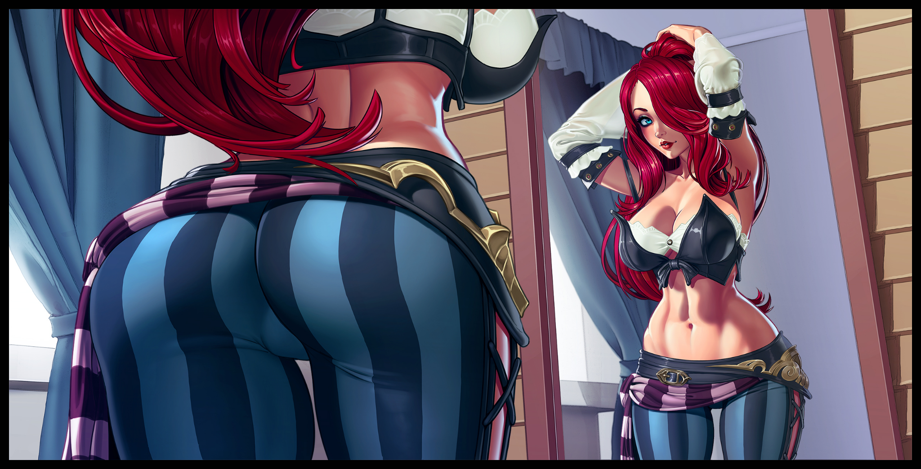
As much as she would've liked to acquiesce to that reasonable request, Charlie could not control the instinctive movements of her spastic body. Willing but failing her crooked legs to keep still while fertile hips escalated by bucking and thrusting. Shooting juices further and further despite herself far enough to almost hit the tip of Sarah's heels. All while lengthening locks of dark brown bobs and swings around her voluptuous frame. Burning with vivid scarlet flourishing from the roots as the last strands of wiry hair thin and congeal with the collective mass stretching down long enough to form a wavy mane that curls just above the crack of a smashing derriere. Leaving Charlie a nude replica of the lady in the photo, putting a smile on Sarah’s face as furrowed eyes finally open.

"I've never seen you work your magic on a man before Sarah but damn…that was…hot…"

“A-Are we done? Y-You’re not gonna put clothes on me?"

'I'm not your sister Charlie~ Well…not entirely…but you're gonna have to handle that bit yourself. I made sure to include all the know-how and whatnot inside that pretty little head of yours. Now go on and get changed, you've got a date to catch don't you?'

"D-Date? But aren't we supposed to-woah!” Silenced by a firm tug on her shoulders, Charlie falls quiet by Emily's side. Realizing how easily she had been pulled into submission now that her overall mass had been reduced despite an apparent increase in size that leaves her towering a full head over her girlfriend when the two were about the same height a few moments ago. “C’mon now dear~ Let Sarah clean in peace alright? We’ve gotta get you dressed up and ready to hit the con!”

Without waiting for a response, Emily would haul her newly acquired redhead girlfriend over to the other side of the room where a dresser filled with outfits and a table lined with makeup awaited them. Giving Sarah one final wink before focusing all her efforts in guiding Charlie through the steps of dolling herself up in the attire of Pirate Queen Bounty Hunter Miss Fortune; the famous League of Legends character whose likeness she was to portray for the length of the convention…and what an event it was; packed to the brim with a crowd that must’ve numbered in the thousands. Packed together like a slow but chaotic procession of heads moving with and against each other. Their droning voices coming together to form an incoherent mess that, when combined with the bassy boom of speakers blasting their own noise, made for a sight that would have left Charlie stunned and out of place were it not for the aforementioned changes Sarah had made to her psyche. Ridding her of the cold sweat that would’ve broken out right about now if her unwillingness to present herself before such a large crowd was still there to weigh her down. Leaving Charlie free to walk the walk of a top cosplayer. Striking poses that would turn heads for miles around as if it were second nature while displaying none of the awkward embarrassment seen in the changing rooms when Emily had been gawking at her like an owl. Paying little heed to the piercing gazes of both the adoring public and her ‘fellow’ cosplayers. Interacting with the two without a single stutter to fluid sentences spoken with the firm air of the confident socialite many knew Secilia, the illustrious redhead Charlie had the honor of stepping in for, to be. All while Emily remained close at hand, never taking her eyes off of her for even a second in a bid to savor the rare moment of her ‘boyfriend’ getting the chance to put herself out there. Even if she needed the aid of Secilia’s mannerisms and personality tics to get by. Maybe she’d get there someday, to speak without hesitation and her mind free of thoughts about people judging her, but as things stood. It was a perfect start to a great convention.

“H-Hey! Secilia? Man, I thought you weren’t gonna show up? You should’a called me if you were gonna show! Nice outfit by the way, goes great with your hair!”

Like any other voyage however, the venture would soon face its first obstacle in the form of a man with dreadlocks emerging from the crowd to engage with Charlie in a way not even the other cosplayers had. Brushing up close enough for her to smell the strong scent of deodorant wafting off of his chiseled frame while a lax hand moves to brush against her cheek, taking the opportunity to wrap his other around the exposed length of her waist to pull her in closer. Tucking a stray lock behind her ears before planting a tender smooch atop the bridge of her nose. An act that should've left her feeling disgusted, not paralyzed by an overwhelming sense of embarrassment and shame, stemming from the muscle memory implanted within her body and amplified by the already meek soul beneath to a point where all she could do in response to Secilia's boyfriend was utter a few soft spoken words that no one could hear. “W-What did you say? Is somethin’ up Secilia? You’re actin’ strange…”

Glancing to the side in a silent plea for aid would bear no fruit, for Emily seemed to be more intrigued by what would happen next rather than stopping her from doing anything rash. Like the passing thought of pulling the confused man in front of her to the sidelines where no one could see them for a romantic tryst, allowing herself to be swept along by the man himself after a period of silence and the realization that their little moment was holding up the crowd around them.

The last glimpse she would get of her girlfriend was a wry smile and a cheeky thumbs up before a swinging door blocks Charlie’s view of the convention floor. Finding herself ushered into an isolated room that looked like a break room of sorts for the high profile cosplayers to use if the need to retreat from the public arose, alone with Allan’s imposing frame staring her down with a look of concern on his gosh darn handsome face…another sidewinder of an intrusive thought that lingers despite a hurried shake of the head and a whip of crimson. Spurring Allan to hurry forward and grab ahold of Charlie's shoulders, forcing a subtle "Eek!" that fails to fly by unnoticed. "Shit…you're shaking all over…if you need a break, just take one. You don't have to push yourself out there y'know?"

On one hand, Charlie knew the man was just being an upstanding boyfriend for his girl. Secilia's memories were already doing more than enough to fill her in on that part. But like some sick feedback loop, the only thing to make the enchanting redhead swoon and grow weak at the knees had ended up 'resonating' with Charlie's innate discomfort and instinct to retreat from a large crowd with eyes on him…that, and the inherent disgust a man might feel from being cozied up to by another member of the same sex had all been flipped on their heads. Leaving the cosplayer struggling to hold back the urge to pounce Allan right then and there from the very moment her brain had picked up on his familiar yet distant voice.

And now that he was closer than before, with physical contact to boot. The floodgates that were close to breaking would suffer a final fracturing that shatters Charlie's resolve. Pushing back with unearthly strength and the element of surprise to send Allan toppling onto his bum. Impacting with an audible 'THUMP' as wide spread arms take most of the force up their length. Giving him just enough time to lift his torso upward before Charlie comes barreling down on him in a flurry of red, pinning Allan down with a firm grip on both knees and the hesitation to harm even a single hair on his girlfriend's head. None the wiser to the flabby imposter who had been voluntarily morphed into the sweat slick clone currently staring at him with bedroom eyes while arid breaths form as visible spouts of steam. Panting so hard her hanging boobs were starting to sway like pendulums. Leaving Allan visibly afflicted with a mix of confusion, fear and arousal…

"S-Secilia?! Snap out of it! Y-You've never done this before!"

"I-I…ugh! C-Can't anymore~ I n-need…WANT…you to…to fuckkkk!!!"

Charlie's head was ablaze. Her eyes saw double to triple layers, made worse by occasional bouts of color being inverted that made the world around her look like a hallucinogenic fever dream. All while her head bobs up and down, making it all the more harder for her to get a proper glimpse of what was going on. Sparing her to the erotic display she was putting on for Allan and any would-be bystanders as she continues to gorge herself silly on her man's girthy pecker after freeing the pent up thing from his pants. Producing the most unladylike noises known to man while sucking him off on all fours, her mind, too far gone to process her actions now that the Secilia's love for her boyfriend had taken the reigns. Leaving Charlie unable to do anything but go along for the ride that was introducing Allan to a whole new world. Evidently a newbie to such aggressive love making that all the hunk could do was grunt and spasm where he laid. Helpless to the vacuum-like suction of his girlfriend's lips, clenching and unwinding around its swollen length while a serpentine tongue coils around the twitching tip. Poking, prodding and tightening around it in a maddened bid to coax the piping hot load being prepped for launch in wrinkled balls bouncing just as hard as Charlie's breasts were, their size and momentum shirking off the already loose and revealing top she had on. Bearing those milky melons of hers in an unintentional display.

With the dizzying heat generated by such unabated lust however, consciousness would steadily begin to leave Charlie as shown in her motions steadily growing weaker and slower. Losing the strength and eagerness that had allowed her to effortlessly take Allan's length deep enough to make her dainty neck bulge like a frog but retaining the ferocity that kept him pinned and helpless. Right up until he could no longer control himself from achieving climax, launching a white hot stream straight into the moaning woman’s core. Causing her eyes to roll back up into her head, blanking out what little remained of Charlie’s lucid self as the overwhelming taste of bitter spunk coupled with the familiar feeling of her prostate cramping before a shimmering spray of ejaculate streaming out of her flower strikes the finishing blow, knocked out cold as all worldly senses quickly vacates her unmoving form after slumping to the floor beneath Allan’s feet. Mouth ajar, foaming with semen and spit while messy strands of red glued themselves to a stupefied expression of vapid glee.

The last thought on Charlie’s mind would be of shame and worry, clueless to the sound of the single door to the room opening up alongside hurried footfalls and a slightly concerned voice too muffled to make out exactly it belonged to as the last figments of a blurred out room fades to black, unable to keep drooping eyelids from sliding shut now that the adrenaline had faded. Allowing for the full strain of what had actually been a few hours of walking the convention floor with Emily close behind to set in, swiftly coaxing Charlie into a state of deep sleep…

-

“Ugh…where am I? Limbs so…stiff…Em? Sarah?” The immediate concern that came to a waking Charlie was his voice; still the same airy tune Secilia that had. Meaning that he was still a she…and that the brief flashes of a certain event playing back inside the back of her head during a brief yet eternal moment spent in wonderland were real. The joy she felt while putting herself out there, the pleasant interactions with her fellow cosplayers…and the orgasm that had knocked her out cold after being gripped by an unshakeable, primeval urge to blow a man that wasn’t even her boyfriend from a technical standpoint… “Oh god…what do I do now…ueck…I think some of it’s still in my mouth…”

“Wakey, wakey sleepyhead~ How’re you feeling dear? Not too bad I hope?”

“E-Em?! Em, are you there? W-Where are we? Is the con still going on? I can’t move my-ow!”

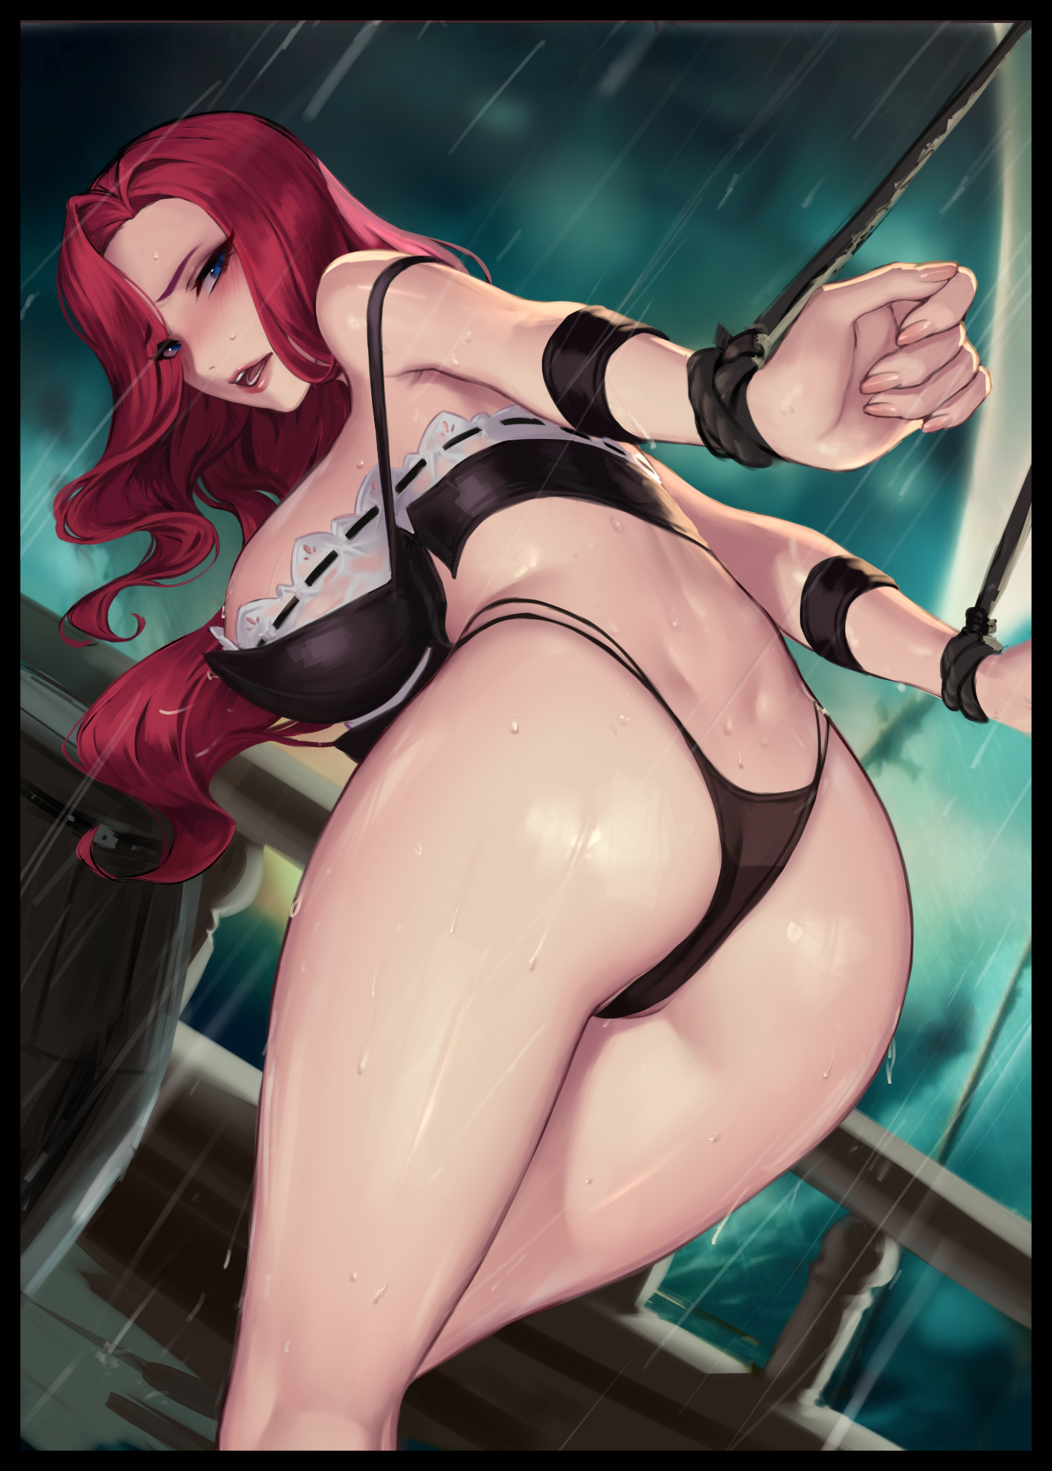
Upon attempting to turn her neck toward the source of Emily’s voice cooing out from somewhere in the darkness, the pinch of her wrists being caught in the biting length of what felt like heavy duty, cotton-weave ropes used on ships would sent a brilliant bolt of brief but lasting pain up the length of bare arms. Realizing why her limbs felt so stiff and cramped when they had been strung up behind her this whole time. With even her legs being given the same treatment in an effort to ensure she remain standing. “E-Emily! This…This better not be your doing! It’s not funny you hear me?!”

“Calm your tits girl! It won’t help your complexion to be angry all the time y’know? And besides, Sarah can heal that tender skin of yours right up~”

“Sarah’s here? Then get her to turn me back!”

A shrill, exaggerated laugh rings out across the room much to Charlie’s frustration as she continues to struggle against her bonds. Taking in more of her surroundings with a furrowed eye now that her vision was starting to adjust to the darkness, picking out vague but strangely familiar silhouettes while the disembodied voice of his girlfriend continues to speak to him. “I’m afraid that’s not possible just yet. Don’t you remember that little thing you had going with Allan? Sarah’s…well…she's busy ‘taking care’ of him if you know what I mean. Conflicting memories and all that…plus, we’ve still got 3 more days to go!”

“Three more days?! B-But I can’t spend three more days as Sec-” A sharp click of the light switches being flipped would leave Charlie momentarily blinded once more by the searing, amber glow of the light from above. interrupting her before a stunned realization does the rest; she was back in her bedroom. Their bedroom back at home!

But there was something more worrying about the state of it now than when she remembered it earlier today. The lack of a wardrobe for instance, presumably moved out of the way to make space for the diorama-esque stand depicting the point of view of a sailor on a rickety boat staring out across a malevolent ocean. Frothing with rage to produce waves that threatened to capsize the entire thing at any moment. A scene she could more easily place herself in after a chilling bucket of water had been dumped over head by Emily. Bringing awareness to her nubile form being dressed in nothing more than a skimpy set of old fashioned underwear that serves to highlight her assets instead of concealing them as beads, trails and eventually layers of freezing water coats exposed skin while leather cuffs were the only other noteworthy accessories clothing her naked body…

Feeling irate and wanting to be free, an angered shout narrowly slips free before a warm pair of lips rises to meet Charlie’s own. Locking her into a warm kiss that staunches the flames of wrath from rising even further in her gut. Coming to her senses before the face of her pajama clad beloved despite her bondage. Venting her frustrations would've served no good besides adding strain to their relationship…and at the end of the day, the whole affair had been a consensual thing on her part. She had the chance to walk away but decided to forego it in favor of helping Emily out. "It's evening already? It barely feels like half a day's gone by though…"

"That's when you know you had fun! Don't deny it Charlie, I could see it in the way you were totting about the con all smiles. Sure, there might've been a bit of Secillia in there helping you out…but you can't deny the fun right? That…and your little escapade with Allen…so? How was it? Your first time sucking off another man?"

"E-Em! Don't say it like that…but…about what you said; with Sarah and all…did Allan find out?"

"About you masquerading around the con with his girlfriend's body pasted over your own? Nah…though we did have to wipe his memory about that little bit. As strange as it is, Secilia's a gentle girl despite how hot she looks. Both in and out of bed, can't have him thinking otherwise right? It'd mess with their love life for sure."

"And…you're not mad about that? Our love life I mean…you didn't even lift a finger to stop him back there so you can't pin it on me!"

"What was I supposed to do? Tell him you're not his girlfriend? I barely even know the guy besides his name and how he treats Secilia. That…and I wasn't expecting you to go ham on him like that…which leads us back here~"

Spinning round to face Charlie up front, Emily falls to her knees with the same sly look on her face she had sent her way back at the convention center. Unflinchingly setting to work by slipping her fingers down into the thong holding her panties together before tugging downward, exposing a barren vulva in all its glory…

"H-Hey Em? What gives? You know that wasn't my fault right?"

"Yeah…but you also helped me out, remember? You tuckered out early, but for a first timer with a crutch, you handled things fine and dandy at the convention. So think of this as a…treat…for a job well done! And if you keep things up for the next three days, I might even let you eat me out~ Now relax alright? Oh, and no worries about running into Allan again, we’ve made sure he won’t be turning up for the next few days~”

“Relax? But I haven’t even said if I could go for the next three da-ahn~”

Throwing her head back with a sonorous moan upon the feeling of Emily’s moist tongue brushing against her clitoris before thrusting into her folds in one fell sweep, Charlie’s woes would be swept away from the euphoria of having lesbian sex with her girlfriend. Left with no other choice but to let the unexpectedly experienced blonde work her body like never before.

But as much as she liked to wail about it, Emily had been right about her finding joy from the experiences of the first day save for its raunchy midpoint. And if the next three days could be just as fulfilling with plentiful moments together with Emily to build on and cherish, then she would take it hands down over three boring ones back in the office. Managing to catch her lover’s attention by cupping her cheeks between her thighs as a curious question passes her by.

“Em? Any chance you could join me on the floor tomorrow? Like…for real?”

“Tomorrow hm? Maybe…I wasn’t planning to bust out the big guns so soon but…for you, I could make an exception! Don’t think I’ll be letting you cruise through it so easily though, the training wheels are gonna come off one by one till you’re on your own…Love you dear~”

“Me too Em…me too…”

THE END
Image 1 by Nikichen : https://www.pixiv.net/en/users/9116965

Image 2 by Cian Yo : https://www.pixiv.net/en/users/4196200

