BUDDY COPS
COMMISSION STORY
BY CHALDEACHANGE
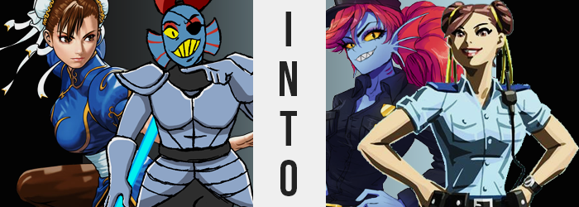

“I have access to every channel in the known multiverse, and yet there still isn’t anything good on.”

Had the nekomata girl, who was sitting with such zeal upon the reclining chair of her living room, really flipped through all of those channels? Absolutely not! She liked to complain just for the sake of complaining, for with all of her ultimate power she often ran into inspiration regarding how to use it via this very same method. She was a girl that acted according to her whims, and so there wasn’t often a lot of thought put into her plans, nor did she require much to justify them once put into action.

That was one of the perks of being so powerful that no one could challenge you, after all.

“You know what trend seems to have died out when it comes to movies?” Hisa had no audience, but like the host of a television show she shrugged and pointed at you, the reader. “Buddy cops! They used to be all the rage in the 90s, so where did they go? Hmm... Perhaps I could do something with that, then?”

Beads of sweat poured down the face of Chun-Li as she returned to the private changing room she had been provided. Busy as she was as an officer of Interpol, she still often responded to requests for her to fight in local martial arts tournaments, which she had just finished the first round of. She had about an hour now to rest and clean up before the second round, and she was certainly going to spend that hour both catching up on any Interpol developments that might require her attention.

Or, at least, that would have been the plan if not for something very strange ensuing. “Uh?” Having stepped into the bathroom of the changing room to wipe the sweat off of her body, she had inevitably stepped back into the portion that was more like an office. The issue? The room wasn’t at all like she recalled.
In fact, it was as if she had stepped into one of the changing rooms back at one of Interpol’s stations. There were officer uniforms hung up everywhere, but they weren’t for Interpol agents. They looked more generic. Even looking behind her? The door into the bathroom she had just stepped from was gone. There was only a wall there. “How on Earth? Am I in a completely different building?”

The surprise of it all provoked Chun-Li to jump forward, and as she did so? It felt as if the pants she were wearing were on the verge of splitting. She looked down only to find herself dressed in a dark blue cop uniform, one that seemed several sizes too small for her bust and ridiculously thick thighs. The mis-fit hadn’t resulted in any tears, fortunately, but the pants did raise high upon her ankles as a direct result.

“…Mhm. That’s not right.” The officer didn’t really need to confirm it aloud, but she ended up doing so anyways. Her circumstances were strange, certainly enough to put her on guard. It certainly wasn’t every day that you found yourself (presumably) teleported into a different location and even different clothes. There was something supernatural at work here.

And whatever it was? It made the woman’s skin feel unbelievably clammy. For the next few minutes it also came with a disorientation that could only be likened to the side effects of a hangover, despite Chun-Li not having consumed a single drop in the past month. “Ugh, my head… No, this is just a distraction of some sort! I need to invest… igate?” As well intended as that idea had been, she very quickly hit a roadblock. While she could move her upper body just fine, it was as if her feet had been glued to the floor. Maybe that was for the best, because at first any sudden movements would have torn the gingerly fit pant legs.

At first, anyways. “What!? How!?” Chun-Li was poised to see the correction take place before her very eyes, the spectacle both visual and felt – for the strength draining from one’s limbs was not something that could possibly go unnoticed. Feet still glued to the ground, her knees buckled once the weight of her own body became a harder burden to bear, all in tandem with the thickness of her muscular thighs dramatically lessening.

From Chun-Li’s perspective, the thighs that had once been on the verge of erupting from her dark blue pant legs were deflating as if a pair of balloons that were slowly having their air released. The fabric of those pants loosened around legs that gradually came to better resemble the legs of any ordinary woman – still pleasantly plump, but not with such great abundance that the warrior’s masterful pair had just possessed thanks to her tireless training and emphasis on leg-based combat.

Apparently not at all content with draining her thighs alone, so too did her bust diminish. It wasn’t as significant as the loss in her thigh area, but each tit did lose a cup size – maybe even two – so that the uniform top could be buttoned higher than it had been before. Something that Chun-Li immediately did. “My figure? How is this possible? No, even my body isn’t as muscular, and yet…” She had even grown several inches so that the fit of her clothes rested more comfortably, but with everything else going on she could hardly be blamed for not noticing.

With hips narrowing to better compliment her narrowed legs and, unfortunately, a shrunken ass, the woman suddenly felt something that didn’t make sense. Her strength returned? No, it returned tenfold. She could feel the muscles that remained tightening, and with that tightness she felt impossibly powerful, as if her raw strength now dwarfed anything any human could possibly muster. Which, by definition, would give her the strength of a…

Monster.

Chun-Li didn’t realize that she had begun to do so, but she had steadily started to grind her teeth together. Anxiety and an uncharacteristic agitation had both begun to build, and that tension likewise culminated in a scratching of her exposed neck with the fingers of both hands. “Ugh, why the hell can’t I stop!?” Her agitation came through clearer in her voice now, and as her mouth opened to deliver every word? It revealed something that should have been unsettling.

Within the woman’s mouth her teeth had grown razor sharp, each one like a tiny blade that housed a tongue that was slightly longer – and subtly forked – than a human’s would be. Even the scratching of her neck paid unintended dividends, for on both sides three of her fingers on either hand slid into a trio of slits. Slits that she didn’t even realize she was now breathing through. Gills. The gills of a fish.

What had once been so shocking to Chun-Li was rapidly becoming a phenomenon that she was left with no choice but to accept, for her memories were gradually being altered to accept it all. Skin that had become clammy prior was now changing in color and texture, beginning in small patches that soon spread across her form.

The skin of each of these patches was rougher than normal, human skin. Tiny grooves separated portions that raised slightly until it would have been very clear what they were upon closer examinations: scales. Scales that carried a very blue pigmentation, at that. The natural odor of the martial artist’s body subtly shifted to something fishier as these blue scales spread, ultimately robbing her of any hair beneath her neck and leaving her nipples a ruby red.

That very same ruby red, mind you, found itself rooted elsewhere. The roots of Chun-Li’s brown hair found the very same coloring present, bright red sweeping entirely through its length – and then extending that length so it swept far down her back. This red hair became thick and voluminous, bangs swept long in the front while in the back they were bunched up into a huge, red ponytail beneath her police cap.

“Why do I feel so GODDAMN sick!? I didn’t drink anything last night, DID I!?” Chun-Li was never unnecessarily loud, and yet with a voice that was gruffer than her usual tone, she was practically shouting everything she said. This was indicative of the fact that her personality and memories were close to fully changed, surely.

The pupils of the woman’s eyes widened into vertical slits, and as they did so the colors of her eyes around them soon changed. Yellow not only plagued her pupils but her sclera as well, and before long those eyes were just as monstrous as the rest of her body. The shape of her face in general had contorted though, giving her wider eyes, and a much sharper jaw. Toss in how thick and jagged her eyebrows now were, and how rigid the bridge of her nose was, and any resemblance to Chun-Li was basically gone.

She shook her head from side to side rather violently with no shortage of discomfort on her sharpened features as the final change settled in. Her ears were pulled out to the sides, lobes thinning as crimson filled the space between the spines that those ears earned. In fact they could hardly be called ears when all was said and done, each side of her head now possessing a fin that the woman could still somehow hear from. How does she hear then, you ask? Well, some questions are best left unanswered. Probably.

The woman took several steps forward groggily, forgetting she had even been glued to the floor in the first place.

“Huh? Feel like I was hit by a friggin’ truck!” Rubbing at the back of her head of crimson hair, the new monster cop Undyne seemed to be rather perplexed about her predicament. Well, no. She wasn’t really perplexed anymore, was she? The fish woman could have sworn that something really damn weird had just happened, but now she couldn’t exactly piece together what that weirdness was. She’d just gotten ready for her shift, hadn’t she? It wasn’t really more or less complicated than that.

Although that did remind her of something. “Ah, crap! They’re assigning me a new partner today, aren’t they? A human, and a big shot from the global police force at that. They’re going to be a huge pain in my ass, I can already tell.” Undyne already had enough people telling her to be quiet on the daily, really.

Meanwhile, in the underground realm of monsters…

“Ugh, I’m so bored! I’ve already burned through all the anime that Alphys leant me, and that kid isn’t back from confronting King Asgore yet either!” It didn’t seem like they had lost though, because things would have been hell down there if so. Still, the fish monster knight wasn’t exactly amused with her lack of, well, amusement. Maybe she should pop up to the castle to check on things after all? But there was no small part of the knight that was worried she might get yelled at for letting the kid through in the first place.

But it was not her fault that they were brave, strong, and kind! Surely a warrior of such talents had earned their right of passage so that they might meet with the king? Undyne’s thoughts about the situation were surprisingly complex considering how she had a tendency to just act without thinking normally.

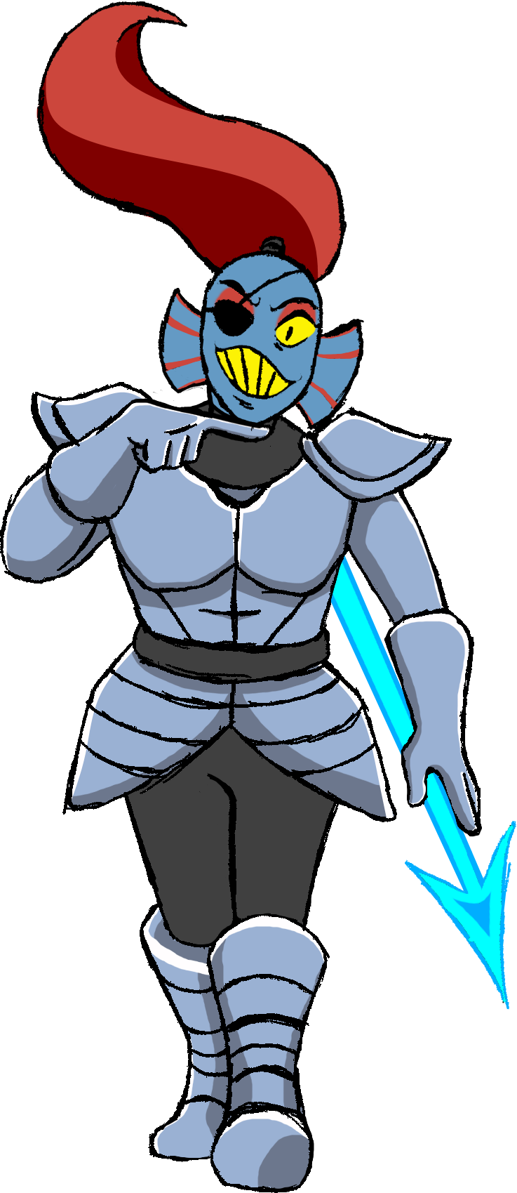
As she paced back into her living room though, something had occurred that Undyne, even in her occasional bouts of idiocy, could notice. “Huh!? Where the hell am I!?” She’d stepped into her living room, or so she had thought, but instead? She was in what looked like a private room, brightly lit with some clothes hung up. It was far brighter than any place she’d seen underground – well, okay, maybe it was comparable to Alphys’ laboratory in Hotland.

Even the door she’d walked through behind her was gone! Stranger still, she was dressed in some strange clothes all of a sudden. A light blue uniform that was very loose around her chest, hips, and legs. Consider police didn’t exist where she came from, it wasn’t surprising that she couldn’t identify just what it was that she was now dressed as. “What am I WEARING!?” Didn’t stop her from expressing her shock, though.

Undyne wasn’t the type of monster that liked to experiment with fashion. She only wore the clothes and armor that she knew she liked, and it was strange to find her wearing something that didn’t fit perfectly as a result. Even now, the looseness of this getup was pissing her off. “Hey! WAIT!? EVEN MY EYEPATCH IS GONE!?” Now that was unfortunate. How else was she going to look cool?

She honestly had the urge to just smash down these unfamiliar walls with her monstrous strength. That’d teach whoever had monsternapped her! Yeah! She’d just destroy their place! Before she could put that terrible plan into action though, she had been thoroughly stopped in her tracks. “Why can’t I move!? No, I can move! I can’t lift my feet!” Just as another woman elsewhere in this very building had been, Undyne found her feet bound to the floor by a rather mysterious force.

It was just as well in the end, because it made the monster woman painfully aware of the fact that something was happening to her body. After all, where the front of her pale blue uniform had seemed a little loose in the beginning, it was now becoming blatant clear that something was trying to obscure her ability to look at the legs that were frozen. Well, somethings, actually. “Er…?” The fish scratched at the back of her head, pondering whether or not what she was seeing was actually being seen.

“My chest… isn’t bigger, is it?” Not only was it bigger, but the front of her top was filling out with even more significance as she gawked. At best it was only two cup sizes that were applied to the woman’s overall bust, but it was enough to make it so that the fit of her shirt and the bra beneath was now proper. “HOW THE HELL!?”

Undyne was so distracted by her tits, taking her hands up to jiggle them almost like a child, that she didn’t notice that further growth was unfolding farther down. To begin with, her waistline had narrowed, and her hips had swung out several inches, making those dark blue pants of hers look even wider than before.

That width, at the very least, was put to good use. What had been lost by Chun-Li elsewhere in this facility was being applied directly to the monster woman, and that included the raw strength exemplified by her legs and, particularly, her thighs. Dark blue cloth stretched around swelling fat and muscle alive, thighs erupting so that they not only filled the gap left between her legs by widened hips, but also met and rubbed up against each other in the middle.

This same flourish was applied to Undyne’s ass, and scaly cheeks were quick to push out the back of the waist-high pants. In fact, they were so vigorous in their growth that the size of her cheeks left a notable indentation of her crack in the fabric. A side effect of the overall changes to her lower half had actually rendered her height several inches shorter too, but with everything going on it was very hard for her to notice.

“Uh… Uhm… Huh.” Perhaps the knight should have been screaming to the high heavens about such a change, but as fingers ran across her features? This was kind of nice, wasn’t it? Her figure was much fuller. Wouldn’t Alphys like this?

Unbeknownst to her though, things were quickly worsening. The red of her hair was dimming, a plainer brown settling into its place while the length of it all regressed so that it hung just barely past her shoulders. Not only did the color change, but before long the length that remained had thinned, and as if guided by a mysterious force it was eventually pulled up into a pair of neat little buns.

But so too did brown find her eyes. Undyne’s pupils shrunk inward to become small circles, and directly around them? A sphere of brown that matched her hair sectioned off her pupils from the yellow her sclera. Even then, that yellow eventually lightened into a very human looking white. The shapes of the woman’s eyes in general narrowed, brows thinning and softening while the general aesthetic of the woman’s face softened. Round cheeks, a button nose, and thick lips painted pink were in her future – that pink looking quite strange against her blue scales.

Within her mouth, the tip of her tongue had rounded and her teeth, once as sharp as a shark’s, turned into molars in the back and regular, flat teeth in the front. Gradually, every little thing about her visage that would make her appear intimidating towards a human was being taken away from her.

Not that those scales were longed for this world any longer. In fact, someone else had already inherited them, which meant it was time for her own to go. Whether she had noticed (she didn’t), the color of her scales began to lighten towards white before inheriting a pinkish and then slightly yellowish hue. And yet? Those scales softened, the grooves between them rendered obsolete as fleshy, human skin became the norm from head to toe. With this new canvas to grow upon, tiny hairs found her arms and there was indications that she had shaved her legs. On the other hand? A tiny bush of brown erupted atop a pussy that was just as pale brown as her nipples now were.

She looked less and less like a monster, and more and more like a human with each passing moment. Even now, the fins on the sides of her head regressed in size while the spines smoothed and rounded. The same color that decorated the rest of her body now permeated throughout the cartilage that persevered, giving her a pair of cute, round ears.

“I didn’t drink last night, did I? Why do I feel so woozy?” Undyne’s impulsive nature was no longer reflected in her words nor mannerisms, and she in fact could not remember being a monster. Yet she somehow recalled what monsters were, and she was fairly certain she had a job coming up that had something to do with one? A little confused thanks to her grogginess, she rubbed at the sides of her neck just as her gills sealed, forcing her to breathe solely through her mouth and nose.

After shaking her head one last time to try and ditch the grogginess, the sensation seemed to disperse – allowing her to take several steps forward. Had she been immobilized somehow? On some level the woman felt like this had been the case, but there certainly wasn’t any proof of this now in any capacity.

Little did Chun-Li now realize that she had ever been a monster. In fact, her mind was teeming with anxious thoughts about having to meet with her new, temporary partner that day that was a monster herself. Not that she had anything against them. People were people, humans and monsters were no different in that regard. From the reports she’d read though, this Undyne character was something of a loose cannon, never doing things by the book like she should.

Chun-Li could recognize that sometimes that type of action was necessary, but it happened way too often on this monster’s watch for it to not be a bad habit. With a sigh, steeling herself, the Interpol officer then stepped out of the private office in the local police station and into the numbered room where she was meant to meet this new partner of hers.

“Hello, I am Chun-Li of—”

“I KNOW WHO YOU ARE! SOME HOTSHOT FROM THE WORLD POLICE!”

The monster woman’s voice was almost deafening, largely because she’d gotten up in Chun-Li’s face to shout. She wasn’t, well… Not what the human expected. She was surprisingly humanoid. Attractive, even. But that didn’t mean she would be okay with this treatment. “Interpol, actually. And I’m your commanding officer in this unit we’re sharing. Please try to conduct yourself more professionally so that it doesn’t reflect poorly on either of us.” As she understood, part of the reason she had been recommended was to correct Undyne’s bad behaviors.

“LIKE HELL I’M TAKING ORDERS FROM YOU!”

Elsewhere, on her couch, Hisa was watching this all unfold. It was a situation of her own doing, of course, and she was quite enjoying watching it all unfold on her television. “Well, if the producers won’t make buddy cop movies a thing anymore, I supposed I can at least do it myself!”

