REPORT ON FATUI RECRUITMENT DRIVE TEST

After a recent discovery gleaned from an entirely accidental encounter with an isolated coven of Abyss Mages. The R&D teams back at Snezhnaya have managed to cobble together a device that makes use of the foreign energy given off by the fragments of a strange tool discovered after the team from the initial encounter had managed to subdue the Order's mages.

Utilizing the material's symbiotic nature and it’s more volatile properties by magnifying its effects tenfold before directing said energy through suitable dispersal methods connected to a device or vessel of appropriate make, it could serve as a viable option to support our existing troops spread out across Teyvat and out various operations by cutting down on time and manpower spent recruiting and training suitable men and women to bolster the Fatui’s ranks. Especially after the results of the first field test in the countryside of Monstadt, carried out under utmost secrecy and care. From the hundreds of citizens who’ve applied, only a few were exposed to the device and its enhancing energies, applied through various methods. And from this small handful, we’ve picked out three unique instances to showcase;

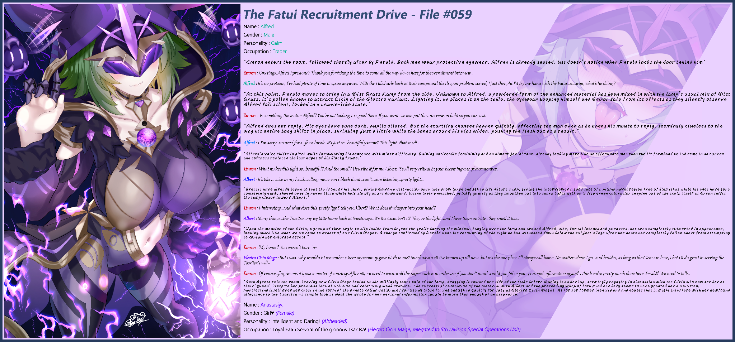

File #059

Name : Alfred

Gender : Male

Personality : Calm

Occupation : Trader

*\*Emron enters the room, followed shortly after by Ferald. Both men wear protective eyewear. Alfred is already seated, but doesn't notice when Ferald locks the door behind him\**

Emron : Greetings, Alfred I presume? Thank you for taking the time to come all the way down here for the recruitment interview…

Alfred : It's no problem, I've had plenty of time to spare anyways. With the Hilichurls back at their camps and the dragon problem solved, I just thought I'd try my hand with the Fatui…so…wait, what's he doing?

*\*At this point, Ferald moves to bring in a Mist Grass Lamp from the side. Unknown to Alfred, a powdered form of the enhanced material has been mixed in with the lamp's usual mix of Mist Grass, its pollen known to attract Cicin of the Electro variant. Lighting it, he places it on the table, the eyewear keeping himself and Emron safe from its effects as they silently observe Alfred fall silent, locked in a trance-like state.\**

Emron : Is something the matter Alfred? You're not looking too good there. If you want, we can put the interview on hold so you can rest.

*\*Alfred does not reply. His eyes have gone dark, pupils dilated. But the startling changes happen quickly, affecting the man even as he opens his mouth to reply, seemingly clueless to the way his entire body shifts in place, shrinking just a little while the bones around his hips widen, pushing the flesh out as a result.\**

Alfred : I-I'm sorry…no need for a…for a break…it's just so…beautiful y'know? This light…that smell…

*\*Alfred's voice shifts in pitch while formulating his sentence with minor difficulty. Gaining noticeable femininity and an almost jovial tone, already looking more like an effeminate man than the fit farmhand he had come in as curves and softness replaced the last edges of his blocky frame.\**

Emron : What makes this light so…*beautiful*? And the smell? Describe it for me Albert, it's all *very* critical in your becoming one of our number…

Albert : It's like a voice in my head…calling me…c-can't block it out…can't…stop listening…pretty light…

*\*Breasts have already begun to tent the front of his shirt, giving Emron a distraction once they grow large enough to lift Albert's top, giving the interviewer a good shot of a plump navel region free of blemishes while his eyes have gone completely dark, shaded over in raven black while hair slowly pours downward, losing their unwashed, prickly quality as they smoothen out into sharp tufts with an indigo green coloration seeping out of the scalp itself as Enron shifts the lamp closer toward Albert.\**

Emron : I-Interesting…and what does this 'pretty light' tell you Albert? What does it whisper into your head?

Albert : Many things…the Tsaritsa…my icy little home back at Snezhnaya…it's the Cicin isn't it? They're the light…and I hear them outside…they smell it too…

*\*Upon the mention of the Cicin, a group of them begin to slip inside from beyond the grails barring the window, hanging over the lamp and around Alfred, who, for all intents and purposes, has been completely subverted in appearance, looking much like what we've come to expect of our Cicin Mages. A change confirmed by Ferald upon his recounting of the sight he had witnessed down below the subject's legs after her pants had completely fallen apart from attempting to contain her enlarged assets.\**

Emron : 'My home'? You weren't born in-

Electro Cicin Mage : But I was…why wouldn't I remember where my mommy gave birth to me? Snezhnaya's all I've known up till now…but it's the one place I'll always call home. No matter where I go…and besides, as long as the Cicin are here, I bet I'll do great in serving the Tasritsa's will~

Emron : Of course…forgive me, it's just a matter of courtesy. After all, we need to ensure all the paperwork is in order…so if you don't mind…could you fill in your personal information again? I think we're pretty much done here. Ferald? We need to talk…

*\*Both Agents exit the room, leaving new Cicin Mage behind as she willingly takes hold of the lamp, dragging it toward her side of the table before placing it on her lap, seemingly engaging in discussion with the Cicin who now see her as their 'Queen'. Despite her previous lack of a Vision and relatively weak stature. The successful resonation of the material with Albert and the proceeding warp of both mind and body seems to have granted her a Delusion, manifesting itself over her chest in the form of the ornate collar designated for use by those fitting enough to qualify for duty as Electro Cicin Mages. As for her former identity and any doubts that it might interfere with her newfound allegiance to the Tsaritsa…a simple look at what she wrote for her personal information should be more than enough of an assurance.\**

Name : Anastasiya

Gender : Girl♥️ *(Female)*

Personality : Intelligent and Daring! *(Airheaded)*

Occupation : Loyal Fatui Servant of the glorious Tsaritsa! *(Electro Cicin Mage, Relegated to 5th Division Special Operations Unit)*

Utilizing donated genetic samples to direct the enhanced Abyss material, insertion of Fatui ideals and realigning the subject's loyalties becomes a trivial matter. As long as raw exposure is made without proper protection, the subject's mind and body will gradually be fused with that of the genetic donor. In this case, *Katarina's* appearance dominates Albert, going so far as to cause a complete gender inversion in addition to a fully functional female reproductive system. A discovery that would come later with the arrival of our second subject of interest not too long after the first.

As stated earlier in the report however, the use of the term 'fused' implies a combination of the subject and the corresponding material. Not a complete subversion of the original despite the seeming lack of the original host personality as was the case for Anastasiya and as you will soon see; our second unique case…

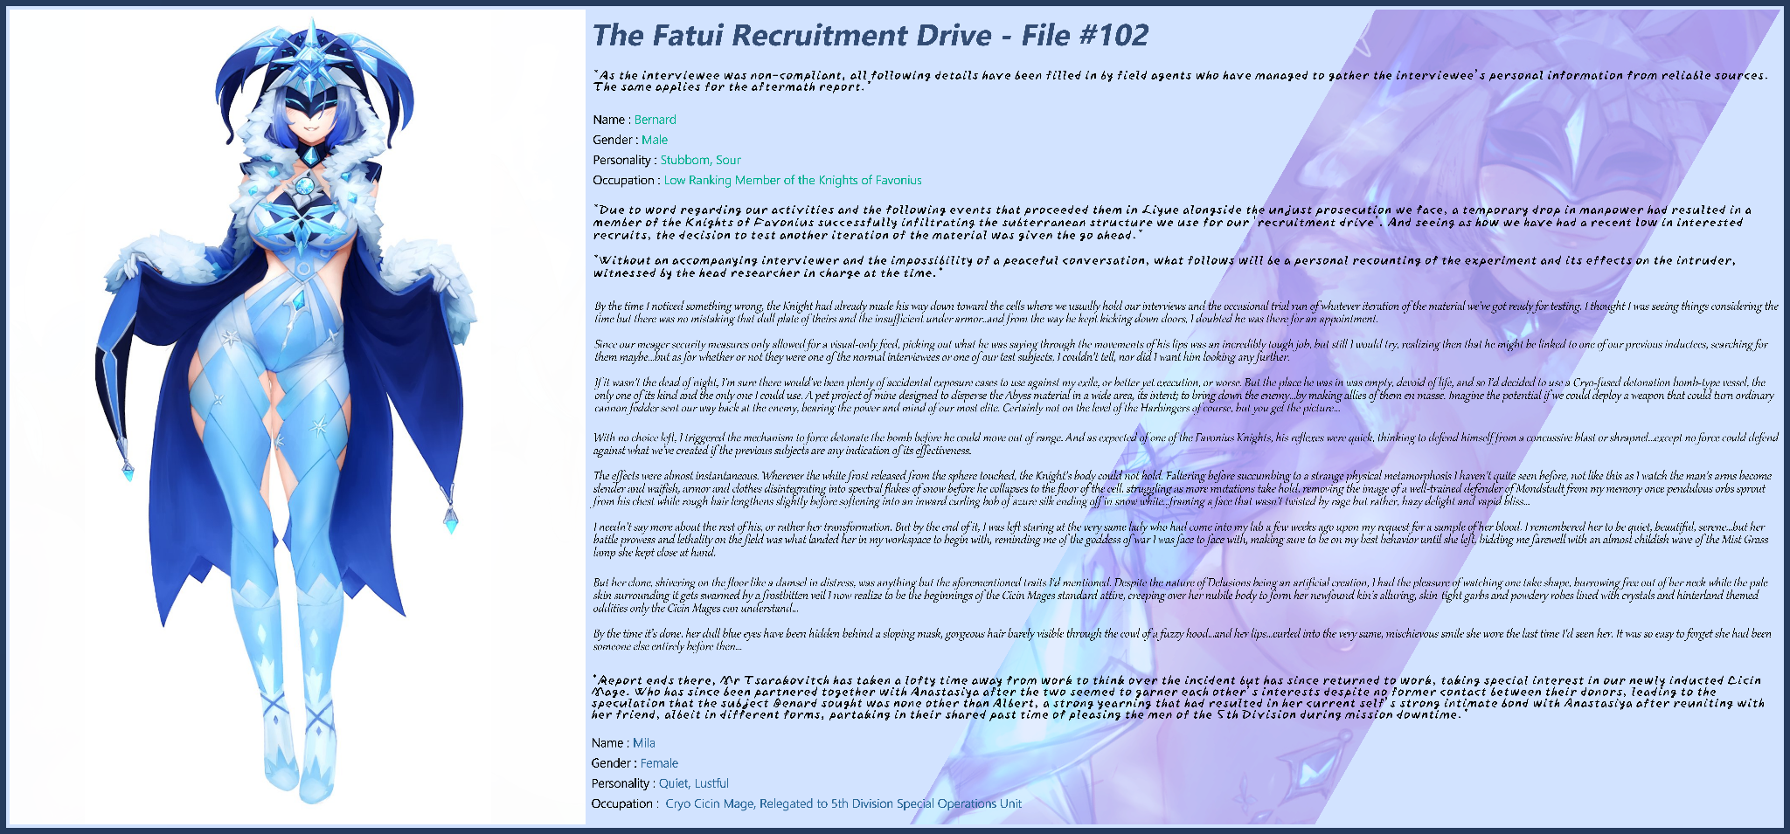

File #102

*\*As the interviewee was non-compliant, all following details have been filled in by field agents who have managed to gather the interviewee’s personal information from reliable sources. The same applies for the aftermath report.\**

Name : Benard

Gender : Male

Personality : Stubborn, Sour

Occupation : Low Ranking Member of the Knights of Favonius

***\*Due to word regarding our activities and the following events that proceeded them in Liyue alongside the unjust prosecution we face, a temporary drop in manpower had resulted in a member of the Knights of Favonius successfully infiltrating the subterranean structure we use for our 'recruitment drive'. And seeing as how we have had a recent low in interested recruits, the decision to test another iteration of the material was given the go ahead.\****

***\*Without an accompanying interviewer and the impossibility of a peaceful conversation, what follows will be a personal recounting of the experiment and its effects on the intruder, witnessed by the head researcher in charge at the time.\****

By the time I noticed something wrong, the Knight had already made his way down toward the cells where we usually hold our interviews and the occasional trial run of whatever iteration of the material we’ve got ready for testing. I thought I was seeing things considering the time but there was no mistaking that dull plate of theirs and the insufficient under armor..and from the way he kept kicking down doors, I doubted he was there for an appointment.

Since our meager security measures only allowed for a visual-only feed, picking out what he was saying through the movements of his lips was an incredibly tough job, but still I would try, realizing then that he might be linked to one of our previous inductees, searching for them maybe…but as for whether or not they were one of the normal interviewees or one of our test subjects, I couldn’t tell, nor did I want him looking any further.

If it wasn’t the dead of night, I’m sure there would’ve been plenty of accidental exposure cases to use against my exile, or better yet execution, or worse. But the place he was in was empty, devoid of life, and so I’d decided to use a Cryo-fused detonation bomb-type vessel, the only one of its kind and the only one I *could* use. A pet project of mine designed to disperse the Abyss material in a wide area, its intent; to bring down the enemy…by making allies of them en masse. Imagine the potential if we could deploy a weapon that could turn ordinary cannon fodder sent our way back at the enemy, bearing the power and mind of our most elite. Certainly not on the level of the Harbingers of course, but you get the picture…

With no choice left, I triggered the mechanism to force detonate the bomb before he could move out of range. And as expected of one of the Favonius Knights, his reflexes were quick, thinking to defend himself from a concussive blast or shrapnel…except no force could defend against what we’ve created if the previous subjects are any indication of its effectiveness.

The effects were almost instantaneous. Wherever the white frost released from the sphere touched, the Knight’s body could not hold. Faltering before succumbing to a strange physical metamorphosis I haven’t quite seen before, not like this as I watch the man’s arms become slender and waifish, armor and clothes disintegrating into spectral flakes of snow before he collapses to the floor of the cell, struggling as more mutations take hold, removing the image of a well-trained defender of Mondstadt from my memory once pendulous orbs sprout from his chest while rough hair lengthens slightly before softening into an inward curling bob of azure silk ending off in snow white…framing a face that wasn’t twisted by rage but rather, hazy delight and vapid bliss…

I needn’t say more about the rest of his, or rather *her* transformation. But by the end of it, I was left staring at the very same lady who had come into my lab a few weeks ago upon my request for a sample of her blood. I remembered her to be quiet, beautiful, serene…but her battle prowess and lethality on the field was what landed her in my workspace to begin with, reminding me of the goddess of war I was face to face with, making sure to be on my best behavior until she left, bidding me farewell with an almost childish wave of the Mist Grass lamp she kept close at hand.

But her clone, shivering on the floor like a damsel in distress, was anything but the aforementioned traits I'd mentioned. Despite the nature of Delusions being an artificial creation, I had the pleasure of watching one take shape, burrowing free out of her neck while the pale skin surrounding it gets swarmed by a frostbitten veil I now realize to be the beginnings of the Cicin Mages standard attire, creeping over her nubile body to form her newfound kin’s alluring, skin-tight garbs and powdery robes lined with crystals and hinterland themed oddities only the Cicin Mages can understand…

By the time it’s done, her dull blue eyes have been hidden behind a sloping mask, gorgeous hair barely visible through the cowl of a fuzzy hood…and her lips…curled into the very same, mischievous smile she wore the last time I'd seen her. It was so easy to forget she had been someone else entirely before then…

***\*Report ends there, Mr Tsarakovitch has taken a lofty time away from work to think over the incident but has since returned to work, taking special interest in our newly inducted Cicin Mage. Who has since been partnered together with Anastasiya after the two seemed to garner each other’s interests despite no former contact between their donors, leading to the speculation that the subject Benard sought was none other than Albert, a strong yearning that had resulted in her current self’s strong intimate bond with Anastasiya after reuniting with her friend, albeit in different forms, partaking in their shared past time of pleasing the men of the 5th Division during mission downtime.\****

Name : Mila

Gender : Female

Personality : Quiet, Lustful

Occupation : Cryo Cicin Mage, Relegated to 5th Division Special Operations Unit

An additional oddity presented by #102 was the amplification of formerly suppressed feelings and/or desires taken from both sides. In Mila's case, it had been her donor's penchant for the pleasures of the flesh. An activity we hadn't even realized she participated in until further investigations were made. And when that impressive libido had melded nicely together with Bernard's strong friendship with Albert (strong enough to go looking for him all the way out to our hidden recruitment branch that has since moved sites with bolstered security), the resultant mix has, safe to say, neutered any threat Mila might post to us with her stigma and personal vengeance with the Fatui failing to make it over the fusion process.

The higher rates of success in transferred personality and emotions seem to lie in their intensity, and evidently enough, Bernard's rage wasn't quite hot enough to survive the mutation. Just like Albert before him when Katarina's aloof nature proved victorious over his witless persona. Succeeding him in the form of Anastasiya, Mila's best friend and fellow subordinate to the new leader of the 5th Division's Special Ops Unit; our last subject for this report;

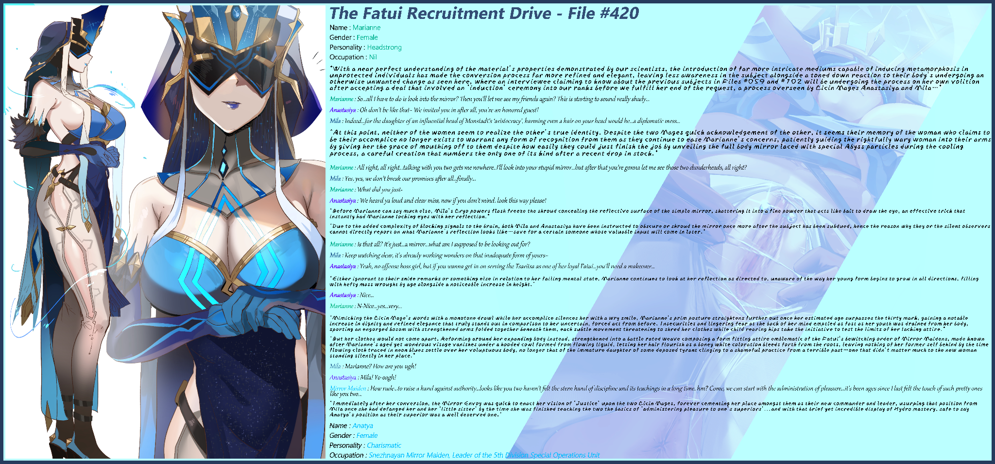

Name : Marianne

Gender : Female

Personality : Headstrong

Occupation : Nil

***\*With a near perfect understanding of the material's properties demonstrated by our scientists, the introduction of far more intricate mediums capable of inducing metamorphosis in unprotected individuals has made the conversion process far more refined and elegant, leaving less awareness in the subject alongside a toned down reaction to their body's undergoing an otherwise unwanted change as seen here, where an interviewee claiming to know about the previous subjects in Files #059 and #102 will be undergoing the process on her own volition after accepting a deal that involved an ‘induction’ ceremony into our ranks before we fulfill her end of the request, a process overseen by Cicin Mages Anastasiya and Mila…\****

**Marianne :** So…all I have to do is look into the mirror? Then you'll let me see my friends again? This is starting to sound really shady…

**Anastasiya** : Oh don’t be like that~ We invited you in after all, you’re an honored guest!

**Mila** : Indeed…for the daughter of an influential head of Monstadt’s ‘aristocracy’, harming even a hair on your head would be…a diplomatic mess…

***\*At this point, neither of the women seem to realize the other’s true identity. Despite the two Mages quick acknowledgement of the other, it seems their memory of the woman who claims to be their accomplice no longer exists to warrant any form of recognition from them as they continue to ease Marianne’s concerns, patiently guiding the rightfully wary woman into their arms by giving her the grace of mouthing off to them despite how easily they could just finish the job by unveiling the full body mirror laced with special Abyss particles during the cooling process, a careful creation that numbers the only one of its kind after a recent drop in stock.\****

Marianne : All right, all right…talking with you two gets me nowhere..I’ll look into your stupid mirror…but after that you’re gonna let me see those two dunderheads, all right?

Mila : Yes, yes, we don’t break our promises after all…finally…

Marianne : What did you just-

Anastasiya : We heard ya loud and clear miss, now if you don’t mind, look this way please!

***\*Before Marianne can say much else, Mila’s Cryo powers flash freeze the shroud concealing the reflective surface of the simple mirror, shattering it into a fine powder that acts like bait to draw the eye, an effective trick that instantly had Marianne locking eyes with her reflection.\****

***\*Due to the added complexity of blocking signals to the brain, both Mila and Anastasiya have been instructed to obscure or shroud the mirror once more after the subject has been subdued, hence the reason why they or the silent observers cannot directly report on what Marianne's reflection looks like…save for a certain someone whose valuable input will come in later.\****

**Marianne** : Is that all? It's just…a mirror…what am I supposed to be looking out for?

**Mila** : Keep watching dear, it's already working wonders on that inadequate form of yours~

**Anastasiya** : Yeah, no offense boss girl, but if you wanna get in on serving the Tsaritsa as one of her loyal Fatui…you'll need a makeover…

***\*Either ignorant to their snide remarks or something else in relation to her failing mental state, Marianne continues to look at her reflection as directed to, unaware of the way her young form begins to grow in all directions, filling with hefty mass wrought by age alongside a noticeable increase in height.\****

**Anastasiya** : Nice…

**Marianne** : N-Nice…yes…very…

***\*Mimicking the Cicin Mage's words with a monotone drawl while her accomplice silences her with a wry smile, Marianne's prim posture straightens further out once her estimated age surpasses the thirty mark, gaining a notable increase in dignity and refined elegance that truly stands out in comparison to her uncertain, forced act from before. Insecurities and lingering fear at the back of her mind emptied as fast as her youth was drained from her body, sporting an engorged bosom with strengthened arms folded together beneath them, each subtle movement threatening to shred her clothes while child rearing hips take the initiative to test the limits of her lacking attire.\****

***\*But her clothes would not come apart. Reforming around her expanding body instead, strengthened into a battle rated weave composing a form fitting attire emblematic of the Fatui's bewitching order of Mirror Maidens, made known after Marianne's aged yet wondrous visage vanishes under a hooded cowl formed from flowing liquid, letting her hair flourish as a boney white coloration bleeds forth from the roots, leaving nothing of her former self behind by the time flowing cloth traced in neon blues settle over her voluptuous body, no longer that of the immature daughter of some deposed tyrant clinging to a shameful practice from a terrible past…one that didn’t matter much to the new woman standing silently in her place.\****

Mila : Marianne? How are you-*ugh!*

Anastasiya : Mila! Yo-*oagh!*

Mirror Maiden : How rude…to raise a hand against authority…looks like you two haven’t felt the stern hand of discipline and its teachings in a long time, hm? Come, we can start with the *administration of pleasure*…it’s been ages since I last felt the touch of such pretty ones like you two…

***\*Immediately after her conversion, the Mirror Envoy was quick to enact her vision of ‘Justice’ upon the two Cicin Mages, forever cementing her place amongst them as their new commander and leader, usurping that position from Mila once she had defanged her and her ‘little sister’ by the time she was finished teaching the two the basics of ‘administering pleasure to one’s superiors’...and with that brief yet incredible display of Hydro mastery, safe to say Anatya’s position as their superior was a well deserved one.\****

Name : Anatya

Gender : Female

Personality : Charismatic,

Occupation : Snezhnayan Mirror Maiden, Leader of the 5th Division Special Operations Unit

After we had managed to intervene and get the newly formed Maiden to acquiesce before putting a shroud back over the mirror before anyone else got caught in it, it didn't look like Anastasiya or Mila would be able to talk back freely anymore, not when Anatya had led the two Cicin Mages out of the room on leashes of flowing water, never to command and entertain the members of the 5th ever again. Something no one but the poor soldiers would despair over.

With the incorporation of Anatya among our ranks, I'm proud to say the 5th Divisions performance has seen an overall improvement across the board, no doubt thanks to our unsuspecting new recruits boasting the veterancy and skill expected of a seasoned member of the Fatui, just like their genetic donors still are to this very day, unaware of their like minded twins running around Teyvat, doing their best to enact the Tsaritsa's will wherever they might be. Something I have no doubt they will accomplish with their upcoming assignment to Fontaine (See attached photograph for the fully formed 5th Div Spec Ops Unit).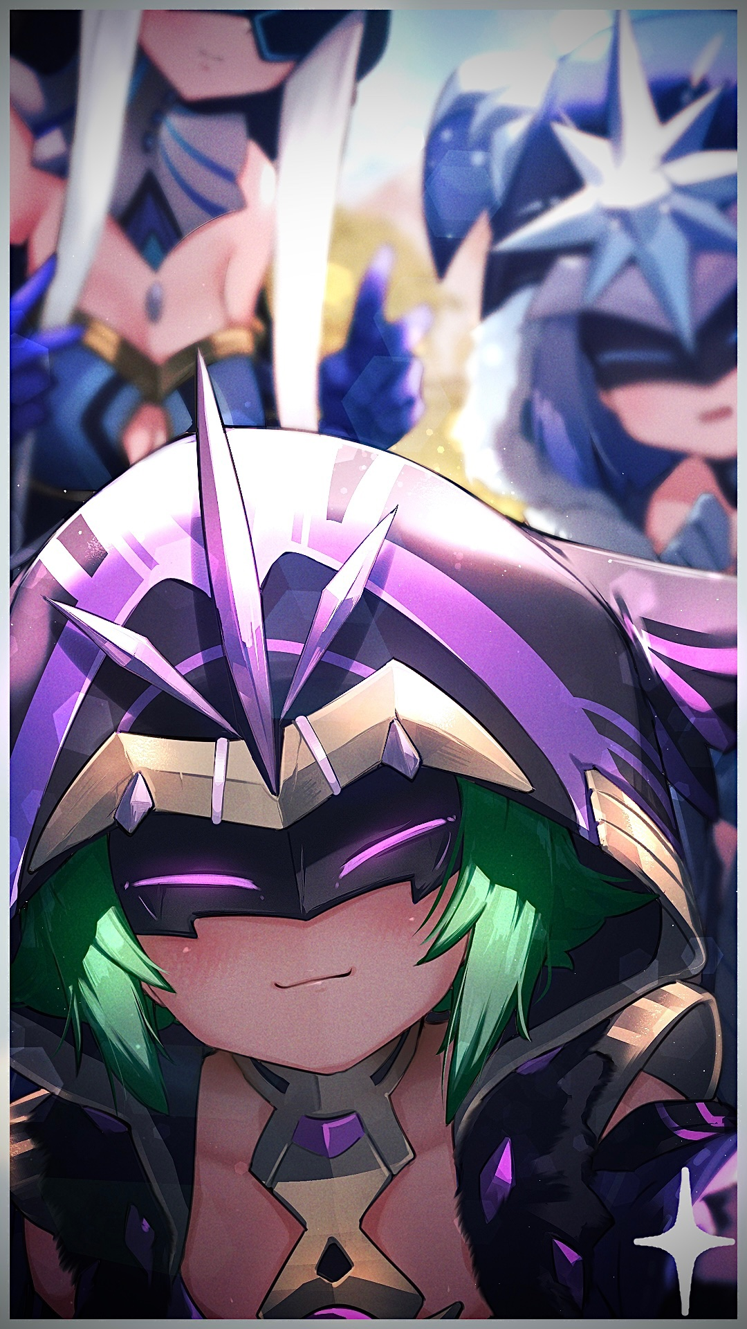

But to loop back around, my point still stands that it's imperative we find more of or better yet; the source of the Abyss' new material…a ready made army where no training, no Delusions are necessary. Simply genetic donors, the very best of the best…and the Fatui need not worry about another loss ever again.

More concerningly however, I wonder what the Abyss Order even intended to do with it before we intercepted them by accident, because if they can achieve something like what we've done, I fear we might have just discovered another thorn in the side…no, a pus blister we need to purge at the root before it reaches critical mass…please, consider what i’ve said with the utmost urgency and seriousness, that is all I ask…

FATUI RECRUITMENT DRIVE REPORT - END

*Image Sources*

Image 1 by Barbariank : <https://twitter.com/Barbariank>

Image 2 by Chamame : <https://www.pixiv.net/en/users/34554540>

Image 3 by Nez-Box : <https://www.pixiv.net/en/users/13223970>

Image 4 by Xiaodi : <https://www.pixiv.net/en/users/1367942>

Image 5 by Ormille : <https://www.pixiv.net/en/users/882970>

Image 6 by Uru : <https://www.pixiv.net/en/users/29804833>

Image 7 by Hizake : <https://www.pixiv.net/en/users/129075>