*The Virus*

In a world where humans coexist with powerful creatures called Pokémon in reference to the device used to capture and transport the so-called monsters being small enough to fit inside one's pocket, Team Rocket was a name that anyone would assume was something a bunch of kids had come up with for their secret hideout hideout if they heard it the first time. Or in the case of those living outside the Kanto and Johto regions; a mimicry of other criminal organizations wreaking havoc in their respective lands, but the other Teams scattered across the world wouldn't be the focus for today's tale.

Led by a mysterious man who had the skill and tact to lead a double life as the missing gym leader of Viridian City while directing the Team's efforts. Giovanni was an ambitious tyrant who saw no qualms in leveraging both Pokémon and his fellow humans, treating them like pawns to be shuffled across the board regardless of what became of them. As long as the end results were satisfactory, he could care less about what they thought of him. Which made one wonder why any sane person alive would ever willingly enter into service under such a belligerent man.

The answer was obvious; a criminal group whose endgame was complete dominance over the world, with its members being given carte blanche with the way the way they went about furthering Team Rocket's goals, stooping to new lows with the theft of Pokémon from their trainers, illegal experimentation to figure out new ways to exploit the innate abilities of the poor creatures unfortunate enough to fall into their hands and the selling of precious materials gleaned from the bodies of Pokémon both living and dead. It was the wet dream of many crooked individuals. From petty thieves to apathetic men of science who saw ethics as a ridiculous notion, they all flocked under Giovanni's banner. Forming a seemingly unstoppable force that could rival even the strength of the Elite Four and their Champion in the Kanto region.

But luckily for the rest of the world, a brave few had risen to the challenge, foiling Team Rocket's sinister plots and preventing powerful Pokémon from falling into their hands, culminating in the defeat of Giovanni himself, with the man vanishing without a trace before justice could be dealt. This led to a drastic fracture in the ranks of the organization that would eventually see a revival in the neighboring Johto region by a disparate few whose loyalty to their leader spurred their efforts in keeping the flame he had lit going strong. But with their numbers culled and Giovanni gone, their second campaign was a pitiable one. Ending with the final blow that disbanded Team Rocket for the foreseeable future. With their great leader lurking in the shadows, many feared that it was only a matter of time till the ruined group reared its ugly head once more.

In the meantime however, certain fragments of the once glorious criminal group remained functional, working in the shadows with one certain sect conducting highly questionable experiments in the secrecy of their underground laboratory. Unlike their predecessors who sought ways to bend and exploit Pokémon to their whims, this group of men and women worked to strengthen the human form, theorizing that if Pokémon were capable of such amazing feats like levitating a thousand tonnes of rock with their mind alone or firing jets of water strong enough to dent steel all from simple evolution, then the same could be done for ordinary people.

Run by a wealthy lady going by the name of Gina with pockets deep enough to fund her team's projects ten times over with a personal investment in ensuring that Team Rocket's legacy continued, the ambitious woman would personally partake in the dangerous experiments going on down in the subterranean complex her underlings used to hide away from the world, watching as Pokémon and man alike suffered and toiled far underground, away from the morals of society aboveground. But the suffering these poor souls were forced to endure had to mean something, convincing herself day after day, all in some vain attempt to prepare a suitable gift for Giovanni himself should he one day return. Never forgetting the time he had saved her from a pack of wild Pokémon when she was a simple child. While she had her reservations about Team Rocket, her eyes were set on Giovanni alone.

But tampering with forces unknown was bound to cause trouble one day. And that day would soon come after Gina had acquired something from overseas related to a new discovery, something that allowed for a new process of Pokémon evolution dubbed Mega Evolution, revolving around the bonds a human shared with their Pokémon companions. Figuring it would be a great idea to immediately begin testing the strange stone on a young Ralts, Gina's men had gone ahead with the plan without consulting her, binding the poor thing to a table with tools and machinery at the ready.

On yet another one of her daily rounds through the facility, Gina and her escort had been sent crashing to their knees when a massive explosion rocks the entire structure, sending dust and debris raining down from the ceiling while hidden doors and containment barriers come crashing down, compartmentalizing the different sections of the lab in line with containment procedures.

Meaning there was an escaped Pokémon on the loose, a very dangerous one judging from the strength of the explosion that had Gina's skull shivering as its shockwaves ran over her and the rest of the guards, leaving them stunned and confused as the others that had recovered from their shell shocked states begin to call for help, dialing numbers into their radio sets to see if anyone could explain what was going on. All while the distant sounds of human screams and roaring Pokémon grow closer, alongside a strange humming and a steady pulse beating the ground beneath them.

With the reverberation growing to become a steady rumble, the guards were nowhere closer to calling for help with Gina left frustrated and scared, huddled in one of the many safe rooms located in the walls only accessible to those who knew of a passcode.

***Important people like Gina and the head scientist's…***

That was when she heard the screams of tormented metal from outside, followed by the terrified and guttural yells of the guards reacting to whatever had broken through the barricade as they sent out Pokémon to presumably fight off the creature. But from the shouts of disbelief followed by the cries of her men as they fell, Gina had to assume that their Pokémon had been turned against them, a Psychic type then.

Gina wouldn't have to speculate much further when the thick drill of a Rhydon pierces through the reinforced door concealing her hiding spot before wrenching the thing free of its mooring, allowing for a plume of thick purple smog to come drifting in.

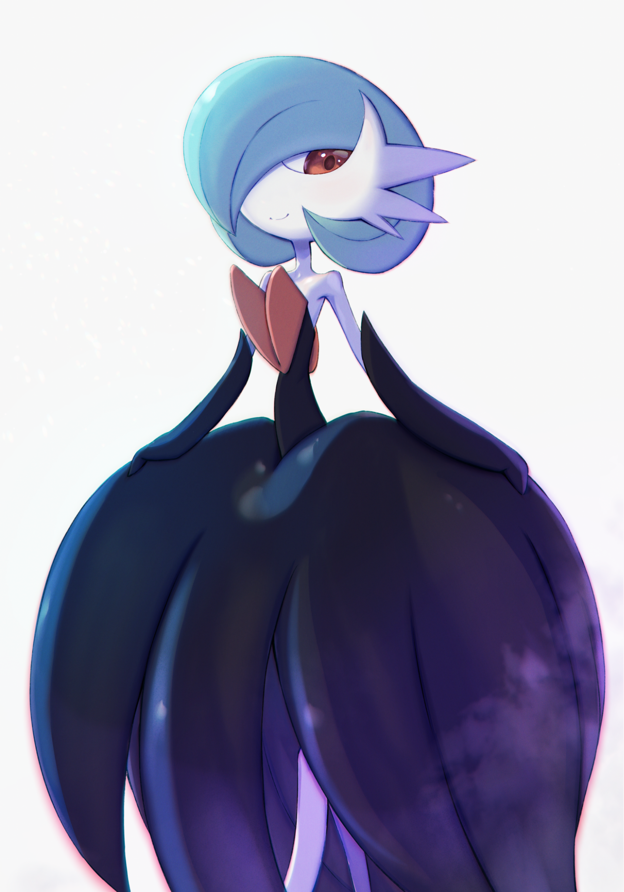

But instead of going after her, the Pokémon seemed to move on, leaving Gina to her fate as a tall menacing shadow with a crown of horns jutting out from the sides of its face and a large circular mop of hair arching over it comes into view, sporting a gown not too dissimilar to Gina's dress but with impossibly huge eyes and large, twin red spikes coming through the center of its chest, covered in pristine white skin that contrasts against the black of the flowing hide giving off the appearance of a bride standing silhouetted against an ominous backdrop of red and purple.

It was a Gardevoir unlike any she had seen before, radiating an air of confidence as it spins on a dainty leg, fluttering it's dress and sending a renewed blast of smog headed Gina's way, realizing too late that it was being produced by the Gardevoir before her and not some excess runoff from a Poison type. And judging from the way her entire body was already shivering under the influence of an electrifying tingle, holding her breath was useless, feeling her lungs tightening in her chest as the pain wracked noble lady falls onto her side, writhing in turmoil, all while the new Gardevoir subspecies watches with a glint of satisfaction in it's large red eyes, purring before moving on to resume it's onslaught on the facility, on those who had thought to treat it like a sack of lifeless meat to be experimented on.

With foam spilling out of the corner of her mouth while her vision grows blurry alongside the growing heat in her body, Gina's last thoughts before losing consciousness were of regret; not being able to fulfill her end of a self sworn promise with Giovanni to make him proud upon his return. Unaware of her role as a tool in the man's eyes, just like the rest of Team Rocket, just like the Pokémon they used before tossing aside once their purpose was served.

As a voice comes over the speaker declaring total loss of the facility, Gina and the remaining few exposed to the noxious purple clouds fall silent, lying deathly still where they laid. Unaware of the changes beginning in their bodies, a slow metamorphosis that would leave them forever changed…

Coming to in complete darkness to hear pained groaning and panicked breathing just outside the dimly lit opening she could see just a few feet away, Gina struggles to get to her feet, crying out in uncertainty and pain when her limbs refuse to listen, feeling strange all over with new sensations where there shouldn't be. It reminded her of the pain one went through after strenuous exercise, but this was on a whole new level.

Every inch of movement brought pain; a twitch of her fingers, shuffling forward, trying to right her posture, it all made her feel as if her entire body was clad in searing hot iron with a torturous inch wide gap between her skin.

But thankfully, she was alive, and that was enough to feel relief despite the pain she had to endure, clicking her tongue as she finally managed to right herself, kicking off her heels to get a better grip on the cool metal floor beneath her.

No matter how hard she shook her legs though, no heels came clattering to the floor, only realizing something was wrong the moment her eyes caught sight of her heels already tossed out behind her, glancing downward in horror to see her feet reduced to pale white stumps with the toes fused at the tip.

A sight anyone, man or woman, would scream at in terror, especially if it was an affliction they were suffering from themselves.

With Gina's shrill scream being loud enough to echo down the halls outside, a steady parade of approaching footfalls leads to a surprising revelation for the distressed woman as her head turns to the door, finding her men alive and…mostly well, eyes widening at the sight of the physical deformations all of them seemed to be suffering from as they rushed to help her up; white bony protrusions taking shape on their cheeks, some with red horns protruding from their chest, others with their unruly head of hair turned a shade of lime green, all of them with most of their bulk beginning to give way to lithe, slender frames unbefitting guards, much less a man.

And as they bring her outside into the expanse of the ruined corridor, Gina could see others like her with their legs rendered useless, turned into stumps with some already further along the process, lacking any remnants of their former toes and their legs bereft of hair and color. But when one of the men at her side eventually collapses with his pants falling off an already changing waistline to reveal the beginnings of an organic flap of flesh akin to a gown with a line green coloration underneath, it didn't take long for Gina to realize what was happening to them all as they sat her gently down against the wall. Recuperating alongside her men, a worried Gina, watching the last of her toes fuse together into a sharp pointed pillar that were her new legs, would be briefed on what was happening to them all.

Shortly after the rest of the facility had been evacuated, those that were unlucky enough to fall victim to the purple smog emitted from the escaped Gardevoir specimen were left behind, considered dead and since Gina was supposedly among them, had presumably left what little men remained scattering in the wind, making off with their lives after repeated distress calls remained unanswered. With no funding and no lab left to speak of, it was understandable why they left. Especially with a dangerous mutant on the loose.

But the mysterious Pokémon had vanished, with the survivors that hadn't been mauled by their own Pokémon turned rogue reporting no further sightings of both, having whisked them all away into the outside world.

That left the question of what was happening to them all, with the remaining scientists left in their ranks, some had managed to return to the labs down a floor or two, relieved to find at least some part of it that hadn't been left in ruins while aweing at the massive crater left behind, no indentations, no scorch marks, no shrapnel. Whatever made it had simply sheared away everything caught within its sphere of influence, like a black hole had suddenly formed right then and there. But the survivors shook their heads off such a triviality, for they had more pressing matters to tend to.

Taking fluid samples from the afflicted, it wasn't long till they had discovered the cause; a mutagenic virus with a short half life once exposed to the elements outside a host, guaranteeing this wouldn't end up becoming an epidemic unless everyone was tightly packed together.

But unlike other viruses, this one was unique in that it was causing a cellular change in the victim, rewriting genetic material, and repurposing existing cells. In other words; reforming the human body from the ground up into an entirely different shape altogether with the end result being blatantly obvious in the velvety white skin the infected were beginning to show alongside the growth of skin flaps, red horns and a very feminine body shape with twig thin limbs and ungainly feet akin to a ballet dancers shoes.

They were all becoming Gardevoir, or in some cases, earlier stages along that particular Pokémon's evolutionary path; shrinking down to take on the diminutive stature of a Ralts or the childlike proportions of Kirlia, and while infected women retained their shape, the men were faring much worse, having to watch their strong, muscular bodies fade away into a slim, curvaceous physique with their erect genitalia turning into sleek, sharp peckers. The only thing that could differentiate them from the soon to be female Gardevoir among their number, something the men would offer Gina a sight of as they help her up to bring her to the observation cum quarantine room they had set up for those further along their infection.

But the troubling issue was the effect the virus was beginning to have on their minds, seemingly stripping them clean of any memory of the humans they once were, an effort in some way to ensure the human mind would calmly embrace their fate without having to swallow in despair for the rest of their lives. Something Gina could already see clearly in the many Gardevoir and their kin idling in the room, behaving not like newly turned humans but wild Pokémon, showing not a hint of their former selves, watching one in particular still dragging the drapes of a scientists robe off of her slender body with an ID tag over her right breast; Mackie, she remembered the blonde haired scientist being an eccentric individual, but she could see no trace of the spunky blonde left in the serene Gardevoir walking over to comfort a Kirlia that had once been a security guard judging from the oversized helmet struggling to stay on his new head crowned with red horns, rubbing blurry red eyes before vocalizing mesmerizing chirps that seemed to indicate worry, before being picked up by his elder, raising him up like a parent would a child.

And as Gina watches on, all worry and fear, the last bits of who he once was, fades from the hazy red eyes of the Kirlia, cheering happily in the Gardevoir's arms.

Averting her gaze from the sight as her arms begin to twitch involuntarily, Gina are drawn downward olto witness a bright green growth spreading over both her arms, flexing them in wonder as her fingers lose their rigidness, morphing into fleshy flaps reminiscent of an amphibians fins. Losing 5 fingers in exchange for 3 dexterous ones that were harder than they looked. It seemed she had little time left as a human.

But the prospect of becoming a Pokémon, much less one free of the burdens of her human self, was starting to become an oddly appealing outcome. For as long as she could remember, her 'debt' to Giovanni and the resulting drive that had led her to spend her family's inheritance on furthering Team Rocket's research had always weighed down on her shoulders, plaguing her with the heavy weight of guilt, hoping that when the man himself would inevitably return one day, it would all pay off, relieve her of any sense of wrongdoing or futility.

Years now, and news of Giovanni had stopped circulating entirely, in Kanto and abroad. None had heard or seen a peep of the wanted man. All this seemed to be a wake up call for the wayward lady as her mind clicks with all the pointless cruelty and atrocities committed.

Sighing despondently with a vague itching sensation behind her ears as they begin to lengthen into pale spikes, Gina's mind comes to a decision as she turns to face her remaining men, bowing to thank them all for their services before boldly making her decision known;

**"As much as it scares me…scares us all…I think I'd very much like this fate…"**

Unsurprisingly, the majority had reacted incredulously, arguing that a cure could be found despite the increasingly small odds of such a thing being possible when most of the scientists were already halfway through becoming Gardevoir themselves. With some even showing signs of memory loss; unable to speak words as animalistic cries escape their lips instead, their faces losing any hint of individuality as they begin to change. It was an inescapable fate, and a rather fitting one for all of them. Something the wisest among them knew as they come forward with a solution, not to cure them, but to speed up the virus' work;

An exchange of fluids and an increase in physical exertion, since the virus could not survive outside of a host and would vanish upon the complete conversion of human DNA, what little remained of the scientist's intellect had concluded that pushing themselves, either through working out or…through more intimate means, would accelerate the change. But it wasn't something that had come from a spur of the moment, but rather their new selves coming forward, something evident behind the glass with the eldest in the group; the Gardevoirs, beginning to make out with one another, separating themselves into bonded pairs before mating with one another without a hint of shame, doing as their nature commanded them, uncaring of their demihuman audience watching just outside.

But who would bed Gina? Out of the entire crew, she had no one to call a friend, much less a boyfriend, but at this point, the Pokémon within them all were clearly beginning to influence their decision making, with a frustrated female guard who had already lost her original visage as she shirks off her helmet to reveal the face of a Gardevoir beneath stomps away with a fellow man, dragging him along as his loose fitting trousers slide off, freeing a voluminous pale skirt concealing the very womanly pair of legs his new kin were known for. Off to have their last and first time together as humans with the door to the quarantine room sliding shut behind them, drawing the attention of a few of the wild Pokémon within but not their ire, simply keeping a safe distance as they watched the two half transformed humans strip themselves of their clothes before making out with one another.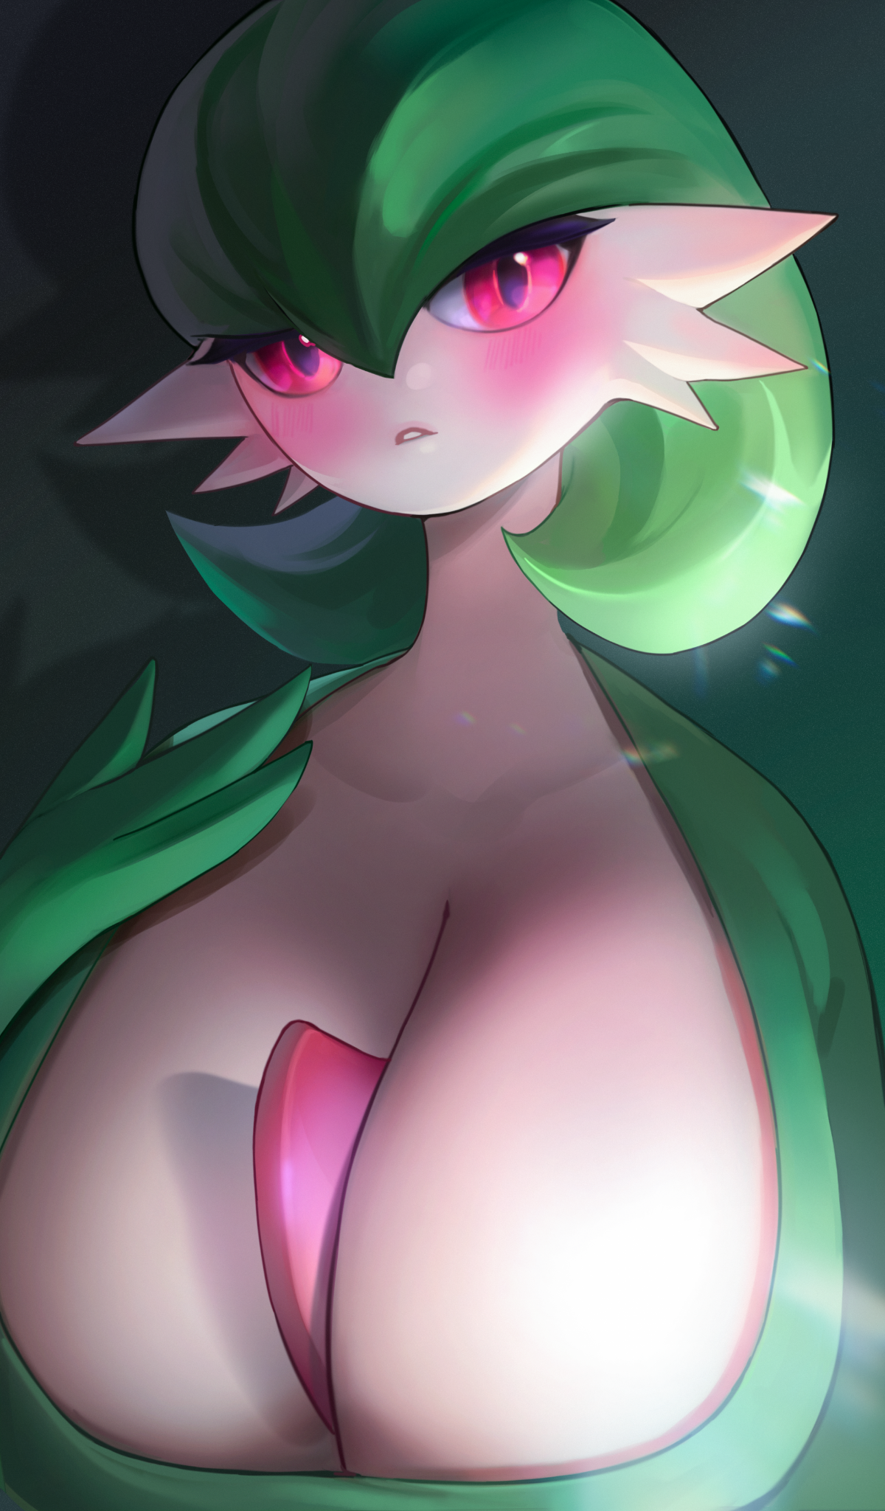

And the scientist's hypothesis would soon prove to be true; watching as the pairs transformation accelerates at an alarming speed, piercing the woman's surprisingly impressive bosom was a red bony horn protruding from between her chest, losing the heart shaped tattoo over her shoulder as it abandons all trace of bulky muscle while coating over in that signature green skin, trading her last words for the joyful cries and chirps of her new simple identity as her conflicted eyes begin to slant into an expression of joy. Were it not for her breasts, the newly formed Gardevoir would have blended in seamlessly with the others, but that would soon fix itself with her partner unloading his first load deep inside her womb, fertilizing the egg within as her chest recedes, becoming a smooth flat chest atop a tight, curvy torso. Dripping with sweat and juices as she floats to her feet, fluttering her gown like flaps while running a tri fingered hand over her belly with a warm smile in a display of maternal affection, the tomboy guard she once was no longer present in mind and body.

And as for her mate? He too had become a Pokémon in full, rising up to join his mate hand in hand as they stroll over together, walking into the crowd of Gardevoir before the audience inevitably lose sight of the pair. Entranced by their sexually spurred transformation, it had all happened so fast and the act had been without much fanfare. One moment they were there, and the next, gone, showing no regrets or concerns as they dance and meditate among their brethren.

Tearing Gina's eyes away from the sight with a firm and gentle grip on her shoulders, the heated lady would turn to face an unrecognizable individual, their infection already having progressed to a point where the only way she could tell them apart was from the ID tag hanging off their chest; Simmons. She recognized that name. A new hire and a rather kind soul, she had often wondered why he had come to develop an interest in aiding Team Rocket's ambitions despite their insidious nature.

But from the feminine body concealed beneath his baggy clothes and the erect green pecker poking through his gown, Gina could tell he couldn't even remember anymore, for the person he was wouldn't just grab the arm of a another woman in such an intimate manner nor boldly display his privates without shame. But then again, neither was she a woman at all, or at least, a human one upon realizing her dress had slipped off her body to make way for new extremities, feeling her long auburn mane begin to regress and stiffen up as her eyes widen into gentle orbs framed by her new crown of lime green hair.

Whether or not he was the man for her, she couldn't tell, but from the copious amounts of slick fluid trailing down her spindly legs, her raging libido and the urge to procreate needed immediate attention.

Gina's memory from that point on would be a blur, dulling her senses as her vision spins around, making out the vague silhouettes of the other scientists and guards already having split off into their own pairs or in the case of the unwilling, struggling to escape back where they had come from. Although she knew it was a futile effort. An evil deed's repercussions would eventually catch up to the sinner no matter how small their implication in the deed.

By the time Gina felt Simmons intense member push past her folds however, the grateful woman could no longer remember such a thing, embracing her mate while clenching her innards tightly around the stuff rod jammed into her snatch, feeling her old self fade with each knock against her womb, the lick of the cool air against her exposed skin, it was a sensation so strong, so blissful, that the passage of time bore no meaning for the female Gardevoir entranced by her partner's vigor, crying out in climax before collapsing into a heap, dripping with sweat and juices as her mind shaves itself of any lingering doubts, unable to recall anything else besides the simple thoughts that ran through a Pokémon like herself. They had no need for names after all, able to pick each other out through pheromones and psychic signals, chirping as her mate lifts her to her feet. Escorting her towards the chamber that held their brethren before opening the door and signaling for them to follow. Moving as one out of the confines of this man made cavern and out into the grassy forest aboveground while recruiting more wayward souls along the way, chirping happily amongst themselves as they bask in the sunlight while breathing in the fresh air.

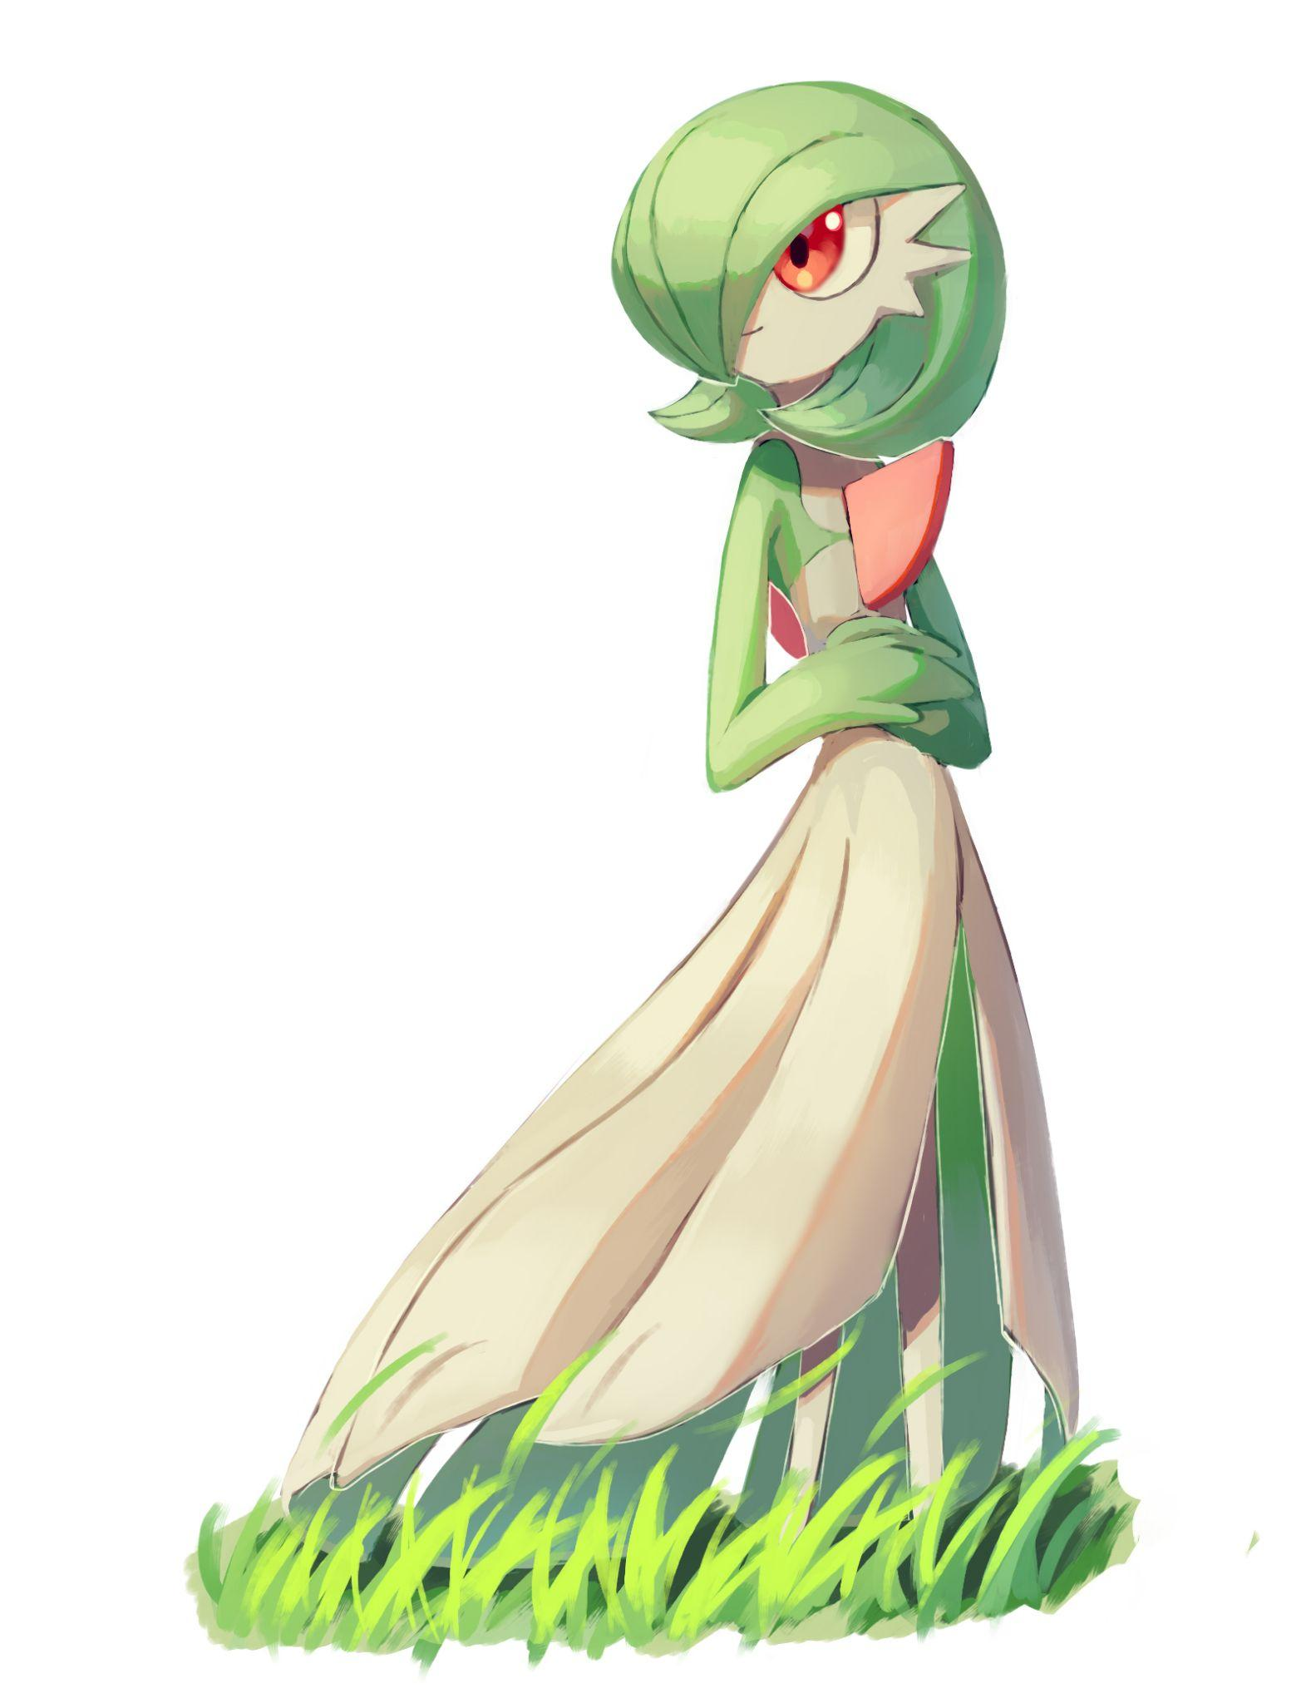

Taking one last look behind her at the cavernous opening in the forest floor with an odd look of satisfaction on her face, the Gardevoir that had at one point in her life been a regretful human whose name she could no longer recall holds her arms over her warm belly, calling after her mate whose urgent cries demanded her presence by his side. She had no reason to stay but something about that forlorn abyss resonated with her, urging her onward to be with her new family, to forget what little she remembered of the metal den.

For what felt like the first time ever, she was happy, truly happy. Feeling as if a weight had been lifted off her shoulders, walking hand in hand with her destined mate reassuring her the whole way as they made for destinations unknown, to settle down and start a family.

By the time the herd of Gardevoir and their lesser evolved kin had moved on, the sun would begin to crest over the distant mountains, casting the abandoned facility in darkness, never to be used ever again, empty and derelict for the rest of time…

*THE END*