**Specific Rotation**

**Worksheet**

Organic Chemistry Tutor

1. 0.5 g of a chiral stereoisomer was dissolved in 20 mL of solution. The observed rotation measured by a polarimeter was found to be -3 degrees at 25o C using a wavelength of 589 nm. The sample tube of the polarimeter is 20 cm long. What is the specific rotation of the stereoisomer?

2. The specific rotation of (S)-2-bromobutane is +23.1o. If 0.3 g of its enantiomer is dissolved in isopropyl alcohol to make a 20 mL solution and placed in a sample tube with a length of 400 mm, what will be the observed rotation of this solution?

3. Which of the following statements is false?

A. Chiral molecules show optical activity.

B. A pair of enantiomers will have the same density.

C. Diastereomers have different physical properties.

D. Achiral molecules can rotate plane polarized light.

E. A pair of enantiomers have equal but opposite optical rotations.

4. Calculate the % enantiomeric excess for each solution with the following enantiomeric composition: (a) 90% R and 10% S. (b) A racemic mixture. (c) A single (R) enantiomer. (d) 14g of R and 6g of S.

5. Which of the following statements is/are true?

I. A racemic mixture does not rotate plane polarized light.

II. Meso compounds are optically active.

III. Enantiomers have the same physical properties but different optical properties.

A. I Only

B. II Only

C. I & II Only

D. I & III Only

E. I, II, & III

6. A solution has an enantiomeric excess of 40%. (a) Calculate the relative percentages of the R and S isomers. (b) How many grams of the R and S isomers are present in the solution if a 30 g sample of the chiral compound was dissolved in the original solution?

7. Which of the following statements is true regarding the two compounds shown below?

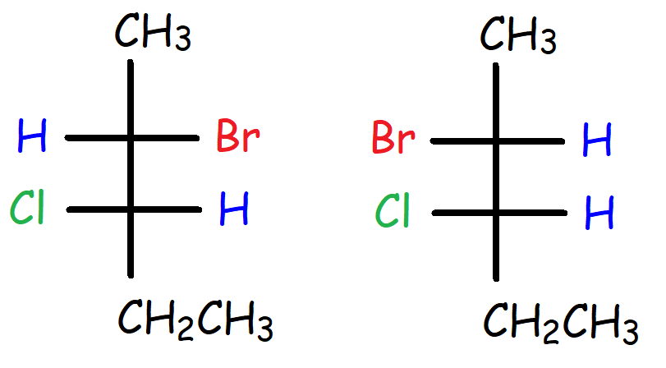

A. They have the same density.

B. They have different boiling points.

C. They have the same optical properties.

D. They are meso compounds.

E. The two compounds are constitutional isomers.

8. The R-enantiomer of a certain compound has a specific rotation of +80o. What is the observed rotation for a solution containing the following mixtures? (a) 70% R and 30% S. (b) 50% R and 50% S. (c) 40% R and 60% S. (d) 32g of R and 8g of S.

9. Which of the following can be separated by distillation?

A. Enantiomers

B. Diastereomers

C. Meso Compounds

D. None of the above

10. The R-isomer of a certain compound has a specific rotation of +200. A 20 g sample consisting only of the R and S isomers produces an observed rotation of +140. (a) What is the optical purity?

(b) Calculate the enantiomeric excess. (c) How many grams of the R and S isomers are in the mixture? (d) What would be the new observed rotation if the enantiomeric excess of the S-isomer is 30%?

**Answers:**

1. = -600

2. α = +1.3860

3. D

4a. 80%

4b. 0%

4c. 100%

4d. 40%

5. D

6a. 70% R and 30% S

6b. 21g of R and 9g of S

7. B

8a. +320

8b. 00

8c. -160

8d. +480

9. B

10a. 0.70

10b. 70%

10c. 17g of R and 3g of S

10d. -4.20