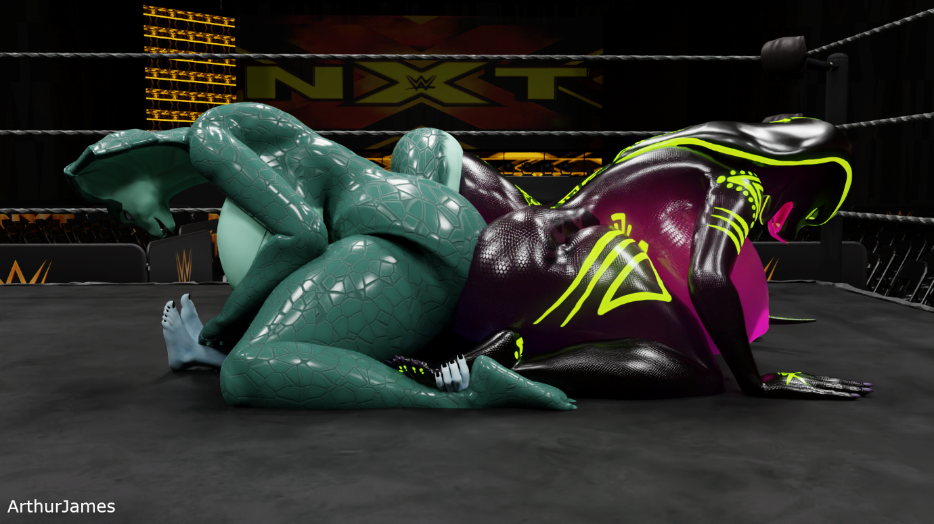
It was early in the morning and Clyde had gone out jogging. He was known in the village to be the throat swabber in the ring, he often would show his dominance in the ring with finishing the opponent by humping them in the mouth. Sometimes, Clyde would go for the ass and the pussy, but he knew what he likes. Outside of the ring, Clyde is quite the peaceful person. He would often chat with people about his persona in the ring, he had to explain why he loves humping the losers in the mouth. Clyde’s reason for it was the opponent would often be huffing by the time he does the act and, they would be submissive and begin sucking on his cock.
While Clyde was jogging, he came across 2 huge anthro cobras near a lake stretching with their backs to him. Clyde was staring at them while he was still jogging. Not looking at where he was going. BANG!!! Clyde had jogged straight into a lamp post. This sudden noise had alerted the 2 cobras as they turned around to look over to Clyde, who went red with embarrassment. The girls giggled as Clyde was rubbing his head, while looking at the girl’s huge breasts before picking himself up and jogging away.
Clyde was sitting at home with some ice on his head in the kitchen with a drink of water, when his phone rang. Clyde picked up his phone to hear the receptionist from the wrestling club he goes to, was asking for him.
“Hi Clyde, it’s Dale from the Feisty Wrestling Club.”
“Hi Dale, what’s up?”
Dale cleared his throat before he started to speak.
“Well, we had 2 visitors this morning. Um, and they were, err, very tall and feistier than anyone else I’ve seen here.”
Clyde had placed his ice pack down and was sounding more enthusiastic.
“2 new visitors? Big and feisty? What did they want?”
“Um, they had seen and heard about you. They wanted to challenge you to a wrestle but, their way.”
Clyde shuffled in his chair.
“Challenge me their way? What do you mean by that?”
“Well, they wrestle together, so 2 on 1. They wrestle naked and their wrestling style is like domination. They gave me a video to show what they do, and I have to say, they weren’t joking. They try to get their opponent on the ground and that’s when they dominate them. They know the rule we have here, the match doesn’t finish unless the person submits defeat. So be careful, Clyde. You might be great in the ring but, these girls have never lost a match. They’ve joined the club this morning, they were in the unisex changing room showers earlier, squashing a small male canine with their huge butts. Oh, I’ve just been told they’re sitting in the cafeteria. They’re waiting to be told if you’ll accept the match.”
Clyde was feeling a bit taken back by being challenged and they specifically asked for him.
“Um, well, I guess I can wrestle them or try to. When do they want to wrestle and who are they?”
Dale laughed.
“Ha! They want to wrestle today. Oh, they’re names are Mali and Qhala. They told me not to say what they are, it’s a surprise apparently.”
Clyde just sat humming.
“Hmmm, I suppose I can come over now.”
Dale quickly spoke.
“Great! They’ll be very happy about that, see you soon.”
Clyde hung up and went to his bedroom to pack some of his things for having a shower and some extra things he might need. Once Clyde was ready, he put his phone in his pocket and left his house. Getting into his car, Clyde had driven for 10 minutes before he reached the club. Parking up, Clyde got out of his car walking to the door thinking about the match and a strategy he could use against these 2 very tall competitors.
Clyde was walking through the front door when he was greeted by the receptionist.
“Clyde! Welcome, they’re waiting for you in the ring. They’re very eager to meet you and wrestle.”
Clyde had walked up to the reception desk when Dale had spoken to him. Clyde stood at the desk and had a quick chat.
“Why are they so eager to meet me and wrestle?”
Dale smiled as he looked at Clyde.
“Oh, they’ll tell you that for sure. Just get yourself ready and go in there. Have fun.”
Clyde gave Dale the side-eye and walked away towards the locker room. Clyde started to undress and put his things into his locker. Padlocking his locker, Clyde took a few deep breaths in and out before walking out and towards the wrestle arena.
Clyde reached the arena door and when he opened it, his face dropped, and his cheeks went red. The 2 huge female cobras he saw earlier in the morning, when he hit his head jogging, were standing in the arena smiling at him. Clyde’s cock was becoming erect at the sight of them, their huge breasts bouncing, they had huge butts, and they were casually fingering themselves as they watched Clyde, gingerly walk closer to the ring. Mali spoke as Clyde got into the ring and went to his corner to face them.
“How lovely, the cutie who hit his head is the throat swabber. How’s your head?”
Clyde stuttered.
“I…um...my head is fine now, thanks.”
The girls giggled as the referee spoke to them from outside of the ring.
“Ok guys, come to the centre, shake hands and back up to your corner ready to begin.”
Mali, Qhala and Clyde walked to the centre. It was clear to Clyde that he was so small compared to the girls. Seeing them in the distance, he couldn’t get a clear view of their height until now. Clyde’s head was slightly below the girl’s pussy, he could clearly see they were horny as their pussies were leaking. Mali and Qhala knelt to handshake Clyde. As soon as Mali and Qhala had a hold on both of his hands, they rubbed their pussy and wiped their pre-cum over his face, giggling. Clyde closed his eyes as he felt their sticky pre-cum get smeared over him. The girls released their grip on Clyde’s hand and walked away sniggering to each other. Clyde’s cock was fully erect, and he was looking at the girls who were staring at him smiling, before he turned away to walk to his corner. The referee called to them to be ready, with a wiggle of their breasts, the girls were ready. Clyde looked at them and then at the referee, with a pose at the ready he nodded. The referee rang the bell and Qhala and Mali giggled as they bent over when they started to walk towards Clyde with their arms outstretched, to get him.
Clyde jumped to the side as Mali went to grab him, having moved quickly Clyde went to trip Mali over. Qhala saw Clyde was focused on Mali, so she took the opportunity to sneak behind Clyde while he grabbed Mali’s tail. Mali just swiped her tail out from his grip and swiped him with her tail, pushing him backwards into the arms of Qhala who was on her knees behind him. Qhala pulled Clyde into her huge breasts, embracing him, Qhala was giving Clyde a tight hug. Mali had knelt behind Clyde and was squeezing Qhala’s huge breasts, smothering Clyde in hot, sweaty breasts.
The girls were deeply enjoying smothering Clyde in Qhala’s breasts, they almost forgot about checking him. Mali stopped squeezing Qhala’s breasts and allowed Qhala to release her hold on Clyde. With a flop and a grunt, Clyde was on his ass wiping the sweat off his face. Qhala and Mali were giggling as Clyde went to get up. Clyde saw Mali and Qhala go to grab him, with a duck and a dive he was able to gain back some distance. Qhala sighed as she got up and looked at Mali.
“I suppose we should start being serious, Mali. Let’s fuck him.”
Clyde was poised, ready for them to charge at him. He could see them smiling as they chuckled at his ready position. Qhala and Mali started to run towards Clyde, who ducked out of the way of Mali’s lunge. Clyde gave Mali a push behind the knee which made her fall over, Qhala laughed as she fell on her back. Clyde was going to escape to an open area of the ring, when Mali had got up and swiped her tail at Clyde sending him flying into the corner of the ring. Mali had rushed over to Clyde as he hit the corner of the ring. Clyde was turned around by Mali, she had hold of his arms. Mali was about to raise her leg on the ropes when Qhala had jumped out of the ring and had walked behind Clyde.
“I’ll hold him.”
Mali nodded as Qhala held Clyde’s arms back. Clyde tried to struggle as Mali turned around and bent over. Mali held her butt cheeks open revealing her sweaty anus, with a giggle she squashed Clyde to the corner with a squeak. Mali held on the ropes as she began grinding her butt on Clyde’s face. All that could be heard was the squeaking of Mali’s butt rubbing on Clyde’s face and Mali moaning. Qhala was cheering Mali on to rub her butt harder on their new friend. Mali started to rub harder, and she occasionally would shake her butt with Clyde’s head firmly stuck between her sweaty butt cheeks. Mali was trying to talk over the loud squeaking.
“We should pin him down; I want to grind my pussy over his face.”
Qhala chuckled.
“Hehe let’s make him wet. I’ll have a turn on his face, you can sit on his cock.”
Qhala released her hold on Clyde’s arms as Mali walked towards the centre of the ring with Clyde’s head still stuck firmly in her butt. Clyde was having to try and walk when Mali moved with him. Qhala came over and pulled Clyde’s head out from Mali’s butt with a pop. Mali moaned as she felt Clyde’s head come out, Clyde’s face was coated in sweat from being trapped between her huge butt cheeks. Qhala pinned Clyde to the ground and waited for Mali to kneel above Clyde’s cock. Mali’s pussy was leaking so much with anticipation of having Clyde’s cock inside her. Clyde was wanting to try and protest but grunted as Mali sat down with a slap and leant over to hold his legs. Qhala gave her the thumbs up while Clyde’s arms were pinned.
Qhala was kneeling behind Clyde’s head holding his arms down while Mali had begun riding Clyde’s cock. Her huge butt cheeks were slapping on his body every time she sat back down. Mali wasn’t being gentle her riding Clyde’s cock; she was enjoying the wet sensation of her juices making his cock soaking wet. The feeling of something so wet sliding in and out was making her feistier. Qhala was about to drip onto the floor when she released her right hand and caught her pre-cum and rubbed it over Clyde’s face who wasn’t aware that she would do that. He tried to moan but, Qhala closed his mouth.
After a while of Mali riding Clyde’s cock, she could feel he was about to cum in her. Mali stayed seated and looked at Qhala.
“Quick, sit on his face. I can feel him tensing up.”
Qhala released her hold on Clyde’s arms and turned around and positioned her leaking pussy over Clyde’s face. Clyde’s hands were stretched out when Qhala dropped her hips down on his face with a squelch. Juices were starting to fall down Clyde’s face as she sat there. Both girls had sat down on Clyde’s body, their butts were covering his body leaving his legs and arms visible. Qhala leant forwards with her hands on the ground, she began riding Clyde’s face like a dildo. Mali giggled and continued to ride Clyde’s cock as well.
Mali and Qhala were enjoying dominating Clyde so much, he was coated in so much cum from them. Clyde couldn’t control himself any longer and moaned as he cummed inside Mali’s pussy. Mali stayed seated as she felt him cum while she orgasmed over him as well, Qhala started to grind her wet pussy over Clyde’s mouth as he opened it. Qhala held Clyde’s head with her left hand as she pushed his mouth open as she sat on his open mouth. She continued to grind her pussy as she continued to leak into his mouth. Mali had continued to ride his cock again after she orgasmed when he cummed in her.
After a while of Mali riding Clyde’s cock and Qhala rubbing her wet pussy over Clyde’s open mouth, Mali stopped and stayed seated as she spoke to Qhala who continued to rub her pussy on Clyde.
“Do you want to swap places?”
Qhala was enjoying herself so much she didn’t hear Mali ask for a swap, Qhala just orgasmed in Clyde’s mouth who gurgled at the huge amount of cum flowing into his mouth. After Qhala finally finished cumming into Clyde’s mouth, she sat down on his face and turned her head to Mali.
“Oh, that was amazing, I love cumming in defeated opponent’s mouths. Nah, let’s take him home. We have so much more to do with him, contact the other girls and the guys. They all need to try out this amazing stud. But first, are you going to submit defeat Clyde?”
He kept his eyes closed as Qhala hadn’t gotten off his face yet. Mali got up, making Clyde grunt with the weight being lifted off him. Mali walked in front of Qhala and knelt. Qhala got off Clyde’s face and moved down his body and sat on his cock, slowly rocking her hips forwards and backwards. Clyde wiped the sticky cum off his eyes and upon opening them, he saw Qhala looking at him smiling and Mali behind him smiling too. Clyde hadn’t lost a match since he went against the 2 male elephants, which was 3 months before this match. Clyde was thinking of his options when Qhala started to bounce on his cock.
“Well? What are you waiting for? Submit defeat or shall we carry on dominating you here?”
Qhala stopped bouncing on Clyde’s cock and she was rubbing her breasts together, waiting for Clyde to decide. Clyde sighed as he looked at Qhala and Mali.
“I suppose this is a defeat. Although, what other girls and guys are you on about?”
Qhala stayed seated on Clyde as Mali knelt next to Clyde’s shoulders facing him. Qhala leant forwards, her huge breasts wobbled about.
“We have other snake girls and guys, our height as well. Some of our friends are male and female elephants, hippos, rhinos, orcas and horses. They’ll love playing with someone like you. I can’t wait to see them dominate you. We should get going, leave your car here and you can come in our vehicle. Don’t worry about your car, we’ll return to collect it, when everyone is finished dominating you.”
Qhala got up, letting Clyde’s cock flop out from her wet pussy as cum leaked out from her pussy. Mali stood up and Qhala held her hand out to help Clyde back onto his feet. Clyde, Mali and Qhala climbed out of the ring, and they walked to the unisex locker room. Qhala, Mali and Clyde had their showers and were now ready to make a new adventure. The receptionist saw them head to the exit and wished them well. Qhala had her hand on Clyde’s right shoulder as she guided him with Mali to their large vehicle. Qhala picked Clyde up and placed him into the vehicle as she climbed up to sit next to him. Mali went to the driver’s side and got in. With the keys in the ignition and turned, the engine roared to life, and they were ready to make their way home. Qhala was very excited about taking Clyde back to their home, she began messaging everyone in the huge group chat, she had created with Mali. More than 30 of her friends responded and said they’ll be on their way over. Qhala just sat back and giggled, telling Mali and Clyde that a lot of their friends are going to be making their way over to dominate Clyde. Mali cheered as they drove away for an adventure, Clyde was not expecting to have today or for the next few days.

