HOMUNCUSIS
SEPTEMBER 2021 REQUEST STORY
BY CHALDEACHANGE
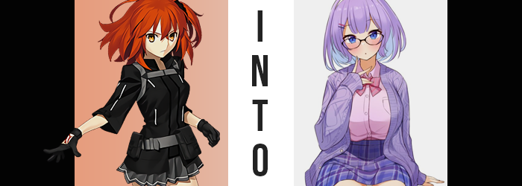

“I really wonder what it would be like to be a sibling. I’ve never had anyone like that before.”

Minamoto no Raikou could only tilt her head to the side with slight curiosity as she listened to the wonderings of one Mashu Kyrielight within the open bath. The Berserker had been getting changed in the changing room, and so hearing such a comment had come as wholly unexpected. And yet there it was: a comment so irresistible that Chaldea’s self-proclaimed mother couldn’t help but giggle at. “Is that something you truly desire, then?” Well, she’d been holding on to a Holy Grail for just a moment like this.

Ritsuka Fujimaru was exhausted from a long day of collecting Materials from Chaldea, with every facet of her body aching thanks to the grind. Honestly? She just wanted to collapse on her bed, and that was the plan she was in the middle of carrying out. Her feet her sore, her head was ringing, and her spirit was (temporarily) broken.

All Ritsuka knew was that, when she had returned to her room, there was a neatly decorated box upon her bed. “Hm? Did someone put this here? Mashu?” It had to be, right? Mashu was the only other person in Chaldea with her room’s keycard unless someone had lifted it from her. “It was nice of her to get me a gift, but hm…”

She could ponder its existence all she liked, but it wasn’t actually a gift from Mashu. It was the product of a wish, imbued with a magic that would affect the very existence of whomever adorned what was within. And who had made that wish exactly? Why, none other than Minamoto no Raikou herself.

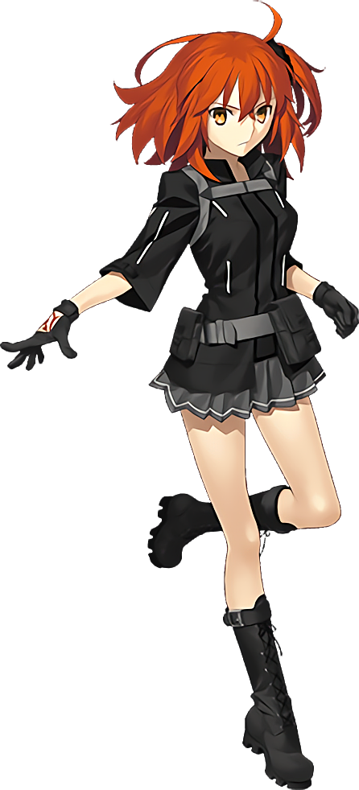
After lifting the lid off of the box, the Master didn’t really know what to make of it. It was a pair of glasses with oval lenses, which was fine, except for the fact that Ritsuka’s vision was perfect. Had Mashu wanted them to match? Perhaps it wasn’t all that farfetched that this might be the case since she was always looking at new ways for them to become closer, but...

“As I thought, my vision is— Eh?” Just to entertain the idea a moment, she had pushed the frames up the bridge of her nose. Her vision had been expectedly blurred for a moment, but then the blurriness faded. Returning only when she removed them. “What the!? Did these mess up my eyes!?”

Were they like the ‘Glasses of Disturbed Vision’ or something? She hadn’t sensed any magecraft upon them, so she doubted they were an item that simply robbed you of your ability to see. But other than how, Ritsuka was left wondering why as well. What was the point of worsening her vision!? And yet that was hardly the only thing these glasses had done to her eyes in the end.

As quickly as they’d blurred in the first place, an unusual color had bled into them. Well, perhaps ‘unusual’ was the wrong word in a sense? It was a very normal color, and in fact a color much more normal than the bright orange the young woman typically held. But this blue, like water pouring into a dirty tub, washed away that orange as it were nothing, leaving irises sparkling that gorgeous blue after the fact.

But beyond her eyes themselves, unusual side effects began to grip the girl’s face. Her narrow, Japanese eyes rounded so that those baby blues were even clearer than before, and an unintended wriggle of her nose saw those glasses sit more comfortably along a lessened slope. With cheeks swelling slightly, it was clear that she didn’t really look Japanese anymore, and for a brief moment? She almost looked identical to Mashu with blue eyes, at least before a creeping age brought her face’s arch and complexion to create the impression that she was a little older. Twenty-four? Twenty-five? Somewhere in there.

“Uu… I feel a little weird. Maybe I should bury my nose in a book or something? …Eh? Why would reading a book make me feel better?” Not that there was anything inherently wrong with reading a book, but it certainly wasn’t something that Ritsuka defaulted to for alleviating discomfort. She wasn’t all that much of a bookworm, really. And yet at that moment nothing sounded better than snuggling up under her covers with a good story.

In the meantime, with her face rewritten a similar phenomenon ultimately came for her hair. Locks that were a mix of ginger and orange were subjected to their vibrancy fading as their overall shades approached a much more pastel orange – and yet once they wholly reached that point, the colors inversed entirely so that a pastel purple took claim of her head of hair as well as her brows and pubes entirely.

Without thinking, and without noting the color change, despite feel off Ritsuka reached up a hand to fluff her bangs. They’d looked a little too jagged to her despite them normally being in her usual style, and as she played with them the overall style of her hair did change. It didn’t grow any longer or shorter, but it certainly softened and fluffed up at the sides, becoming completely straight and bending into a perfect bob. Those bangs she was playing with soon found peace in the center of her forehead while the rest were parted to the sides.

Again, while different, it was uncanny just how much more she resembled Mashu.

“Maybe I should go talk to my little sis… I mean…! I meant to say Mashu, right? I don’t have a little sister… and she’s not her even if I had one! But that kind of sounds right somehow…?” Disoriented and slowly becoming plagued by conflicting memories, it was easy for whatever was affecting her to insert this new reality into the Master’s psyche. One that completely erased the Command Seals upon her right hand. Even her mannerisms had begun to differ, for fingers now sporting properly manicured nails rubbed at her thickened lips in an expression of anxiety that wasn’t typical for her.

Can I really be Mashu’s sister though? I mean I don’t really look like her! After all, her body is much more bombastic than mine… In her head she was trying to piece together her thoughts and feelings on the entire situation, yet she didn’t realize that these things she was considering were rectifying themselves as she considered them. It was something that should have been readily felt, and yet the woman hardly reacted to them at all short of a few groans of discomfort.

After all, her body had begun to expand, though thankfully not in a way that suggested a shift in healthiness even though her muscles did soften quite considerably. Instead, it was a trend plaguing two notable areas in particular, the first of which being below a narrowed waist. Both of her hips popped in a way that shook her standing posture, but this was merely a preparatory step for what was to come.

After all, the excess space between her legs was necessary for the added weight that would find itself within her thighs. “Mm… I’m feeling a little frisky. Can’t do anything about that until everyone goes to bed for the night though.” Ritsuka was simply speaking without thinking now, mind torn between figuring out if she was Mashu’s sister and now, surprisingly, thinking about sex. Her fingers, now daintier, twitched a little at the idea – and she raised and dropped her feet in anticipation in a way that revealed they appeared to be a little smaller than her socks were designed for.

She was certainly developing a figure that would attract interest from others in such an activity though. Her thighs were pinkening as ample volume pulled the skin tight around flesh that jiggled delightfully, pushing out her skirt at the sides where her hips had already caused some damage. The gap between her legs had so quickly filled, and now her thighs were rubbing together as her own arousal built. That in itself should have been strange, but something deep down told Ritsuka that she had always been a deviant. Even though her personality was so demure and reserved in public.

Unseen, the cut of her pubes was decorated into a purple heart as if to suggest this further.

“It’s no good though! Sis has a key to my room, and if she were to walk in on me fingering myself again…” Huh? Had an incident like that really happened? It didn’t sound like something she’d do, and yet it totally sounded like something she’d do. Still, stimulated as she was she finally allowed her rear to fall down onto her bed. …And she immediately felt the sensation of her panties pulled very far up her ass crack. “Eep!?”

In truth, her ass had met the mattress a little sooner than it normally did too – and the back of her skirt was flipped up much higher than normal. This was, of course, because her ass had grown with the same thickness her thighs had. Her figure was one-upping Mashu’s entirely, and as cheeks squished against the bed the excess weight was pushed backwards to make it appear even bigger. Once she stood again, there was no doubt that those massive buns would jiggle, and then rise and fall with each of her steps.

I’m alone, right? So why am I still dressed all stuffy? I should get comfy and settle in with a book if I can’t do anything else for now… Chaldea’s Master had fully succumbed to the mental dissonance her transformation had brought about now, and so lengthened fingers played with the zipper and belts of her jacket, eventually discarding it just in time for the upper buttons of the dress shirt beneath to go flying off.
But Ritsuka didn’t even bat an eyelash at that, and instead continued to unbutton the top on her own. She was quick to cast the shirt to the side, revealing what was to be expected fully. Her breasts had not only doubled in size, but were continuing to swell even now. She’d always had a leaner sizing that complimented her more agile frame – but that wasn’t what she remembered now. Ever since I was little, I had really big breasts! It makes me anxious when people leer at them, and I guess that’s where a lot of my shyness comes from…

They reached D-cups not long after, and as the woman removed her straining bra, her bosom was free to spill out with a moderate bounce that was largely fueled by the fact that these tits were growing even bigger and more indecent. The bigger they grew, the more certain in her mind she became that they were an ‘asset’. She was a shy girl socially, but when it came to acts of sexual deviancy, those tits were her secret weapon! Before long each breast was larger than even her head, and with the cool air making her nipples erect she couldn’t help but grab them and press them together.

“Mm… Did I really dress in clothes that don’t fit? My little sis would totally make fun of me if she saw me this way! Well, if she didn’t scream at me to cover up. But it’s not really my fault that I’m the curvier of the two, is it?” As the young woman fell back against her bed, her G-cup bosom jiggled up and down before eventually settling. Melanie Kyrielight had little shame about her figure, even though she typically dressed so bookish and conservatively.

Much like her little sister Mashu, she had been created. But because she was older, she had been the test version more or less. She worked in Chaldea as a member of the staff and hadn’t suffered from the same shortened lifespan that Mashu had. On the other hand, she didn’t have any compatibility when it came to magecraft or being a Demi-Servant. She didn’t really mind though!

After all, she got to spend plenty of time in the library, and not to mention plenty of time in the presence of attractive Heroic Spirits. Be they man or woman, she didn’t mind giving them a top-up now and again. Not that her self-proclaimed mother knew about this. After all, Minamoto no Raikou would likely pop a vein if she knew that her favorite adopted daughter was up to such things.

“Girl’s gotta fuck though, right?”

