DRAGON FORCED IV.
BIWEEKLY STORY #131
BY CHALDEACHANGE
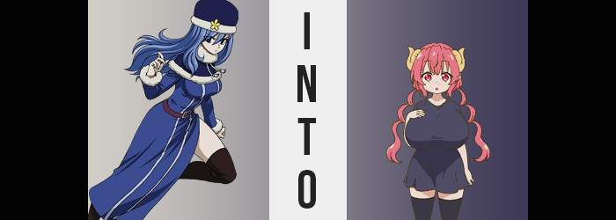

It had been nearly two weeks now since three of Fairy Tail’s strongest members had gone missing. Well, to be fair they had only just officially become missing one week ago after the trio of Team Natsu women had failed to report in on time. The quest that Lucy, Erza, and Wendy had all gone on should have been a simple one. They had just been investigating an old set of ruins without much noted in the way of danger, and yet?

No one from the nearby town had seen them since they had left – while simultaneously noting that there had been some sort of ongoing activity in the ruins themselves.

In the end it was only natural that an investigation would be held, and along with Mirajane and Lisanna Strauss, Juvia Lockser had been deployed by the current guild master to investigate. “Ah! Why wasn’t Gray-sama allowed to come with me? Juvia feels so alone!” It wasn’t quite a matter of him not being allowed. The boys of Team Natsu had been off on another quest and were returning home. Juvia’s squad had been sent out as a preliminary group and others would join if it ended up being dangerous.

“They said there was a lot of activity? But Juvia doesn’t see anyone!” Hiding in some bushes on the exterior of the ruins, the water-make mage was examining the surroundings with a pair of binoculars. She had been too impatient to wait for the Strauss siblings before setting out and instead decided to go ahead without them. “Hm? Wait…” For a second she thought she had seen something sticking out from some nearby bushes instead. A child’s head? A girl with silver hair, or so it seemed.

Was that a lead? Expecting as much she dropped her binoculars and ran over. “Helloooo! Little girl!? Juvia has a question for— AAAAAAAAAAAH!?” Her innocent intention to pose a question had been rudely interrupted by a hidden hole just a foot from where she had seen the child. Juvia stepped over it and fell through, comically screaming for a second before she landed on… a navy blue blanket? It must not have been that far if she hadn’t taken much damage.

“Ah. I caught one.”

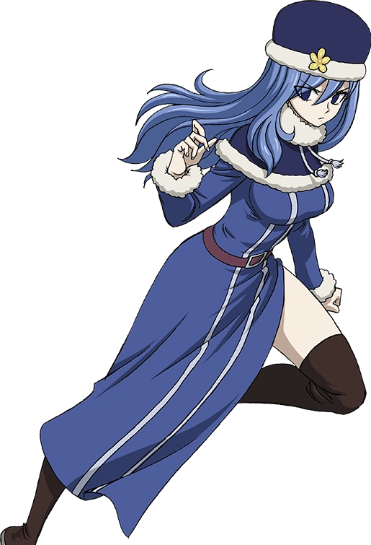
The sound of an unfamiliar voice coaxed Juvia into directing her eyes to a torchlit doorway. There stood the girl that she had seen in the bushes, horns and all. Horns? Did that mean that the child wasn’t human? “Caught one? A-Are you talking about Juvia? What does that mean? What are you planning on doing to me?” The Fairy Tail mage didn’t really like the sound of any of that. But wait! If she’d been caught down here then wasn’t there the chance that…?

“Did three girls with this mark come down here?” The mage flashed the Fairy Tail symbol on her thigh without much fanfare. Lucy, Erza, and Wendy; it was possible that they were missing because they had fallen into a trap like this, wasn’t it? Unfortunately the answer that she got from the girl wasn’t exactly a comforting one. It began to the horned and tailed girl shaking her head.

And then she turned to leave, a stone door closing behind her. “Mm… Nope. I don’t think so. But I’m just supposed to leave you in here so, good luck?” The door shut seconds later with a loud crash, leaving the woman trapped within to stand up in a panic. Had she really just been trapped in the room? Perhaps with her magic she could cut through the stone? Or maybe she could turn herself into water to move underneath?

“Eh?” Before she could do just that, a glowing at her feet caught her attention.

It was the blanket that she had fallen on. If Juvia had inspected it closer then she might have realized that it wasn’t a blanket at all and instead a large shirt overtop some undergarments, but in that moment a blanket is what it had seemed like to her. “Why is it glowing all of a sudden? Juvia doesn’t understand…” It didn’t feel like magic, or well it kind of did a little bit. But it simultaneously felt different as well. She could only tell as much because it was interacting with her body, which traditionally wasn’t a good thing. “Er…”

But the Water-Make Mage had nowhere to flee its effects. Doubly so once she realized that her own magic wasn’t working like it should. Try as she might? “Juvia can’t turn into water!?” That would have been her easiest out. Instead she was trapped inside with the glowing cloth as her torso began to tilt farther and farther forward… “Huh?”

It wasn’t until the woman said it aloud that it finally struck Juvia that her body shouldn’t have been doing that. It was tied to a growing tightness in her dress – specifically around her chest – that the woman subconsciously grabbed it. “JUVIA’S BOOBS!?” Fingers pressed into a bosom that was significantly larger than it had been before, and Juvia realistically already had one of the more sizable bust sizes among the guild’s women.

The thicker material of her dress was struggling to contain a pair of tits that were burgeoning forth with weight even still. But Juvia had a new skill! One that she was quick to put into action because the growth had given her no choice. With one fluid motion… she stripped. “Forgive me Gray-sama!” It was a technique she hadn’t wanted to use for something like this! But it was definitely effective, for bare boobs that were already comparable in size to the woman’s own head bounced free off-rhythm. One bounced up as the other fell down.

Juvia almost fell over while doing this. Her breasts were still growing and their heft was so great that it was as if she had a legitimate pair of melons strapped to her chest. They almost bordered comical by the time they had peaked at S-CUPS, nipples both larger than the woman’s own mouth. It was a real struggle to keep herself standing upright even after digging delicate fingers into the squishy mountains to stabilize herself. “What would Gray-sama think if he saw Juvia like this!?”

Obviously the glowing cloth had done this to her. The woman was on the verge of tears. Forget Gray, how could she present herself to anyone with a chest that large? Unfortunately for her, the comical side of her appearance didn’t improve at all. It worsened instead. “Wh-What now!?” She could feel it. She had only just found balance with her new bust, and yet a literal sinking feeling had made it difficult to stand up straight once more.

In a way it was almost like someone was placing a series of heavy books upon her head that began to weigh her down. There was no pain nor tangible pressure but her body soon compressed, height shedding away so that her arms, legs, and even her torso were condensed. Hands and feet shrunk so that there was nothing uneven about her overall appearance as Juvia dipped beneath the five foot mark. The issue? While everything else was shrinking… her S-cup tits were the only part of her body to retain their size.

“Wh-Why!?” Juvia chirped, her voice significantly higher as she neared her intended height of 4’3”. Her hips had only narrowed a bit and so, fortunately, her panties had remained on to cover her loins above thighs that felt plumper compared to her compressed height. But she was naked otherwise. Naked, and presenting with a dwarf-like height. Everything around her felt so big. It was all so foreign.

…Wasn’t it?

Nothing was right. She wasn’t supposed to be so short and stacked but it was getting harder for her to believe in reality itself as the curse affecting her body finally began to seep into her mind. Memories and understanding alike were being exchanged and in turn that affected her perception and personality. As her mind shifted her almost goldfish-like eyes expanded in shape as a deep crimson bore into their color – just as a pink emerged amidst hair that largely shortened and thinned. Oddly, pointed ears peeked out from the sides.

A bit of drool pooled in the corner of Juvia’s mouth, a symptom of her mind temporarily hitching. She wasn’t aware of anything in her current state, and so the not so subtle shifting of facial features to give her a rounder and more babyish facial shape went unnoticed. But despite how that face looked she was still an adult. She just stood there, wobbling, seemingly unaware of anything happening around her any longer.

Yellow nubs began to protrude from the sides of her heads. The honest to goodness horns of a dragon that curved down and then up again into a compressed shaping. A heat welled within her huge chest courtesy of her draconic flame sac, and around her hands? Big, crimson scales were hardened out of her skin. Fingers and palms thickened and swelled into a pair of mighty dragon hands, complete with long and terribly sharp claws. What ultimately filled out the look was an extremely thicc tail that emerged from just above her ass. It was about four feet long and swished about passively, until…

“Ah!?” She snapped out of her stupor.

The small woman – and she was in fact a similar age to Tohru – looked around the stone room with renewed understanding. “Lucoa called me… But why’d she lock me in a room!?” She stomped like an actual child might, but the tremor caused her excessively large tits to jiggle while her equally meaty tail swished about behind her. Ilulu didn’t hesitate at all to charge at the door that she could recall Kanna exiting through, even though she didn’t have any recollection of dropping down as Juvia in the first place.

All it took was one clawed fist crashing through the door for it to crumble, the big tittied dragon proudly stepping through the rubble to find herself face to face with the Kanna Kamui that had placed her there in the first place. “Hey! What do you think you’re doing, trapping me in a place like that!?” Ilulu barked, but Kanna retained her calm expression and just pointed back at the room. “Huh?”

“…Baka. You were standing on your own clothes. Why did you storm out here naked?” There was a slight smirk on Kanna’s face as she watched Ilulu’s bare flame sacs bounce about. The ‘adult’ in question’s face turned quite red and, after yelling in frustration, ran back inside to throw on the oversized shirt, underwear, and tights. She even hid her tail and claws, giving her a more human form before meekly stepping back outside. “That’s better… Lucoa wants to see you before the others arrive.”

…Others?

