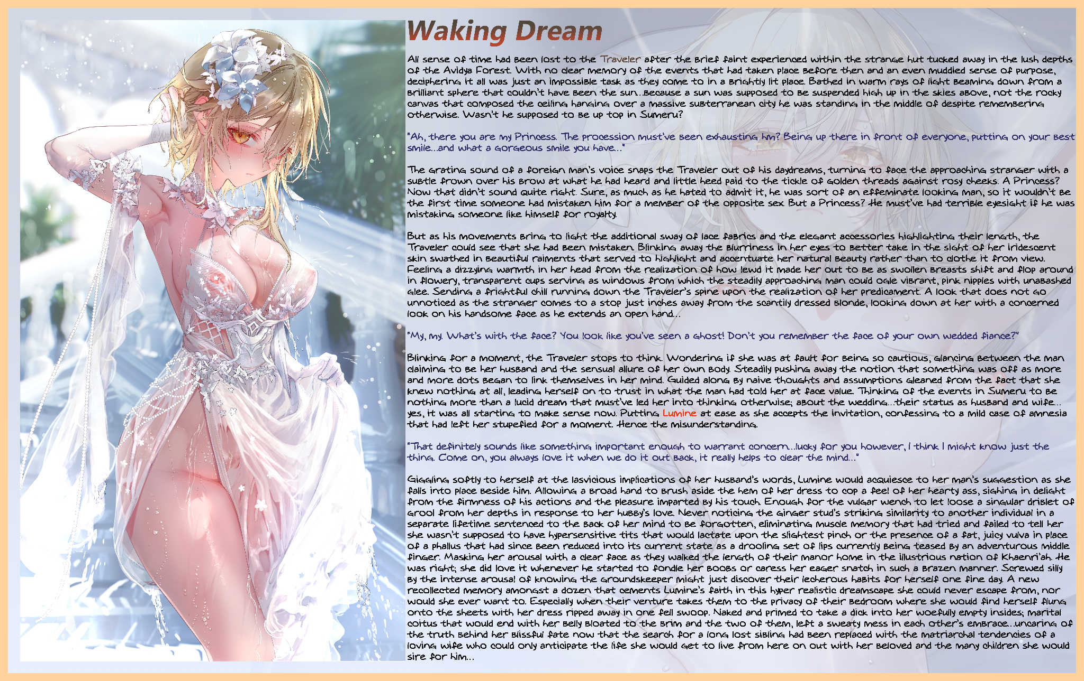

All sense of time had been lost to the Traveler after the brief faint experienced within the strange hut tucked away in the lush depths of the Avidya Forest. With no clear memory of the events that had taken place before then and an even muddied sense of purpose, deciphering it all was just an impossible task as they come to in a brightly lit place. Bathed in warm rays of light beaming down from a brilliant sphere that couldn’t have been the sun…because a sun was supposed to be suspended high up in the skies above, not the rocky canvas that composed the ceiling hanging over a massive subterranean city he was standing in the middle of despite remembering otherwise. Wasn’t he supposed to be up top in Sumeru?

**“Ah, there you are my Princess. The procession must’ve been exhausting hm? Being up there in front of everyone, putting on your best smile…and what a gorgeous smile you have…”**

The grating sound of a foreign man’s voice snaps the Traveler out of his daydreams, turning to face the approaching stranger with a subtle frown over his brow at what he had heard and little heed paid to the tickle of golden threads against rosy cheeks. A *Princess*? Now that didn’t sound quite right. Sure, as much as he hated to admit it, he was sort of an effeminate looking man, so it wouldn’t be the first time someone had mistaken him for a member of the opposite sex. But a Princess? He must’ve had terrible eyesight if he was mistaking someone like himself for royalty.

But as his movements bring to light the additional sway of lace fabrics and the elegant accessories highlighting their length, the Traveler could see that *she* had been mistaken. Blinking away the blurriness in her eyes to better take in the sight of her iridescent skin swathed in beautiful raiments that served to highlight and accentuate her natural beauty rather than to clothe it from view. Feeling a dizzying warmth in her head from the realization of how lewd it made her out to be as swollen breasts shift and flop around in flowery, transparent cups serving as windows from which the steadily approaching man could ogle vibrant, pink nipples with unabashed glee. Sending a frightful chill running down the Traveler’s spine upon the realization of her predicament. A look that does not go unnoticed as the stranger comes to a stop just inches away from the scantily dressed blonde, looking down at her with a concerned look on his *handsome* face as he extends an open hand…

**“My, my. What’s with the face? You look like you’ve seen a ghost! Don’t you remember the face of your own wedded fiance?”**

Blinking for a moment, the Traveler stops to think. Wondering if she was at fault for being so cautious, glancing between the man claiming to be her husband and the sensual allure of her own body. Steadily pushing away the notion that something was off as more and more dots began to link themselves in her mind. Guided along by naive thoughts and assumptions gleaned from the fact that she knew nothing at all, leading herself on to trust in what the man had told her at face value. Thinking of the events in Sumeru to be nothing more than a lucid dream that must’ve led her into thinking otherwise; about the wedding…their status as husband and wife…yes, it was all starting to make sense now. Putting ***Lumine*** at ease as she accepts the invitation, confessing to a mild case of amnesia that had left her stupefied for a moment. Hence the misunderstanding.

**“That definitely sounds like something important enough to warrant concern…lucky for you however, I think I might know just the thing. Come on, you always love it when we do it out back, it really helps to clear the mind…”**

Giggling softly to herself at the lasvicious implications of her husband’s words, Lumine would acquiesce to her man’s suggestion as she falls into place beside him. Allowing a broad hand to brush aside the hem of her dress to cop a feel of her hearty ass, sighing in delight from the firmness of his actions and the pleasure imparted by his touch. Enough for the vulgar wench to let loose a singular driblet of grool from her depths in response to her hubby’s love. Never noticing the ginger stud’s striking similarity to another individual in a separate lifetime sentenced to the back of her mind to be forgotten, eliminating muscle memory that had tried and failed to tell her she wasn’t supposed to have hypersensitive tits that would lactate upon the slightest pinch or the presence of a fat, juicy vulva in place of a phallus that had since been reduced into its current state as a drooling set of lips currently being teased by an adventurous middle finger. Masking her arousal with a clear face as they walked the length of their manor home in the illustrious nation of Khaenri’ah. He was right; she did love it whenever he started to fondle her boobs or caress her eager snatch in such a brazen manner. Screwed silly by the intense arousal of knowing the groundskeeper might just discover their lecherous habits for herself one fine day. A new recollected memory amongst a dozen that cements Lumine’s faith in this hyper realistic dreamscape she could never escape from, nor would she ever want to. Especially when their venture takes them to the privacy of their bedroom where she would find herself flung onto the sheets with her dress ripped away in one fell swoop. Naked and primed to take a dick into her woefully empty insides; marital coitus that would end with her belly bloated to the brim and the two of them, left a sweaty mess in each other’s embrace…uncaring of the truth behind her blissful fate now that the search for a long lost sibling had been replaced with the matriarchal tendencies of a loving wife who could only anticipate the life she would get to live from here on out with her beloved and the many children she would sire for him…

THE END

Images by Pottsness : <https://www.pixiv.net/en/users/59336265>