HEART IN THE CARDS
COMMISSION STORY
BY CHALDEACHANGE
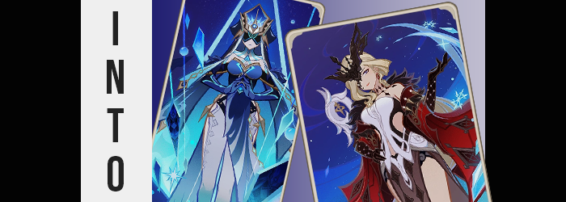

A certain nekomata had gained herself a new obsession.

Genius Invocation TCG. It was a card game that wasn’t played in the real world, instead being isolated to within the confines of the game ‘Genshin Impact’ for the time being. While it was a game within a video game that didn’t mean that it wasn’t robustly designed, however. It had its own rules and strategies, each one revolving around picking character cards that could deal different attacks and bolstering them with support cards.

It was extremely engaging and scratched that trading card game itch for the right people. There was also the fact that the game was regularly supported, with each patch adding new cards and sometimes even new challengers to play against. Unfortunately, Hisa was one of those people whose obsession with card games had gotten her instantly hooked. She had sat within the confines of her pocket dimension playing for days on end now, but there was one area in which she felt a little stuck.

“Ugh, I feel so burnt out, but I really want those cards!” As was a common feeling when someone spent too much time doing the same thing over a short period of time, the cat-featured girl lamented her growing fatigue. There were two cards that she really wanted to get but she also needed to take a break from playing! Her OCD really worked up at times like these! But then it occurred to her.

“Wait a sec. I’m an all powerful being. I could get those cards in a more amusing way, couldn’t I?”

“Brr… Why is it so— HUH!?” A cold spell had suddenly possessed Joseph in his sleep, or at least that was what he had believed until his eyes had finally fluttered upon and he found himself laying in an unfamiliar room atop an unfamiliar cot. He immediately jumped off the bed and onto his feet, finding himself still dressed in his bedwear. But he was a little underdressed for the climate he now found himself in. It was a big, open prison cell. One that only had a small window that peered up at a night sky that showed both stars and what he believed to be the Northern Lights.

This had to be a dream, right? He’d gone to bed and then woken up somewhere unfamiliar. But the intensity at which he felt the wintery chill was suggestive of the idea that maybe it wasn’t a dream? “Obviously something’s up here but…” Any explanation he thought up felt like it was impossible. Namely because any memories of the nekomata responsible had been wiped away to keep things ‘fresh’.

At the very least he began to feel warmer. Like way warmer.

Feelings of dissonance were certainly very apparent. He had just been freezing cold, but now? It felt like he was being burned up from within. “What the hell…!?” The conflicting physical sensations were disorienting but, in a way, masked changes that began to permeate across his skin. It gradually all looked softer to the touch as a light layer of sweat began to accumulate from the heat, but there was also another change that he did notice the moment his eyes fell upon the back of his hand. “AH!?”

It was so shocking that he had jumped. His olive complexion was entirely gone, replaced instead with a paled white from head to toe. A real life ‘white person jumpscare’ and that white person was somehow… him? Joseph was at a loss for words that only deepened as he watched his hands further. “Er… This needs to be a dream, right? There’s no way this could be happening to me?” He raised not one but both of his hands, watching fingers narrow and lengthen while the nails on this fingers slid an inch longer with a perfect manicure.

“My hands look like a girl’s…” That was the first thought that came to mind but it wasn’t even isolated to his hands. His feet had actually become daintier beneath his weight, hardly noticeable on their own. But there was a related change to both of these things that put it all into perspective. “Woah!?” Smaller hands were thrown out to catch himself because, from the man’s perspective, he had naturally assumed he was falling.

It was mere moments later that he realized that this wasn’t the case. His nearly six foot stature had actually collapsed in on itself or, more plainly spoken: he had been shrinking. “There’s no way…” A crack in his voice accompanied this change and pants slipped from his hips. It made sense that clothing fit for his height would become disheveled if that height dropped, and fortunately this also meant that his shirt became long enough to properly hide everything below the belt.

But that didn’t really explain why he had suddenly dropped down to a height of 5’7”. “I’m shorter too?” Joseph’s brain was working a mile a second, trying to comprehend what was going on in the moment. Bodies didn’t just transform, but it did feel a little like he was the subject of one of those art pieces or stories he was a big fan of – that oddly reassuring some of his anxiety away.

With his height reduced, the burning sensation began to become more tolerable and the changes themselves took a turn to fall more in line with what his hands already suggested. That is to say that his body was becoming more effeminate overall. The sides of his waist were pulled in beneath his shirt so that he had a delicate arch to his body’s silhouette, but that arch was somehow deepened by hips that swung a little outwards and forced his knees to buckle. “Eek!?” That was quite the girlish squeak of surprise that had left his lips.

But speaking on the man’s lips? They felt heavy. That was because they were bloating, nearly doubling in size while simultaneously pinkening to give them an obvious and abundant pout against the backdrop of his paled face. The abundance of those lips were highlighted as his face warped, cheekbones pulling higher so that his face’s shape thinned overall – receiving a touch of help from the excess weight on his body bleeding away in the first place.

“Come to think of it, this is rather… rather…? My voice? No, why am I speaking like this too?” Joseph’s voice definitely sounded like a woman’s. But he also sounded self-important? The way he was inflicting his tone and his choice of words both contributed to this. And it very matched the face of a mature woman that he had developed, narrowed greyed eyes with lengthened lashes and all.

Realistically he had little choice other than to accept what was happening to him at this juncture. Even as his dark hair fanned out and lightened around his head. It cascaded well past his shoulders like a waterfall, each strand set aglow by a platinum blonde while bangs framed his face and twirled exceptionally long on the right side. So much so that it was hard to see through that eye past his new bangs.

The final phase of his transformation was surely expected by this point, but that didn’t make it any less weird to experience firsthand. “O-Ohhh~!” Her cock and balls going the way of the dinosaurs triggered this final phase, with the elephant between her legs pushing up inside of her to attach to a newly forged womb as a new pussy. It was a sensual experience that had her rubbing her thighs together – which should have been impossible since her hips had widened, right?

Not only had it just barely been possible initially, it grew even easier as her thighs, well, grew. Weight that Joseph had lost early returned with the vengeance, only targeting the key areas of her body necessary to give her the beautiful body of an attractive woman. Thighs became plush and the cheeks of her ass perked up into a bubbled shape. This was all quite appealing, but it was hardly as much of a draw compared to what bubbled upon her chest.

Where no mounds had once existed, a pair forged thanks to an accumulation of weight beneath her nipples. This weight grew and bounced as weight surged into her new breasts in waves, each bounce forcing her nipples to swell big and puffy as well. Before long? She had a pair of F-cups attached to her chest. Perky and sensitive, the woman they belonged to was stuck gawking at this new weight beneath her shirt. “This is…? But wait. If I’m a woman then who am I?”

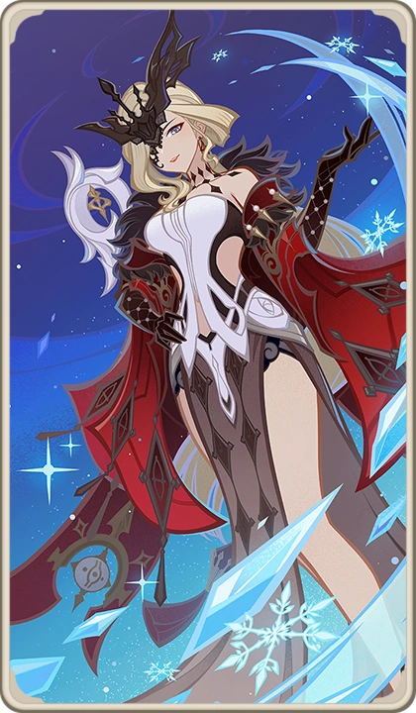
This question was easily answered with a change of clothing. All of her menswear disappeared, not leaving her naked but instead decorating her in something that not only fit her but made it obvious to the one wearing them who she had become. This included a black half-mask over her right eye and a diamond-patterned choker around her neck. Black earrings hung from her ears, matching studded black gloves and a crimson cape that hung off her shoulders. That coat was open to reveal a sleeveless, white gown with cutouts around the sides of her tummy and even her bellybutton too. This gown had black cloth than hung over her ass and pelvis, but her legs? They were essentially bare, showing off her shapely thighs above high heeled footwear.

“I’m Rosalyne? How in the world is this possible!?” She appeared and acted the part of La Signora, one of the Fatui Harbingers found within the story of Genshin, and yet the woman’s memories still belonged to her past life. Every movement she made felt both familiar and not as her new curvature shifted contributing to this strange sensation on her part that everything was as it should be, yet simultaneously wasn’t.

But the woman’s concerns changed she stepped a heel down in front of her. The moment she did? She found she couldn’t lift that foot again and a blue light radiated from her heel. “Hm?” La Signora was confused. She had already been changed, so what else could be happening? For a brief moment she was able to catch the sight of the light’s source. It looked like a… playing card? “What is happening now!?”

She hissed as her eyes were torn away from the card against her will. In fact much of her body froze up and was twisted into a brand new pose. One foot vaguely in front of the other, one hand on her hip while the other was lifted with her palm pointed to the ceiling. It was troubling and unsettling, and she hadn’t even noticed that the way the lighting hit her body suggested she was no longer a 3D object but a 2D existence. She could only smirk against her will as the shining light absorbed her…

And she was trapped completely immobile in the card on the floor.

“Where did this card come from?” Sitting at his desk while working, Axel had gone to reach for his glass of water without looking when he not only found himself struggling to grab his beverage, but desperately searching fingers had instead moved a piece of paper that hadn’t been there before instead. It had been a playing card. “Isn’t this one of those cards from Genshin?” Well he knew the answer to that question. It featured art of La Signora after all.

But that didn’t change his concerns about where it had come from, namely because much like the woman trapped within the card itself his memories of the one feline who could conjure things into his room had been subdued. He merely turned the card over several times to examine it, wholly unaware that his friend was actually trapped inside. “It’s a good looking card. Too bad it’s presence here is sketchy at best…”

And he’d soon learn that hunch of his was correct.

Immediately, in fact. Axel sharply inhaled like he had just been winded and from his perspective? He honestly wondered if he had been for a moment. It caused him to stand up from his chair in a panic, not thinking about how odd it was that his pants and boxers slipped off from the motion. He was a bigger guy, after all, and there was hardly ever a situation where his clothing was too big for him. It was usually the other way around!

But he just as quickly realized that he wasn’t winded and exhaled. His shirt slipped over to one shoulder in the process, finally giving him a reason to look down at himself and— “HOLY SHIT!?” A lot made sense all of a sudden as it was related to what he had felt in the past fifteen seconds or so. The tension he had felt but have been a sudden and intense suction, because looking down?

How else could his weight have dropped from nearly 300lbs to what was likely a mere 150lbs? All of that extra mass was gone, which explained why his pants and underwear had slid off, and not only was he thin but any stretchmarks or comparable deficiencies that weight loss usually came with just were nowhere to be seen. But with his shirt in the way he couldn’t even see just how thin his waist had become, sliding in to create the beginning of an hourglass figure.

And that beginning was expanded up. “This is… How could…? Hey!?” Axel’s knees buckled, adding to his distress thanks to hips jutting a few inches wider in their reach. His skin was softening in the meantime, any unneeded body hair being shaved away so that his skin was silky smooth. Yet any hair that ultimately remained? Pubes, brows, the hair atop his head… it was all bleached until it was white. And at least regarding the hair on his head’s top? It spilled out in length, reaching well past his shoulders.

“Eep!?” As someone who didn’t grow his hair out it was only natural that he’d be surprised at the sensation of that hair tickling his exposed neck. But the short scream that had jumped from his lips was certainly more maidenly. It held a deepness to it, but it was more like the deep voice of a woman instead of a man. Which, looking at his face, made a great deal of sense.

Cheeks had already naturally thinned as a result of his sudden and dramatic weight loss, but that didn’t explain why his cheekbones had risen or why his jawline had narrowed. This definitely gave his face a much more androgynous appearance that was soon capitalized on by a swelling of lips that were soon painted blue and a narrowing of eyes – eyes that paled in color until they were a snowy white while simultaneously encapsulating a ferocious feminine slant. This was now the face of a gorgeous woman in her early thirties.

“My hair, my voice…” Axel couldn’t see his face of course, but he could feel how full his lips were with a brush of a finger that was now pointedly thinner and even bore lengthened nails. “Am I becoming a woman!?” But why a woman with white hair? The only thing he had interacted with was that Signora card but she didn’t have white hair. And not that there needed to be more evidence that she wasn’t who he was becoming, but his near six foot height didn’t change at all.

But of course that didn’t mean that his figure overall would no longer change. Weight that pooled beneath his shirt sure saw to it that that was the case, his posture passively tilting forward more and more as what blossomed upon his chest other than a pair of… tits? “I… What!? I have boobs, and yet…?” Something was a little more off with Axel’s mind than had been the case with Joseph. Owed to the vague identity of the ’character’ he was becoming, it felt increasingly difficult to identify what should or shouldn’t have been wrong with his body.

His new F-cup breasts, perky nipples and all, were just as much a part of this confusion as an ass that swelled into a perky heart shape. It protruded behind him in a way that lifted his shirt, porcelain cheeks just asking to be given a good squeeze or slap. And of course his thighs weren’t far behind when it came to absolute thiccness, that ample gap left by widened thighs soon filled by plush upper legs that touched each other gingerly in the center. Yet oddly enough? They didn’t crush her…

Wait. If she was a woman then there shouldn’t have been anything to crush, right? “No… Am I not supposed to be a woman? But my post is only for women…” Her sex aside, she wasn’t even sure what she meant by this. Wasn’t her job simply to write? No, it almost felt as if her life had been reserved for something far greater. Almost like they were doing so to give Axel that clarity that she sought? Her outfit changed to finalize any visual shifting.
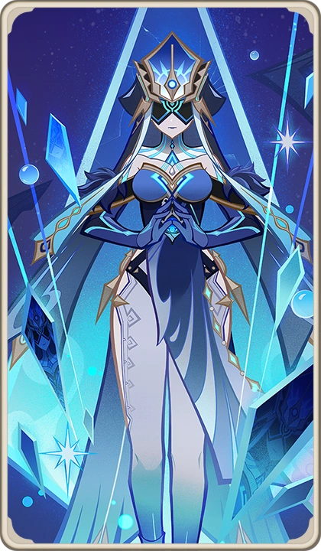
Leaving her in a blue top with dark, fluffy sleeves that were attached at the breast. Fabric from the top fell over her ass and pelvis similar to Signora’s outfit, but rather than keep her legs bare she now wore tight, white paints with thighs and hips bare thanks to strategically placed slits. She had blue gloves, heels, and a neckpiece that had baby blue lines running up her neck and collar bones. But what was perhaps the most striking was the big hat atop her head. All of her hair had been tied into a bun beneath it while a black veil covered her eyes. And yet it was transparent enough that she could still see through it.

There was something oddly calming about wearing it all.

The Mirror Maiden stood there in awe, her mind far more jumbled than Signora’s had been at the end of her transformation. She was largely concerned because she couldn’t recall her name. “What was it? Who am I?” Because she had been modeled after an NPC enemy class in the game there was no real identity attached to her new body. She was just a loyal yet attractive woman soldier, even though deep down she knew she hadn’t been one moments ago.

That was when she noticed the card on the desk again. “La Signora…” Her cheeks flushed a little pink. Right, she was working under La Signora’s orders, wasn’t she? She was strong and beautiful, not to mention kind to her underlings. She was just the sort of boss any woman could have hoped for. It gave her the slightest shred of clarity. “But no… I’m not supposed to—” The Mirror Maiden clutched the chest to her chest as she walked around.

But she was forced to eventually look down as her heel came down on what appeared to be a blank card cut in the same style as the one she was holding. It glowed with a blue light and she was forced to drop the Signora card as her body began to stiffen and move against its will. “Ah!?” As much as she wanted to reach out to grab the card, the Mirror Maiden’s hands were intertwined beneath her chest as if she were in prayer. Her posture straightened, her elbows swung out to the side, and she made a solemn face as she too became a 2D existence.

Once that was absorbed into a card so that both fell side by side.

But this time? A pair of small hands reached down to pick them up. “Well I guess that worked! Bet neither of you were probably expecting to be turned into playing cards today, huh?” Red-furred cat ears twitched atop the child’s head as two tails swished about behind her. Hisa admired her handiwork, well aware that the women trapped within the cards she was holding could see her as well as hear what she was saying. “But look on the bright side! You’re both so pretty!”

Surely neither La Signora nor the Mirror Maiden were looking on the bright side as their memories of Hisa returned. But it was too late. They were powerless to do anything about their current fate if they couldn’t even speak, much less move. “And now I don’t need to do those stupid battles to get these cards! Score!” The child giggled, unsettlingly.

At the very least she had provided them a small mercy. That while still within the borders of the cards that held them, they would be able to move and talk in the future.

But only when they were in play during a game…

