ANDROID ANIME DEBUT
BIWEEKLY STORY #85
BY CHALDEACHANGE
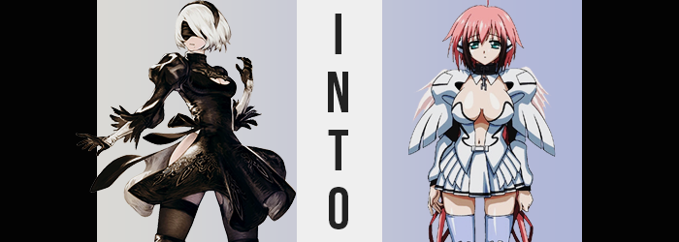

The life of a YoRHa android was not an easy one, and yet it was the only life that this android knew.

She had been created for the sake of her own mission. Follow orders, suppress your emotions, do not question the state of the world around you. It was an existence that was simple in nature, but only because YoRHa No. 2 Type-B strictly followed her orders. Had she ever wondered if the nature of this world might be flawed? Different from what she was being told in some very dramatic ways?

Of course the thought had crossed her mind, but who was she to question it? Just how many machine lifeforms had she killed at this point? It was simpler just to go along with orders and not dwell upon the ramifications of what she had done. And to those ends? 2B had found herself wandering a long abandoned mall that afternoon. Or, at least, that was what her data banks told her that this building had been called long ago.

Her make of android had never had the privilege of living alongside humans. Long ago they fled to the moon to escape the threat of the machine lifeforms, and ever since? YoRHa had been doing their bidding so that they might one day return. And so any information they had on the ways of the humans that had once lived on Earth had been relegated to information packets they could access whenever necessary.

“I see. So this was a center for shopping? That is why there are so many different shops about.” She could recognize stores based on their signs and product displays, but time had clearly crept into this facility. Walls were crumbling, and vines and various other plant life paved the halls and counters. She doubted that much in this building was usable nor worked in the case of what were surely ancient electronic devices.
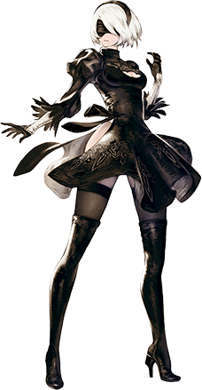
As she walked past a display of monitors behind a glass window, however? Something that betrayed this assumption forced a pause from her. “Hm?” One of the screens had turned on and was briefly displaying static. “This is a television, isn’t it?” Based on the store name, TV World, this absolutely appeared to be the case. And while it showed static for a moment, it suddenly changed to show a very colorful scene.

A town? A song was playing? Vibrant colors lit up as well. She didn’t have the knowledge to know that this was an old anime, but for some reason she couldn’t take her eyes off of it. Likely because she had never seen anything like it before in her life. But she didn’t realize just how absorbed she was getting into it.

Like… literally absorbed into it.

And before she knew it, she was standing in the middle of a colorful bedroom of human make. Yet it hadn’t been touched at all by time like the rest of her world had been. “Erm…?” Her visor didn’t appear to be functioning correctly, either. Almost like it was no longer compatible with her eyes? But that certainly couldn’t be the case. Or at least she would have liked to think that it couldn’t be the case, yet it very much was.

You see, an android like 2B did not belong in this world. But this would did have androids of a different sort, and so it was simply a matter of assimilation. The fact that her visor wasn’t working? It was a compatibility issue. One born from the fact that her eyes, beneath said visor, were not of the same make or appearance as they had been before. In fact, not only had those eyes grown dramatically larger, but the color of the lenses had turned from an icy blue to a greenish teal. Something about them, though? They almost looked tired. Or at the very least? Disinterested.

And thus began a process that would affect every aspect of the android’s build. Her eyes had been part of it, but a surplus of color was quick to reveal that it wasn’t something that would ultimately be isolated to her optics alone. For hair that had been designed to be entirely white, the emergence of a pastel pink amongst the highest of the locks most certainly looked out of place. Even more so as any hair that was dyed in these colors seemed to lengthen in slight, with an ahoge popping up from her head’s peak.

That said, some of it grew much, much longer in the back, with thin bunches reaching as far as the android’s ankles. And the hair on the sides of her head? While lengthening so that it properly framed her features, it also darkened past pink towards a brown that gave her shaggier hairdo a multi-layered appearance.

“Something isn’t right with my… programming…” A distortion in her voice box found the hum of her voice turning even more monotonous than it normally was. While 2B always spoke in a dry manner, she at least had some force behind her words. That force seemed to be melting away as she grappled with the fact that something had clearly begun to tamper with her systems. Ever since she had arrived in this unfamiliar place. In Tomoki’s house. “…What? Where did this data…?”

The vocal distortion was quickly becoming more common, but 2B herself was fixated on the data stored within her memory banks. Not only was some of it missing, but there was data that didn’t belong as well. It gave her an increased familiarity with her surroundings, and there were other memories in there that didn’t match up with what they had before. Such as being activated, found by a human boy… It didn’t make sense but made total sense simultaneously.

It all rendered the android stunned, at least momentarily. Her processor couldn’t quite comprehend what was happening, and a Logic Virus felt like the most plausible cause. Nonetheless, it left her mind in a momentary hang-up while her body continued to go through its new motions.

Motions that seemingly began to have more profound effects than simply dyeing her hair and slightly changing its length. This was plenty evident around the woman’s bust. Because the bust in question was swelling much, well, bustier. The cleavage window of her dress was rapidly stretching because it had no choice, for the mounds beneath continued to expand until they finally tore through the window altogether. Now free, they bounced along with her pink nipples at sizes that were practically comparable to 2B’s head.

Yet the android did not bat an eyelash at the fact that her tits were not only huge but were now totally exposed. She was still rendered in a stupor by changes to her memory banks that were becoming dramatically more intense, practically erasing her purpose, and presenting her a new one. Such dramatic changes would ultimately require a reboot, but that was something to be saved for when she was finished changing.

And she was gradually getting closer to that point. Something about the woman’s overall appearance looked meatier, and that wasn’t meant in a bad sense. Her bombastic bosom was just the beginning, for a thickness beset her torso that preserved her hourglass figure while leaving her looking softer. Even the wide gait of her hips was preserved, but her thighs? They didn’t exactly grow, and instead did the opposite. They actually thinned in slight so that they weren’t so terribly bombastic, with knees buckling in the center a little less so as a result. That didn’t mean they weren’t still thick and meaty, but they certainly weren’t as abundant as they had been prior.

2B’s face appeared to fill out a little, although the visor across half of it made it difficult to see. What could be seen was how her lips grew plumper and her nose a little smaller by contrast, overall presenting her with a much smaller visage upon a slightly rounded face. Even the beauty mark under the android’s lip faded away. “I… need… to… Tomo…?”

Those were the last words she uttered before her systems shut down, prompting a reboot that would span almost a minute. During that minute, however? Her YoRHa uniform lightened in color so that it was mostly white, before the cloth wriggled around to cover her body in a different ensemble altogether. It covered her breasts at least, but only the tips for everything else, including her navel was exposed, while below a short, frilled skirt was fashioned.

There were also pauldrons on her shoulders and boots across her feet that seemed armored. While around her ears, something like a pair of triangular earmuffs or headphones coated them. Her real ears simply disappeared with their functions overwritten by these cones. Teal eyes completely exposed, the world around her came back to life clearly as the rebooting command reached its pinnacle.

But not before a pair of small, pink, feathered wings grew out from the backs of her shoulders. Almost like she was an angel. An angel android.

An Angeloid.

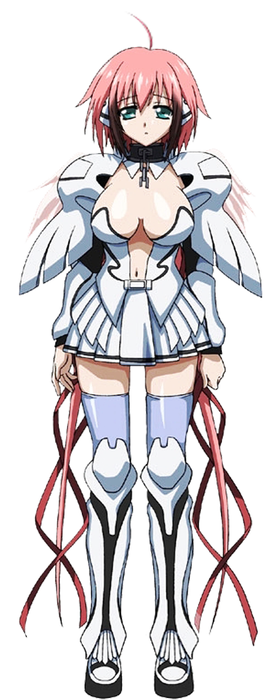
If 2B had been emotionless by definition before, than the woman she had became was extremely emotionless. As 2B she had simply been burying emotions she naturally possessed. As Ikaros? She hardly seemed to be capable of grasping what an emotion was, much less how to properly express them. As a result, her resting expression almost appeared to be tired and disinterested, despite how her body had been remade into something else. She was still very much an android, but of a much different make.

“Tomoki? I need to see Tomoki…” Rather than being bound to a faceless organization, thinking back to who she served, Ikaros could only think of a human boy that lived in the room beside hers. He was her master, and she would follow him to the ends of the Earth. Such was the existence her programming defined for her. While it wasn’t a very good scenario for an android created to liberate humanity…

It sure made for an interesting anime plot, huh?

