DESIRE FOR HIRE
FEBRUARY 2021 REQUEST STORY
BY CHALDEACHANGE
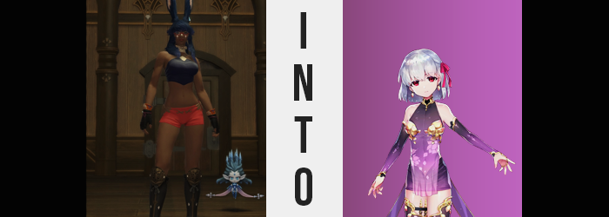

“This… is an unusual job.” Iona had been thinking it for a while now, but it wasn’t until the one who had requested it had gone off on her merry way that the Viera thought to express as much vocally. She’d taken the quest under the assumption that it would just be your regular busywork, but in the end? “I have to sample all of these? Am I going to be able to smell anything by the time this is over!?”

She spared a glance at a box that had been set aside for her in the backroom of this little apothecary. It was filled with tiny pouches, each apparently containing healing herbs… and yet it wasn’t so simple. Falsifying herbs had become a pretty cohesive scheme with the underground these days, and apparently the owner of the apothecary was concerned she was being slipped fakes. The issue was that if a customer used a healing potion that had been made with these fakes, there were major risks to their health. It was also a time consuming endeavor, so she’d needed to bring in help.

A shame that this fell on Valentione’s Day. It wasn’t exactly what she wanted to spend her holiday doing… not that she specifically had anyone she wished to spend this day or romance with anyways.

All of Iona’s worries about the process, however? They met confusion the moment she’d lifted the first pouch. “Huh? Why is this…” So heavy? Herbs were, naturally, light. But it felt like there was a stone in this bag… and there was. Removing the object she found inside, it had been a beautiful, purple gemstone modeled in the shape of a flower she could not identify.

It was a lotus.

The dark-skinned Viera held it in her right palm, looking down at it with skepticism. Was this a real gemstone? Had someone been attempting to smuggle it in with the herb shipment? Did it end up here accidentally? She couldn’t be sure, and she wasn’t exactly sure how she was going to raise this to the apothecary who had hired her services either. Iona knew the best thing to do would be to turn it into the authorities and have them deal with it, but greed was a powerful drug.

What if the shopkeeper sought to keep it for herself? Were this smuggled, it was possible she could become a target of whomever had been smuggling it in the first place. “What should I—” Her question was interrupted and the need for a solution removed, however, as with a bright glow the lotus gem seemed to disappear entirely. “H-Huh!?”

But it hadn’t gone anywhere. Rather, it had planted itself within the Viera. A core meant to summon the power not that unlike that of a Primal into a flesh host… at the cost of that host’s identity.

“That’s odd. It couldn’t have just gone n-nowhere, right?” Sheepish as always, Iona looked from side to side within the small room to make sure she hadn’t just misplaced it somehow. She wasn’t exactly sure how that could be possible, all things considered, but she had to rule it out for sure, right? But of course, it hadn’t left her at all.

Wearing a sleeveless top that likewise exposed her midriff, it had taken root in one of the few places she wouldn’t be able to see. That is, on top of her heart, imprinted against her dark, left breast, a pale lotus flower tattoo had taken shape. Incidentally, it overlapped with her nipple and had turned it a bright pink, which was a little odd for a tattoo. But it wasn’t really a tattoo either, as it was quick to demonstrate.

Well, unless tattoos typically began to seep further into one’s skin, as was the case here. While only a finite amount of space had been painted atop her bosom at first, the pale lotus flower marking began to grow, spreading out in every direction, dyeing more of her skin until its shape was completely lost.

It spread across her flesh at a heightened pace, pale skin eventually peeking out from beneath her top and finding its way across her arms and down her back and belly. Her second nipple became just as pink as the first, and beneath her shorts? Even her pussy brightened in tone just as it ate away at the darker tone of her thighs and reach all of the way down to her tootsies. Naturally, her face wasn’t spared either, and before long her complexion in its entirety was far paler by comparison.

But even if Eorzeans had possessed an understand of what the word ‘Caucasian’ meant; this wasn’t exactly the term that could be best used to describe the rabbit woman’s new appearance. No, as change began to seep into her facial features, it was clear that her ‘race’ (in the loosest sense of the word, since it had a different meaning in a world populated by fantasy races) best resembled a native of Doman. Her eyes pinched thinner at the sides, giving them a much more almond-like shape when compared to the rounder designs that they’d sported just before. Even their colors flickered to new life, an almost eerie crimson claiming her irises.

This red was accompanied by a sudden sour feeling, and Iona’s expression was forced into a scowl in no small part because she’d caught sight of the skin on her arm. “The hell!?”, she groaned in a far more disgruntled tone than she’d ever cared to in the past. The Viera was a kind yet withdrawn woman, she wasn’t one to lash out even when surprised. But she’d been set off somehow, for some reason. “What happened to my skin!?”

Although, if she was shocked by her skin color, she absolutely should have seen her own face. Eyes aside, her features had seemingly been shuffled in design. Lips were plumper and glossier, and her nose was small and rounded (as opposed to taking the flatter tops many Viera were known for). Even her cheeks sported a softer glow with designs that seemed almost… plumper somehow. Her face appeared more youthful than the rest of her body in a strange way.

It was around this time that she suddenly became very receptive to something. The feeling was a strange one, like a sickening sweetness attacking her from all directions, seeping into her soul and making her skin crawl. Most would have found this feeling to be a fond one, surely, but something about Iona’s disposition as it was rejected the feeling outright. “Ugh…”, she grumbled almost instinctively.

That didn’t change that the lotus gemstone was continuing to have an influence on her body, of course. Strands of her dark blue had taken on an almost sickly purple tone, and that color was quick to spread just as the whiteness that had claimed her one darker complexion. Before long, her entire head had been dyed, creating a contrast with the color of her flesh that was far more subtly, although the crimson of her eyes stood out all the more readily. The bulk of this mane was cut at her shoulders as if waned by an invisible razor, the excess fluttering down towards the ground where it disappeared outright. Otherwise? The hairs atop her head had become much finer and straighter, the bob cut she now sported neat and tidy.

But strangely enough? Her Viera ears kept their blue fur. This was because those ears weren’t longed for this world if the growth stretching out from the sides of her head were any indicator. Regular, Hyur ears were quick to take shape on these side, while the bunny-like pair atop her head? They were pulled downward, fur disappearing into their skin before being completely absorbed by her scalp. She made a convincing enough Hyur now.

“Ngh! Enough! I don’t want to deal with these feelings, they’re annoying!” She continued to lash out at the forces penetrating her body from all ends, and the more she was subjected to their onslaught, the more she realized what they were. Feelings of love. Not directed at her, but for some reason her very existence could resonate with them. Love made her stomach churn, even though Iona had never considered it much in the past. These feelings of her own, this hatred, it was far too intense.

The angrier she grew though, the less of the woman there appeared to be. She’d yet to realize, but her point of view was rapidly diminishing, so much that her shorts were sliding down her legs and her top was hanging loosely from her torso. It wasn’t until her shorts fell from her legs completely, undergarments the only thing left to conceal her special area, that she final realized. “Hya!?” Her voice was far squeakier, so much that the childish design of her new face made perfect sense in retrospect.

Her abundant Viera height had been stolen from her along with her age, and now she looked like a girl around the age of twelve or thirteen, standing at around only five feet in height with a figure that showed promise but was otherwise lacking. Her hands were small, fingernails painted in pink, and her clothing? It hung off of her by the skin of her teeth, even the slightest of movements enough to risk the fragile balance coming undone.

She was even more sensitive to the feelings of love that swirled around now, but Ioma pushed those thoughts aside for the time being “At least give me something proper to wear, damnit!” A snap of her fingers saw the clothing both around her and pooled at her feet dissipate into golden particles, leaving her naked for half a moment as they swirled around her. Shortly after though? They reconverged against her bare skin, reforming into a see-through, purple dress with golden petal clasps around her chest, a pair of dark purple shorts evident around her legs while similarly colored detached sleeves and footless leggings saw to it that her limbs were covered. The piece de resistance was a dark pink ribbon that found its way tied into the left side of her hair, golden earrings dangling from her ears.

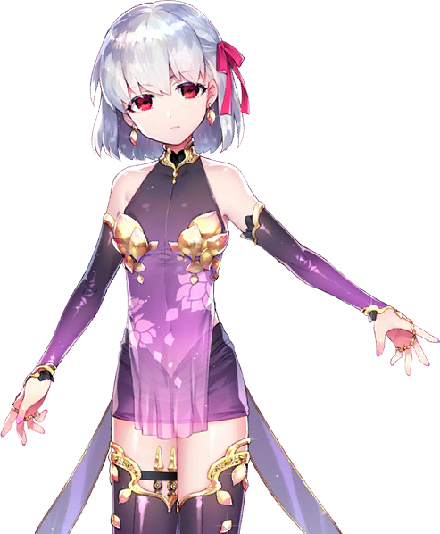
“Better.” Koma seemed quite proud of herself, hands planted on her tiny hips as she did her best to continue ignoring the feelings of love assaulting her from all directions. Why the hell was everyone so lovey dovey today!? She’d forgotten that it was St. Valentione’s Day, but that could be forgiven. After all, her memories had slowly been swapped out for different ones. Forget the day, Kama didn’t even know where she was.

The child growled, taking in the surroundings of the apothecary. “This place looks pretty shitty though. Can’t see anything from here. Guess I need to go outside.” Not that it mattered. Walls or no walls, she could still feel those unsavory desires bleeding in, assaulting her from all fronts. She was the God of Love after all, how could she not be privy to such things?

After escaping the shop, Kama spent much of the rest of Valentione’s Day perched above the city proper. The concept of love itself was enough to churn her stomach, much less how intensive the feelings that swelled around that city were that day because of the holiday proper. “Gross. Disgusting. I want to die.” She spat over the edge of the building she was resting on, her saliva hitting the top of the head of Viera woman down below that was spending time with her Miqo’te girlfriend. They appeared distraught.

Good.

As much as she loathed others loving each other, however, it was in part because of spite. Kama did not love herself, but to be happy with someone else, like all of those people below were? That was actually what she wanted, and she couldn’t stop thinking about it. But considering she was in the form of a child, no one was going to love her that way!

“…I wonder if I can trick a couple into giving me candy?”

Might as well get something out of this.

