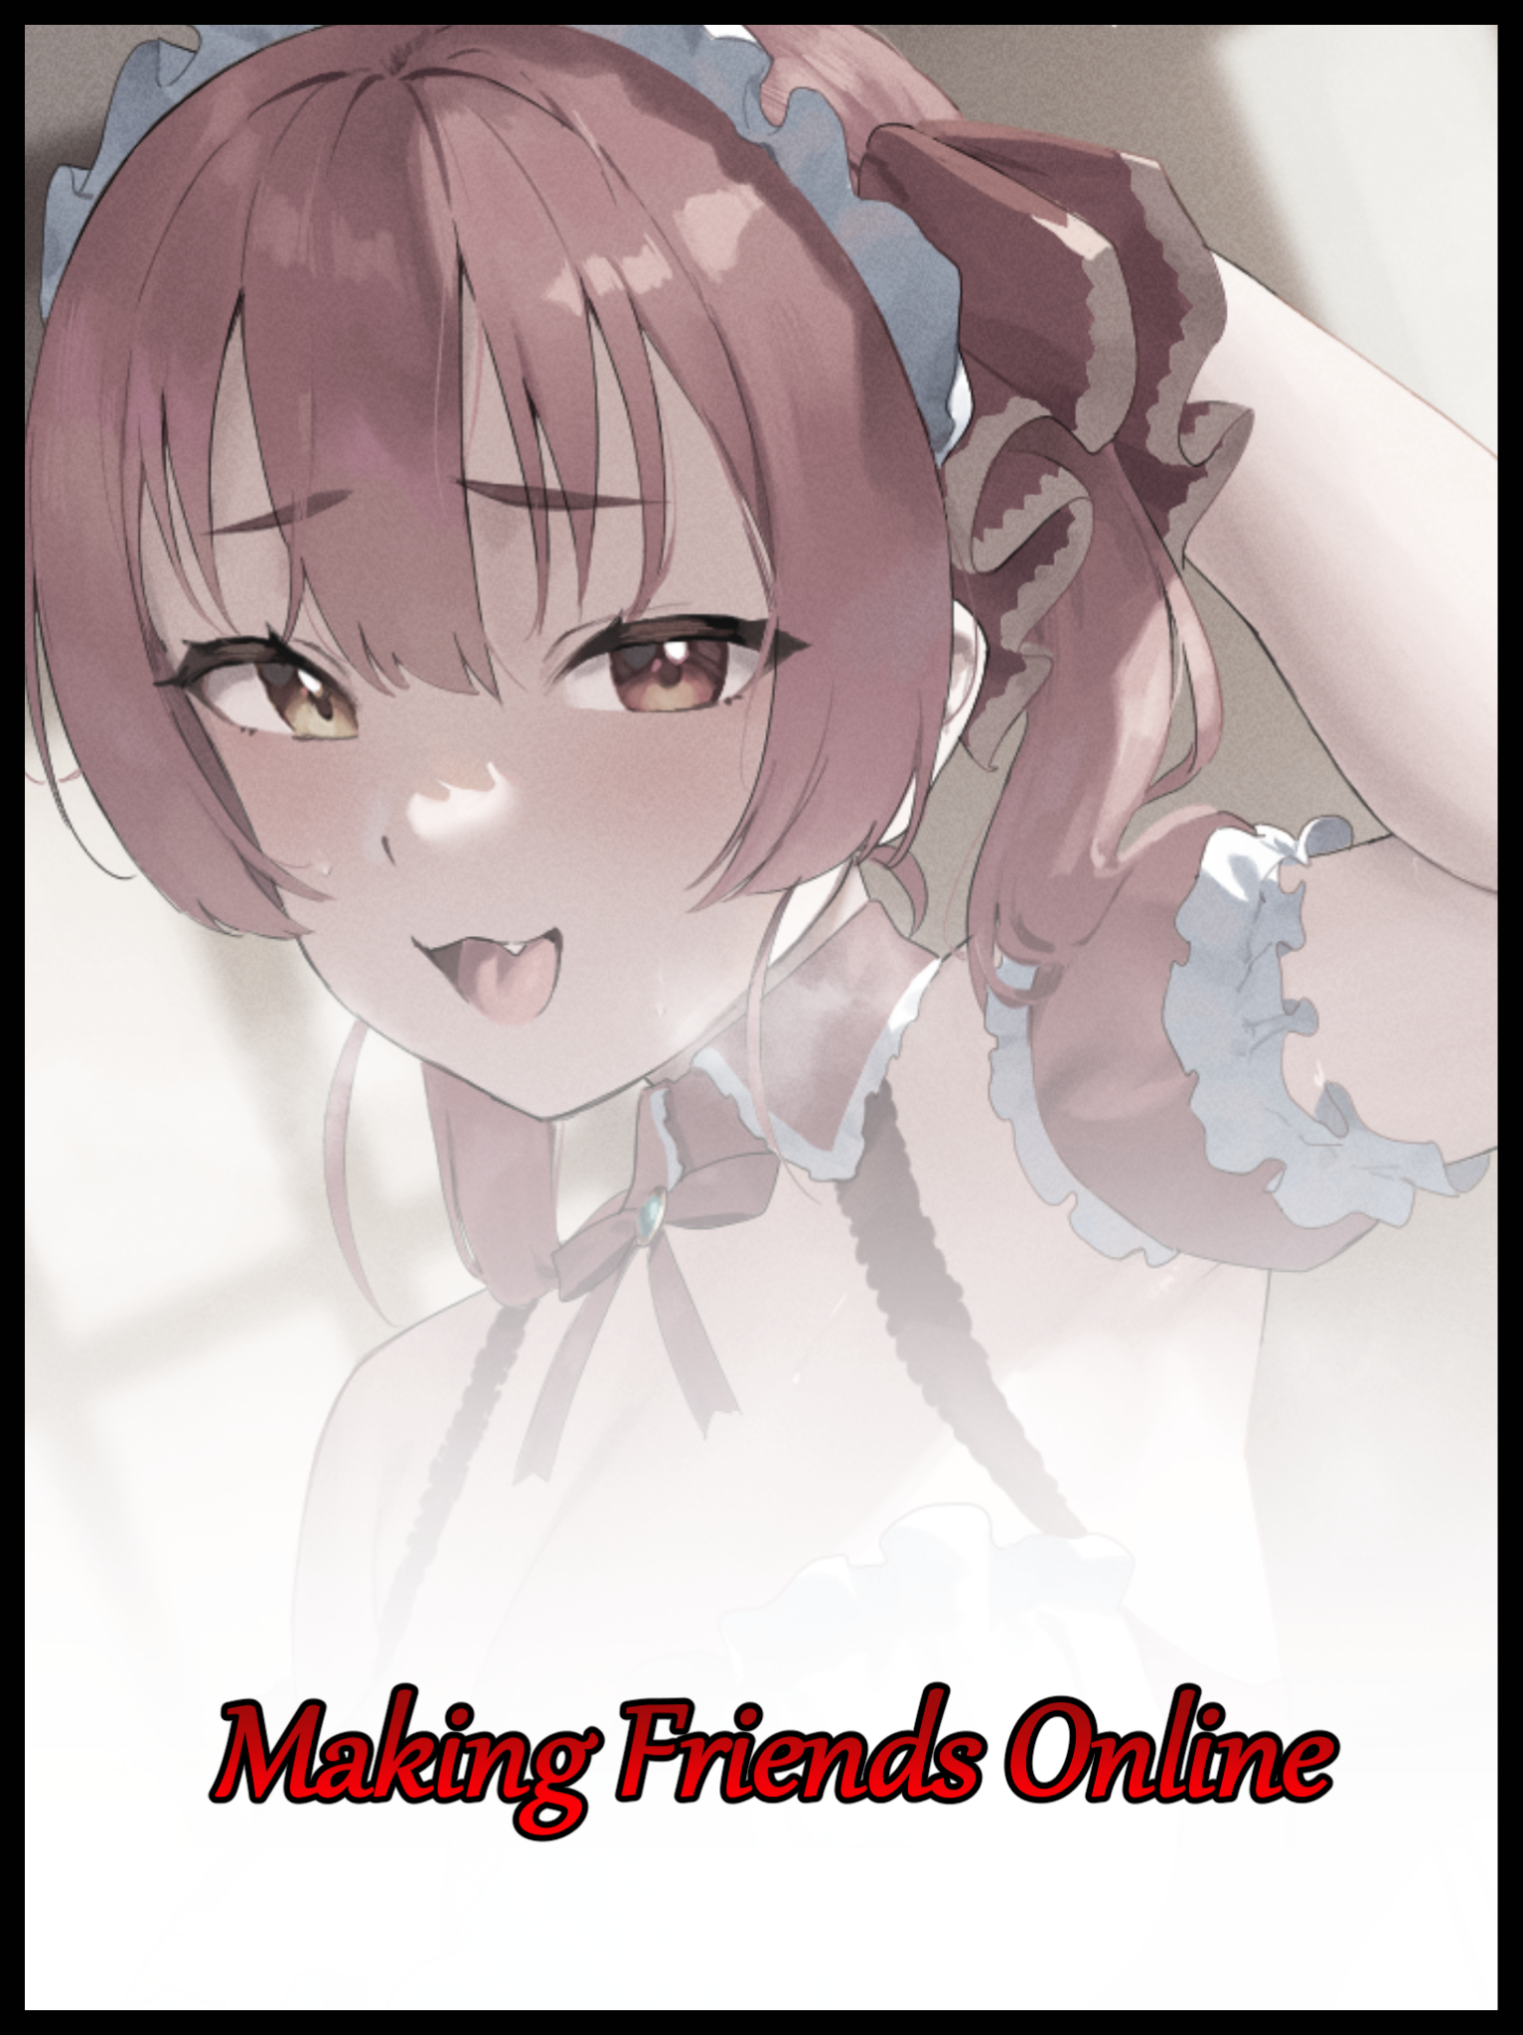

The world of online streaming was a harsh, competitive space where only the most prominent figureheads could hope to survive and remain in relevancy. A cherished position not even the major players were guaranteed to hog forever when there were plenty of instances where the high and mighty had been kicked off their thrones atop the daunting pyramid with only a small handful amongst the unfortunates who could ever claim to have left on their own accord, leaving new spots in the meat grinder open for new blood to settle in before leaving all the same at some point or another down the line.

To those who couldn’t be bothered about achieving viewer retention and top spots however, streaming was something more akin to a passionate hobby instead of a full-time career. A distraction to lose themselves in, to forget the stresses of the real world and anything else that might plague them on a day-to-day basis. Just as long as they had a soul or two tuning in to whatever it was they might be broadcasting to the world with the occasional conversation, that was more than enough.

Unfortunately for those humble few however, rotten eggs of the sort no one besides those drawn from the same thread would ever associate themselves with were always close by. Individuals whose presence in any community no matter the reputation was all but certain. Cretinous minds always on the lookout for the next unwitting target to focus their impish efforts on as if there was nothing better to do on their hands. A statement applicable to most of the degenerate souls willingly participating in such tomfoolery; choosing to spend their days stuck behind a monitor hurling insults and other terrible remarks, most often towards those who were just looking to have a relaxing time online. Harassing them with choice insults and derogatory terms aimed at chasing their victims off the respective platforms they terrorized, returning again and again through proxy accounts that mattered little to the perpetrator as if they were a festering wound that refused to go away no matter what.

But the effects of such harassment extended far beyond the limits of the digital world, with more ‘fragile’ individuals suffering from long-term mental harm and other related off-shoots stemming from harassment. A terrible outcome people like Darren Ermans cared little about while having their bit of fun online, for as long as they were happy, empathy for their victims mattered little. Simply moving on to the next unsuspecting target after breaking down the poor soul whose only crime had been to fall under the notice of such apathetic monsters who derived pleasure from the suffering of others to fill the irreparable hole they themselves had gouged into their own blackened hearts by choice or otherwise.

No matter how bleak or uncontrollable their respective backstories were, what they did to cope with their past was still an unacceptable thing. And for the more prolific figures amongst the scum of the net, Darren had done too much for his degeneracy to be passed off. For no one besides the holiest amongst men would ever be able to find it in themselves to forgive a narcissist with an innate hatred for anything that wasn’t himself.

Born into a family who could not be blamed for his eventual regression later in life, Darren for the most part had complete control over his life; living in a home with loving parents, kind siblings and a handful of trustworthy friends. But when the time came to lean on the supporting figures he had come to know and love, Darren had hid himself away. Keeping the wounds, both figurative and literal, hidden away without anyone’s notice besides old classmates who were far too young then to know what the best course of action would’ve been besides ratting on the bullies to insensate teachers who couldn’t have cared less about what the annoying brats under their charge were up to. A negative view Darren himself would soon adopt at the tail end of his metamorphosis from innocent boy to loathsome cretin, the first step of which would take place after weeks of being subject to the bullies idea of playtime. With the young boy lashing out at his tormentors without a clear head in the game to think about the repercussions of resorting to violence as a means to an end.

Most bullies would've moved on if their target was as unresponsive as a sack of potatoes being nudged around with only a few instances where the perpetrators would double down on their efforts in an attempt to reach that glorious feeling of release everytime their victims broke down or attempted to fight back against their dominion. Darren’s friends knew that fact well, influencing their decision to let things be and hope their tormentors would move on before long once they got bored.

Darren however, saw no other alternative but to engage the scum. Feeding into his own insecurities while they continued to gloat and boast, hoping to escalate things so they could bring the fool down that much harder when the time came to deliver the finishing blow as most bullies tended to once enough had been said and the time came for their fists to do the rest.

Ultimately, the ‘big release’ the bullies yearned for would never come. Not when the unsuspecting boy they had chosen to vent their frustrations upon had turned out to be far too much for them to handle after push had come to shove and the fighting began. Showcasing a live demonstration as to why looks weren’t the end all be all when it came to judging the victor of a fight. One that had left the triumphant boys in a sniveling mess once Darren was done ‘showing them the error of their ways’, as he would calmly quote when asked about his reasons behind bloodying up three of his fellow classmates. And when those who witnessed the one-sided brawl were left far too afraid of Darren to say anything in his defense when the one-sided lies began to pour from the humiliated trios misshapen lips…

Maybe things could have played out differently if Darren had been taught to better control himself when it came to such precarious situations where blame could easily be shifted from one end of the conflict to the other at a moment’s notice, or if he’d just explained things better, things wouldn't have turned out the way they did. But it was all moot, just hopeful thinking and what-ifs to busy the mind with. For even if he could bring up worthy evidence of the bullies outlandish behavior, nothing could clear his name as the one who had dealt a beating so severe one of the boys was said to have suffered a fracture or two that could lead to further complications further down the line if they failed to heal properly. Something the bully's parents were obviously quick to capitalize on when the time came for the final verdict to be decided on.

And to the boy at the heart of it all, there had been no greater injustice suffered than being labeled a villain for standing up to the enemy. Unable to see reason and how his brashness was partly responsible for shaping the outcome, because how could he when boyhood fantasies and childhood experiences told him otherwise? To do good meant he had to stand up for others, just like the heroes in comic books and TV shows. So why was he being punished for doing the same? Why did he have to move schools while the thugs didn't after so many months of them getting away scot-free doing the heinous things they did?

Unfair. Ridiculous. Evil. Darren would simmer with his thoughts in a vile broth formed from the hatred he had begun to harbor from that moment onward, becoming a shadow of his cheerfully naive former self after reaffirming himself in the ill-advised belief that no one was truly there for him after something inside of him had broken apart upon seeing the faces of those he had thought to be friends and family. Becoming a social outcast with no particularly distinguishing attributes to call his own besides an incredible hatred for the world nurtured by the following years Darren had spent away from those who had been by his side until the incident in middle school had left him a broken husk, never to place his trust in anyone ever again. Even if it meant cutting the many connections he had already established in such a short span of time, including his mother and father.

Fast forward a few tumultuous years, and Darren's ruination had been all but complete. Leeching off his parent's goodwill after graduating from highschool with middling scores and a lack of enthusiasm for life moving forward, the man had lost all hint of ever being the bright eyed brunette haired child seen in the few photos scattered around the depressive household. Adopting what many of the uninitiated would simply call 'emo' at first glance. The signature, brooding aesthetic of goth fashion and one Darren felt resonated strongly with his being, making a mockery of himself online when attempts to prove his 'maturity' ended in utter failure when met with the blunt reception of the internet's denizens. A middling reception that only served to cement the arrogant youth's belief that he was right and how everyone else was just an ignorant hater, such was the echo chamber he had shut himself in ever since. Wasting away his days becoming a literal keyboard warrior who, like the ones who had set him on this ruinous path, found joy in going after others to spread his misery to. And nothing piqued his interest quite like the streaming service had…

Because no other method allowed for him to view his target's reaction live while he tormented them with atrocious spam and malevolent private messages. Taking in their voices as they claimed to be unfazed despite the discomfort and hurt apparent in their eyes and faces. Adoring the empty threats sent his way knowing nothing would ever come of it from the safety of his dark room and getting off to those who thought him easy to brush off, returning through ban after gan like an incessant mosquito until they took their streams offline before delighting in the act. Petulant behavior that unsurprisingly meant Darren had accrued numerous foes over the last two years since he had taken refuge within the shadowy confines of his rank bedroom.

And while most of these antagonized individuals had no other means besides messages and the flawed report system to spite him, a select few had access to methods which would allow them to hit Darren where it really mattered; in the flesh. But there would be no slap on the wrist lying in wait for the moody cretin and no prior warning for the fate that was about to befall him, learning for the last time just how cold reality could be after he had unknowingly picked on the worst person imaginable. One with connections to the sort of people with the power to make certain things ‘happen’, and on a humid weekend morning where the sun was nice and bright. The perfect outcome of the dastardly plan that had already been kicked into motion the instant Darren had logged into his desktop would soon take shape within the Ermans’ household, a plan that would see justice served and a broken family restored through the most debauched means beyond human comprehension. A process that shows itself through a gradual lengthening of the nails that tipped speedy fingers blitzing across the keyboard, producing less noise once the claw-like extensions painted entirely black had trimmed themselves down to a more appropriate length. Extending just a tad beyond the boundaries of sleeker fingers that had also undergone silent alterations of their own; discarding excess mass and shedding pale, cracked skin to form a feminine silhouette moving too fast for the naked eye to catch a glimpse of darkness giving way to light as a new shade of strawberry supersedes Darren’s original goth polish. Leaving the man with waifish hands that looked like they’d belong better on the slender arms of a sociable fashionista, not the scab-riddled, waxen form of a depressed young man. A problem that would begin to fix itself as the changes spread onward and upward, masking the crack of wrist joints conforming to a more bourgeois configuration as supple flesh and tender fat begins to blossom all over the goth’s skeletal frame. Feeding vitality back into the wasted man’s body in seconds as scrawny forearms become soft and rosy cushions while broad, angular shoulders with gaunt crevices near the clavicle compact into a smaller build while magically inserted ‘meat’ does the rest. Leaving Darren with effeminate arms sporting baby smooth skin colored a subtle beige in comparison to the decrepit mess it once was, for not even his fingers looked like they were on the verge of succumbing to in-grown nails.

Before Darren’s hastily written message to a forum for like-minded oafs could be finished, sleep deprived eyes catch sight of the polished nails as light from the monitor bounces off their pristine surface. Frowning a little before continuing with what he was doing with a noticeable increase in care and finesse with the way he typed. Moving slowly as if to avoid scratching the delicate things across the keyboard while a little more thought would be put into the words flaring up on screen. Deleting all he had written after a newly seeded sense of dissatisfaction told him to redo it, there were just so many unnecessary abbreviations, swears and internet slang in that message…what was he even thinking? Putting out something on that low of a level? People would be laughing at him for how crude and idiotic he sounded if they were to catch sight of the contents within that atrociously written thing. Sighing with more of a sonorous tune to an airier voice before clearing his throat, ready to begin anew as the rattle of buttons return in a slow, methodical rhythm instead of the chaotic cacophony that had filled the air not too long ago…doing so with a straightened up posture to an inward slanting spine that grants emphasis to a core and chest that offer themselves up as the next subject for the unseen forces afflicting Darren to focus their efforts on while mental additions continue in the background to fuel a brain that finds itself engulfed in knowledge critical to an adolescent student in college rather than a dropout who couldn’t care less about the future.

And as they did, the overtly feminine nature of the changes could not be denied. Not when the man’s torso would start to tighten and expand all at once, gaining plenty of curves from the simple act of his waistline becoming a narrow band perfect for one to slip their arms around while tender flesh wraps around a skeletal structure to build on the momentum, leaving a smooth hourglass behind while mass begins to steadily build behind tingling nubs that stiffen up once wiry strands of body hair detach from lightening areolae, following suit to leave Darren’s body stripped of hair save for the flowering mop atop his head and a tiny strip down below a fattened tummy squeezed tight by pants that could no longer contain all the added mass. Streamlining itself as the messy bush it once was vanishes in favor of a far more cleaner (and salacious) line of mahogany pubes shaped like an arrow pointing toward the morbidly fascinating sight of an already unimpressive weiner becoming even smaller to achieve a diminutive size that would make anyone with a toe dipped in the adult world think of it as less of a penis and more of an erect clitoris. Standing obscene over a warping chasm of wrinkled skin, shifting flesh and small trails of milky white excretions leaving a damp spot between Darren’s legs while the blocky ass planted firmly in the seat pumps itself up into a pair of hearty cushions. Jumping the man’s height up a few inches while he continues to type with a renewed sense of frustration centered more on the message board itself than what he was typing once the encroaching tendrils of a new, believable memory set begins to settle within unwary synapses. Doing away with a dark past that had, until now, been thoroughly seeded into every last inch of Darren’s mind, reinforcing it’s loss with a gradual change of scenery that signifies a point of no return for the oblivious man who still had nary a clue as to the drastic edits his body had undergone since booting up the computer, including testicular devastation the likes of which, permanently seals her new sex in stone once a final gush of shimmering fluids ejected through a rousing canal allows for scarlet folds and perky lips to adjust themselves into a juicy cameltoe. Nestled between legs that were no longer those of a decaying corpse but rather, a curvy pair that compliments a voluptuous figure completed by broad handlebars that had snapped outward around the same time Darren’s mediocre bum had become a pliable derriere. Clicking away from the toxic forum just in time for the last bulge of a deflated Adam’s Apple to ebb and fade away, leaving a dainty neck untouched by blemish now that the last hints of masculinity had been stripped away from the formerly boney man.

With a loading screen to catch the attention of a dullard’s hazy eyes and musings about why she had even decided to log on to such a poisonous forum filled with the scum of the Earth to busy an addled mind that wasn’t even aware it had been hijacked, the room would undergo its own change unseen in the darkness as invisible cleaners went about the place. Whisking the heaps and mounds of dust, dirt and miscellaneous debris out of existence before a brand new coat of paint lathers itself across the walls and ceiling. Updating torn wallpaper and repairing holes left by abuse to match the rest of the household before the furniture would come next, with what little there was taking on a more feminine flair as seen when an oak wardrobe, eaten by mold from within becomes a pale, ornate piece. Decked out with multiple compartments housing different articles of clothing that definitely weren’t for men; like one shelf being reserved for an assortment of panties ranging from ordinary cotton to lascivious lace sporting an insinuating cutout around the crotch while another hid within its depths, a matching lineup of bras and tops that served as fitting substitutes. Contrasted greatly by the new, simplistic one entwining itself around Darren’s voluptuous body while she would continue to be enamored in her own thoughts, especially when they would begin to shift priorities. Changing focus from an unimportant website that soon deletes itself from the desktop’s history anyway to a new train of thought that had bubbled forth into the depths of the newly shaped female’s hazy mind after wandering eyes take note of the date…alongside all the teensy tiny little details of the significance behind it once her very being falls prey to the magic, giving in to the seedy thoughts and memories pouring in through a gap in the back of her mind like a leak that quickly escalates into a flash flood. Pushing Darren’s persona down a mental stream, chipping away at who she once knew herself to be like dirt flaking off in the wash.

And with every little bit of Darren Ermans irrevocably lost to the brutal deluge of a rushing river borne of a recollection stemming from the new life that awaited, so too would the barrier between the girl’s mind and her newly transformed body as nerve ends connect to new organs and muscles while erogenous zones flare up where there had been none before. Assaulting Darren with bodily sensations the likes of which she had never been able to experience before, leaving her completely helpless to resist when all she had felt over the past few years was bitter rage and empty solace in the ruination wrought by the short years she had spent in isolation and despair. Mocking people online while shunning everyone who had tried to help because of terrible circumstances. A far cry from these new experiences that would gradually coax Darren into believing in them wholeheartedly simply because of the warm bliss it bestowed in place of the cold emptiness she had been encased in for so long now.

Experiences like living life on the other side of the fence as a little girl. Coddled by her parents well into middle school where nothing had gone wrong instead of the tumultuous timeline experienced by Darren. No bullies, no outlandish habits spurred by comic book heroes and weekend television. Just a simple life lived in middle school alongside her first ever friends after spending kindergarten at home thanks to her dutiful mother raising her up at home. Bypassing the life-changing events that had set her on the road to ruin, a path she had been forcibly shoved off, only to land right onto another that, depending on the individual, could be considered a better outcome or an even worse fate to live through. Triggering a final series of edits serving to coax the ill-fitting visage of Darren that had held out for this long into the great beyond to make way for a visage that would fit the body of a woman who could easily manifest within the wet dreams of just about any hormonal male as bountiful breasts grown from non-existent pecs jiggle with fervent energy as yet more mass pumps itself into the pillowy masses. Causing the sweat soaked fabric of a racy singlet to stretch thin and rub against the milk laden udders after their unprecedented growth spurt from unsuspecting B’s to incredible E’s, making a despondent Darren sigh in reflexive response to the arousal gleaned from the stimulation, only for lean lips to pucker and inflate, catching the last of bits of vibrating air to shape what would’ve been a simple noise into a titillating vocalization as dark eyes shimmer with brief flickers of amber gold before they start to widen and slant into foxy slits framed by tender lashes. Removed of the eyebags that once burdened them not too long ago just as pudgy cheeks fill in around a shapely little nose, painted over in a rosy blush that attests to the arid euphoria rocking the woman’s mind and body hard as slender arms fall limp to the sides after slipping off the table top. Unable to comprehend anything but the tidal surge of mental information overwriting the last parts of Darren’s fragile psyche with another that displays little to nothing of the original.
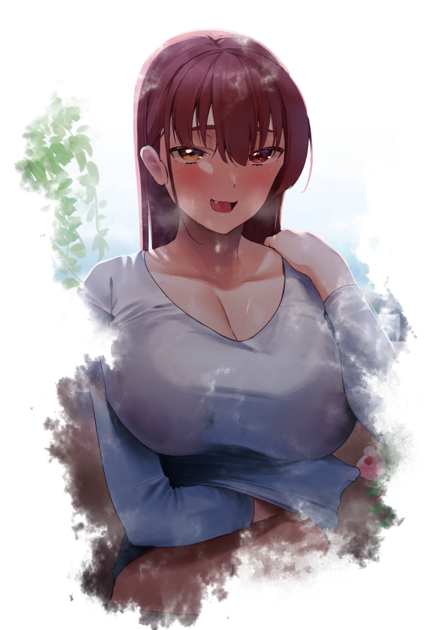
A far more outgoing personality, a bubbly spirit that very little could do to blunt an aggressively positive outlook on the world even when bad grades and a gnawing libido would begin to affect her life in an undoubtedly negative way after accidentally exposing herself to the indecent world of pornography after a two year stint as the highschool's hall monitor had led Felicia Ermans into encountering a group of rowdy boys lurking under the stairwell of the school's fifth floor where very few besides the janitors would ever think to explore.

It would be in that dark, seedy place where Felicia would peep on the boys and the pervy videos they were gloating excitedly to themselves about with hushed voices. Setting aflame the coals of lust within the redhead’s beating heart, lingering within her being even after she had managed to tear herself free from the dizzying maelstrom of male and female voices entwined in coitus alongside the earnest sounds of two bodies coming together…SLAP…CLAP…PLAP…the noises would remain with Felicia all the way. Making the lessons she had to sit through a confusing mess to pay attention to when her own body had begun to overwhelm her mind with alien emotions she had never felt before until then.

Never one to pay much heed about matters relating to her sexuality, Felicia had been a sweet girl. None the wiser to the envious looks cast upon her natural mane of matte red and gorgeous body whose shapely figure they all desired to attain for themselves. Unable to believe such a bland, goody two shoes had managed to do so before they had despite all the effort they had put into dolling themselves up. A fact that left them all the more frustrated when the hall monitor’s presence alone was enough to draw the eyes of all the boys away from them, something the virgin maiden had no clue about either until her dilated eyes would come to rest on a male classmate of her’s whose name she could no longer remember. All she knew was that he had been the first to stoke the cinders even further, remembering the way her nipples had stuck up straight and erect to tent the front of her singlet. Showing clear through the soaked material back in a room steadily being bathed in rays of sunshine peering in from an unsealed window. Dust-free curtains pulled wide open to reveal an otherwise unchanged table and desktop save for the sudden appearance of a great many tools and equipment related to streaming…and a little something linked to the seedy new profession the mature Felicia had taken up ever since graduating from highschool.

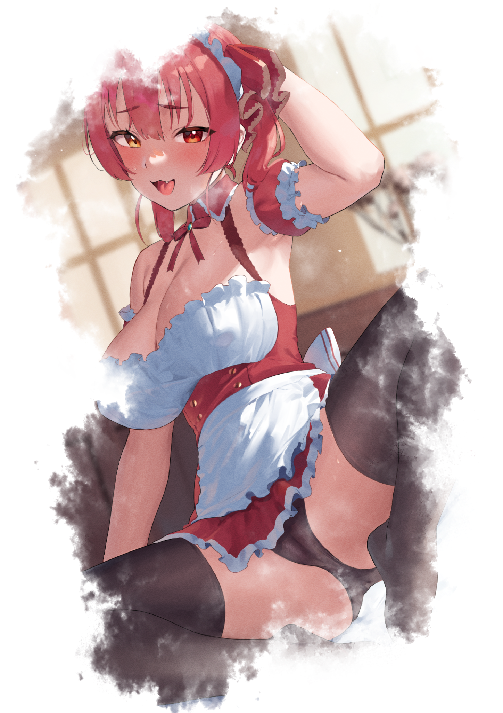
The seed inadvertently planted by the boys and their perversions would take root and flourish within the mind of the eighteen year old back in that classroom. A revelation of sorts that had opened her eyes to a whole new world of debauchery she had not wasted any time in indulging herself with the moment she had gotten home in a relatively normal if catatonic state, only to end up dropping her skirt after ushering herself into the privacy offered by her bedroom. Reflecting that as a messy bed retains it’s crumpled appearance once the overhaul was done warping Darren’s domain into that of Felicia’s, complete with a nightstand stocked with lubricant and sex toys built to order from a seedy website online that had blessed her orifices with many a custom made dildo shaped after the dicks she had come to love over the years ever since she had first tasted the sexual release offered by the fulfilling rush of adrenaline after achieving climax. Spasming in her seat with an emotionless look on a flushed face as her body registers various memories informing Felicia of how it had felt like when her dainty little fingers stroked with uncertainty when it came to tending to a shivering vulva back when she had masturbated for the first time all the way up to the intense pain when her first fling in school had impaled her on his mighty pecker. Followed up by the mind melting electric bliss that had shot through her entire body when the jock had slyly ignored her request to do it with a rubber, slumping into her seat with a rain of ichor toned hair that tumbles down all over her sides and back. Legs spread wide to expose the obscene lips of a well used vagina that had tasted many a phallus, squirting ejaculate all over the pristine floor of her lavish bedroom without a care in the world for the vanished thing that once hung between trembling thighs. Too enamored by the hazy smog of sex and debauchery flooding her mind to care about the insignificant details…if anything, the only thing she wanted right now was for something long and hard to plug her pussy with…or her ass…or her mouth…or all three even.

Because if what memory told her was correct. Then why should she even be worried about such a stupid passing thought? A girl like herself was meant to take cock, not have one to call her own blocking up her tight little snatch unless it was something like a two-way strap on where she could fuck and be fucked at the same time. No, those pesky vestiges of some moody little brat didn’t matter to Felicia, not anymore when all lingering attachments to said life had been rendered null and void a long time ago…right when the joys of a female body had seared itself into the core of her being to be exact. The fashion trends she needed to keep in touch with to adorn herself in whatever slutty getup was all the rage with the internet these days. The obnoxiously gaudy talks with her gal pals on campus about boy bands and which handsome stud they should bag next…etcetera…etcetera…

From the moment she had caught on to her body’s natural beauty and the powerful hook it had over the minds of all those horndog boys out there, Felicia had dropped the facade of an innocent girl without hesitation when the day had come to an end with her parents being none the wiser to the darkness that had taken over their daughter. Passing off the radiant energy she exuded at the dinner table that night as something good that must’ve happened at school.

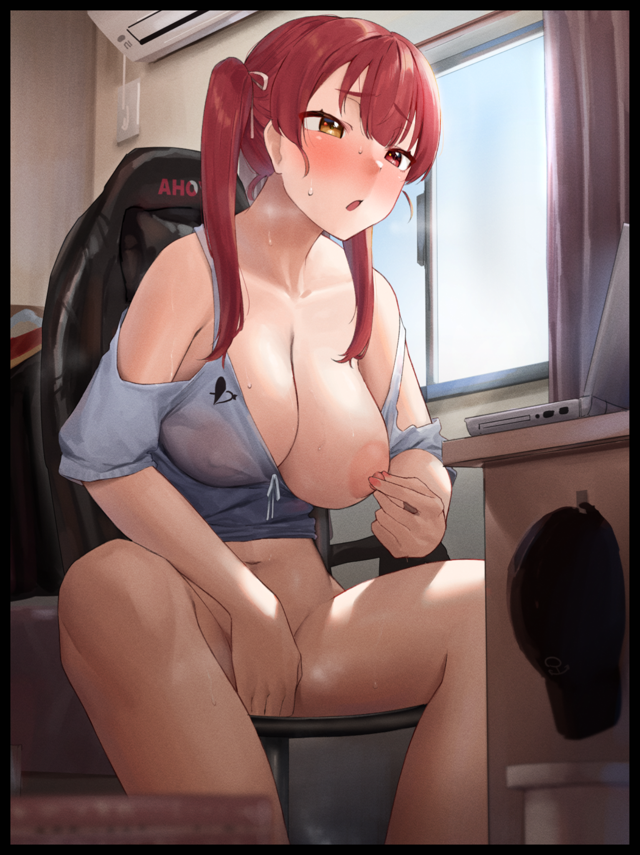
And while they weren’t exactly wrong, the freedoms they had afforded her would ultimately serve as the pivotal stepping stones that led to Felicia’s descent from model student to lecherous slut. Foregoing afternoon studies she had diligently stuck to for so long now in favor of experimenting with her sex; shlicking her sopping wet cunt with curious fingers, using the edge of her trusty table that had remained by her side for so long now to stroke at her clit and labia in one fell swoop, tweaking her nipples with a combination of the above…so much had been tried and done that by the time Felicia had thought to buy herself a dildo, the thought to partake in the real thing had already taken up residence in her mind. A thought she would entertain come the end of her eighteenth birthday where one of the school’s most notorious thugs she used to rat on a lot before resigning from her post would be granted the honor of taking her virginity with glee. A vivacious experience that brings Felicia back to life in the here and now as the light of free will returns to full strength within shimmering irises of gold, letting out a throaty moan as wanton innards clench around the phantom penis pushing it’s way inside of her. Jerking with a notable jiggle to plump tits as they jostle around within their inadequate housing of drenched fabric to the movements of her arms as they writhe, struggling to tie her hair into the signature low-hanging twintails she always had them done up in whilst her body began to be consumed in the warmth of estrus. Dismissing the sudden lack of pants and underwear after said clothes had spirited themselves away with the recent memory that informed her of the challenge she had lost about an hour ago with a viewer. The terms of which stipulated she had to go without pants for the rest of the stream, replacing the anger and confusion she had felt from learning about that strange internet forum with the dizzying rush she felt just from knowing that there were over a thousand viewers with their eyes glued to her half naked body thanks to the high definition tracking camera she had installed just a few inches above. Offering her loyal viewers an amazing view of her boobs as slightly saggy left tit flops free of its prison, swollen nipples eager to be caressed by tender fingers that knew just where to apply pressure for maximum effect. Crying out loud without a need for restraint now that her parents had gone out for their weekend date, giving her free reign to make whatever unladylike noise she desired without planting a hand over her lips to hush herself. A stark change to the moody mother and disgruntled father stalking the halls outside when their deadbeat son had yet to complete his metamorphosis into their sex-crazed daughter who had, to their knowledge at least, gotten herself a cozy job with earnings enough to pay for her own college fees while providing for them all…a veil that had lasted long enough for Felicia to cultivate a sizeable following online that consisted solely of hormonal men who wouldn’t mind tossing exorbitant sums of cash her way just to glimpse her bare body, or have her pose and dress up live for their pleasure as if she were their plaything. With a lucky few even getting the chance to meetup with Felicia in person just so they could do it live and raw on stream, forcing a sigh of longing out from the newly twisted maiden’s lips as half lidded eyes gaze at her own raunchy reflection cast back at her from a variety of angles on the screen of a high end laptop to replace an old desktop now that her bank account was overflowing with the funds to do so. Using her own scantily clad body as the subject of which she would masturbate to before the arrival of a certain someone she had become acquainted with in college after tiring of her first time being pounded hard in the locker rooms back in highschool. Doing more than just helping a lusty little bimbo like herself study once he had found out about her second life away from the lecture hall.

By the time her prostate gland had begun to produce more pockets of nectar in preparation for a mighty orgasm, nothing remained of Darren Ermans within the hypersexualized body of Felicia Ermans. Bearing little to no resemblance toward the goth loving man who unknowingly had his flesh and blood form adapted and repurposed to give shape to the scandalous bitch shamelessly fingering herself in front of a live audience. Providing them with a visual and auditory experience that escalates as donations and rabid cheers begin to flood the screen, swaying her nubile young body with primal lust while the sounds of a woman in heat rise and grow yet louder, ending off with a pitch perfect howl as muscles tighten while limbs stiffen. Groaning in ecstasy as her second orgasm of the day releases a quick spray of juices reaching high enough to splatter the camera in the literal fruits of her labor. Completing the unseen perpetrator’s revenge plan, leading to Darren’s fall and Felicia’s welcome rise in the void left by the former’s disappearance as a smirk spreads across the face of the man who had his phone out and at the ready, standing before a familiar door before knocking hard on the sturdy wood once the Twitter account he was observing had flickered completely out of existence before a new one would take its place in a snap. Shocking the occupant within to action as the flustered voice of a young woman could be heard from somewhere deep inside, telling the man to hold for a minute or two while she ‘got ready’. A warning the stranger would promptly ignore as a key produced from his back pocket allows him entry into the woman’s home. Welcoming himself into an empty living room he would cast a dismissive eye over before heading on upstairs, taking his time while listening closely to the sound of miscellaneous objects being thrown about behind the closed door nearest to the stairs alongside hushed mutterings about how ‘you guys are totes gonna love this!’ and ‘if you like, drop me a thousand, I’d totally let you come by and do me! Sex is good and all but I’m not a cheapo y’know?’. A daring proclamation that had him frowning in mock disappointment before clicking his tongue loud enough for the seditious woman to hear, taking in the sounds of renewed panic and excitement before eventually moving on past the last obstacle between him and his prize…and what a prize she was…

When his brother had come to him asking for help of the magical sort, the man had been skeptical. He had raised his kin to be independent and he knew the youth could hold his own out there in the big bad world, so to suddenly have him walk up and ask for him to use his dangerous reality warping powers was concerning. Doubly so after he had listened to what he had to say; about some base bastard that had driven his childhood friend to suicidal tendencies after targetting her in a relentless online campaign of bullying with seemingly no motive. Only ceasing once she had taken the drawing stream down. A severe outcome that, thanks to the anonymity and complexity of online identities, his steadfast brother could do nothing about. Hence the reason why he had to come to him for help; for no one besides another skilled in the arts of taming magic’s wild essence could remain hidden from its all seeing eye.

With the aid of his supernatural abilities. The responsible big brother had sought out the culprit; one Darren Ermans living a depressive life in an equally gloomy house before leaving it up to the incredible forces at his command to reshape the bully as they saw fit. And with every bit of cognitive information fed into his brain as the world around him began to ‘update’ itself to the new existence being weaved into the fabric of reality, the man could only smile in anticipation for what awaited him once he could enter and greet the one responsible for a good bit of suffering. The majority of which, had thankfully been reversed with the erasure of the emo she once was, for not a hint of Darren could be seen in the buxom redhead dressed in slutty getup befitting her new profession as an adult entertainer…an E-girl without a shred of decency to her name. Willing to put herself into a variety of shameless positions if the money was right and the request was appropriately satisfying enough for a whore of her caliber. Confident in her identity now that she knew everything there was to know behind her newly written and very sordid past leading up to her cushy place in life in the present. Things like her preference for creampies after nurturing an addiction for the act after that first ‘accident’ in highschool. How those udders of hers had been groped and squeezed so much to the point where they had jumped up a couple of sizes to the pendulous E-cups they now were to the penchant her new boyfriend had for ‘playing dress-up’…but not in the way that innocent term implied.

Because as much as he liked to play the part of a wizened elder who had a responsibility to raise his juniors in an appropriate manner, there was always that incorrigible side to himself he just couldn’t help but indulge in every now and then. And seeing such a voluptuous beauty cosplay his favorite (and arguably the most lewd) virtual youtuber save for the heterochromatic eyes she sported in her design was enough to get his pistons going, relishing in the feel of Felicia’s fair skin brushing against his broad shouldered frame as he allows her to disrobe him before coming to rest atop heavenly sheets that smelled just like she did; the unmistakable stench of sex…
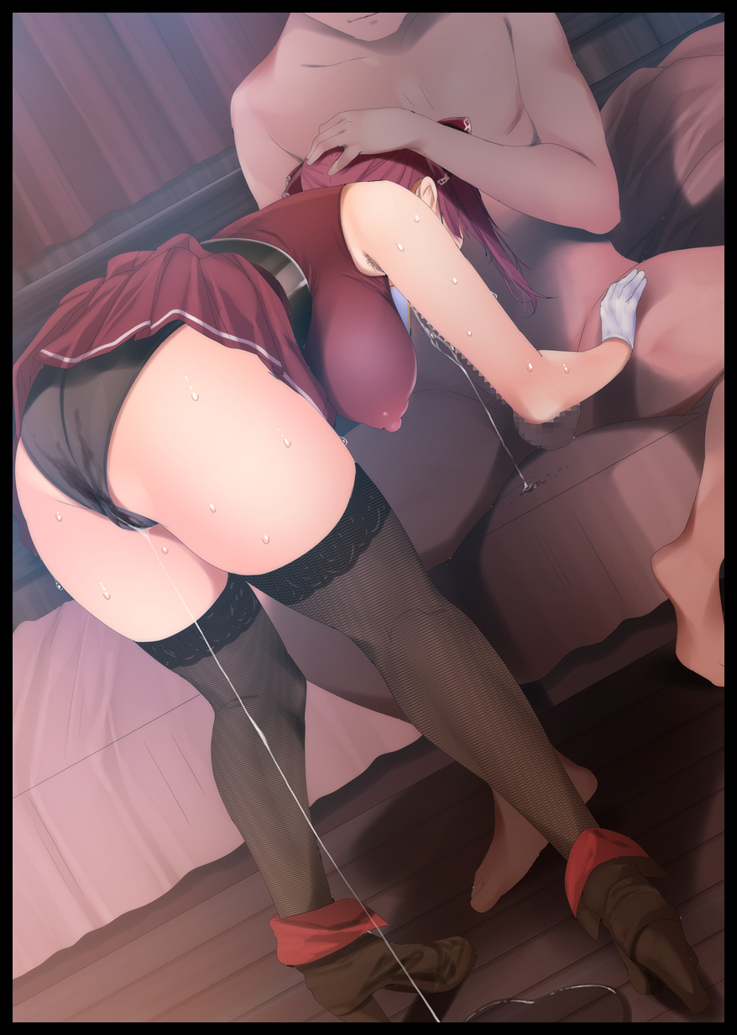
Planting gloved hands on her boyfriend’s sturdy thighs to support herself, Felicia would begin to give the man who had made her the woman she was a sloppy blowjob with all he gusto expected of a seasoned streetwalker who had sold herself to anyone with a dick between their legs. Choking with the most euphoric of *Ugh!*’s every time she would lower her head further and further, jamming that veiny rod deep enough to poke at the back of her esophagus. Triggering a gag reflex her viewers had come to adore as the auto-adjusting camera zooms in on cushioned lips wrapped around the stranger’s girth, showing the world how ridiculously wet Felicia’s oral cavity could really get as a liberal fountain of saliva and cum oozes out from between the gaps. Dropping to the floor while sturdy strands remain hanging in the air like detached spider webs. Swaying to the vigorous motion of Felicia’s expert maneuvers as foxy eyes shut in concentration. Making her happiness known through giggly moans, vapid mumbles and a noticeable swelling of the nipples as they harden yet further into solid arrowheads that stains the elegant top with splotches of milk loosened from jiggly tits as they bounce to the rhythm of Felicia’s bobbing head, stopping on occasion to adjust her posture or tuck a stray strand of hair that had come loose behind her ears. Adoring in the resonant beeps and boops coming from her laptop as envious men the world over raged at each other over who would be the next lucky one to win their Goddess’ favor while flinging exorbitant sums her way, delight that would soon be cut short as a sudden application of force against her head snaps Felicia out of her giddy stupor, slapping at her boyfriend’s lap when she realized she couldn’t remove herself from his grasp with a *Uhurgh!* of faux panic, knowing full well that this was all just a show at the end of the day.

And as she felt the familiar bulge of a vein flaring up against her tongue followed shortly afterward by a flood of delicious cum shooting down her throat, Felicia’s mind would go blank while the laptop behind her would vibrate with renewed cheering fueled by the combined sentiments of an ecstatic fanbase as they watched the twin tailed lady wet herself in front of them. Cumming all over the floor despite the fresh change of absorbent lace panties she had decked herself out with prior to her man’s arrival, signaling an end to part one once buckling knees fall to the floor before restraining arms finally allow Felicia to go free, collapsing into a drooling mess with her pretty face twisted into a vulgar expression of unabated ecstasy; complete with cum bubbles dripping out of her nostrils alongside foamy bubbles pooling around glimmering lips as they open. Showing her boyfriend how loyal of a gal she was after having swallowed every last drop of the yummy batter he had sent straight into her empty tummy as it growled for more. Knowing full well she would soon be granted that wish as strong arms pulled her around as if she were a ragdoll until her sopping wet rear was facing the other way. Giving the camera a good look at Felicia’s happy face while her snatch would hover just inches away from the unfazed member, primed and ready for round two…

THE END

Images 1, 2 & 3 by Frikulu : https://www.pixiv.net/en/users/24827522

Image 4 by Fumihiko : https://www.pixiv.net/en/users/2658856

