MATERNITY SERUM
COMMISSION STORY
BY CHALDEACHANGE
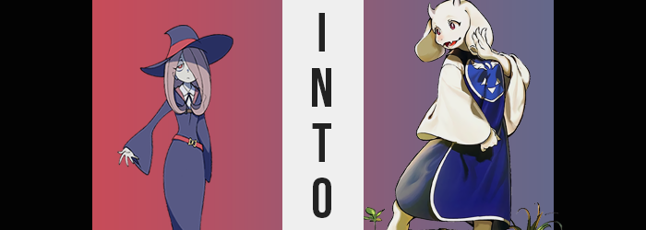

Sucy Manbavaran was certainly an interesting young girl.

She was a quirky witch from Southeast Asia with a love for, of all things, brewing poisons. This wasn’t exactly the safest of hobbies. Not by a long shot, even though she was generally conscientious enough to make sure that these poisons wouldn’t actually harm anyone. At worst they would usually cause some mild suffering to anyone who ingested them, but poisons could realistically have all manners of effects – just like magic itself.

“Hm… I’m stumped.” Resting her chin on her desk in the room that she shared with Akko and Lotte, the young witch lamented something cryptically to herself before eventually turning her cheek to the side to rest upon it. Her poison brewing hobby hadn’t exactly come to an end or anything like that; it was actually the opposite. She was unintentionally building up a surplus of product that was essentially going unused.

The faculty of Luna Nova Magical Academy were always telling her that she shouldn’t be using her poisons on the other academy students at first, and she had pretended to abide by that while secretly using them on Akko in the end. That girl had basically become Sucy’s little lab rat, and nothing too terrible had happened to her! At the very least, it was less noticeable than using it on random other students.

But in the end? One of the staff members had eventually caught on. Akko had missed too many classes because she had been induced with one of the strange effects of her poisons, and since they lived together? The line of incrimination had easily been drawn to her, and the girl had once again gotten in trouble. “I can’t be out of options, though. If the issue is that I’m getting caught administering my poisons to others, then what if there was a way for me to not get caught?”


Sucy rolled her head over onto the other cheek and continued to stare at one bottle of poison that she’d set up on her desk. It was one that she had really wanted to test no matter what. It was from a fresh batch with ingredients that had been sent to her from her homeland. One of which was extremely rare. ‘Goat root’, it had been called in her native tongue. Not because it looked like a goat, but based on legends it made those who ingested it ‘baa’ like a goat. It hadn’t grown for over two hundred years, so there weren’t many records about how true that was.

But the poison brewing witch had been eager to find out. “It’s too difficult to sneakily spike drinks. I’d get caught eventually since I would need to be at the scene of the crime.” She was almost willing to get in trouble if it meant being able to test this brew. Funnily enough, however, she wasn’t willing to test it on the one person who it would actually be ethical to test it on.

Herself.

There weren’t actually any rules about that, but it just wasn’t an option in her eyes. As Sucy saw it, if she ended up in too much danger because of any of her poisons, then who could possibly save her? No one knew more than her about them! Not even the teachers! So, she went back to mulling over possible, discreet methods of administrating the poison to others. …And then she burped. “’Scuse me.”

A silence hung over the room for about ten seconds. But the teenager eventually shot up with a cry. “AHA! Why didn’t I think of that?” It seemed that, somehow, her burp had bestowed her with the inspiration that she had needed. She slipped off her chair and began to root through a cupboard nearby, eventually pulling out a small burner. The flame was ignited, and she put the poison brew on the desk over the fire so that it could heat up.

“Through the mouth isn’t the only way to make someone ingest a poison. If I can turn it into a gas, then just by inhaling…? Crap!” A couple of minutes later, Sucy had begun to talk herself through this plan of hers when she had realized a fatal flaw. She had been way too excited to try and had ended up boiling the poison in her room without a lid on it – or something to contain the gas with. That meant that if she didn’t turn off the heat before it was too late, then she risked inhaling it herself.

She turned the heat off in a panic, hoping that nothing had become so hot that it had transformed into a gaseous form for her to inhale. Because she couldn’t smell anything, but also because she’d been doing it by an open window? The girl felt pretty confident that it was probably fine. Liquids couldn’t turn into gasses that quickly, right? That was certainly what she was banking on, anyways! “I don’t feel any different. It's probably fine. But I guess I need to figure out what I can catch the gas with… Or should I just light a batch somewhere where students gather?”

Though, that probably ran a higher risk of her getting caught.

As it had turned out, however, Sucy actually had been too late in turning the heat down. Such a small amount of poison had been transformed into a gaseous form that it had been almost impossible to sense. Not that it was detectable now. Because when the girl had gotten close enough to turn off the flame? She had inhaled it. It was already in her system. She just hadn’t realized it yet, but it would make itself known to her.

Rather immediately as things turned out, because the girl could feel her body growing violently hot. “Eh— Wait.” Being an expert when it came to poisons, she immediately put two and two together once this vague, burning and tingling sensation rippled through her body. “Did I actually inhale some of the poison after all? That’s probably not good… How long before I start baaing?” She wouldn’t ever start baaing, actually. But that didn’t mean that nothing goat-like would happen. That would come later, however.

“So, what is this poison even going to do?” Sucy felt warm, but she didn’t feel weak or like she was in pain. Not all poisons afflicted their victims with these traits though, and in many cases, they could be used in a similar fashion to poisons. That was why witches were allowed to study them despite the risks. This brew of hers must have been very unique. “…Oh.” In the end, it didn’t exactly take very long for her to notice one effect. Unless she was somehow levitating with her feet rooted firmly on the floor, that was.

Needless to say? The effect she had noticed was one that had challenged the girl’s vertically. The witch was 5’4”, which was a fairly normal height for a girl in her mid-teens. What wouldn’t be normal would be if she was significantly taller than that. Say, about ten inches taller? And yet that was the very same fate that the poison had inflicted upon her. Sucy’s height shot up like a weed’s, and she very rapidly outgrew her Luna Nova Academy uniform so that the base of the long skirt reached her knees, and her long sleeves ended up only covering as far as her elbows.

“It made me a little taller? I guess that isn’t necessarily a – RIIIIIP – bad thing?” The sound of cloth tearing mid-sentence had been courtesy of her sleeves. The girl had grown so tall that having narrow shoulders didn’t really make much sense regarding her body’s stability, so those shoulders broadened along with her torso. “Oh, this is getting worse.” Because her uniform hadn’t been designed for a wider body either, the sides of the gown practically split from exposed armpits all of the way down to the sides of her stomach.

The girl clicked her tongue. “Wait a sec. If my body is getting this big, then… Ah, actually, I can hear it in my voice.” Sucy had drawn a conclusion all on her own without a mirror. She could feel it in a sense. And she could definitely hear it. Her voice was deeper, and her body was bigger. “Did I get older? Or am I getting older?” The truth was actually a little bit from both columns. She now looked like she was closer to twenty when it came to her face.

But that promptly and quickly escalated. The girl’s facial features appeared increasingly less like those of a mere girl, almost as if her body had been fast forwarded through fifteen or more years of her life. With how full those facial features became, like her lips, she looked more like she was in her mid-thirties by the time her age had seemingly settled. She placed her hands on her chest though. “If I’m really older, then why hasn’t this area grown any bigger?”

Did she want them to grow? Kind of. And in a way her desires did manifest. Just not in that exact way. Not immediately. Because there certainly was growth to be had and experiences, it just didn’t grow in there first. Instead? The skirt of her gown become subject to even more tearing. “H-Hey!?” And in this case, it was a little dangerous? At least if she wanted to preserve any of her shame.

Because Sucy’s hips had just flared out, finishing the tearing job at her uniform’s sides while weight gathered around her upper legs and rear. Her butt was once so small and compact as a teenager, but now that she wasn’t? There didn’t seem to be much need for it to remain that way. And since she was so tall? She had a lot of growing to do to better fit this rapidly transforming body of hers.

“Urk!?” Her panties snuggly dug into the crack of her ass before they snapped all on their own, her cheeks growing well beyond they means as they eventually rivaled cantaloupes in size… each. They jiggled and bounced with each and every movement she made, and the woman was doing her best to try and avoid those cheeks showing in the back with her uniform in the condition it was. Her thighs pushed out of her gown’s torn sizes, becoming thick and luscious with a girth to match her huge ass. But just as it seemed like her loins might be shown with all of this girth?

Something ended up obscuring her crotch, though.

White. A fluffy white. Fur had not only replaced her pubes but seemed to rapidly be growing all over her lower body. “What’s… that? Fur?” Sucy was dumbfounded, watching it spread down her legs and over her feet. Since she wasn’t wearing shoes? She could see how those feet were deformed by the fur. Toes became thicker, and her nails narrowed and hooked into little claws. And was she missing her pink toes? Like the feet of some kind of animal. An animal shaped like a very well endowed woman? The fluffy, goat-like tail that poked out just above her ass certainly demonstrated as much!

“This truly is strange.” What might have been stranger was how the woman was talking. It didn’t have the same creepy tone that it normally did. She sounded oddly mature and polite, even though she could feel the fur beginning to coat her chest. She had never really been panicked by what was happening, but now more than ever? She almost felt at home. A hand was raised just in time for her to see the fur coat it, thickening her fingers and giving them claws just like her feet, missing pinkies and all.

But she didn’t gawk for long. Sucy took that hand and gripped the front of her uniform. …So that she could tear it off with one big pull. It didn’t really matter in the end. Her small breasts were already covered with white, nipples and all. But that also didn’t mean that she couldn’t appreciate the sight of them inflating. It was almost like they were jealous of how big her ass had become, because they bounced as she kneaded and groped them with her paw-like hands. Each one quickly grew to be a little bigger than her head.

Which was even more miraculous when you considered her head wasn’t the same size now, either. The fur had spread over her aged facial features, and as it had done so? It had pulled her maw forward into a snout. Her nose merged into it, while lips thinned into a black leather. Her canine teeth became much more pronounced, too. All while her long head of hair retracts so that it was only short fur that covered her scalp.

Not that this meant there was nothing on her face. “This feels a little odd…” Thick fingers touched at her snout beneath larger, browner eyes. It was distracting because her sense of smell seemed to be stronger. But so did her hearing? Only because her human ears grew bigger, longer, and flatter while raising, handing against the sides of her head like a pair of goat ears. In a similar vein? A pair of white horns erupted just above her forehead.

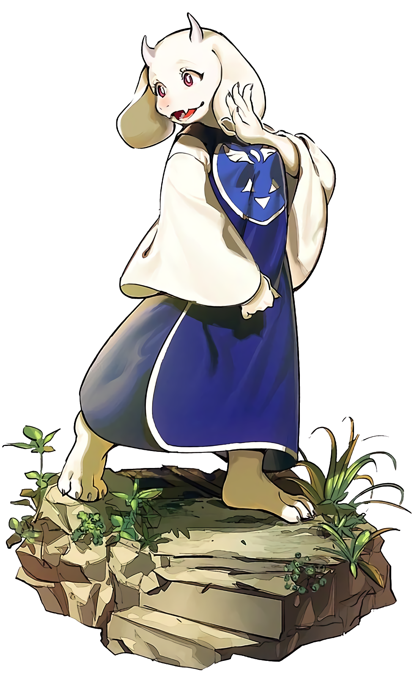
“I… see… So, when the legends spoke about making those who consumed it ‘baa’, it was a much more literal meaning than we thought?” The soft voice of the tall, supple goat woman mulled over the effects of the poison that she had just experienced. Much of her had changed, from her appearance to her demeanor, but deep down? She was still very much Sucy. She just behaved a little bit differently, even though her motivations really hadn’t changed at all. “I wonder if it was because of the other ingredients I placed in the brew? Is it permanent?”

It actually was. And once others found out about it? They wouldn’t really have much luck in trying to reverse it. Sucy was more or less stuck in the form of a goat woman MILF forever, and before long? She’d find that name didn’t suit her very well. She’d end up taking up the name of Toriel, a name that stuck out to her in the back of her mind for some reason. Well, it must have simply been a side effect of the poison.

“Wouldn’t this work in my favor, though? I mean, I feel like I must be much more approachable now? It would be easy to get others to test my ‘products’ for me if I were to show them a little bit of kindness?” She may have been gentler and kinder, but evidently that hadn’t dissuaded her from wanting to brew and test her poisons at all. Rather, it just seemed to embolden her somehow.

The goat woman glanced back at the potion on her desk. “I don’t even need to remain like this alone, do I? If it worked on me, then perhaps if I used it on others, I could prompt the same effect?” It was an exciting prospect, really. When Akko and Lotte returned, maybe she could use it on them? They could be a unique trio of goat women!

Surely that would all work out in the end?

