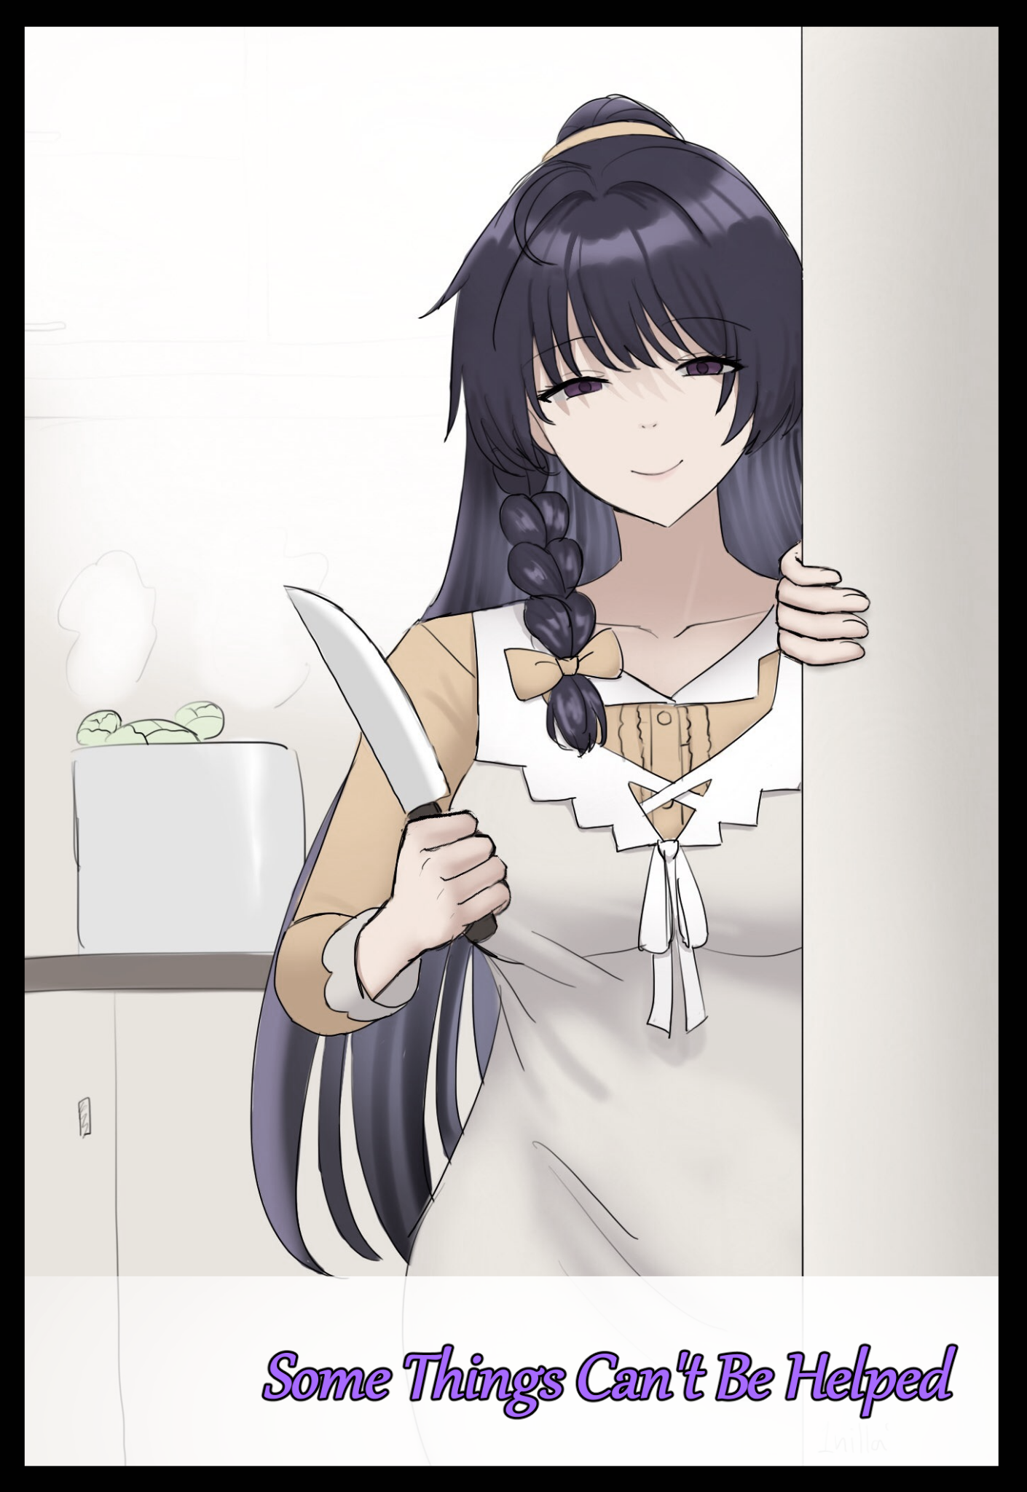

**“C’mon Sarah! Just..do like we practiced, and you’ll be fine.”**

**“B-But what if he doesn't-”**

**“Sarah…I'll be here with you every step of the way, so give it your best alright? You can do this!”**

**“O-Okay! Okay! I’m going! I’m going! I'm gonna do it!”**

Sighing as she watches her friend scamper off around the corner and into the lecture hall, the tall raven haired woman rubs her face with one hand before sidling up against the wall, following after the nervous girl and coming to a stop right at the edge of the open door.

Slipping her smartphone out of her pocket, she aims the camera where she knew the highest point of the hall would be. And there, on her screen, stood her friend, shifting her weight from foot to foot in a fidgety mess, wide eyes focused on the back of the second person in the room with her taking out cleaning supplies from the closet.

It was a young man dressed in ordinary drab attire that seemed to suggest he wasn't the type to dawdle too much on what clothes would fit him well or whatever the latest fashion trend was amongst the hip and cool crowd. Despite that, he must've had something going for him if one of the most popular girls in school was gunning for him for quite some time now.

*'Just hurry up and tell him how you feel already! Hell, just smack him with it in the head right now!''*

But no matter how much mental encouragement she yelled, the girl did nothing, shivering in place even as her crush turned to hand her a broom with a puzzled look on his face. Even though she couldn't hear what they were saying from here, their body language was more than enough for her to figure things out as she watched him press his palm up against her forehead, sending a noticeable tingle running through her bunched up form as their hidden spectator whistles soundlessly to herself

Bold, but maybe this would finally be the push she needed to get her lips unzipped and the words to flow out. And indeed she would, for her firmly pressed lips would finally open, mouthing words she could only hear as a muffled murmur from the entrance. This was much better than all their previous attempts, so much so that in no time at all, it seemed the two were chatting like normal friends as they began to clean up the place. Hearing the occasional laugh or two from either party.

*'Atta girl…'*

Feeling confident about how everything was going, the towering lady steps back and sway from the entrance, leaving the two to finish up their cleanup job while she leans back against the wall, one hand in her pocket while the other fiddles around with her phone, scrolling the news feed and browsing social media while she waited for her friend.

A good fifteen or so minutes later however and the clanking of the metal closet doors slamming shut would be heard, followed by inaudible voices, the clacking of lights being turned off and footsteps fast approaching the entrance, keeping her stoic front up because she already knew who'd exit the place first, coming face to face with the classmate she was supposed to be doing cleaning duty with today.

**"Afternoon Alex…y'know, you're looking healthy…for someone with the flu…"**

**"What can I say…I'm built different I guess…got something else you wanted to talk about?"**

Shaking his head in disappointment, the disinterested youth shoulders past his comparatively taller adversary without another word. Although she was technically at fault here for not showing up to do her part, the tomboy could only stare with disinterested eyes after the boy as he stomped off down the hallway out of sight. Making friends wasn't her priority, and although she had left that life behind a long time ago, she still took some delight in ignoring the views of honor student wannabes like him. And she was technically doing all this for a good cause…

**"You didn't…do anything to him…did you Alex?"**

**"Nah, just had a little heart to heart…so? What did he say?"**

Turning to meet her friend as she steps outside with a broad grin that looked nothing like the cold stare she had on her face earlier, the unruly gal eagerly awaited her response with bated breath. Clearly having missed the flustered look of sadness on the girl's face.

**"I…uhh…I didn't…manage to tell him…"**

**"That's great! Now you two are…wait…run that by me again?"**

A few minutes later, and the two would be sitting outside on the steps leading into the campus, the girl looking sheepish and unsure of what to say next while the tomboy sips on a crushed can of cola between her thighs, head downturn and defeated.

Things were going so well, it looked like the light at the end of the tunnel was almost in reach. And now here they were, back at square one. It left Alex conflicted on deciding her next course of action as she gazed down at her side pocket where a thumb drive currently laid nestled within.

For as long as she could remember, Alex had been close friends with Sarah ever since they met sometime during middle school where she had once been a bully while Sarah played the role of the fair class monitor looking out for everyone. Despite their clashing lifestyles however, Alex and Sarah came together surprisingly well, they shared interests, bounced off each other with differing opinions that opened both their eyes to new light while relying on the other's individual strengths to counter their own weaknesses. Pretty soon, Alex had gone from rough bully to overprotective friend while Sarah became something of a little sister to the towering brute of a girl. The fact that both had been born with hair colors that went well together soon earned them the moniker of 'Magenta' every time people saw them considering how often they were together. Though that title was quickly dropped once Alex had dyed her crimson hair an ordinary raven black, leaving Sarah's lustrous head of purple. A decision her friend chided her about to this very day, arguing she had ruined a 'natural work of art'.

Things continued this way for quite a few years now as they stuck fast through high school and now university. But as they entered that part of their lives, that was when the fledgling maiden’s heart within Sarah decided to fully nurture, rousing alien emotions within the girls chest she had no idea how to pick apart; experiencing bouts of heartache and breathlessness whenever she came near to or sighted one of Alex's classmates, an unsuspectingly ordinary young man named Roger. A textbook dweeb in the tomboy’s eyes. But to Sarah, he might as well be Prince Charming considering how often Alex had caught her staring at him with dreamy eyes and flushed cheeks. It didn’t even take her a second to realize her friend was in love.

Alex had tried to reason with Sarah, saying how it could just be her heart acting on a whim, implanting love over superficial desire, but her friend wouldn't budge. And no matter how she tried to deny the fact that her friend, now a beautiful young lady in her prime, could ever fall in love with someone so plain, all she had to do was to get the two within viewing distance and the undeniable truth would reveal itself.

*'To think this all started cuz little goody two shoes decided to give Sarah a tour of the engineering wing…'*

Seeing no other alternative, Alex had decided then to try and get the two to officially become a couple, putting Sarah through multiple attempts at confessing her feelings for Roger, manipulating her heart strings through the notion that someone else might get there first and snatch him away from her when she started to get cold feet. A dirty move Alex felt was absolutely necessary, especially after she saw how quick her friend moved to act once that fear had been implanted in her mind.

But whenever she came face to face with Roger, that determination and grit would vanish altogether, replaced by meek stuttering and an immediate distraction away from the topic of confession. Alex had done her best to place the two in the most perfect scenarios one could imagine for a nice, romantic moment between a man and woman; empty rooms, the back of campus, even outside each other's homes for god's sake. But none of it worked. And she was beginning to get the sense that Roger was becoming cautious of Sarah once his classmates had poked fun at him for always being seen together with her.

Even today's attempt was a bust when a deflated Sarah told her their entire conversation was basically about how Alex had left Roger to do all the cleaning himself and how Sarah didn't have to swap out with her. If only she could bring that determination with her, then maybe they stood a chance at getting her true feelings across…because as Alex saw things, nothing seemed to be working, at least, as far as conventional strategies were concerned.

Rather than smack her head against another wall, Alex clenches her fist around the little gray thing before lifting her head up from her lap, having decided on what to do next. It was time to resort to more…unorthodox methods.

Sarah needed to be more assertive, more confident. Even though Alex never said this up front, she knew her friend needed to be more confident and forward with what she wanted. If she continued this way, forget about a stable love life, she'd be easily manipulated and pushed around by others! As her friend, Alex knew she needed to do everything in her power to help prepare her for that, even if that meant disrespecting her wishes for a proper relationship to flower between her and Roger.

**"H-Hey…Sarah?"**

**"Hmm? W-What is it? You're not mad are you?"**

**"Nah…nothing like that…It's just…I think I might have something that could help you calm your nerves in front of that guy…it's sort of strange though but I've tried this guy's stuff before."**

**"A thumb drive? What's on it?"**

**"Well, y'see, a couple months ago, I started having these real hard times going to sleep at night. So I looked around for stuff that ain't pills, that's how I found these. Helps in soothing you to bed at night while refreshing your mind, keeps you focused and all that stuff…just thought it could help here since I noticed you always flunk the confession…what gives anyway?"**

**"Heheh…I don't really know how to say it but…it's like my head just…goes blank! Like I can't think of what to say next or do anything really. In the end I just end up going along with whatever Roger starts talking about and before I know it…we're saying bye and going our separate ways."**

**"Hmm…well the music in there will help get that empty headed thing of yours cleared up in no time, …maybe, I used this for sleeping problems and lack of focus…no idea how it'll turn out on your end."**

**"That's too kind of you Alex…but I'll keep it in mind! Do I have to use earpieces for these?"**

**"Either way works fine! Speakers, earpieces, as long as you can hear it when you go to sleep, it'll do its job."**

**"Hmm…subliminal messaging…I'll give it a shot then…thanks for helping me out so much Alex."**

**"Ahh don't mention it…it's what friends do right? We're in the home stretch now, I can feel it! Just a lil more and Roger's gonna be yours!"**

Although there was much more to the story than insomnia, Alex couldn't really afford to tell Sarah she had nightmares. Being especially proud of her rock hard outer shell, telling anyone a girl like her woke up sweating to spooky dreams was like jabbing her self esteem with a knife. Just a simple excuse was more than enough to get the message across that the audio on the thumb drive would help as she passed the tiny little thing over to Sarah before rising to her feet, preparing to head home for the day as the afternoon sun begins to sink back down over the horizon, saying her farewells as she waved Sarah goodbye, parting at the gates to go their own separate ways.

But whether or not she was aware of it, the tape worked by amplifying one's inner desires and their drive to achieve it. While Alex simply wished for a good night's rest in the simplest way her straightforward mind could think of, Sarah was in love…and figuring out love was a matter leagues above someone trying to figure out the complex mental gymnastics behind how to get their brain to sleep.

And so, as Sarah lies curled up under the sheets with the speakers playing the audio track her friend had so graciously provided her on the desktop, her initial surprise at the static like noise would soon give way to a soothing warmth that gently coaxes her asleep like a phantom masseuse had gotten ahold of her stuff brain meat, rubbing and kneading until she falls asleep where she would be at her most vulnerable towards the suggestions hidden within the unceasing soundwaves pinging off the walls of her ears and into her head.

When next she awoke, Sarah would start off her morning routine as she usually did after shutting off the repeating track playing since last night, washing up before picking out her usual clothes to wear for the day. Except instead of the usually baggy t-shirt, she reaches confidently for a long sleeved woolen top while trading her trousers for form fitting jeans. Things she had bought on a whim before never wearing them again , complaining about how suffocating and hot they could get after just a few hours. Not considering how much it would chaff and bite against her skin when her mind seemed preoccupied with other, far important thoughts today.

*'It's just ~~a little change~~ to get Roger's attention, that's all. Yes…that's all it is…'*

Nevermind the fact that they seemed a tad bit too tight now considering she had gotten them a few years ago, Sarah saw nothing wrong with wearing them as she picks up the drive, connecting it to her phone before heading out the front door for school, uploading a fresh copy of the pleasant tune that had put her to sleep while earning herself more than a few unwanted glances from people who never would have taken note of her until now as she strode around town with her toned silhouette clearly outlined through the tight clothes that pressed up against her body right enough to show off the bumps of her bra strap and the indents of her shoulder blades. Keeping a pleasant smile on her face as she makes her way toward campus, veering off the path towards her school as she strides confidently toward the engineering school where Alex and Roger studied. Being a stickler for early arrivals, Sarah would now put the ample amount of time she had on hand towards fulfilling her long standing desire to*~~confess~~ make Roger hers*. Brooding visage breaking into an ominous grin once she spots her target already seated at his chair, laying out textbooks and revisionary materials over his table, making her way towards him with calm and a finesse she had never displayed before until now.

By the time Alex arrived just a few minutes before classes were about to begin, Sarah was already at the tail end of a conversation with Roger without stammering and tripping over her own words. That was more than enough to make her double back in shock, but seeing her friend who she thought she knew like the back of her hand dress so…provocatively…made a chill run down Alex’s spine at the sudden change, spurring her forward, hand outstretched with the intent of pulling her away from Roger and out the door for a little talk.

**"Oh! Hi Alex~ Just who I wanted to see! You won’t believe this but…oh no, I'm late!”**

Before the peppy girl could continue however, the distant echo of a ringing bell catches Sarah's attention. Urging her to make a quick exit as she speeds by a dumbstruck Alex. Making one final stop at the entrance to the hall waving at Roger with a warm smile on her face, before speeding off.

For a moment, alarm bells rang within Alex’s mind when her friend had turned to intercept her grab. Even though she didn't raise a finger, the stare she sent her way the entire time she spoke so cheerfully looked…threatening. Even though she was smiling and her expression suggested happiness, her eyes, the window into one's soul, were empty, devoid of the usual glimmer she had come to expect of someone as jovial as Sarah, shaking her head as she sat herself down in preparation for the first lesson of the day.

But after that chilling glimpse and the strange 180 in Sarah's behavior, Alex just couldn't focus. Head roiling with conflicting emotions about the stare, the calmness with which she spoke to Roger with, the change in attire…and then her eyes widen just a little as she remembers the curious little thumb drive she had given her the previous day.

*'There's just no way is there? How could she change so much after just one night?'*

Clicking her tongue in frustration, she could only wait out the lesson with impatience, failing to see the need to talk to Roger due to the misconception that the good news Sarah was talking about was her confession being heard and accepted judging by the giddy look of disbelief and muted excitement on her crush's face. While this would normally be good news to her, the fact something within Sarah had been 'tweaked' to allow for it to happen was unacceptable. Even moreso when Alex realized that it was partially her fault.

Forging plans to confront her friend and recover the drive as soon as possible, Alex scrolls through her phone, sighing in relief once she realized the two had similar schedules today, with hers ending just an hour after Sarah's. If things proceeded as usual, she would be waiting for her outside the school.

Unbeknownst to Alex however, Sarah had already made plans with Roger, inviting him over to her house immediately after classes were over for lunch and some help with her art studies.

In truth, Sarah hadn't confessed, she had simply taken the first step forward in starting a true relationship with Roger after so long being held back by indecision and embarrassment. Smiling to herself as she flips open her phone to gaze at the new number in her list of contacts and the name above it with wide eager eyes sparkling in disbelief and awe, all while that strange, monotonous buzzing continues to ring inside her ears from the wireless earpieces plugging them right. It was so ambient, so unnoticeable, Sarah figured it couldn't hurt to listen to it during a lesson, and it was a blessing.

It was like all that information was gluing itself to her being, finding herself able to understand and replicate whatever it was the lecturer demonstrated and explained on the whiteboard in perfect detail, all while a pleasant tingle like the one she felt the night before spreads once more across her body, whispering to her like a fairy godmother bestowing her princess with words of wisdom, urging her to stay the course and never let Roger out of her sight now that she had him close at hand.

*'I have to remember to thank Alex for lending this to me…ohh but I'm supposed to be having lunch with Roger…ahh! I could invite her over too!'*

Just before her finger could thumb the pages over toward Alex's chat box however, Sarah's hand tenses up as a new thought crosses her mind, Alex was a girl, just like her…would Roger get distracted by her presence? Would Alex get herself involved in their budding relationship somehow? They did have a rivalry between each other didn't they? So many questions suddenly entered her mind, and the answers to all of them were enough for her to stay her hand, snapping the phone shut before turning her attention back to the lesson with a silent apology to her dear friend uttered in the depths of her mind. She would've felt bad for pulling something like this without telling Alex, but any remorse was quickly shoved aside by an all consuming need to see Roger once more, clutching a hand over her bosom while her an uncharacteristic smile creeps over her face.

*'I'm sorry Alex…but you'd just ~~start a fight with Roger~~ get between me and darling…'*

Love wasn't something to be tampered with so easily, and although Alex wasn't aware of it as she continued to sit through her lesson while Sarah had long since left the campus for home once her lesson was over to prepare a warm lunch for her first date with Roger, she now had a ticking time bomb on her hands, a result of her unwittingly shifting the fragile balance between romantic love and the aforementioned desire she tried to warn Sarah about. A feeling that bore no real meaning of emotion behind it; a simple urge to be fulfilled. And now that same wanton lust was beginning to creep over Sarah's pure love for Roger, twisting it little by little into something perverse and dangerous.

By the time the bell rang for the second hour, Sarah wasn't where Alex had expected her to be, neither was she back at her school, spooking the otherwise quiet art students as the panicking tomboy sped through the halls looking for her friend, deepening the pit in her stomach for each empty room she passed. Messages bore no fruit either, with every single one going unread while she continued her search until there wasn't a door left to kick open, no furniture to turn upside down. Sarah had vanished.

Cursing herself, Alex speeds back outside, realizing by now that she must've told Roger to meet her somewhere, maybe during that brief conversation in the morning or even through a quick exchange of messages via messenger. But with so many possible places for a meetup, Alex would have no choice but to single out the closest possible choices first before going on a wild goose chase, pressured by the knowledge that each passing second could be one where Sarah listened to more of that accursed tape if she somehow got it onto her phone.

Deciding to head for her home before the mall since it was the closest choice, Alex ditches the train, relying instead on her own two legs to carry her through the streets, blitzing through town with a cloud of dust left to mark her passage, leaving bystanders stunned as she made a beeline for Sarah's home, coming to a screeching halt outside her front door in a sweaty mess, sweating buckets as she jogs up toward the entrance, ringing the doorbell before being surprised by how quick the front ebony wood swings open, coming face to face with none other than Roger himself, looking equal parts confused and unenthused to see Alex outside.

**"Oh…it's you…what is it? Hear to*-oof!*"**

**"Out of my way! Where's Sarah?!"**

**"How am I supposed to know?! I just got here!"**

Kicking off her shoes while leaving Roger to catch his balance, Sarah runs inside, feeling her tummy rumble as the nauseatingly strong smell of freshly cooked rice and stew wafts in from the kitchen, drawing Alex to its source before she inhales sharply, backing away just in time to avoid her eyes being poked out by the polished edge of a kitchen knife held out carelessly toward the doorway.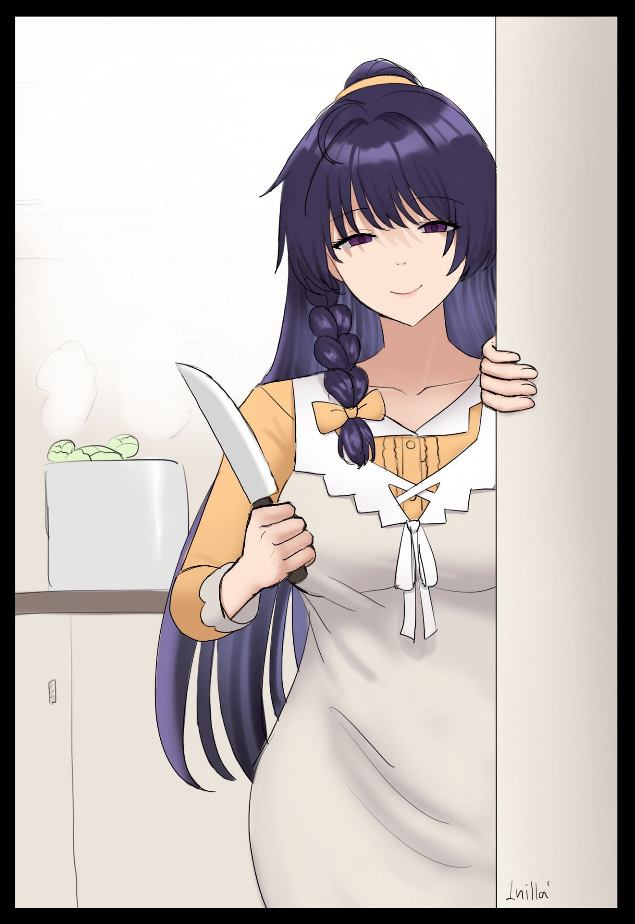

And the one holding the deadly kitchen apparatus, to Alex's shock as she catches herself on a chair, was Sarah. Narrowing deadened eyes with the brief sight of a scowl vanishing under a slim smile, the type reserved for pretense. It was like looking at a complete stranger from the way Sarah had done her usually unkempt mane of hair up into a ponytail with a side braid hanging down over her shoulder. Combined with a tight apron, and Sarah looked more like a young mother than she did the clumsy, yet adorable ditz she was just a day prior.

The look she was giving her though, was anything but motherly. They were ice cold, bereft of emotion. No doubt caused by the culprit Alex could barely see behind the curtain of purple jutting out of her ears.

**"My, my, you really should be careful there Alex! Don't you know it's dangerous to turn corners like that so suddenly? Take a seat! I wasn’t expecting two guests today…oh! And do be civil with Roger alright? I’d *hate* to intervene…ufufu~”**

**“Jesus Sarah! Y-You almost…poked my eyes out!”**

**“Aren’t you just overreacting? I was in the middle of preparing lunch until you came running in like the house was on fire! Now just stay put alright? When we’ve all got a nice warm plate of food in front of us, we can talk about what’s gotten you all worked up~”**

*'Shit! She's completely lost it! Goddamn it!'*

Swallowing the lump in her throat with a slight nod of confirmation, Alex pushes her back against the seat knowing the time for talk had long since passed, waiting till Sarah vanishes back into the kitchen before whipping out her phone and opening the seedy website where she originally downloaded the 'self help' audio track from, hurriedly looking for a solution or a counter to whatever the heck this thing was doing to turn her friend into an unhinged psychopath. Ignoring Roger as he walks inside the dining room with a frown on his face while Sarah sets aside a third bowl, shaking a handful of sleeping powder (don't question why or how she got it) into it before pouring vegetable soup inside. Stirring it until it all mixed together into a fine broth guaranteed to knock someone out for days on end. It was then that Alex would realize some things just weren’t meant to be interfered with, that maybe some shortcuts weren’t meant to be taken when helping some people.

**“I’m so sorry Alex…but I'm simply doing as you told me to; Doing all I can to keep darling safe and in my hands…even if it’s you trying to get in my way. I won’t hold back~”**

But let’s hope Alex had learned her lesson in time to figure out a way to get out of this mess unharmed while reversing the effects of the subliminal messaging currently worming its way deeper into Sarah's psyche, slowly corrupting her plans for an innocent afternoon of studying into a lecherous bondage session involving Roger and a chair. And the best thing about this whole situation?

The lovestruck maiden, even with her feelings for Roger intensified, still hadn't confessed her love for him…

THE END