# WALKTHROUGH & CHEATS for SPACE PAWS FINAL VERSION

**Cheat Codes:**

To activate the “codes console” you have to: go to your bedroom, click on the floor or any unclickable place, tap the spacebar and a blue rectangle with a button will appear. The cheats you can type are:

* **“shiny thing”:** receive the bracelet
* **“my name is JC”:** strength 100
* **“got a cramp”:** strength 1
* **“sophisticated mind”:** knowledge 100
* **“pi=3”:** knowledge 1
* **“this guy rocks”:** charm 100
* **“I just farted”:** charm 1
* **“unlock gallery”:** unlock the gallery
* **“skip diary”:** bypass Alison’s diary part*   
    
  *this cheat must be written in the storage room instead of the MC’s room.

**Plus, there’s another cheat.**

* **If you press the key “O” (Omit) during Maya’s Drones Mini game:** get 100 hits and skip the game.

# All interaction energy requirements:

* Talk:-10
* Ask:-10
* Give:0
* Date:-80 // 10 if you fail
* Girlfriend: -60 //10 if you fail

Keep in mind there’s a day limit of 100 days.

# ROSELYN'S ROUTE

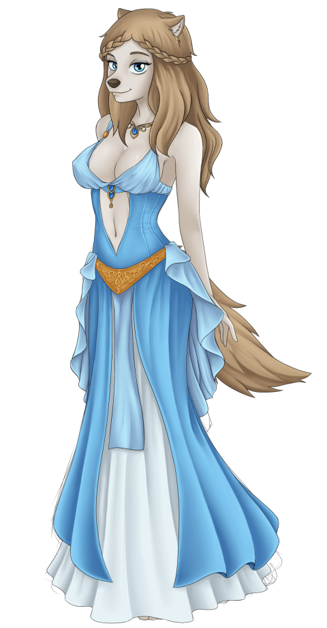

First of all, you have to go to the Market. You can interact with some characters (Max, the girl in red, and the Merchant). Talk to the merchant and do his riddle challenge (Requires knowledge 15+). The answers are:

1. A stick
2. D
3. What?
4. Your mother
5. Tomorrow

Once you answer all questions correctly, he will give you a **red ball**. You'll need this ball to distract the guard in front of the gates of the Roselyn's castle. Give him the ball. If you have strength 20+ you'll throw the ball far enough and the guard will completely disappear.

Inside the castle, you'll find Amber, Roselyn's counselor. She'll demand a "reference" in order to let you in to talk with Roselyn.

In the market, talk with Max. He'll ask you to babysit his hyperactive puppies (if you haven’t talked with him before, you'll need to talk to him a few times). Accept.

After that crazy night, you'll talk again with Max. The job is done and you have your reference. From this point you can visit Roselyn and you can also talk with Alison, who's in the spaceship's library.

Focusing on Roselyn's route, go to the castle, talk with her and you'll explain her your mission and your relationship status will become **Acquaintance**.

From this point, you have to talk with Max, he'll go with you to "the Dungeon where nobody dares to go in". To enter in the cave you'll need or Knowledge 25+ or Strength 40+. Once you're in, solve the puzzle and you'll obtain **Roselyn's bracelet**. (Alternatively, to skip this and just get the bracelet, go to your room on the spaceship. Click anywhere on the floor and press the spacebar. In the box that appears at the bottom of the screen, type “myprecious”. You should now have the bracelet in your inventory.)

**IMPORTANT: since the v0.69 if you want to do Roselyn and Nebet's route in a same game, you should complete Nebet's routes first. Eventually Pharaoh will give you the bracelet back so you will able to go forward with Roselyn's route.**

Go back to the castle, and give Roselyn her bracelet. In order to become **Friends** and be able to date your charm must be 20+.

If you successfully become friends, now you can date her. Here starts the "fun". :-P

You can obtain an H-scene with her in EVERY date. If you obtain at least 1 H-scene on the dates, you'll become **Fuck Buddies**.

To obtain the H-scenes, you'll need:

* Forest: Charm 30+
* Lake: Strength 40+
* Snowy Mountain: Charm 35+

Once you're fuck buddies you can Girlfriend her. That means that after the first date if you fuck with her, you can do directly the final challenge with Roselyn, BUT you'll be missing the other H-scenes (that's your choice!)

You can also date with her on the three places (without fucking her) and then do the challenge. The answers for this are:

1. Loryns
2. Manifus
3. Oranges
4. 912
5. I went once
6. (Pick any of the options, except for indifferent – that’s the worst thing you can say to a girl like Roselyn!)

If you did it well, you'll get Roselyn's ending. Congratulations! She’s crazy for you and I bet you're crazy for her too.

# ALISON'S ROUTE First of all, there's an Easter Egg with Alison. See the easter eggs below to see how to get it.

To interact with Alison, you need first to babysit Max's puppies. All that noise will make Alison go out of her room and you'll be able to find her on the library since the day after you babysit. Talk with her; she'll be impressed of all your efforts to make your mission. Your relationship will change to **Acquaintance**. If you go to sleep, you'll have a dream of her.

Now, you need to date with any of the main girls of the game (Roselyn, Nebet, Siaren or Vyl Daemith) and visit 3 different places in order to know good places to plant the sprouts (in Vyl Daemith’s case, just to convince Alison they aren’t that bad). On the dates, you can do dirty things with the furry girls (or not, that's your choice) and it won't affect to your relationship with Alison (let’s assume she won’t notice). Note that if you choose to go on the Badlands date, you will need strength 50+.



Once you've visited the places, talk to Alison again. You two will become **Friends**, so now you can “date” with her with the excuse of measuring the ambient of every place. When you go on dates with her, you'll see her with different outfits and how your relationship is quite better than before. After the dates, Alison will want you to take the shovels that are in the Storage room (the one blocked from the beginning of the game).

There, you'll find the shovels in the closet. But, there's something more. On the left side near the floor, you'll find a mysterious book. That's Alison's diary. You can't open it yet, because it has a password. On the cover, you can see the word “CaNdYCaNe”. That's not the password, but it is the hint you need to open it. Remember the words with their capital letters and go to the library. There, look at the Periodic Table of the Elements. The password is made of the atomic number for each element:

Ca= 20

Nd=60

Y=39

Ca=20

Ne=10

Only a library rat like Alison would make a password with the Table of the Elements. Anyway, put the password in to unlock the book: 2060392010.

*Dramatic music...*

Ok. Now, you can keep reading her diary. Reading every chapter requires a lot of energy (60), so you are only able to read one chapter every day. After reading a chapter, go to sleep, and you'll dream about a labyrinth. Every chapter unlocks a different labyrinth (or lost memories in your head). In every labyrinth, you must find the key and the exit door to unlock the memory (H-scene) of the chapter you read.

How to solve the **first Labyrinth:**  How to solve the **second Labyrinth:**

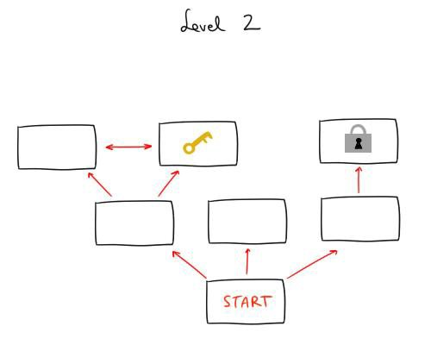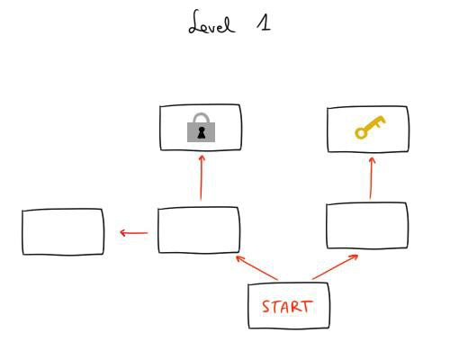

How to solve the **third Labyrinth:**

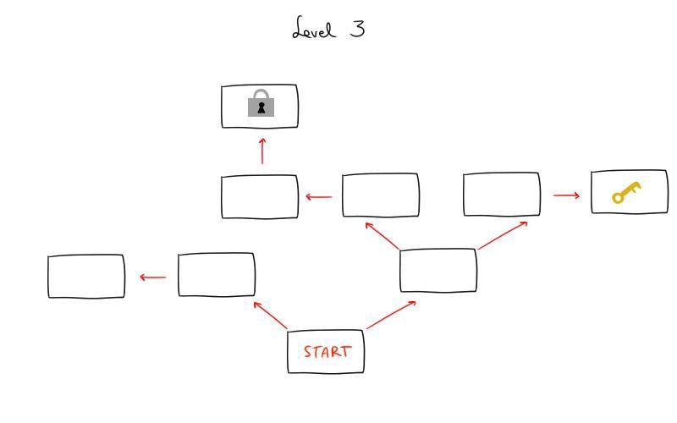

How to solve the **fourth Labyrinth** (2 KEYS):

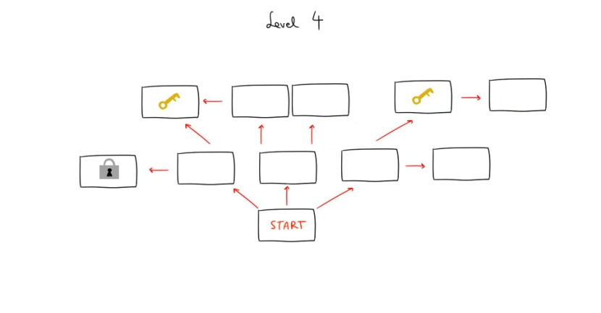

How to solve the **fifth Labyrinth** (3 KEYS):

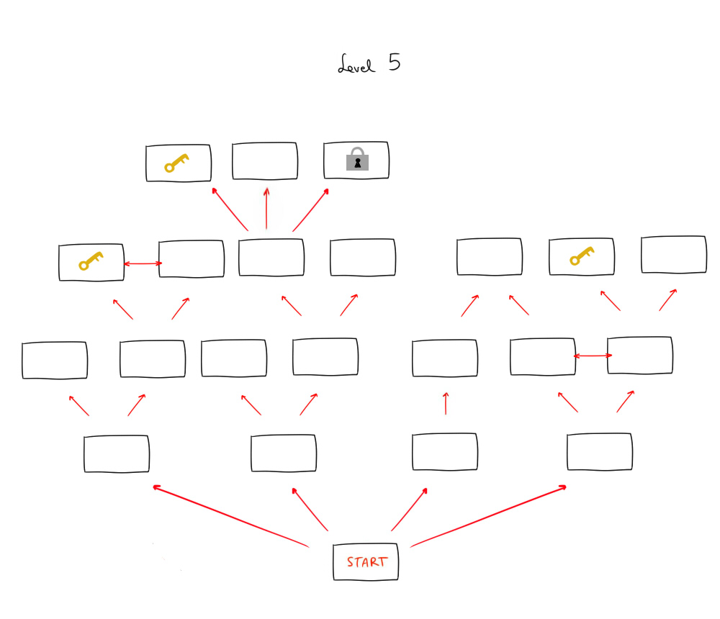

At this point, you'll be able to read the 5th and last chapter of the journal. After reading it, Alison will catch you. Oh man! She will get very angry for that and will shut the door with you inside the storage room. Dramatic music plays, the spaceship is moving... WTF is going on?

You hit your head when the Spaceship is moving violently and you pass out. After that, you get to get out of the storage room. You talk with E-Millio and he doesn’t know anything about what happened because Alison made sure he wouldn’t remember anything. So you need to explore the planet were you dated with her. There're 3 possible places where Alison could be on every planet (in the Lacertan case, two possible places).

Dog planet 🡪 She’s on the Snowy Mountain  
Cat Planet 🡪 She’s on the Badlands

Fox Planet 🡪 She’s on the Whistle Rocks

Lacertan 🡪 She’s on Drullu

After you find her and you save her, there you ask for an explanation and she will tell you everything. (At least everything she knows haha!)  
You will need to choose between forgiving her or not. And of course, if you want a happy ending you'll need to forgive her.

**Note**\*: Depending on the planet you unlock the good ending, you’ll see different H-scenes and foreplays.

# NEBET'S ROUTE

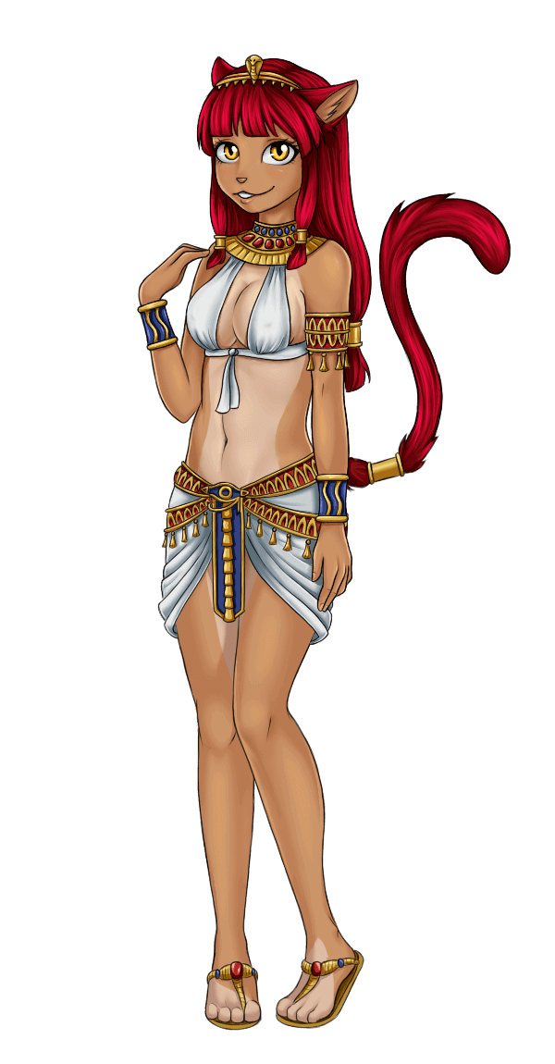You land on a desert planet with an Egyptian town. Go there, and you'll find two cat guards blocking the town's gates. You have to discuss with them and select the correct option to say in order to get in.

There's a hint available if you have knowledge 30+: you have to mess with them. So, you have to select the option that they will make the two cats confront each other. The correct options are:

1. (To strong cat) so you're the boss, right?
2. (To skinny cat) but is he who always speaks?
3. (To skinny cat) I bet he's always who sees everything first...
4. The sight is not the problem dude. He instills more respect
5. Hey! Wait! The most important thing is...Why is his weapon bigger than yours?

Ok, the two cats are now fighting and the gate is no longer blocked. Get into the town, there you'll find some villagers. You can talk with them, but you'll need to talk with the old cat and with the mother cat at least once in order to make Nebet appear.

Talk with her. She'll think you're a messenger of their Gods and you go along with that. Now, you'll need to train your charm (40+) in order to get an audience with the Pharaoh. He's an untrusting old cat but thanks to your training in charm, you'll achieve to go along with all your sham.

Now, talk to Nebet and she'll tell you she wants to take you to their temple to..."take care of you" ;) Accept.

There'll be an H-scene with Nebet and their priestesses (click on the priestess to zoom in the CG) But it seems that after all this passion, Nebet has scratched your back. It wouldn't have affected you if you were a messenger of the Gods... but unfortunately you're a mortal being and you start bleeding a bit. Gotcha!

Don't worry, you explain Nebet everything about your mission and you convince her to help you. She accepts, and after a premonition, she tells you where you can find the jewel with the blue scarab that Pharaoh wants to see (surprise! Roselyn's bracelet!).

So, you'll have to do Roselyn route until you get the bracelet. (Alternatively, to skip this and just get the bracelet, go to your room on the spaceship. Click anywhere on the floor and press the spacebar. In the box that appears at the bottom of the screen, type “shiny thing”. You should now have the bracelet in your inventory.)

When you show the bracelet to Nebet, she'll cheer up and you'll be able to visit the Pharaoh again. Go and after talking with him, now you and Nebet are Friends and you'll be able to date with her.

These are the dates and the order you should follow to obtain all the H-scenes:

**Oasis:** This date is not strictly needed to get Nebet's ending, but it's the most important to obtain 2 of the 3 H-scenes of the dates. Be sure you have trained your strength (you’ll need 40+ to do this date). A pair of bandits will appear and one of them will try to rape Nebet (CG). You must beat one of them (the biggest one!) in a minigame. Take into account that "Claws" is stronger than you and every hit he does will do to you double the damage you do to him. When it's your turn to attack, look carefully at where he's blocking, and attack him anywhere else. On your turn to defend, you'll have to look carefully where he's attacking you to block it successfully (be careful, an uppercut punch starts from below and finishes on your head, so protect it well!).

After beating him, the two bandits will escape, and... Nebet will offer to compensate you for saving her. Now, you’ll be able to choose between Vaginal or Anal Sex H-scene. Don’t worry, you can repeat the date later to see the other H-scene.

**Canyon:** You'll have to obtain a vine that you'll need for the Badlands' date. If you fought and won against the bandits on the Oasis, you'll notice that Nebet is a bit nervous, and she will keep reminding you that she is debt with you for what you did on the last date. So, yes, in order to unlock the Oasis' and the Canyon's H-scene you have to win the fight against "Claws".

**Badlands:** You'll need charm 50+ to unlock this H-scene. Nebet will pass out, you'll have the chance to be a gentleman... or not. If you have enough charm, you'll see the H-scene. In any case, after that Nebet will be naked (woohoo!).

Now you have to use the vine you obtained on the Canyon. After roping down, you'll find an immense cave with an awful lot of water. Oh, and a bunch of rocks blocking the water! You'll have to talk with the Pharaoh again.

Once the date have finished, you'll explain him what you've seen. Now you've figured out how to solve the drought problem. You become friends with the Pharaoh and you have his permission to live on his planet.

Now, you can "**Girlfriend"** Nebet. She will ask you to answer some questions before leaving her responsibilities as a priestess to be with you. The answers are:

1. There are two, one hidden and one visible
2. Your accent and suit
3. There's one of the biggest rivers
4. It's where the essence of the life is
5. Neftet
6. To be with you/ to bang you every day of my life / to know more about you

After answering, you'll get the final foreplay and H-scene with Nebet. Enjoy! :)

# A:\Users\Txus\Desktop\siaren full.pngSIAREN'S ROUTE

Go to the third planet (the green one). After landing, go through the jungle (costs 20 energy). There you'll meet Siaren.

After some chatting, she we'll ask you to join FRY and you finally accept. She will take you to FRY's base and there you'll meet the rest of the members. Once you talk with Gunter and accept to become a new FRY's member your relation with Siaren will change to **Acquantaince**.

At this point you'll need to train your aim with Maya's minigame. You have to get a record of 50 hits in order to further the story. If it is too difficult for you for any reason (not using a mouse, using a bad mouse, actual bad aim skills...), there's another way. Talk with Zaphirus and Zirkon. They will give you the choice to do an intensive training with them in order to achieve 50 hits. If you finally choose this option, you'll spend 10 days with them and your skills will decrease 10 point each! So, it's a good idea to try Maya's minigame a few times before giving up.

Then, click on Gunther's aim button. He'll check if your aim is over 50 points, and he'll give you your first mission. After that, go to the landing zone. On the bottom right corner you'll find a teleport beacon. Click on it. You'll be taken to the floating city.

Talk with the citizens there. After that, a mysterious fox will take you to an alley and give you a paper. Your work is done! But after that you'll see in the city a very mysterious fox wearing a red tunic giving orders to the Vanguards. Keep reading to bring those little children with you.

After that, just go to the FRY's basement in order to give them the mysterious paper you got from the stranger fox. There you will find Siaren. Give her the paper and try to decipher the meaning together.

You’ll need **50 points of Knowledge** in order to solve it, and the correct options are:

1) The numbers and their position

2) The highest numbers

3) Join the points in Fibonacci's order

4) Think of the quote and the kite

It's done! The hint Da Winki gave was "Wind".

Since now, you and Siaren will be **Friends** and you'll be able to date with Siaren. There're 3 available places to go:

- Coast of Lovers

- Whistle Rocks

- Silent Fields

The Silent Fields is where you should go, but it's blocked until you go to the other 2 places. You can go to the Coast of Lovers and the Whistle Rocks in any order and you won't miss any H-scene for that.

Coast of Lovers

To get the H-scene just DON'T be charming. Siaren doesn't like charming guys. If you act like a confident playboy you'll be a mood killer to her. So "Fight against your instincts" and be sure to have Charm less than 20! You'll be rewarded with a nice Thighjob H-scene. :)

Whistle Rocks

As in the last date, the point is not to be charming enough and having your knowledge skill over 55.

If you do, keep talking and select the option **"Take off your clothes".**   
Has anybody asked for a Footjob? :)

Silent Fields

Well, you are in THE PLACE. Da winki’s lair is here but you'll have to find it. Once the chat ends, just put your mouse in the center of the screen. Then, slightly to the left there's a button **"Trees"** that should appear. Click on it. Da Winki's hideout is there, but the door is blocked by a password. Don't worry, it's easy if you followed the story (especially if you are reading this walkthrough lol). The password is "Wind", the hint of the paper. (doesn’t matter if you write “WIND”, “wind” or “Wind”)

If you click on the **"No idea"** button, Siaren will tell you the password, BUT you'll miss the H-scene. Maybe Siaren is crazy but she isn’t impressed by someone that doesn't remind what he deciphered some days ago :)

Once you are in the hideout and after the chatter, clicked on the **"Play detective"** button. This way you'll receive a blowjob. *(Creator's note: Mmm... should I get a job as a Detective?)*

After that you two go back to the bunker and...voila! Da Winki is there! It seems that the FRY members already knew where he could be and for some reason they decided to keep you busy... mm, that's suspicious. Da Winki reveals to the rest of the inhabitants of the planet that the members of the New System are... Lacertans! (the reptilian new race that you don’t know yet)  
After all this talk it is recommended to talk again with Gunter. He will explain you the reason why they kept you busy.  
Now with Siaren you can talk to her, repeat the H-scenes of the dates and Girlfriend her. There's a Quiz you'll need to answer correctly. The correct options are:

1) Tie up people

2) I was a fucking party pooper

3) Air has particles that acts like sex pheromones

4) The wind goes around the mountains

5) There was a white noise

6) A virgin

And this is it! You and the crazy fox girl Siaren are now together.

**VYL DAEMITH’S ROUTE (in development)**

**Attributes needed to get all the H-scenes with Vyl Daemith:**

* Strength: 80
* Knowledge: Between 40 and 50 (not more than 50)
* Charm: 65

This route has a slightly different mechanics to the others.

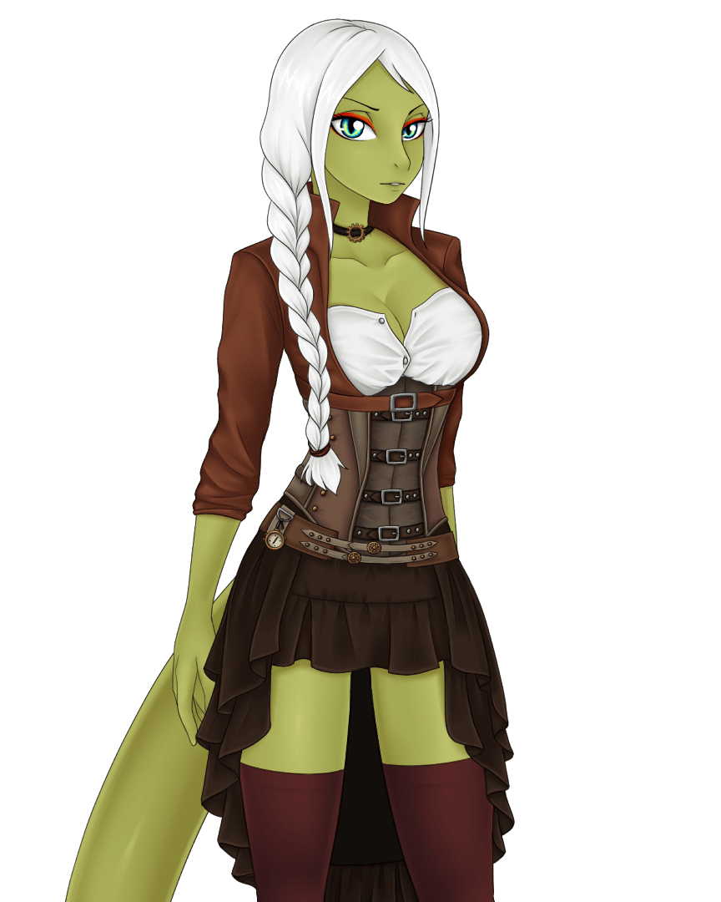

Go to the 4th Planet (brown at right) and there just click on **explore** the planet. You and Alison realize that it’s impossible to live in that planet so you return to the spaceship. This will activate a trigger. 7 days after this event, a Event will start just when you awake.

After this, the E-millio videoclip… you will need at least 60 points of strength to visit their mothership because E-millio thinks that you’re not in shape enough to visit them.

Once you are above 60, just click on the mothership (instead of their planet) and you’ll land there.

Inside a Guard will be waiting for you and he’ll drive you to Vyl Daemith’s throne. There she’ll scolding a Lacertan. Anyway, just go forward and select the option ***“I’m stronger than you***” otherwise you’ll get a Bad Ending.

Thanks to E-Millio’s warning, you’re strong enough to beat her causing a notable conmottion. After this she’ll request you to be her coach.

**Sleep** because the fight will leave you exhausted

(energy 0). The next day, talk with her again (talk, or ask or date…it doesn’t matter the button you click now). She will tell you somebody stole the Gloves of the Golden Sun, gloves that represent the power of the Lacertan’s leaders. You accept to recover her gloves.

Ok, time to visit a bit more the spaceship. On the City, go to the **bar** (at right) and talk with the bartender. Talk with him again and this time select the option ***“Be a gentleman“*** that will require 30 points of Charm and 40 points of knowledge. Now, you can eavesdrop on the bar (left side of the bar). Every try will need 30 energy points and you’ll need 3 tries to find a hint. It seems that a guy called Kor Astrutus took them. This guy work on this boilers, so go back to the city and then click on the rightest part to **go to the boilers**.

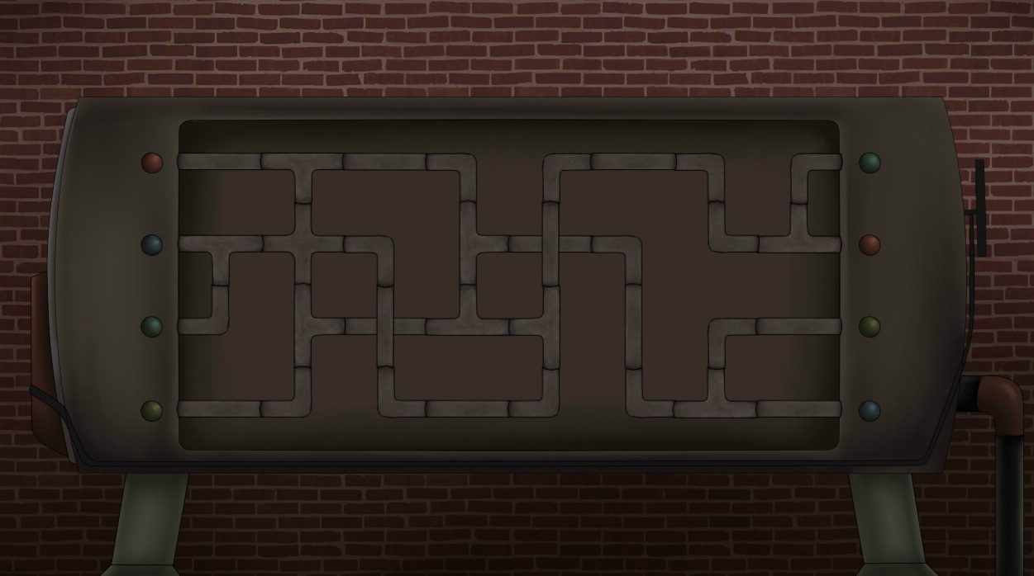

There, a boss will be scolding that Kor Astrutus guy. Then you talk with Kor Astrutus, he’ll recognize you but you’ll found out that he’s…special. Anyway, accept to “***help******him fix the boiler”*** (you’ll need 40 points of knowledge and 20 of energy). A mini game starts here. You just need to rotate the tube parts until all the colors are connected. The solved minigame should look like this:

Kor Astrutus will give you the gloves of the Golden Sun, so now, you can return with Vyl Daemith and give her what she wants (the gloves so far :P)

She’ll be really impressed for that and you two will become ***“Friends”***. From this point you can date her. Two locations will be able at the beginning:

-Bar

-The Green Zone

To unlock the 3rd place, you’ll need to date her on these two places before.

Bar

You two go to the Bar to start Vyl Daemith’s training. In fact, you go to the bar’s basement: a cellar.

In this place, you two chat a little bit and eventually you’ll have to decide between two options. If you want to unlock the H-scene of this place, select **“Sounds Good”** when Vyl Daemith suggests drinking and chatting a little bit with you. You’ll need **Charm over 50 and Knowledge less than 50** for that, though.

The Green Zone

In this place you two keep getting to know each other a bit better. Vyl Daemith explains to you interesting “pastimes” Lacertans have with the other races. Eventually, you two get unexpected company, but they seem to be “occupied” to even notice you two are here. Then, you’ll need to choose between 2 options:  
  
**-“We can’t train here”** date ends.

- “**Take advantage?**” Allows you to see the H-scenes of this date. For this option you’ll need Charm 65+.

After choosing “take advantage”, you’ll be able to choose between:

**“my limits?”:** unlocks 69 H-scene

**“your limits?”** unlocks anal H-scene

Drullu

No matter if you unlock the H-scenes of the previous dates, if you visit these two places, you’ll be able to select the third location when you click on the Date button. An option named **“???”** will appear. Select this and Vyl Daemith will decide to go on with her training on Drullu.

Once there, Vyl Daemith will tell you her story and how she got to become a Vyl, climbing from the lowest status of the Lacertan Society.  
Then, you two start the training (more seriously this time). In the middle of the training you’ll have to decide what movenent you want to do. Select **“Block it and knock her down”** to unlock the the H-scene of this date. You’ll need **80 points of strength** or more to do that.

After dating / training with her in all 3 locations, visit her on the Lacertan Throne room and click on the “Love” button (Heart). You two will confess your feeling to each other but, as with the other girls, you’ll have to answer correctly to the final quiz. The correct option are:

1) Sulphur Dioxide

2) They are free people not very appreciated.

3) You wanted to give your race a new home.

4) For accepting the post, they should come with me.

5) She’s a splendid scientist. She will easily become Shrah.

6) You aren’t being honest with me nor with yourself.

And that’s all. You and Vyl Daemith are now together.

**Harem Route (Main)**

Harem Route is the longer route of the game. It’s a bit hidden on the game, because you have to meet Roselyn, Nebet, Siaren AND Vyl Daemith, and go on until you have their final quiz available.  
In summary:  
- Date with **Nebet** and solve the drought on her planet.   
**Status: Close friend** (don’t forget to help Nebet before Roselyn, to get the bracelet again).  
- Get at least 1 H-scene in any of the datesOR do all 3 dates with her.  
**Status: Friend or Fuck buddy**.

-Kick out the New System from Ytsunne.   
**Status: Friend or Unpredictable.**

- Complete **Vyl Daemith’s** training: do all 3 dates with her.  
 **Status: Friend or Fuck Buddy**  
Don’t complete the girlfriend challenge’s quiz (because you’d get the Ending of that girl and that’s not what we want here).  
  
-Once you’ve done all that, complete Alison’s route. You can choose any planet to do the dates, it really doesn’t matter. Read the diary, the chapters, get caught by Alison, go find her, rescue her. All the same.

Now, the important point: once you’ve rescued Alison and you guys are talking about why you lost your memories and all that jazz, there’s a point when you usually have to choose between: not forgive her or forgive her and love her. OK, so now, there’ll be a 3rd option**: I love you, but there’s more…**Click on this new option. You’ll confess Alison your feelings, and you’ll tell her that there’re other girls besides her that you also love.

Once the conversation ends, the next day you’ll find a note from Alison on the corridor. She’s out and she asks you to stay in the Spaceship taking care of it and E-Millio. Just do this. Wait/Sleep a couple days and she’ll be in your bedroom when you wake up. From this point, just read and enjoy :)

**Harem Route (Easter Egg)**

Easter Egg Harem Route is activated by one of the wishes you can ask Ginny to grant it. So do the requisites to meet Ginny (see how to obtain this Easter Egg below). Make sure to **NOT read Alison’s dairy** before this, otherwise Ginny won’t be able to grant your wish.  
Ok, so now, once Ginny makes you choose your wish you’ll find a new wish “**I don’t want to have a relationship or commitments”,** select this wish.

After this, Ginny will ask you to meet girls that want the same as you. So that’s what we’ll do, BUT, after this chat with Ginny, go back to the Spaceship. Alison and you will talk and after the talk she’ll be in her room and won’t be available anymore. You won’t be able to complete any route with Alison if you’re following the easter egg harem path. From now on, meet Erin, Maya and Kor Beatrix and unlock all the H-scenes of each girl. It’s ok if you already did all those meetings before the wish too, but if you haven’t seen all of their scenes, go find them. Once you’ve met and unlocked all their H-scenes, the next day when you wake up you’ll find Ginny in your room. This indicates you have followed correctly the Harem Easter route. Ginny will tell you that Alison has made a decision. Let’s see what happens :)

# 

# Easter Eggs

# Easter Egg [Dog Planet]

In this world, there's an Easter egg where you'll be able to see 2 H-scenes with Erin, the girl in red of the market. To unblock it, just talk with her before day 13th. Once you've talked with her, go back to the market on the day 13th. When you arrive to the market, you'll see a pair of old (and ugly) ladies in the market instead of Erin. They will bring you to the widow's forest and thereyou'll have to help Erin with a short minigame. The correct order for solving this minigame is:

Yellow, Green, Purple, Black, Red, Blue, White, Orange  
If you succeed, you’ll be able to select how you want to be milk from her :P (Intercourse or Blowjob)

If you talk again with Erin on the market, you’ll be able to redo this and select the other H-scene available.

Now, if you have unlocked both H-scenes and you have visited the Forest with Roselyn, you’ll be able to unlock a 3rd H-scene. Just talk again with Erin and take her to the Forest. You’ll get a new Cowgirl sex scene with her.

# Easter Egg [Cat Planet]

To unlock this Easter egg, don't solve the Cat planet issue until after the day 20. From this day on, visit the well that's near the cat city (click on the left side of the screen, where there're some palm trees). If it's day 20 or more, the drought problem will be quite severe and this will mean the well has less water. That makes possible to see a shiny object at the bottom. Grab the lamp, rub it, wake *Ginny the genie* up, and make your wish. The H-scenes are the wishes "**You have such amazing boobs**" (for a double titjob) " **Threesome   
with you and Bast**"(for a threesome) and **“Sex with Bast”** (only with Bast).   
 **NOTE**: This easter egg can't be repeated in a same game, so save your game before finding Ginny's lamp if you want to try the other wishes.

# Easter Egg [Fox Planet]

# This is probably the most challenging easter egg so far. To unlock Maya's easter egg, you'll need to play the shooting drones minigame and reach at least 100 hits. From this update, you can hit the key “O” to skip this and go directly to the most interesting part :P However, there's another alternative way to unlock it. If you feel you're not good at this kind of games, you're using trackpad or whatever, you can also unlock it trying the shooting drones minigames 8 times. No matter your score, after spending energy and days in the minigame, the easter egg will auto unlock.

# Now, if you want to unlock the 2nd H-scene, you only need to talk again with her and offer your help. And that’s all. Just enjoy this beautiful scene (and the H-scene).

# Easter Egg [Lacertan Mothership]

# To unlock this Easter egg you’ll have to meet Kor Beatrix, a panda girl living with the Lacertans. She’s a worker of the boilers but she’s not visible at first sight. Once you’re in the boilers, just click at the bottom (there’re some silhouettes there) and she’ll start talking to you. Once you’ve done this, go again to the boilers, when your energy is below 20.

# To unlock the second part of her easter egg, visit her from the town (“KB’s place” button) at least a day after the first part of the easter egg, and your energy should be 20 or less. With this you’ll know a bit more of her…and you’ll get an anal H-scene.

# Easter Egg [Alison Solo + Fantasy]

It won't affect to her route, but you'll get 2 nice H-scenes with her if you unlock it. You know there’s a peeping scene at the 3rd day where you wake up and see Alison naked in her room after having a shower, right? Well, the next day she’ll have some sexy fun on her own! But you’ll only get to see it if you have at least **40 points of knowledge by the day 4** and click on her door. (You’ll find the first H-scene).  
After that, you can spend the rest of the day as you please. Once you go to the bed, you'll feel unable to sleep and you will fantasize with her because what you saw that morning had turned you on (2nd Hscene).

**OTHER H-SCENES**

**[Amber]**

You will be able to unlock a hidden H-scene with Amber if you advance on Roselyn’s route until Amber takes you to meet Roselyn (and you do this BEFORE day 17).  
After this, on day 17 Amber will be on Roselyn’s Courtyard. Just speak with her and you’ll get her H-scene.

**[WPG]**

Once you beat WPG enough times on the rock, scissors, paper game to take all of her clothes off, she will offer you VR sex.