LITTLE DEMON ACADEMIA
CHAPTER 4: RESPONSIBILITIES
BY CHALDEACHANGE
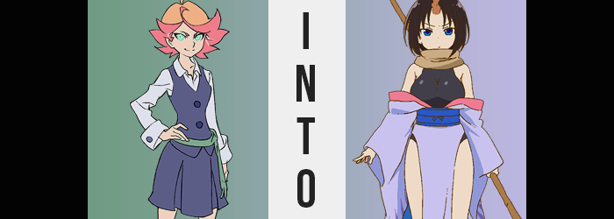

Unlike most of her peers at that time of day, Amanda was neither in her Luna Nova Academy uniform nor her pajamas. And unlike Sucy and Lotte, she hadn’t bothered to study for their test the next day. In fact, Akko’s whereabouts hadn’t even been a topic that had weighed on the witch’s conscience even once even after she’d been a no-show for half of their classes. She counted herself among Akko’s friends, but she wasn’t exactly a close friend of hers either.

No, Amanda was clad in her gym uniform consisting of a white t-shirt and blue shorts. She had felt restless throughout class the entire day and had wanted nothing more than to go for a run, something she was notorious for with her boundless energy. But she hadn’t expected some other girls to want to run with her, and before she realized where the time had gone the sun had already begun to set.

Because she had appreciated the company, she sent off the other girls to clean up on her own as a favor. Not that there was a lot to do to tidy up the racetrack. All she really had to do was collect the pylons they’d used for a few friendly races that they’d waged, but in the ten minutes it had taken her to collect them all, her peers had already all gone back to their dorm rooms.

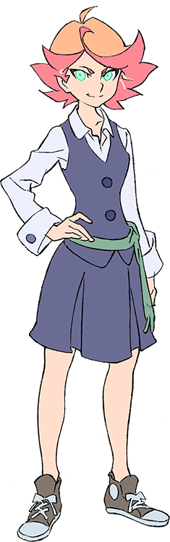
“If I remember correctly, the pylons go… Yeah! There they are!” Back in the storage room for the gym, it took Amanda a few moments to remember where the pylons were stored within. Fortunately it didn’t take her too long, but the sound of something moving nearby did take her by surprise. “Huh? Is someone there?” Someone had definitely moved, and now she could hear shallow breathing. “Are you hurt? Is this some kinda prank? It’s a little creepy, you know…”

Maybe it wasn’t a person? Sometimes the professors brought in creatures to show off to their classes? Perhaps one got loose and ran down to the storage room? “Uh, hello?” Amanda was more than certain that she had managed to catch sight of it. “Whoa!?” It had looked like a human, but not? It was all green, and did it have tentacles on her head?

FORGET WHAT YOU JUST SAW, AMANDA! WELL, I GUESS IT’S INEVITABLE THAT YOU WON’T CARE SOON!

A voice had called out. One that sounded familiar, and yet at the same time it didn’t quite sound human. The girl recoiled, for a bright flash of green light filled the room – and she was fairly certain she felt the energy that accompanied it burrow into her skin. “Forget what I just…? Hey! Who the heck are ya!?” Something about that encounter had certainly come off as familiar.

Perplexing as it was, though, Amanda was very quickly distracted by a chill that seemed to start from the tips of her toes and run straight up to her head. It never peaked at the very top of her head, however, instead seemingly focusing itself on the middle of her forehead. …Where a strange pressure built in the meantime.

“Huh, what’s… OW!?” The mystery of it all didn’t linger for long, for something exploded without any blood nor torn skin from the pressure point, provoking both of the witch’s hands to reach up and feel around for whatever it was. But it didn’t take long, seeing as a protrusion had extended itself from the point of confusion. A horn that was almost like a narwhal if not for its erratic curviness, swirling from side to side. By going cross-eyed, Amanda could see it. It was a brown color that stood out against her pale skin. “The heck’s a horn doing there? Is this some kind of magic?”

Considering she was a witch, this was the easier assertion to make about it. She wasn’t exactly studied enough to consider the possibility that she was succumbing to what was better known as a curse, much less did she have the means to prevent it from spreading – which it verifiably was.

One needn’t look and farther than Amanda’s hair, really. The emergence of her new horn had already split her bangs down the middle, but now their bright orange color was darkening. First to a chocolatey brown, but it wasn’t long before it reached a shade that was teetering on the verge of black. This hair grew finer, and while it didn’t exactly change in length, the natural curls that lifted it at its tips did eventually give way, a straighter styling wrapping messily around her head. Her bangs were the only area where the length had legitimately changed, shortening just enough so that her horn stood out all the more.

In the meantime, the girl’s eyes followed suit when it came to darkening. First to a much darker emerald, but then, as if the yellow had been extracted from the green, they turned wholly to an ocean blue instead. The shapes of these eyes expanded, and yet the look of them suggested something that was very unlike Amanda. She looked very tired. The girl was beginning to feel tired, too. Despite how carefree she typically was, as brows narrowed her expression looked far too serious.

Things weren’t helped as that face rounded some, cheeks growing just the slightest bit chubby while her lips engorged in a way that was indicative of greater maturity. In fact, on the whole, her facial structure was much more befitting of a woman in her late teens. “I don’t get what’s going on here, but it’s really bothering me.” See? Serious.

Yet she’d already turned a blind eye to her new horn in favor of pulling at her gym clothes. Had they always been this loose? No, it had to be related to whatever was happening to her, didn’t it? After all, she was pretty sure the tummy of the shirt had never been so baggy, nor did the shorts fall so low on her legs. Rather, it felt more like she had shrunk. Not so significantly that her clothes were about to fall off, but enough that the fit of them wasn’t quite right.

That situation was quick to worsen. “Oof!?” In a voice that was far deeper than Amanda was typically capable of, this discomfort was made audible once the base of her white gym shirt came to be hoisted even higher upon her torso. It wasn’t exactly without no cause, either. The cups of her B-cup bra were already full (since she wore the right size for her body type), but they had soon found themselves overwhelmed by additional mass, straining the fabric of her top and winding her via pressure alone.

Without any better options to speak of, she plummeted her fingers into the neckline of her shirt and pulled downward. Miraculously, as if she were cutting butter, the fabric tore without any effort at all. Almost as she’d somehow grown stronger without noticing. Regardless, she left a bit of the shirt together at the base, allowing it all to act as makeshift support that just barely obscured to engorged nipples of her now (easily) E-cup tits, ones that jiggled a little with every breath. “My chest is so… No! This is a distraction or something, right? I’m supposed to be worried!”

“So why don’t I feel at all worried?”

Instead, even though she had every reason to be upset and uncomfortable, Amanda had come to just accept the strangeness of it all – on some level even welcoming it. She didn’t even bat an eyelash as her shorts began to tighten around her waist, largely propelled by the expansion of her hips at first, but soon becoming bolstered by a swelling weight upon her ass.

Her cheeks had once been tight and firm, hardly possessing much in the way of extra weight. This changed both rapidly and dramatically, with shorts filling up with an undeniable jiggle that saw buns reshape into those of a fresh, perky peach. While those shorts had loosened thanks to the woman’s height decrease, that excess was left to quickly accommodate her big ass, as well as thighs that took on a rosy tint once the excess weight bled into them.

Even with her hips being wider than they’d once been, her thighs now rubbed up against each other in between her legs. It was clear that her shorts were struggling to contain it all, with the cleavage of her ass poking out the back and the tightness of the shorts around her thighs clear by how hard they were gripping her thighs in the center. The undergarments she was wearing within were just as unlucky, panties grinding in between her cheeks and cameltoeing her pussy – with brown pubes poking out of the sides, of course.

There was nothing about her outfit that looked comfortable now. But it definitely looked erotic, her taut and bouncy body all bound up by clothes that hardly fit her at all. “Change of clothes, please!” Amanda wasn’t even sure who she was demanding this of, really. In fact, she wasn’t so sure that her name was even Amanda anymore.

Someone was evidently listening on the other hand. With a flash of light from the shadows of the storage room came the evisceration of her old outfit, ample flesh breathing a bouncy sigh of relief while something new reformed around them. A sleeveless, black leotard that hugged her chest so tightly that you could see their shapes – which meant it had been specially designed to do that – with a light blue kimono resting upon her elbows.

While her transformation appeared to be complete though, it actually wasn’t. The back of her leotard had a big, gaping hole where her tailbone was, and the location of this bone was made clearer… because it began to protrude. Growing longer and longer the base grew thick enough to fully plug in that hole while it thinned near the tip nearly four feet away from where her back was. At first it remained covered in skin, but sapphire scales soon usurped the tail’s aesthetic while a teal fin not only ran down the top, but fanned out at the very tip. Like the tail of a serpent.

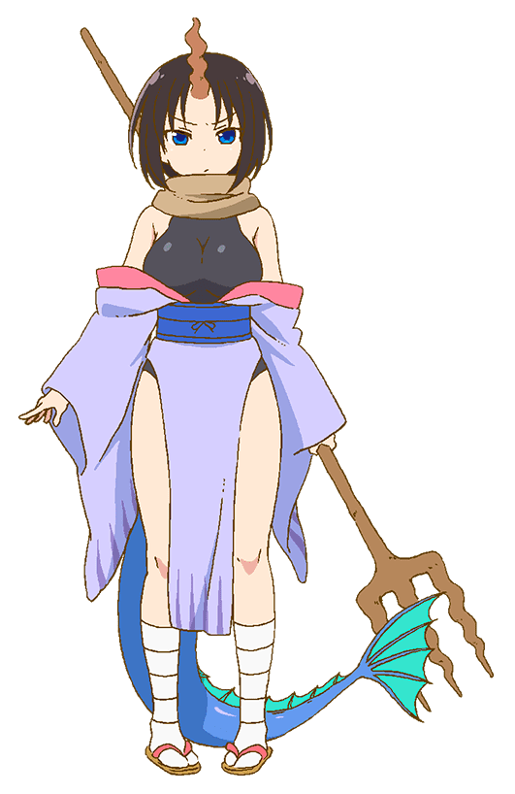
Elma, the dragon, was fittingly flabbergasted by both how she felt and the current state of her memories. There was no shortage of disarray within, and that chaos stood contradictory to the order she was so persistent in maintaining. “Eugh, it really makes me anxious.” And that anxiety made the woman fidgety, pulling at the outfit she’d been forced into wearing. It was unfamiliar and yet wholly familiar at the exact same time. At the very least it was comfortable, even if it left so little to the imagination.

Given a moment more, the fog over her mind began to clear a little more. She could recall that she had once gone by another name. But she had been… transformed? By an entity known as ‘Cthulu-chan’? That must have been the monster she had seen that had transformed her in the first place, and while Amanda would have been upset by all this?

There was a surprising calm from Elma. It was so very easy to accept, but maybe that was simply an aspect of the influence that had transformed her in the first place? Either way, something was happening with Elma that Cthulu-chan didn’t predict. “This just isn’t right. Someone should address this.”

