PIZZA PALS
JUNE 2021 REQUEST STORY
BY CHALDEACHANGE
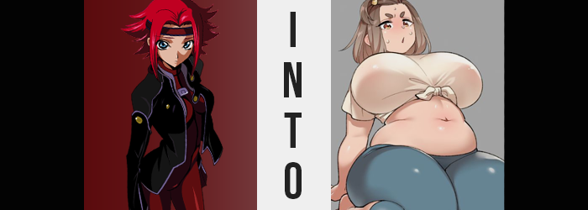

“Again with the pizza? I wish she’d clean up her damn messes!”

Kallen Kozuki wasn’t in the best of moods. Stressed by the day-to-day routine of playing student when the sun was up and being a part of a rebellion during the night as is, the last thing she had really wanted was for more stressors to be added to the equation. And yet? C.C. had suddenly been dumped on her doorstep a few days ago bearing orders from the leader of said rebellion, Zero.

Kallen. Could you give C.C. a place to stay for a few days? I need her to lay low, and I trust you can keep an eye on her.

She’d been flattered that Zero would trust her with such a task, but it was for that reason alone that she had agreed. She knew fully that C.C. could be a handful, and that this wouldn’t be so simple as letting another girl sleep over. And she’d been very, very right.

Every time she’d returned to her home since, there had been more and more pizza boxes scattered around her dorm. Sometimes open, sometimes not. Sometimes upside down, sometimes on their sides. The mysterious girl didn’t seem to do anything short of eat, sleep, and leave her messes around for others to clean up!

“What? You don’t enjoy my company?” Kallen had assumed that C.C. was off napping somewhere, and yet she had turned up in the doorway of the living room she’d complained in. Evidently, she’d overheard that complaint. Dressed only in an oversized, white, button-up dress shirt (did Zero let her dress that way?), she also wore an expression of discontent. “Clearly you don’t enjoy pizza as much as I do.”

Clearly? Kallen almost never ate junk food. She needed to be in peak physical shape to run the missions she did. “All of those calories aren’t good for you, you know? And I’m talking about leaving all of those boxed around!” Her tone was rigid, and the green-haired teen certainly didn’t seem to appreciate that.

C.C. sauntered closer, concealing her right hand behind her back until she could practically press her breasts against the Japanese girl’s own. But at the last minute, she revealed the hand along with the half-eaten slice of pizza held within. Kallen didn’t have time to push her away before she found a melody of cheese, pepperoni, and tomato sauce shoved into her mouth. “MMF!?” Spitting it out would have been gross, so she reluctantly swallowed. “What’s the damn idea!?”

The response? A smirk as C.C. turned her back and strut out of the room. “I just figured I’d make you as big of a pizza fan as me, is all!”

“WELL IT DIDN’T WORK!”

How was force-feeding her a meal she had already stated she didn’t like supposed to make her a ‘fan’ of it? That girl was so freaking strange! But she supposed the sauce had been pleasantly sweet, and the cheese ratio was exactly right… “Huh?” Since when had she been such a pizza connoisseur? The last she’d had it had been years ago at best.

Yet, Kallen had began to smack her lips together, occasionally prodding them with her tongue as if to try and steal away any added pizza flavoring that she could find. Her mouth had begun to water, and her stomach let out a cry. No way! Am I actually craving pizza? That crap is terrible for you!

She turned up her nose at the thought, and that nose? It wriggled on its own just a moment, for its tip seemed to round, and Kallen’s nostrils flared so that it didn’t quite look like her nose. The arch of her eyes? It widened so that they didn’t quite look like her eyes. The brows above them? They thickened and shortened until they were a pair of ovals that didn’t quite look like her eyebrows. The lips upon her mouth? They swelled so that they didn’t quite look like her lips, and yet even though she was smacking them together she didn’t really catch their growth.

Until, finally, Kallen’s face didn’t quite look like herself. She looked like an entirely different girl altogether, one a little older than she actually was, perhaps? Not that this impression was one that lingered, for just as quickly, Kallen’s cheeks then swelled with a chubby weight that rounded it all out, making her appear even more unlike herself than she already did.

“Ugh, why do I feel so dizzy? Is it from eating that? It really was super greasy.” She kept her diet pretty healthy. A soldier had to eat well to perform well, after all! So in her mind, maybe just the slightest amount of unhealthy food might make her dizzy? The teen’s head really was spinning, and her body felt a little sluggish almost like she’d just ran a mile.

But all she’d done was consume a slice of pizza.

Resting a hand on the edge of the nearby couch to balance herself, Kallen remained oblivious even as the color of her hair gradually lost its red, a much more mundane and generic soft brown surfacing in its place. Almost like it was indicating the fact that her fiery personality was at risk of being stripped away just the same. With time, this would be proven to be true.

The girl shook her head. Try as she might, she couldn’t help her mind from wandering back to the pizza she’d just been forced to consume. So warm, so saucy, so delicious… her stomach gurgled, demanding a second slice. And she was almost on the verge of giving into these demands.

In the meantime, her breathing was shallowing, and her school uniform? It was disappearing, only to be replaced with a different ensemble altogether at the blink of an eye. A plain white t-shirt that seemed far too immense for her current frame (so much that it was tied in the front to show part of her belly), along with a pair of blue yoga pants that seemed the same. There was the added accessory of a hairclip that bound her bangs backwards, highlighting the fact that her hair appeared to be straighter and greasier than it probably should have been.

Her tummy rumbled again, and this time Kallen heaved an exhausted sigh. From head to toe, all of the muscles in her body felt as if they’d just given up. “Maybe I’m getting out of shape? I only jogged back to the dorm…” But there were physical indicators that, while her wondering about her physical condition had some merit, she probably wasn’t envisioning the extent to which they had come to fruition.

All of the muscles in her body had relaxed, and upon doing so inflated so that her entire body became thicker. From an observational standpoint, it was almost like her body had been holding in a breath for her whole life, only for it to exhale once and the weight she was holding back to just resettle into place. As a result, her strength dwindled, and her limbs grew chubby – not to mention a few inches peeled directly off of her height.

Even so, her current outfit posed no problem, not even as the softness shifted into a much more pronounced bloating that tore her thinness asunder. “Urp!? Why do I feel so… So heavy…?” Kallen didn’t even think to stifle the pizza burp that seemingly softened the tone of her voice a grade or two, and despite how dramatic the changes to her body were becoming, she’d been lulled into a state where no amount of change would truly register.

It would have caused too many problems for the one that was changing her in the first place had she been allowed full awareness.

Her belly, once firm and toned, was abscessing forward gratuitously, an unhealthy heft stretching the skin and deepening her belly button in the process. The greater it grew, the harder it became for the girl to resist plopping a squat in the couch she was currently using to prop herself up, ample rolls forming on the sides and drooping out while more rolls formed on her back. It really weighed her down, and on the whole? It was a very exhaustive process.

Tits had been met with a similar expansion, her nipples swelling several inches in diameter as the meat her breasts below expanded not only with fat created by an unhealthy diet and lifestyle, but a more natural well-endowment as well. Her body wasn’t held back by the limitations of Kallen’s old form after all, and this was reflected in changes to her general demeanor. Even so, breasts lifted up the tied white t-shirt, showing off her big, pudgy tummy without any iota of shame – but with a bosom that transcended even the H-cup sizing when all was said and done, could it really be considered unattractive?

Big women were just as attractive as thin ones, there was no debate to be had there.

Beads of sweat rolled down her bare tummy, some dripping into her impressively deep navel while others rolled down to her waistline. Keeping some consistency to her weight distribution, her lower half had been rolling out expansion of its own – starting with hips that had no choice but to stretch the elastic of her yoga pants. “Urp!” Kallen burped again, something she was now ‘remembering’ she was prone to doing after eating a little too much pizza. But hadn’t she only had one slice? No… a whole box?

If she’d eaten an entire box, it was certainly all going to her thighs. The blue fabric of the yoga pants was stretched to capacity with how they exploded, each leg rivaling her immense breasts in terms of circumference. Every step would see them jiggle, but then again, every step would see her entire body do the same. Her ass filled out the back of the pants all the same, cheeks big enough to fill two whole seats of the couch were she to sit down, and…

She finally did, collapsing into the soft embrace of the furniture (with a loud creak as it weathered her amplified weight). Kallen looked the part of an overweight teen that likely would have had an incredibly shapely figure were she thinner, but she’d let herself go at some point. It’s fine though, I’m working on it! As long as I burn more calories than I eat, then…! But aren’t I still pretty like this?

Internally? She was a mess. The girl hadn’t actually realized just how much her demeanor had been misshapen into that of a polite, quiet, and lazy girl that didn’t even go by the name she was supposed to. Not thinking much odd of her body, though? She began to lift her breasts in her now grubby, little hands. Why did she feel so horny all of a sudden? And hungry.

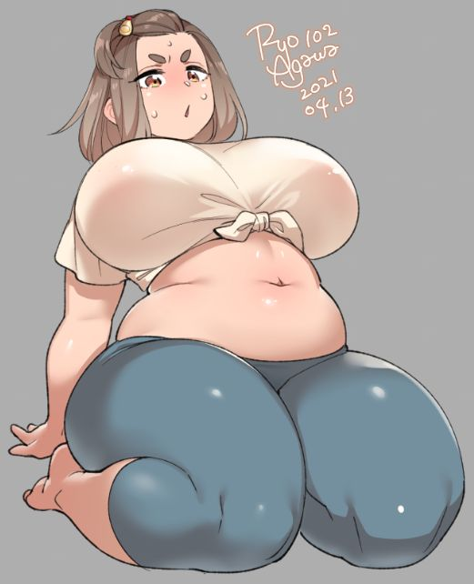
“Oh? I see everything went well. How are you feeling, Kallen?” C.C.’s voice soon broke the awkward silence that had come in the wake of the bigger woman fondling her impressive bust. Had she been her old self, she would have jumped the witch and restrained her on sight for what she’d done to her, but as she was now? There were two major problems.

The first? She didn’t have the motivation even if she’d realized much of anything was wrong. Running, much less jumping someone, sounded like a lot of work and she bruised easily! Hefty as she was, it would have been a struggle to lightly jog for ten minutes. There just simply wasn’t any real muscle to her body mass to speak of.

The second? C.C. was carrying a box of Pizza Hut, the contents so piping hot that she could see the heat escaping from the indentations in the sides of the box. The scent of a fresh pie hit her nose, and Kallen practically felt it hit her right in the soul. Her lip was quivering, her stomach gurgling wildly… it felt like she hadn’t eaten in days, okay!? “Are… Are you going to share that?”

She hadn’t even answered the question at hand, but C.C. took it as one. It seemed that the little spell she’d cast had worked to perfection. Lelouch might be mad at her for ruining one of his top pilots though… Could she spin this to be someone else’s fault? He didn’t know she had this strange ability!

“Why’d you call me Kallen, by the by? My name’s Chizuru…” No, wait? Her name was Kallen! She knew that, but why couldn’t she say it!? Unfortunately, it wasn’t pressing enough of a concern to pull her eyes away from the Pizza Hut box though. “By the way, have you heard anything from Milly? N-Not for any particular reason, I was simply curious!”

C.C. had made sure to alter her memory enough that she felt like a completely different person, but deep down she would still remember things about her old self from time to time. Sooner or later she’d realize that her weight wasn’t supposed to be so… gratuitous. She was no longer fit to be a member of the Black Knights, so she’d replaced all those recollections with fun time school memories, and some where C.C. was a fellow student. There was also that little crush on Milly Ashford she’d thrown in there, just for a chuckle.

“Milly? Oh, I’m afraid I skipped school today. It’s so cute that you have a crush on the president, though.” Smirking, the green-haired girl set the pizza box down on the couch and flipped open the box before gesturing at it. “It’s all yours. I got it for you as a gift for letting me stay.” There was another pizza she’d set aside in the guest room for herself, of course.

Chizuru couldn’t deny that something seemed really wrong here. Why did she keep calling herself by that name? She wasn’t supposed to be this hefty, either! Yet she couldn’t outwardly express that, making her something of a prisoner in this softer, kinder shell. Case in point: the moment the pizza had been exposed, grubby fingers had scooped up a slice.

“Thanks so much, C.C.! You can stay as long as you’d like, you’re no trouble!” Things were a little messy with all of the pizza boxes around, but hey!

She was contributing to their number as well!

