AGD

The After-effects of Chemically Induced Acute Gonadal Dysfunction

A Scientific Paper (of a sort)

By Maryanne Peters NSD MN (Hons)

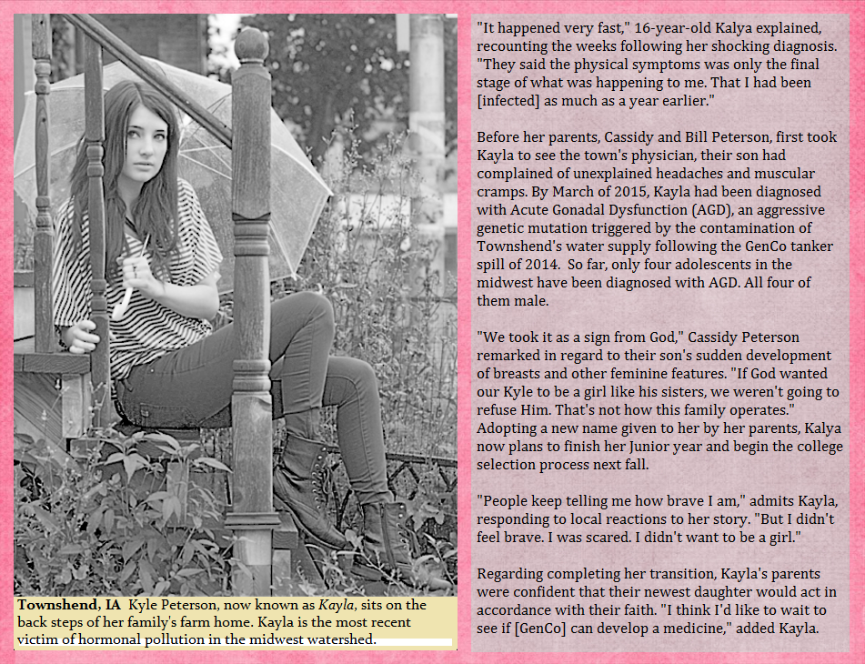

The above is an extract from a story that appeared in the Des Moines Register on April 1st 2018. The publication date made many readers consider the story a prank, but among medical researchers the presence of Acute Gonadal Dysfunction is well known, although research is limited by its rarity.

Some three years before this article appeared the presence of four cases in the state of Iowa led researchers to isolate the cause as being a chemical spill into the water supply of the small town of Townshend in the Southeast of the state. A tanker operated by the pharmaceutical giant GenCo had missed a bend on the ridge above the catchment valley and a large amount of waste material marked for disposal had been discharged into the water quite near the collection point. As a result for only a few hours before the contamination was identified, the town water supply contained high amounts of an advanced form of the pesticide component atrazine, a chemical know to effect hormones in vertebrates (see references below). This chemical was unaffected by local water supply purification processes.

Several people ingested the water and those people were identified following symptoms becoming apparent. The most significant symptoms were only indicated in the male population. Adult males exhibited some breast growth and body hair loss in ensuing weeks, but these effects abated over time.

The most drastic effect was on the four boys the subject of this study, who were pre-pubescent at the time of the ingestion of the contaminated water.

Subject A

While other subjects are referred to by pseudonyms, Subject A has already been identified in the above article as Kyle now Kayla Peterson, a resident of Townshend. As also referred to in the item, because of religious convictions the family of this subject did not seek medical intervention so that the changes brought about by the chemical were allowed to proceed unhindered.

The resulting changes are scientifically remarkable. As well as breast growth the male genitals have all but disappeared in a manner consistent with congenital persistent Mullerian duct syndrome (PMDS), with cryptorchidism [undescended testes] and a radical deformation of the prostatic utricle into a true “vagina masculina”.

The response of the subject’s parents was to urge the youth to adopt a feminine lifestyle in accordance with the physical changes being “a gift from God”. The parents believe that the changes will be total over time and that Kayla will be a fully functioning female in due course, although conventional science must rule this out as a possibility.

Kayla has been accepting of the situation, largely because of medical advice that these changes are progressive and that the only possible remediation would be surgical, which her parents would never consent to. She used the phrase: “I suppose I have to give it a shot”. She has grown out her hair and wears only female clothing, although favoring pants.

She described a period of uncertainty and reluctance that caused her great concern. But her parents encouraged her to “follow the plan God has for you.” She made the effort and presented then as she does now, as a very attractive young woman. She developed a special relationship with a young man she has known for some time and with whom she played sport with as a boy.

I interviewed this young man who confirms that he regards himself as her boyfriend. He appears completely accepting of Kayla as female. He explained that he had known the boy as Kyle for many years and they had been close, but the changes had resulted in them initially becoming distanced. Then, as he explained it: “I looked across at her and realized that she was hot”.

While Kayla did not share the same details of it, he claims that they have vaginal sex regularly and that it is more than satisfactory. Apparently, Kayla is able to receive him fully. I have no reason to believe that his phallus is not of normal proportions although I did not request to examine him.

There is nothing in Kayla’s appearance that would lead one to believe that she was anything other than a young woman, and she appears to relish this new identity. She explained that she has had time to come to terms with her situation and with the support of her parents and her now boyfriend, she is determined to be positive. As she put it: “I was just coping and then (her boyfriend) came along and while I may have been a reluctant girl, I love being his girlfriend”.

Her parents too, seem entirely comfortable with the changes to their child, after an initial period of shock. They regret the earlier publicity and would prefer that Kayla be allowed to live her life as a woman, and they hope as a wife and mother, in private. They are convinced that she will give them grandchildren and I was not about to disabuse them of that prospect.

Subject B

This young person, whom I shall refer to as Janet, is also a resident of Townshend with similar symptoms, but has not been accepting of the drastic changes to her body. Janet’s parents sought medical help from the early stages but in accordance with accepted modern medical practice in relation to genital disorders in young people, restorative surgery was not recommended, and early treatments were limited to drugs. There was no response to estrogen blockers or to massive doses of male hormones. This is not uncommon with AGD.

For the three years in which Subject A went from male to accepting female, Subject B continued to live as a male through an effective female puberty, hiding the developing breasts and placing stuffing in the crotch of her pants. But without any body hair or deepening voice, the fact of the female development was difficult to hide, in particular when the circumstances of Subject A were known to all locally.

By the time of the publication of the above article Janet was not yet 16 but there was already discussion taking place regarding surgical options. Given the lack of response to drugs it seemed to advising physicians that a successful transition to an adult male (or a return to maleness) would be unlikely to be successful. Her situation was very different from a female to male transsexual, and this was something that she needed to come to terms with.

At the time that I interviewed Janet she was living as a woman in a stable relationship with a genetic woman who is accepting of her body. Janet has adopted a female name so that she can present as a lesbian without disclosing any disorder, and to tant extent she is accepting of the changes. However, she remains of an essentially masculine nature.

She agreed to a physical examination. Like Subject A she has well formed breasts, a female body shape, no external organs and a very deep prostatic utricle that may well function as a vagina just as it does for Subject A, should that be required in a lesbian relationship.

Her sexual partner declined to be interviewed, but did say to me: “being a woman is wonderful and I hope that, with my help, she will come to know that in time.”

Subject C

Roberta (or Robert as he was then) was visiting Townshend from Bloomington IL at the time the contaminated water was consumed. For that reason, the diagnosis of Acute Gonadal Dysfunction was delayed on the assumption by her doctor that this was a boy with simple gynecomastia. It was only when the testicles disappeared up into the inguinal canal that the attending physicians made the link with the Townshend water contamination.

Roberta frankly admits that she was confused. But she was an outgoing and practical person and found that a way of adjusting to her circumstances was to accept the rejection of her male peers as her appearance changed to that of a young woman, and instead find company among the female students at her school. It was that new circle of friends that directed her towards an acceptance that the feminine gender as offering her the best opportunity for a future.

Her attitude was pragmatic. Once she understood that a reassignment back to a male gender would involve hurdles beyond even that of a female to male transsexual, she saw the difficulties as being significant. She remarked: “I can live with who I am now. In fact, it is kind of fun.”

Certainly, Roberta is attractive and she appears to be very popular at school where she is active in dance and cheerleading. My understanding is that she is sought after by fellow students of both sexes for her enthusiasm and good humor.

Roberta remains not in a relationship with any person at present, but she is clearly interested in men sexually. One statement she made was: “The only girls who are interested in me are not my type, but the guys are just the kind of people I like.”

She appears ambitious and claims to have little time for romance. She intends working in women’s fashion after graduation and she has a wide group of female friends who share her interest in this industry. While not qualified on this subject her clothing choice would appear colorful and avant-garde and designed to show off a body that is definitely female in appearance.

I also interviewed Roberta’s younger brother whom I will call Andrew. He was a witness to the changes in his brother whom he frankly admitted he worshipped as a hero to him growing up. He told me that Robert had been an achiever and a natural sportsman, but Roberta could now barely throw a ball should she want to. This young man is very confused and even admitted to sexual fantasies about his older sister, which probably reflects the fact that she is “a new arrival” and without the presence of the incest taboo that one would expect in a conventional family.

When submitting to a physical examination Roberta did ask about whether she might be able to become a mother when (rather than if) she finds the right man. I was ready to explain to her that this must remain a scientific impossibility, but I must confess that after the third examination of a subject in this study, and given the same incredible transformation of genitals both externally and internally in all three of them, I rather declined to rule out the possibility.

Subject D

This is a young woman (now) living in Michigan, her family having removed her from Townshend to leave behind bad memories associated with the drastic changes brought about the contaminated water.

This is a person who wrestled with the changes. She adopted a gender neutral name so I will call her Jordan. Being an only child, unlike the other subjects, and being the focus of her parent’s attention they were prepared to move homes to help her to adjust to the effects of the poisoning.

Because of the effects of the chemicals, the physical changes and lack of response to hormone therapies, she found it hard to adjust to life as a young man in an ongoing state of prepubescence. Matters were made worse by substantial breast growth – more than other subjects.

The family moved to another town where it was assumed that Jordan was female, and this seemed to allow for less estrangement. But Jordan remained a loner, and spent much time hiking and camping in the woods on her own. It was on one of those excursions that she met her husband whom I shall call Ken. It appears that they found themselves stuck in a cabin during a snowstorm, and this led to intimacy and eventually to a proposal.

Ken remains unaware of Jordan’s past, but she disclosed to her fiancé that she was very likely infertile due to “a birth defect”. However, my physical examination of this subject disclosed some remarkable internal developments that I had not explored with the other subjects, and in particular what appears to be a cervix at the top of the “vaginal” passage.

It appears that by the time of the wedding Jordan had abandoned her gender neutral clothing and lifestyle as her parents proudly displayed the wedding album of their buxom daughter in full bridal gown, hair and makeup and smiling at her husband. She now presents as very feminine although she says that she remains essentially “an outdoor kind of girl”, something her husband clearly approves of.

Her father did pull me aside to question me about the study and whether the chemical that had brought about these drastic changes in his child was still in existence. I pointed out that this batch had been a highly unstable synthetic chemical that had arisen in unknown circumstances and had therefore been dispatched away from the laboratory for safe disposal – that was the tanker that crashed.

He was very disappointed. He explained to me that he was, and always had been, a transgender person who had watched the changes in his then son with some envy. He said that the changes had been so total and that his new daughter was now living the life that he craved so much, that he would pay almost anything to drink that original contaminated Townshend water.

While the chemistry is beyond the scope of this study, it did leave me curious as to whether the processes might be replicated in a way to synthesize the same compound. Certainly the judiscious use of it to promote Chemically Induced Acute Gonadal Dysfunction may have some commercial applications.

References:

1. “Atrazine can turn male frogs into females” <https://news.berkeley.edu/2010/03/01/frogs/>
2. “Atrazine induces feminization” <https://www.ncbi.nlm.nih.gov/pmc/articles/PMC2842049/>

© Maryanne Peters 2020