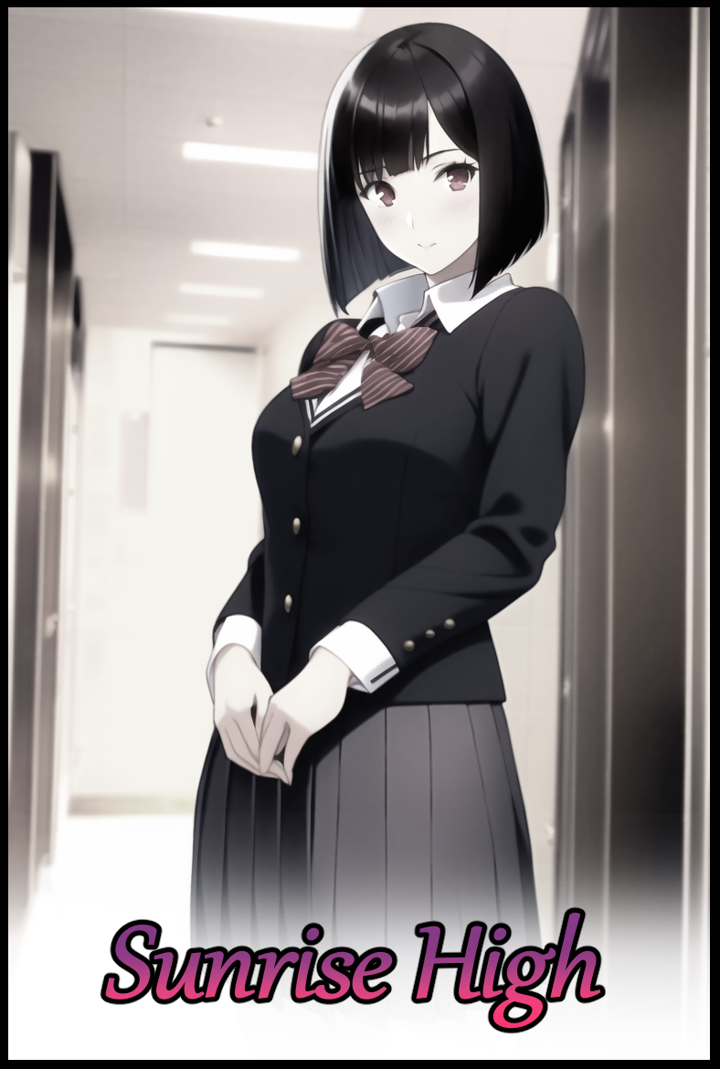

Sunrise High was just an average highschool no different from the many others scattered across the American continent. An institute to nurture young minds in an effort to prepare them for the next step in their educational career.

In the distant past however, Sunrise High went by a different name altogether and it's status as a run off the mill, government backed highschool was thought to be an impossibility by the womenfolk who ran the place all those years ago, a memory many had already moved on from with fewer still clinging on to the false hope that the 'glory days' would return someday.

But one of these individuals didn't simply sit by and twiddle their thumbs, hoping for change to happen without lifting a finger. For they knew the status quo wouldn't budge unless they took matters into their own hands, and with the discovery of a certain something, sinister things were set in motion. Centered around a local highschool and its forgotten history as a series of strange happenings begin to occur beneath the notice of the public eye, all except for four souls who would have the misfortune of being privy to the machinations of the unseen mastermind.

As the saying goes; *Ignorance Is Bliss…*and in the case of the unnatural occurrences plaguing Sunrise High, those words couldn't be more true.

It all began when the highschool's more or less even split in the gender population began to undergo a strange flux in the form of the school leaning on an increasingly…feminine angle. Where one could expect to see groups of boys in their own tight knit groups, the usual cliques gossiping amongst themselves and the occasional straggler going about on their lonesome way just a few months ago. Now there seemed to be more female students than there were made, with some of the new faces occupying lockers and seats once helmed by forgotten folk, gone with the wind and no one wise enough to bat an eye.

All except for Samuel and three other students, forming an unwitting circle once they caught on to the fact that no one besides themselves were aware of what was going on with the school they'd been studying in for awhile now, long enough to notice things like the infamous bully, Zack being replaced by a soft spoken girl named Zola. Or how Mr Frederick, no-nonsense math teacher and a known grump, had suddenly vanished in favor of Mrs Felicia, a salacious minx of a woman with a motherly persona that made her gel well with whatever class she taught for biology…

Besides Hubert, who happened to be Samuel's classmate. The other two hailed from different classes altogether, one of them being Timothy, the classic nerd with a reclusive heart and…as strange as it was, his bully; Dick (not a pun unfortunately). The two were made known to the sudden change when they had overheard Samuel and Hubert exchanging hushed words about the increasing scale of the oddities occuring in Sunrise High and how no one else seemed to notice, not even when people began to be replaced entirely.

Forming up everyday after school, the group would discuss whatever they could dig up while ensuring they remain in close contact with one another in the worst case scenario where one amongst their number would be claimed by this 'phenomenon'. And with each passing day, more and more people were left unrecognizable. Not even the girls were safe when Dick had brought up the fact that Cecilia, the student council president, had failed to show up to class. Instead, Regina was there to take her place, a brooding girl with heavy goth inspirations tacked on to compliment her pale, ghostly appearance. Just one out of many others they would talk about, indicating a marked increase in cases as the days flew them by.

Samuel's gang would do everything they could to try and weed out the root cause of it all. Snooping around for hidden or out of place objects in the school, looking for shady individuals in an unrecognizable setting, and even staking out after school in an attempt to see if anything or anyone was out and about…but at the end of the day, they were just students. Young adults who had no idea who or what they were going up against as they pried further and further into the matter. So it wasn't surprising when the quartet's activities would eventually put them on the radar, akin to staring into the abyss for far too long, earning the ire of its singular, unfeeling eye…

Students, faculty, even the janitorial staff and the contract workers running maintenance. So many people were falling victim to the invisible spell that there was now a palpable fear instilled within the hearts and minds of the four boys, each one wondering when their turn would be and if there was anything they could do to stop it. By the time a month had passed since their initial meetup, Dick and Timothy were left alone with three other boys that had yet to be touched by the invisible hand of change. The nerds Timothy used to hang with? They were more concerned with talking about boys and makeup than they were with comic books and entertainment media. The jocks and flunkies Dick used to have following around in his wake? They didn't have the interest nor friendship with their former leader to carry on with their bullish pastimes, not when they were busy preparing for final year exams to score a high enough grade to progress their studies as every proper young lady should aspire towards…

But now that the 'terror' was so close to home, Timothy's sharp eyes had gleaned important visual information that would both aid and doom the four of them to their respective fates.

A stone, Timothy claimed to have seen Regina pull out an inert stone before slinking into their classroom right after lunch…and when he entered, the sight of Betsy in conversation with Regina, sitting where Brock usually did was all the evidence he needed to be more than certain that the now magenta tinged stone was the culprit…but Samuel found it strange that Regina was the one holding on to it as doubts and questions ran through his mind. Had she been…twisted by its influence? Forced to turn others like it had done to her? Or maybe…just maybe…the mastermind behind all this had recruited her to their side after forcibly changing then giving her whatever that stone was to further their cause…but to what end? The teen could not know.

But before he could bring up an argument, Dick had immediately stood up, pushing the chair that bore his weight so hard it clattered to the floor of the library they met up in, anger and frustration burning in his eyes instead of the almost depressing cinders they once were. Now that they had a face to plant over their invisible enemy, Dick was eager to pay Regina back for what she had done to his boys, claiming confidence in his strength and how there was no way he'd lose in a physical confrontation with the 'emo bitch', refusing to listen to the others as he shoves aside two curious bystanders blocking the way out, followed after by a hurried Timothy.

Over the course of this one month, both bully and victim had sewn an amiable link together, one that would nurture and strengthen into a strong bond of friendship after putting their heads together to solve the case. And despite their tumultuous history, Timothy couldn't just stand by and leave Dick to do this by himself, saying how he'd back him up if necessary.

Samuel and Hubert would remain in the library with bated breath, keeping in contact with Timothy over messaging as he struggles to keep up with his irate friend, providing details regarding his location and the situation whenever he could.

[Running along hall now, Dick's not stopping.]

[Slowing down near computer lab, think we've found her…he's not waiting.]

After that, there was a long, worrying wait as the two boys sat rooted in their seats, wondering what was happening beyond the sidelines. Until eventually, a reassuring beep sounds from the phone, except what Timothy had to say was anything but;

[They changed him, not himself anymore…]

[They're talking now, can't hear…]

[This is bad, I think she to-]

Before they could finish reading what Timothy had sent, the phone screen flickers for a brief second before returning to normal, erasing the entire message history Samuel had with Timothy as the display returns to the homescreen of the messaging application, instilling panic in the two of them as they rush to figure out what happened, denying the worse case scenario as they scroll through their respective phones, hoping to see Dick and Timothy's details safe and sound.

To their dismay, both names and their associated contact numbers had been struck from existence with morbid implications alongside a hint as to how thorough and far reaching the effects of this stone was. If their numbers and messaging history had been erased…then that meant-

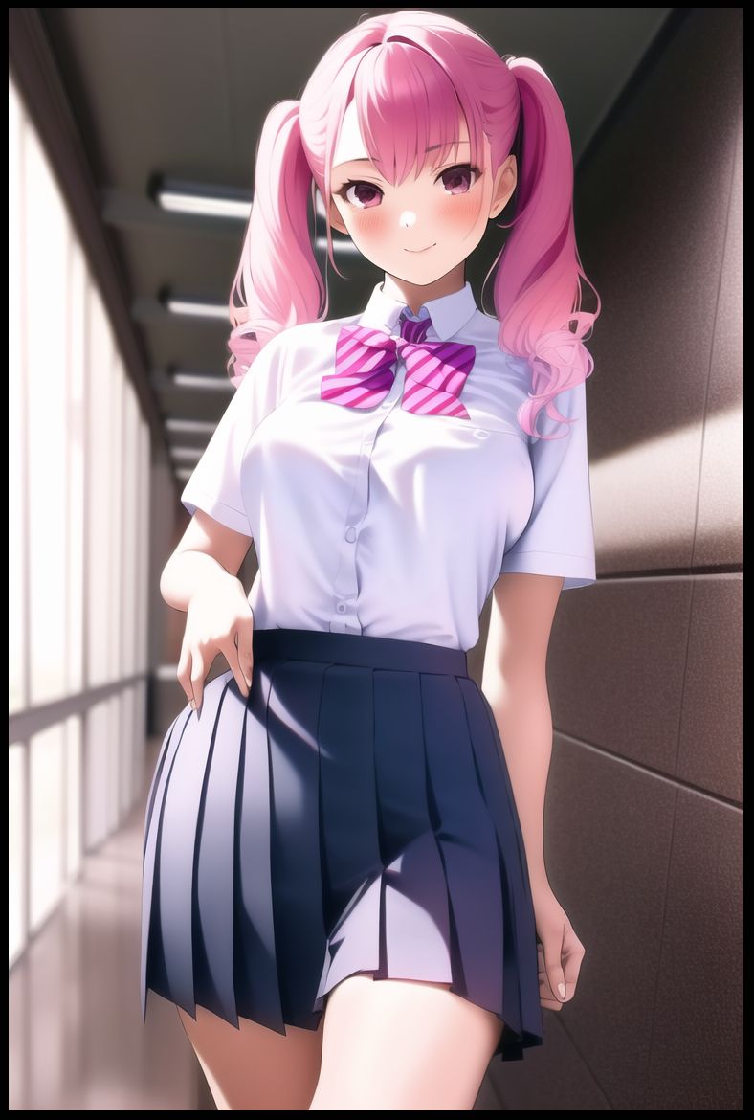

**"How nice it is to see you two still sticking around after that shit you tried to pull on me…Tiffany? You can go now, thanks for the assist…”**

**“Aww, don't mention it~ It’s the least I can do for you Regina!"**

The jig was up, and before either Samuel or Hubert could react, their arms were bound behind their backs by girls they had never seen before, quickly confiscating their phones in the midst of the confusion and panic. And there, before their eyes surrounded by two more matching bodyguards that looked like twins, was Regina herself, accompanied by a spunky girl with an eye catching head of gaudy pink hair done up into curly twintails that pour down the sides of her small, rounded shoulders, bringing the eye down towards her fashionable face and her modest assets hidden beneath a pristine uniform. But her name…she couldn't have been…

Not giving the two a chance to talk with her and upon Regina's interference, Tiffany promptly turns to leave the library, skipping on her heels with a bounce in her step, leaving her former companions to their fate shortly after joyfully rafting them out with the residual traces of Timothy's mind before subsuming it entirely for her own image.

In the span of a few minutes, their secretive operation had been dismantled. Losing half of their number alongside being found and apprehended by those they sought to seek out and bring to light themselves as they struggled to break free from their captors iron grip, all while frowning in a mix of fear and anger at the vile pink light emerging from between the clenched fingers of Regina's right hand as she extracts the stone from her skirt pocket, intending to finish the job once and for all while muttering snide remarks about them sending muscle in an effort to rob her.

But before she could wreak havoc on the two of them, a call interrupts Regina, evidently an important one if her entire demeanor seemed to change into that of an earnestly devout follower talking to their leader. Using proper words and a gentle tone as she spoke in an effort to defend her impetuous behavior. And when she was done, Regina's foul temperament, a perversion of her former self, was back in earnest, clicking her tongue as her eyes soured at the look of the boys before her, stopping her gaze as it comes to rest on Samuel, looking him up and down with disdain as if he was the lowest form of scum on the planet.

**"Looks like today's your lucky day…someone wants to see you…girls, you know what to do.*You* on the other hand…you'll do…"**

Wresting Samuel away from Hubert's side with a hand tightly held over his mouth in an effort to stifle his defiant tells, the two friends were forced apart, permanently putting an end to their little group as the girl holding him hostage escorts Samuel like a convicted inmate outside the library, earning a few stares and hushed murmurs from the swarm of girls passing them by. But none of them seemed disturbed or intrigued by the sight of a student being treated so harshly…not when they all had their minds and bodies adjusted by whoever had repurposed Cecilia into their willful pawn.

Not even stopping to rest as they hurried on up through flights of stairs and down corridor after corridor in a familiar place turned hostile and foreboding, Samuel's struggles eventually bear fruit in the form of his neck slipping free of his charge's grip, knocking the student in the head hard enough to break free before dashing towards the closest door he could find, slamming it shut behind him before locking it tight. Adrenaline and fear masking the searing pain at the back of his skull and the irate cursing from beyond the door.

**"Oh? Well aren't you a looker~ Whatcha doin' runnin' in here all sweaty for stud? Eager to have some fun with lil ol' me huh?"**

Turning in surprise toward the sultry voice wafting in from the blackboard in front of a neatly arranged row of computers, Samuel back's himself up against the door in shock at the sight of a tanned girl wearing an altered set of the girls uniform that made her look like…to be frank; a slut, sitting with her long, curvy legs spread wide apart, woefully short pleated skirt doing little to hide the plump lips of a camel toe pressing up against silken lingerie adorned in rose motif, sitting with her attractive body thrust forward, emphasizing her petite yet firm bust to the sole male in the room through a popped button atop her suffocatingly tight top with a cutout exposing the entirety of her toned belly and supple back.

Judging from the minxy look on her face framed by a well cared for head of dirty blonde hair tied into a long flowing ponytail glowing in the afternoon sunlight, the shameless gal had no issues with how much skin she had on show, in fact, her advances only seemed to grow once she noticed how her promiscuous advance had an immediate effect on Samuel, rising off the chair she had laid the cheeks of her bubble butt on long enough to leave an imprint behind as she saunters toward her prey, running a wet tongue over her pillowy lips while her attractive eyes narrow in l

**"Whatcha scared for? Pretty gal's for your tongue all tied up? Mmmhm~ Stay right there, and I'll…take care of that for ya~"**

Too panicked to realize he was standing in the computer lab where Dick himself had vanished into in an attempt to ambush Regina who had not been alone, Samuel's back, pressed up tightly against the door, immediately sends him falling backward as a key from the other side frees the lock, cutting his view away from the pervert and toward his pissed off escort with a bruise on her forehead, wasting no time in hauling him to his feet with a growl to keep still whispered into his ears.

**"Uh oh! Looks like someone's in trouble~"**

Whether or not that ditzy gyaru had a hand in keeping him busy to stall or her presence was entirely coincidental was a matter Samuel would never know the answer to, not when he was being hauled away at an even faster pace, taking him to a part of Sunrise he'd never been to before; the general office and then eventually, the principal's office as his guard raps her knuckles on the door three times, entering with a curt bow before depositing Samuel inside, taking her leave without a second word and one last furious gaze cast his way, leaving him alone with the one person he had never suspected to be the one pulling the strings behind the events of the last few months; the newly inducted principal who had come into her position of power around the same time people started changing.

**"P-Principal Tanner?"**

She would offer no response to the accusatory tone in Samuel's startled remark, saying her name out of disbelief rather than in a manner asking why he was here, simply rapping away at the keyboard of her computer, unfeeling eyes laser focused on the screen with whatever it was she was doing…before suddenly piping up without diverting her attention from the computer.

**"Samuel Haden…yes? I had my reservations after Cecilia…but to think a *man* would be able to resist the influence of the stone…no matter. If the other three can still be remade through direct exposure…then I'm sure you'll follow suit just as well."**

**"Other…three? What did you do with Hubert?!"**

**"What did I do? My, my, so quick to blame, typical. Tiffany and Erica, you've already met I assume. They were critical in divulging information related to whatever it was you four hoped to pull off. Everything the stone touches, I see and hear. And…ah, dear *Helena's* enjoying a warm afternoon session of cheer practice right about now…"**

Left with nothing to lose upon the reinforcement of what he dreaded go hear, Samuel struggles to keep the urge to beat a woman far above his age in check, even more so upon the sight of Principal Tanner rolling another stone in the palm of her now relaxed hands freed from the computer…except her eyes remained elsewhere, as if she didn't want to see a lick of Samuel in those dull brown eyes of hers.

**"W-Why are you even doing this? Why bring me here? Just change us back!"**

**"Why, you ask? For the restoration of Sunset High's former glory of course. A return to form I intend to enact upon this wretched shell of what once was…starting with the student body…this place is supposed to be a haven for young women…and it shall be again…but a haven needs an enforcer to keep the peace. And as you no doubt saw, Regina is hardly a capable candidate…brash, ill minded, prone to impulse…but you, I sense the makings of great talent inside that rotten shell of yours…and with the stone's power, I can help it…*nurture*."**

**"You won’t get away with this! You can’t ke-”**

Ruthlessly cutting Samuel off midspeech with a disinterested look on her face, the woman fondles the stone in her hand, this particular specimen shining an ominous red as it works it’s invisible hand on Samuel, freezing him mid stance and triggering a series of physical changes that aim to deform the protesting boy, reshaping him like putty in whatever form Principal Tanner desired as her gaze finally turns to focus on Samuel, but by then, nothing was left of the former boy to even call him by that name anymore, painting a smirk on the woman’s face as she sculpts and carves, painting ample curves, an innocent yet attractive visage adorned with slant, almond shaped slits, a cute nose and warm rosy cushions to frame a soft spoken mouth. Finishing it off with a neatly trimmed head of raven black in place of drab brown, frayed tufts softened and cut into a prim bob, all while a skeletal frame widens outward to conform to the demand and allure of a blooming lady’s hourglass figure.

Invisible tendrils of magic stroke at an erect cock, coaxing it inward bit by bit, creating a new home for the shrinking pecker by repurposing emptied testicles into smooth sacs of sensitive nerves and moist folds, gouging out a heated canal leading up to an as of yet, empty incubator situated just below a trained navel lined with balanced layers of baby fat and toned muscle between handlebar hips. Atop which hangs two fleshy melons tipped with inverted nipples cleaned of hair and colored flush red in irritation as silken fabrics move to form a fluffy pink bra to support the hefty D milkers masked unsuspectingly behind a thick blazer and the usual undershirt that made up the girl’s uniform of Sunrise High while matching panties sling themselves around the inflated cheeks of a massive butt before giving the newborn girl’s vagina a good tease as the cotton undergarments finishes forming around them, concealing the tiny crown of pubes above the virgin slit with the finalization of a pleated skirt falling down around stocky legs formed from thick thighs and strong calves, tapering off into waifish feet clad in socks and polished sneakers….

…all while synapses in her brain exploded like fireworks on the fourth of July, thoroughly frying away her old self while new memories, knowledge and habits seed themselves in her very being, giving rise to someone else altogether from the ashes of the old.



By the time it was done, Samuel Haden as he was, no longer existed. Irrevocably replaced in both body and mind by *Samantha Tanner*, sole daughter to the principal of Sunrise High and the newly elected student council president. Information she was now more than aware of as she folds her arms before the front of her skirt, performing a graceful bow with a familial smile on her face, the ire and hate burning in her now crimson irises forever lost to the ether alongside the memories of her old life…bowing before the woman that had taken everything from her without hesitation.

**“Is there anything else you have for me Mother?”**

**“No…I think that will be all for the monthly report…keep up the good work alright dear? I have high hopes for you…”**

Seeing her off with a smile on her face that showed more kindness than she would’ve liked, Principal Tanner turns her focus back to the screen, showing the completely altered records of Dick, Timothy, Hubert and Samuel…or as they were known in this rewritten reality; Erica, Tiffany, Helena and Samantha, eyes lingering over the face of the young lady on her screen, a visage that bore a startling resemblance to the Principal back in the old days when she had been around the same age. Something she’d never thought possible till now after months of testing had brought fruition to her plans of remaking this sorry institute from the ground up the way it was always supposed to be.

First came the discovery of that unsuspecting stone in the backyard after a sudden sizzle had roused her from her sleep. Then came the accidental discovery of its unique properties after getting into a fight with her then husband-turned-housewife she kept around the house to do the chores butt naked save for a skimpy apron; the very thing he looked for in women apparently after she’d told him off about his snide remark about women leading easy lives, turning into the perverse caricature of a dutiful wife envisioned in his mind…all while the stone she used as a mantlepiece burns red as if in response to her fury…

From there, her days of silent wishing to return to the past were over. With her newfound power coupled with determination and grit to achieve the impossible, she had worked her ass of, doing all she could to rise the ranks of the educational ladder until she was fit to become Principal, replacing Sunrise High’s previous head upon her retirement, free to enact her plan of change within what she saw as a ruined home. Learning how to refine the process of transforming someone, replicating the stone into lesser ones that drew from the main piece, linking her mind with the stone and its replicas…and finally; thoroughly rewriting someone’s existence to fit prescribed conditions just like what had happened with her former husband. Producing the daughter she never could’ve had thanks to her infertility. A defect that left her in shambles and her husband ashamed of her…but none of that mattered now, not when she had been given a blessing in the form of Samantha, a girl she envisioned what her own daughter would have looked like if she were able to bear one. Overlaying her over a template that had once been someone else, uncaring of the consequences faced by the Haden family with the unknowing loss of their son…

Principal Tanner could care less, they could make another child, she couldn’t. And if anyone were to get in her way or lay a hand on her Samantha…well, there was always the stone to fall back on, curling her sincere smile into a wicked grin as her eyes reflected the red glow burning in the core of the crystalline mass. There were only a handful of men in the school left to convert, and once that was done, only then would Principal Tanner’s ambitions truly begin in earnest…

Unbeknownst to her however, some fragments of Samuel had survived her purge, living on in Samantha as she strolls down the halls of her school as if nothing had happened, bright eyes scanning the empty classrooms and silent stairways with a half lidded look of serenity.

Everyone had gone home to enjoy a Friday afternoon with family, friends and whoever else they knew, leaving just the clubs left to populate the school. And while she was taking her own sweet time wandering the halls, her belongings were stowed away elsewhere far outside the main building, beyond the fields near the stadium where she was supposed to meet someone…ten minutes ago. But Samantha didn't seem to mind. This was one case of tardiness she would gladly accept, especially when it came to her. 

Enjoying the mild afternoon breeze billowing by her cheek as she crosses the grassy field toward the sports stadium with the occasional student waving her goodbye, Samantha's visage warms at the sight of a girl running up to her from the back of school's immense sporting facility, waving pom poms at her while dressed in clothes she wouldn't particularly consider safe for casual wear…but her eyes couldn't seem to leave the girl's amazing figure, rippling with lean muscle and wrapped up in yellowish beige skin that was as smooth as hers…a fact she was intimately aware of as she braves herself for a bear hug by the charging cheerleader.

**"Took ya long enough! Your mom chewed ya out or somethin'?"**

**"Please…she would never…and I just wanted to leave you cooking under the sun for a little while longer~ Payback for the stunt you pulled earlier today!"**

**"Oh c'mon! That was Erica's idea!"**

Snuggling against Helena's bare shoulders while taking in the feel of her closest friend's belly rubbing up against hers, Samantha frees herself from the hug if only for a moment, standing on her tippy toes to land a kiss on her slick nose, earning her a chiding and a giggle as the two lovers exchanged friendly words between each other.

For the longest time now, she'd harbored feelings for the unlikely cheerleader she hadn't expected to fall for in her three year tenure of being student council president in the school her strict mother ran. Although lesbians weren't a rarity in the predominantly female population, she suspected that such an environment had transformed her friendship with Helena. Turning them from girlfriends since middle school to a bona-fide couple, keeping their relationship a closely guarded secret in fear of Samantha's mother finding out.

Would she want her to find a proper man to marry? Did she keep their maid walking around the house dressed so shamelessly because she liked her or something else? Did that mean she too was a-

**"Huh-loooh? Helena to Samantha? Ya listening to me?"**

**"W-What? I-I'm sorry Helena…I was just…thinking about our relati-*ahhn!* D-Don't do that here!"**

A sneaky hand under the skirt, a brief caress of her loins before fingers suddenly enter into a pinch, squeezing her clitoris through the fabric of her panties with immediate results in the form of a gushing waterfall jetting out of Samantha's stimulated urethra.

After sharing a bed with her friend for the umpteenth time now, Helena was more than aware of what made her tick, knowing that when she said to stop, she really meant to say 'keep going', and that was what she did, pushing Samantha back all while a dexterous hand free of its pompom works on her lover's snatch, peeling apart her soiled panties, pushing her against the tree that kept them hidden before bowing a little to lock lips with her, exchanging fluids while the bashful student council president quivers in shame, vaginal juices trickling down her soft, heated thighs in the throes of orgasm.

Popping open her top, Helena's heart pings with a sense of jealousy at the sight of her future wife's tits hanging out like swollen balloons, parting from her kiss to trace her tongue across the curved length of Samantha's left breast, ending with a bubble that sends the girl into a fit as her curvaceous form twists and turns in agonizing bliss, palming both hands over her mouth if she hoped to stifle a scream of ecstasy she couldn't control.

**"Payback huh Sammy? Lemme…show ya a thing or two about that word~"**

**"P-Please! H-Helena?! If we get caught my mom will-OH MY GOD~!"**

**"Keep that shouting up and they'll find out~ That voice of yours is just too good t'stop now…"**

And so the two changed ladies would continue to make out under the obscuring shade of the lone tree by the back of the stadium, their two forgotten bags leaned against each other like their bodies were, pressed up tight in coital union. Finding solace in what should've been an otherwise bleak ending.

Very soon, Sunrise High would return to its former status as a private, all girls school for the bright. And until then and even beyond, Samantha and Helena would remain happy and content, as long as they had each other close at hand…

THE END