DANGEROUS STEREOTYPES
COMMISSION STORY
BY CHALDEACHANGE
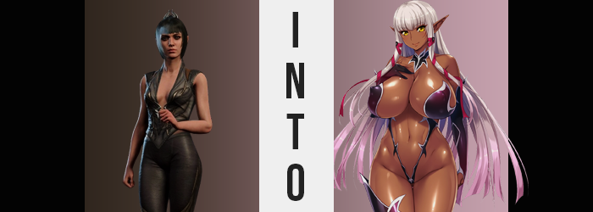

“Isn’t our quiet little camp supposed to be, you know, quiet at night?” Gale murmured to Wyll beside him, the two resting alongside the campfire the duo of men listened to the sound of what seemed to be two women screaming off in the distance. “Feels like it’s becoming a little more common between those two as of late, doesn’t it? I’m surprised Astarion hasn’t resorted to making his usual passive aggressive comments about it during our travels.”

Wyll merely chuckled and took a swig of her mead. “Not sure if I have any right to complain after how I ended up joining this merry band of adventurers.” He’d stormed into the camp looking for Karlach one night himself, and then fate had handled the rest. “But even Astarion doesn’t seem to have very much of an appetite for pissing off Lae’zel, does he?” The two shared a chuckle over their drinks.

But they were the only ones laughing.

“Ugh, she is so insufferable.” The woman on the other side of the argument that everyone else in the camp had overheard was Shadowheart. A follower of Shar who was presently in the middle of undergoing a great trial through which she had lost her memories, she was one of many that had joined the Tav’s party after coming to terms with the fact that they all had little, literal brainworms that would one day turn them into terrible monsters if not treated.

It had begun as an alliance of convenience between most of them, but with time legitimate friendships and mutual trust had been forged. Unlikely friends and allies had been forged, and Shadowheart even considered the githyanki Lae’zel to be among them. Even despite instances of her trying to take the lives of the Tav and the others in the recent past.

But the half-elf wasn’t exactly all that innocent herself. She had a barbed tongue that she couldn’t keep still, and the sharp comments that she made about others often led to arguments even with those she felt closest to. “Taking the last scrap of meat and then telling me I didn’t ‘deserve it’ because of what I’d said… I put in way more work than her today!” All for calling Lae’zel ‘slimy’ earlier on!

Well, perhaps githyanki found it more offensive than the other races?

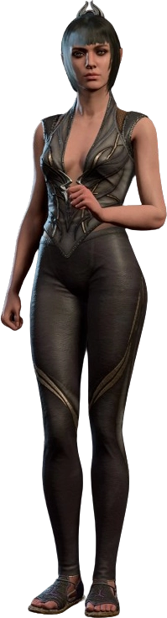
“That’s… not the point!” Shadowheart set her ass down in her own personal camp now that she had returned, pushing aside any thoughts of potential culpability for the time behind. At least she wouldn’t need to worry about any further interruptions that night. She always made a point to pitch her tent as far away from the others as she possibly could to avoid any unnecessary noise. Which was a little but ironic with how loud she and Lae’zel had been not even ten minutes prior.

Not yet ready for bed (because she was still agitated), she began to sort through her pack. Anything she picked up during the day was stored there, and sometimes she picked up things that needed to be disposed of later. Food scraps, weapons, gemstones… “Hm? When did I pick up this?” But on rare occasions she would find things in her pack that she couldn’t really remember grabbing in the first place. “Did the Tav shove it in there without telling me?” That was a very real possibility. Why were they always overburdening themselves with supplies?

The object in question looked to be some kind of pocket mirror? It didn’t seem to be that old, but Shadowheart could tell that it was some sort of magical relic. Probably the sort that Gale would enjoy feasting on. But if the Tav had really put it in her pack then that probably wasn’t its intended use. Otherwise, they would have just given it to Gale in the first place.

She opened and closed the mirror several times in quick succession, wondering if she should toss it out or not. In retrospect, it was a rather foolish idea to apply so much force to a magical item that she didn’t understand. Because of all of that fiddling? It had prompted it to activate, connecting the mirror with energy from another world. It began to feel warm in her hands, which eventually stirred her into realizing something was wrong. “Erm…?”

Shadowheart stopped her fiddling with the mirror open and caught sight of her reflection in it. Or… no. That wasn’t that her reflection, was it? Who was the dark skinned elf looking back at her? “Who are— HEY!?” The elf in the mirror had mouthed the same words she was speaking. But only until it shot a beam of light at the half-elf, temporarily stunning her and eventually pushing her to stand up in a panic once that stun had worn off. “What in the name of Shar was that!?”

Generally speaking, being struck by what could best assumed to be an unknown magic was typically never a good thing. You were liable to suffer unintended effects, and they typically weren’t boons. There were very few corners of the world that didn’t contain stories of men and woman being turned into toads, chickens, or any other manner of creature through the misfortunate of interacted with a cursed magic item, whether intentional or not.

“But usually, those effects are instantaneous. Had my status changed?” That didn’t seem to be the case. She didn’t necessarily feel much differently either, aside from perhaps being a touch warmer than she recalled. Shadowheart could easily handwave that as a mere side effect of the shock she felt in response to what had just transpired. But if, say, hypothetically, a character sheet was a real thing she could access? She would see that ‘half-elf’ had been scratched out beside her race, with ‘dark elf’ etched in beside it.

Normally this would be impossible but there were things that indicated that it wasn’t merely possible, but the cleric herself was the victim of some sort of ‘changed identity’ curse. The tips of the half-elf’s ears were growing a little bit longer, but more than that those tips had darkened. A rich tan had plagued them and was moving down towards their bases before the darker color seeped into the rest of the woman’s face.

Not that this was something she could readily observe just yet. “I suppose not… But I do feel a touch too… frisky.” Shadowheart felt like she was usually fairly good at keeping her sex drive in check, so why was it she could feel her arousal deepening? Was it a side effect of the mirror she had dropped? While contemplating this, the tan spread through the woman’s facial features and seemed to rearrange things a little bit in the process. Her face’s shape softened in places but sharpened in others. All in all, structurally that face was ultimately left looking far more mature due to lips puffing up and eyes narrowing with lengthened eyelashes. But the shapes and decorum of her eyes was hardly as alarming as the yellow speckles of her otherwise green eyes becoming the dominant color, ultimately replacing them entirely so that her gaze had a golden glow to it.

“Mmn… Hm? Were my lips always so…?” It was a first. The woman had noticed her body was changing, but only because her growing arousal had pushed her to bite her lower lip suggestively. That lip was so much larger that she finally noticed and raised a hand to poke at them while the tan slipped down beneath her camp clothing, destined to spread out to her fingers and toes until her body was covered entirely by the dark caramel tan. Patches had begun to develop all on their own elsewhere too, as if to speed up the process.

But there was one part of her body where this wasn’t the case, and it instead became lighter instead of darker. Shadowheart’s raven black hair paled towards a silvery pink that better contrasted her new skin tone, but simultaneously? Its length and style shifted as it do so, growing past her hips and fanning out into silky smooth, impossibly straight pieces all around her. “…What?” Some of that hair eventually swung across her golden gaze, and when she reached her fingers up once more to check them?

She was stunned.

Luscious lips sat agape for a moment, her hand lingering in front of her vision before even reaching her hair. “My fingers…” It was their colors that had stood out first. Dark caramel skin on top, but their undersides and her palm were a little lighter in color. Not to mention how her fingers themselves seemed longer, with lengthier, manicured nails to match. And yet they weren’t too long. No way I’d want ‘em to hurt me when I’m masturbating! Or if I’m stroking someone off!

Shadowheart had been so hung up on everything else that her voice had escaped her notice. It was certainly bubblier and higher pitched, even though her body looked more mature than it had facially. That dissonance was intentional as her body came to gradually inherit stereotypes that were common of elves in a certain type of media, different from the fantasy world that she lived in.

“Why I like thinking up such raunchy things!?” What was up with her vernacular? It sounded too casual, too modern, certainly not in a way anyone in the world she lived in spoke. But in terms of things that the people of this world didn’t typically do or have, they were becoming increasingly common as there was increasingly…

More of Shadowheart.

The dark elf’s had now become entirely painted in its new color, but her body hadn’t really changed very dramatically as the color had spread like it had for the woman’s face. But the very second the last speck of pale was stolen from her? That changed in a very big way. “Ah!?” Literally so, beginning with her vertical ‘bigness’. Her spine and limbs alike all stretched, her height jumping up to 5’8” so that her top rose to reveal her stomach and her tight pants had no choice but to slide down, unfortunately pulling her undergarments down to reveal a shaved pussy in the process.

Shadowheart blushed fiercely, but not because she was embarrassed. Now that her snatch was exposed to the night air, the heat it was giving off was cooled and allowed the pull of her growing arousal to guide her. “This is sooooo not the tiiiiime!” It really wasn’t! Why did she want to masturbate so bad!? No, at this rate her fingers just wouldn’t do. What if she seduced one of her fellow campers? She could climb atop Lae’zel while licking her lips, allowing her huge tits to weight down on—

“My huge what!?” She had to push aside her feelings about Lae’zel (because since when did she want to fuck her!?) to consider why she had just envisioned herself with huge tits, much less why she had thought about using them in such a predatory way. The dark elf had never been one to throw herself at others, or at least she hadn’t been. But she also hadn’t possessed a pair of giant tits, yet…

They exploded. “MNN!?” Shadowheart bit her lower lip far more intensely than she had previously. Pressure had mounted beneath the nipples of her fairly sized bosom, but the intensity of that pressure built rapidly until it finally culminate with a forward burst that sent Shadowheart’s body flying forward. Fortunately, she landed in her tent and avoided hitting her face, but only because her chest had hit the ground first.

And because, having escaped the confined of her top, those tanned tits had grown to pillowy J-cups! “Why me!? But I certainly can’t deny how… nice and soft they are.” The sound of climbing atop someone with them to seduce them felt even more appealing now. “Would you stop it! I’m not that kind of gal!” But she still couldn’t stop using strange phrases, even as she fought against her horniness.

Unfortunately, she was having problems fighting against gravity too. Her tits were so heavy that she couldn’t push herself up until her back muscles firmed up to accommodate their heft, and in the meantime? She was left with her ass pointed lewdly in the air. Perhaps this was for the better in the end though, because it made it easier for that ass to swell on its own accord. It didn’t take long at all for cheeks to grow so big that they tore through the tight cloth and jiggled in the air, once again cursing her with an excess of mass. “My ass too!? But…”

The elf had screamed at first, but as she shook her hips in the air, she realized she kind of liked the feeling of her exposed cheeks jiggling about. She felt similarly once thighs tore through the pant legs, so thick that they would rub up against each other even when she stood up straight. “Why does this body feel so good…?” Even though it must have looked so egregiously sexy. It certainly wasn’t suited for adventuring!

But would she want to continue adventuring like this?

Putting all of her strength in her palms, Shadowheart finally— “One… Two… Three… Hup!” She finally found the strength to push herself up onto her knees and then climb onto her feet once more. Her tits and ass swung and jiggled from the process, but tattered clothing was no longer too much of a big deal. Because a dark red, steel bikini hugged her body. The cups only barely covered her nipples, and the lower portion literally only concealed her slit while a single, thigh high piece sat on her right leg. The left only had a boot, while her hair had been tied by red rope around her cheeks.

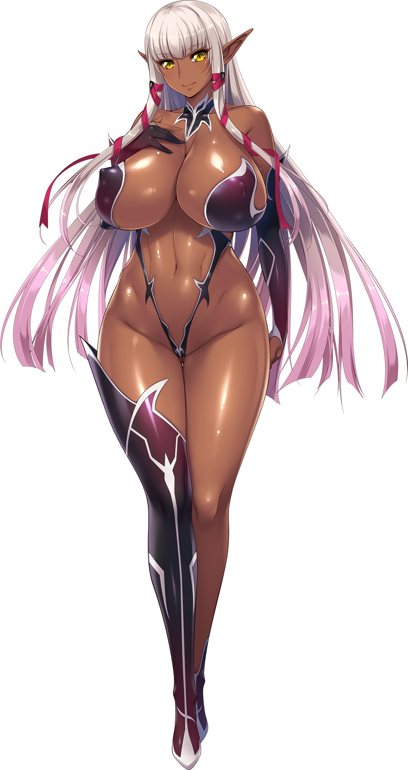
But seemingly? Rather than care about any of that? “Heeheehee! Bouncy… bouncy… BOUNCE!” The woman standing under Shadowheart’s tent was certainly a… sight. Tall, dark skinned, and infinitely bustier than she had been only moments ago, she was playfully arching her back and correcting her posture over and over again in quick succession – all so that she could enjoy the sensation of her big, pillowy tits bouncing about. She wanted to make a move on someone so bad with this new body of hers.

Rhinola Wazas was the name she went by now as a pure blooded dark elf, but her memories up until the transformation, and the transformation itself, all remained. She still knew who she had been, but she didn’t really care about all that. Her intellect had dropped sharply and that had certainly helped her accept things, but just in general her new personality was more relaxed. Maybe too relaxed.

“My, my, I really need a good fucking right now.” She was far more immature, but she had flashes of trying to play the part of an older sister too; in a way that almost felt intentionally erotic, at least. In fact, her sex drive appeared to be far higher than it had ever been. Man, woman – Rhinola didn’t really care who. She just wanted to fuck someone. Because this new identity of hers had been channeled from the life of a fantasy hentai game character. That explained her obsession with sex and why she had such little shame. And why she kept imagining scenarios only a fetishist who had watched too much hentai could come up with.

The tall woman groped at herself and licked her full lips, thinking about who would be best to mount among the campers. “Lae’zel…” There had been shades of it earlier, but there it was again. Shadowheart had been so disgusted with the githyanki in the past, finding her ways grating and her body unappealing. But now? Just thinking of Lae’zel stirred something in her loins.

And not only because Rhinola thought she was physically a smoke show. Lae’zel’s strength, her assertiveness… How she wondered what it might be like to be dominated by a woman like that. “Mmn…” The thought alone was enough to drive her to moan as she visualized the dominating sex she might experience as Lae’zel’s designated sub. “That’s it! I’m not waiting anymore!” How could she wait? She was just so horny! She wanted to straddle that githyanki and let her go to town on her big tits, and how could Lae’zel say no to that?

“Oh, before I go, though!” The simple act of bending down to grab the pocket mirror and standing up again was enough for her tits, ass, and thighs to bounce appealingly once she stood up again. “Gonna need this!” Lae’zel would naturally be confused about how Shadowheart had changed into such a person, and knowing her personality? She wanted to lower the chances of getting shanked before she got fucked. So, if she had the mirror then perhaps she could use it as some type of proof?

But she couldn’t have known how bad of an idea bringing the mirror to Lae’zel would be.

For Lae’zel, anyways.

