ROMANCE 101
BIWEEKLY STORY #80
BY CHALDEACHANGE
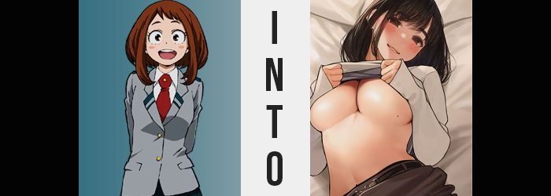

Uraraka was new to all of this. Having feelings for others, that is. It had been a few months since she had realized that she had a romantic interest in Deku, but she really didn’t know how to move forward with that realization. While she could admit it to herself, too, she still hadn’t managed to confide in anyone about this realization – which probably would have helped her a great deal if she’d been able to.

But one of her friends had realized all on her own and had been observing Uraraka from afar. Mina Ashido, being the self-proclaimed ‘love expert’ that she was, had been more anguished by her friend’s struggles more than her friend herself was. Was she really that inexperienced!? If you like someone then you should just tell them! That was what she believed.

By sheer coincidence one day after class Mina had encountered a find that she believed might be of some use at the local convenience store. A DVD titled ‘Romance 101’, and it was the last one in stock! “I bet Uraraka could use this! I’m gonna buy it for her!” And so, thinking it must have been a popular seller, the pink-skinned teen made her purchase. Utterly unaware that there was only one left because there was only one in existence.

All that was left was to deliver it!

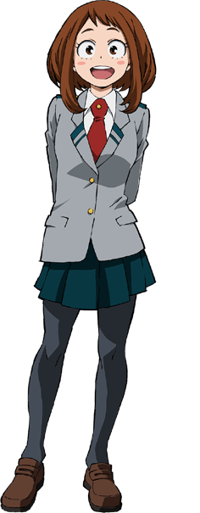
The next day after school, Uraraka returned to her dorm room as she always did. She was going to meet up with the other girls a little later to study, but she wanted to get changed into something a little more comfortable before then. When she had slipped into her living quarters on campus, though, she was surprised to find her television in. “Huh? Romance 1o1? …Is someone pranking me?” There was a DVD menu up that suggested something had been inserted into the gaming console she had hooked up to her 24” screen.

This couldn’t have been about Deku, could it? Maybe it was just a coincidence! Well, she did have some suspicions about Mina being onto her, but she’d never spoken up about it. Come to think of it, this type of incident was definitely up her pink friend’s alley. “I’m going to have to talk to her about this, aren’t I?” Sighing with defeat, she pressed in on the power switch for her television. But it didn’t turn off in the same way that it typically did.

Instead? The screen turned bright pink and continued to glow that color. What was strangest of all? It felt warm and kind of tingly? “Is my TV about to explode!?” Having never encountered a phenomenon like this before, she worried about a potential detonation and recoiled. But it didn’t. It just turned off. Because it had already begun the process it existed to begin in the first place.

Uraraka, being the subject of that process, was quick to realize that something was amiss. “H-Hey!? What’s going on? Was that like static electricity or something? I feel kind of tingly…” She wasted no time in taking a step away from her TV, her body feeling almost like it had been electrified somehow. The warmth added an extra layer, almost creating the illusion that she had become sick just from touching the television, but that couldn’t really be true, could it?

Maybe that was part of the prank? This was still a prank done by Mina, right?

As much as she hoped that this was the case, everything that had transpired since walking into her room was not what Mina had intended at all. In fact she was none the wiser, off in the lobby waiting for Uraraka to come out (presumably upset but thankful). That was the outcome that the pink-skinned girl had idealized. She certainly hadn’t planned on the DVD being what it was: an object created with a quirk that could transform those who interacted with it according to the type of content that was on the disk.

And the girl that had tried to power off the screen showing this would be the first to fall to its abilities. Taking a look at Uraraka’s hair of all things, this couldn’t be plainer. After all, the chestnut brown that she was so well known for was in the process of darkening to an almost raven black, and some of its length was becoming askew. Most of that length change was in the back though, for the hair that framed the sides of her face was already longer than the rest. Darkened locks in the rear only grew longer so that they were consistent with those in the front.

The change in color and length permeated throughout other parts of the girl’s body that were meant to be hairy, including her eyebrows. Thicker they became until they were more like bushy caterpillars across the peaks of her eyes, while in her panties? Darkened hair grew a little bushy that the teen was typically comfortable with thanks to her age. But right.

Her age would soon be a point of contention in itself.

“That DVD wasn’t going to help me anyways… I mean, I already know that showing off my body is a sure fire way to get into a man’s pants! …HUH!?” That second part, that line delivered with way too much enthusiasm for what she was saying… She hadn’t meant to say that! Uraraka was only in her mid-teens and didn’t really think about men like that. It wasn’t appropriate! But if the fact that she was in her mid-teens was the obstacle standing in the way of that solution, then there was a sure fire way to make it more plausible.

Still baffled by what she had blurted out, the maiden’s emotional state didn’t allow for as much recognition of her current predicament as it might have previously. For like a weed the teen had begun to spring up. Not significantly so, but a few inches found themselves applied to her height, and with them? The fit of her UA uniform felt just a little tighter.

“What’s up with my clothes?” Her voice now deeper, even though the cause of her discomfort should have been plain, eyes now glazed over with a brown that was much darker than her regular color could not quite rationalize the change. She did at least pull off her jacket and tie, throwing them on the bed, but the fact that the base of her shirt revealed her tummy now went strangely unnoticed.

Maturity began to show in all facets of her visage, whether it was the natural beauty of her face slimming with age, granting her generous, plush lips and a narrowed gaze, or fingertips that had extended and been decorated with freshly manicured nails. Even her loins burned briefly, for with adulthood came the tells of sexual conquest. She was no longer a virgin, that much was certain.

While never perfectly trim, the little weight that Uraraka had upon her body grew some, too. Her belly pushed out just a little, creating a gently lip that implied she might have had one too many snacks as of late. Her belly was hardly the point of focus when it came to gains in weight though. No, it was the features that brought appeal to a woman’s frame that inherited the greatest changes of mass.

If her clothing had felt tighter before, then what came next should have had her questioning her circumstances. “Nn…!?” For the woman’s breasts soon swelled, popping the top half of the buttons off the uniform shirt she wore beneath her jacket. Mounds of sensual flesh burgeoned forth, and manicured nails idly reached to fondle them. But Uraraka didn’t once find them strange – she somehow saw them as what her breasts were supposed to look like, even after surpassing a DD sizing. Even as a mole appeared at the base of her left tit where one had never been before.

The fit of Uraraka’s skirt was tested not long after, along with the tights that she always wore atop her underwear. The cause? While her waistline pinched in so that the skirt could remain fixed, her hips had parted wider, earning a rather sharp curves as the side of her body were etched from her enlarged bosom to her thin waistline to hips that had popped wider than her shoulders. This left her panties and tights feeling even tighter, and things certainly weren’t helped with the bloat that accompanied at all.

The cheeks of her ass rose as if they were fresh buns in an oven, promptly pulling down the hem of her tights until they got caught halfway down her ass. This left the upper portion, as it continued to grow bigger, to look much more engorged than the lower half. Cheeks rivaled her tits in scale, and in all facets of her figure the woman now felt incredibly confident.

“Mmm…” Smacking her thickened lips with her tongue, the tightness of it all somehow felt pleasurable. Panties had wedged into the depths of her engorged ass crack, and dense and tender thighs rubbed together within the confines of polyester that was fraying from their girth. “This feels pretty good… But I bet a real man would feel even better~! But I want my next time to be with Deku-kun!” Because she could already recall having had sex a number of times with men and women from her office job.

Speaking of… Her outfit’s fit became much less of an issue, for it was growing to match her new frame. Growing, and changing subtly in fashion so that it was clear she was no longer a student. Her tights remained themselves for the most part, stretching up to reach her bellybutton and mending any holes that had been earned from her growth, while her panties stretched and took on a purply pink color. Uraraka’s skirt remained as such, but its color darkened to black, and the pleats were ironed out so that it was but a short pencil skirt. Even her dress shirt remained one in nature, albeit stretching to fit her torso and buttoning up to cover her tits – tits now housed within a lace bra that matched her panties. In front of her door now, where she had left her shoes? Was now a pair of heels that would fit slightly larger feet.

More than anything, she looked like she belonged in an office.

And according to her memories? That checked out.

“I see, I see~ So if I want to get Deku-kun to notice me I just need to show him a little of these!” The now adult woman, fully dressed in an office lady’s attire, flipped up her blouse to reveal her astoundingly sized breasts as well as the beauty mark underneath the one on her left. While she hadn’t actually seen the DVD, according to her own memories she had! And the advice? “That thing was kinda useless. I already try things like this!”

In fact, she wasn’t bashful at all about her body. Even though she was a little chubby around her belly, the rest of her figure was attractive and Uraraka knew full well! On that note though, while she looked like a completely different woman, she still possessed her original name. All of her peers in the office branch of UA referred to her as Kouhai-chan, though.

Huh? Did UA have an office branch? If it hadn’t before, it did now!

“Oh well, let’s go try what the DVD said on him! So what if there’s a big age gap? I’m going to make him mine!” And so Kouhai-chan flipped down her shirt and bolted out the door, not even realizing her room had shifted into an apartment just down the street from UA. She was just going to sneak into his room and surprise him!

But unfortunately, she would accidentally turn him into another office lady from her work.

