S-C Fitness: The Trial Run
By Soul-Controller

Although most citizens of his small British town were still fast asleep at 3 AM, Tom Williams had a pep in his step. With a thermos of coffee in hand, which he occasionally took a sip of every minute or so, the man briskly made his way down several blocks towards his local gym. Despite barely getting any sleep the night prior writing fanfiction rather than doing much-needed assignment marking, Tom pushed aside his grogginess due to the promise of what would be awaiting him.
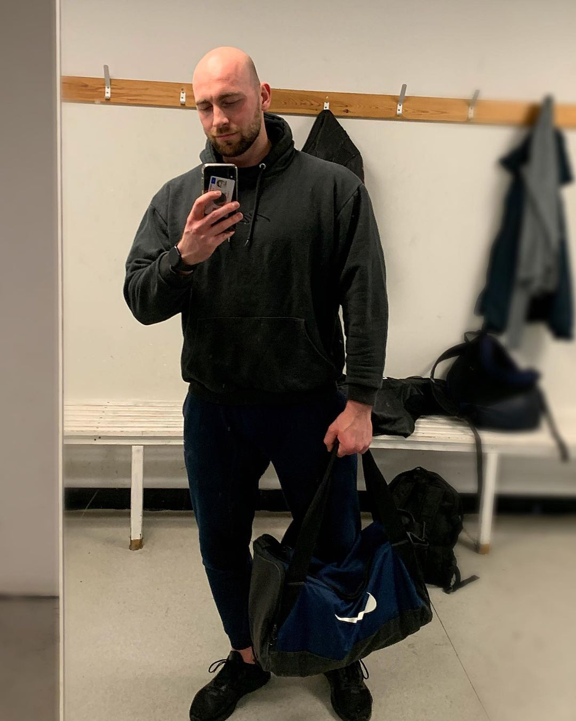
As he made his way around the corner and arrived at the front entrance of his gym, a bashful grin emerged onto his face. Leaning against the brick walls of the building while checking his phone was his gym crush Dylan. Given the late hour, Tom’s footsteps against the damp concrete quickly alerted the bald bodybuilder about his arrival. Upon looking up from his phone and taking note of the new arrival, Dylan’s face lit up into a light grin as he quickly slipped his phone into the pockets of his sweatpants and pushed himself off of the wall. Once he finished readjusting the strap of the gym bag slung over his broad shoulder, Dylan approached Tom until they met right in front of the gym doors.

“Uh, alright mate?” the bald man began, his smile never faltering even once he got an up-close look at the average new arrival. “You’re Tom, right?”

Realizing that his cheeks were already reddening in thirst upon seeing the man, Tom opted to try and say as few words as possible until his mind could finish wrapping itself around the bizarre situation at hand. As such, the teacher quickly nodded his head to confirm Dylan’s inquiry.

Unfortunately, this confirmation only caused the hunk to become even more cheerful and talkative. “Oh great, it’s nice to meet you man! Sean told me about you the other day, so it’s great to finally put a face to the name.” After taking a pregnant pause, it seemed as though Dylan was eager to have a full conversation with his fellow gym-goer. “This whole situation is pretty crazy right? Free memberships just for working out with someone new! Absolutely beautiful trade-off if you ask me! Should be fun, right?”

As Tom stood there for a minute looking at the other man, his hectic mind was shifting between moods of thirst and annoyance. Although the thirsting was understandable given just how hunky he found Dylan to be, the annoyance wasn’t related towards any jealousy of the man's muscular body (although Tom dreamed of one day being a similar size). Instead, he was annoyed that he hadn’t tried to introduce himself to Dylan sooner. Given how enthusiastic and nice the man was being along with how truthful he seemed to be about his eagerness to meet new people and make new friends, it was quite frustrating that Tom had immediately seen the guy’s bulky physique and had just spent years automatically assuming that Dylan would be this cocky asshole.
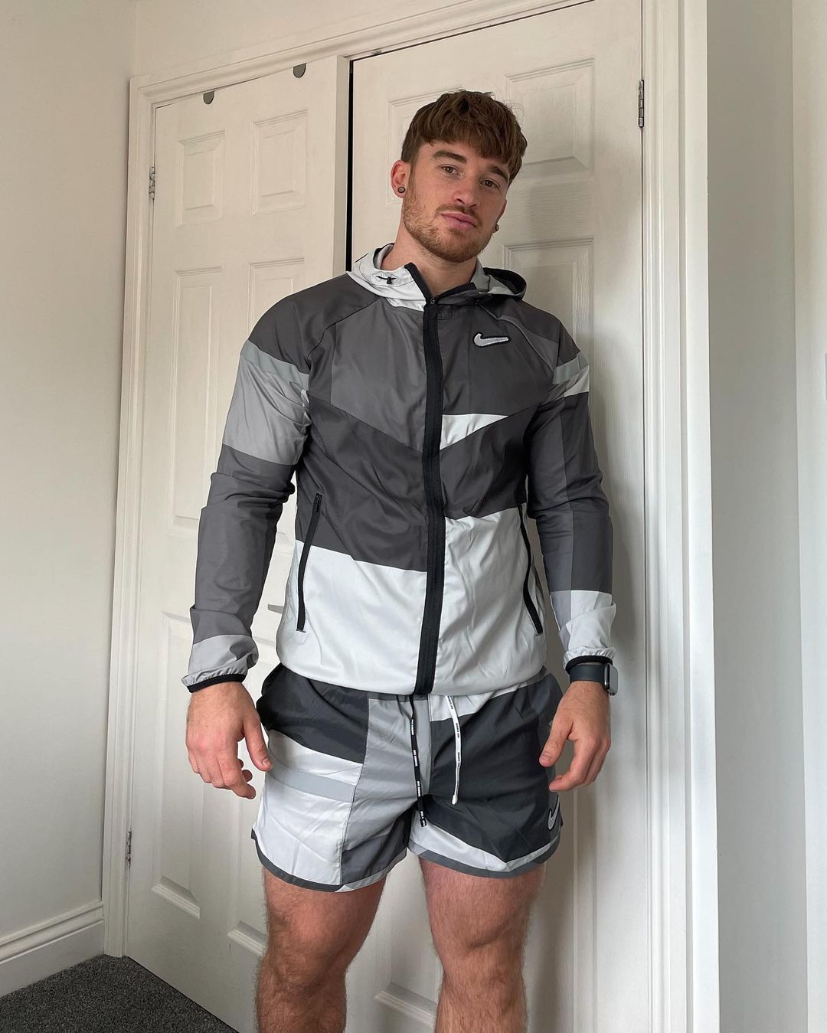
Before he could fall deep into this hole of self-loathing and regrets, the turning of a lock in the gym doors interrupted and demanded both men’s attention. As they both turned their heads, they watched as the doors pushed open and revealed the hunky body of the gym’s owner. The man, whose name was Sean Carpenter, was decked out with a Nike windbreaker and shorts that were quite form fitting around his prominent biceps and thighs. “Hey bros, are y’all ready to get started?” he said, his voice drenched in dopiness. Although the dim-witted tone in which he spoke was already quite disorienting for Tom to listen to, the man’s additional American also always threw the gym novice for a loop.

After looking in Dylan’s direction and nodding his head, Tom forced himself to keep his blushing under control as Sean moved out of the way and allowed the man to enter the gym first. Upon passing through the threshold of the entrance and finding himself engulfed in darkness, the man turned his head to look towards the other two men. While he did this though, his eyes got a quick look at the prominent ass that was jutting out of Sean’s shorts.

Although Dylan was certainly the main recipient of Tom’s thirsting, the meek-mannered man couldn’t deny that the hunky owner was a rather impressive guy. Not only did he have one perky ass, but the man was quite buff and looked incredibly intimidating given the tattoos that covered a vast majority of his body. In fact, checking out that intimidating physique of his had actually been the catalyst for how Tom was here for this early morning gym session.
* * * * *
This occurred around two weeks ago, when Tom had finally decided to return to his gym in hopes of shedding the holiday weight he had gained. Given his hectic job as a teacher with exams and a neverending list of assignments, the amount of marking he was required to do was out of this world. As such, his near-constant gym routine was the first thing to be sacrificed in order to make deadlines and prevent getting in trouble with his asshole of a headmaster.

When he first arrived at the gym, Tom had expected everything to be the same as it had been the last time he had visited two months prior. To his surprise though, the gym had undergone a significant change as the older owner had seemingly finally opted to retire and sell the property. As he entered the newly named S-C Fitness and made his way past the front desk, he was shocked when the young and tattooed hunk sitting there stood up and extended a hand. Upon extending his own out to shake hands, Tom talked to the new owner for the first time as they each took turns introducing themselves. Although he certainly understood why the man would get into the gym business given his ripped physique that was fully showcased in a tight tank top, the gym-goer was confused as to why an American man had opted to purchase this small town British gym. Despite the confusion over Sean’s purchase of the facility, Tom enjoyed meeting the man and continued to think about the encounter as he went towards the locker room to change.

On his way out of the locker room after his hour-long workout though, Tom took a moment to slow down his pace and take a look at the busy gym floor. Given how long he had been away from seeing Dylan in person due to the stresses of his job (although he'd continued to admire from afar by keeping up to date with Dylan's Instagram posting), the man was eager to get even just a passing glimpse at the hunk since he knew that the man usually worked out around the same time. Yet while he was unable to see his crush working out, Tom’s eyes were still quite content with observing the new owner working out.

As he slyly leaned against the back wall of the gym to secretly observe Sean’s routines, Tom got the perfect view as he watched the man from the back. Unfortunately, while he took the moment to savor the sight of seeing everything from his thick calf muscles up to the man’s globular ass, Sean had finished his routine and turned away from the mirrored wall to see Tom’s lustful staring. Before he could pretend to try and look elsewhere so as to not get caught, Sean was already approaching him with an emotionless look on his face. Mentally expecting to be called out by the dopey yet intimidating jock, Tom was quite blindsided when the man’s expression shifted into a smile and began to ask how his workout went.

While he explained what he had done for his first workout after months, Tom noticed how Sean listened with intent and seemed to be fully engaged in what he was saying. It was certainly not what he was expecting and definitely a far cry from the gruff older owner that had often looked at him with disgust, which left Tom pushing aside his confusion over how Sean had ended up here and instead becoming thankful that he had.

This appreciation was further cultivated when Sean proposed a plan that he had hoped would create a more unified connection between all of his gym clientele. With his plan, he was hoping to pair up incredibly buff and devoted gym regulars with novices in hopes of fostering a friendship that defied the typical setup of cliques. Although he wasn’t too convinced that his plan would be effective (and wasn't really a novice but rather just returning from an extended break), Tom was more than willing to go along with it when he learned two important pieces of information. Firstly, joining the first iteration of the program would provide Tom with a free six-month membership at the gym. Given the fact that his teaching salary was nefariously low, any way to save money was quite appealing to him.

The second piece of information about Sean’s proposed plan was the cherry on top that caused Tom to agree without even asking too many questions. According to Sean, Dylan had already signed up to be the gym regular mentor in the trial run of the program. Knowing that this would be a natural way to finally force himself to talk to his crush along with getting turned on by the concept of getting trained by the hunky stud, Tom eagerly agreed and asked Sean when the plan would start.

* * * * *
The sudden speech of Sean forced Tom out of his trip down memory lane as he attempted to pick up on what he was saying.

“So, for this whole program idea of mine, I thought it would be a great opportunity to merchandise and promote the gym on social media ya know?” Sean began, a wide grin on his face that was further illuminated as he flicked on the light switch and the bright white fluorescent lighting roared to life. “Alright, wait here for a second, I’ll be right back,” he said, giving no man a chance to respond before turning back and breaking into a quick jog towards the backroom.

Now left with each others’ company, the duo awkwardly looked at each other and gave a light smile to diffuse any awkwardness beyond their random pairing. While Sean seemed to be stuck tearing apart the backroom due to the loud noises of banging and clattering echoing through the door and reverberating through the empty gym, it was Dylan who opted to break the silence.

“He’s uh, he’s quite the character huh?” he asked, lightly chuckling as he heard Sean suddenly scream a profanity and grunt in pain.

“Oh yeah,” Tom began, “he’s... odd!” As if the duo were playing a game of Simon Says, the man felt compelled to copy Dylan’s light chuckling himself. After seeing Dylan give a soft nod, he found himself growing more comfortable now knowing that he hadn’t embarrassed himself thus far. With this small win already boosting his confidence, Tom found himself beginning to speak more and thus break out of his awkward shell. “He’s definitely better than the last owner though, he was a proper asshole! This guy's a breath of fresh air, don't you think?”

Although it seemed as though Tom had more he wanted to say, he wasn’t given the opportunity to do so as the door to the backroom was pulled open with haste and Sean jogged back out towards them. Once the man was finally in front of them, the duo then watched as Sean suddenly held out a set of clothing to each of them. After quickly explaining that the two sets were plainly colored prototypes and promising that there would eventually be designs added to the fabric, Sean ushered the two men into the locker room so they could change and get through the photoshoot quickly.

Following as Dylan led the way into the locker room, Tom’s horny mind couldn’t help but savor the close proximity to the hunk as he could smell the man’s woodsy cologne. Not wanting to get caught or rock the boat too much prior to the photoshoot and workout though, he kept himself in check as he picked a separate area to change in order to prevent wandering eyes.

After setting his bag and thermos down on a bench, Tom instinctively looked around to make sure no one was nearby before pulling off his clothes. Obviously there was no one there given the fact that the gym hadn’t yet re-opened to the public, which left Tom quietly chuckling to himself as he began to pull on the set of clothing he had been gifted. As he opted to wear each garment provided to him, Tom soon found himself wearing a pair of black shorts along with a dark red t-shirt, unremarkable but feeling comfortable enough against his skin.

Turning to look at himself in the full-body mirror near the end of the row of lockers caused Tom’s face to slightly drop into a frown. While the sleeves looked quite snug against his noticeable set of biceps, the shirt and shorts failed to show off the rest of his body in a positive light. Given the tight fit of the athletic shirt given to him, the man’s pudgier midsection was on full display as it bulged out against the fabric. On top of that, the man’s pale legs lacked much definition and looked rather mismatched with the sleek and shimmery gym shorts. Knowing that both Dylan and Sean were in possession of rather prominent and firm asses, a quick turn and look over his shoulder caused Tom to grimace at the lack of firm muscle that was filling out his shorts. For some reason, the shorts made him look like he absolutely had no hint of an ass!

Not wanting to grow even more self-conscious about his physique, Tom turned himself away from the mirror and shook his head to brush aside those negative thoughts. Assuming that enough time had passed for Dylan to get dressed without accidentally stumbling into him nearly nude, the man grabbed onto his clothing and thermos before heading down the few rows of lockers.
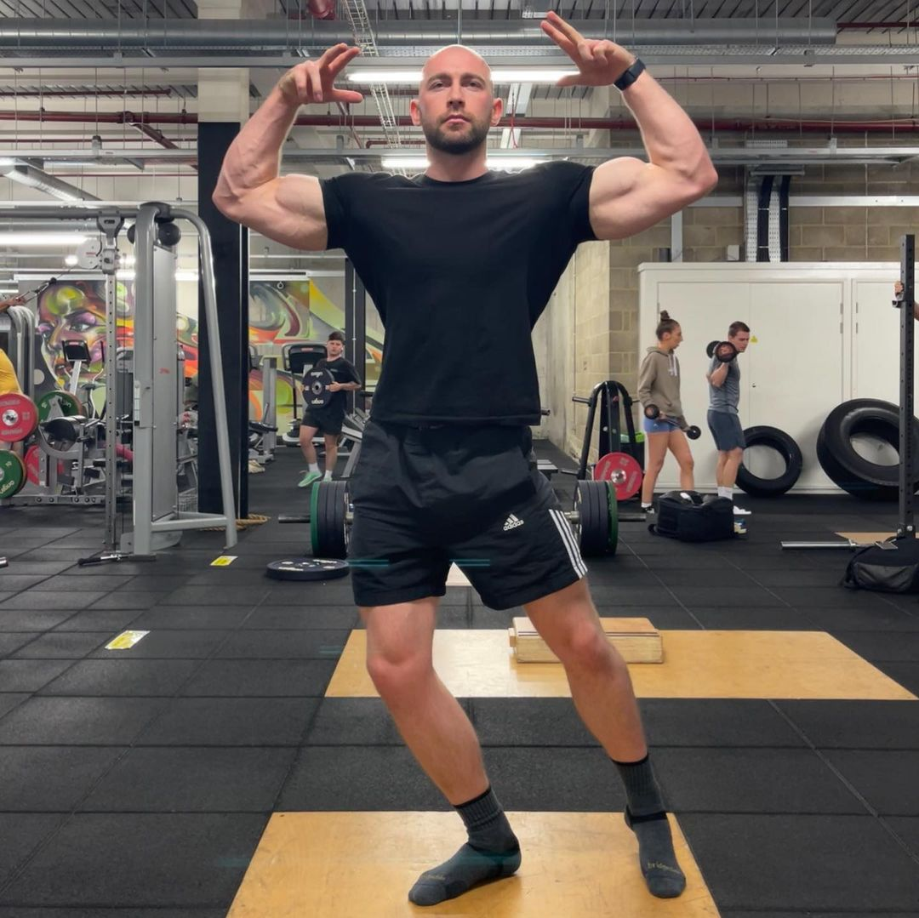
After the fourth row of lockers, Tom finally found himself stumbling onto the area in which Dylan had changed. While he had purposely planned to wait a bit before heading over here in order to prevent getting turned on by his crush’s slightly nude body, this was all for naught because Tom ended up stumbling onto Dylan having a flexing session. Just as his cock twitched in delight at the sight of the hunk’s huge bulging biceps, Dylan’s eyes moved in the reflection and noticed that his gym partner had caught him.

After chuckling and pulling his arms down, Dylan quickly turned himself around and looked into Tom’s eyes. While he did so, Tom could instantly pick up on the slight reddening of the hunk’s cheeks as he was clearly embarrassed by getting caught in the midst of some self-obsessed vanity.

“I- uh, you must think I’m some image-obsessed asshole huh?” Dylan asked, chuckling at the awkwardness of getting caught mid-flex. “I know some guys with builds like mine are like that, but I promise I’m not! I've got this bodybuilding competition coming up in a few weeks and I’m quite nervous about it. I just wanted to check and see where I should focus my next few workouts so I could look the best I possibly can…”

Although it was certainly not the response he was expecting from the jock, Tom was quite amused by what he was seeing. It was so bizarre yet sweet to meet a jock who wasn’t some raging narcissist who thought they were God’s gift to humanity. “Oh no, you don’t have to explain yourself,” Tom began, himself also blushing as he added in a chuckle. “I mean, I know you’re just preparing for that competition, but I wouldn’t blame you for showing off just for your own enjoyment. Hell, I mean if you’ve got it, flaunt it right?”

Relieved to know that Tom understood and accepted his response, Dylan gave a nod of approval before saying that they should probably head out there to keep him from waiting much longer. Although he was sure that Sean wouldn’t mind waiting given the fact that the owner’s plan of having him and Dylan bond was working, Tom certainly didn’t want to test the hunk’s limits and thus agreed and exited the locker room right behind Dylan.

Once they both made their way out into the gym floor, the duo returned to Sean to begin their photoshoot. Despite Tom’s own body image issues and disinterest in being photographed, the man continued to push through the photoshoot as he reminded himself of the free gym membership along with the hope of becoming close friends with Dylan. Although this was enough to encourage him to keep going, Dylan was also quite helpful as he cracked jokes and caused Tom to do a laugh that wasn’t forced in the slightest.

After about twenty minutes of photographs throughout the gym floor with each man taking turns being the mentor and mentee, the shoot was abruptly stopped when Sean’s phone rang. Upon answering the phone and having a conversation for a couple minutes, the owner hung up and quickly explained that there was an emergency that he needed to handle back at his flat. Clearly confused over what’s going on, Henry asked whether they needed to leave or just wait there until he came back. Upon thinking for a moment, Sean told the two of them to go ahead and begin their workout session together and that they could just finish up the photoshoot later once he returned.

Nodding their heads to agree to the man’s proposition, the duo watched as Sean quickly made his way towards the gym doors and exited the building. After hearing the click of the doors locking to make sure that no one could sneak in during their workout, Dylan turned to Tom and flashed a pearly white smile. “Shall we get started then?”
For the next 30 minutes, the duo took turns working out while the other eagerly encouraged them. Of course, Tom knew that Dylan didn’t need much encouragement given his impressive size, but it still seemed like the bodybuilder appreciated the support as the man grunted and pushed himself to complete every set with haste. As for receiving encouragement, the man quickly understood why the bodybuilder had a successful personal training business as Dylan’s words of motivation kept Tom focused and reinvigorated no matter how exhausted he felt.

This was especially true as Tom took his turn doing a bench press session. After finishing up a successful 120kg lift, Dylan took a moment to pull off half of the plates to bring it all the way down to 60kg. Now a little more confident that the weight would be manageable for him, Tom took his place on the bench and shuffled beneath the loaded barbell. With Dylan leaned down and hovering over him like a gorgeous guardian angel (especially since the fluorescent lighting above created a perfect halo of light around his bald dome), the gym novice felt the desire to impress and thus began to do his routine with vigor.

As the man was halfway through his standard eight reps though, Tom’s eyes began to widen at the bizarre sight he was witnessing. Although it seemed impossible, his intense staring towards Dylan (who was still leaning over him and offering words of encouragement) caused him to notice that his head was changing. As such, the man could swear that he was watching the man’s shiny scalp lose its sheen as dark hairs were populating along his scalp. Such a concept should be impossible as Tom knew that hair couldn’t just manifest out of nowhere, but his eyes continued to observe Dylan’s scalp gaining a stubble-like appearance.

Luckily, the shock of the situation caused Tom to push through the remainder of his reps without even focusing on the intense strain his body was feeling. Upon setting the bar back onto the rack, the man pushed himself up from the bench until he was upright and on his feet once more. As he turned around to look at his gym partner, Tom’s vision was proven to be correct as Dylan was now sporting what appeared to be a short buzzcut hairstyle.

“Wha- what’s going on with your head?” Tom inquired, his voice wavering in confusion. Of course, such a question caught Dylan off-guard and thus caused him to ask what the man meant. Upon pointing towards the mirrored wall of the gym, Tom watched as Dylan turned around and stared at his own reflection. The sight of hair on his scalp was clearly quite confusing to the man, as evident by his hands quickly moving up to the top of his skull and rubbing the coarse hairs in confusion.
“How is this possible?” Dylan asked, moving closer towards the wall so he could take a closer look at himself. As he tilted his head down and lifted his eyes up to stare at the wall, he suddenly gasped in surprise as he watched hair suddenly push forth from his scalp at a uniform rate. “M-my hair is growing back?!”

Shocked at what was occurring to his new gym buddy, Tom approached the mirrored wall and lifted his head up to stare at their reflections. As they did this though, the man observed his sweaty visage and noticed how his thick and luscious hair had fallen forward from being drenched in sweat. Wanting to make himself look presentable and get rid of the wet sensation along his forehead, Tom lifted his hand up and wiped his forehead before continuing the motion to push his hair back to match its intended style.

Unfortunately for him though, the simple action led to devastating results as Tom watched as a large chunk of his hair had painlessly been tugged from his scalp. Gasping in shock, the man looked and saw the remaining horseshoe of hair that had residence along the sides and back of his skull. “What the fuck!” he exclaimed, pulling his hand back down away from his head and noticing the large clump of hair that was now resting in his palm.

Although Dylan had originally been devoted to his still-growing hair, the fearful cries of Tom caused the bodybuilder to turn his head and observe the man’s new hairstyle along with the thick clump of hair he was holding. “Holy shit dude,” he exclaimed, lifting up his hand to rub the soft and frictionless flesh that Tom was now sporting. “You’re totally bald now,” he began, stopping himself as he suddenly turned his head and looked at his reflection once more. Upon doing so, the bodybuilder was quickly realizing that the dark-haired, slicked-back style he was now sporting looked quite similar to Tom’s. “I- what the hell is happening to us?!”

As the realization of Dylan’s words finally hit the confused Tom, the man suddenly found himself having to conceal a slight grin that was emerging onto his face. Although he was certainly happy with the hairstyle that he had sported for years due to his profession as a teacher, the concept of becoming bald was a surprisingly intriguing one. For some reason, there were countless men that he thirsted over that sported the freshly bald look. Of course, Dylan was one of the most prominent personal crushes that were bald, but he could also recall his thirst for pro athletes like wrestler Giovanni Vinci or football player Rex Burkhead who sported the sleek style that worked well with their gruff and intimidating visages. Given the fact that his hairline had certainly receded a bit over the past few years, Tom had decided to just wait a few more years until it was far back enough to just shave the remainder off and permanently switch to the simple style. Although he was more than willing to accept that plan back then, the sudden possibilities of taking a shortcut to achieve that level of masculinity caused him to eagerly accept what was occurring to him.

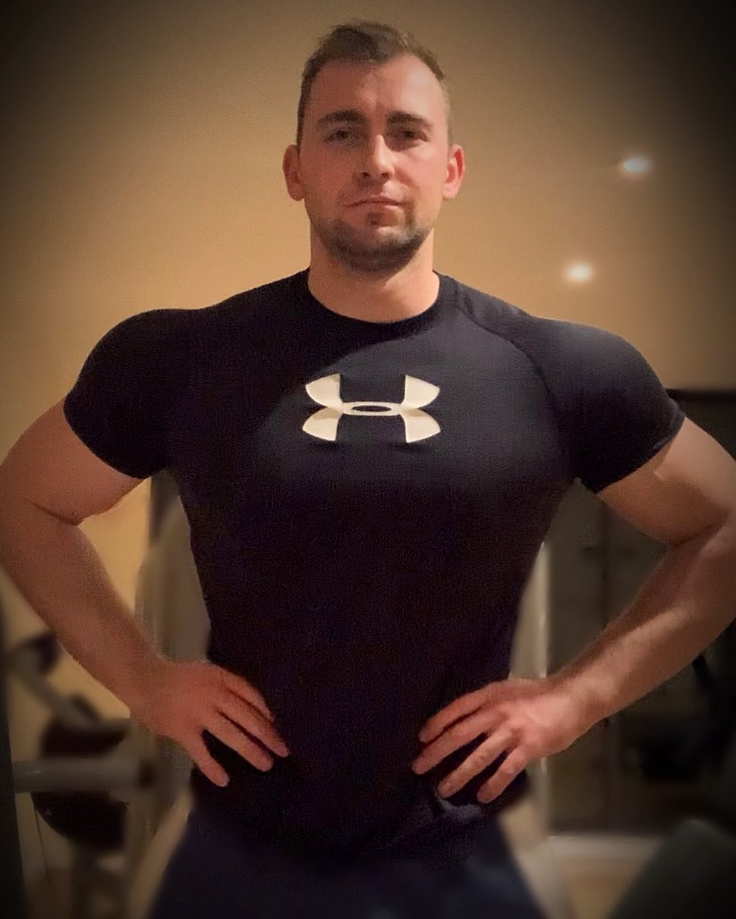
So now that he knew what was occurring to him and the possibilities of it, Tom left Dylan quite confused as he suddenly reached his hands up to his scalp and began to run his fingers through the remaining areas of his hair. The pathetic crown of hair that he was sporting looked similar to some of the older teachers he could recall from his upbringing, so he was quite eager to resist such a path and turn into the bald man the universe apparently wanted him to be.

Just a minute or so later, both men’s scalps had finished changing and thus adopted their new styles for good. Although Dylan was certainly not upset about the hairstyle as it just made him look intimidating when combined with his physique, the shock and confusion over what was occurring to him left him unwilling to really enjoy what had happened. Unfortunately for Dylan, he didn’t even get to verbalize what he was feeling as both men suddenly felt a bizarre sensation overcome their bodies.

While this sensation felt like pins and needles that were slowly numbing each of their bodies, it also had led to additional effects that would prevent either man from moving away from the mirror or speaking until it was finished doing what it wanted to do. As such, neither man could exclaim in horror as they found himself stuck as living statues for the time being.
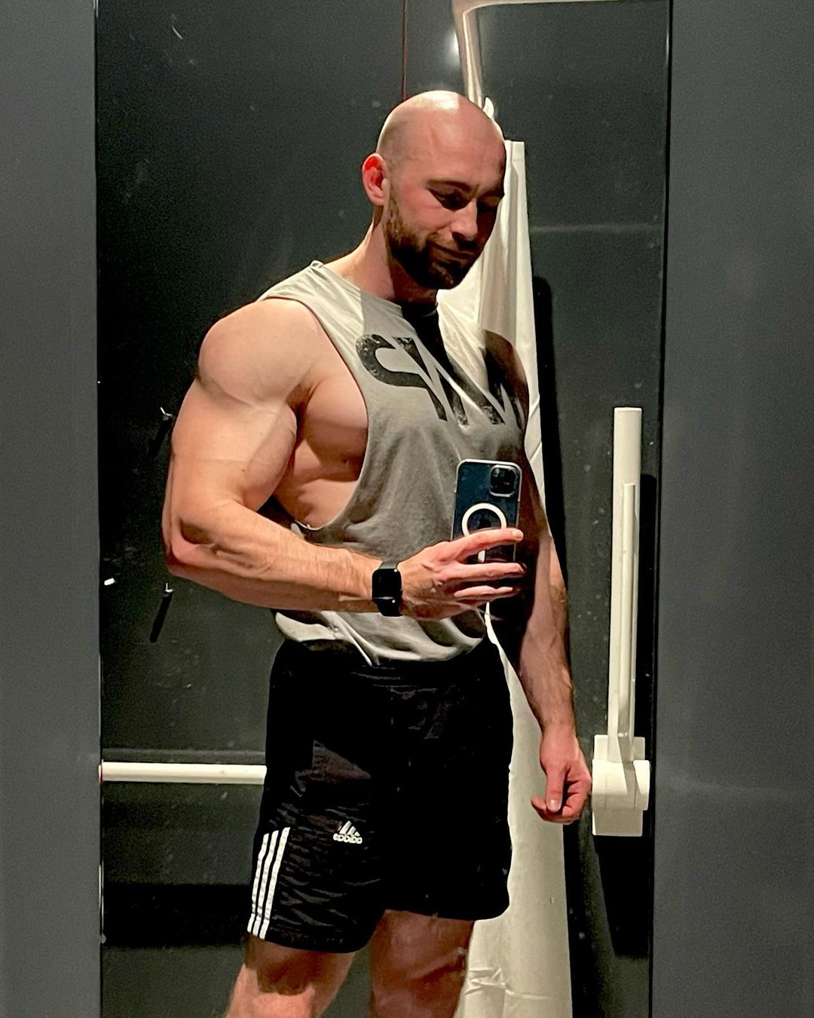
Although this was certainly horrifying for both men, the duo’s eyes bulged in tandem as they stared at their reflections and observed what was occurring to them. All at once, their upper torsos were undergoing extreme changes that left both of them becoming something far removed from themselves. While Dylan’s jaw dropped in horror as he found his bulging biceps and thick pecs suddenly deflating on themselves like popped balloons, Tom was gaining a wide grin as the inverse was occurring to him.

Out of all of his muscles, his biceps were the main event on his body… until now. Even though inches were quickly adding onto the circumference of his already-impressive biceps, the man’s shoulders and chest were widening and becoming quite thick. The man’s chest prior to this gym session was mostly flat with a slight hint of pudge that left each pec a bit droopy, but this was no more as the flab melted away and tons of muscle suddenly invaded. As he took a moment to admire the two impressive slabs of meat that now left his shirt straining from how prominent they were, Tom knew that he would no longer have to feel self-conscious about how his chest jutted forward. Now, that visual just showcased just how buff and impressive he was!

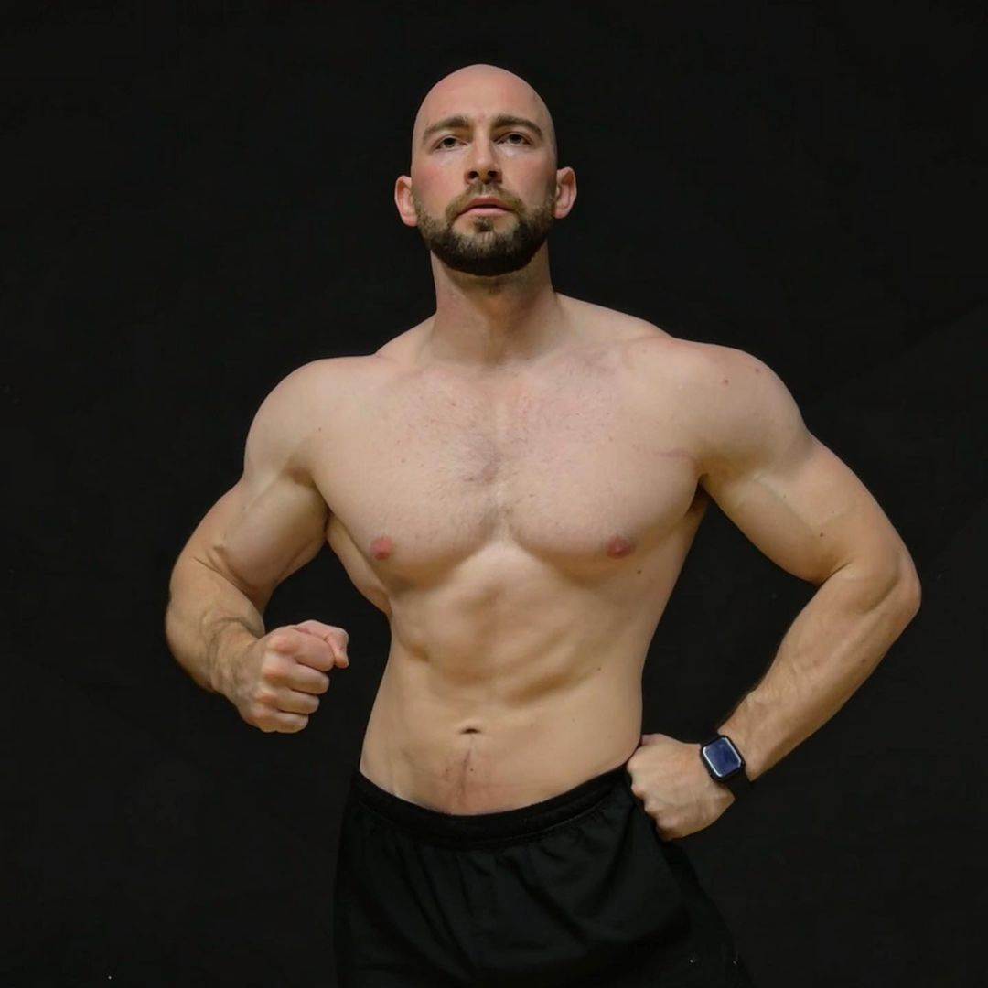
Despite the incredible and seemingly impossible changes that were occurring to them, neither man had much time to really reconcile with what was happening as the changes suddenly progressed. The changes thus began to travel further down their torsos as their stomachs became the next area in need of some changing. This was especially obvious to Tom as he watched the pudgy belly that was awkwardly tugging against the fabric of his shirt began to shrink. As more of that flesh was being pulled from Tom’s physique to lead to the formation of his toned midsection, it was quickly being transferred over to Dylan.

With his eyes beginning to well up with tears, the bodybuilder watched as his new flabby man tits got some company in the form of a slight gut. With the slight hint of his abs fading away as the weight began to quickly invade his waistline to also bring forth the inclusion of some love handles, Dylan mentally cursed his stars and wondered what he had done to deserve such punishment. He was a good guy who tried his best to treat everyone he met with kindness and respect, why was he getting punished while people like those cocky assholes that he saw at the gym got away scot-free?!

As Tom looked down and noticed just how much he could see now that his slight gut was out of the way, the man blushed as he noticed the boner that was pressing against the front of his shorts. While he continued to look down at his manhood though, his jaw began to suddenly drop as he could feel changes permeating through that area. Like dough rising in an oven, he observed his firm cock suddenly lengthening and widening until he was left with a huge 8.5” beast that was now pressing against the waistband of his shorts and resting along the majority of his upper thigh.
Feeling as his ball sack was suddenly grazing against the bottom of his underwear, the man quickly realized that his balls were growing thicker and becoming packed with much more of his potent seed. Although he couldn’t see them for himself, he figured that the heft he could feel now meant that they were the size of golf balls.

For poor Dylan, the inverse was happening as even his flaccid cock was shrinking until he was left with something that would barely reach 5” rock hard. Along with the sudden condensing of his balls until they resembled small marbles, it quickly became clear that the new version of Dylan would struggle to satisfy any sexual partner. While everything previous was a major blow to his mild ego, the diminishing manhood was the final straw and thus caused tears to finally begin flowing down his cheeks.

Speaking of cheeks though, the backside of each man’s shorts began their own changes as they traded asses. As Dylan’s plump rump from a consistent glute workout began to deflate, Tom chuckled in amusement as he felt his ass inflating. Although he knew it wouldn’t get much use as a bisexual top, the firm muscle booty that was filling his shorts out to the max was the cherry on top to signify just how changed he had become. Prior he was just a gym novice that had a few areas that were fairly muscular, now he was becoming an absolute beast from head to toe!

With his mind beginning to grow increasingly more confident and cocky with his muscle growth, the man was quite amused as his changes began to continue down the entirety of his legs. As the meaty flab of his thighs and calves faded away to invade Dylan’s physique and thus lead to the formation of a complete bodybuilder’s physique, Tom’s staring directly into the mirrored wall caused him to notice an interesting side effect. Not only were the duo trading physiques, but they also were trading heights as well. In under a minute, Tom’s legs had lengthened to give him Dylan’s 6’4” stature as the now-former bodybuilder fell to 6’1”.

Given the fact that their faces had remained the same while their bodies changed, the duo had both assumed that they had simply traded physiques for some reason. But as they each looked into the mirror upon noticing that their legs had finished changing, they quickly realized that this wasn’t the case. Although the hairstyles were the biggest difference between the two of them, small additional changes throughout completely sealed the deal to turn Tom into Dylan and vice versa. For Tom, the biggest indicators were watching his irises shift color away from their brilliant blue and adopt Dylan’s darker hazel shade as his facial hair lightened a few shades and gained a more trimmed and professional style. As for Dylan, the biggest shift came as he watched his nose grow narrow and gain a rather prominent tip.

With the completion of their faces shifting, the transformation had finally completed and allowed the numbing sensation that permeated throughout their bodies to finally dissipate. Before long, the duo both regained autonomy over their bodies and thus began to react in vastly different ways. While Tom leaned towards the mirror to admire his visage or grip onto his buff new physique, Dylan was growing quite hysterical as he realized that he truly had turned into Tom. So just as Tom smirked and shivered in lust at how his new visage replicated the action, the former bodybuilder began to uncontrollably sob and complain over what had occurred to him.

“What the fuck did you do to me, you freak?!” he exclaimed, the man finishing the sentence and instantly cringing at his new voice. Given the fact that Tom was clearly enjoying what he was seeing and feeling, Dylan was quick to assume that the awkward gym member was the one behind what had happened to the two of them. “Turn me back now or I’ll fuck you up!”

Upon hearing such an intense threat of violence, Tom found himself growing pissed in no time. Although he had no idea what had occurred to them, the man was insulted that Dylan would instantly assume he was the one behind it. Sure he had a crush on the man, but he would never do something like this (even if he knew how it happened in the first place)! As such, he found himself desperate to get the upper hand over Dylan and enact some revenge. Although he wasn’t sure where this sudden mean streak had come from due to his normally meek persona, he didn’t question it and instead just embraced it wholeheartedly.

“Oh really, you’re gonna fuck me up huh?” Tom began, making his way over towards the man as he puffed out his chest and widened his stance to look as imposing as possible. “I don’t know if your thick skull can comprehend this, but you’re no bodybuilder anymore. Hell, you can barely lift 60kg without almost collapsing now bruv!”

Although he wanted to continue speaking, he found himself suddenly pausing as he realized what he had said. When had he ever used “bruv” before?! He wasn’t some meathead jock… at least until now! For a moment, he stood there in thought as he tried to figure out if it was just an unconscious choice or if the transformation was leading to some unintended side effects. He wanted to continue pondering in hopes for an answer, but the confused-looking staring from Dylan caused him to stop and return to his original plan of intimidation.

“If I was you, I’d stop your fucking blabbing,” he grunted, his cock throbbing and beginning to leak pre-cum due to just how hot and intimidating he sounded. “I’m sure you don’t want to stay in that body forever, so shut your gob and start listening to some ground rules.”

To his amusement though, Dylan was quite the resistant man and instantly began to bolt towards the front door. He wasn’t going to accept this new dynamic, he was going to get out of there and get someone to help give him his original body back! Although he was already in the midst of envisioning his successful plan, a road block instantly became apparent as he pushed on the front door and realized that it was locked. After frantically looking around for a knob to unlock it, he was pissed to remember that it had been locked from the outside by Sean.

Pissed and instantly defeated over what had occurred to him, the man turned back and looked at the smirking Tom. “I- what the fuck is going on? Let me out of here,” he exclaimed, which elicited a series of hearty chuckles from the stern-looking bodybuilder.

As the realization of the locked doors entered Tom’s mind, he quickly pieced together that Sean must have been responsible for the swap between them. Not only did he lock them in the gym together with no way to escape, but he had also insisted that they wore those sets of gym clothes. Thinking fast on his feet with the knowledge that Sean was the likely culprit of the swap, Tom began to speak. “You think I could do something like this on my own?” he inquired, watching in amusement as a lightbulb seemingly went off in Dylan’s head. “I came up with the plan and Sean helped make it a reality with that fake contest idea. So yeah, if I were you I’d save your breath asking him for help once he returns, especially since that will only make things worse for you…”

Realizing that he had seemingly fallen victim to such an elaborate plan, Dylan instanted dropped his head in defeat and rushed towards his unfortunate bully. “Please,” he began, his voice instantly beginning to crack as he struggled to hold back tears, ”don’t do this to me! I’m a nice guy, I’ve never treated you poorly and I know for a fact that several others here have. What if I help you get one of their bodies instead?! I’ll literally do anything, I have a bodybuilding competition coming up that I’ve been training months for!”

Watching as the former bodybuilder began to grovel and beg for salvation, Tom’s ego was quickly growing more inflated. He felt like an absolute god! Not only did he have this gorgeous physique but he was able to easily get the defeated man under his control. “Sorry bruv, but I think you’ve got it twisted. You see, I’m the one who has the bodybuilding competition coming up and you’re the personal assistant who will help me train and diet so I can be the best possible version of myself.” Upon finishing his statement, Tom took a moment to look down at the man and smile before continuing to speak. “If you’re not willing to go along with this new little role of yours though, I’m sure that I can easily start some rumors and make you a pariah in this gym. As someone that everyone respects here, we both know I can easily make your life hell if you dare disobey me. I’m sure you wouldn’t like that… now would you?”

Although the man usually didn’t give a damn about what people thought of him given his self-confidence, the changes that had occurred to Dylan completely obliterated that. With the threat of being ridiculed and tormented by both Tom and other gym-goers, the man found himself shaking in fear like a leaf in the wind. He was already going through hell being forced to take Tom’s non-athletic body, so the added humiliation of having everyone in the gym hate him was too much to handle. As such, Dylan was forced to push aside his bruised ego and accept the terms of his new life. “Alright, I’ll fucking do it,” he said through grit teeth.

“Alright what?”

Upon looking up and seeing the devilish smirk flashed on his new tormentor’s face, it quickly became clear that Dylan was the lesser in this new dynamic and Tom thus wanted that authority over him to be made clear. Despite just how badly he wanted to punch the man’s lights out and destroy him, the former bodybuilder knew this was impossible and thus was left with no other choice but to submit. “Alright… sir.”

As soon as the words left Dylan’s lips, a shit-eating grin emerged on Tom’s masculine new face. “Yes, that’s a good boy,” he said with a condescending tone that left him shivering in pure joy. Eager to continue the torment of the man, the dominant new man’s mind was quickly conjuring up more ways to humiliate Dylan and make his new position in their relationship apparent. “Now that that’s handled, we still need to figure out the proper punishment for misbehaving and yelling at me earlier,” he began, tapping a finger against his chin as he faux-pondered what to do.

“Ah, I think I’ve got it. How about we start with having you come over here and worship this glorious new body of mine. I doubt many people would be able to say they worshiped their own body, so I think your hands and tongue will be quite thankful for the opportunity.” Upon finishing his sentence, Tom quickly pulled off his shirt and tossed it aside. “Then once you’re done with that, you can fully submit by sucking me off and becoming my perfect bottom bitch!”

Immediately, the thought of becoming some submissive man sucking off his former body was quite horrifying. Given the fact that he was still a straight man, Dylan was quite disturbed by the concept of submitting to a man, much less his old body! Despite this though, the fear of ridicule and becoming an outcast was a worthy competitor and thus caused the man to mentally wonder what he should do. As he continued to ponder in thought though, he was suddenly interrupted by the loud snap of Tom’s fingers.
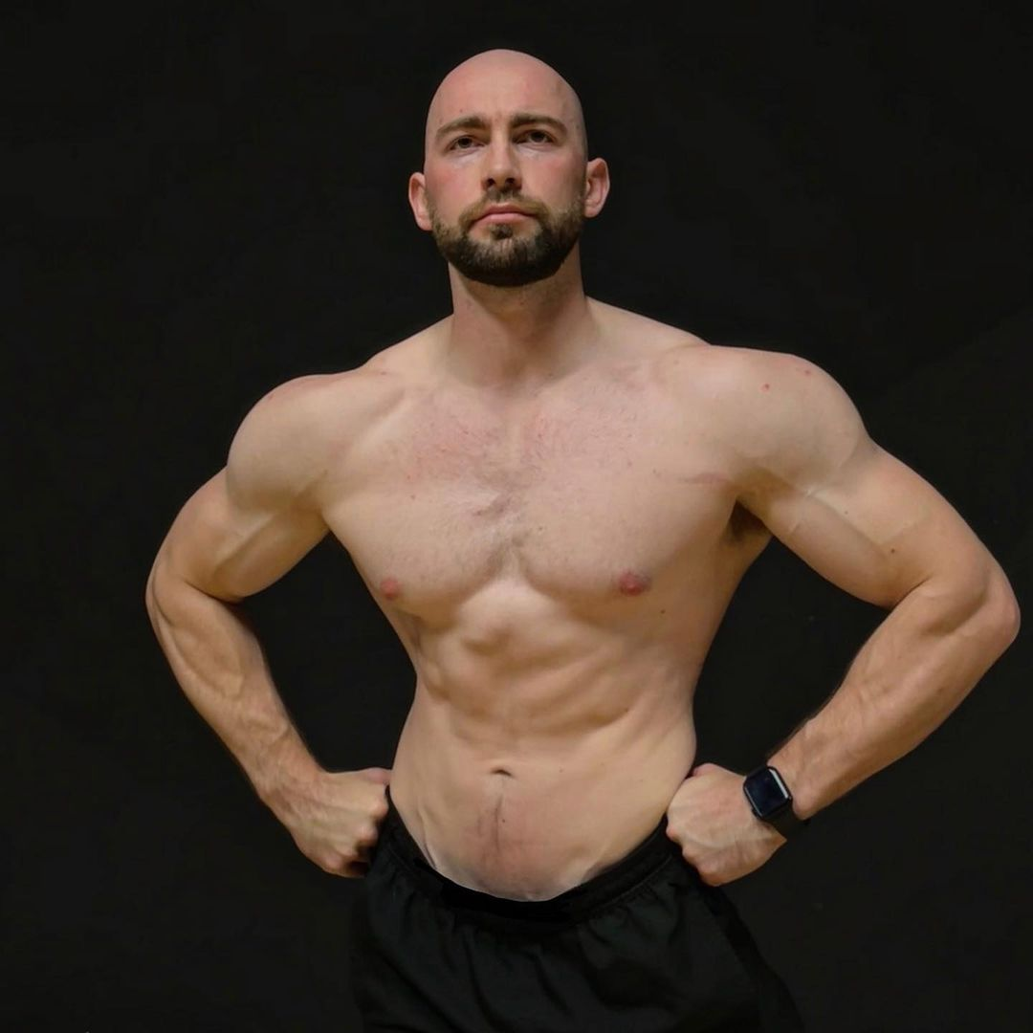
“What is your chubby ass standing there for? Get those man tits of yours here and learn what a real man looks like, boy!” Tom demanded, a stern look emerging on his face as he put his hands on his waist.

To his amusement, the brand new bodybuilder watched as the defeated Dylan fully gave in and made his way over towards him. After telling the man to start on his knees, Tom smirked to himself as he watched Dylan’s hands beginning to graze along his former torso up to his meaty pecs while his lips began to pepper kisses along Tom’s beefy thighs. Looking down and watched as the former bodybuilder fully embraced his new role, Tom couldn’t help but chuckle as he realized that he was a great gym alpha. With Dylan’s assistance, he was sure that he would absolutely dominate on stage for his first ever bodybuilding competition…

* * * * *

By the time Sean returned to the gym after dealing with his apparent emergency, it seemed as though nothing was amiss as both men adapted quickly to their new roles. As he made his way towards the duo, where Tom was completely clothed and Dylan was nearly nude besides the tight pair of underwear he was wearing, the owner couldn’t help but notice the bizarre scent of sweat and cum in the air. Although he wasn’t sure if that was the case, he could immediately pick up on the strange dynamic between the two men.

After Sean broke the awkward tension with a chuckle, the man began to speak. “Well, it looks like you two had an eventful workout huh?” Upon watching as the bald bodybuilder smirked and crossed his arms, the owner turned his attention towards Tom to chat with him. “So, are you two ready to continue with the photoshoot?”

Upon being asked such a question, Tom’s body immediately tensed up at the notion of being photographed after what just occurred to him. Although he used to be comfortable in front of the camera, the shift to a slightly pudgy gym goer in terms of both body and personality made sure that that would be a thing of the past. As such, the man was willing to say just about anything (no matter how long it took with his stuttering) to make sure that he got out of that photoshoot. “I uh, I um, really need to go home. I’m really exhausted and I don’t think I’m in the right mindset for another photoshoot. Isn’t there enough photos from earlier to suffice?”

As soon as the words left Tom’s lips, Sean’s wide smile dropped into a slight frown. Although he could tell that the man had certainly been put through the ringer given how his sweaty clothing was fully stuck to his skin, it was still a deviation from the plan that he hadn’t been expecting. Despite this though, the sad stare in the man’s eyes caused Sean to accept his proposition. “I mean, I suppose we have enough photos from earlier. It would have been nice to do some more to celebrate what seems to be a successful trial run, but I understand I guess…”

Immediately, Tom’s newfound sense of guilt for ruining the man’s plans made him begin explaining himself. “Oh uh, I’m sorry to disappoint. It certainly was quite the… interesting trial run,” he began, his eyes darting over towards Dylan and tensing up as the bodybuilder’s eyes narrowed and warned him to not say a word about what had occurred to him. “I just barely got any sleep last night and now I’m completely exhausted after everything I’ve gone through. Plus, I need to get some sleep since I have a lot of stuff I need to do around the flat,” he further explained, hoping to just say anything possible to get him excused from the photoshoot.

Although he was hoping to get a response from Sean, it seemed as though Tom’s statements had finally caused Dylan to chime in on the situation. “I’m sure he means no disrespect Sean, I’m sure he’s got quite a bit of shit to do at home,” he started, slowly beginning to walk towards Tom like a predator stalking its prey. Just as the man lifted up one of his broad arms and used it to wrap around Tom’s slender shoulder, he flashed a smile towards the anxious man before continuing to speak. “During our workout actually, he was actually telling me that he has a lot of marking to catch up on for his classes. He definitely needs to be all caught up so he can come into the gym tomorrow with me and help film stuff for my social media. Oh, and doing some prep work for my bodybuilding show coming up.”

Hearing that the duo had seemingly chatted enough for Dylan to invite Tom to become his newest assistant, the owner was ecstatic and thus willing to push aside his slight disappointment about the canceled photoshoot. “Oh shit dudes, that’s great that you two clicked in such a short period of time. Go ahead and go home then, I look forward to seeing the two of you tomorrow!”

Upon getting clearance to leave, the meek and anxious Tom immediately thanked Sean for the opportunity before rushing into the locker room to grab his new gym bag and change into his new clothes. While Sean watched the man scurry away, he was surprised to find Dylan still standing there. “You don’t want to go home?” he inquired, an amused smirk emerging on his face as he took in the man’s buff physique.

“Nah, I’ve got much more stamina than Tom does,” Dylan replied, punctuating the sentence with a deep and hearty chuckle as he referred to his old body with disdain. “Hey, we’ve still got some time before the gym opens,” he began, turning to look Sean directly in the eyes,”what do you say we still do that photoshoot of yours as I do a quick little workout?”

Unable to resist such an offer given his eagerness to take more photos, Sean immediately agreed and patted the man on the shoulder. “Fuck yeah bro, that would be awesome! Thanks for being a team player,” he said, slapping the man on the shoulders a few times in appreciation. As he wrapped his arm around Dylan’s broad shoulders and began to lead the way towards the machines, Sean smirked as he suddenly got a bright idea. “Say, I had no idea that you were getting into bodybuilding. I guess I shouldn’t be surprised by how swole you are, but that’s cool that you have a show coming up.” After taking a slight pause, the man then continued to speak as he came up with a new plan. “So, have you gotten any sponsors or anything to help fund your bodybuilding career?”

“Oh uh, I don’t think I do,” Dylan responded, hoping that he was correct in assuming that this was the case.

“Well, if you’re open and looking for a sponsor, I think S-C Fitness might be interested in helping fund your dreams man. I’ve been looking to invest in that section of the fitness industry, so I think we could make a wonderful team…”

Once the deal of the sponsorship was ironed out and finalized with a handshake, the duo watched as Tom exited the locker room and made his way towards the front door. Knowing that he’d need to let him out, Sean jogged over to the door and pulled the keys out of his pocket to unlock the doors and let him out. Once this was done, he returned to his bodybuilder client and watched as the man was already testing out the various machines to pick out the perfect weight.

Although the new Tom had instantly assumed that it was Dylan who had initiated the swap, it was the new bodybuilder’s logic which had been correct. It was in fact Sean who had initiated the change via the magically-infused sets of clothing that he had given the two men. In reality, Sean Carpenter was just an alias created by Soul-Controller as he opted to slowly build his company up by acquiring small-town gyms one-by-one until he had a sizable empire. Although there were countless possibilities that he could conjure up for the two men that wore the clothes such as turning them both into hunky bodybuilders or two twinks who solely used the gym sauna to get their rocks off, the devious and mystical man had decided that it would be amusing to turn the two of them into each other.

Given the fact that Dylan was by far the largest client that frequented the gym, it was a no brainer for him to be one recipient of the body swap. It was the polar opposite choice that left “Sean” struggling to find the perfect candidate. There were surely countless individuals that could fit the bill ranging from a middle-aged DILF to a chubby and clumsy nerd who just signed up as a New Year’s Resolution, but the man’s eyes had instantly picked up on the admiration and jealousy that Tom had for fit men. Hell, “Sean” had even caught the man checking him out when he was working out once! As such, it was just through pure happenstance that Tom found himself paired with his biggest crush.

So as he looked at the brand new Dylan clearly enjoying himself as he flexed in the mirror and whistled at himself, “Sean” was eager to see just how eager the man would be to show off for the camera. Upon pulling the camera back out of the bag he had carried in, Sean announced that it was time to get the photoshoot underway once more. After giving a grunt of approval, Dylan began to follow the man’s instructions as Sean had the man try out several machines to both work out and show off for the camera.

At first the photoshoot started out rather normal with Dylan obeying the man’s orders, but after the third machine, Dylan was clearly feeling himself and getting quite the mean streak. It was alarming to see just how different the former Tom was now in comparison to his original personality this morning, especially as he barked at Sean about what angle to shoot him from and how he was the “hunkiest motherfucker here”. While he continued to think about the new bodybuilder’s behavior, Sean also took a moment to think back to the new Tom and see just how extremely meek and anxious he seemed. Unlike the former Tom, the new version could barely string a sentence together with stuttering like crazy and looking like he was about to collapse from shock.

Although he had certainly intended for the transformation into the other man to occur for both of them, Sean hadn’t planned for the clothing to create the clear mental changes that Dylan and Tom had experienced. While he continued to keep his composure and obey Dylan’s commands on how to shoot him, the magical man’s mind began to brainstorm the reason behind the extreme caricatures each of them had become. While Dylan was a nice and humble bodybuilder, the new version was now incredibly cocky and domineering like most people would expect a bodybuilder to behave. The same could be observed with Tom, as the average man with a decent physique was now a nervous wreck that matched his status as a gym novice.

Was it possible that they were just so different that the magic couldn’t find any commonalities and thus turned them into extreme versions of each other, Sean asked himself. Despite the unintended change and the unsolved questions he now had, his primary goal of creating a S-C exclusive gym program had finally gone through the trial run phase. Clearly he had some elements that he needed to tweak before he disappeared from this gym and infiltrated another to have a round two, but he was still quite amused with what he had created. What’s the harm in adding another asshole bodybuilder into the world, especially since that will just add more clientele desperate to aspire to personalities and physiques as big as theirs…

