DRAGON FORCED III.
BIWEEKLY STORY #122
BY CHALDEACHANGE
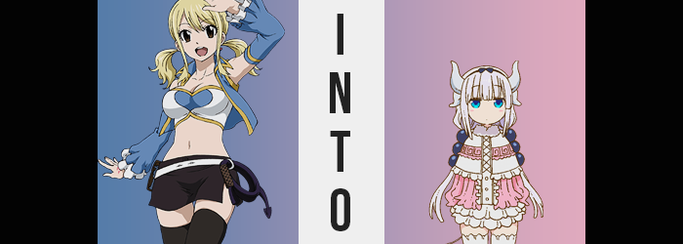

“Wendy and Erza are late. I wonder where they went…?”

Lucy Heartfilia was both confused and concerned, which was a shame because the day had started out so well too! It wasn’t every day that they were given a ruin exploration and treasure seeking quest. And among those they did get, it wasn’t often that they were able to just turn it into a girls’ day out. Natsu or Gray typically insisted on tagging along with them even though the three women were more than capable of taking care of themselves.

But there hadn’t been any threats to find in the ruins they had been sent to anyways. It had been so peaceful that the trio had decided to split up to cover more ground, that way they could do the expedition in a single day instead of two. There was a limit to how much treasure they would be able to carry after all, and now back at the front entrance? Lucy had lugged a fair bit of gold and jewels back with her. She didn’t want to talk about how she had to shove some of it into her cleavage to carry it though.

“Would you like an answer to that question?” Lucy jumped at the sound of an unfamiliar voice coming from the direction of the ruins she had just left. And before her an unfamiliar, horned woman stood. Her eyes were closed and yet the mage could feel her gaze piercing into the back of her mind. Just looking at her a lot stood out aside from her horns, like her bodacious figure for one.

But… “Um… Aren’t you embarrassed walking around like that?” Lucy was instead laser focused on the fact that she was naked. How could she not be? She was trying not to stare! But who was this woman? Did she know where her friends were? Based on the stranger’s aura… would she even like the answer? At the very least her remark had seemingly gotten a chuckle out of the woman. A woman named Lucoa.

Who was actually one of the friends Lucy had been waiting for.

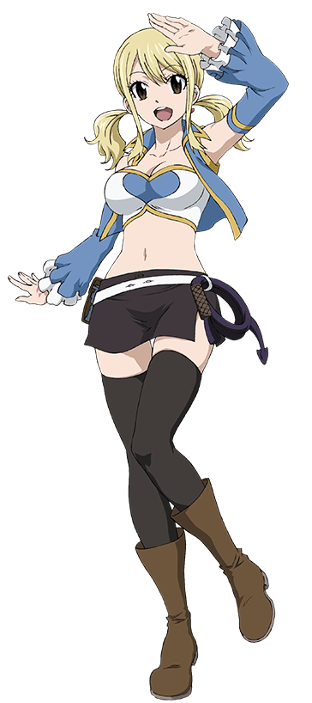
“Embarrassed? Not really, no… But you were looking for your friends, right?” Lucoa paused a moment to watch Lucy nod her answer to the question. “Well, you’ve moved quite a bit of my treasure, so let’s see…” Did the woman just say the treasure was hers? Did that mean that she had been exploring the ruins before they had gotten there? She couldn’t possibly mean that the ruins belonged to her, could she? “Oh! Those should work!”

Lucy had intended on asking the stranger more about herself when the woman’s closed eyes opened, revealing that they were mismatched in color while glowing ominously. It took her a second to realize that another light was shining behind her, from the small pile of treasure she had amassed. “H-Huh?” At the time she had found them Lucy had assumed that the two glowing trios of blue beads atop the pile were just gems, but looking at them now she felt like they were hair decorations.

No. She somehow knew they were. They were her hair decorations.

“H-Hey!” Not only was she beginning to perceive them as hers, but their weight had been translated onto her own twin tails, retaining their style. But their appearance was immediately noted by Lucy. Was she under some sort of attack? Should she use her magic? Her keys? …Huh? Why would keys be magic? N-No! That’s how I use my… Is that right? AH!? Why did she feel so confused!? Looking back at the horned woman who had started this, she was simply standing there, smiling menacingly.

Lucy’s thoughts being led astray was not a phenomenon that was occurring without physical consequences, seemingly. The strands of hair within and around those hair beads were lightening in color, platinum blonde pushing closer to silver with a subtle pink undertone. This discoloration bled deeper into her mane, dyeing roots, tips, and even making sure that any future hair would grow out in the same color. Something that happened immediately, for the length and style of her hair grew out a handful of inches, with bangs cut perfectly straight across her eyes.

The victim of these changes had yet to notice that she was changing for she was still thinking of a way to try and fight back or escape. But she couldn’t think of anything! Eyes briefly went wide, showing off a sky blue that was sparkling midst the usual brown of her irises – ultimately consuming them entirely. Strangely her eyes didn’t narrow again, retaining a bigger, wider, and pointedly more youthful shape.

She didn’t realize this of course. There wasn’t a mirror for her to see her own face – but they youthful nature her eyes suggested was becoming much more widespread. The shape of her face and head overall was the biggest tell. Her cheeks plumped up until her face was perfectly round and her nose shrunk smaller. Lips thinned in kind, robbing her face of any signs of maturity. Not only did it almost look like a child’s head was on a young woman’s face, but she didn’t even look like Lucy Heartfilia from the neck up.

“What is this!? What are you doing… to me?” The Celestial Spirit Mage finally mustered up the courage to ask the dragon woman what was happening and was immediately taken aback by the sound of her own voice. Had it always been that high? High, yet quiet. Lucy was prone to overreacting and that usually carried in her voice too, but attempting to cry out now registered her words in a far more monotonous manner. “I don’t want to be small…”

Those words were said aloud, but the woman speaking them immediately questioned why she had said them. What had indicated that she was going to shrink? Nothing had happened to her yet to give that impression. It was more like she knew? Like she felt as if she was supposed to be a lot smaller. And while she was right, that change wasn’t due to happen without some preparatory changes beforehand.

“Erm…?” Lucy immediately noticed those preparatory changes because they compromised the fit of her outfit, which up until this point hadn’t been affected. But now? Her crop top was feeling very loose, and looking down she could see why. “Oh no…” She wanted to cry out at the sight of her tits shrinking, but her new personality just wouldn’t allocate the energy to make a scene about it. She could only paw quietly at her bosom while nipples drew closer and closer to her ribcage, until there was nothing there at all aside from a touch of puffiness.

She wasn’t even able to gawk at them for long. Her thighs and butt had also been thinning, and without all of that weight to her caboose her hips had been narrowing to boot. This meant that her skirt and panties were on the cusp of slipping off, but the moment they did? “Ah!?” A separate magic had been used and the clothes she was wearing had instantly been replaced by a big and puffy, pink and white frilled dress with which thigh highs, pink shoes, and a black bowed headband. It certainly didn’t look like something an adult woman would wear. But to Lucy?

These were her clothes, aren’t they?

And ultimately she hardly made a sound at all as her height then plummeted. Inches peeled off of her rapidly, limbs shortening and her torso collapsing in on itself. Miraculously the dress changed to fit her shrinking form, keeping pace to remain fitted even one her feet had become miniaturized and her shoulder exceptionally narrow. When all was said and done she was no taller than, and looked exactly like, a nine year old girl. One who had pudgy thighs and a slight stomach bump that were more indicative of her age than anything. “Hmm…”

She held up one of her arms to look at herself before looking back at Lucoa. She recognized the elder dragon now. Because she had a history with her. Because she was also a dragon. The moment this was acknowledged deep down it became a reality, with four horns set up into pairs emerging from the sides of her head. Their white keratin was curved with one horn up and one pointed down to the rear on either side. She likewise grew a tail, but it certainly wasn’t as notable as you might assume. It looked more like a long string sticking out from under her skirt with a light purple ball of fluff on the tip.

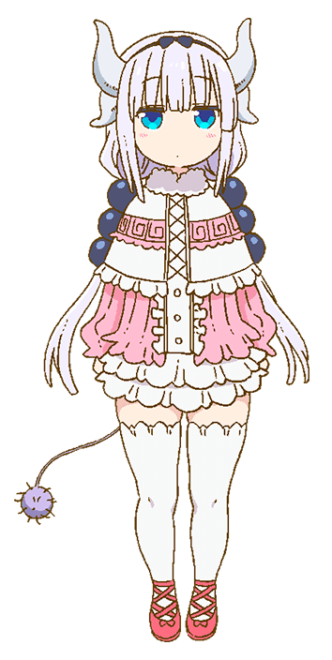
“…Lucoa.” Whatever remaining energy left of Lucy’s ego that had been fighting back, it certainly wasn’t now. Because the girl who spoke was now purely, authentically Kanna Kamui. A dragon just like Lucoa and Elma, who she seemed to simply know was elsewhere in the ruins at the moment. Compared to how boisterous and energetic Lucy was, the tiny dragon that stood in her place might as well have been the polar opposite. She was quiet and kept to herself most of the time. “Did you do something to me?”

The child held no recollections of her past life to know for certain but she could sense Lucoa’s magic on her person. In a way she was correct? The older dragon had directly utilized her magic midst the girl’s transformation. During the past two transformations the clothing of Lucoa and Elma hadn’t changed with their bodies. But Lucoa had made sure that Kanna’s clothing had – because she didn’t want a half-naked child running around.

“Hmm? I just gave you a cute outfit, Kanna-chan! Nothing nefarious, I assure you!” She technically wasn’t lying? It had certainly been nefarious for Lucy, but it was the whole reason Kanna had been reborn on the soil of Fiore. For better or for worse they all had. “I think Elma was planning on making us dinner! Did you want to go and find her?” Kanna couldn’t help but think she was being dodgy with her answer but ultimately just accepted it. But something still felt wrong about it.

“Wait, is Tohru not here?”

“If I can find someone to take her place, then…?”

“…Hm?”

“Nothing!”

…Suspicious.

